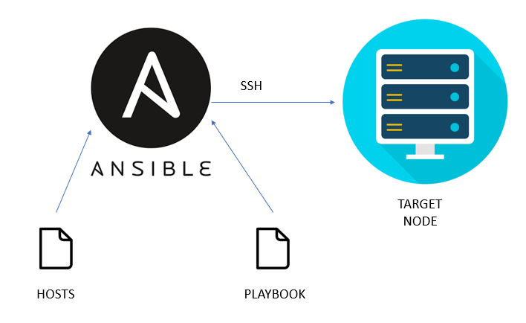
Task Title
Ansible-03
Objective
The objective of this task is to watch the Ansible-03 video posted on slack and worked on executing the Ansible tasks shown in video.
Prerequisites
List all requirements before starting:
- Master Controller server
- Nodes- workers
- Vault
- Variables types of variables
- Playbook
- Ad hoc commands
Issues Faced: Briefly mention issues and how you fixed them. Posted below in the last.
Conclusion
Conclusion has been provided for every task at the end.

Vault

What is ansible vault?
Ansible vault is too used to hide the sensitive data.
Example: username, password etc.

- How to create an ansible vault?
Use command- ansible-vault encrypt file_name

- How to read the content of the file in vault?
Use command- ansible-vault view file_name

- How to edit the content of the file in vault?
Use command- ansible-vault edit file_name

- How to reset the vault password?
Use command- ansible-vault rekey file_name

- How to remove the file created for vault?
Use command- ansible-vault decrypt file_name

Variables

Variable is a placeholder which will hold a specific value for our playbook or for any template.

Types of variables:

- Inline variable
- Vars File
- Command line
- Prompt for variables
- Inventory variables

- Inline Variable:
Directly define within the same playbook
- name: variable playbook
hosts: all
vars:
Name: Techie

Tasks:
- name: Display value
debug:
var: name
This is the basic variable syntax and defined variable directly inside the playbook.

- Vars file:
Create a yaml file with all variables required and include the yaml file name in playbook.

- name: variable playbook
hosts: all
vars_files:
- variables.yaml

tasks:
- name: Display value
Debug:
Var: name

Here, in the playbook, we added a play to display the name of the variables created in the variables.yaml file.

- Command Line:
Pass variables directly when executing playbook.

For example: ansible-playbook -e “name=test” variable.yaml

Precedence Level

Command line has highest priority

- Prompt for variables: Interact with users to enter the variables

-name: variable playbook
Hosts: all
vars_prompt:
- name: variable_name
prompt: “Enter a name for variable_name”

tasks:
- name: Display value
debug:
var: variable_name

- Inventory variables: variables can be defined in inventory

-name: variable playbook
Hosts: all

Tasks:
- Name: Display value
Debug:
Var: name

Before executing the above playbook navigate to hosts file edit the variables in hosts file by adding Worker-01 and Worker-02

Loop

Loops are used in ansible when we need to create directories more than 1 like multi directories in 1 playbook with simple script.

-name: Create directories using ansible
Hosts: all

Tasks:
- Name: Create first directory
File:
path: /opt/ {{ item}}
state: directory
mode: 0755

loop:
-directory1
-directory2
-directory3

Tasks

- Write a single ansible playbook which will install apache and nginx. Note: Playbook should not be hardcoded and pass the variables from different file.

Step by step Implementation:
Login into Controller and delete the apache2 package created earlier.

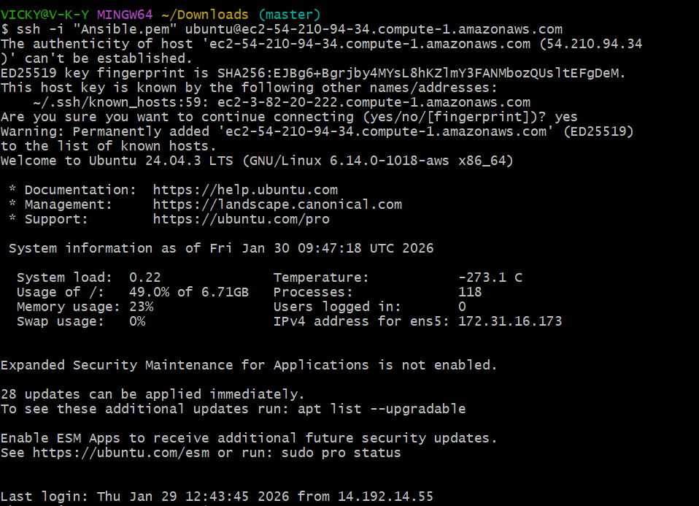

We are able to ping to my both workers
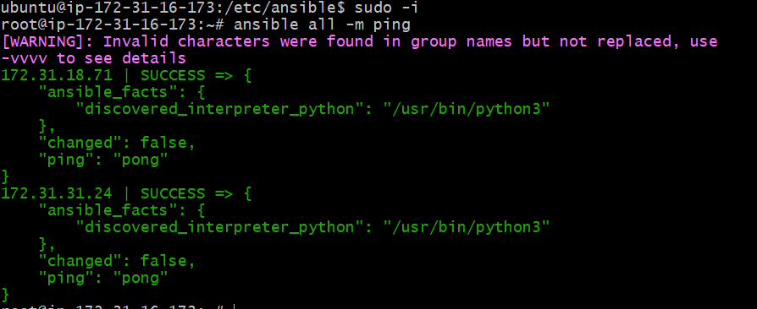
Now, we shall delete the package to all machines

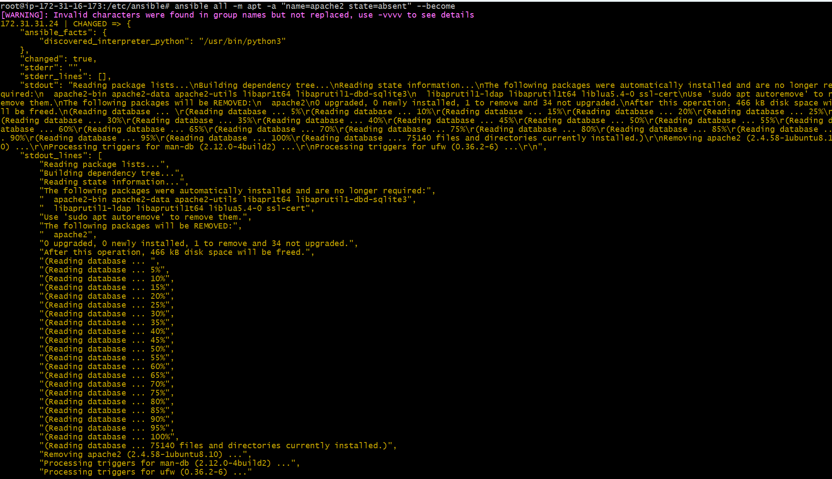

Let’s verify in worker machines
Worker-01

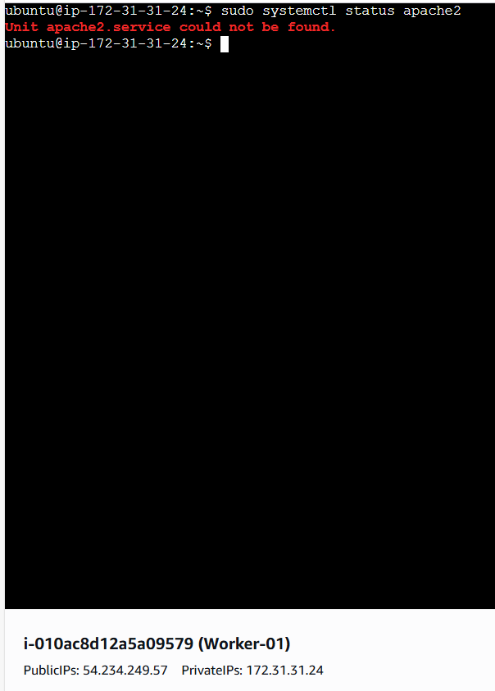
Step 1: Let’s create a vars file to soft code the variables instead of hard coding in the paybook.

packages:
- apache2
- nginx

services:
- apache2
- nginx

nginx_port: 8080
nginx_conf: /etc/nginx/sites-enabled/default

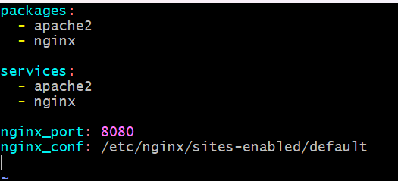

Step 2: Let’s create a playbook to install nginx and apache in a single playbook by adding “lineinfile” under tasks.

- hosts: all
become: yes
vars_files:
- vars.yaml

tasks:
- package:
name: "{{ packages }}"
state: present

- service:
name: apache2
state: started
enabled: yes

- copy:
dest: "{{ nginx_conf }}"
content: |
server {
listen {{ nginx_port }};
location / {
root /var/www/html;
index index.html;
}
}

- service:
name: nginx
state: restarted
enabled: yes
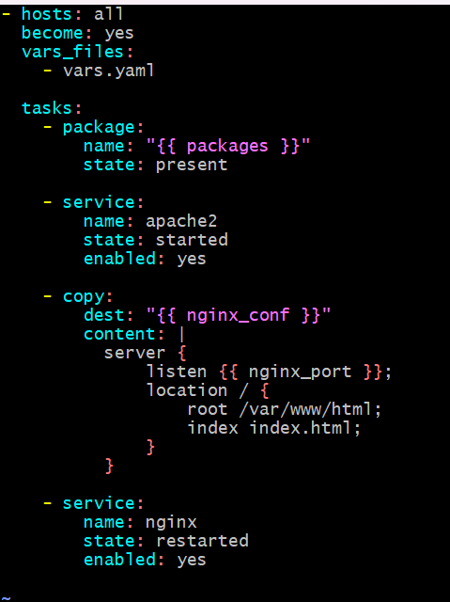
Let’s execute the playbook
Success- playbook ran successfully.

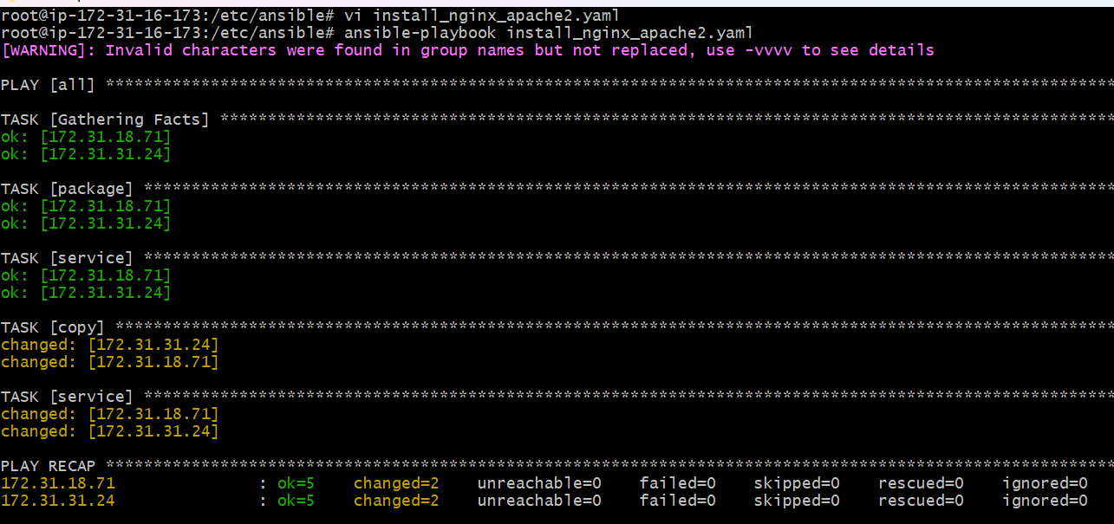

Let’s verify in the browser for workers if apache2 and nginx are working.

Apache2 and nginx in Worker-01

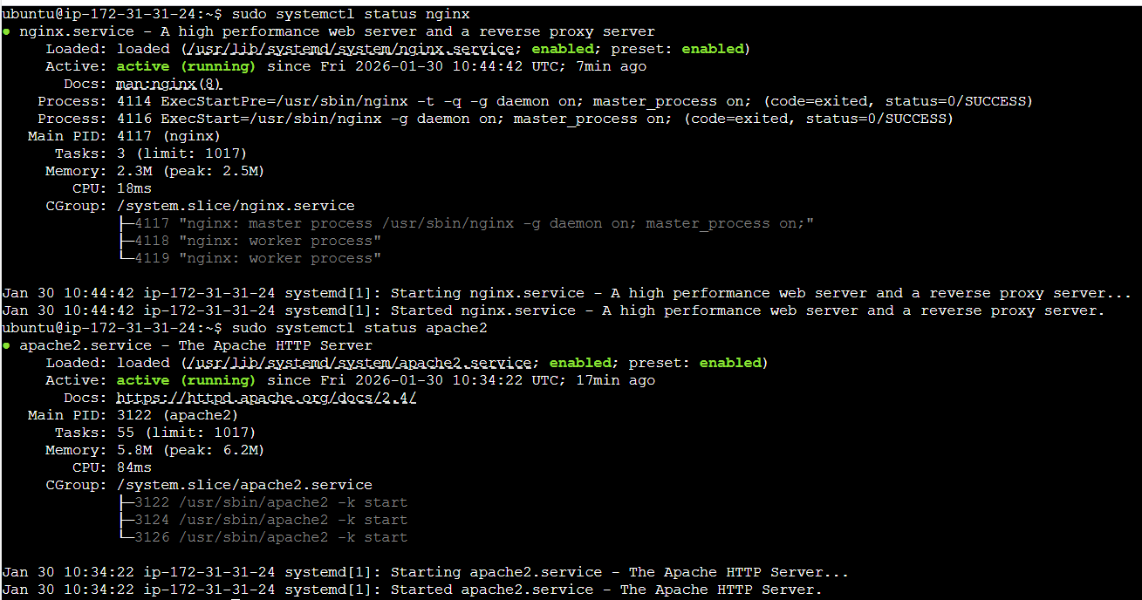

Apache2: success listening to browser

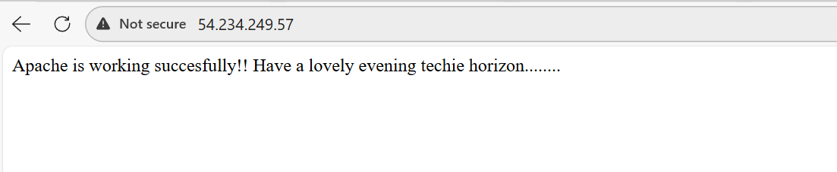

Nginx: success listening to browser

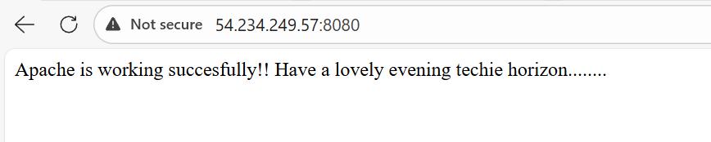

- Ansible playbook to create 10 different directories with minimal code and directory names should be passed as variables.

Step by step Implementation:

Requirement:
Ansible playbook to create 10 different directories with minimal code and directory names should be passed as variables

Step 1: Let’s create a variable file- vars.yaml

# dir_vars.yml
folder_names:
- analytics_01
- archive_base
- build_output
- db_dumps
- logs_internal
- staging_site
- test_results
- vendor_libs
- web_assets
- zone_configs

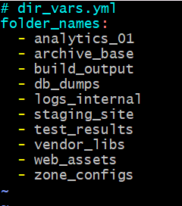

Step 2: Lets update the playbook named- create_directories.yml

---
- name: Create directories from external vars
hosts: localhost
vars_files:
- dir_vars.yml

tasks:
- name: Create directories iteratively
ansible.builtin.file:
path: "./{{ item }}"
state: directory
mode: '0755'
loop: "{{ folder_names }}"

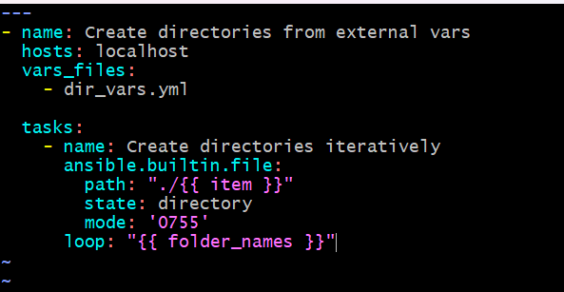

Ready for execution syntax check complete dry run complete
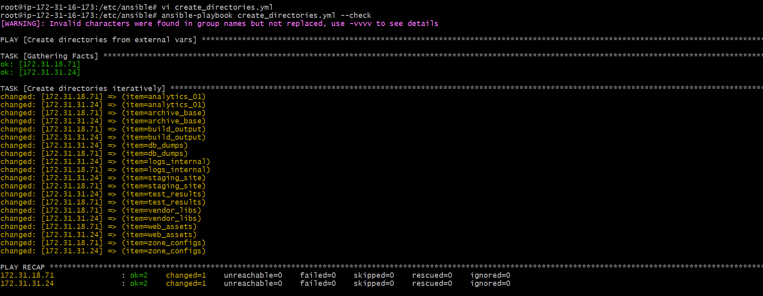

Executed the playbook
Success completed- playbook ran
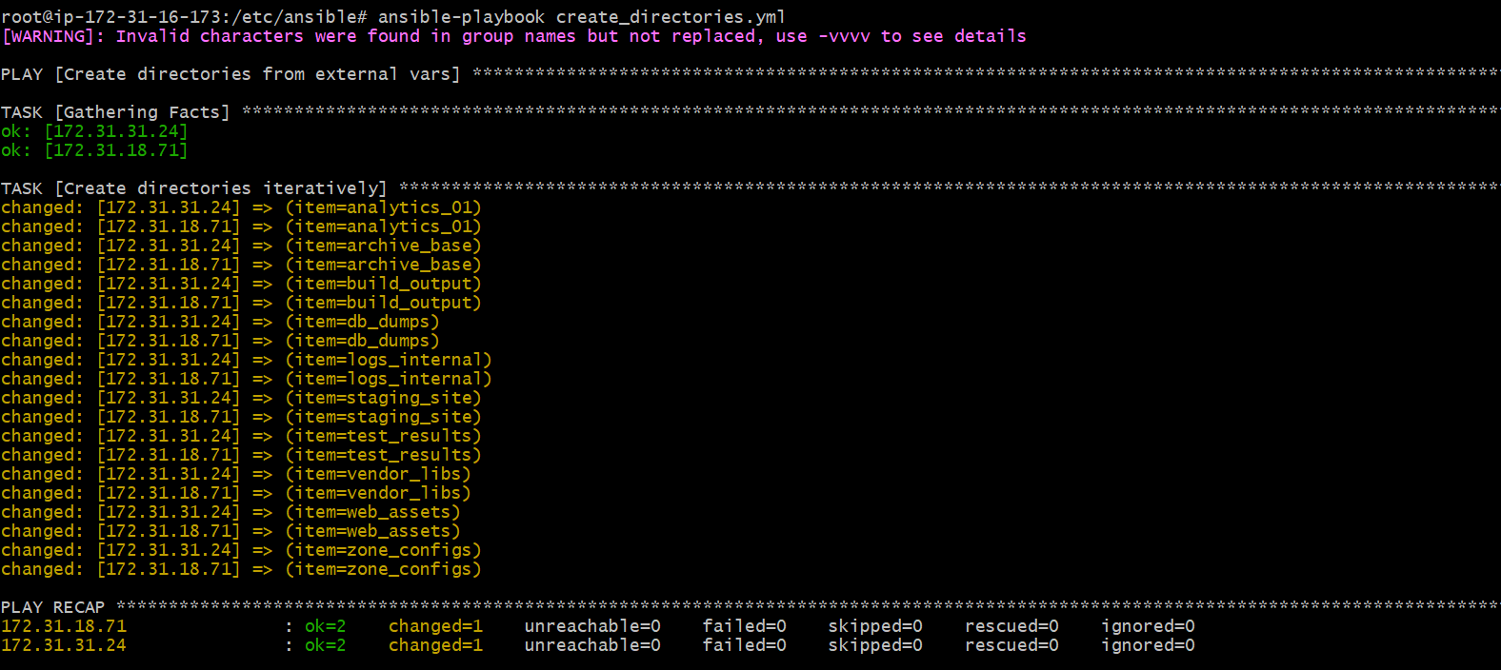

Let’s verify in the worker machines:

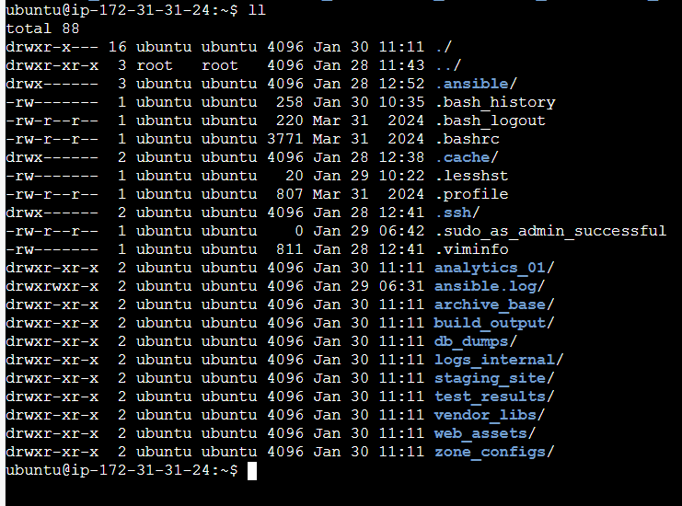

Task completed

- Ansible playbook to copy ssh-keygen from master to worker nodes.
Note:
a) Provision new 3 ec2 machines, one master and two worker nodes.
b) Create common user called ansadm and provide sudo privileges on 3 ec2 instances.
c) Create ssh-keygen in master and your playbook should copy the keygen making it password less authentication.

Prerequisites:

- Infrastructure & Access

- Active Ansible Controller: You must have a control node (EC2 instance) with Ansible installed and a public IP to manage the target nodes.
- Security Group Rules: The Security Group attached to your 3 new instances must allow Inbound SSH (Port 22) from your Controller's Private or Public IP.
- Original AWS Key Pair: You must have the private key file (Ansible.pem) stored on your Controller with permissions set to chmod 400.

- Controller Configuration

- Ansible Inventory: Your /etc/ansible/hosts file must be correctly partitioned into [master] and [workers] groups.
- SSH Key on Controller: You must have already generated a local key on the Controller using ssh-keygen if you intend to manage the cluster as ansadm later.
- Python Dependencies: Ensure python3 and the python3-pip packages are installed on the Controller and all target nodes for Ansible modules to function.

- Software Requirements
- ACL Package: The acl package must be available for installation on the target Ubuntu nodes to handle privilege escalation (become_user: ansadm).
- Ansible Collections: Ensure the amazon.aws collection is installed if you are performing the provisioning step from the Controller.
- Correct AMI: Ensure you are using an Ubuntu-based AMI for the 3 instances, as the playbooks are configured for the ubuntu default user and the sudo group.

Step 1: Provision 3 EC2 Instances

Run this playbook from your Controller to launch your 1 Master and 2 Worker nodes. You will need your AWS credentials configured on the Controller.

Syntax:
---
- name: Provision Infrastructure
hosts: localhost
tasks:
- name: Launch 3 EC2 Instances
amazon.aws.ec2_instance:
name: "{{ item.name }}"
key_name: "Ansible" # The key pair name in your AWS Console
instance_type: t2.micro
image_id: ami-0b6c6ebed2801a5cb # Ensure this is an Ubuntu AMI
region: us-east-1
tags:
Role: "{{ item.role }}"
loop:
- { name: 'Ansible-Master', role: 'master' }
- { name: 'Worker-01', role: 'worker' }
- { name: 'Worker-02', role: 'worker' }

Step 2: Update Your Inventory

Once the instances are running, get their Public IPs and add them to your inventory file.
File: /etc/ansible/hosts
[master]
13.xxx.xxx.10 # Master Public IP
[workers]
13.xxx.xxx.11 # Worker 01 Public IP
13.xxx.xxx.12 # Worker 02 Public IP

Step 3: Create User & Sudo Privileges

This playbook targets all nodes to ensure the ansadm user exists and can run commands as root without a password.

Syntax:

---
- name: Phase A & B - Setup User and Sudo
hosts: all
become: yes
tasks:
- name: Install ACL for privilege escalation
ansible.builtin.apt:
name: acl
state: present

- name: Create ansadm user
ansible.builtin.user:
name: ansadm
shell: /bin/bash
groups: sudo
append: yes

- name: Grant passwordless sudo to ansadm
ansible.builtin.lineinfile:
path: /etc/sudoers.d/ansadm
line: "ansadm ALL=(ALL) NOPASSWD:ALL"
create: yes
mode: '0440'
validate: '/usr/sbin/visudo -cf %s'
Execution Command:
ansible-playbook -i /etc/ansible/hosts 01_create_user.yml -u ubuntu --private-key=Ansible.pem

Step 4: Master-to-Worker SSH Exchange

Once the user is created, run this playbook to handle Task (C). This generates the key on the New Master and pushes it to the Workers.

Syntax:
---
- name: Generate Key on Master
hosts: master
tasks:
- name: Ensure .ssh directory exists for ansadm
become: yes
ansible.builtin.file:
path: /home/ansadm/.ssh
state: directory
owner: ansadm
group: ansadm
mode: '0700'

- name: Generate SSH Key for ansadm on Master
become: yes
become_user: ansadm
ansible.builtin.openssh_keypair:
path: /home/ansadm/.ssh/id_rsa
type: rsa
size: 4096

Step 5: Final Execution Command

Run the following commands from your Controller terminal. Use the Ansible.pem file you created on your server to establish the initial connection.
# 1. Ensure key security
chmod 400 Ansible.pem

# 2. Bypass fingerprint prompts
export ANSIBLE_HOST_KEY_CHECKING=False

# 3. Run the configuration
ansible-playbook -i /etc/ansible/hosts full_setup.yml -u ubuntu --private-key=Ansible.pem

Step 5: Verification
To confirm everything is correct, log into your New Master and try to jump to a Worker:
- ssh -i Ansible.pem ubuntu@<MASTER_IP>
- sudo su - ansadm
- ssh <WORKER_PRIVATE_IP>

Commands and their usage:

chmod 400 Ansible.pem: This command changes the file permissions of your private key to "read-only" for the owner. SSH will reject a key if it is "too open" (readable by others), as this is a security risk.

export ANSIBLE_HOST_KEY_CHECKING=False: This environment variable tells Ansible to skip the "Are you sure you want to continue connecting (yes/no)?" prompt for new servers. This is essential for automation so the playbook doesn't hang waiting for manual input.

User Creation (01_create_user.yml)

This phase establishes the identity you will use to manage the servers.
- ansible.builtin.apt (name=acl): Installs the Access Control List package. Without this, Ansible cannot safely use become_user to switch from root to ansadm.
- ansible.builtin.user: Creates the ansadm user account and assigns it to the sudo group, which is the standard admin group for Ubuntu.
- ansible.builtin.lineinfile: Edits the /etc/sudoers.d/ansadm file to add NOPASSWD:ALL. This allows the ansadm user to run root commands without being prompted for a password, which is required for non-interactive automation.
- visudo -cf %s: This is a validation check. It ensures the sudoers file you just created has no syntax errors before saving it.
SSH Key Exchange (02_ssh_exchange.yml)
This phase builds the "trust" between your Master and Worker nodes.
- ansible.builtin.openssh_keypair: Runs only on the Master node to generate a 4096-bit RSA key pair (public and private) specifically for the ansadm user.
- ansible.builtin.slurp: This is a powerful module that reads the content of a file (the Master's public key) and encodes it in base64 so the Controller can store it in a variable called master_pub_key.
- ansible.posix.authorized_key: Runs on the Worker nodes. It takes the public key stored by the Controller and injects it into the /home/ansadm/.ssh/authorized_keys file.

4.Execution Command Breakdown
When you run the playbook, the flags tell Ansible how to "talk" to the new servers:
Bash
ansible-playbook -i /etc/ansible/hosts 02_ssh_exchange.yml -u ubuntu --private-key=Ansible.pem
- -i /etc/ansible/hosts: Points to your inventory file where the Master and Worker IPs are listed.
- -u ubuntu: Tells Ansible to log in as the default AWS user (ubuntu) because the ansadm user’s SSH access isn't fully ready yet.
- --private-key=Ansible.pem: Uses your original AWS private key for the initial connection.

5. Verification Commands
After the playbooks finish, use these commands to ensure everything is perfect:
- ansible all -m shell -a "sudo whoami" -u ansadm: Confirms that the ansadm user can successfully escalate to root on all nodes without a password.
ssh -v ansadm@<WORKER_IP>: Running ssh with the -v (verbose) flag is helpful for troubleshooting if a connection is refused; it shows you exactly where the authentication is failing

- Ansible playbook to inject ansible vault variables.

Step 1: Create a file and update the variables (username and password of ansible)

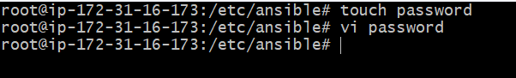

Variables updated


Step 2: Let’s encrypt the file, so no one can read the file except owner

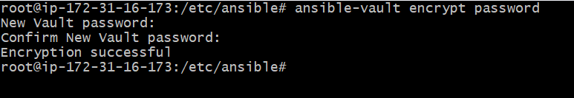

The file is encrypted with password

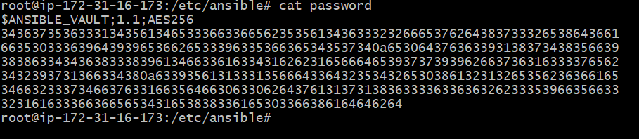

Step 3: If we need to decrypt the file, we can use decrypt and enter the password.

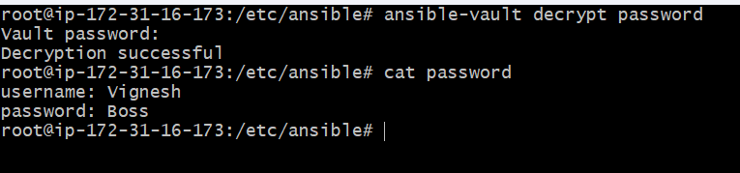

Let’s create a playbook to inject variables in vault

Created a file- password.yaml

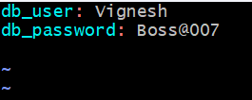

Created a playbook- inject_variable.yaml

---
- name: Use Ansible Vault variables
hosts: all
become: yes

vars_files:
- vars.yml
- vault.yml

tasks:
- name: Print database details
debug:
msg:
- "DB User: {{ db_user }}"
- "DB Password: {{ db_password }}"

