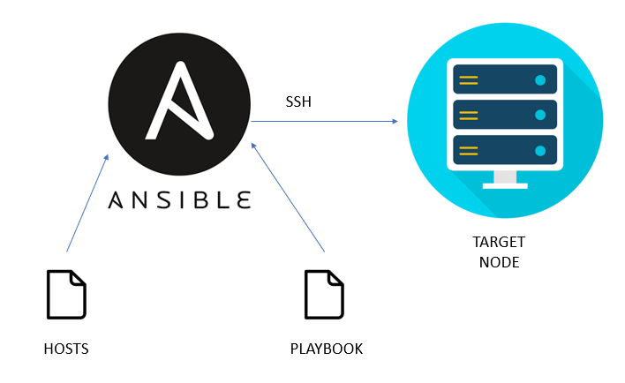
Task Title
Ansible-04
Objective
The objective of this task is to watch the Ansible-04 video posted on slack and worked on executing the Ansible tasks shown in video.
Prerequisites
List all requirements before starting:
- Master Controller server
- Nodes- workers
- Vault
- Variables types of variables
- Playbook
- Ad hoc commands
Issues Faced: Briefly mention issues and how you fixed them. Posted below in the last.
Conclusion
Conclusion has been provided for every task at the end.

Tasks

- Create ansible playbook to create ansible vault.

Objective
To securely store sensitive credentials using Ansible Vault and use those encrypted variables inside an Ansible playbook.
Prerequisites
- Ansible installed
- Inventory configured (/etc/ansible/hosts)
- Target hosts reachable
- Basic YAML knowledge

Step by step Implementation:

Step 1: Login to master controller and worker machines
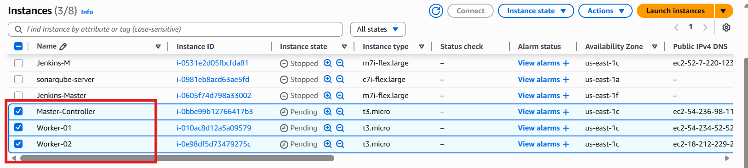

Step 2: Create a file and update the variables (username and password of ansible)

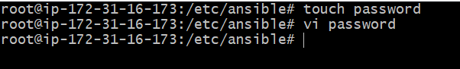

Variables updated

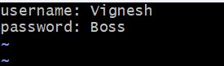
Step 3: Let’s encrypt the file, so no one can read the file except owner

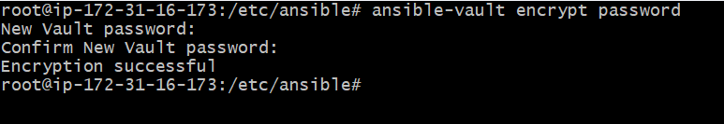

The file is encrypted with password

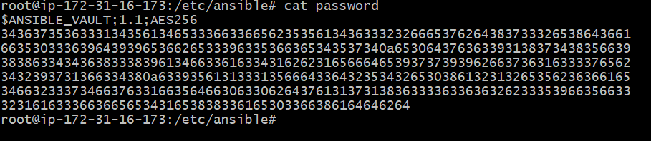

Step 4: If we need to decrypt the file, we can use decrypt and enter the password.

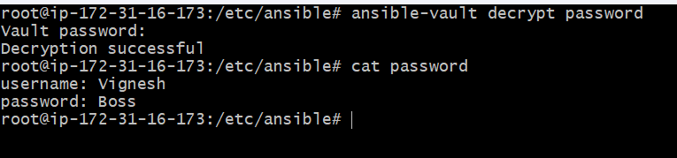

Let’s create a playbook to inject variables in vault

Created a file- password.yaml

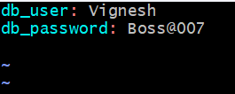

Step 5: Created a playbook- inject_variable.yaml

---
- name: Use Ansible Vault variables
hosts: all
become: yes

vars_files:
- vars.yml
- vault.yml

tasks:
- name: Print database details
debug:
msg:
- "DB User: {{ db_user }}"
- "DB Password: {{ db_password }}"

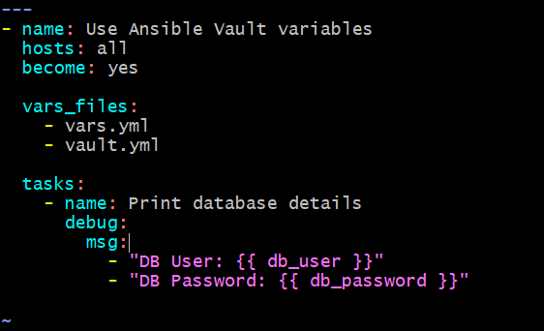

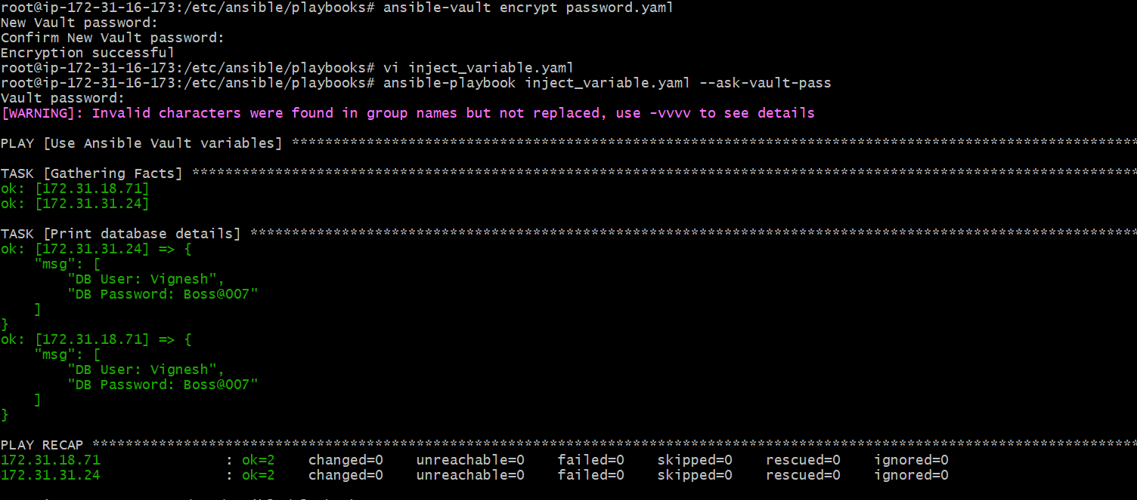

Issues Faced
- Variable name mismatch can cause undefined variable errors
- Incorrect YAML formatting (missing space after :) can break vault parsing
- Printing passwords using debug is unsafe in real environments
Conclusion
Ansible Vault was successfully used to encrypt sensitive variables and securely consume them in an Ansible playbook. Vault ensures that secrets remain protected while allowing automation tasks to run normally during execution.

- Write an ansible playbook to install apache in Linux and ubuntu machine by using when condition.
Objective
To install and start the Apache web server on Ubuntu and RHEL/CentOS/Amazon Linux machines using a single Ansible playbook with OS-based when conditions.
Prerequisites
- Ansible installed on control node
- Inventory configured with Ubuntu and Linux hosts
- SSH connectivity to target machines
- Root or sudo access on target nodes

Step 1: Create Playbook
cd playbooks/
vi install_apache.yml

Step 2: Add YAML Code
apache.yml
Syntax:
---
- name: Install Apache on Ubuntu and Linux
hosts: all
become: yes

tasks:

# For Ubuntu / Debian
- name: Install Apache on Ubuntu
apt:
name: apache2
state: present
update_cache: yes
when: ansible_os_family == "Debian"

# For RHEL / CentOS / Amazon Linux
- name: Install Apache on Linux
yum:
name: httpd
state: present
when: ansible_os_family == "RedHat"

# Start service on Ubuntu
- name: Start Apache on Ubuntu
service:
name: apache2
state: started
enabled: yes
when: ansible_os_family == "Debian"

# Start service on Linux
- name: Start Apache on Linux
service:
name: httpd
state: started
enabled: yes
when: ansible_os_family == "RedHat"

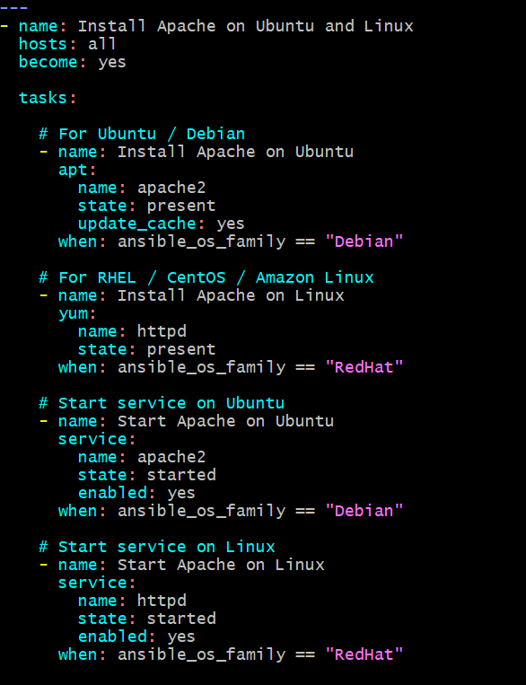

Step 3: Run Playbook
ansible-playbook apache.yml

Step 4: Check Output
You will see:
- Ubuntu → apache2 installed and started
- RedHat → httpd installed and started
- Other OS → skipped
Example:
skipping: [host]
ok: [host]

Success- Playbook ran successfully.
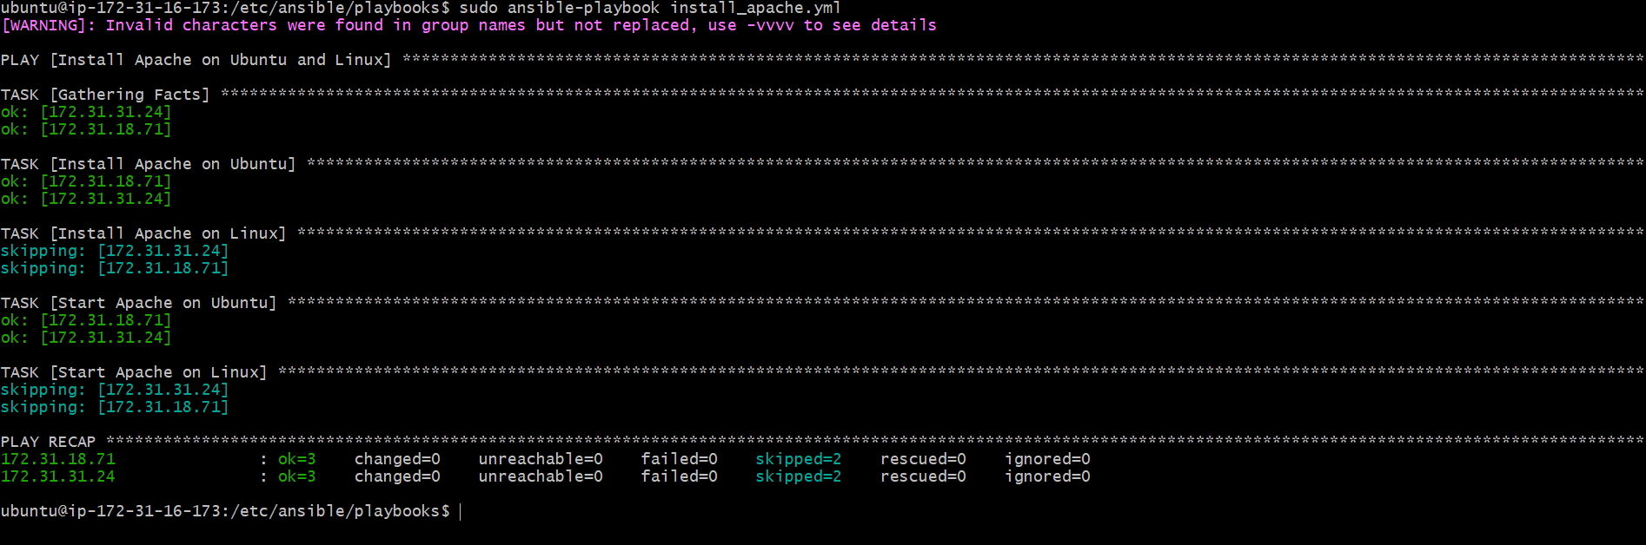

- Create ansible playbook using roles to configure LAMP stack

Step 1: Create Roles Directory Structure
mkdir -p lamp/roles/{apache,mysql,php}/{tasks,handlers}
Check:
ls lamp/roles/
You should see:
apache mysql php

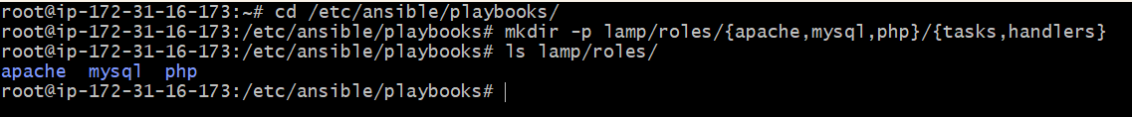

Step 2: Apache Role
Create tasks file
cd lamp/roles/apache/tasks
vi main.yml
📄 lamp/roles/apache/tasks/main.yml
---
- name: Install Apache
package:
name: "{{ 'apache2' if ansible_os_family == 'Debian' else 'httpd' }}"
state: present

- name: Start and Enable Apache
service:
name: "{{ 'apache2' if ansible_os_family == 'Debian' else 'httpd' }}"
state: started
enabled: yes
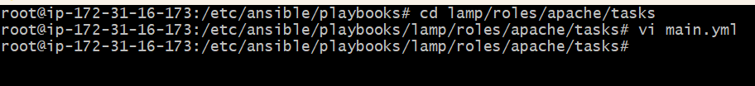
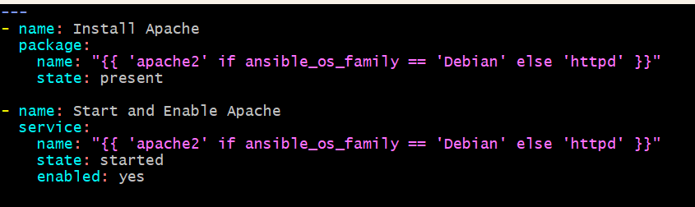
Step 3: MySQL Role
cd lamp/roles/mysql/tasks
vi main.yml
📄 lamp/roles/mysql/tasks/main.yml
---
- name: Install MySQL Server
package:
name: "{{ 'mysql-server' if ansible_os_family == 'Debian' else 'mariadb-server' }}"
state: present

- name: Start and Enable MySQL
service:
name: "{{ 'mysql' if ansible_os_family == 'Debian' else 'mariadb' }}"
state: started
enabled: yes

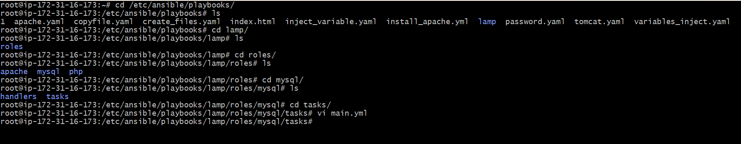
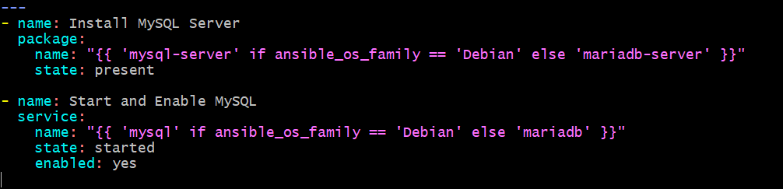

Step 4: PHP Role

cd lamp/roles/php/tasks
vi main.yml
📄 lamp/roles/php/tasks/main.yml
---
- name: Install PHP Packages
package:
name:
- php
- php-mysql
state: present
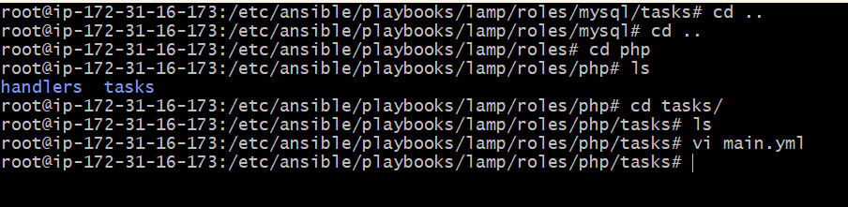
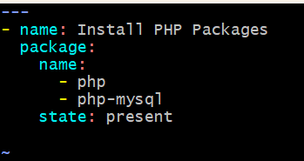
Step 5: Create Main Playbook

cd lamp
vi site.yml
📄 lamp/site.yml
---
- name: Configure LAMP stack using roles
hosts: all
become: yes
gather_facts: yes

roles:
- apache
- mysql
- php
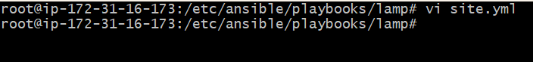
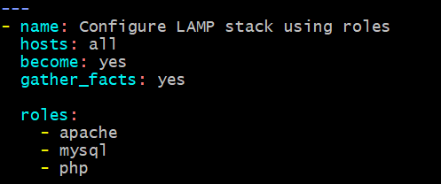

Step 6: Check Syntax

ansible-playbook site.yml --syntax-check

Step 7: Run Playbook

ansible-playbook site.yml
This installs:
Apache
MySQL
PHP
On all servers.
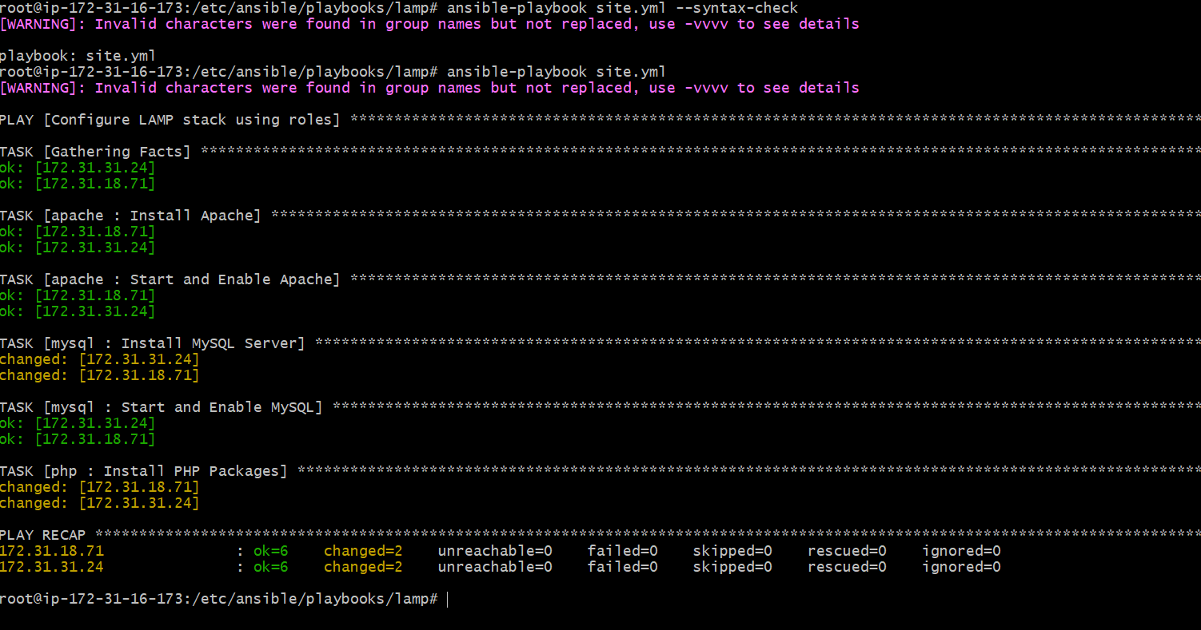
Step 8: Verify Services

Check Apache
systemctl status apache2
Check MySQL
systemctl status mysql
Both should be active (running).

Verified in Worker nodes
Worker-01
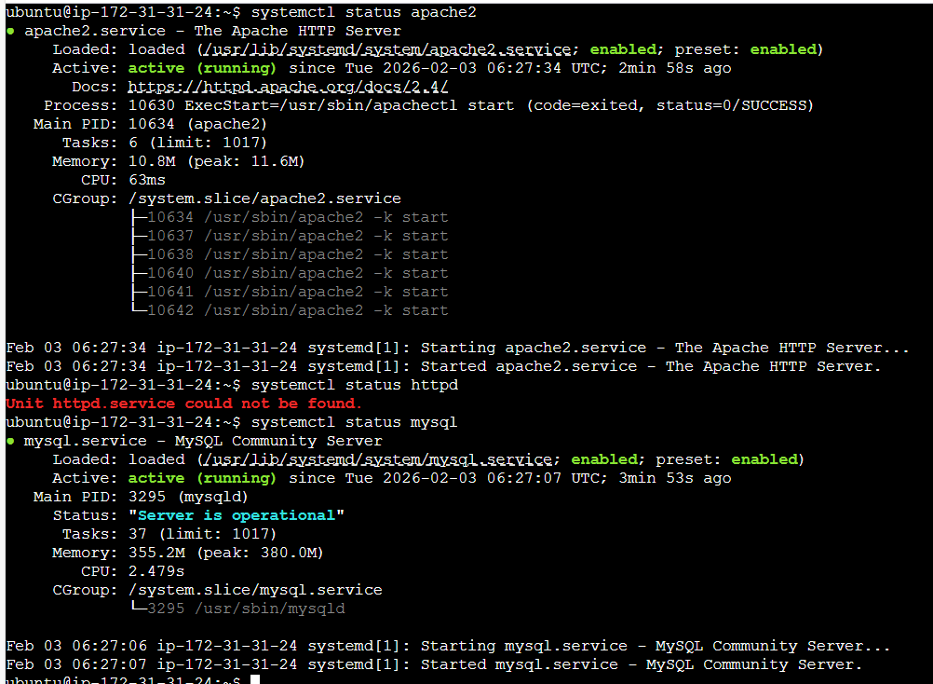
Worker-02
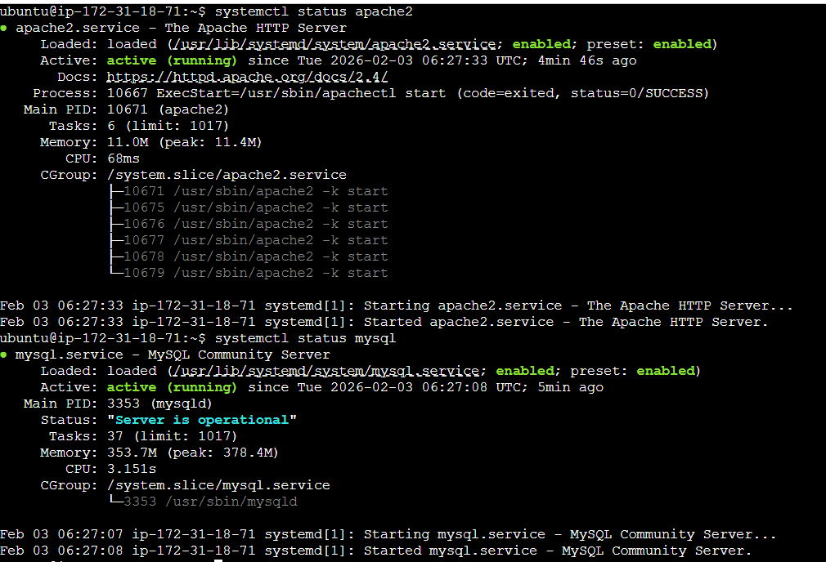
Final Folder Structure
lamp/
├── site.yml
└── roles/
├── apache/
│ └── tasks/main.yml
├── mysql/
│ └── tasks/main.yml

- Setup ansible AWX and explore the options.

Step by step Implementation:
Step 1: Launch Ubuntu AMI
Instance type: c7i flex large
Storage – 20gib
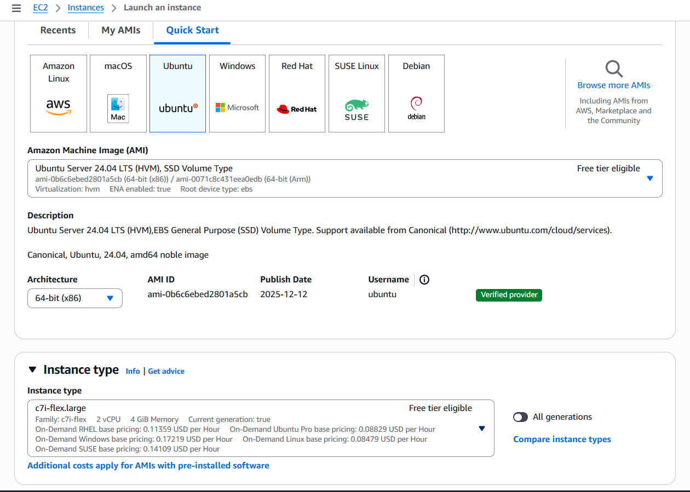

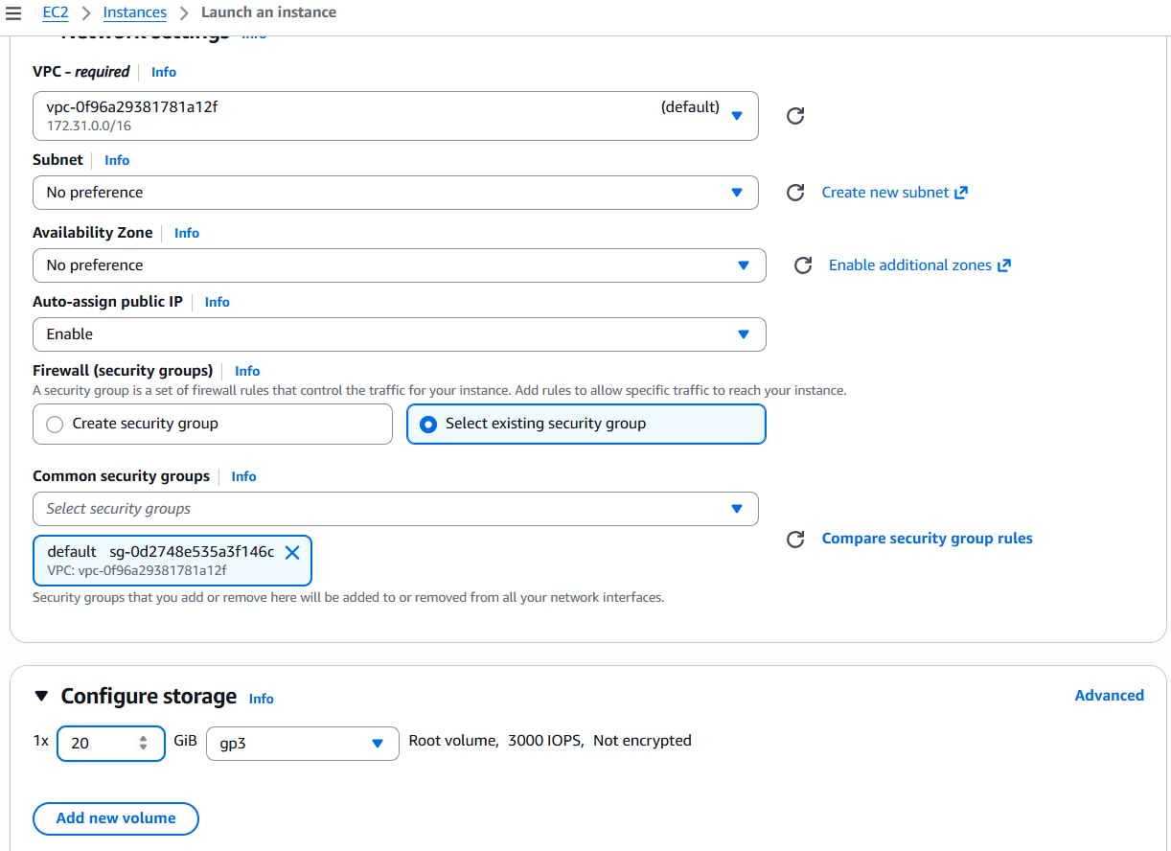

Step 2: Update the required packages
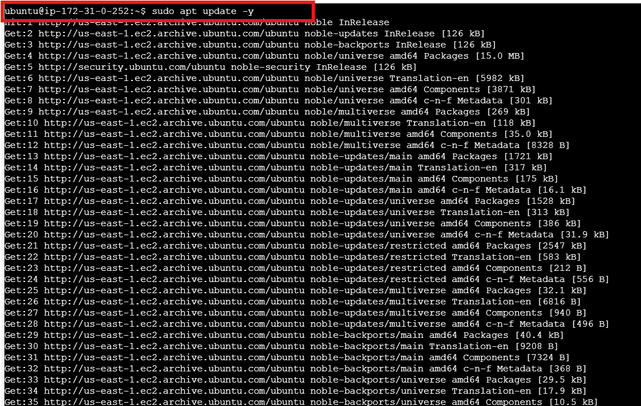

Step 3: Install ansible
apt install ansible -y
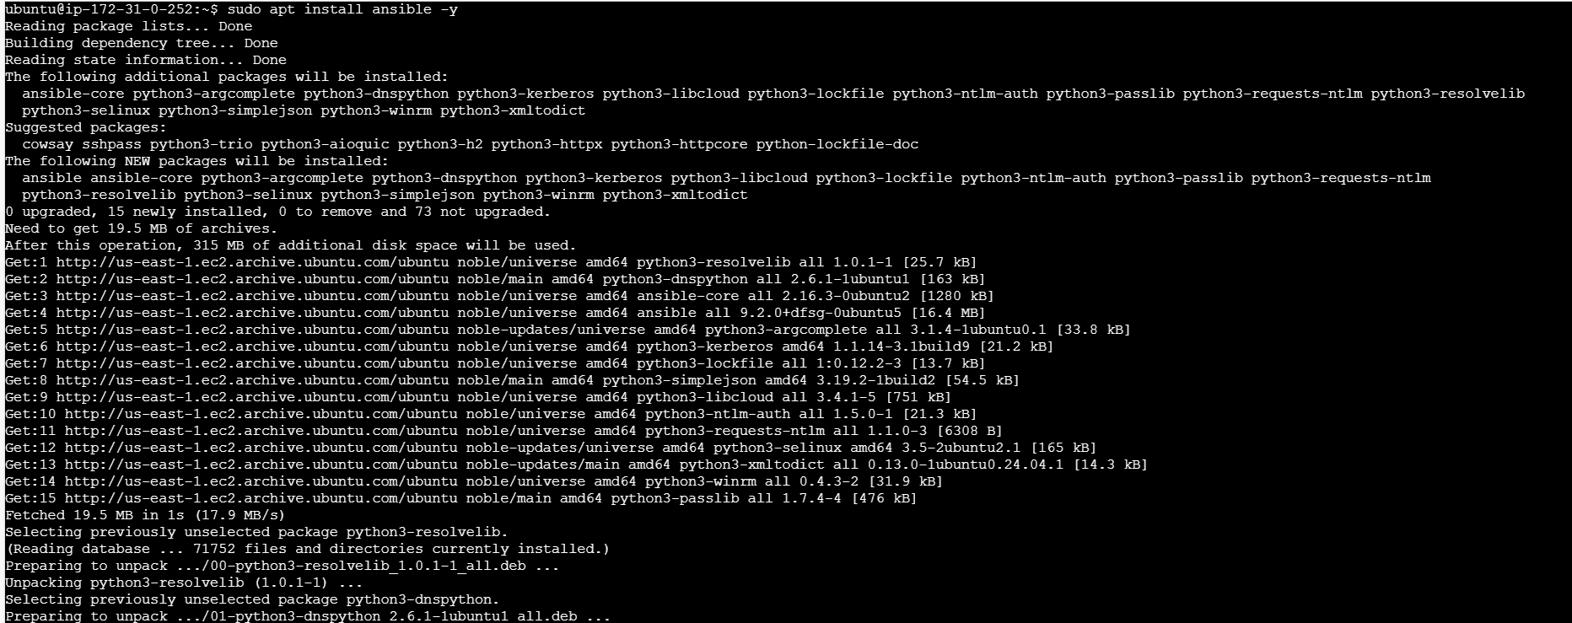

Step 4: Install docker
Sudo at install docker.io -y
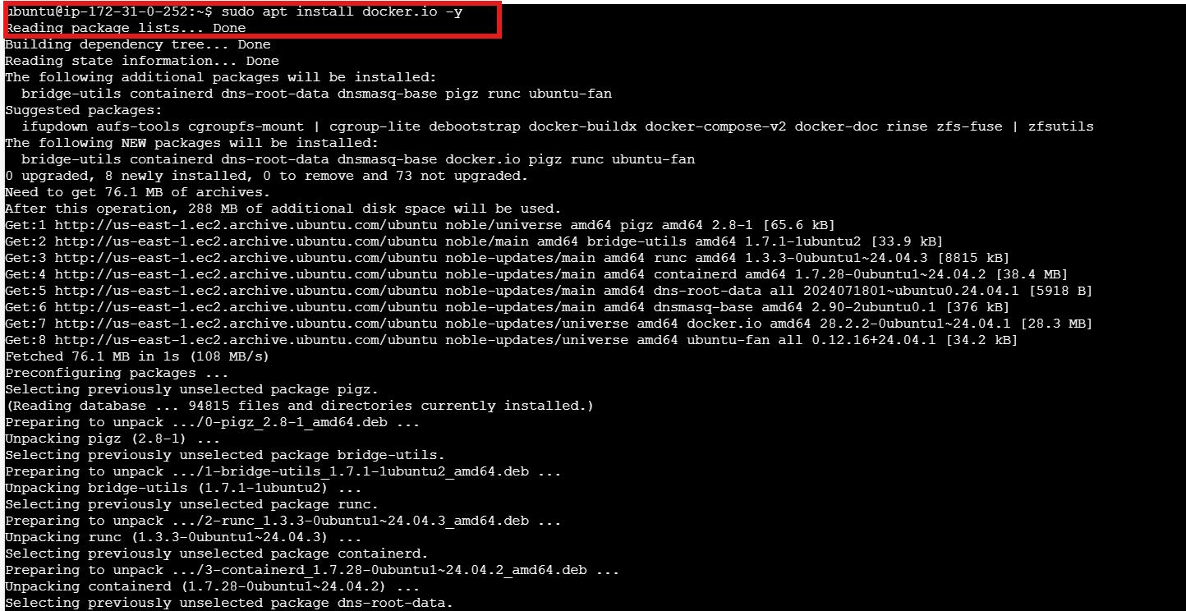

Step 5: Sudo systemctl start docker
Sudo systemctl status docker
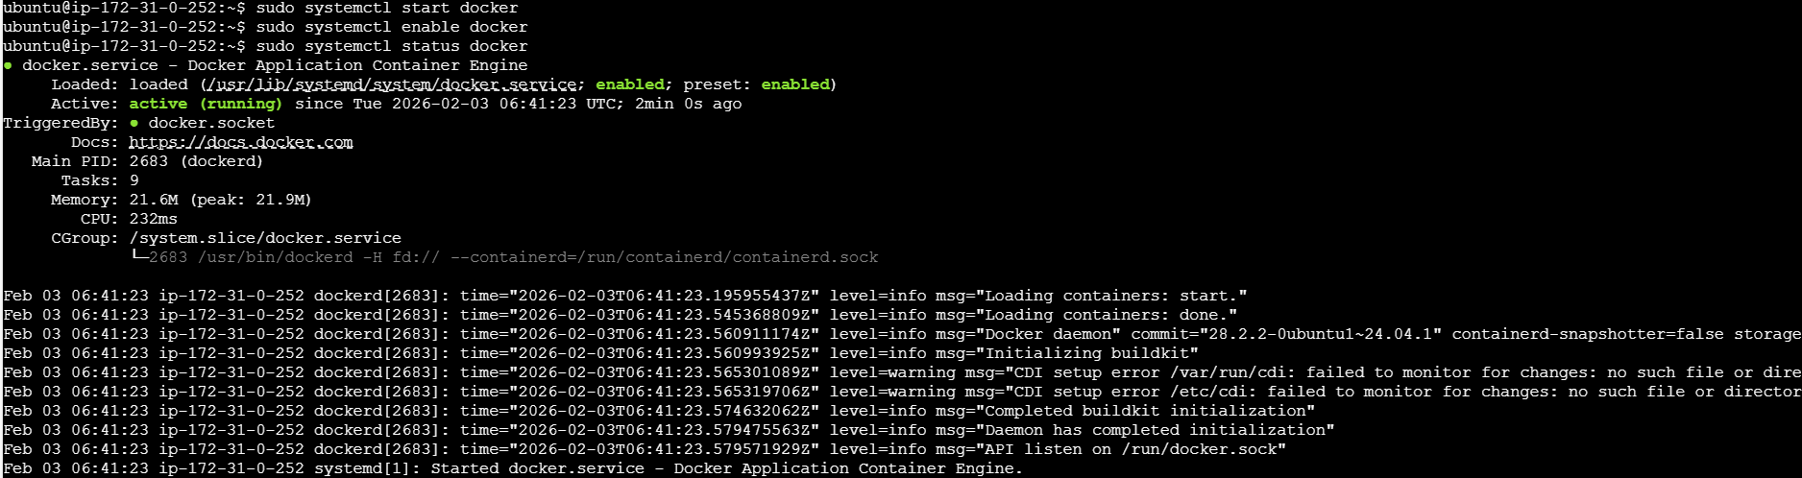

Step 6: Install docker compose
Sudo apt install docker-compose -y
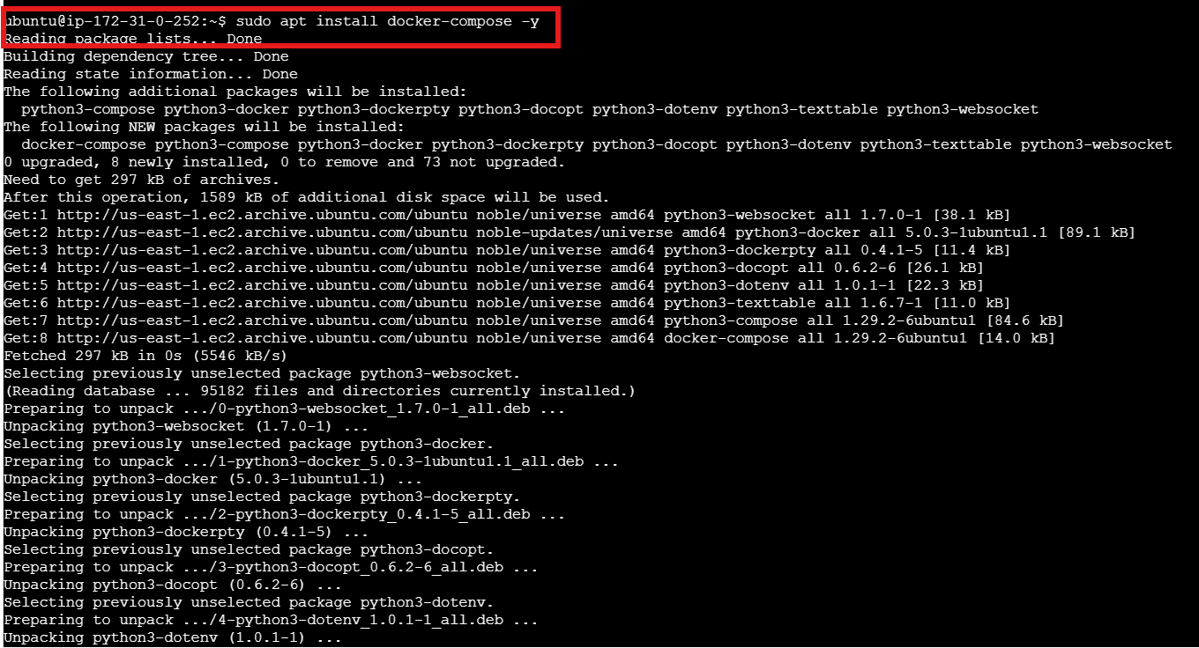

Step 7: Clone the files
git clone -b 17.1.0 https://github.com/ansible/awx.git
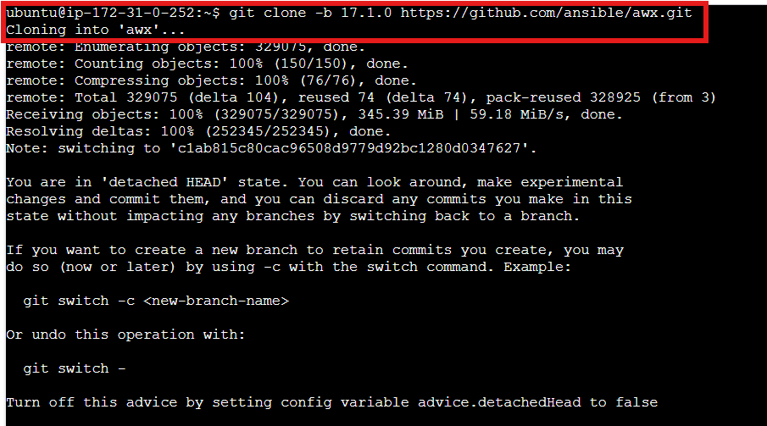

Cd awx

Cd installer
Ls
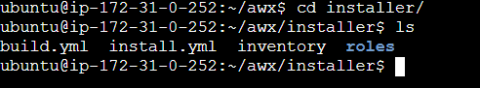
Step 8: Vi inventory
admin_password=Admin@123
secret_key=Admin@123
pg_database=awx
pg_password=Admin@123
awx_alternate_dns_servers="8.8.8.8,8.8.4.4"
postgres_data_dir="/var/lib/awx/pgdocker"
docker_compose_dir="/var/lib/awx/awxcompose"
project_data_dir="/var/lib/awx/projects"
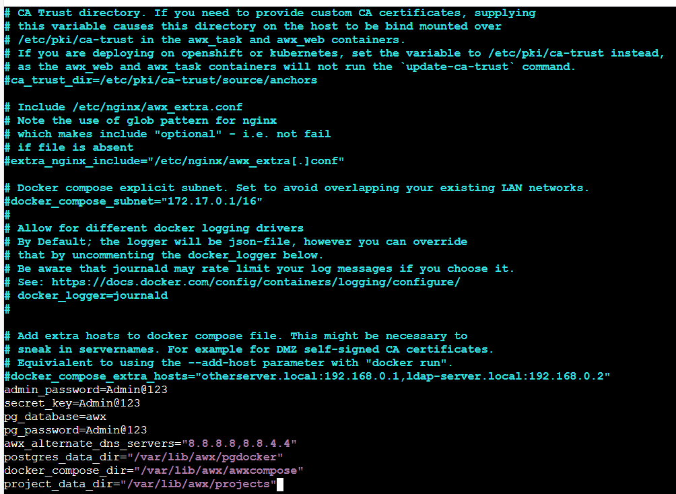
Step 9: Run the playbook
Sudo ansible-playbook -i inventory install.yml
