Jenkins-03
Jenkins Clone and SonarQube Integration

CICD Stages (Different stages available in pipeline):
- Git Clone To clone the source code
- SonarQube Integration To check for the quality of code
- Maven Compilation To compile the source code and create a package for us
- Nexus Repository To store our artifacts in Nexus Repository
- Post Build Actions either by E-mail or Slack notification, we need to send the alert with build output to user.
- Deployment to Tomcat Deploy to Tomcat webapps.

Important points to remember:
- In terms of testing, we can use 1 server (ec2) for installing and deploying (Jenkins, SonarQube, Maven, Nexus, Tomcat). This is called Single-Box environment.
- In terms of Production env, we need to use different servers for all CICD stages and this is called multi-box environment.

Deployment Stages:
- Deployment to Tomcat
- Deployment to ecs
- Deployment to Kubernetes Cluster
Note: Currently for testing purposes, we are using Tomcat deployment. But in companies, we will use Kubernetes cluster.

SonarQube:
- Once code is ready, it will be integrated to Jenkins automatically.
- Then, the code will be integrated to SonarQube to check for the quality of code.
- There are metrics to check for the quality like; Duplicates in the code, bugs in the code, Code smells, hotspots and Vulnerabilities.
- SonarQube has a prerequisite of Java installation.
- Install Mysql for SonarQube
- Port number for Mysql is 3306
- Port number for SonarQube is 9000

Task 1
Create one Jenkins job using the below code and create three stages:
- stage1: Git clone to download the source code.
- stage2: SonarQube Integration to check the quality of code.
- stage3: Slack Integration to send the alerts to slack.
URL: https://github.com/betawins/VProfile-1.git

Objective:
The objective of this task is to deploy SonarQube with Mysql backend, integrate with Jenkins to check the quality of code using SonarQube Scanner and configure Slack under post build actions to receive build output from Jenkins.

Prerequisites:
- Ec2 instances, 1 for Jenkins and the other for SonarQube.
- Java install to be done for both servers
- Slack Workspace

Step by step Implementation:

Step 1: Launch 1 ec2 to install Jenkins.
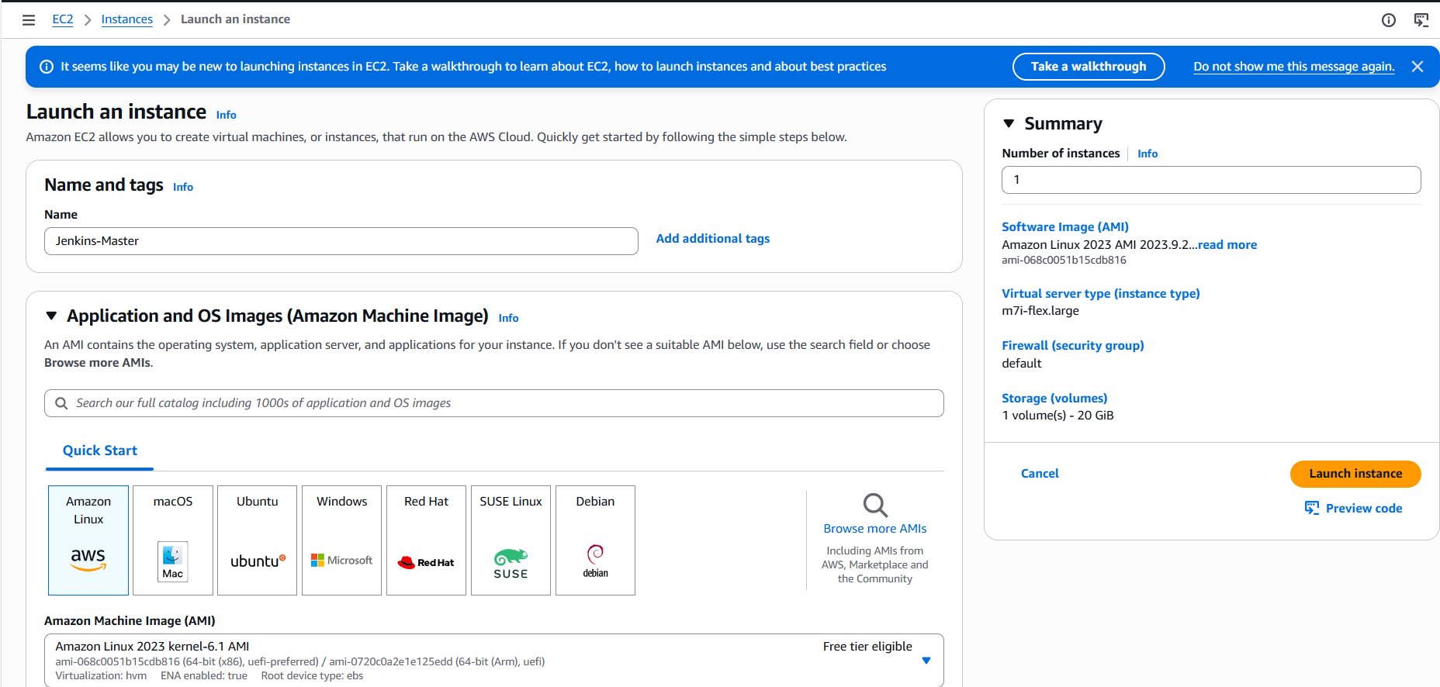
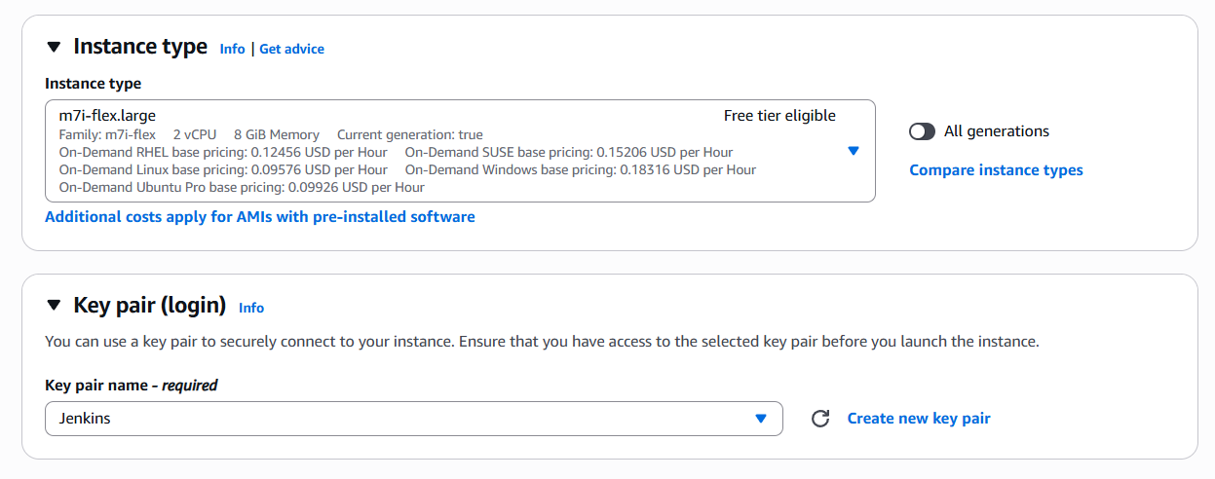
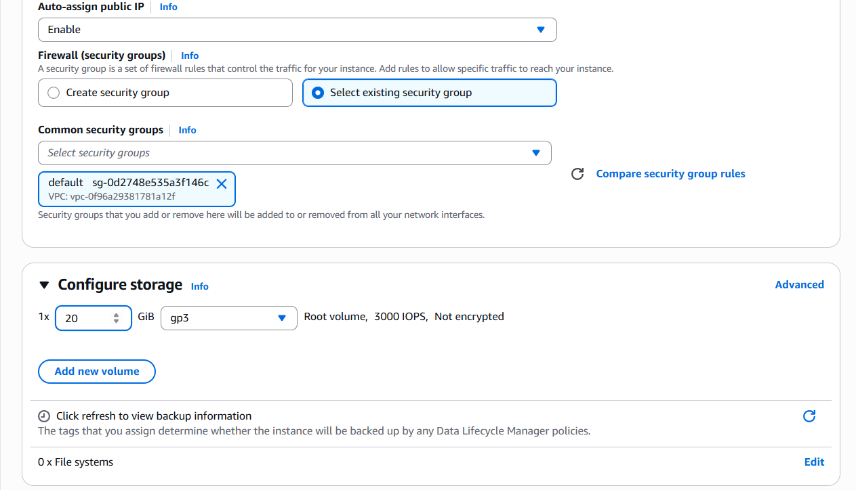
- Now, my Jenkins-master ec2 is launched.
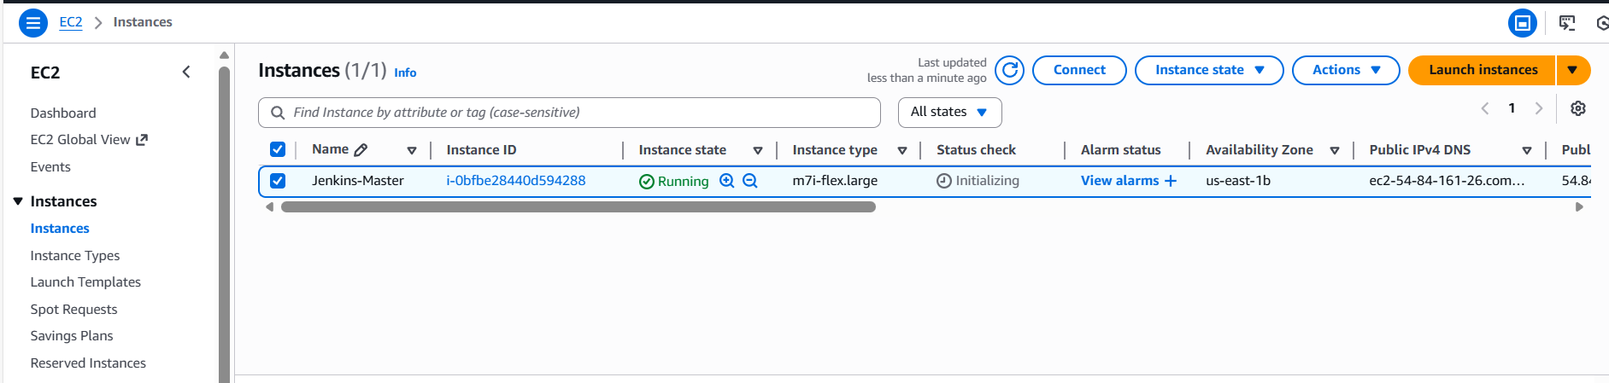

Step 2: Install Jenkins with Bash script, update the User data as, I have stopped the instance and updated the script.
We used Bash script to automatically install Jenkins and prerequisites of Java as well.
Script:
#!/bin/bash
set -e
yum update -y
yum install java-17-amazon-corretto -y
wget -O /etc/yum.repos.d/jenkins.repo https://pkg.jenkins.io/redhat-stable/jenkins.repo
rpm --import https://pkg.jenkins.io/redhat-stable/jenkins.io-2023.key
yum install Jenkins -y
systemctl enable Jenkins
systemctl start Jenkins
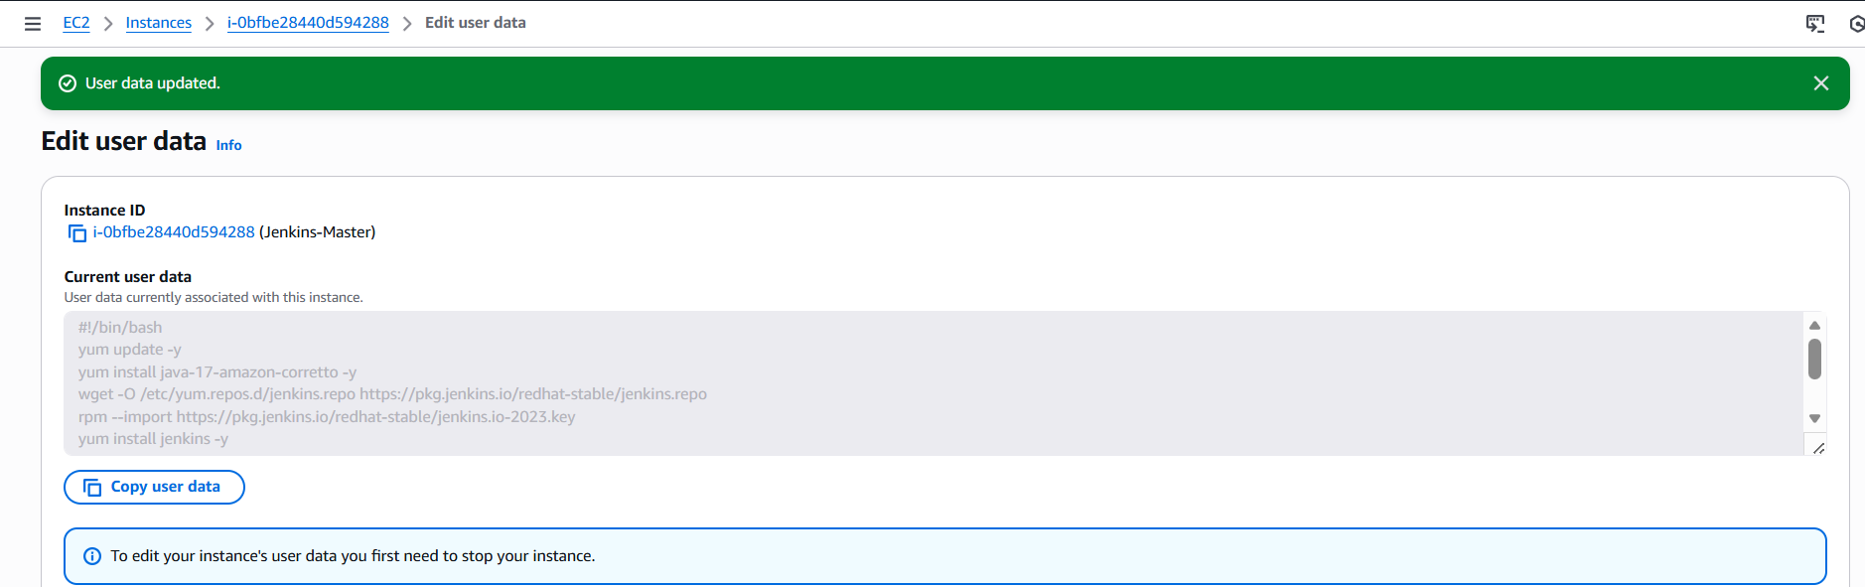
Step 3: As we have installed Jenkins, lets verify if the status is up and running.
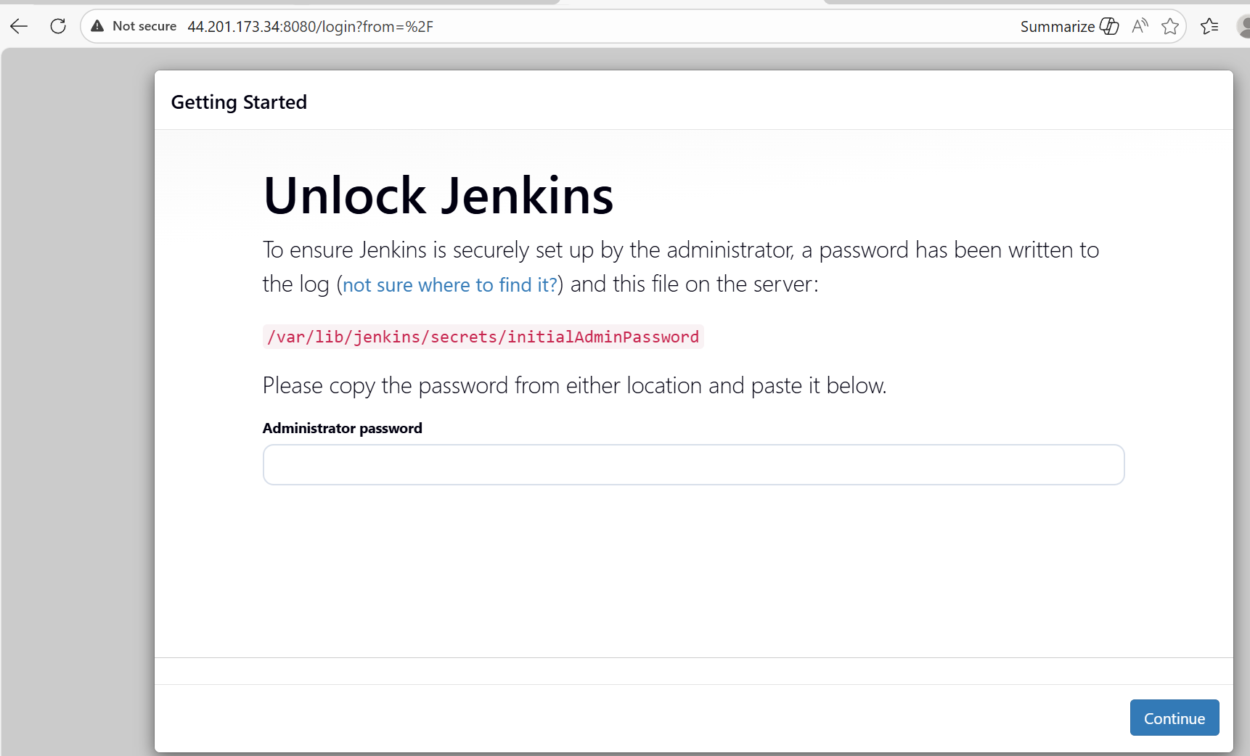
- In CLI, unzipped the Initial Admin Password to be updated in GUI.
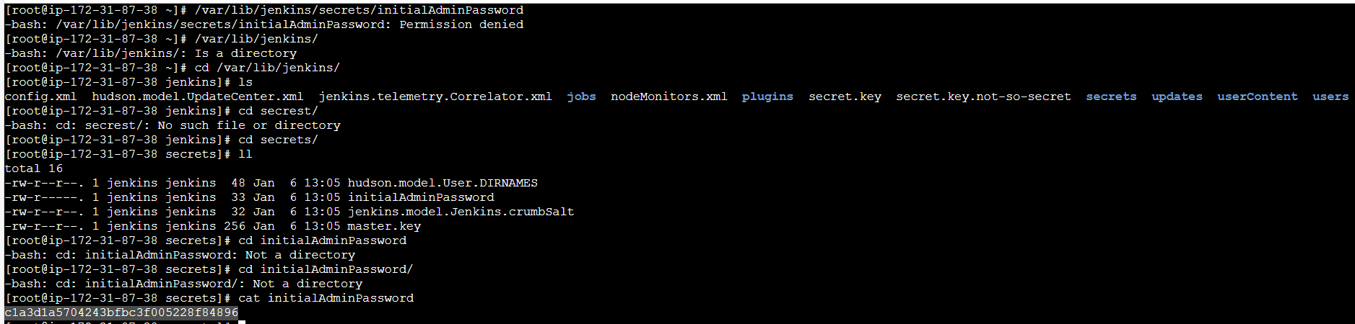

- Password updated in GUI and now, we shall change the Admin password and install the plugins.
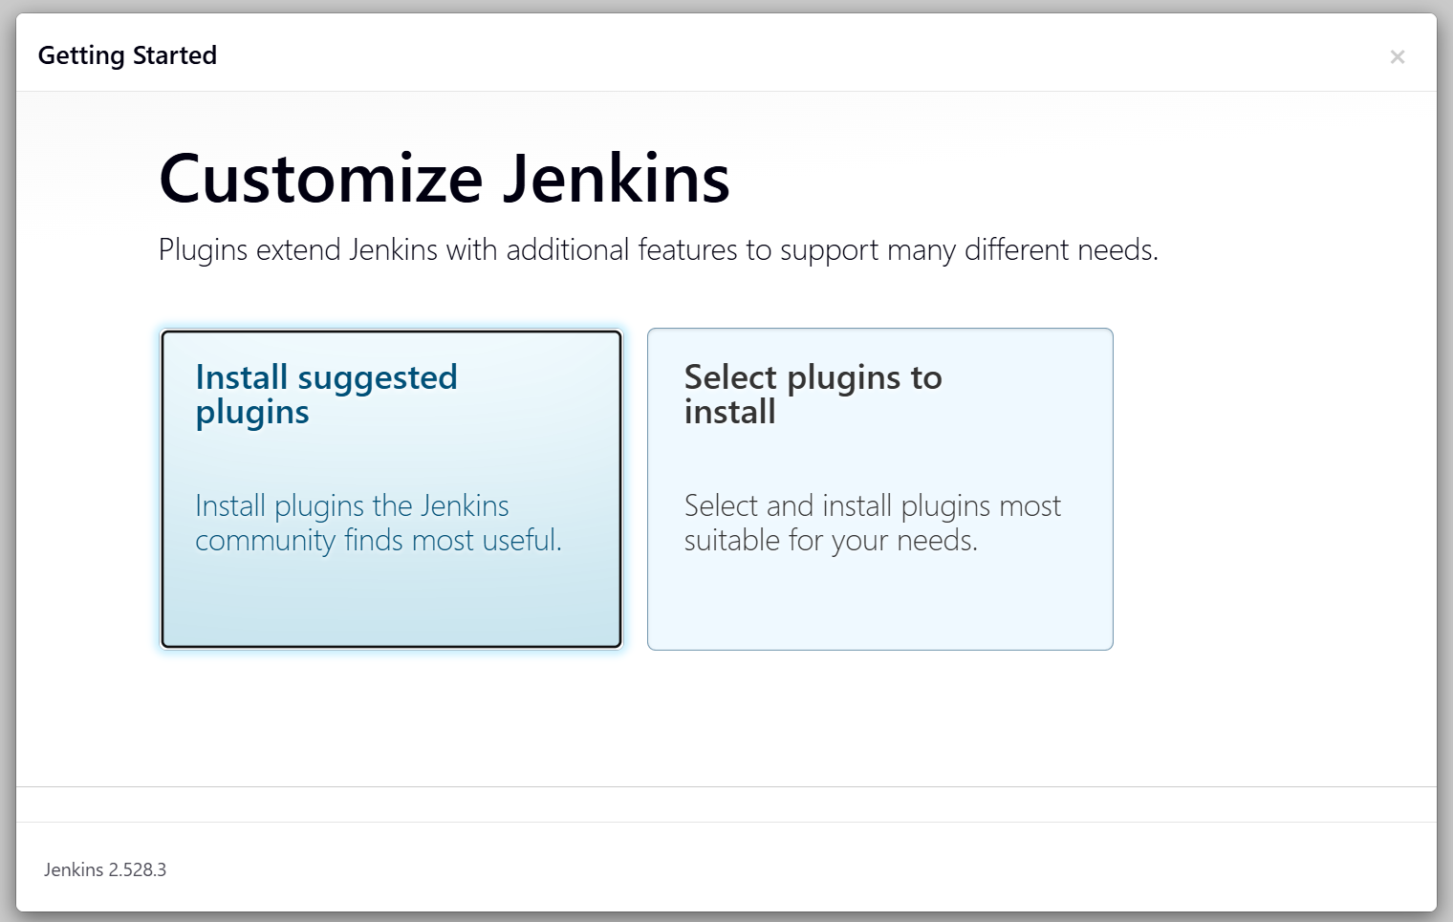
- System id and password updated and now our Jenkins is up and ready.
- Success.
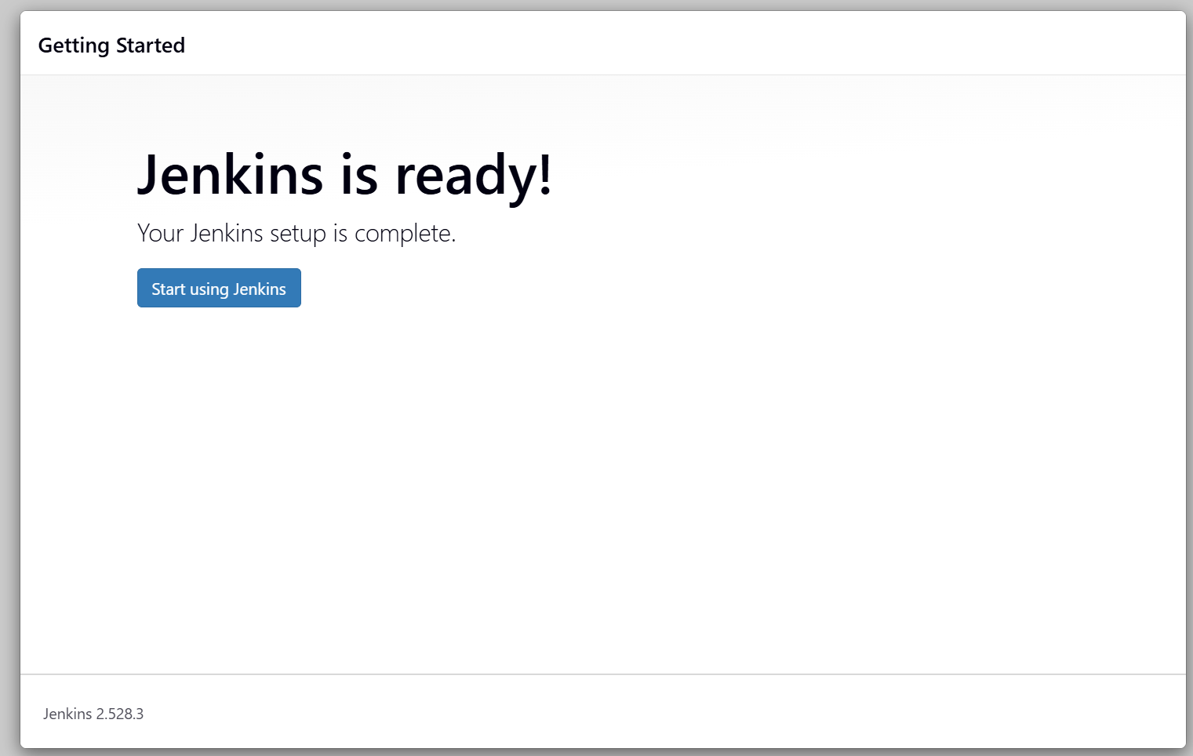

Stage 1: Git Clone to download the source code.

Let’s proceed with step-by-step procedure:
Step 1: We just entered our Jenkins dashboard and verified in the browser; the dashboard is available for further builds.
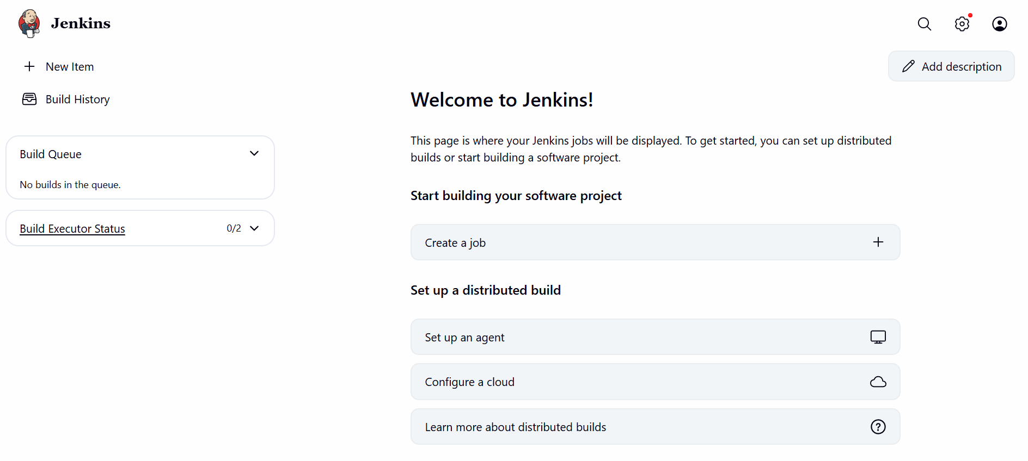

Step 2: Create a new item.
- My job name is VProfile
- Free style project selected

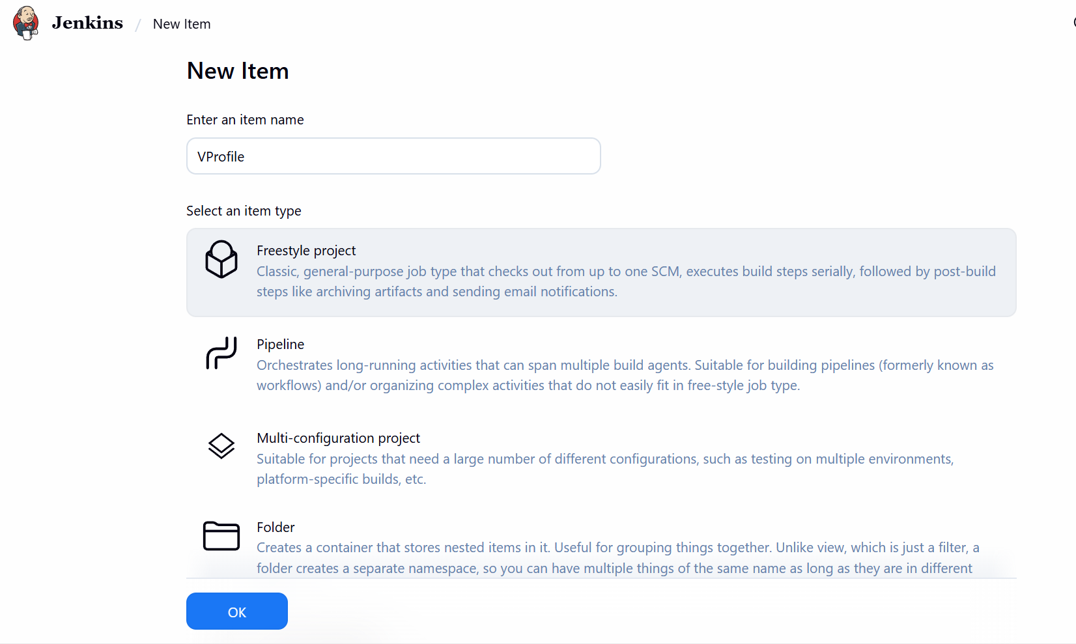

Step 3: Configure Git Repository
- Once job created, in the Configuration page;
  - Scroll to Source Code Management
  - Updated the URL as per task provided
  - URL: https://github.com/betawins/VProfile-1.git
- Yet, we received error that, failed to connect to repo.

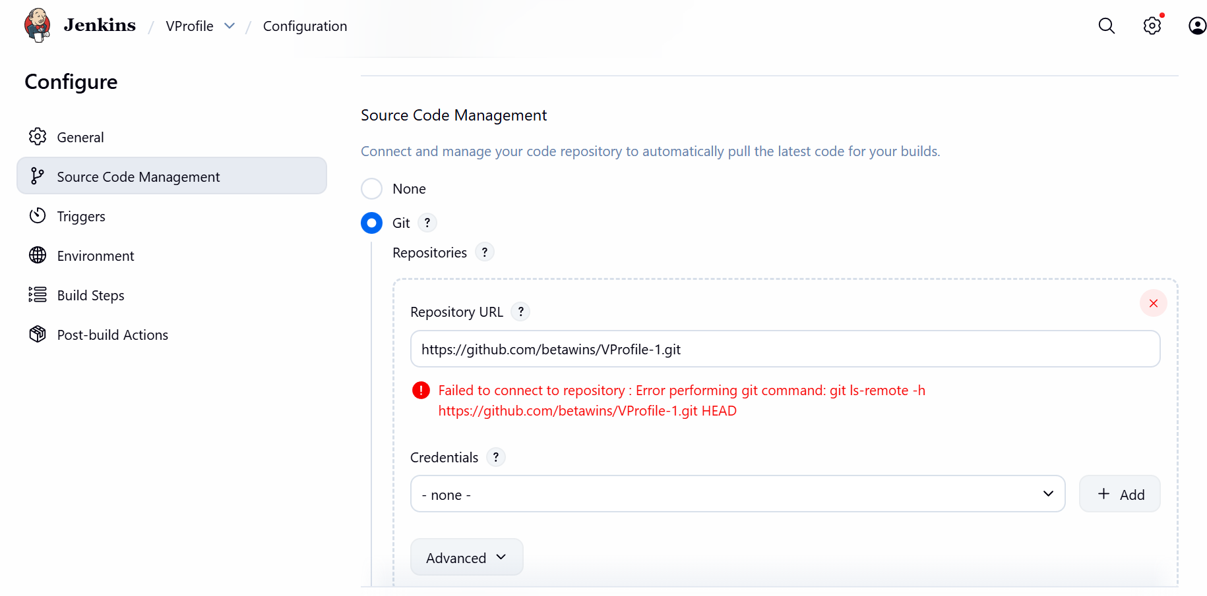

- Reason, we got the error is we didn’t install Git.
- Now, we shall install Git in the server and try again.
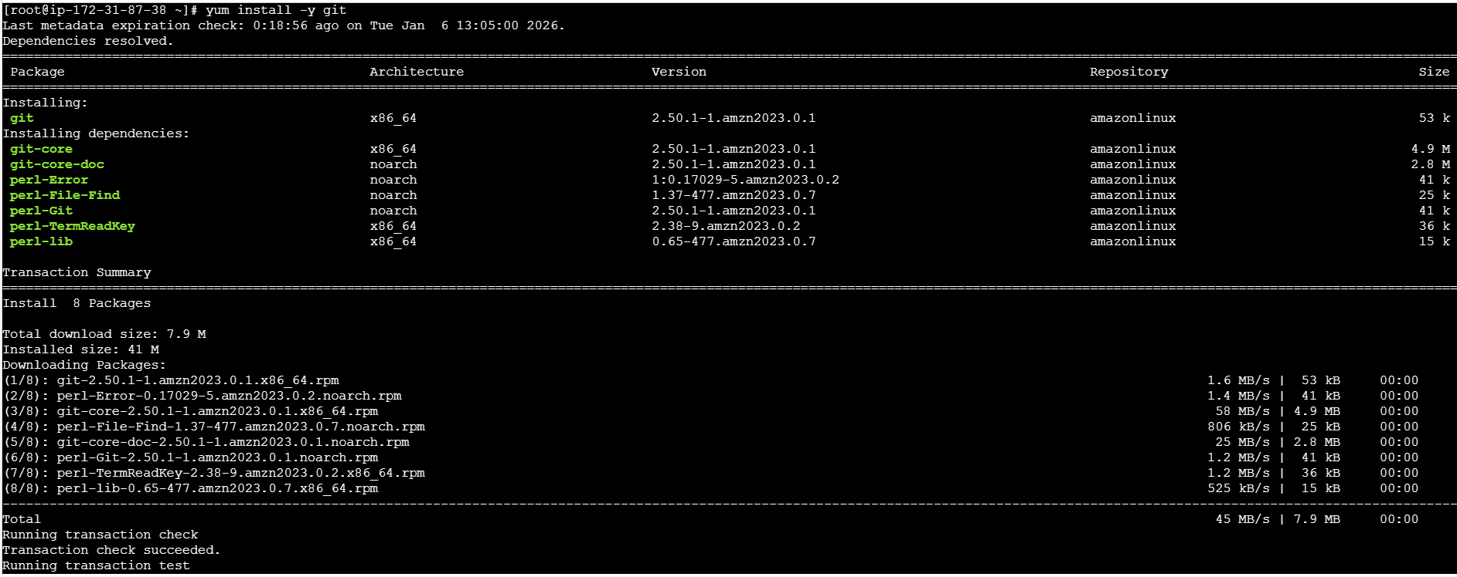
- Success, now we can see the error disappeared.
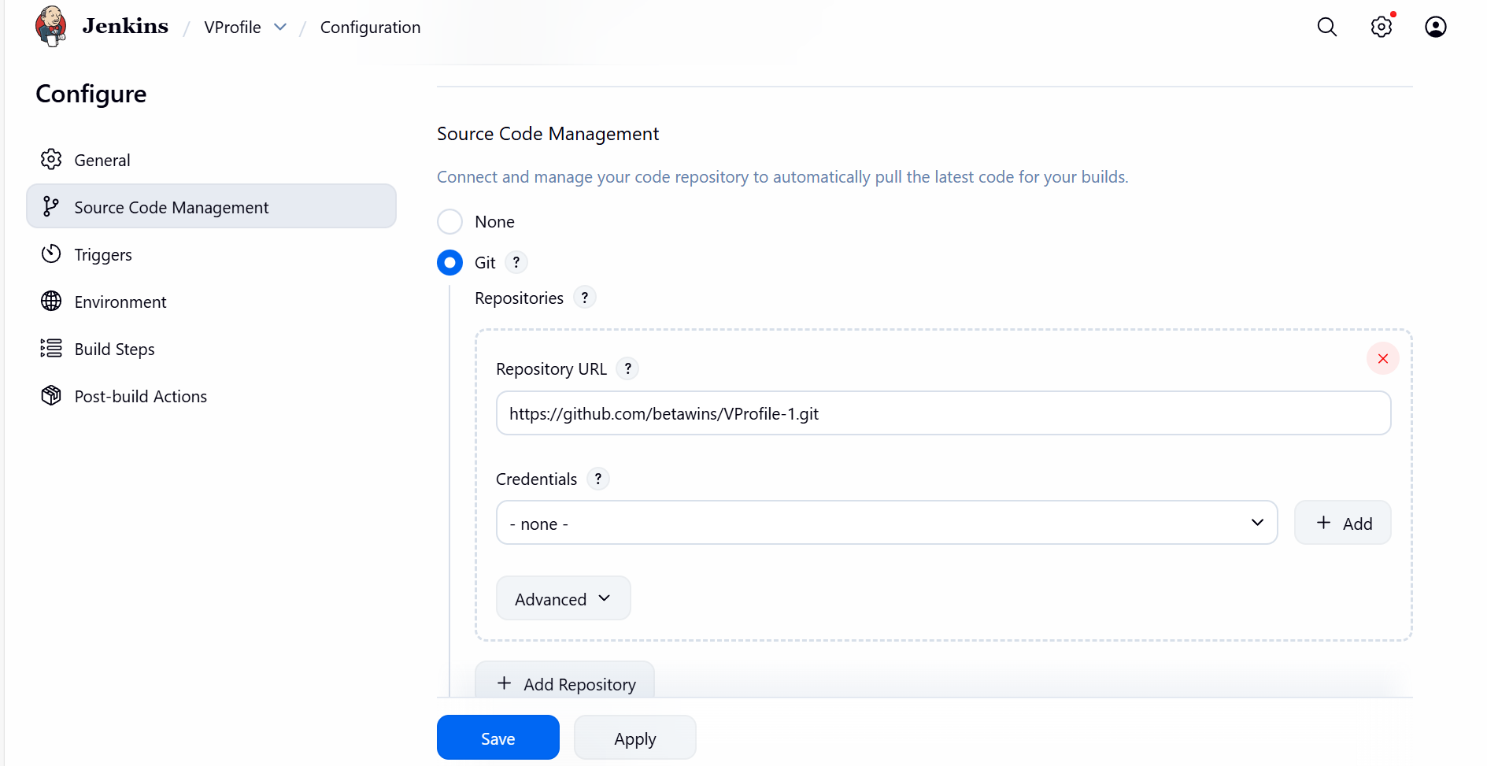

- Now, we saved and shall go ahead and build the job.
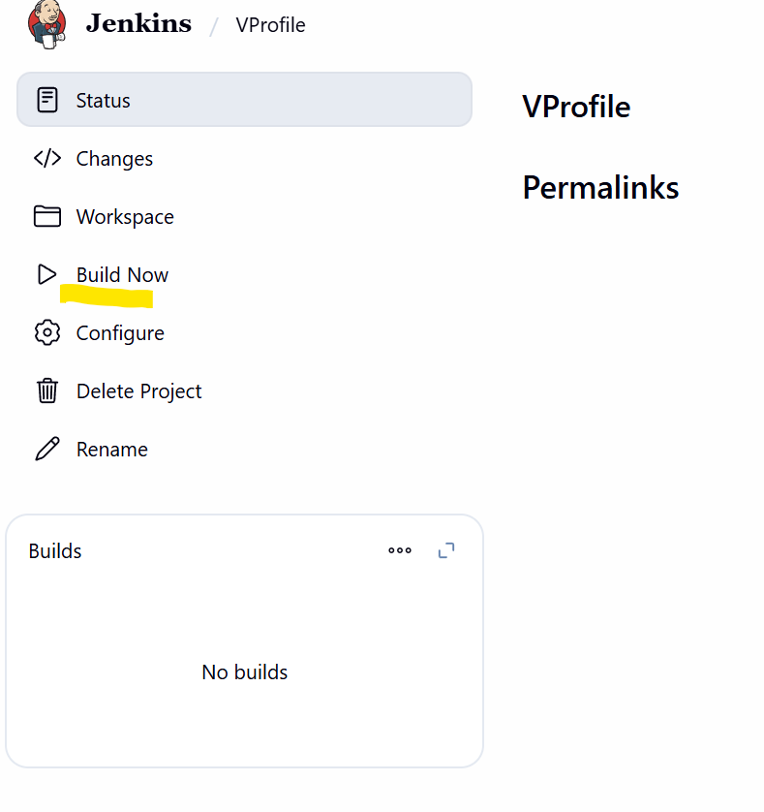
Step 4: Build started and completed.
- Success.
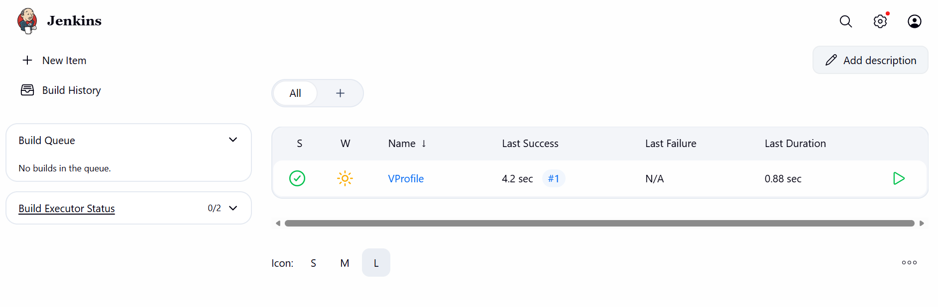
- We can always verify in the Console output for the build execution output.
- Successfully, we now cloned the GIT URL to our Jenkins.
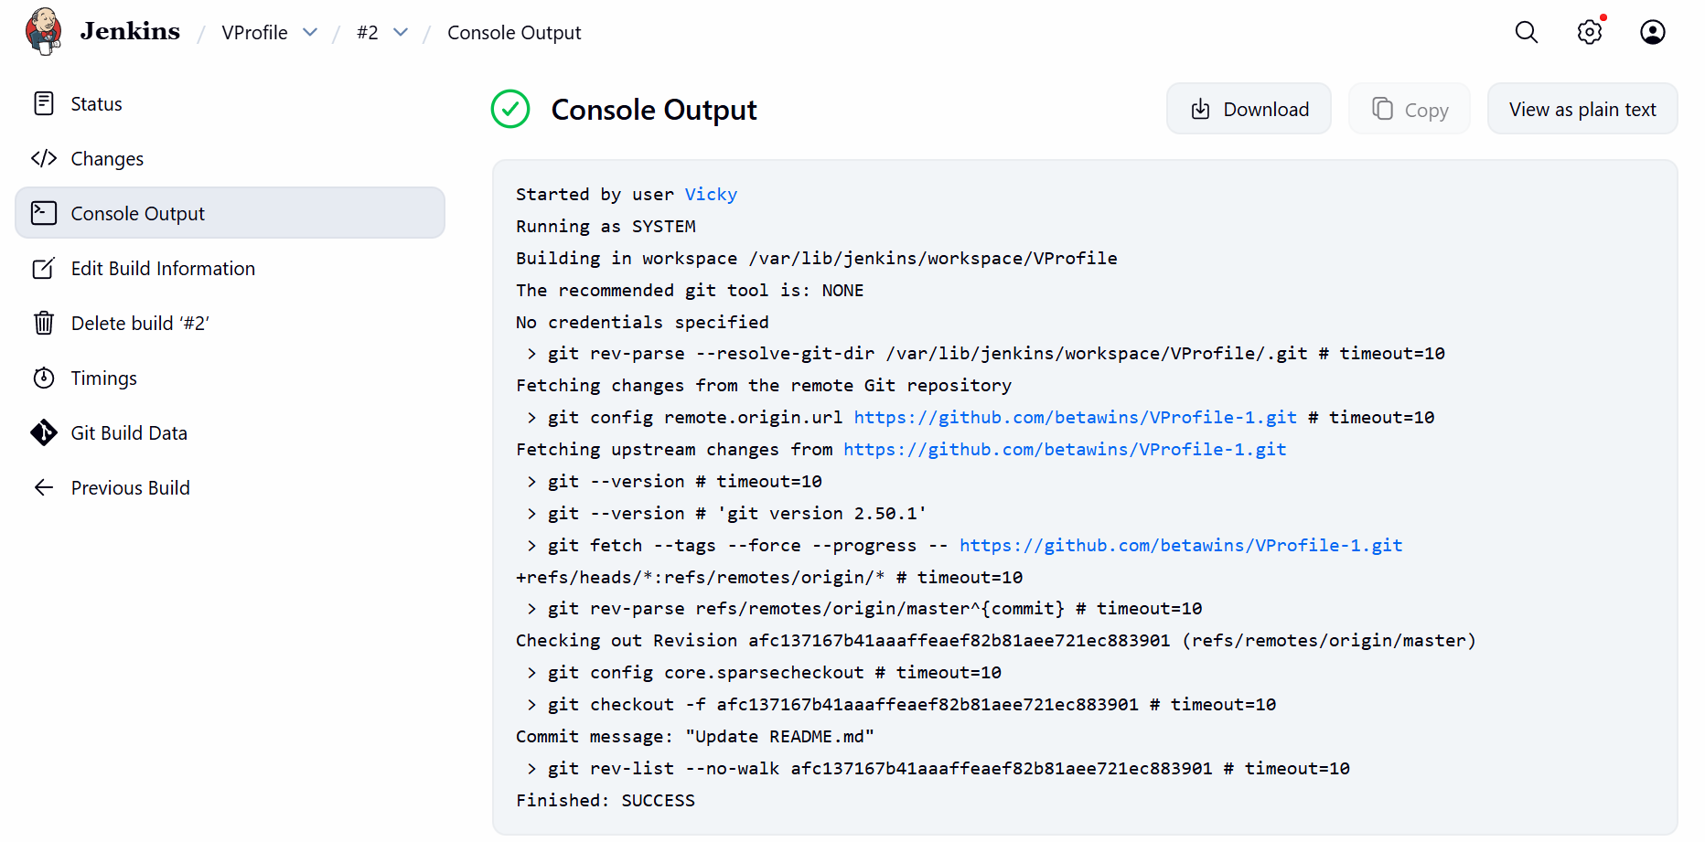

- We shall verify if the Git Clone is successful in server CLI.
- Successfully, we cloned and, in the Workspace, we can see the codes are present from the URL.
- Cd /var/lib/Jenkins
- Cd workspace/
- Cd VProfile
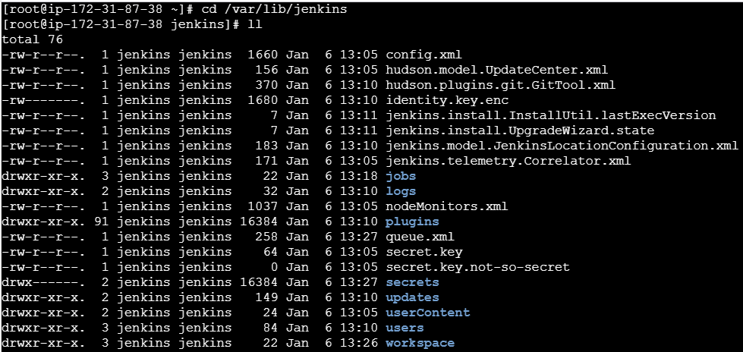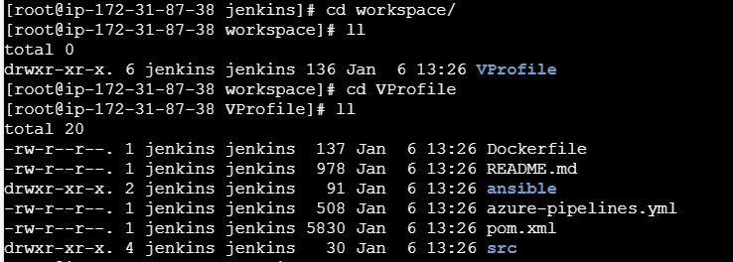

Stage 1 is completed.

Stage 2: SonarQube Integration to check the quality of Code.

Objective:
The objective of the task is to install SonarQube and integrate with Jenkins to check the quality of code automatically without manual intervention.
Prerequisites:
- EC2 instance
- Java
- Specs in ec2- Instance type – c7.large
Storage- 20 GB to run SonarQube
Step by step Implementation:
Step 1: Install PostgreSQL using command- dnf install postgresql15 postgresql15-server -y
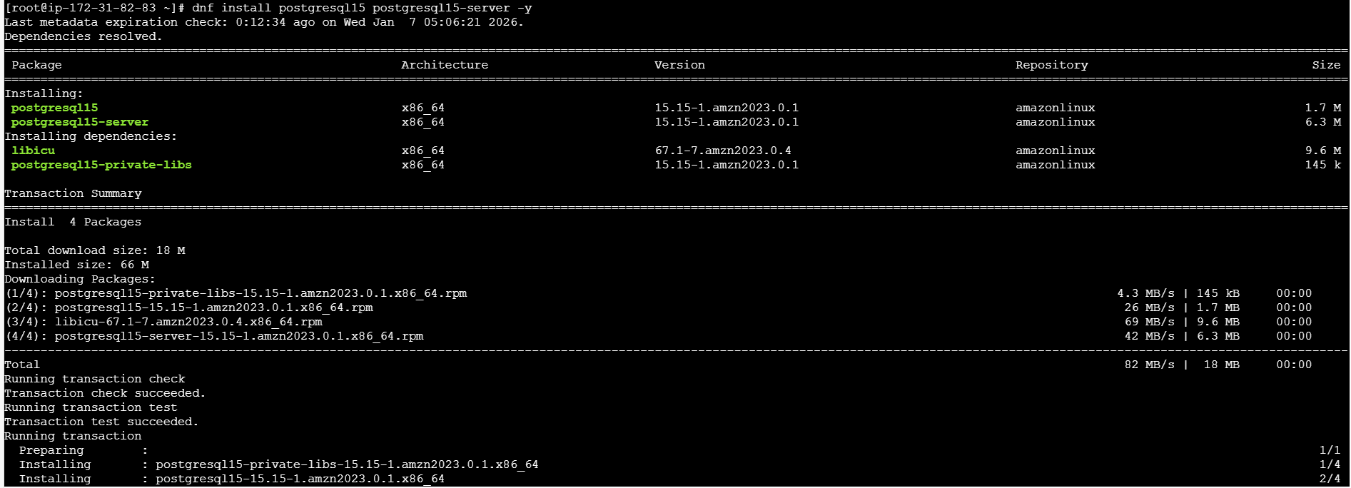
- Using command- postgresql-setup –initdb started the service.
- Start the service, enable and status using systemctl start, enable and status.
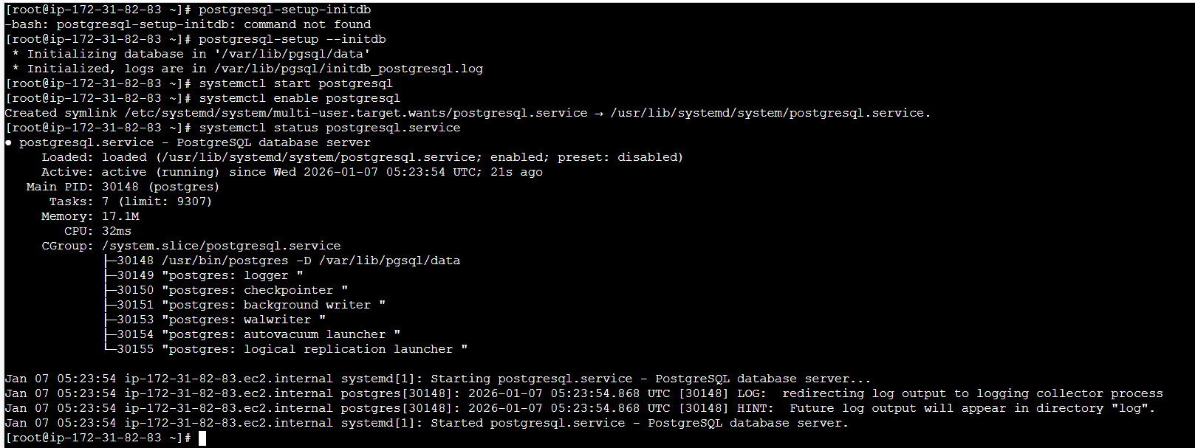
- Su – postgres
- Psql to enter

Step 2: Commands executed
- CREATE DATABASE sonarqube;
- CREATE USER sonar WITH ENCRYPTED PASSWORD 'Sonar@123';
- GRANT ALL PRIVILEGES ON DATABASE sonarqube TO sonar;
- ALTER DATABASE sonarqube OWNER TO sonar;
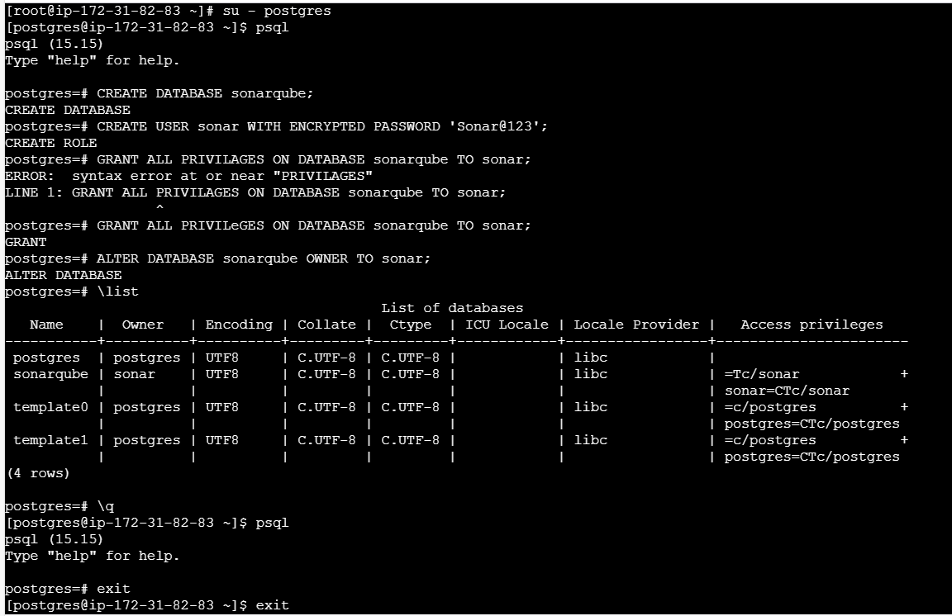
SonarQube Download and Extraction
You downloaded and extracted SonarQube binaries.
Command
cd /opt
sudo wget https://binaries.sonarsource.com/Distribution/sonarqube/sonarqube-9.9.6.92038.zip
sudo unzip sonarqube-9.9.6.92038.zip
sudo mv sonarqube-9.9.6.92038 sonar

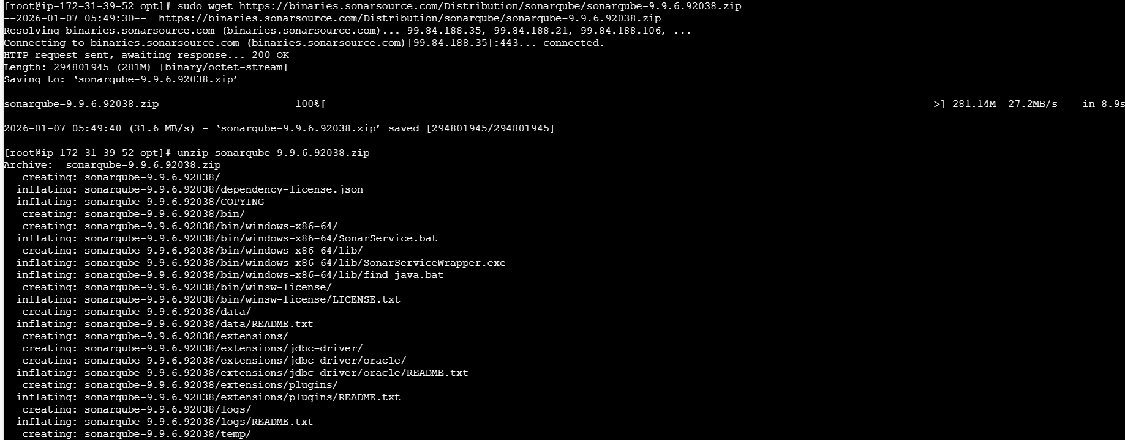
Now, we need to update the sonar properties, so we shall execute the below commands.
Cd sonar
Cd conf
- Before updating sonar.properties, we need to exit from root user and update in ec2-user.
- Cd /opt/sonarqube
- Cd /conf/
- Vi sonar.properties
- Then edit the below.
Updated User and Password for sonar for user sonar
Sonar webhost- 0.0.0.0
Sonar web context- lately, we removed the host /sonar.
Sonar web port- 9000
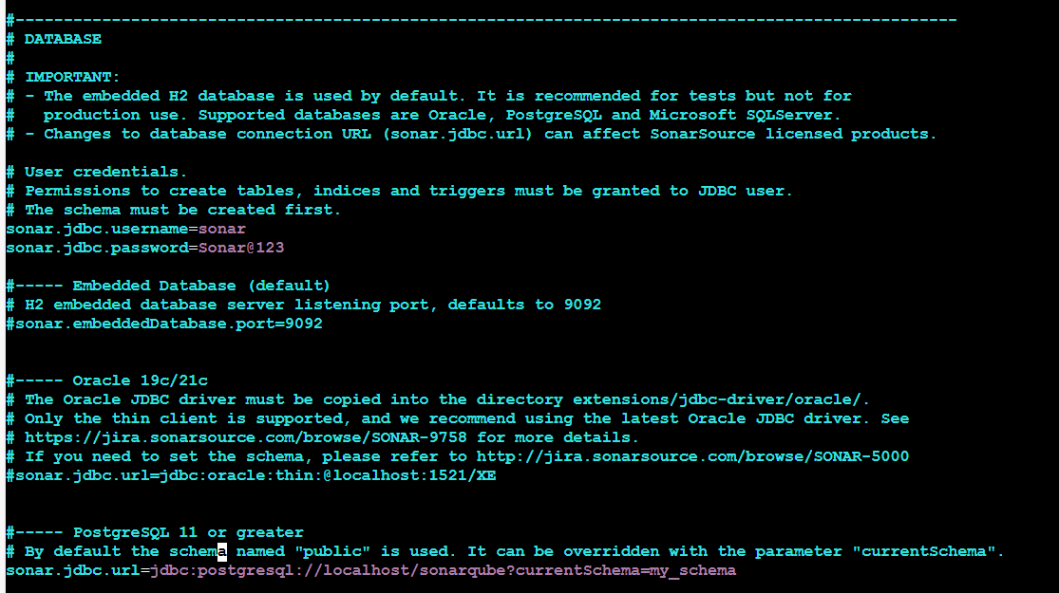
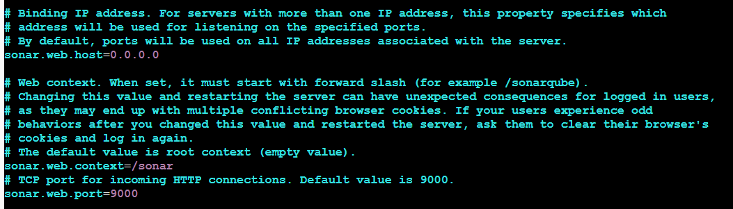
Then, start the sonar.sh using below commands.
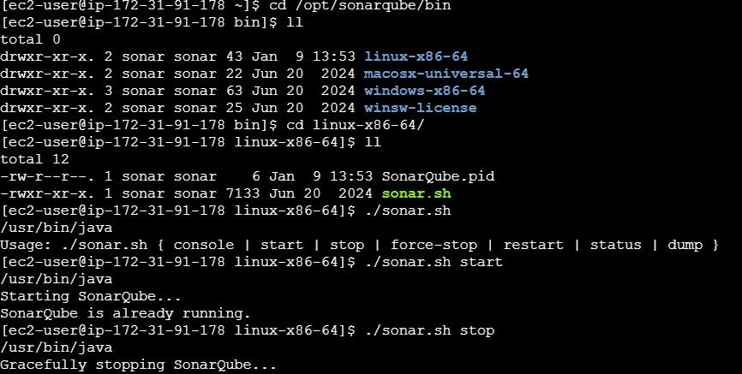

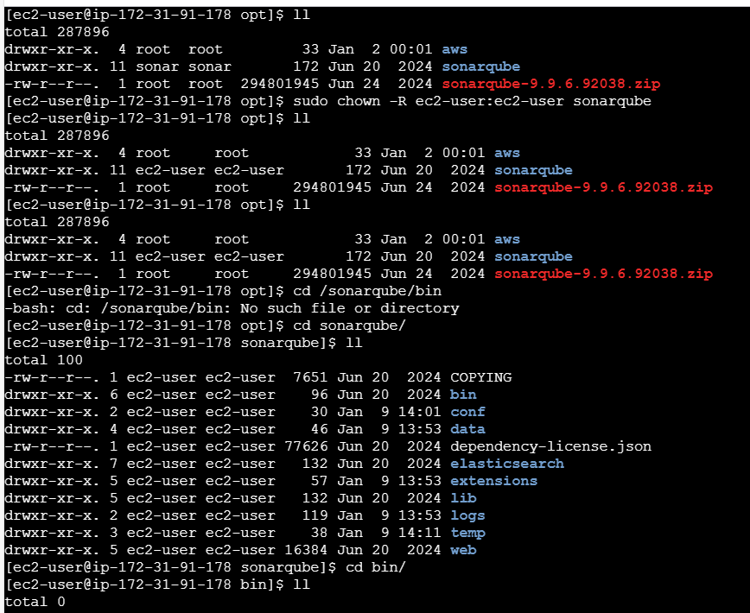

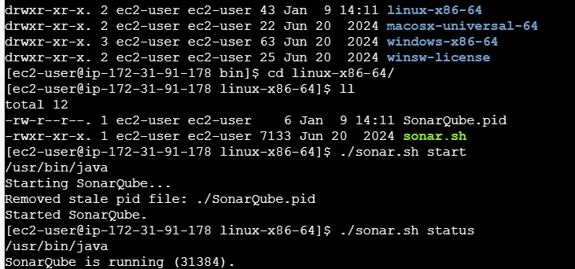

Step 3: Verified the IP with port number and we are inside Sonarqube GUI
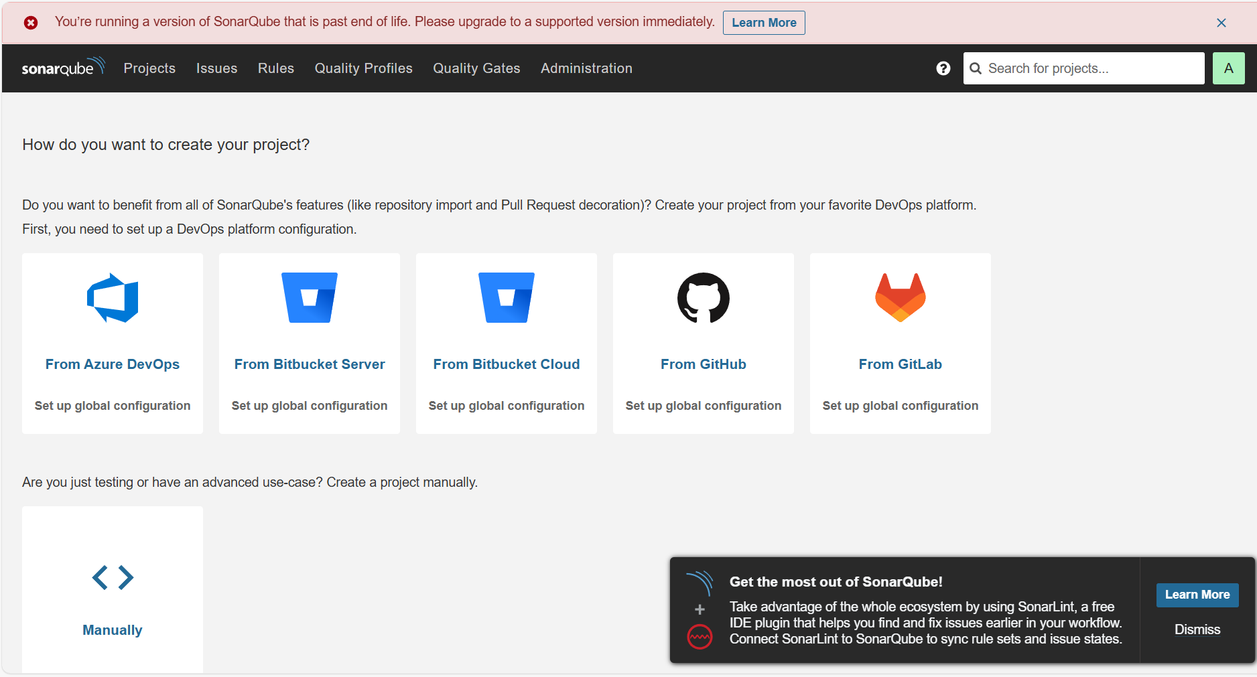
This is the token generated under settings.
sqa_24ab8e1f6db3d25087fb56fb4ed153cf8125d4aa
Step 4: Successfully logged in to Sonarqube, so now we need to generate a token.
- We successfully generated a token and copy the token.
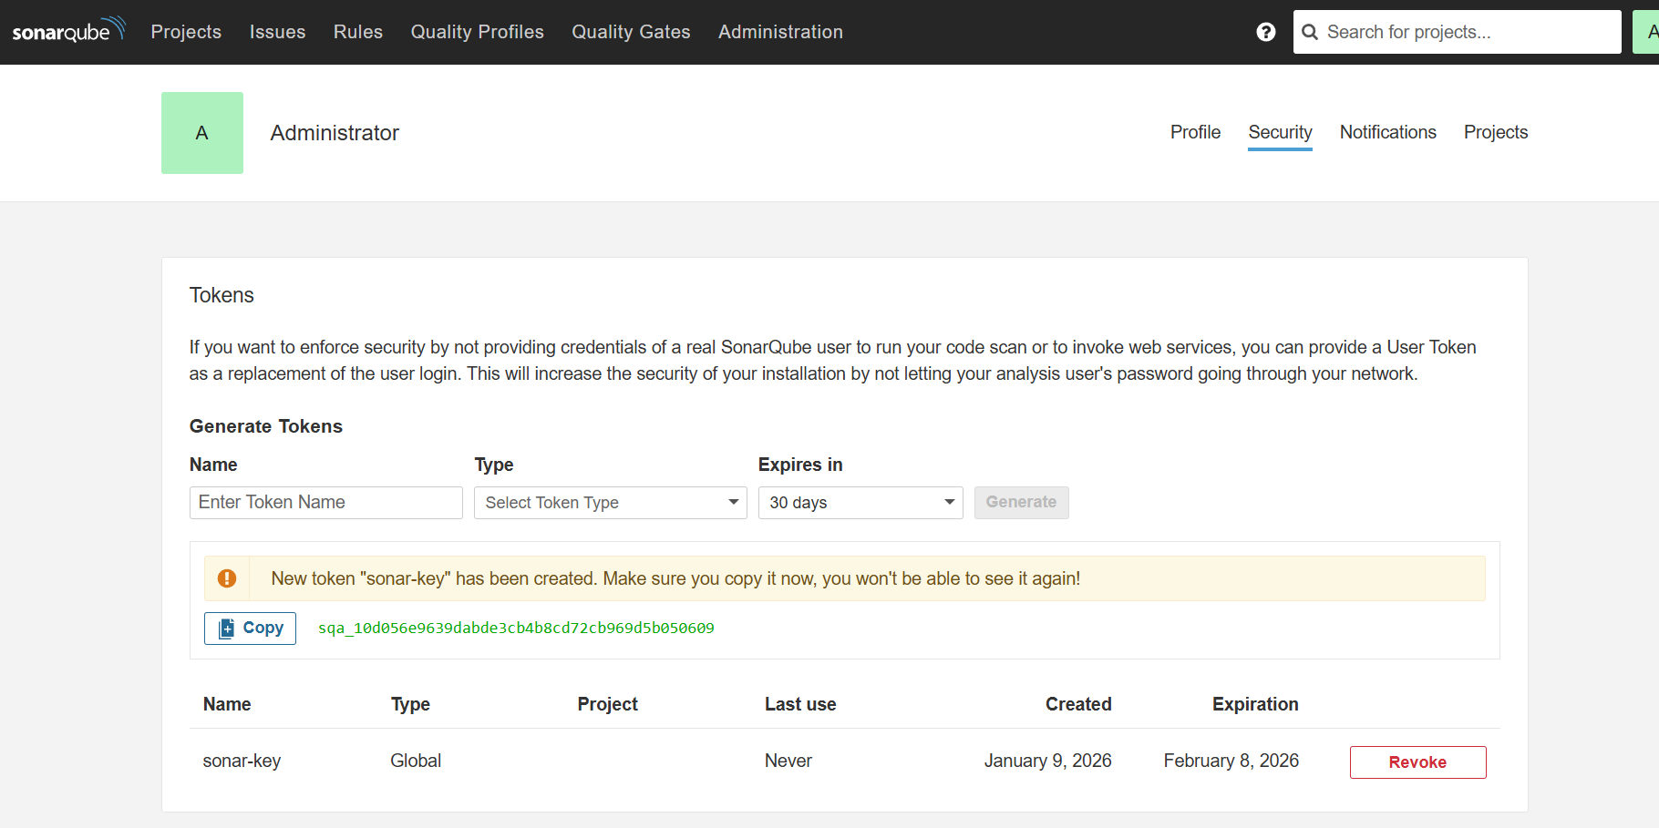

Step 5: Now, lets navigate to Jenkins master GUI dashboard.
- Manage Jenkins
- Credentials and paste the copied token from Sonarqube.
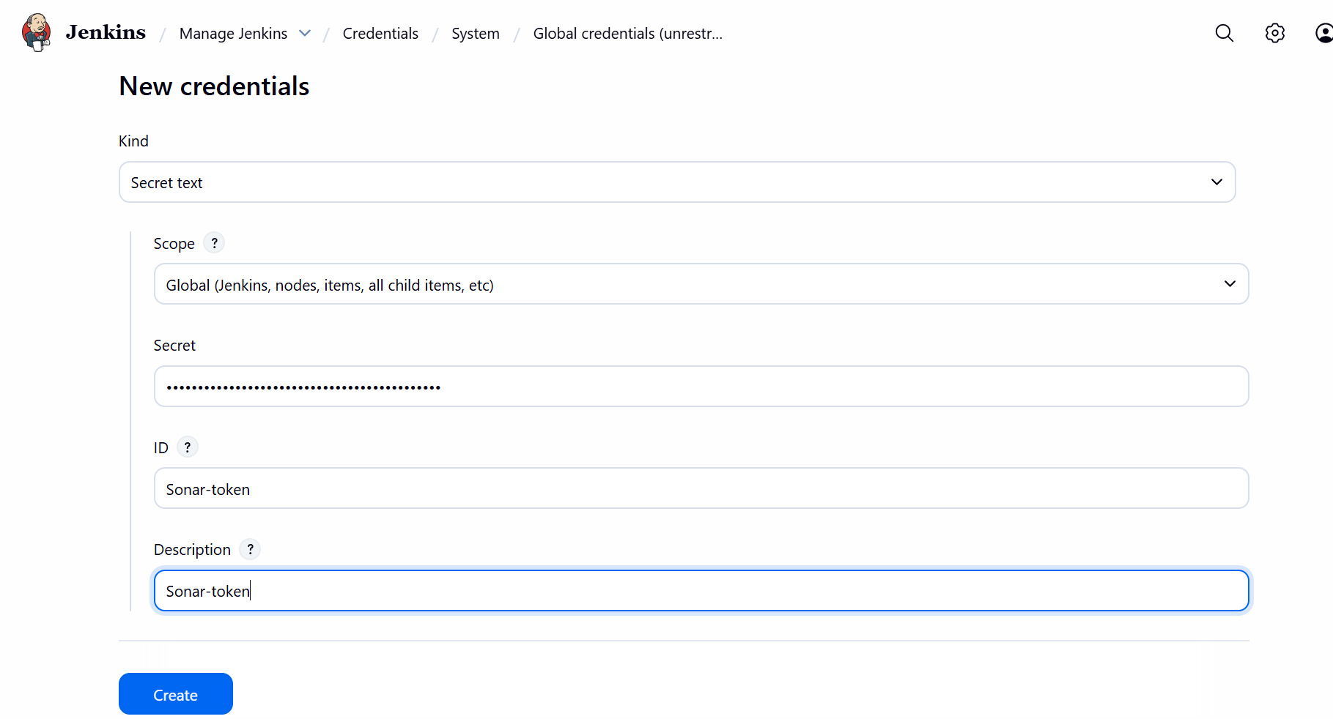

Step 6: Now, we shall install SonarQube- Scanner from Plugins in Jenkins.
- Manage Jenkins
- Plugins
- Install – SonarQube Scanner
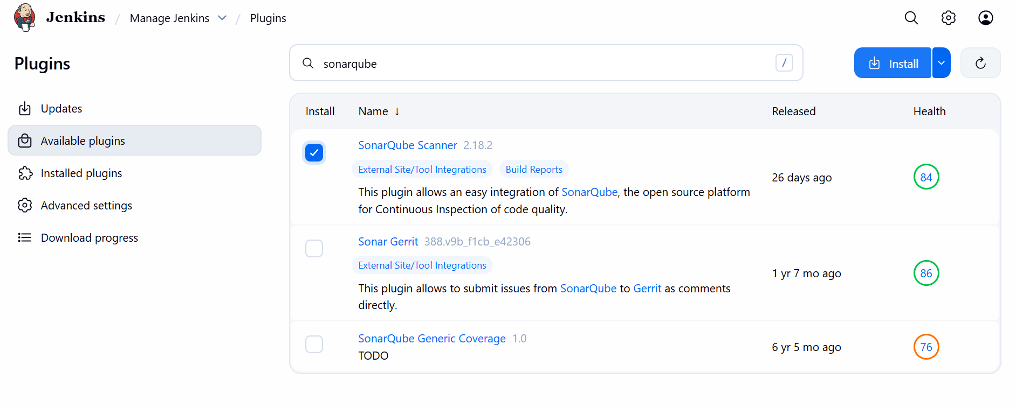


Step 7: Configure SonarQube server in Jenkins
- Manage Jenkins
- SonarQube server
- Add SonarQube
- Save

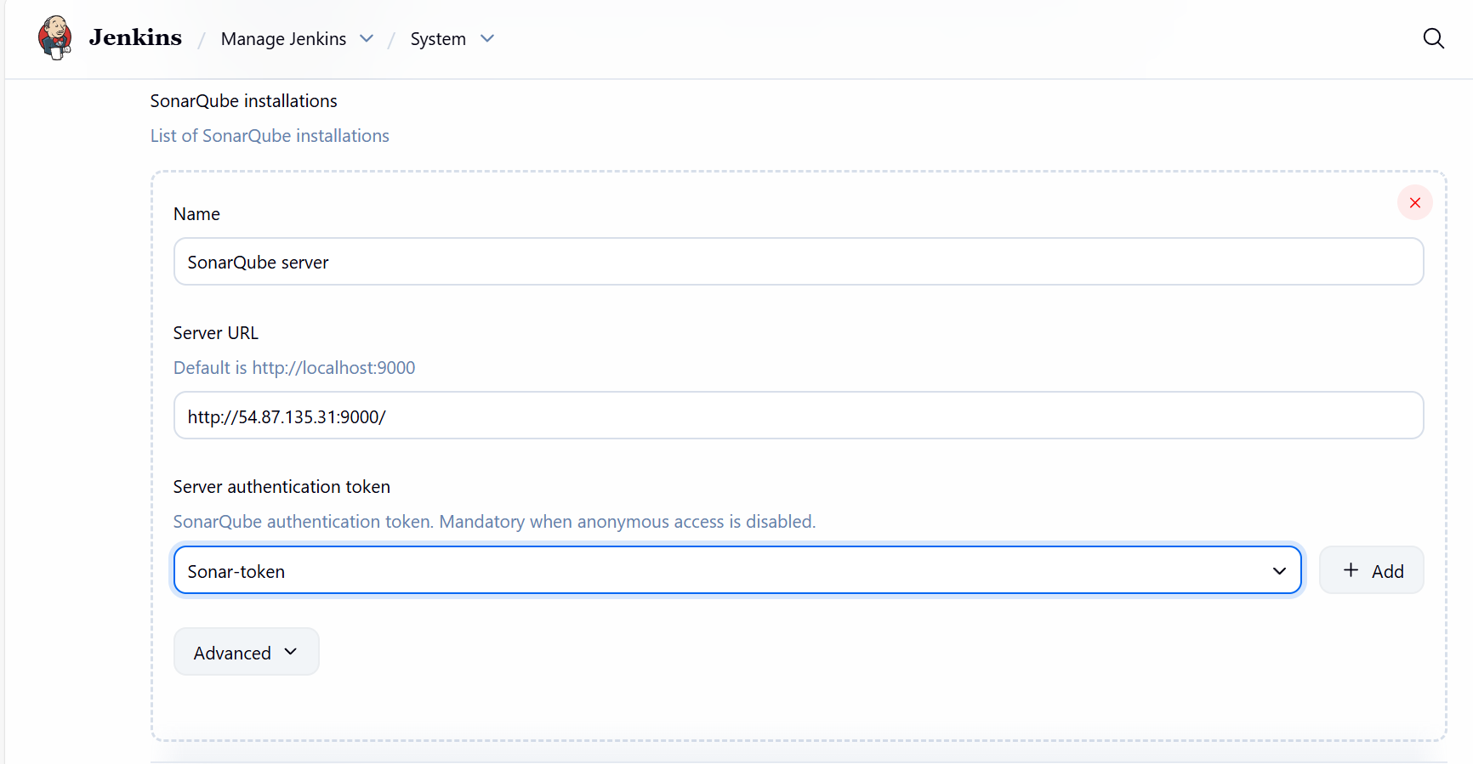

Step 8: Now, we need to have a mechanism to connect between Jenkins and SonarQube.
Now, navigate to Jenkins and use the below commands.
- Wget https://binaries.sonarsource.com/Distribution/sonar-scanner-cli/sonar-scanner-cli-4.6.2.2472-linux.zip
- Unzip sonar-scanner-cli-4.6.2.2472-linux.zip
- Cd /opt/sonar-scanner/
- Cd conf/
- Vi sonar-scanner.properties
- Change the ip to Sonarqube IP and save.
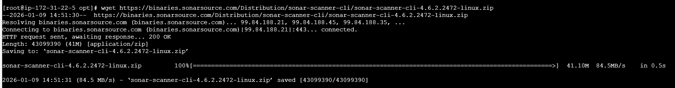
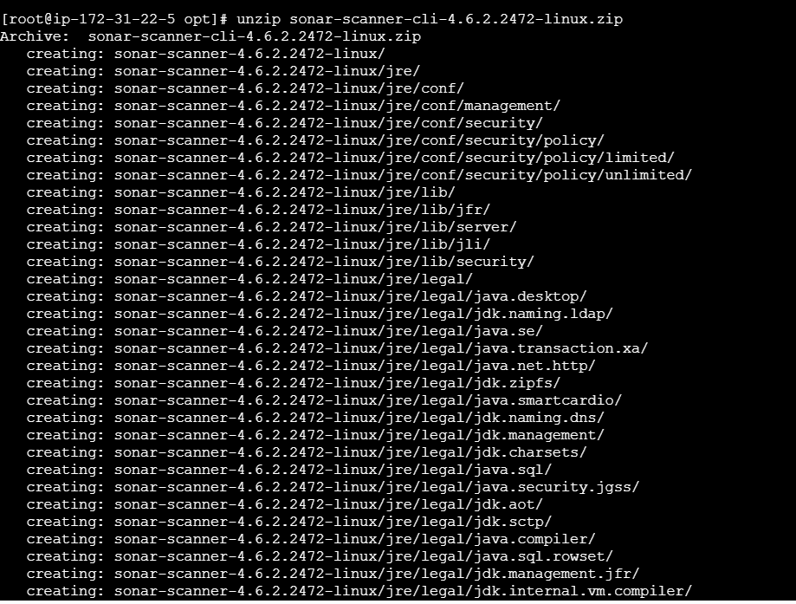

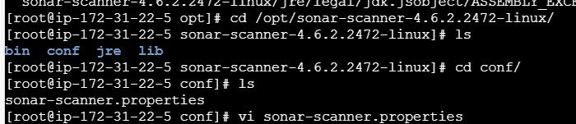

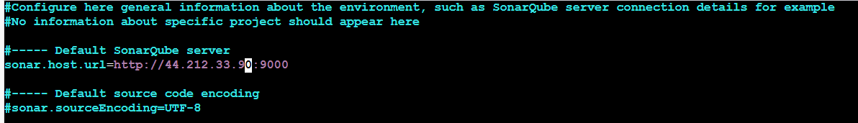

Step 9: Navigate to Jenkins GUI and scroll to Manage Jenkins Tools and add a scanner.
We will get this in Jenkins server under cd /opt/sonar-scanner/bin
pwd
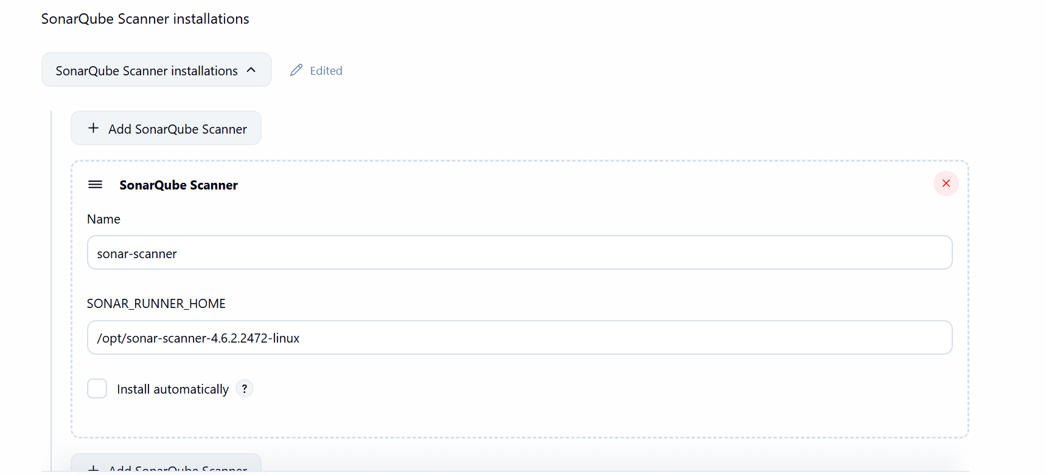
Step 10: Navigate to VProfile and configure Project for Sonar Analysis
- Configure Job
- Add a new build step
- Execute SonarQube Scanner

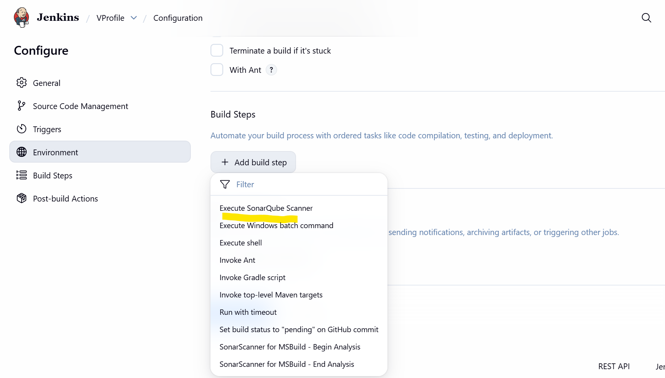

- Paste the below in the Analysis Properties
/opt/sonar-scanner/bin/sonar-scanner \
-Dsonar.host.url=http://44.203.212.114:9000 \
-Dsonar.login=$SONAR_TOKEN \
-Dsonar.projectKey=Sabear \
-Dsonar.projectName=Sabear \
-Dsonar.projectVersion=1.0 \
-Dsonar.sources=src \
-Dsonar.java.binaries=target/classes
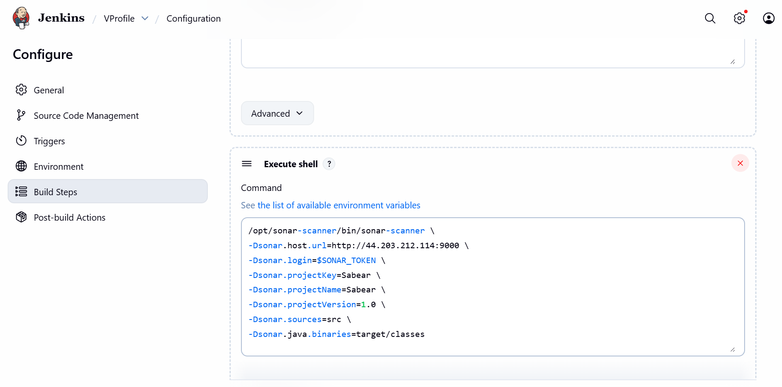

Issues faced:
I got issue when started the build. The error was sonar scanner execution failed and the execution step failed when script didn’t support.
So, tried ChatGPT and installed Maven in Jenkins server, then started the build.
Success.
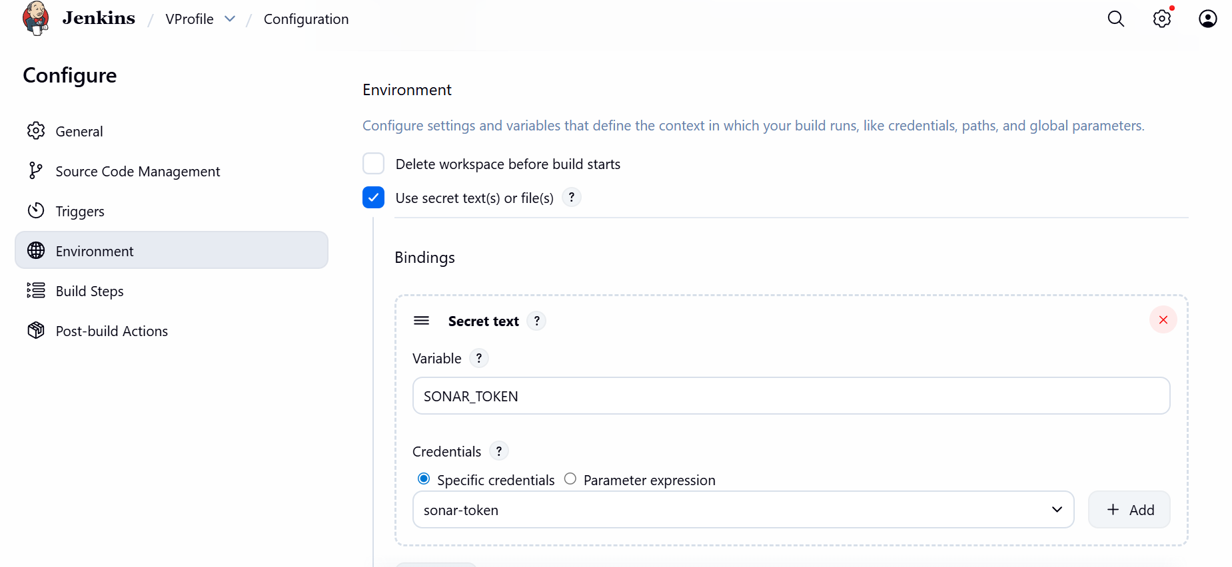

- Installed Maven in Jenkins server and added a script below.
Mv clean compile.
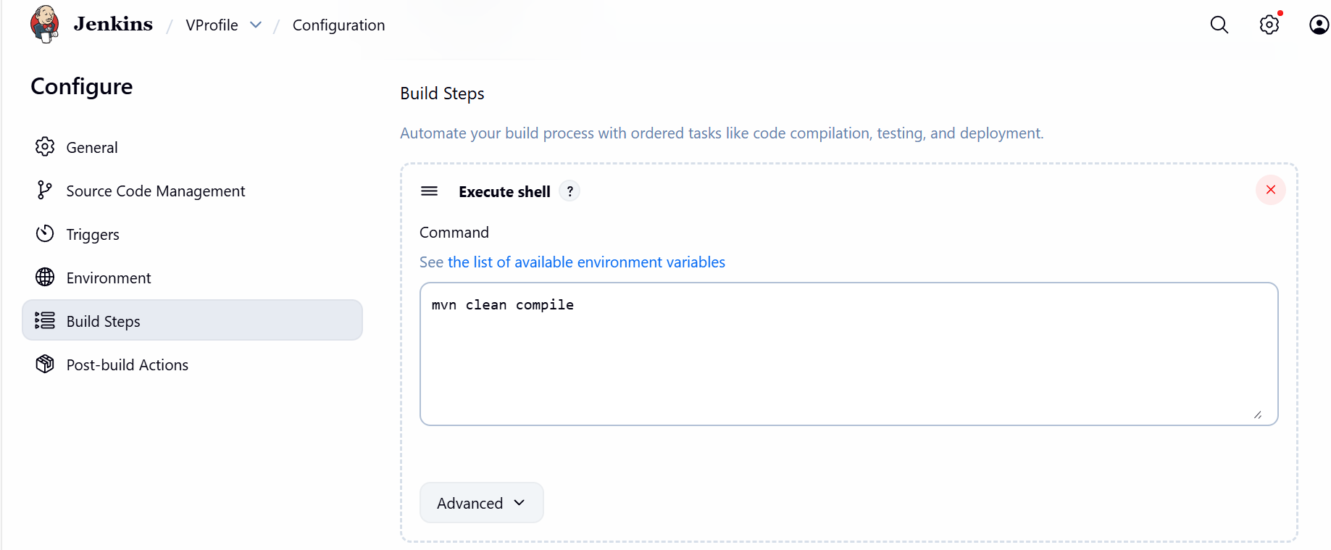

Step 11: Now, lets rock and roll. Hit Build Now and hope we should get success and pass.
That’s it. Yes, we got success and Pass.
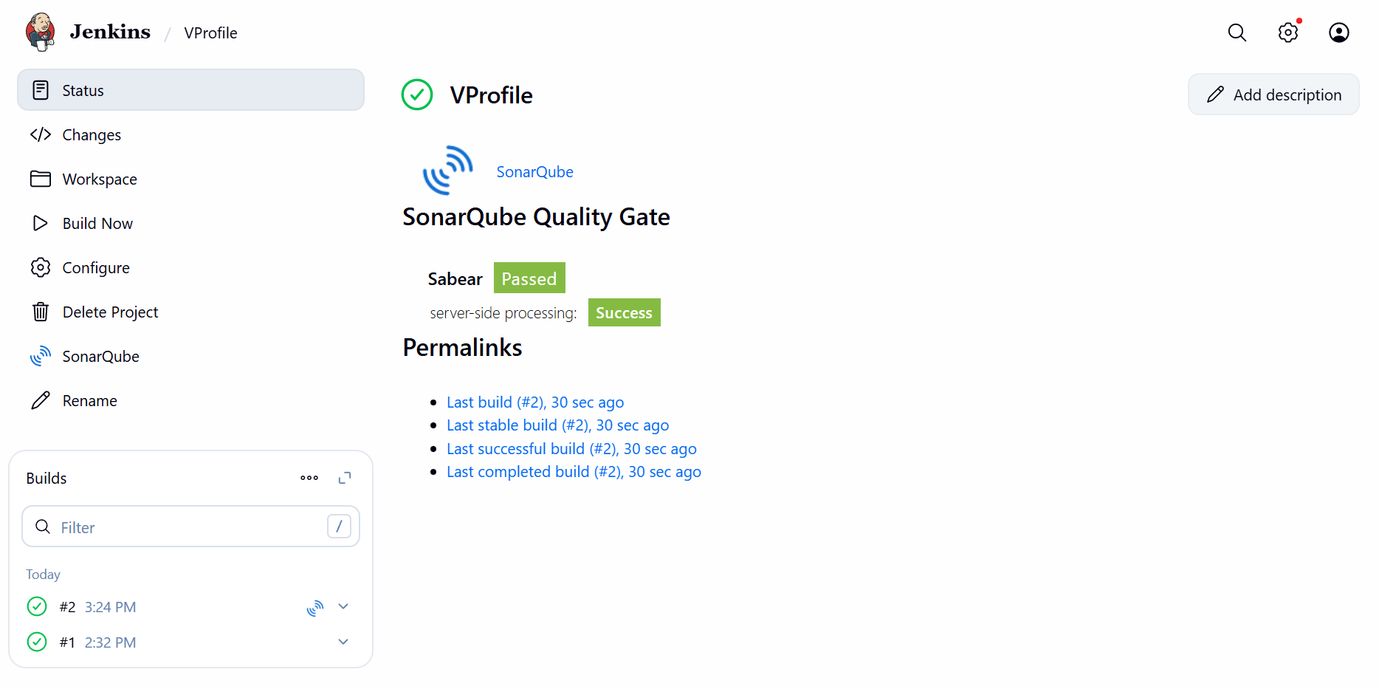
Step 10: Verify in the SonarQube for the Bugs, Vulnerabilities, Duplicates, Code Smells.
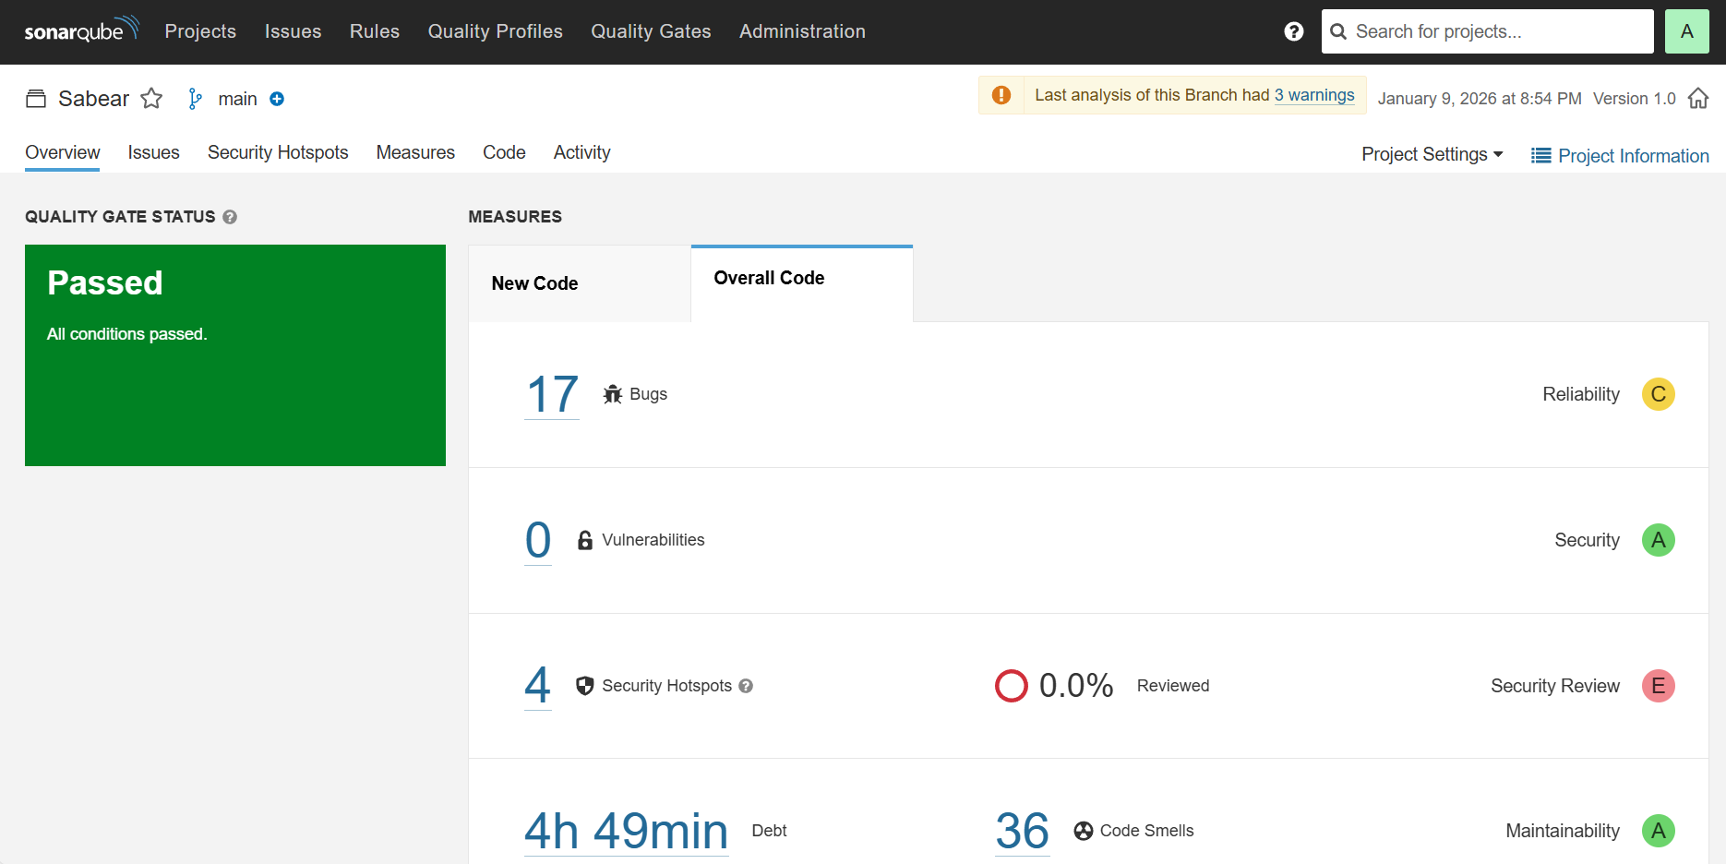

Stage Completed.

Stage 3: Slack Integration to send alerts to Slack.

Objective:
The objective of this task is to ‘Slack is used to receive real-time Jenkins build notifications so the team can monitor pipeline status instantly’.

Prerequisites:
- Slack
- Jenkins GUI
Step by step Implementation:
Step 1: Login to Slack and scroll down to Apps and click on Jenkins CI
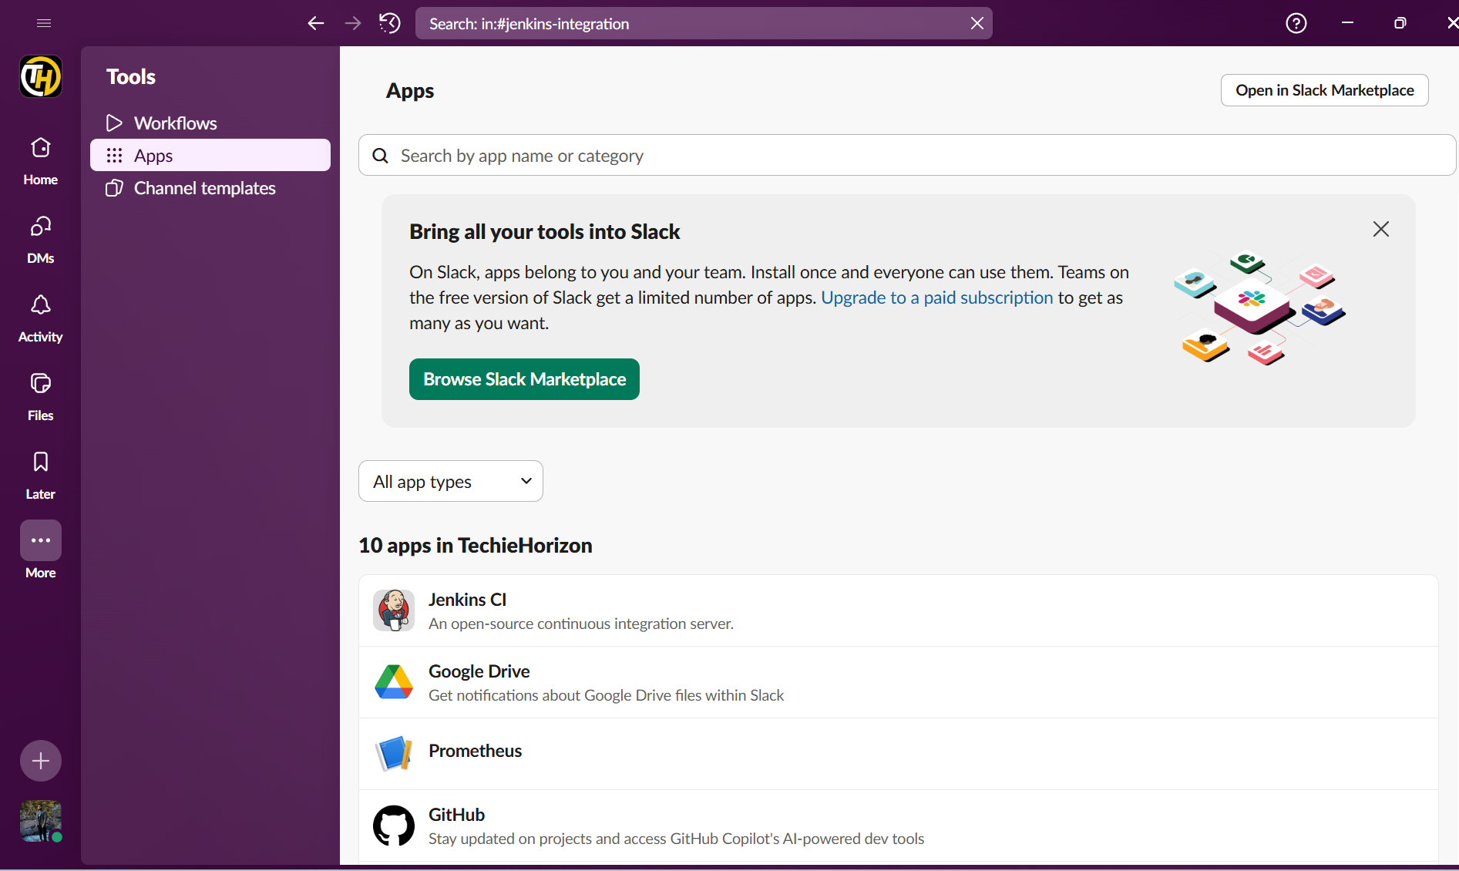

Step 2: Hit Configuration.
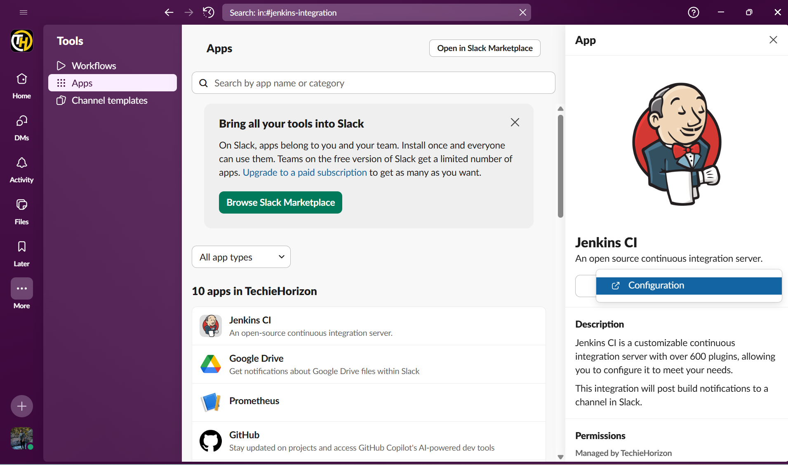

Step 3: Navigate to Jenkins GUI and install Slack Notification from Plugins.
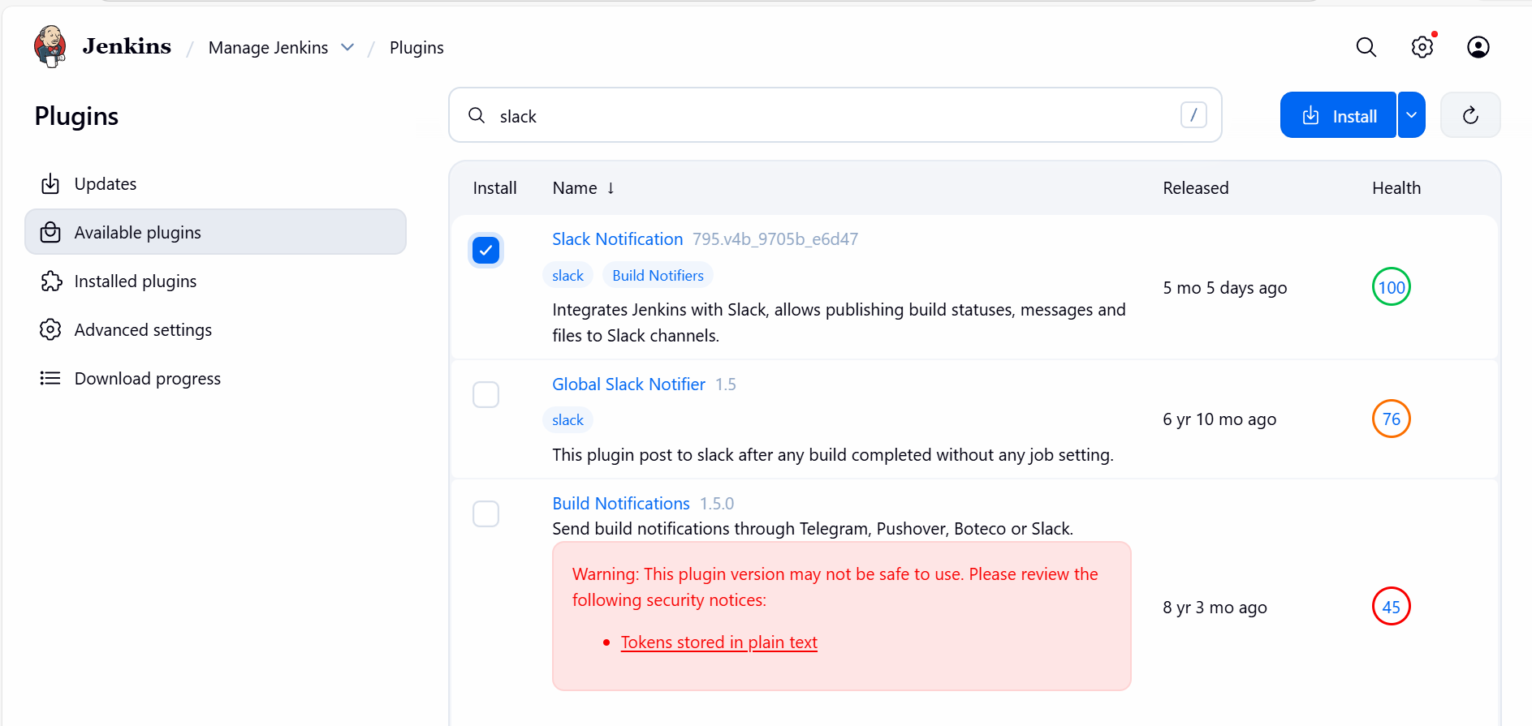

`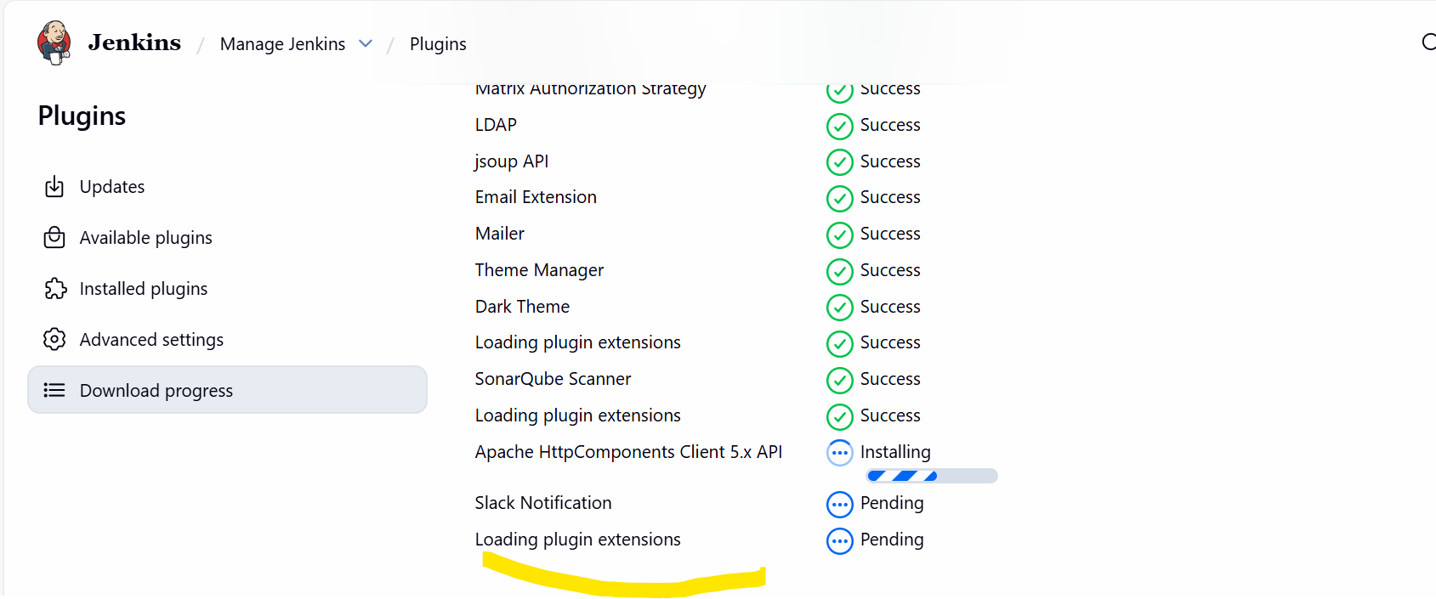

Step 4: Post to our Techie channel.

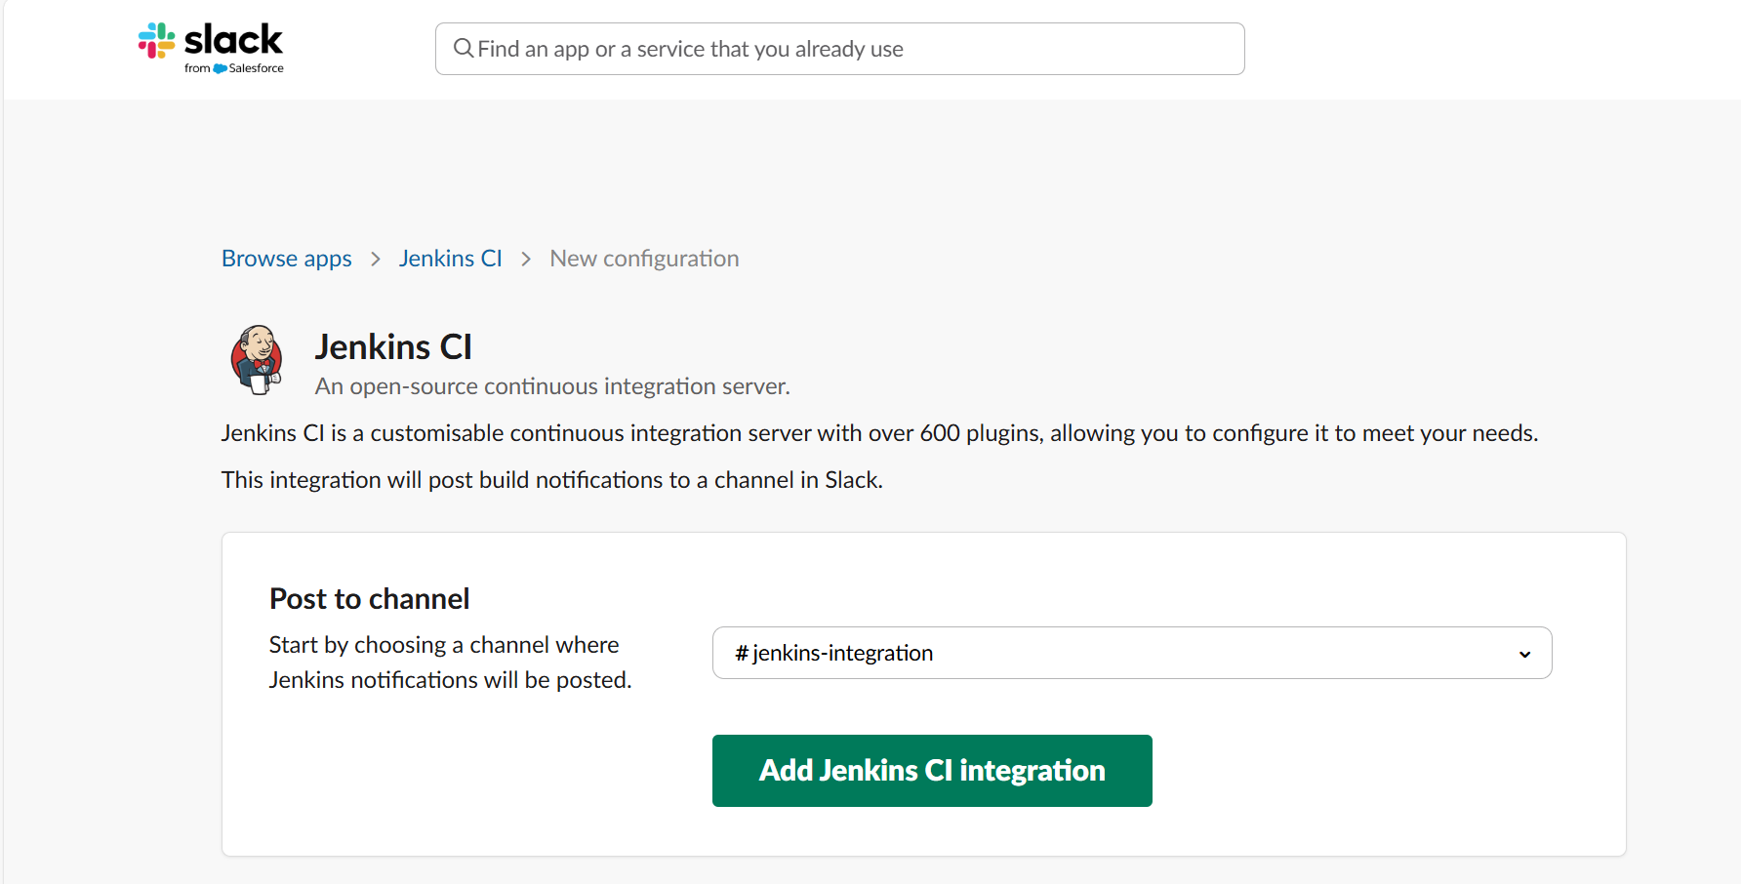
- Follow the steps below and execute.
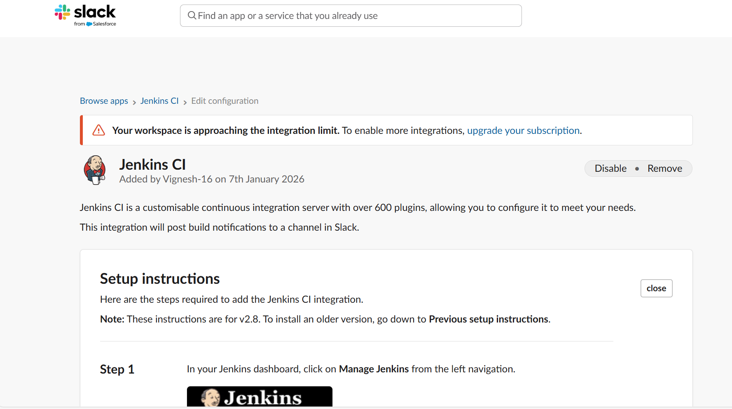
- Copy the below secret code and paste in the Jenkins GUI under credentials.
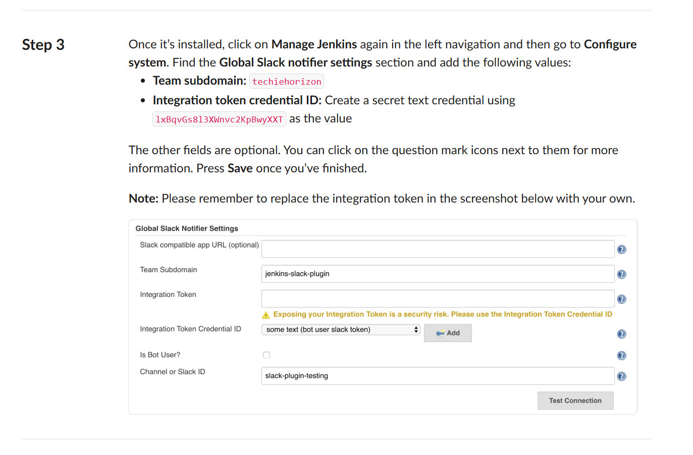
- Create a new credential and paste the above secret key.
- Save
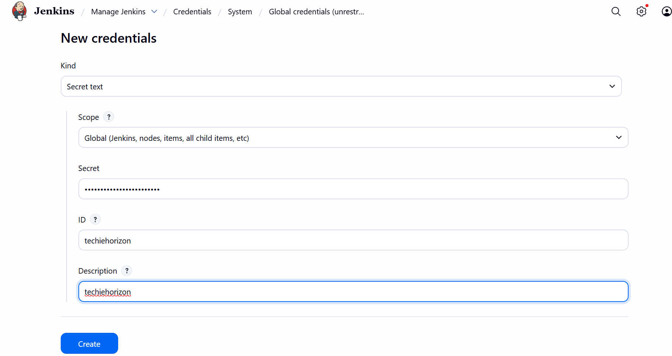

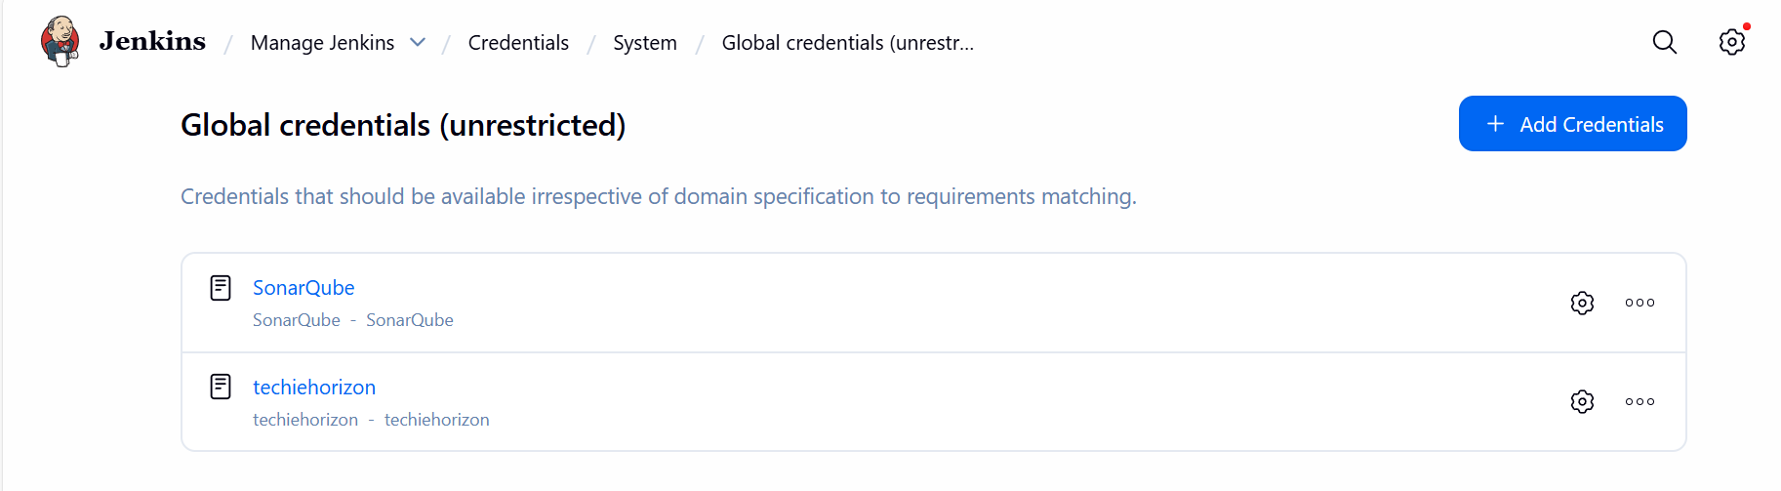

Step 5: Manage Jenkins Credential created post in the Slack Workspace.
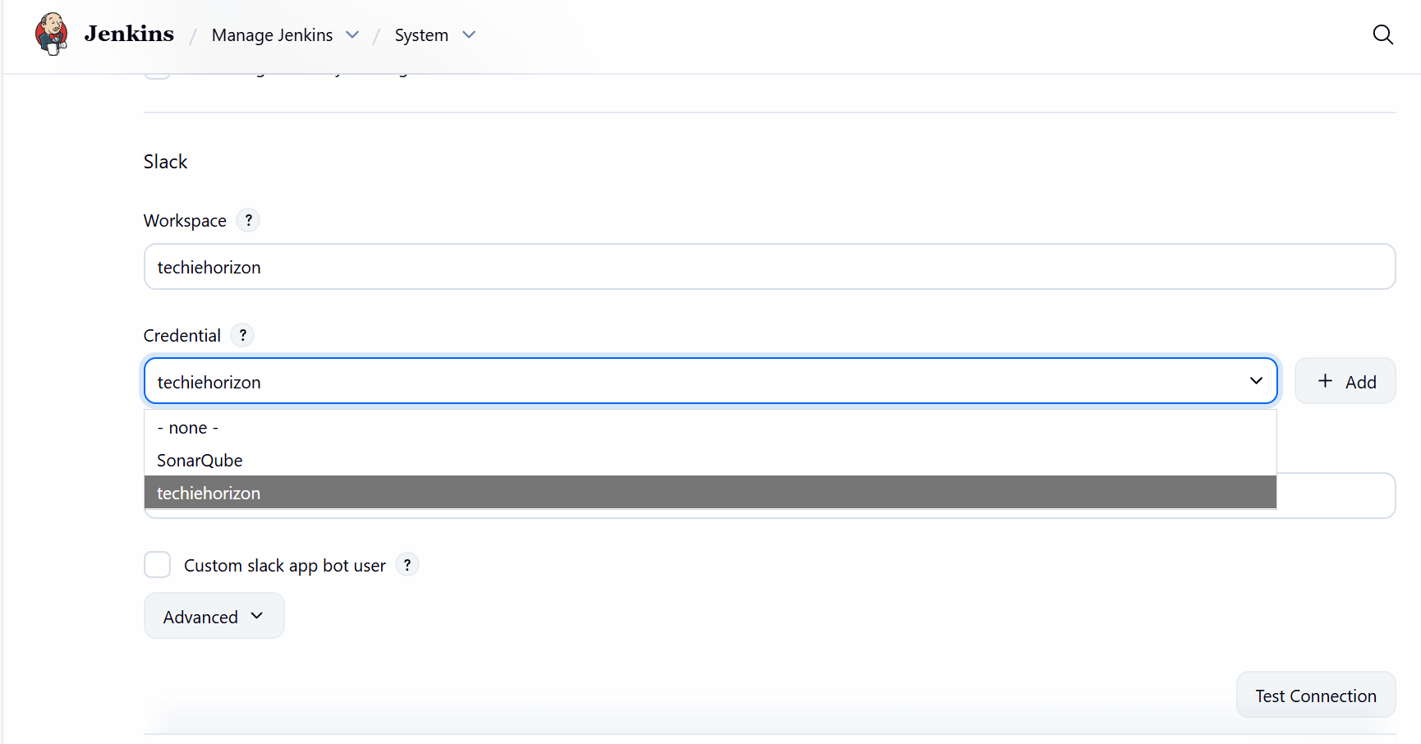
Step 6: Now, got to the job and scroll to the configure.
- Post build actions select all 3 below and save.

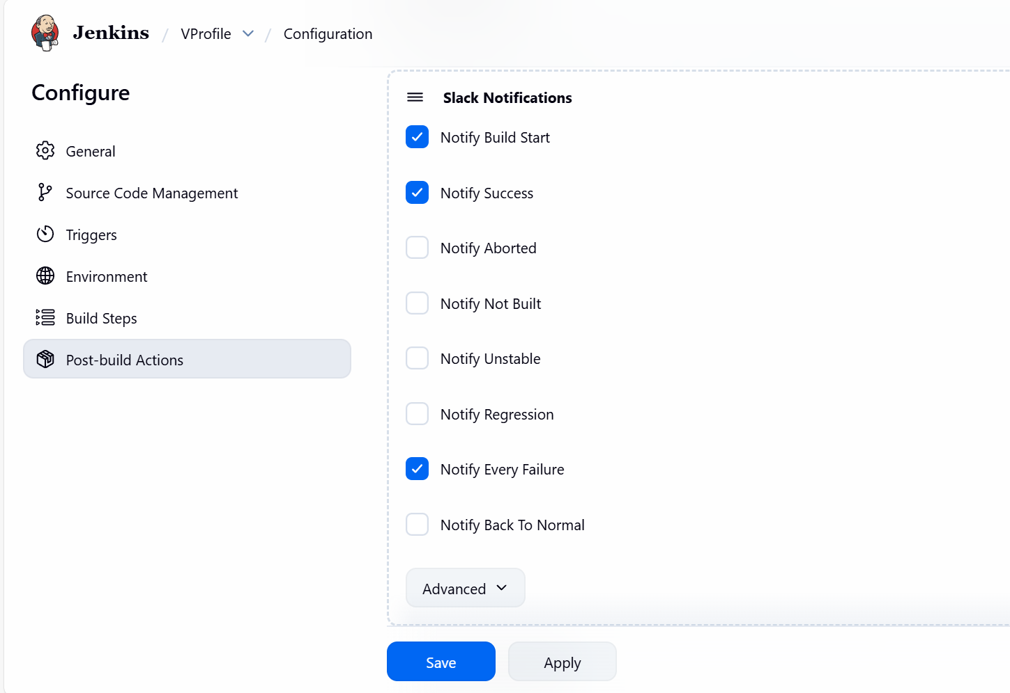

Step 7: Now, its time to build and verify if the success is sent to Slack.
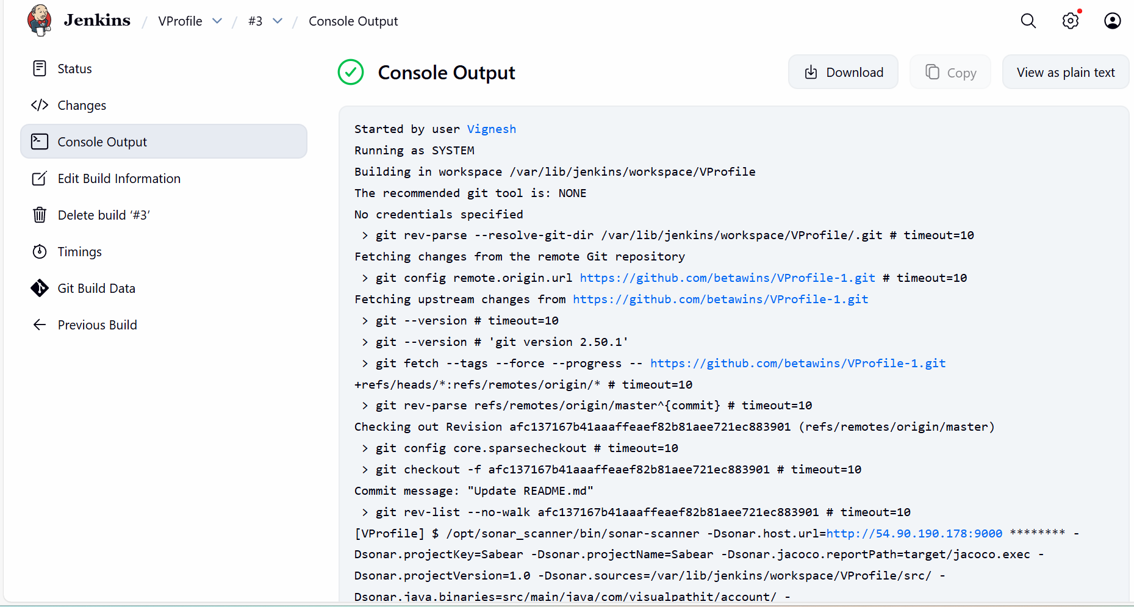
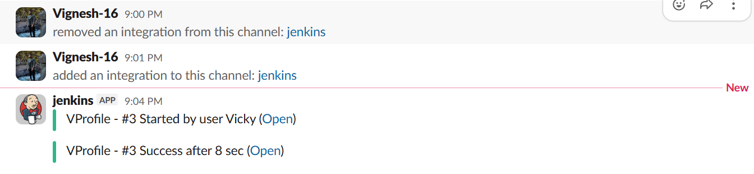

Task-2
Create one Jenkins job using the below code and create three stages:
stage1: Git clone to download the source code.
stage2: Sonarqube Integration to check the quality of code.
stage3: Slack Integration to send the alerts to slack.
URL: https://github.com/betawins/hiring-app.git
Stage 1:
Step by step Implementation:
Step 1: Navigate to Jenkins GUI and create a new job.
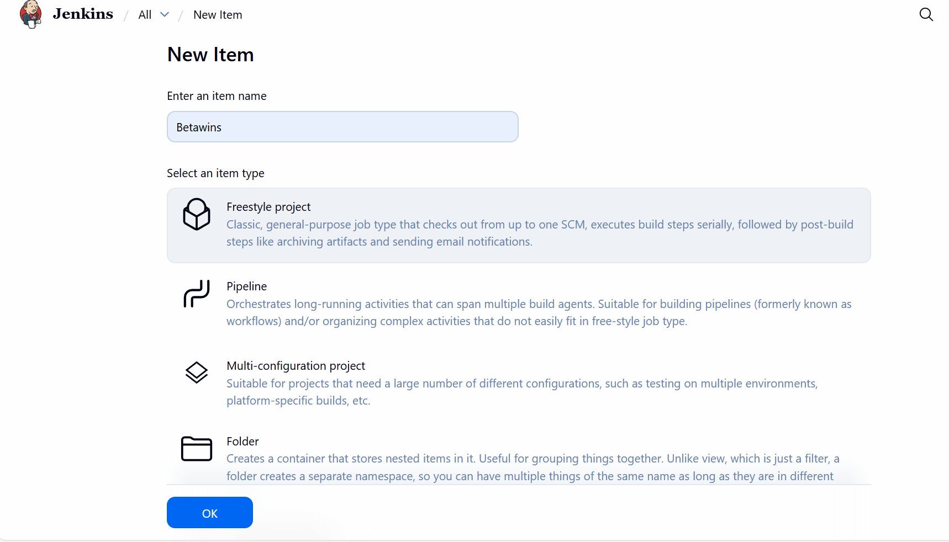

Step 2: Using the URL, let’s clone the code from git to Jenkins.
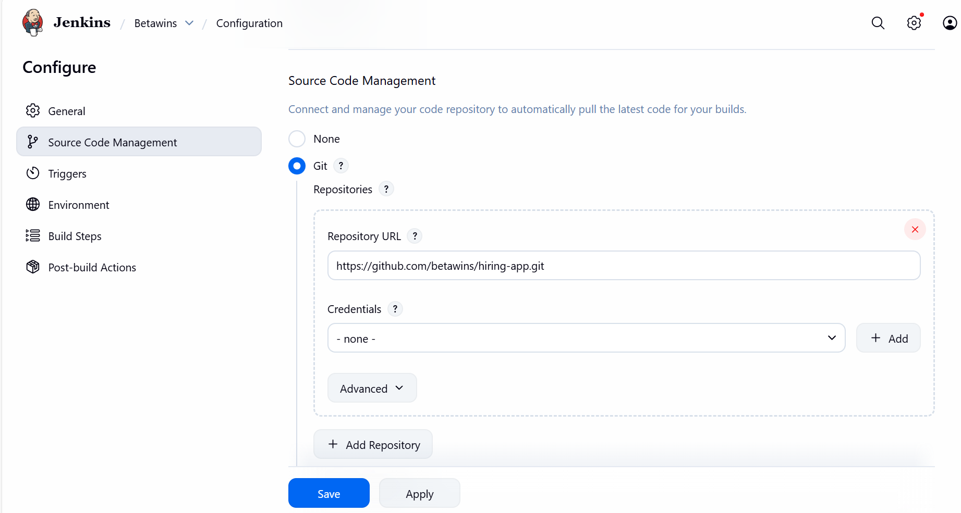

Issues faced:
We always need to check for the branch where the codes are present. I got an issue when clicked on Build now.
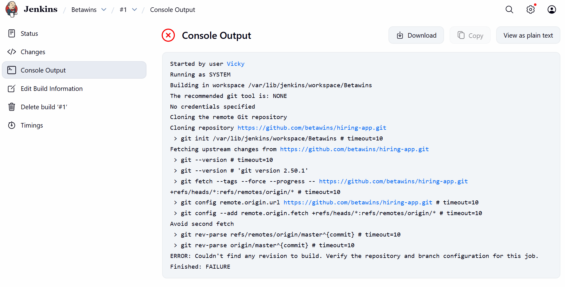
- Changed to main branch and build again.
- It is successful now.

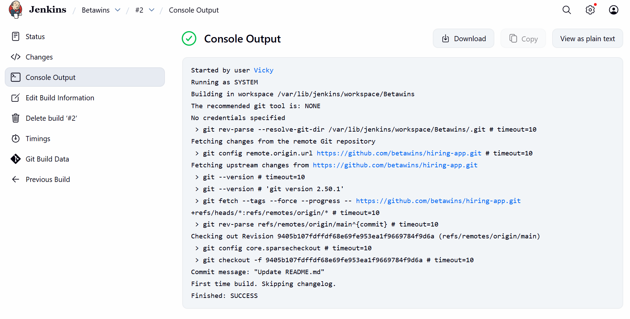

Stage 2:
Step 1: Launch a new instance in ec2.
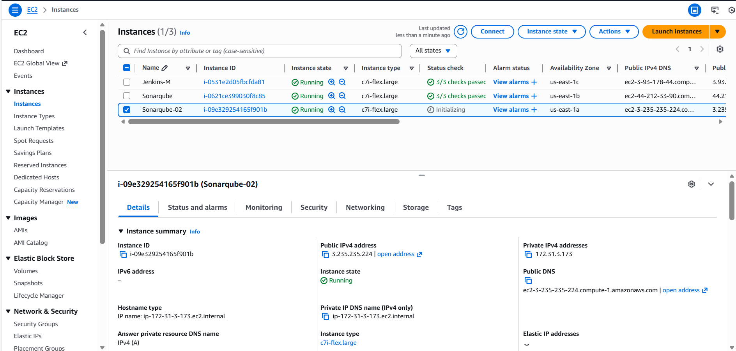

Step 2: Install Docker:
- Sudo yum install docker -y
- Sudo systemctl start docker
- Sudo systemctl enable docker
- Systemctl status docker
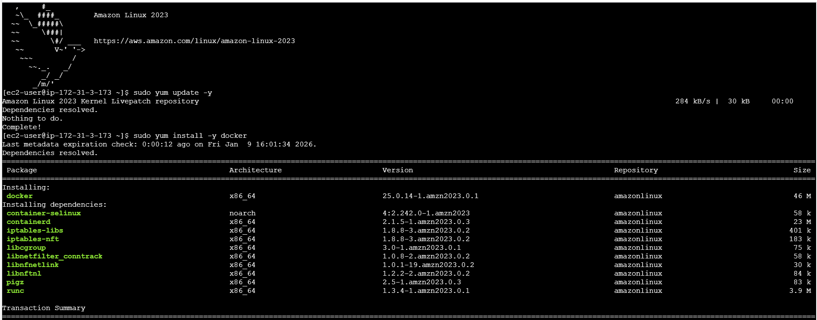
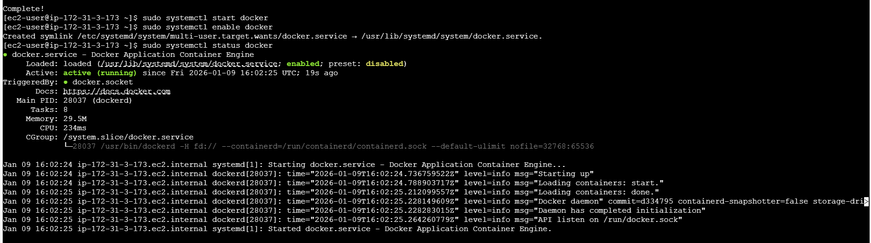

Step 3: Pull Sonarqube image: sudo docker pull sonarqube
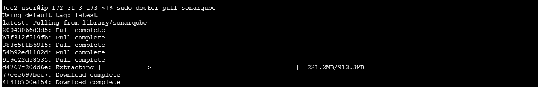

Step 4: Run sonarqube container: sudo docker run -itd -p 9002:9000 sonarqube
- Docker ps
- Copy paste the URL and port number -9002, it should open Sonarqube GUI
- Success.

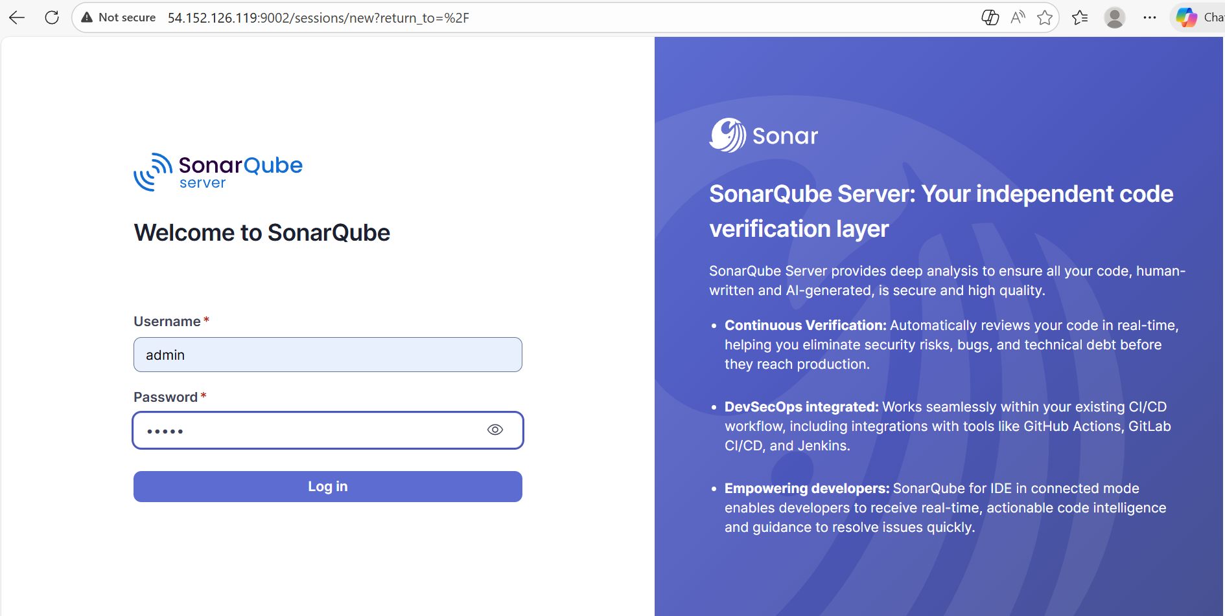

Step 5: Access sonarqube
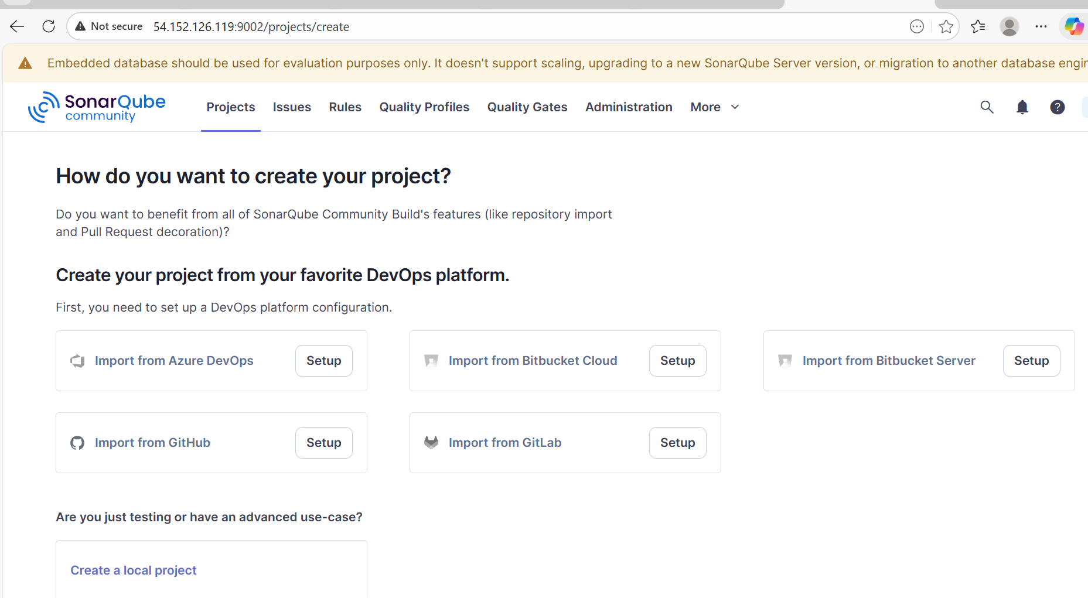
Step 6: Generate token from settings.
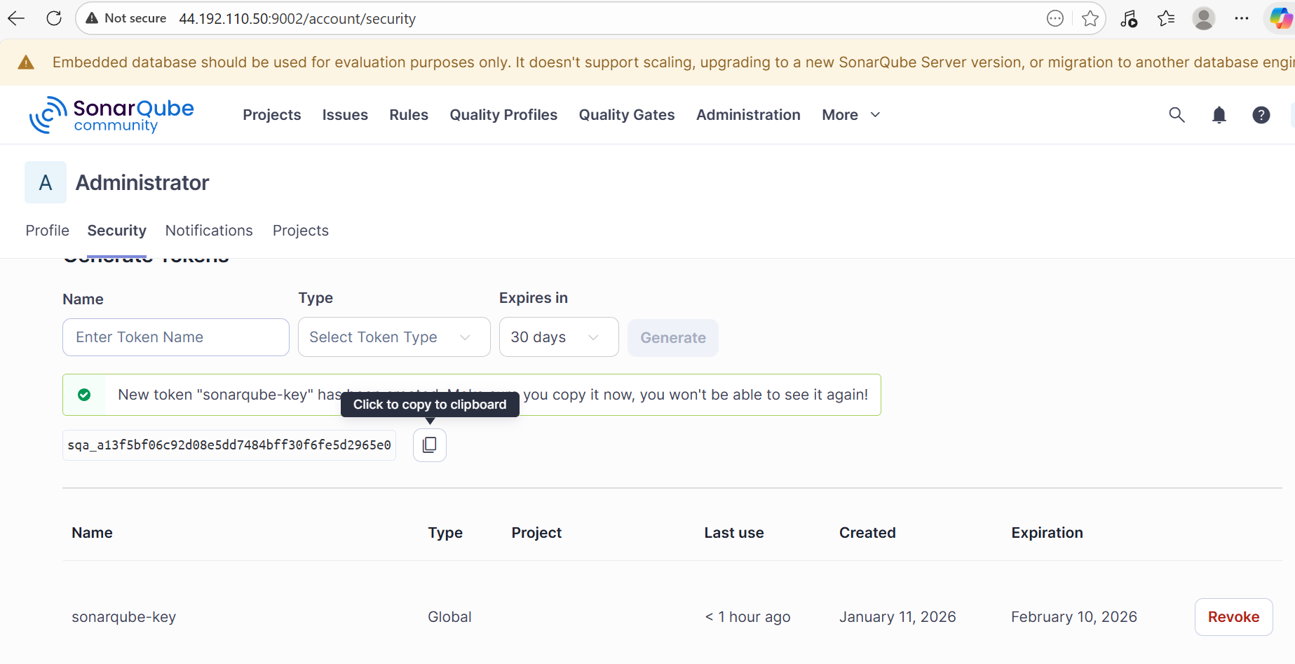

Step 7: Navigate to Jenkins GUI and select Manage jenkins Credentials and copy paste the code generated from Sonarqube.
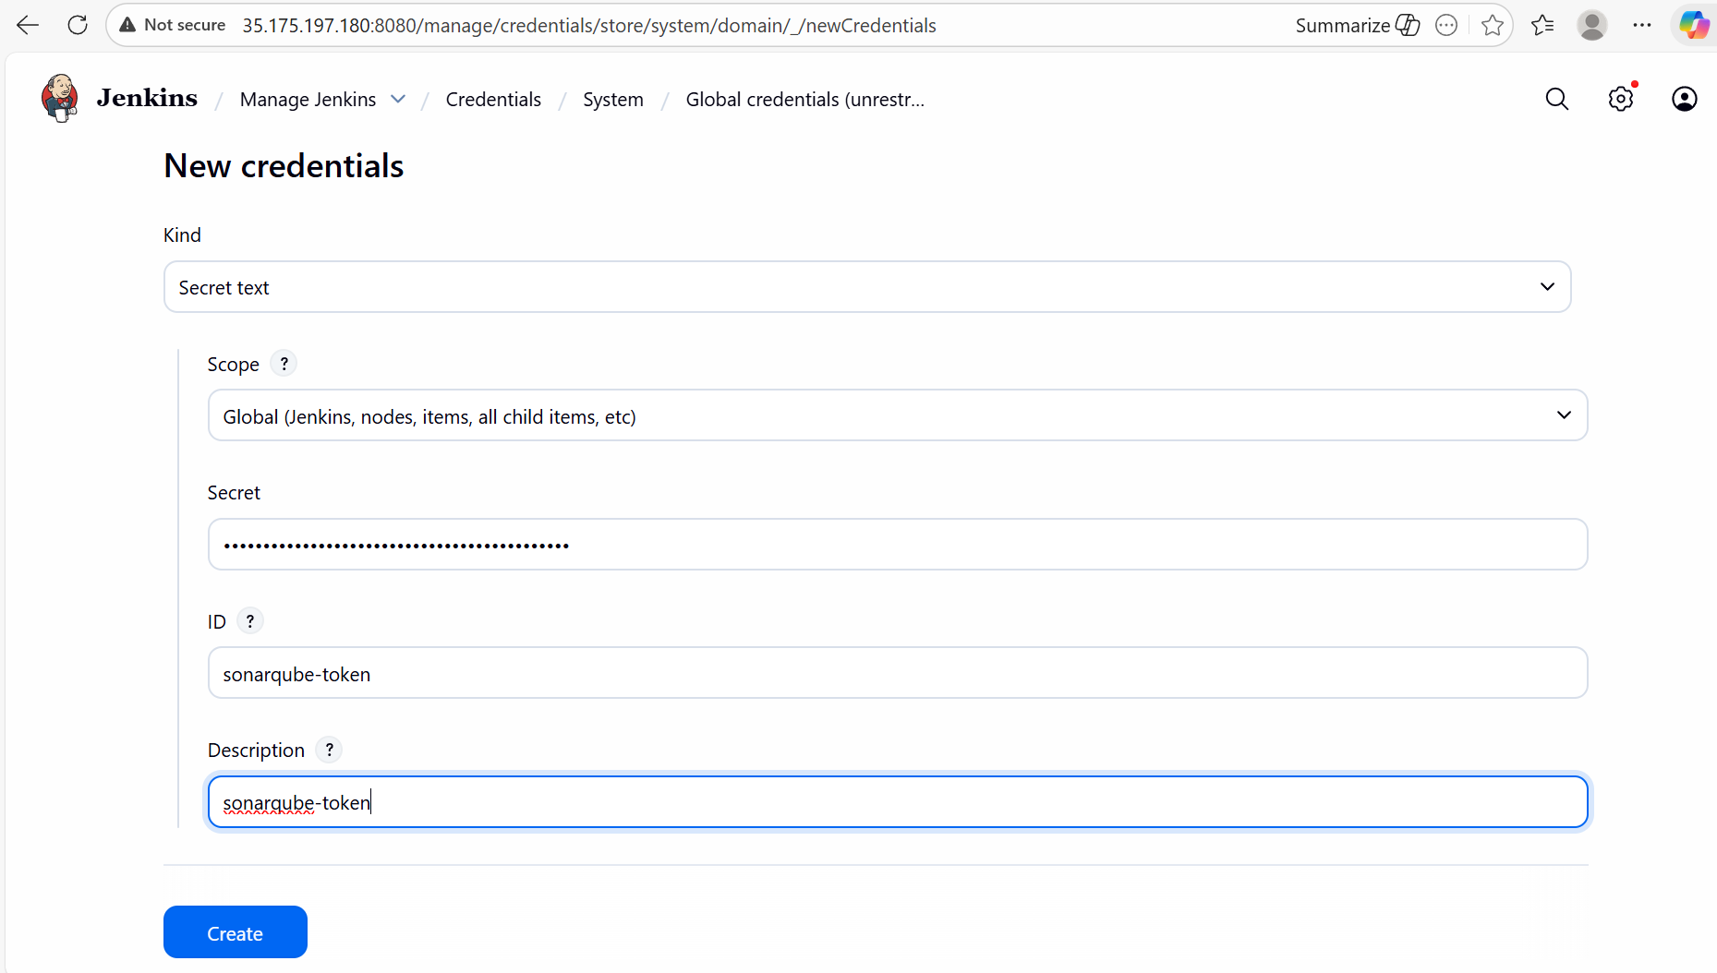

- Changed the Jenkins URL as well, because we stopped the instance overnight.
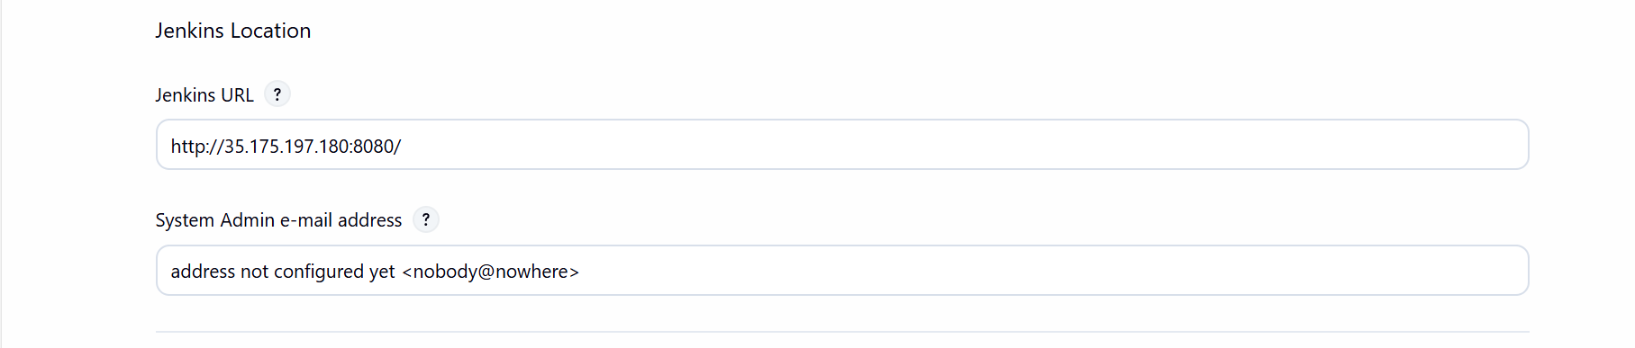

Step 8: Navigate to System and update the Token generated and IP with port number.
Save
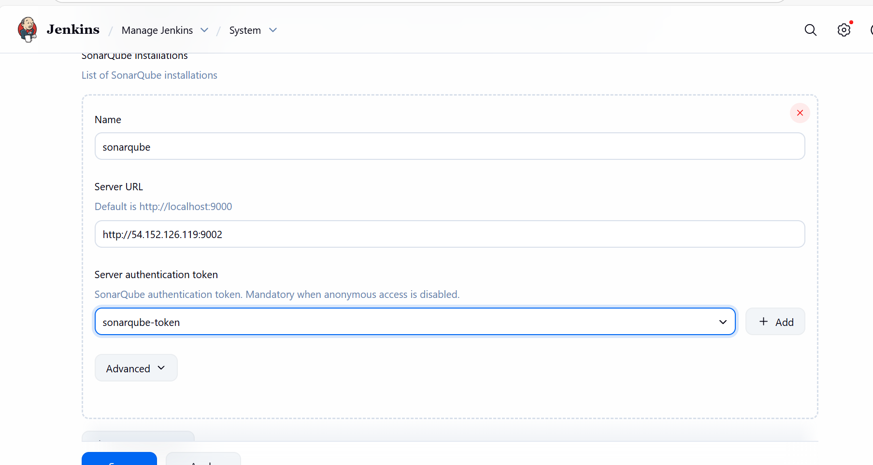

Step 9: Navigate to the Job and create Environment Use secret texts or files Create a key and update the Sonar-key generated from Sonarqube GUI, which we have pasted in Jenkins GUI Manage Jenkins System Sonarqube installations.
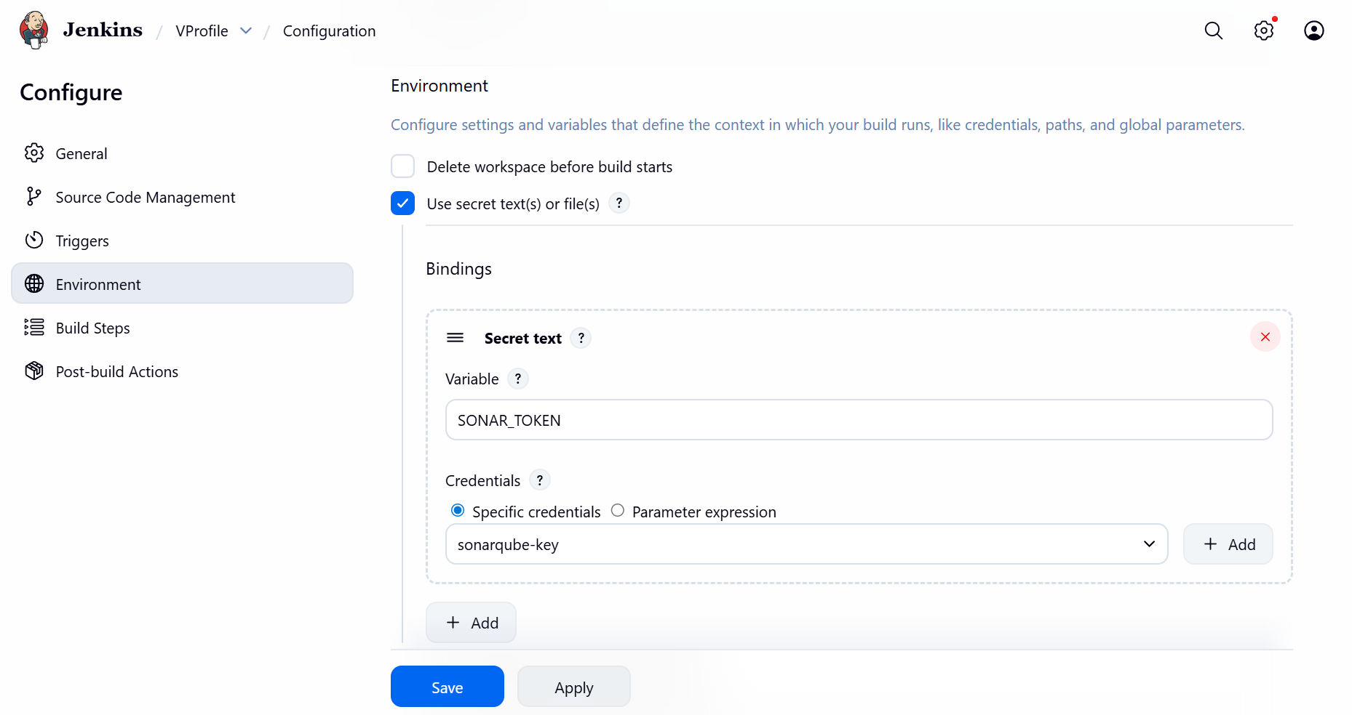

Step 10: Let’s update the Build steps as well update sonar login with current Sonarqube generated token and Sonar.host to updated URL with port number:9002.
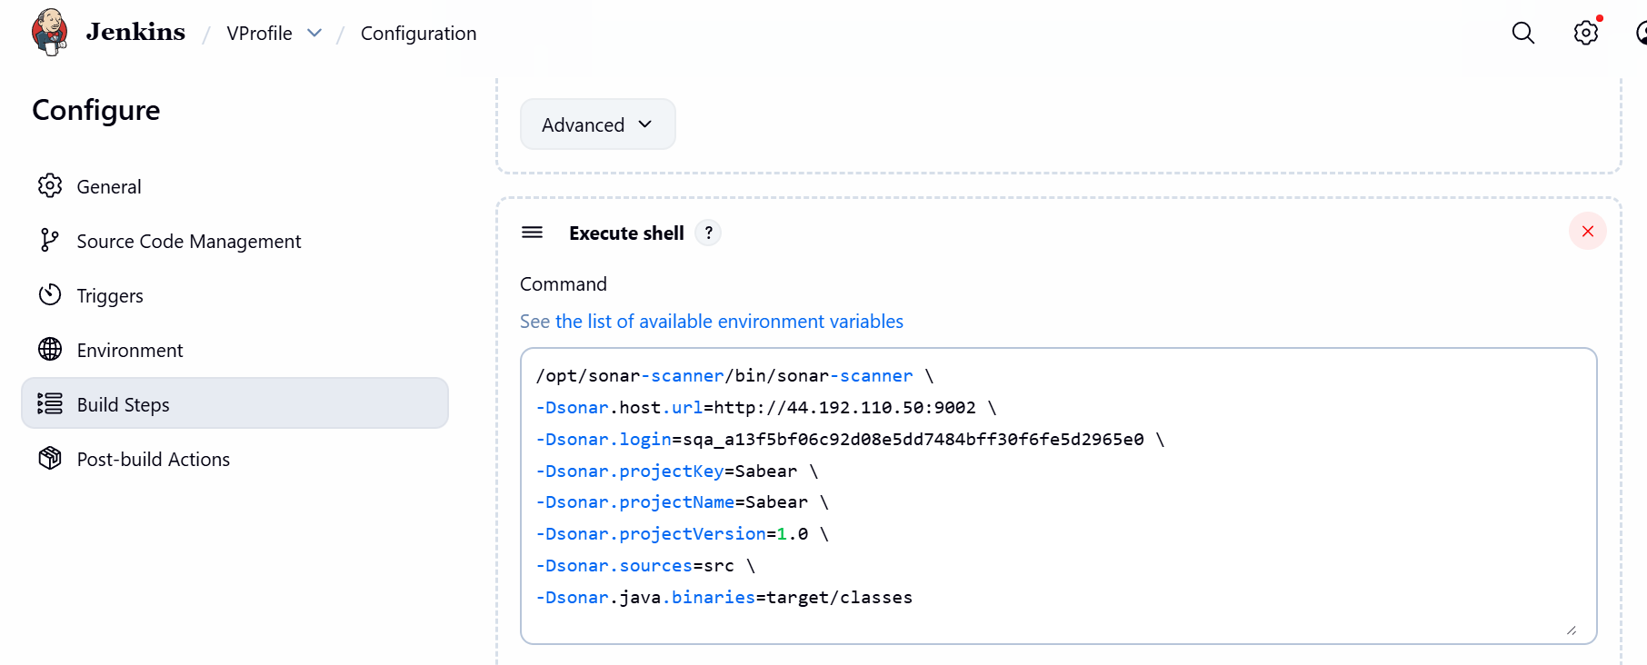
Step 10: Now, lets build and we should verify is its passing.
Success.
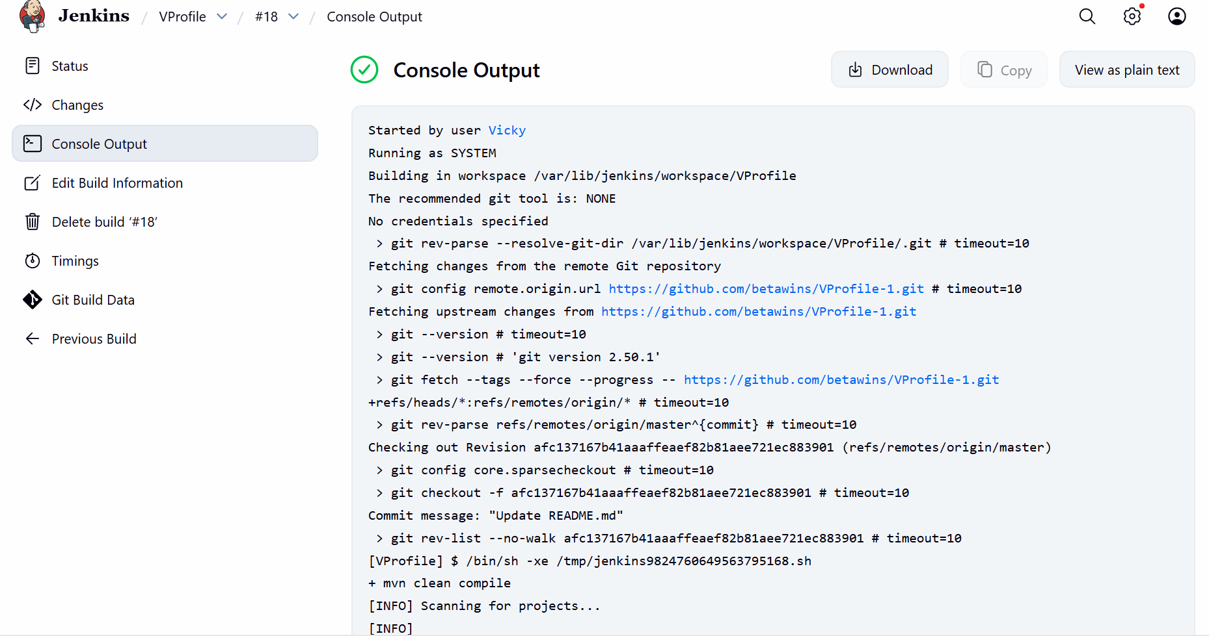

Step 11: Let’s verify in the Sonarqube GUI as well.
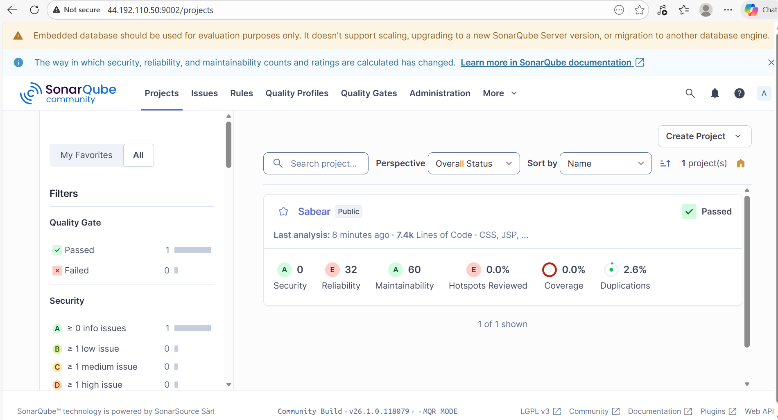

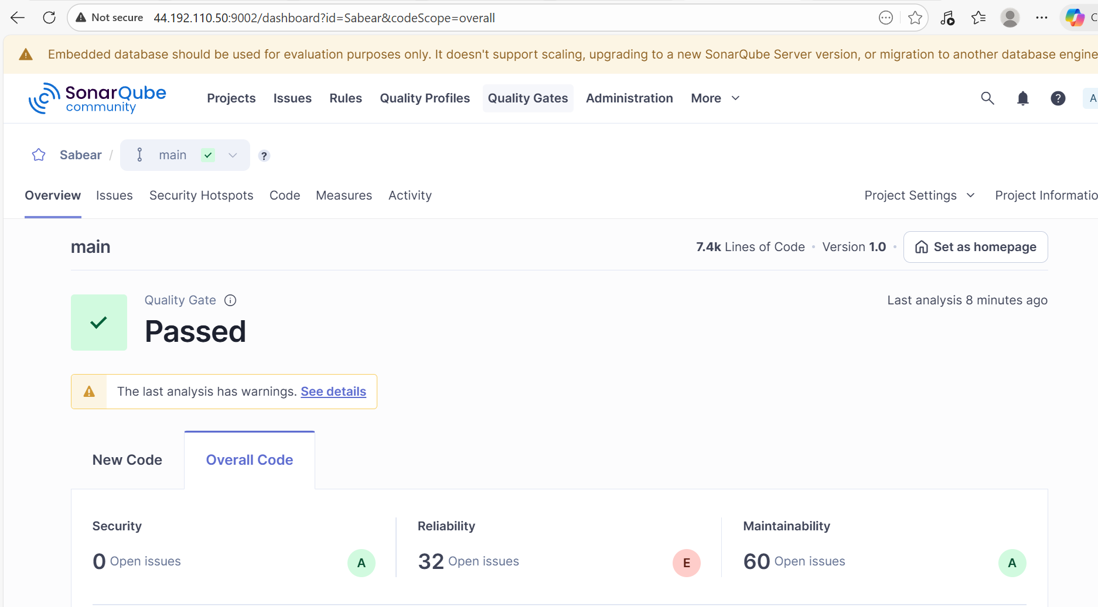

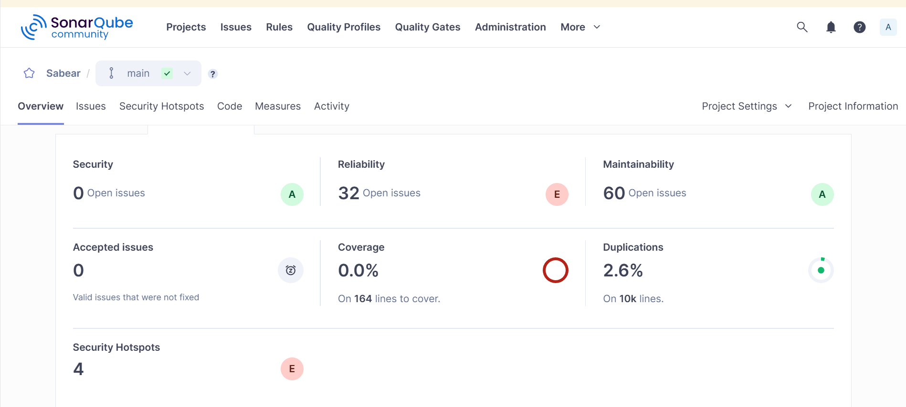

Stage 3: Let’s complete the slack notification as well to see if the build is being notified to Slack.
