Jenkins-04 Task-1

- Setup Jenkins CICD pipeline using freestyle job using Docker containers using below code. https://github.com/betawins/hiring-app.git Stages:
Stage 1: Git Clone
Stage 2: SonarQube Integration
Stage 3: Maven Compilation
Stage 4: Nexus Artifactory
Stage 5: Slack Notification
Stage 6: Deploy On tomcat

Stage 1 and Stage 2

Step by step Implementation
Step 1: Login into Jenkins server.

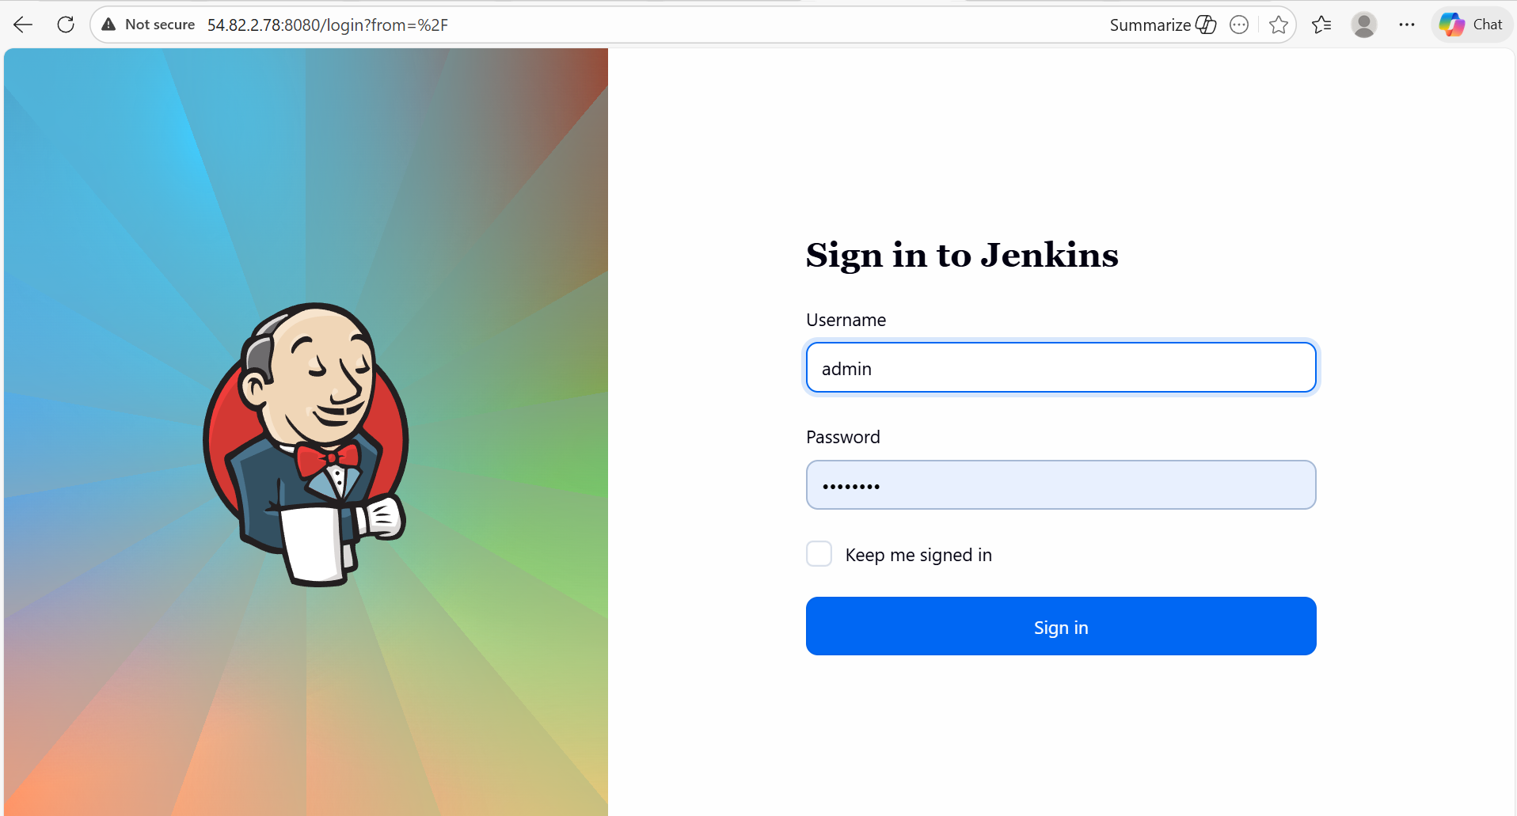

Step 2: Login into Sonarqube server and run the docker which was already running on Port- 9002.

- sudo docker run -itd -p 9002:9000 sonarqube

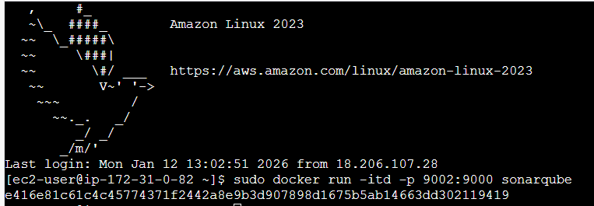

- Whenever, we stop the instance and restart, then we need to login and change the password from regular id and password- admin, admin.
- New Password- Sonarqube@123
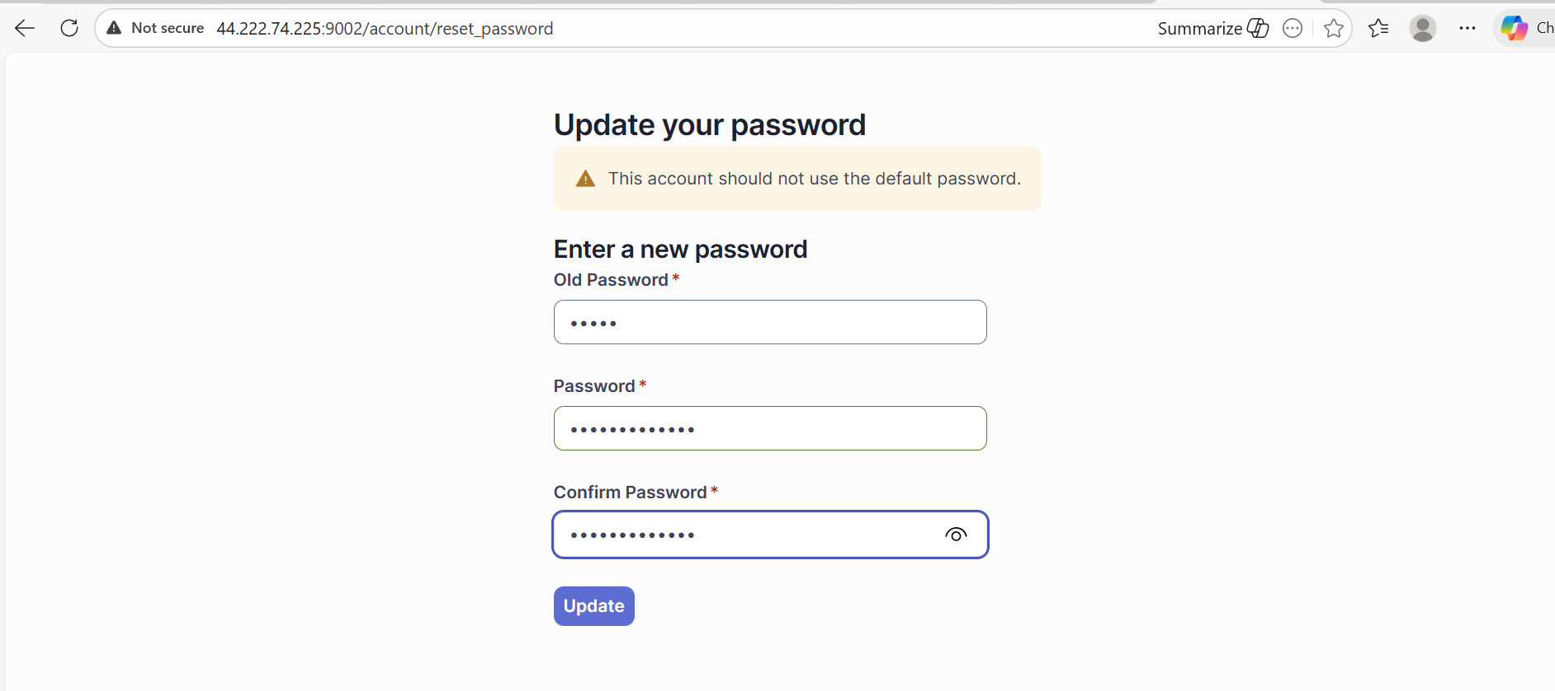

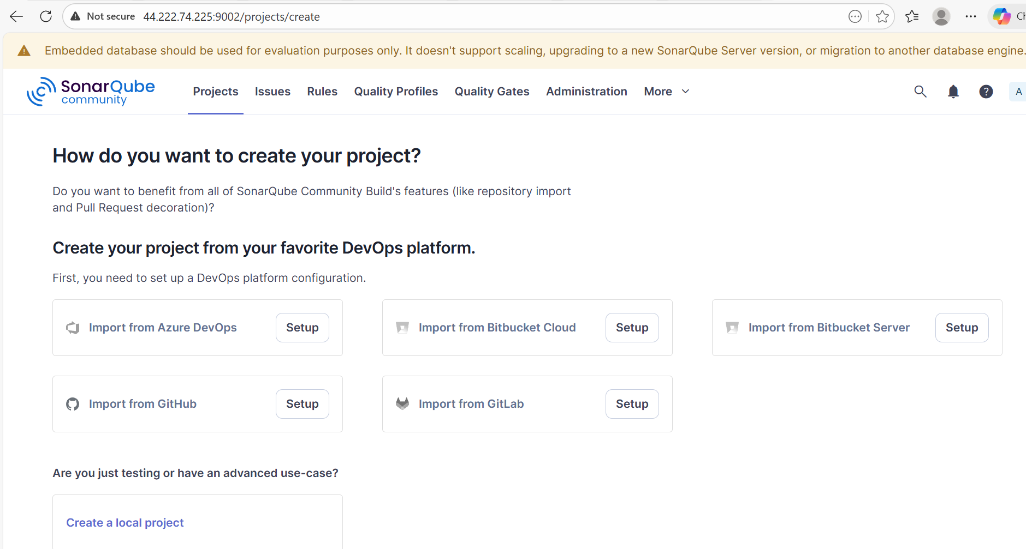

Step 3: Generate a token, since we stopped the instance, already created tokens will be lost.

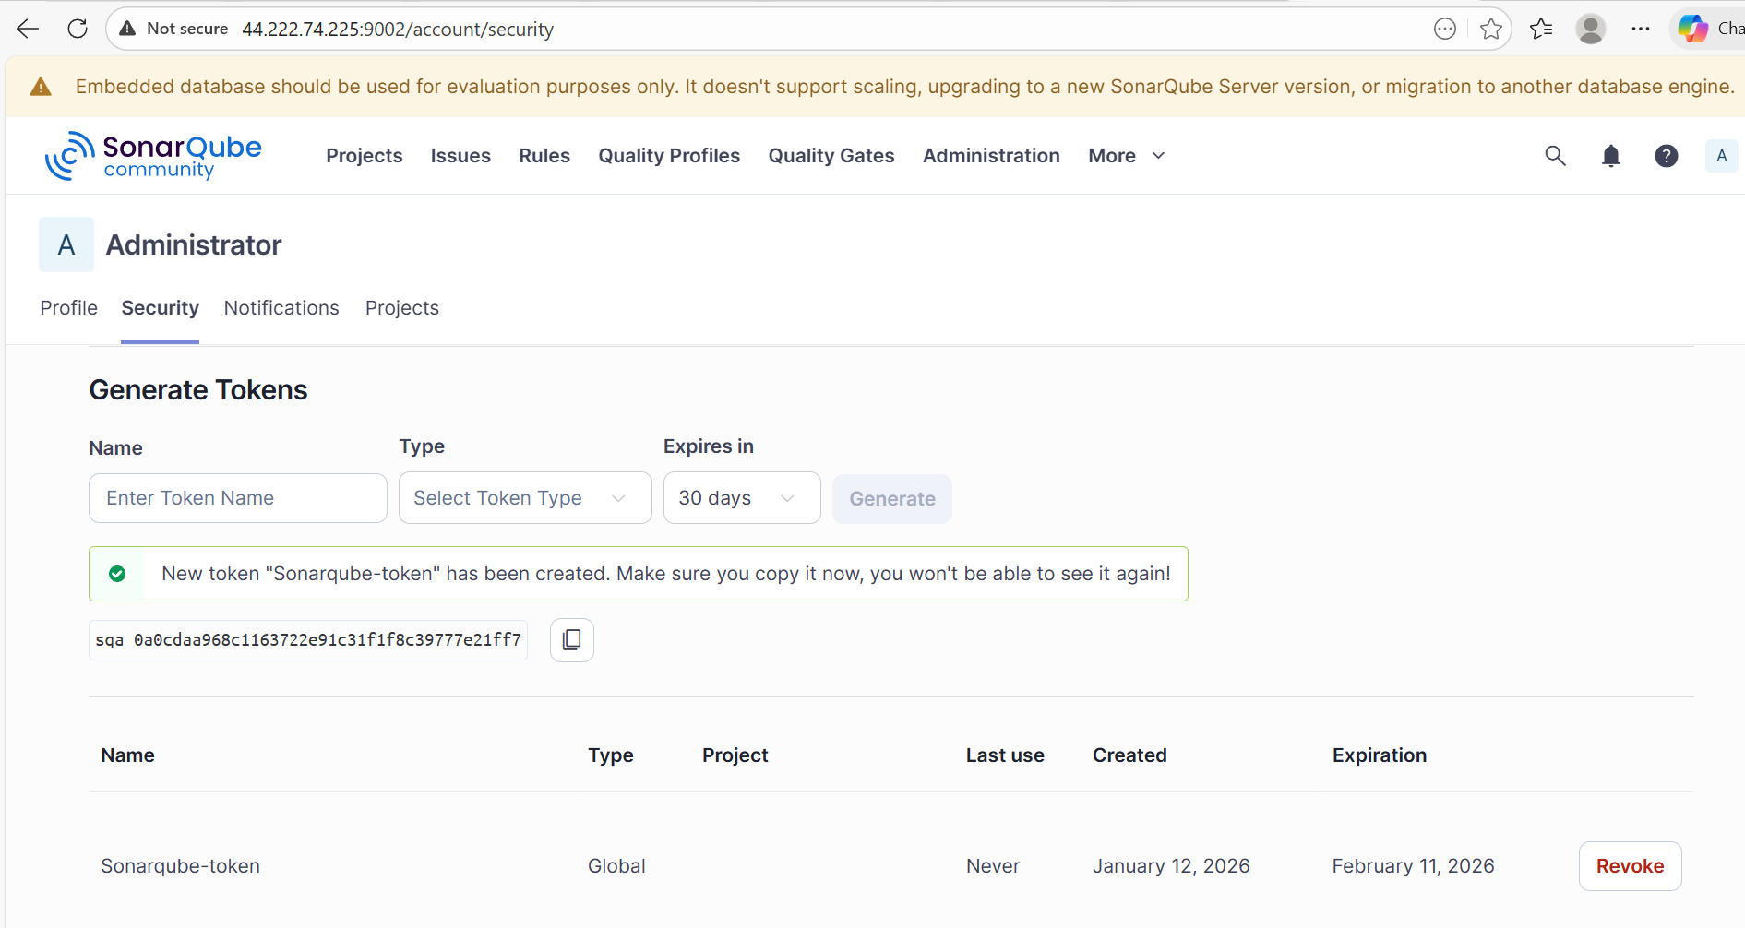

sqa_0a0cdaa968c1163722e91c31f1f8c39777e21ff7

Step 4: Navigate to Jenkins GUI and create a Credentials in Manage Jenkins.
- Update the token created in Sonarqube server.

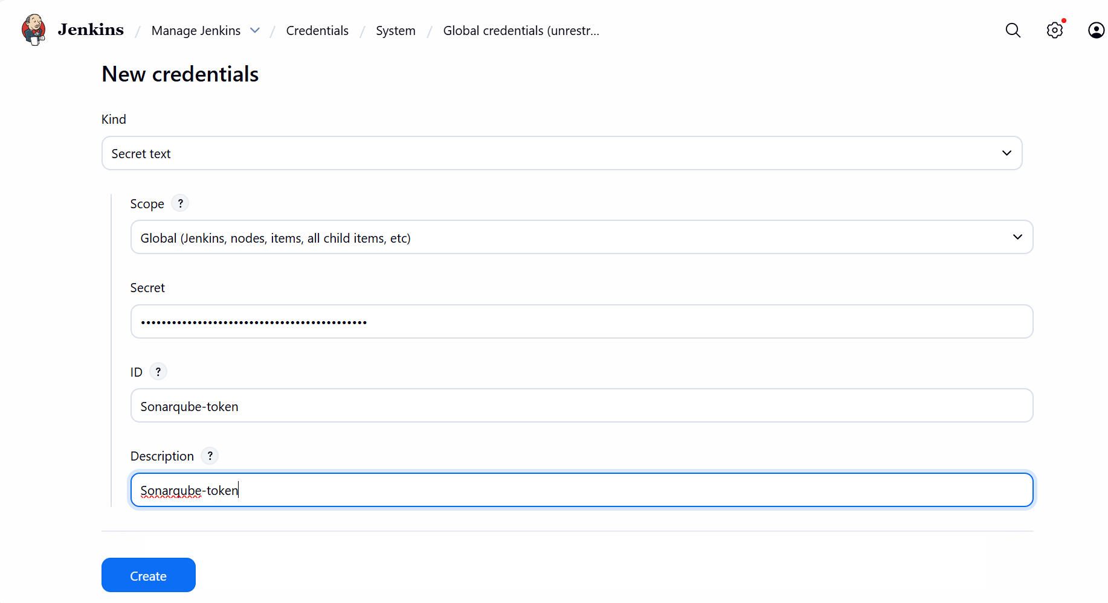

Step 5: Manage Jenkins System
- Update the new Jenkins server IP since, we stopped the instance earlier.

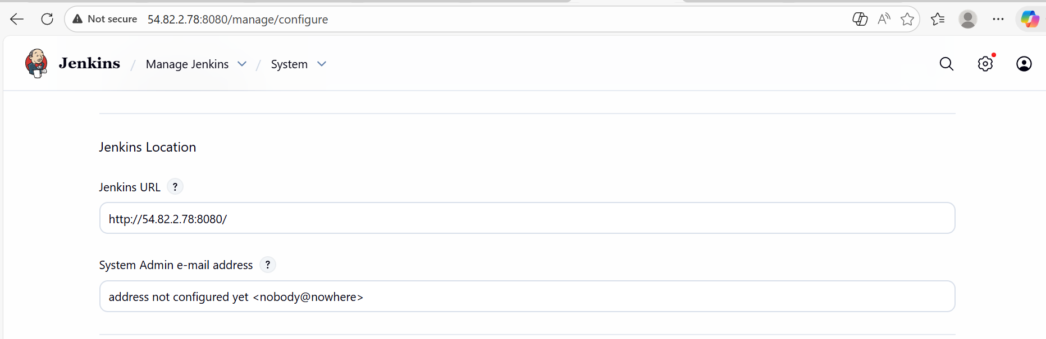

- Update the Sonarqube token which we created earlier in Credentials.
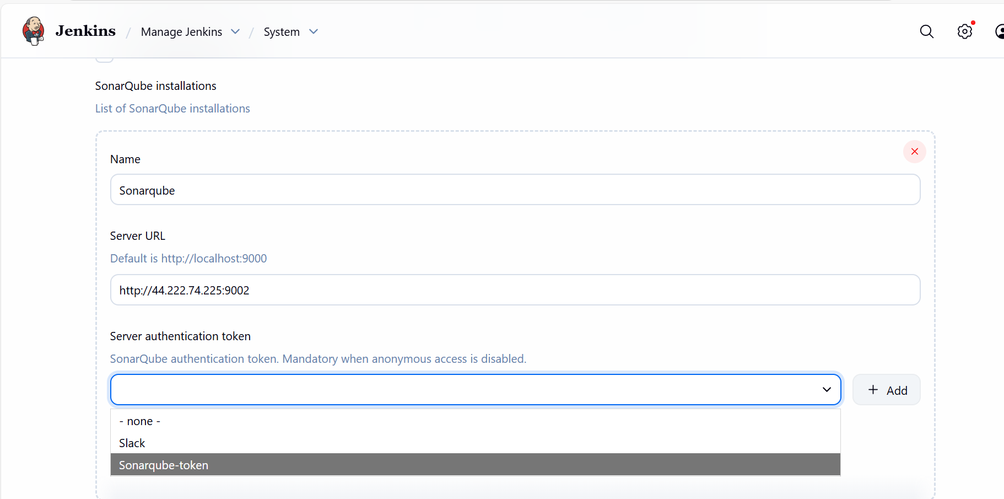

Step 6: Scroll to the Dashboard and create a new job named- Jenkins-04
- Freestyle Job as per task requirement.
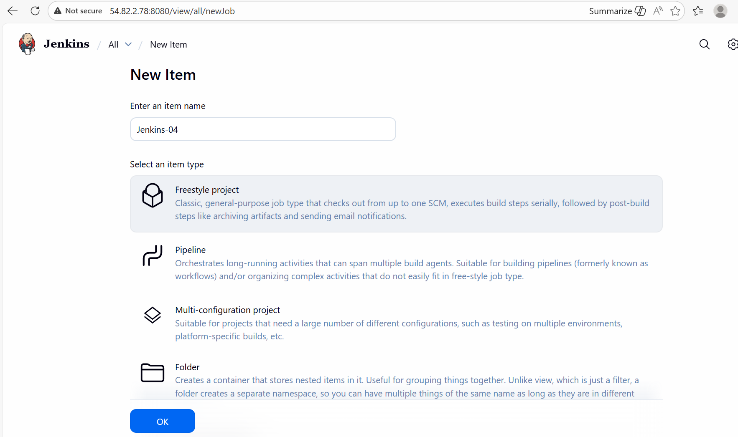

- Update the git URL scroll down to Environment.
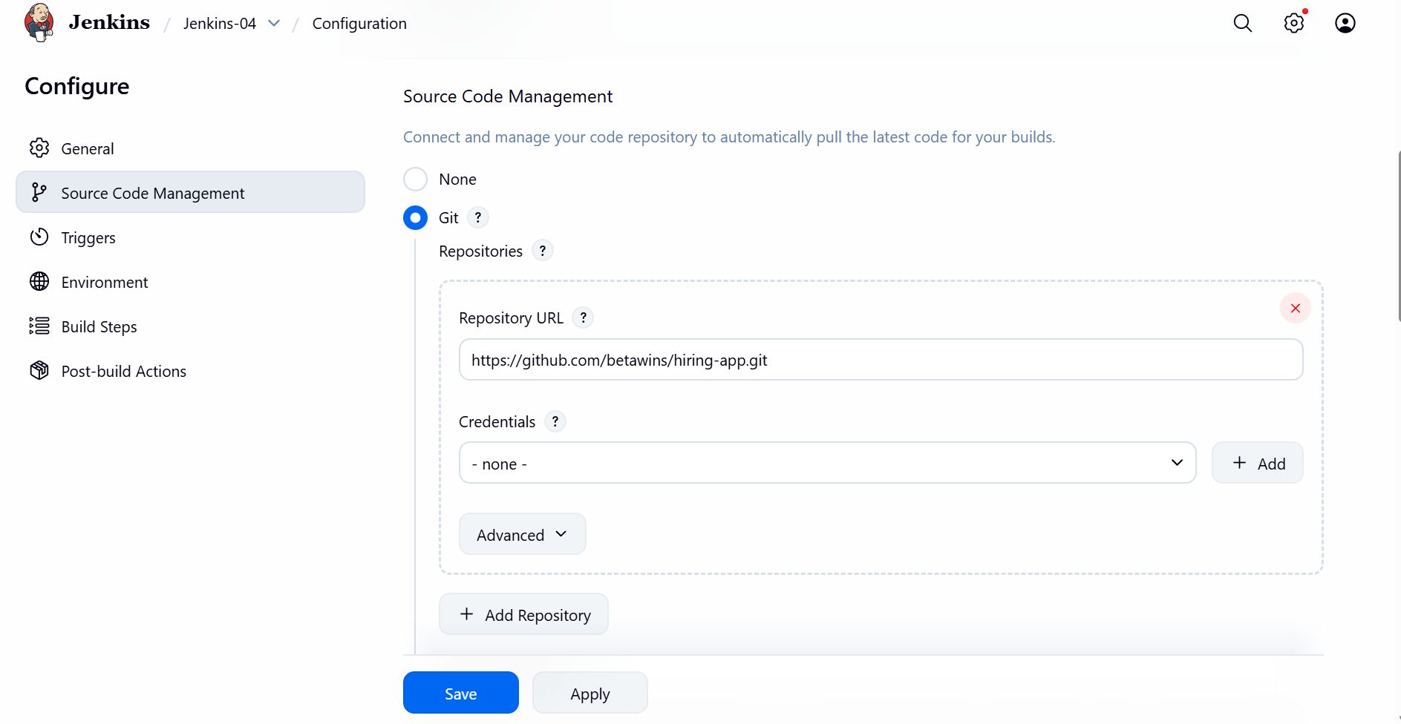

- Create a new secret text under Environment.
- Update the Sonarqube token created earlier.
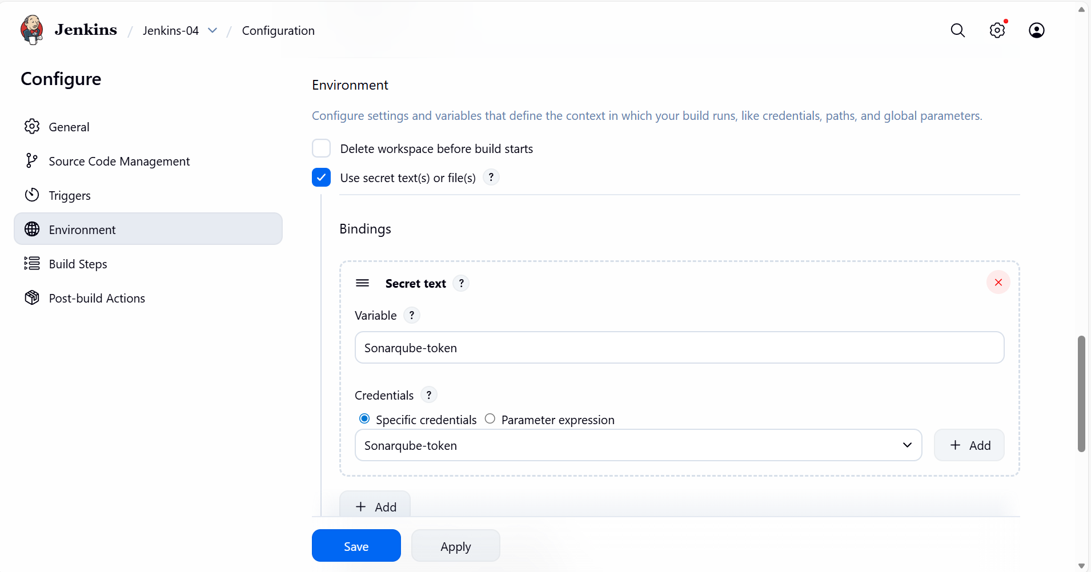

Step 7: Navigate to git URL and copy the sonar properties Readme.
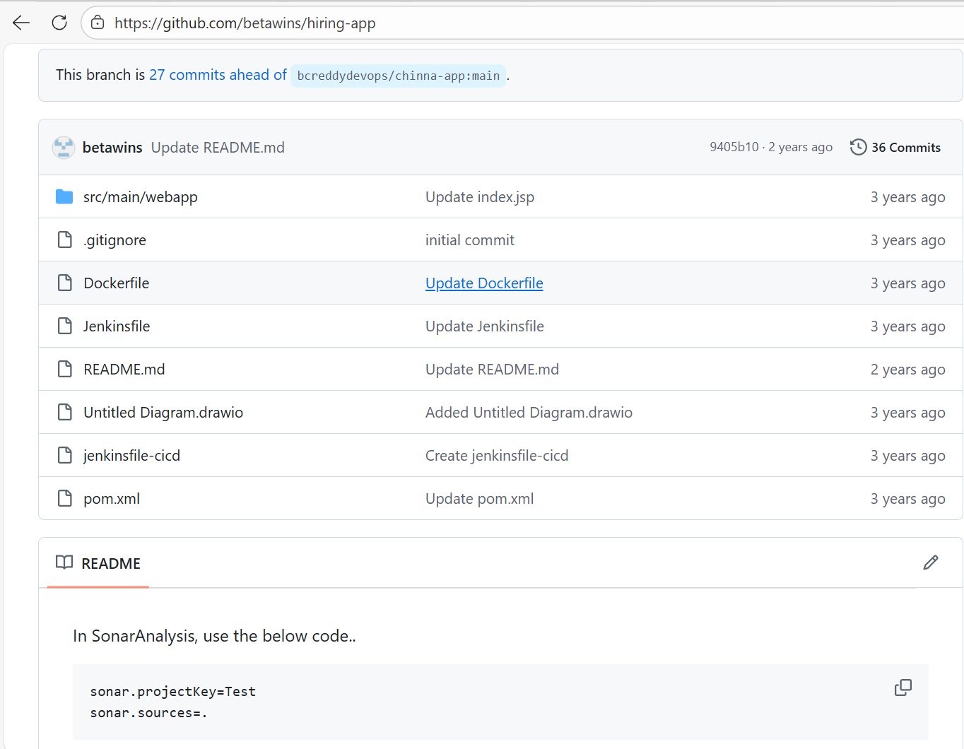

- Navigate back to Jenkins GUI and update the Sonarqube Scanner under Execute in Build Steps.
- Save
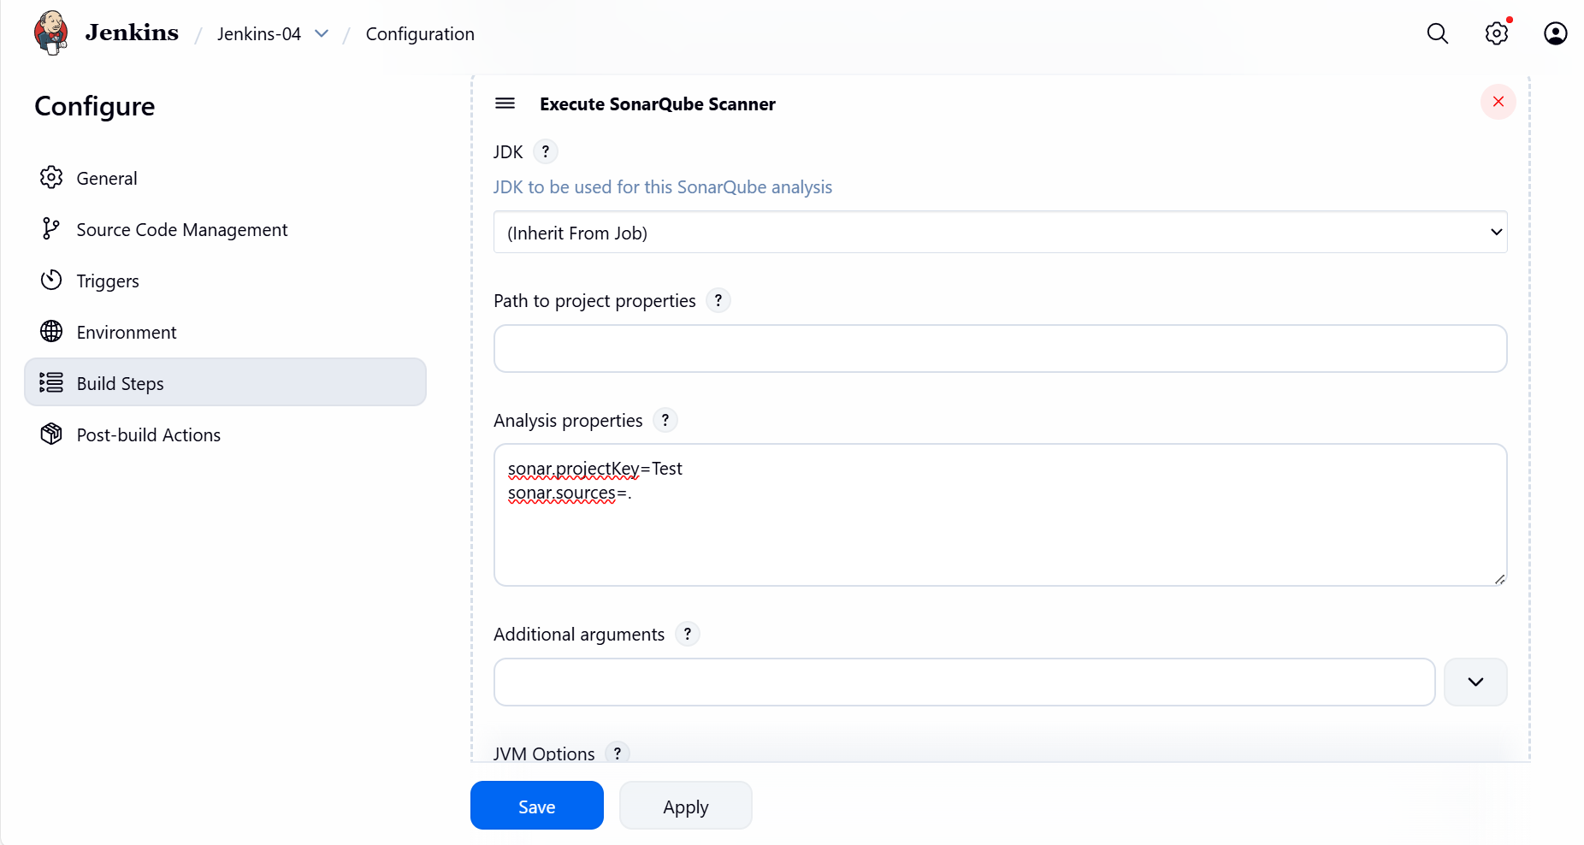

Step 8: Lets rock and roll Build Now and verify if the build is success and passing.
Yayyyyy!! Its passing as per the requirement.
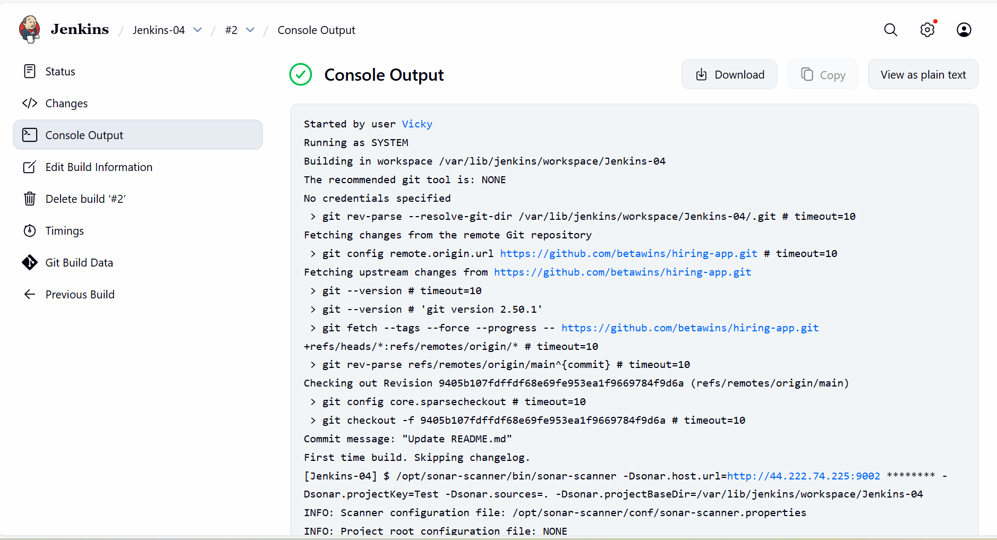

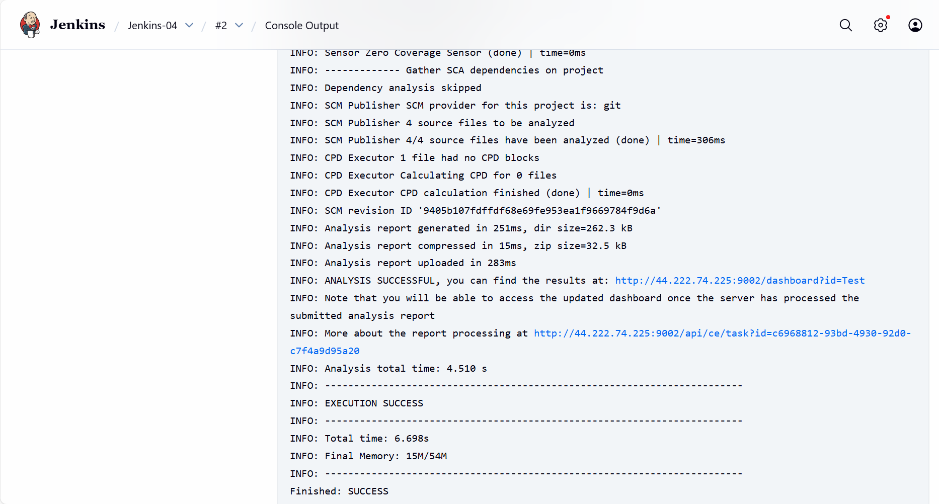

- Verify in the Sonarqube GUI, if the code is fetched.
- Yes, the code is fetched and quality check is passing.
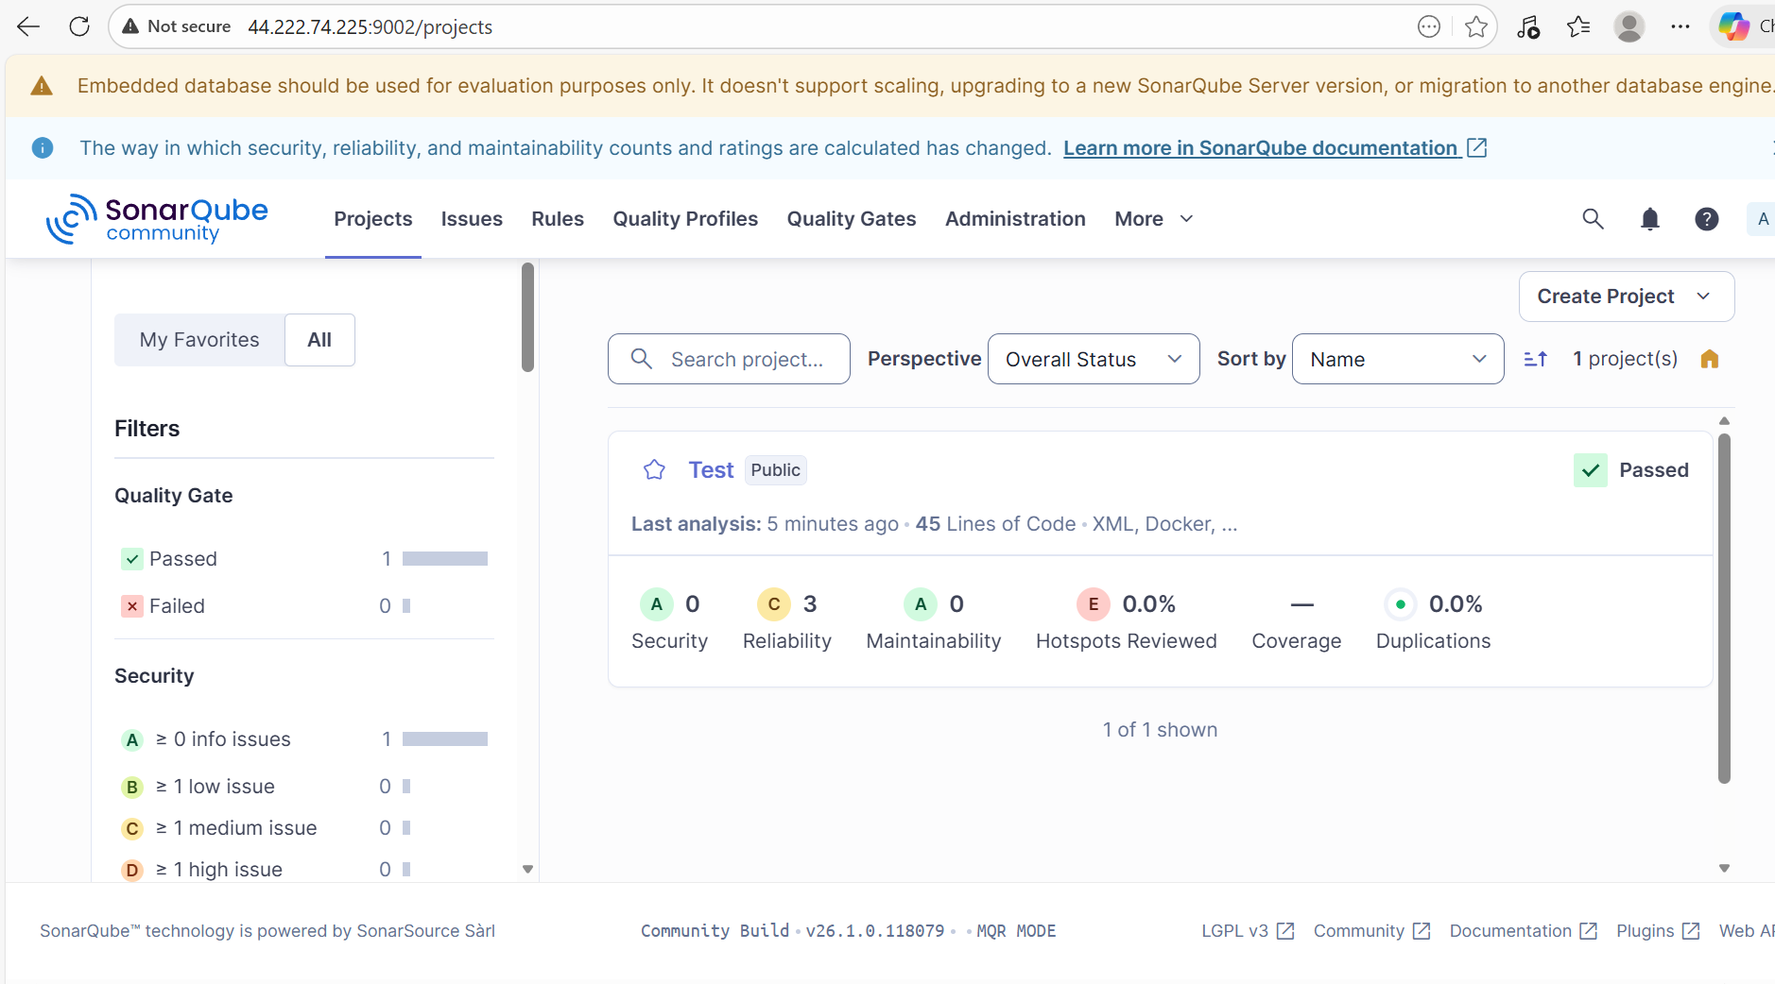

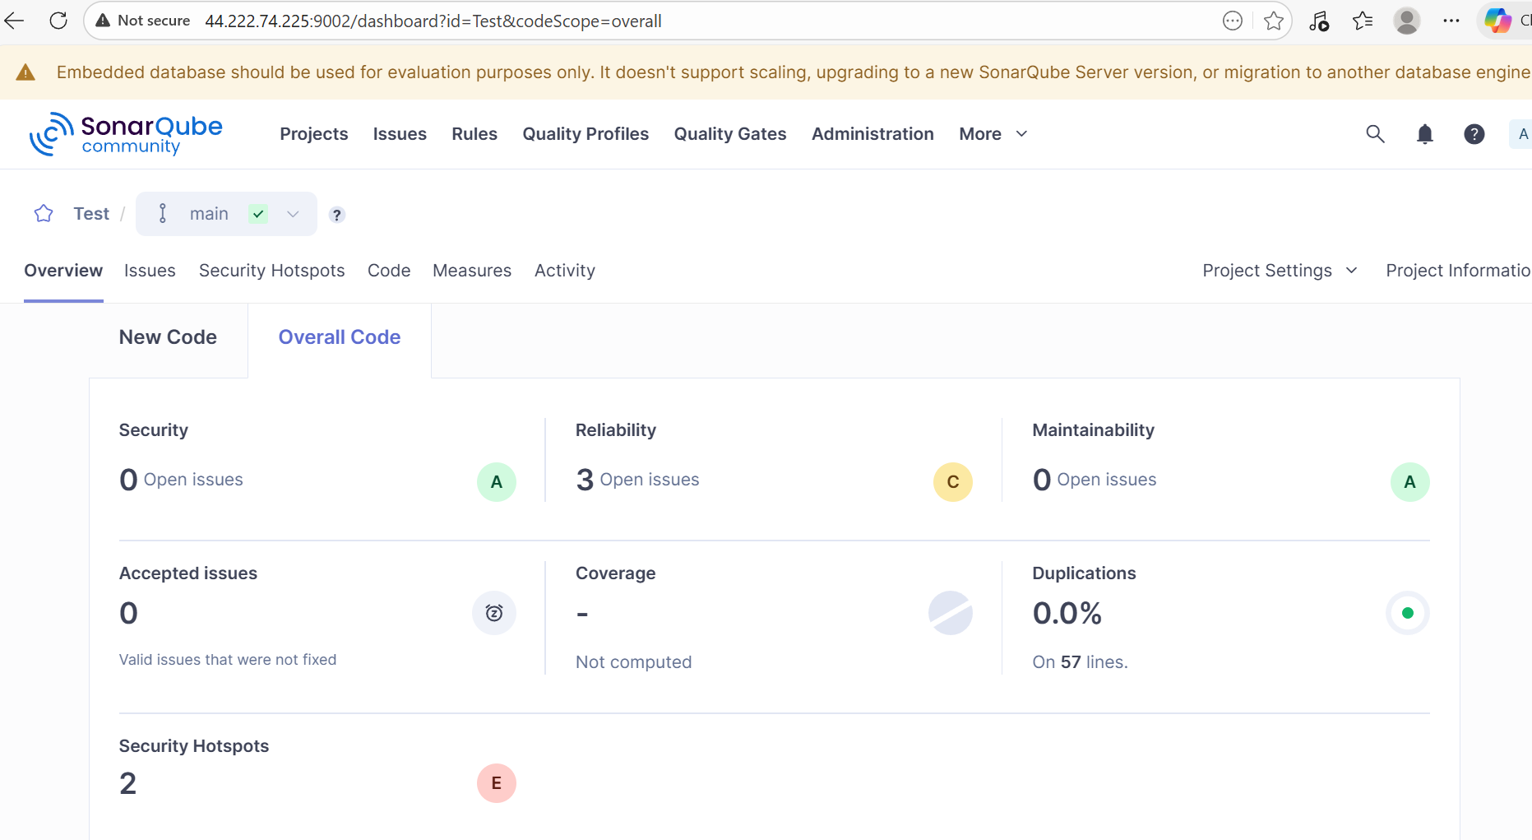

Step 9: Verify if the notification is sent to Slack.
- Yes, the notification is sent and verified.

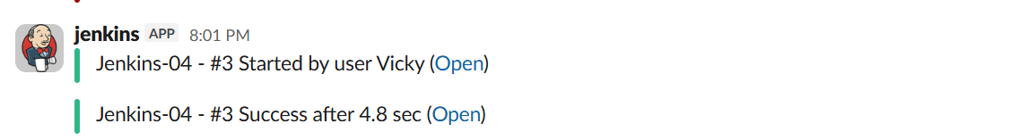

Stage 3: Maven Compilation- Compile the source codes and create a package for us.

- Official page for Maven will provide us the recent package and tar.gz.
- Paste the copied tar.gz in Jenkins server.
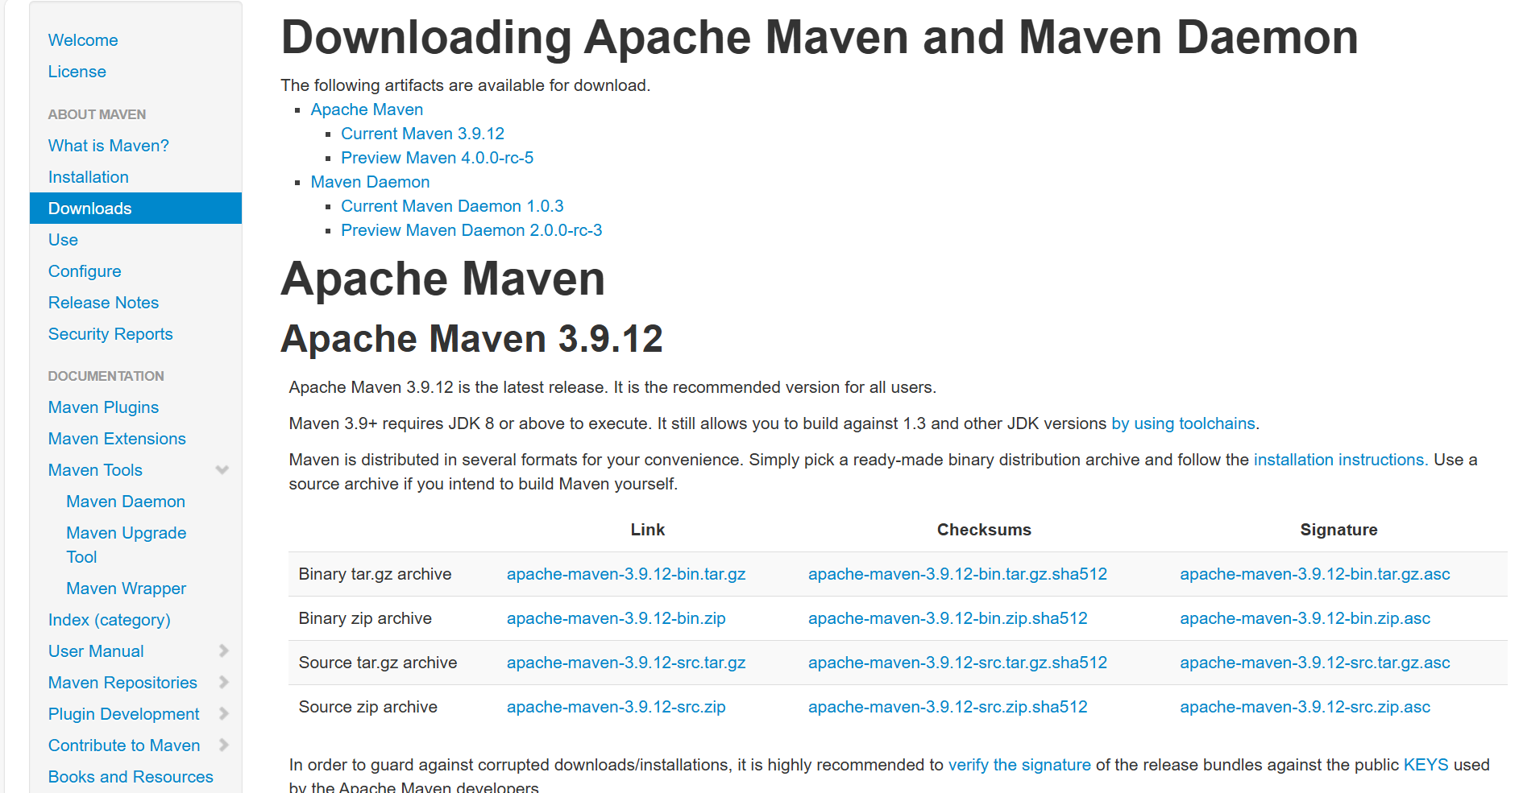

Step 10: Install the Maven in Jenkins server.

wget https://dlcdn.apache.org/maven/maven-3/3.9.12/binaries/apache-maven-3.9.12-bin.tar.gz

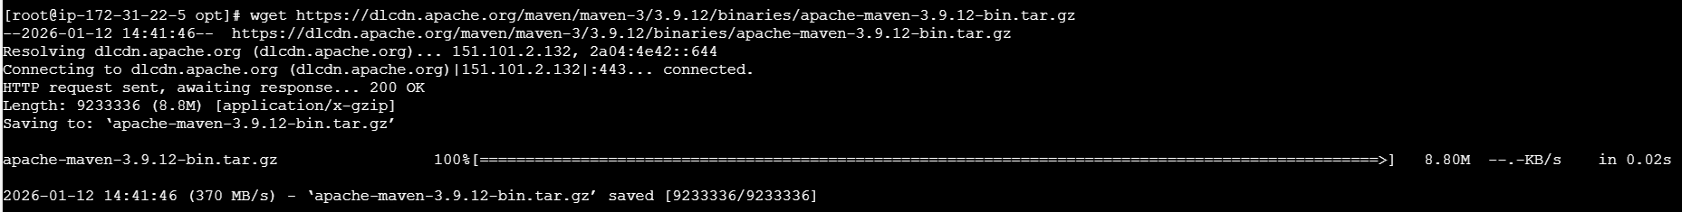

- Extract the package using below command.

tar xvf apache-maven-3.9.12-bin.tar.gz

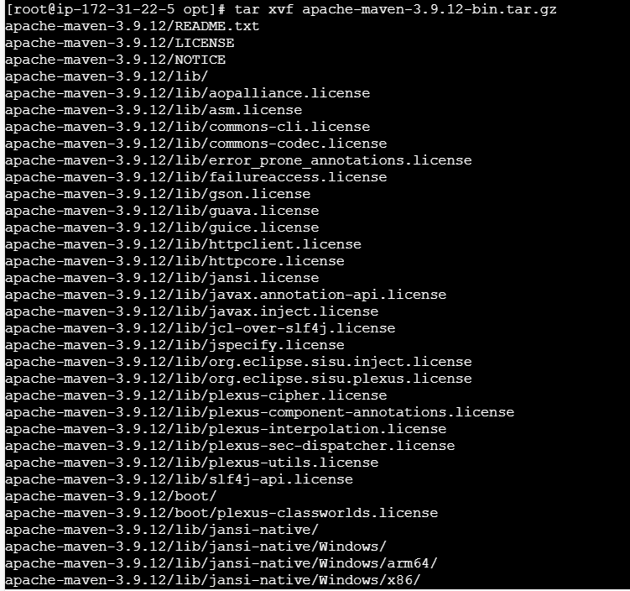

- Cd apache-maven-3.9.12/
- ll

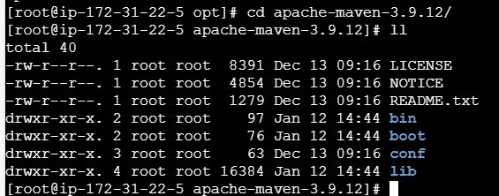

- cd bin/
- pwd
- copy the path and paste in the Jenkins GUI under Manage Jenkins tool

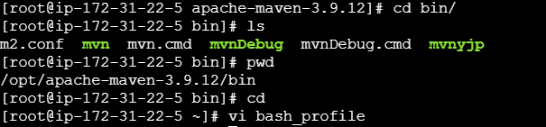

- Using vi .bash_profile, we can make sure to verify if the maven is available via mvn –version.
- This is used to globally verify from any directory or anywhere from Jenkins server.
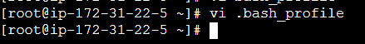

MVN_HOME=/opt/apache-maven-3.9.12
PATH=$PATH:$HOME/bin:$MVN_HOME/bin

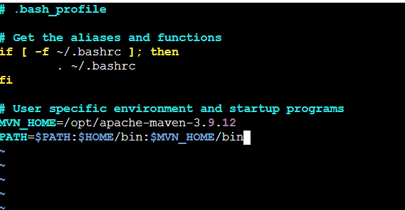

Restart the file using command- source ~/.bash_profile
Verify using command- mvn –version
Success- Its working as expected. Always, make sure to add vi .bash_profile for any file, so that it is globally used version.

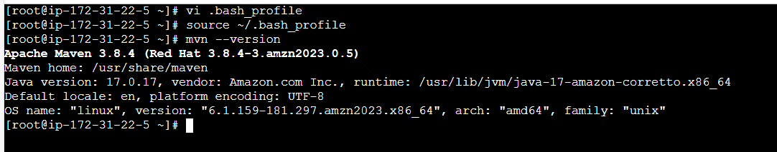

Step 11: Navigate back to Jenkins server and install Maven plugin
- Installed.

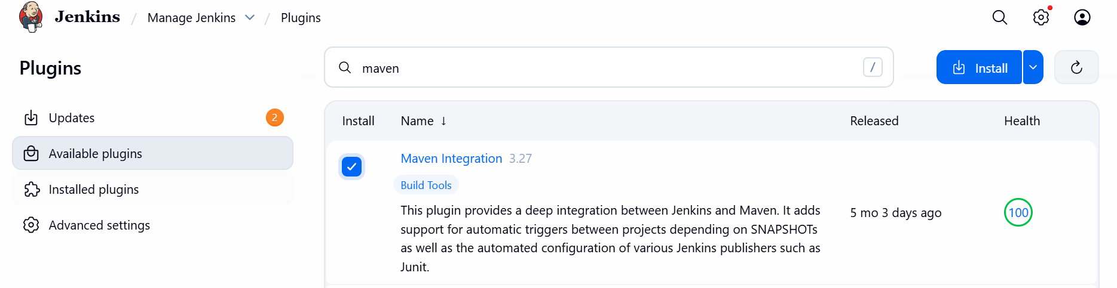

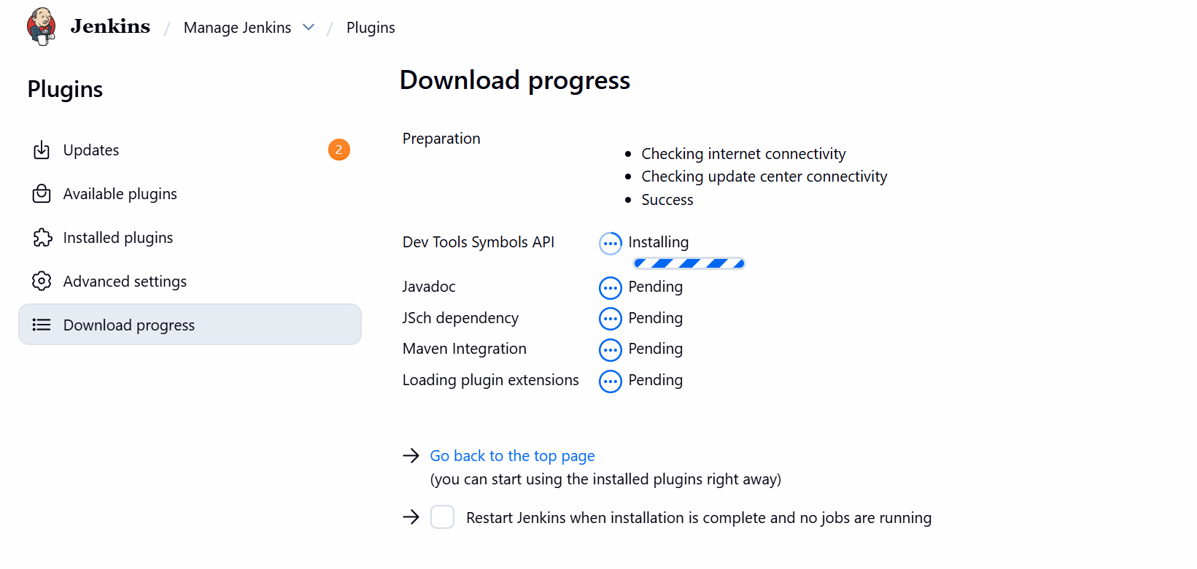

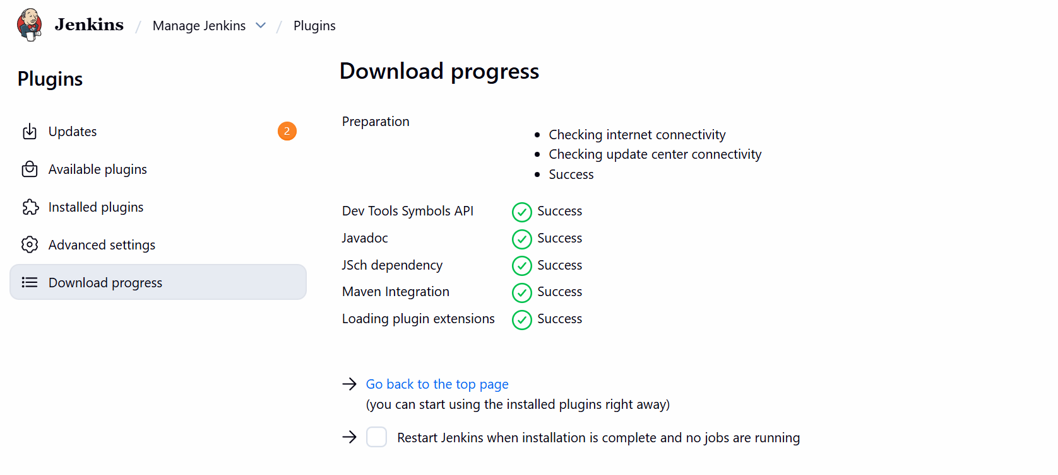
Step 12: As we copied the path earlier from Jenkins server under bin/ directory.
- Paste below in Tool.
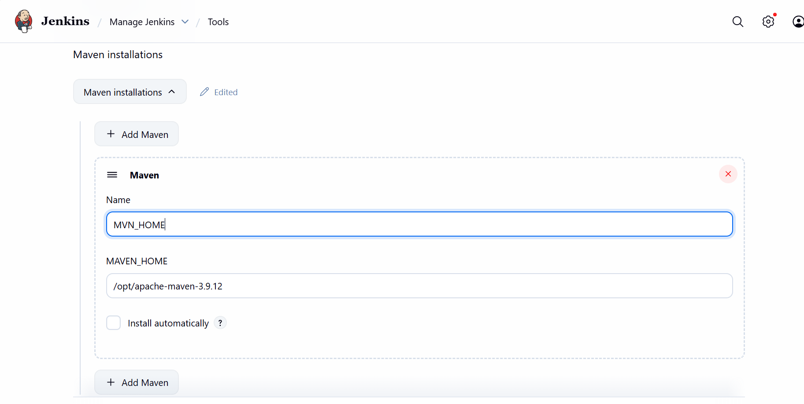

Step 13: Navigate to Job created- Jenkins-04 and under Build steps Invoke top-level Maven targets
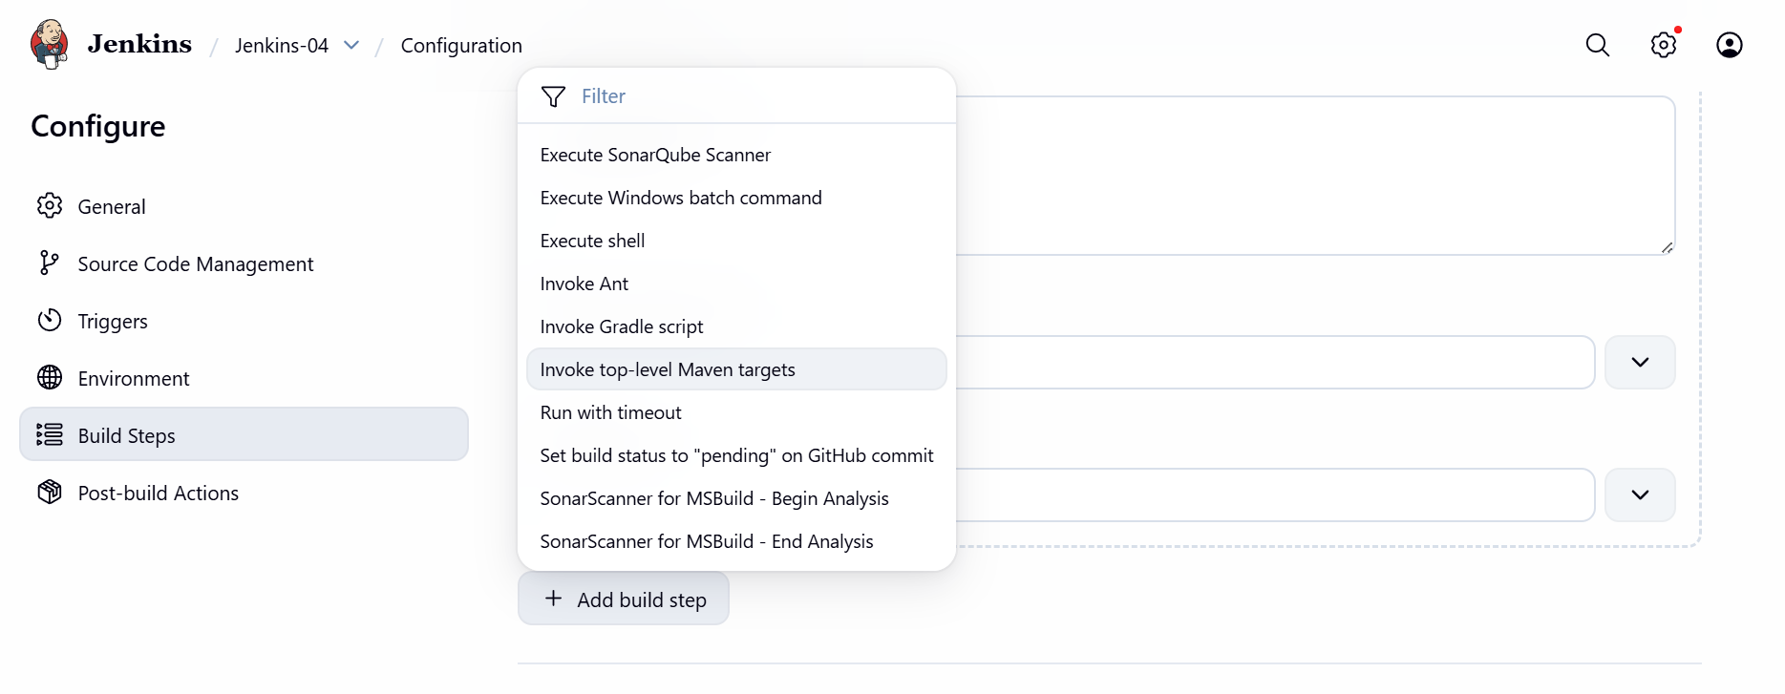
- Update Maven Home which we created in Jenkins server under vi ./bash_profile.
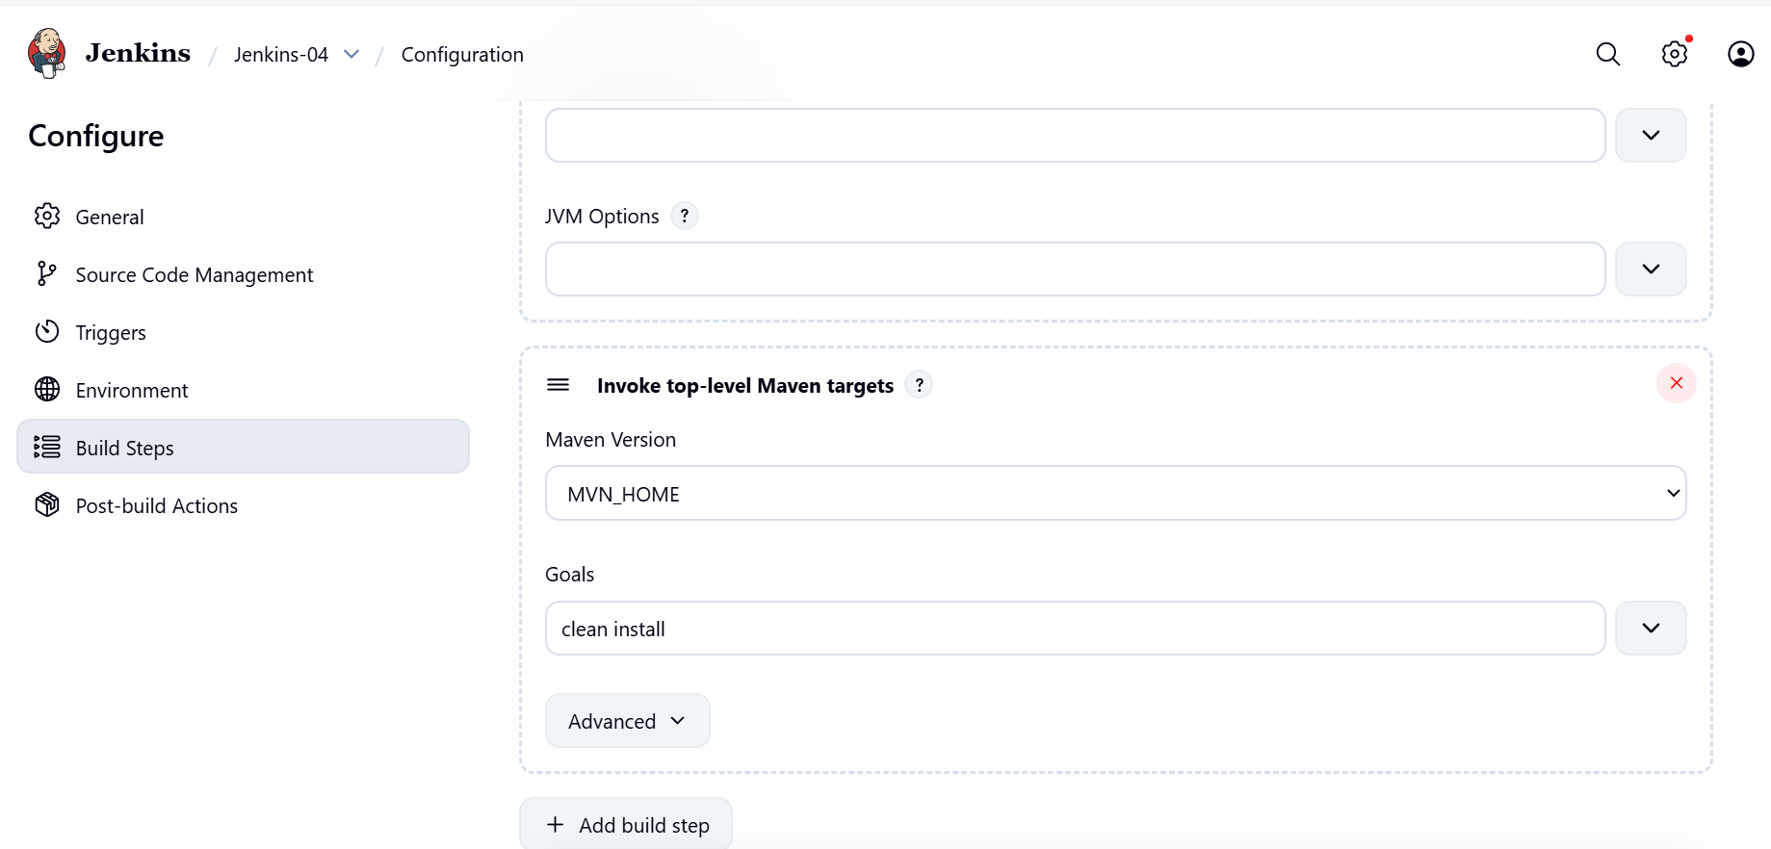

Step 14: Build now and verify if its passing for Maven compilation.
Success and pass.
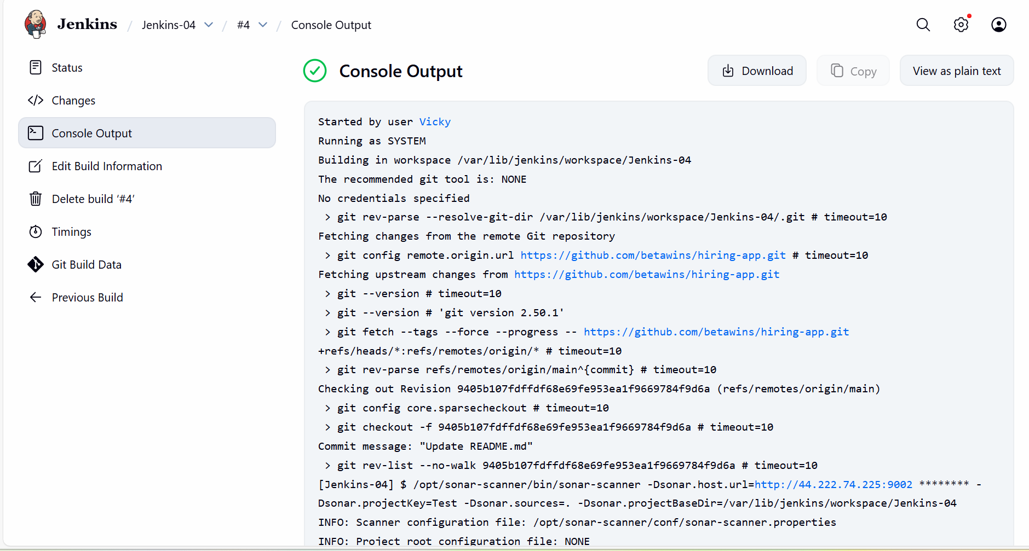

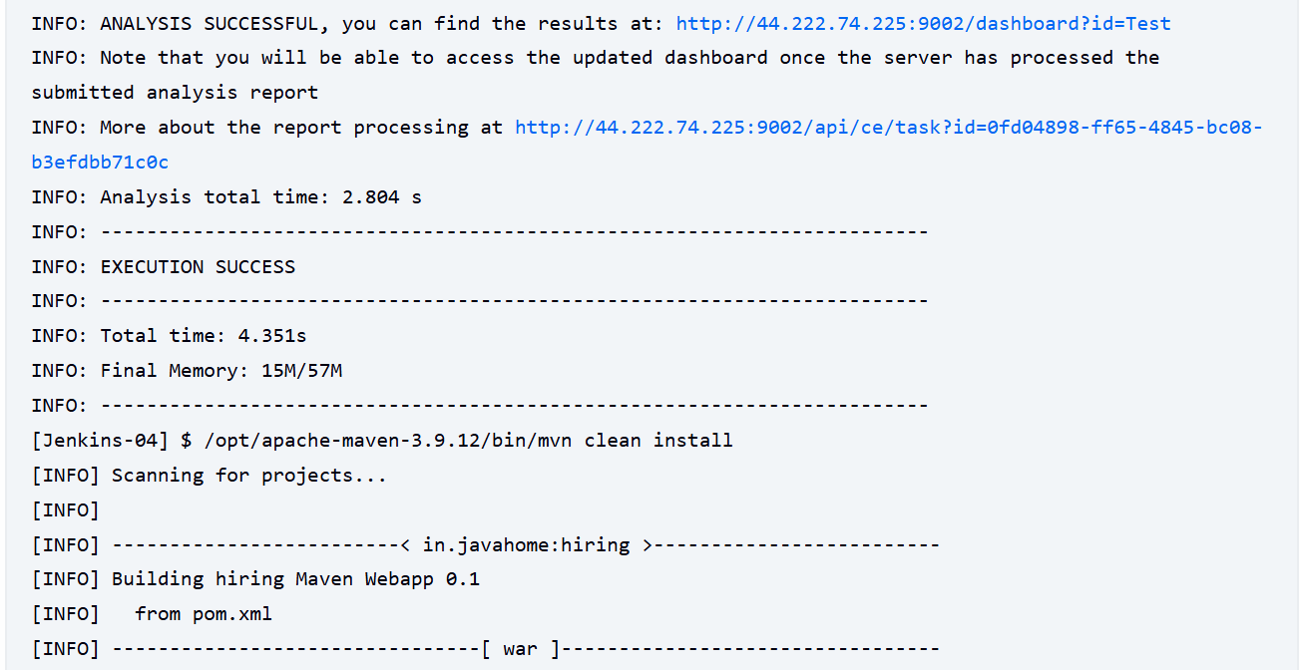

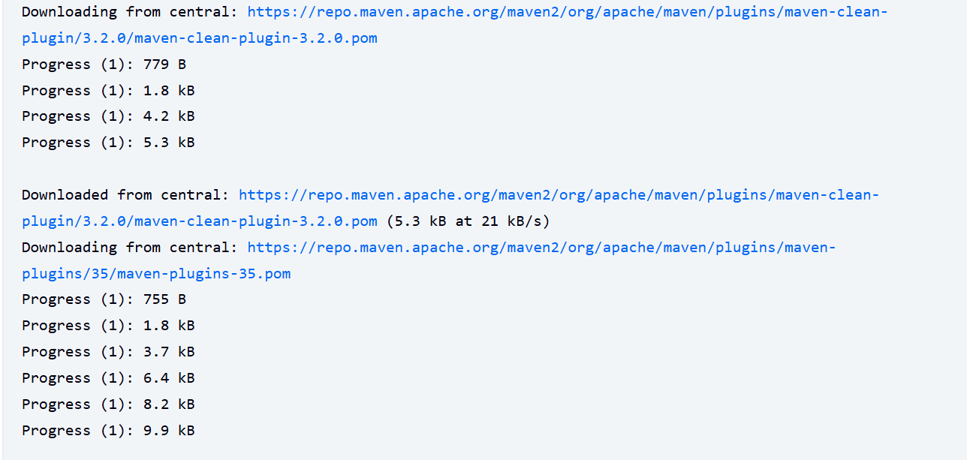

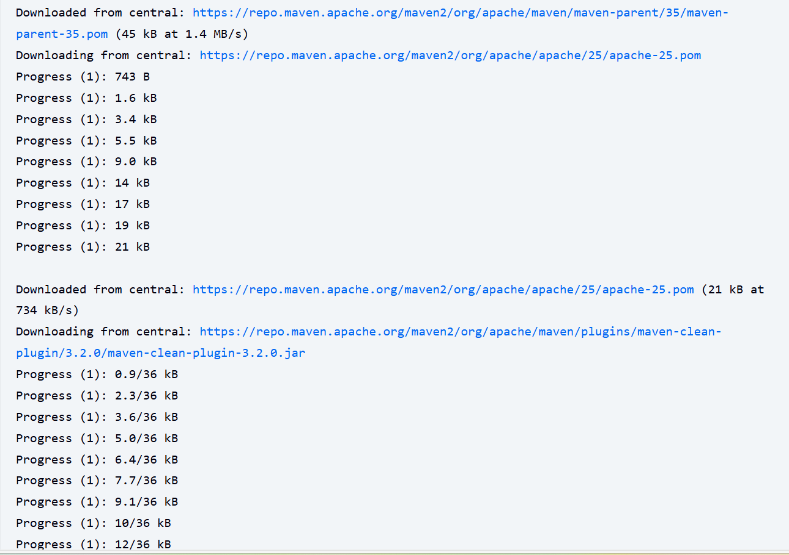

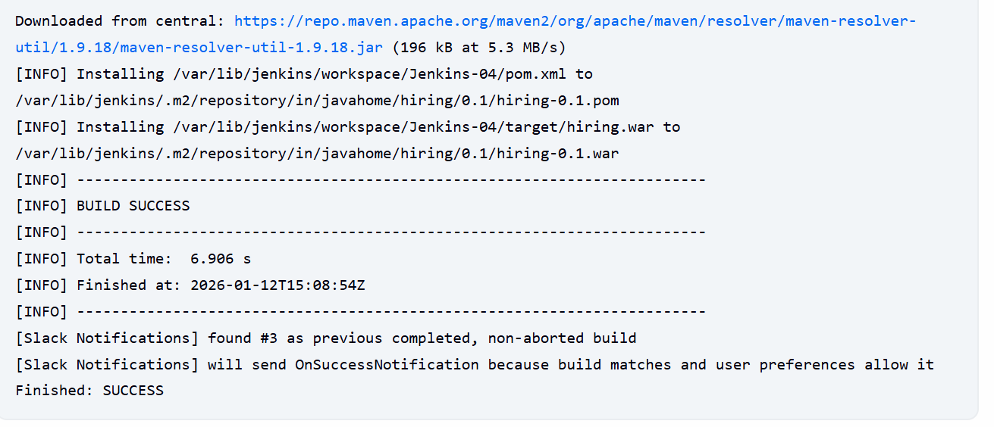

Step 15: Slack Notification if the user is notified.
Yes, success.
Stage completed.
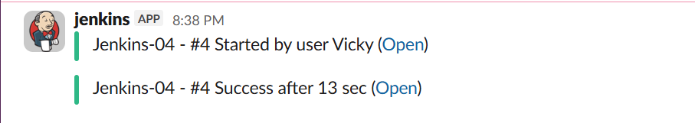

Step 16: Now, we need to verify if the package is created.
- So, change directory to cd /var/lib/jenkins/workspace
- ll
- cd Jenkins-04
- ll target is created once job build is completed.

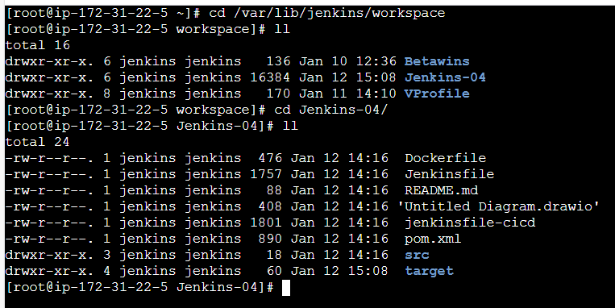
- cd target we can see a package is created for us.
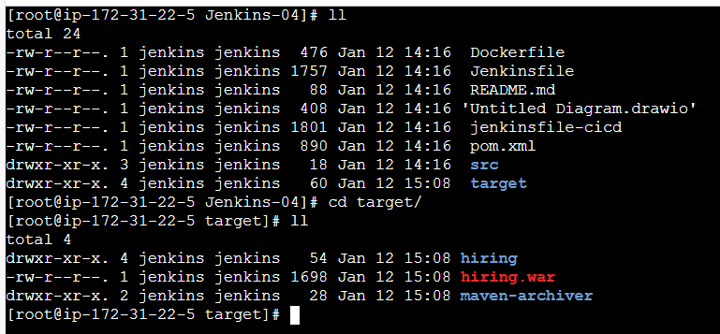

- To verify the dependencies created under target cd /var/lib/jenkins/.m2
- .m2/ is where all dependencies will be installed.
- Cd repository ll we can verify all the dependencies present.
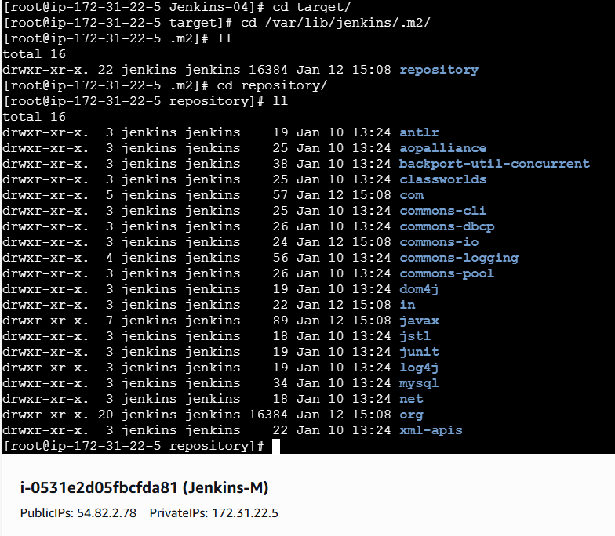

Stage 4: Nexus Artifactory

Nexus Artifactory is required to maintain a central location to secure our ear/war/jar packages which we installed earlier in Jenkins server.

It is not a best practice to secure our installed packages in Jenkins server, so for our team or anyone who has access to project, should be able to pull the package from central location, that Nexus Artifactory.

Step 17: Launch a new instance with name- Nexus
- T3. micro is good
- Instance launched.

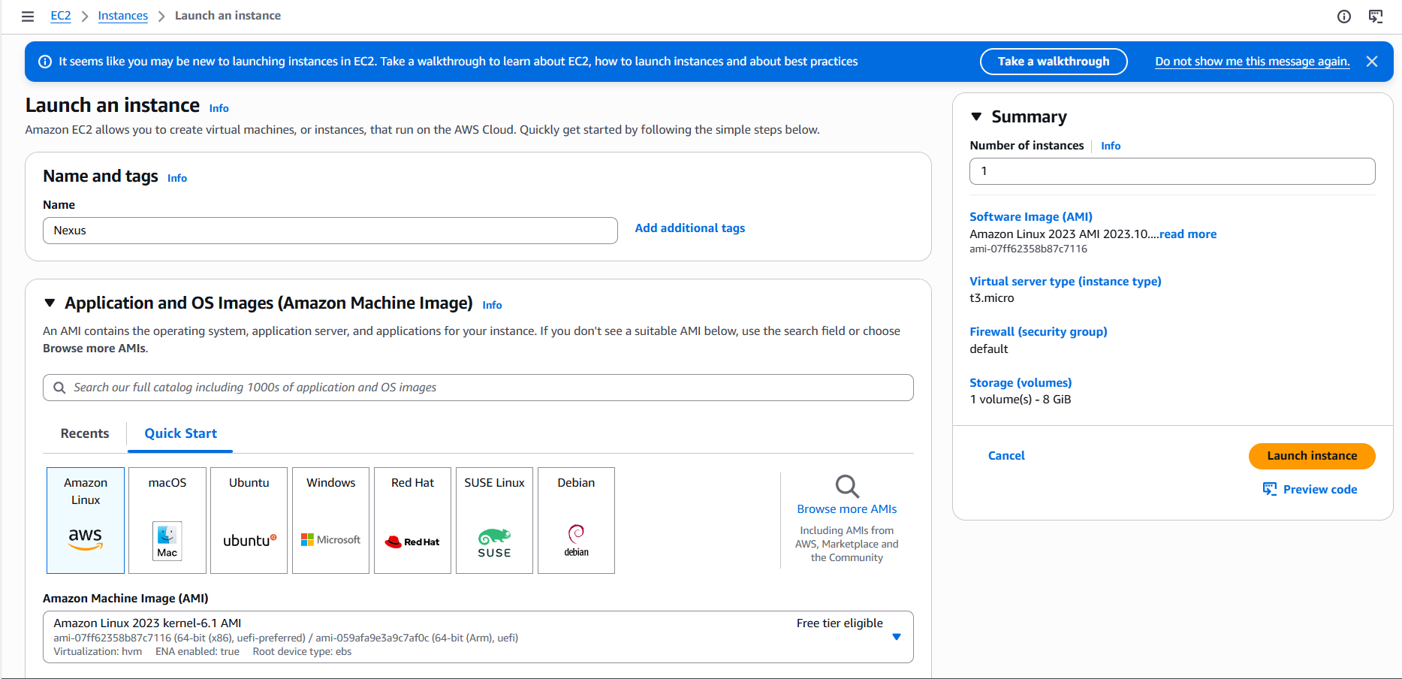

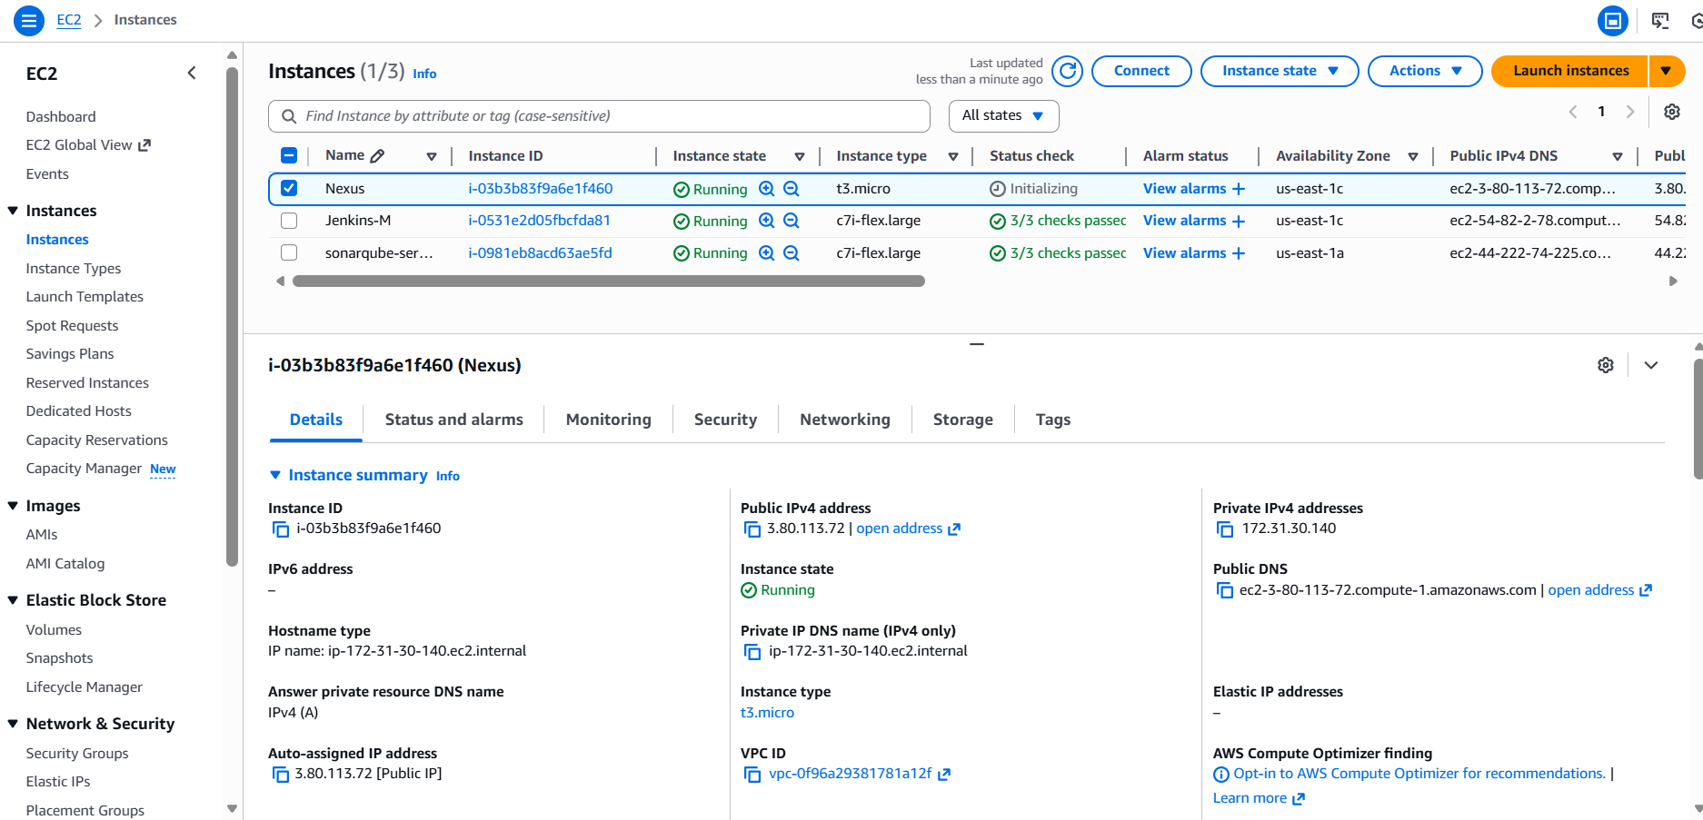

Step 18: Connect to the instance and install Nexus from official website.

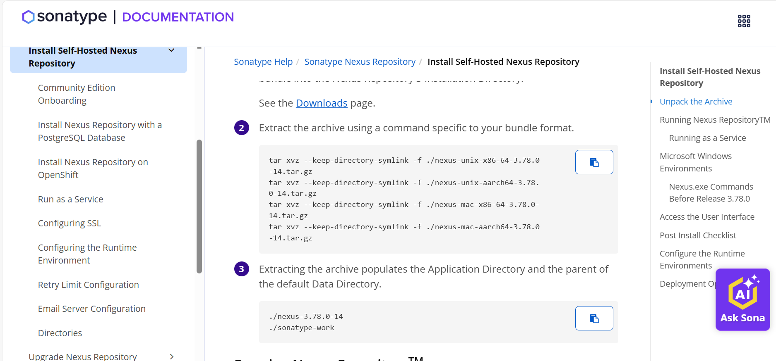

Install: sudo wget https://download.sonatype.com/nexus/3/nexus-3.87.1-01-linux-x86_64.tar.gz
Extract the package- sudo tar xvf nexus-3.87.1-01-linux-x86_64.tar.gz

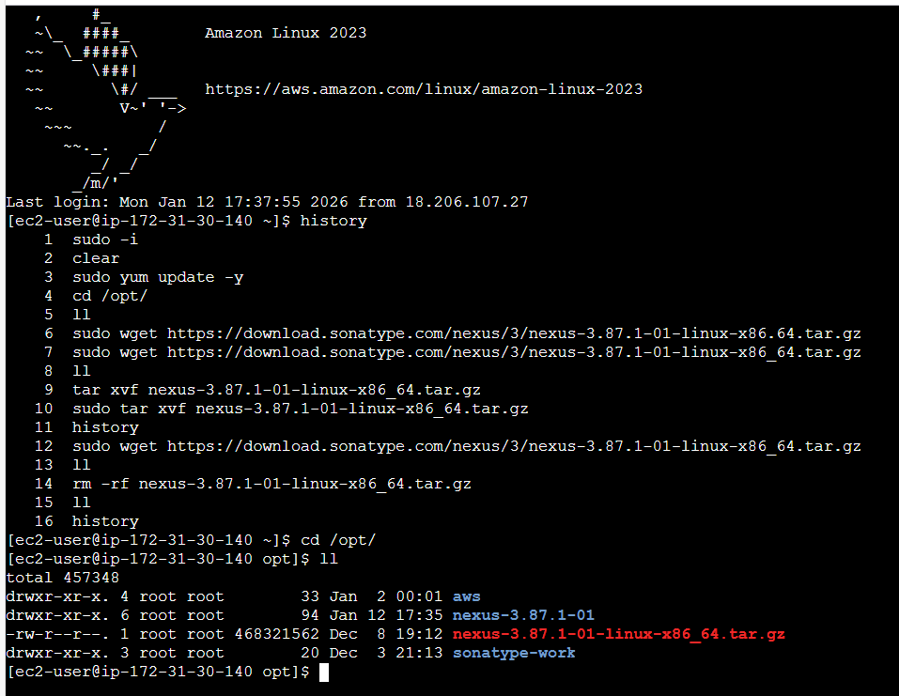

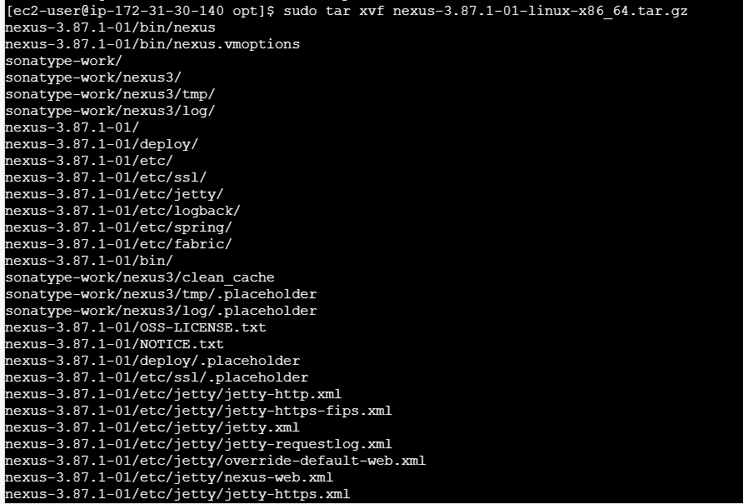

- Cd /opt/
- Cd /bin/
- Verified nexus is ready to start.
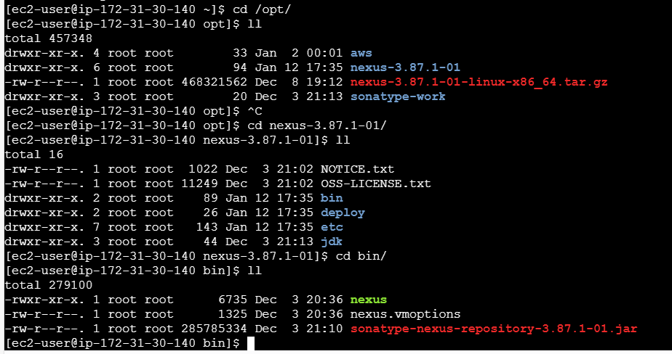

- Let’s start the Nexus service by using command- ./nexus start
- Provided permissions to Nexus, sonatype-work in /opt/ and /bin/
- ./nexus start
- ./nexus status
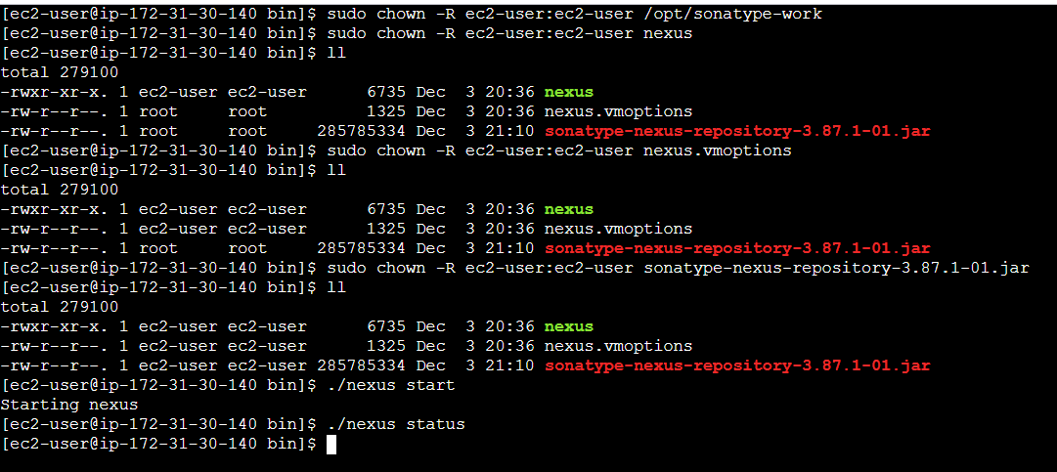

Step 19: Let’s verify in the browser if Nexus is running on port 8081
Issues faced: I chose t3.micro when launching the instance.
Since, we completed setting up nexus, but couldn’t start the service, because the RAM was low.
So, we ran command-
sudo fallocate -l 2G /swapfile
sudo chmod 600 /swapfile
sudo mkswap /swapfile
sudo swapon /swapfile
free -h
Using the below command- we changed the size to
vi /opt/nexus-3.87.1-01/bin/nexus.vmoptions
-Xms128m
-Xmx384m

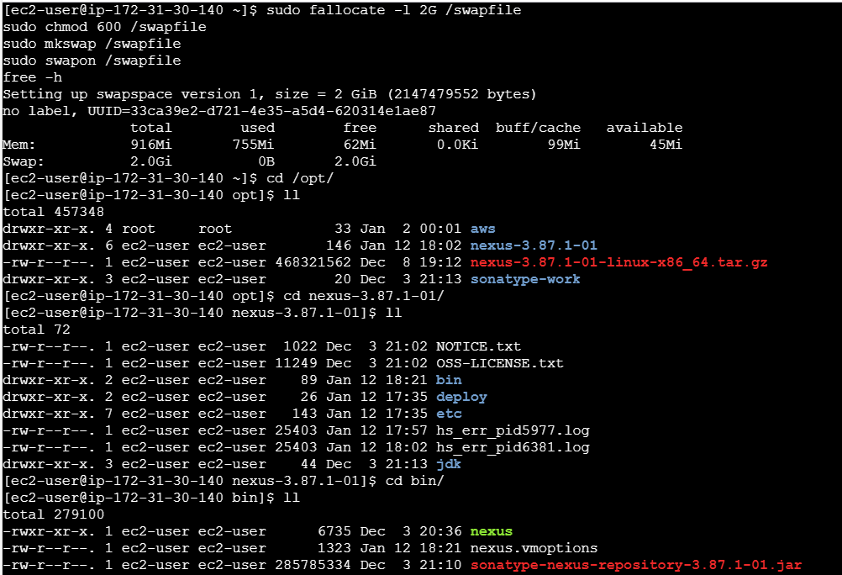
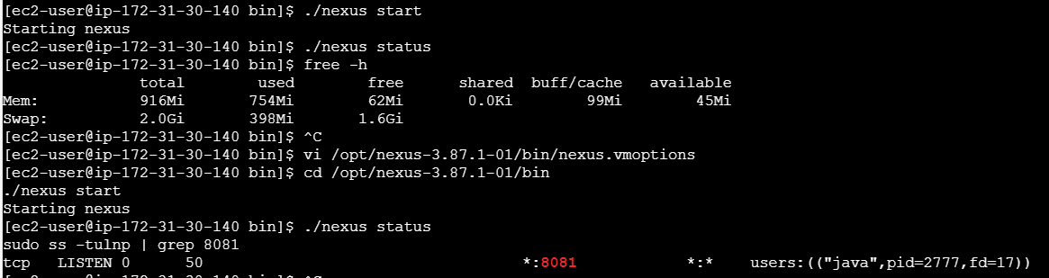

Step 20:
- Now, we are all set we shall verify if Nexus is working on browser.
- Username is admin
- Password- in Nexus server cd /opt/
- Cd sonatype
- Cd nexus3
- Cat admin.password
- Paste in the password.
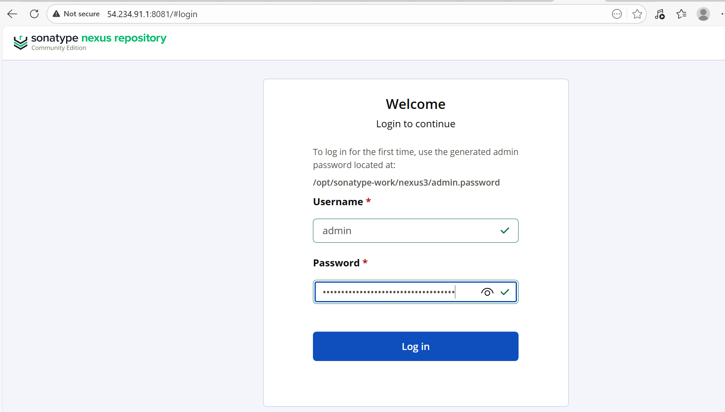

- Create a new password.
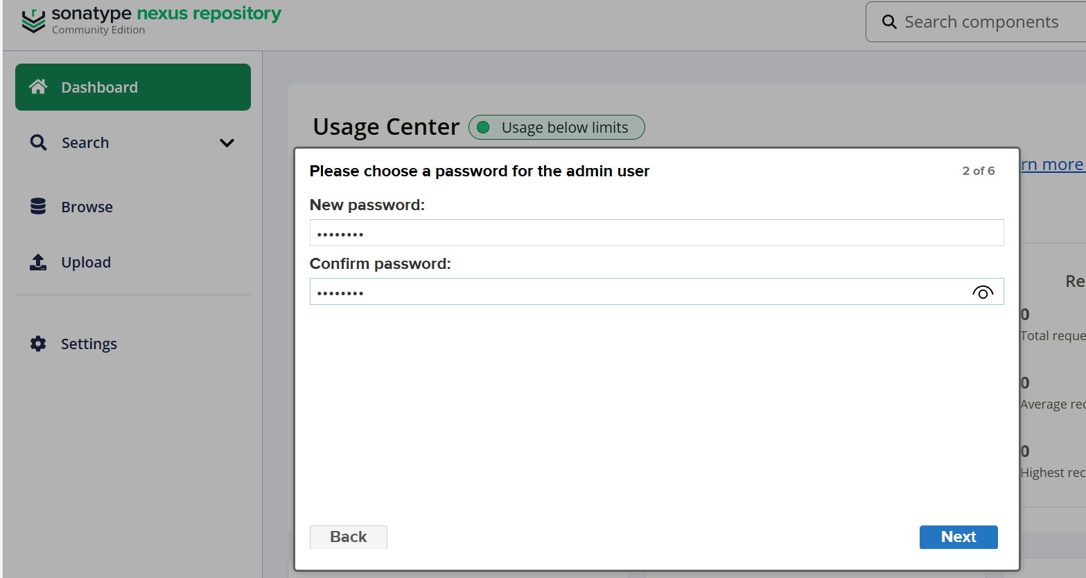

- Nexus setup is complete.
- GUI is up and running.
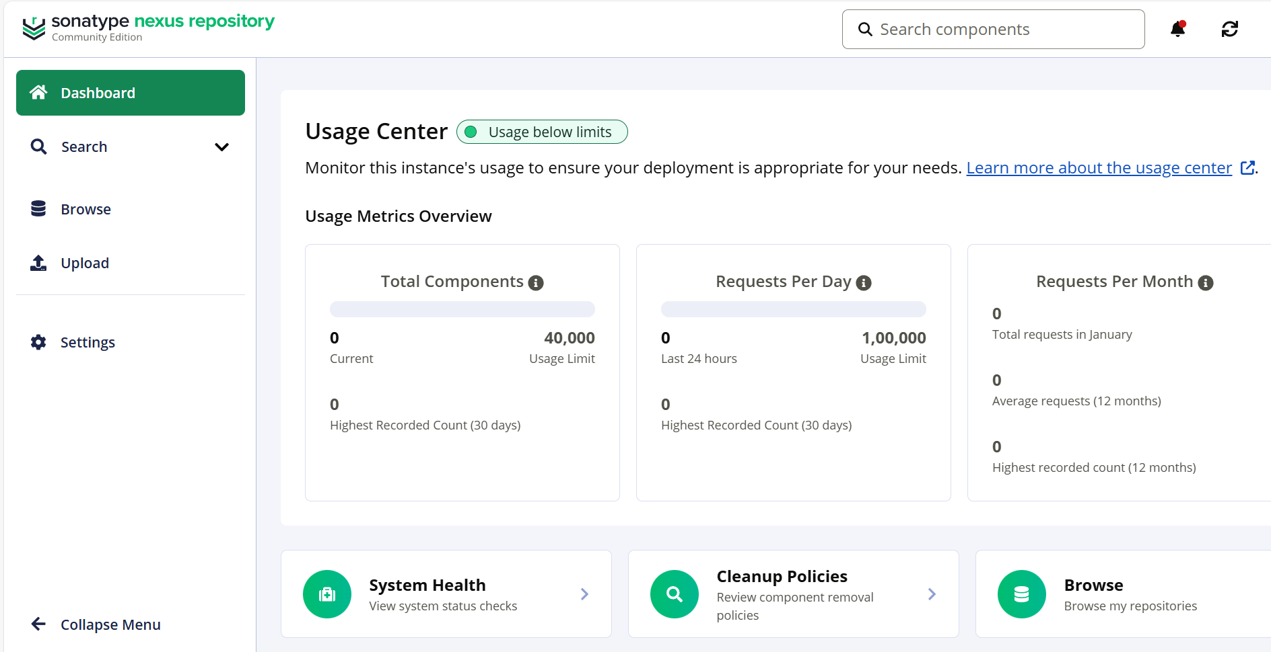

Step 21: Navigate back to Jenkins GUI and install a plugin Nexus Artifact Uploader.

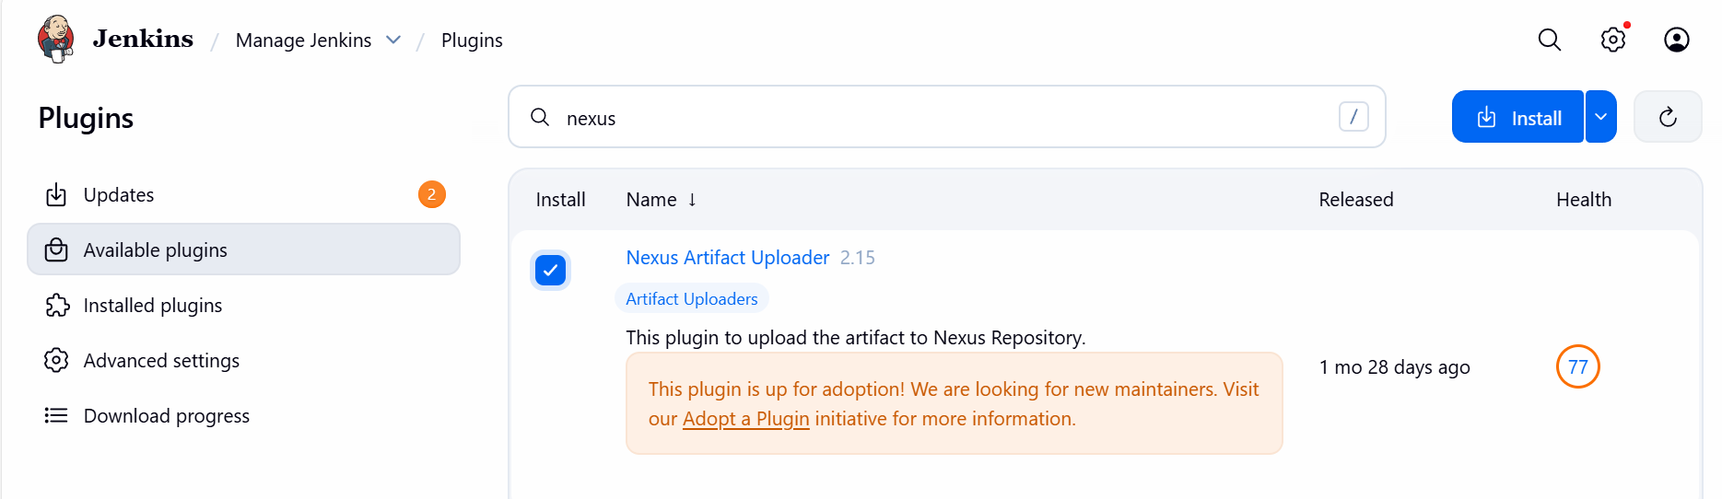

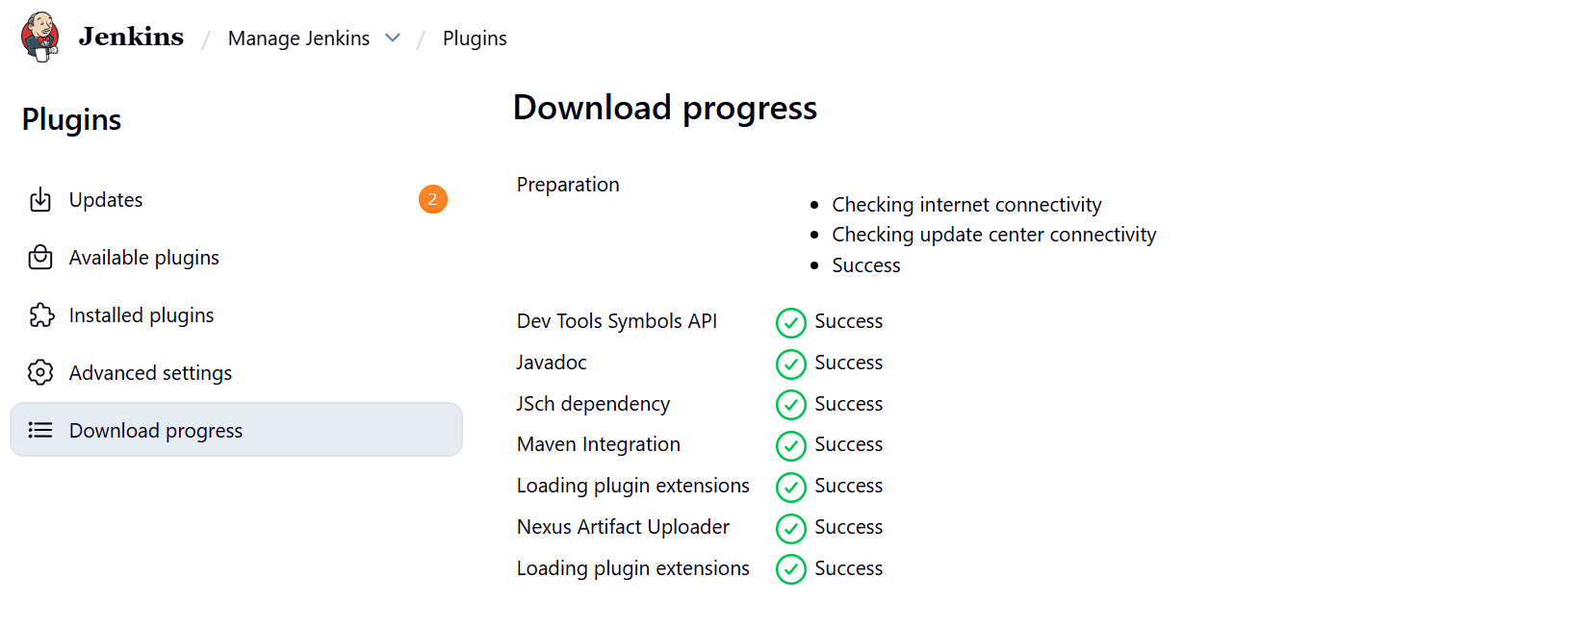

Step 22: Navigate to Jenkins- Jenkins-04 job Configure
- Select Nexus3 version
- URL
- Credentials created below using
  - username- admin
  - password- nexus123

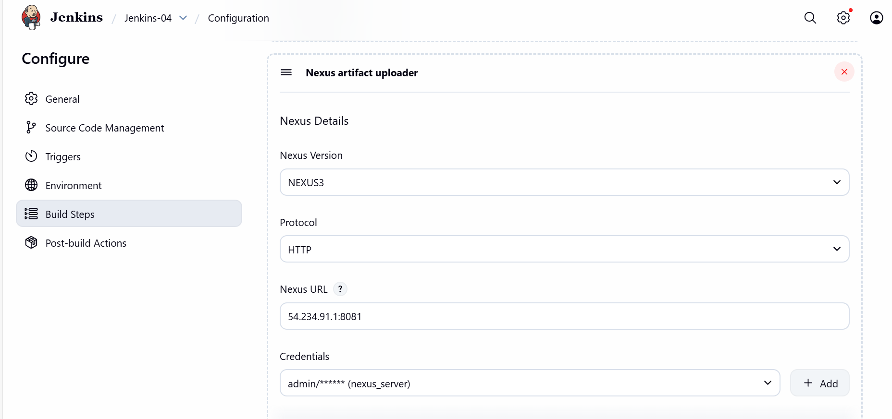
- Update and scroll down to update the rest group id, version and repo.

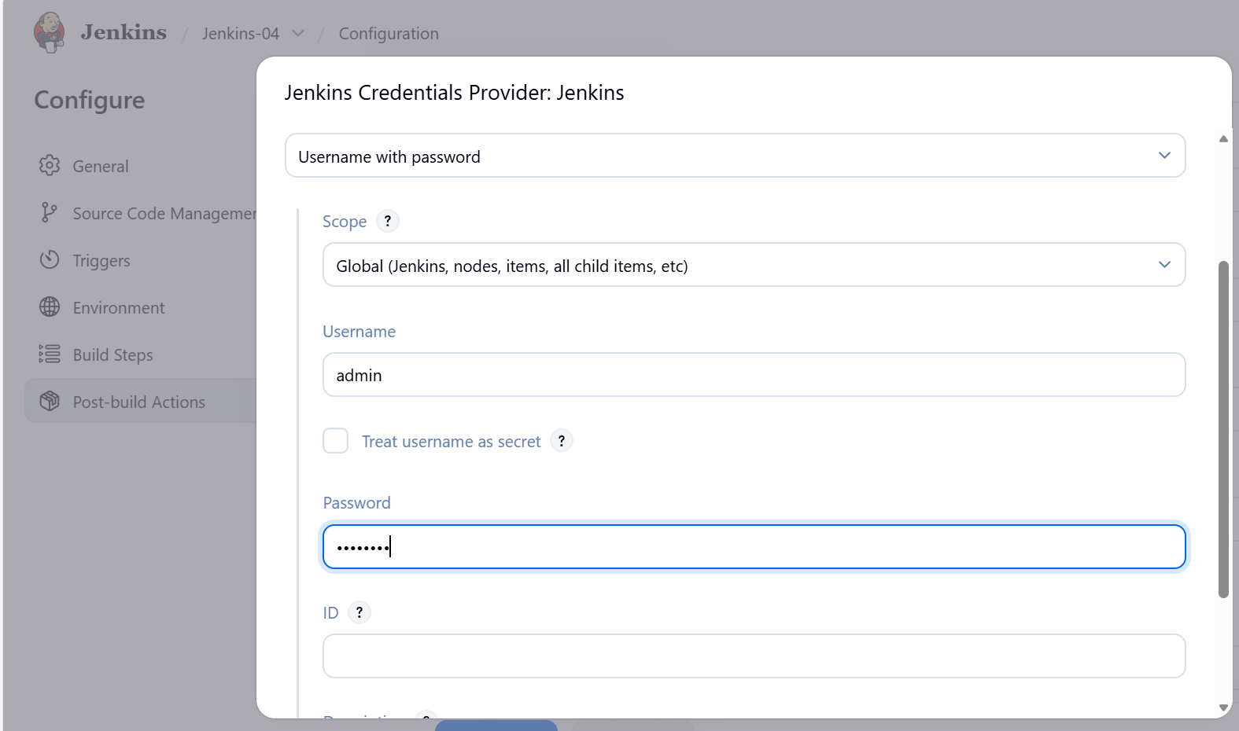

- For group id version navigate to GitHub repo and find the details in pom.xml
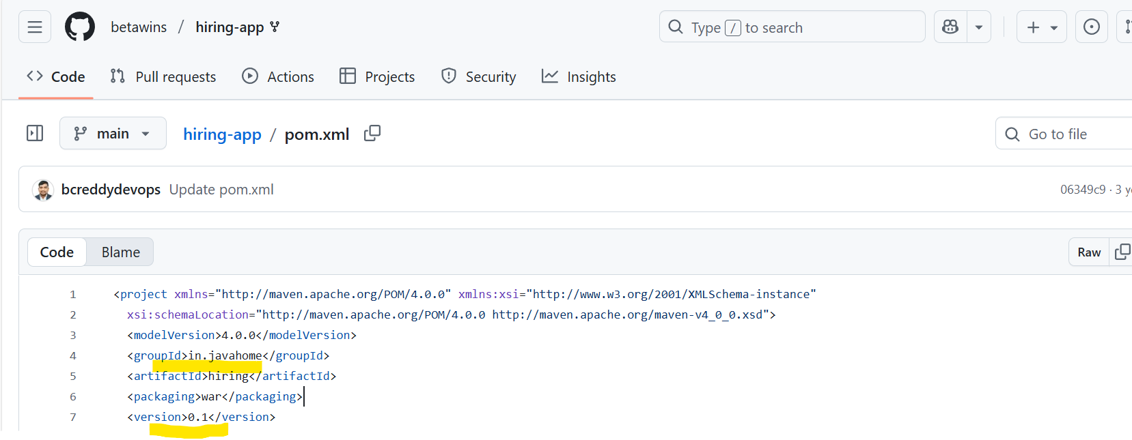
- Repo details need to be created in Nexus GUI
- Settings Repository

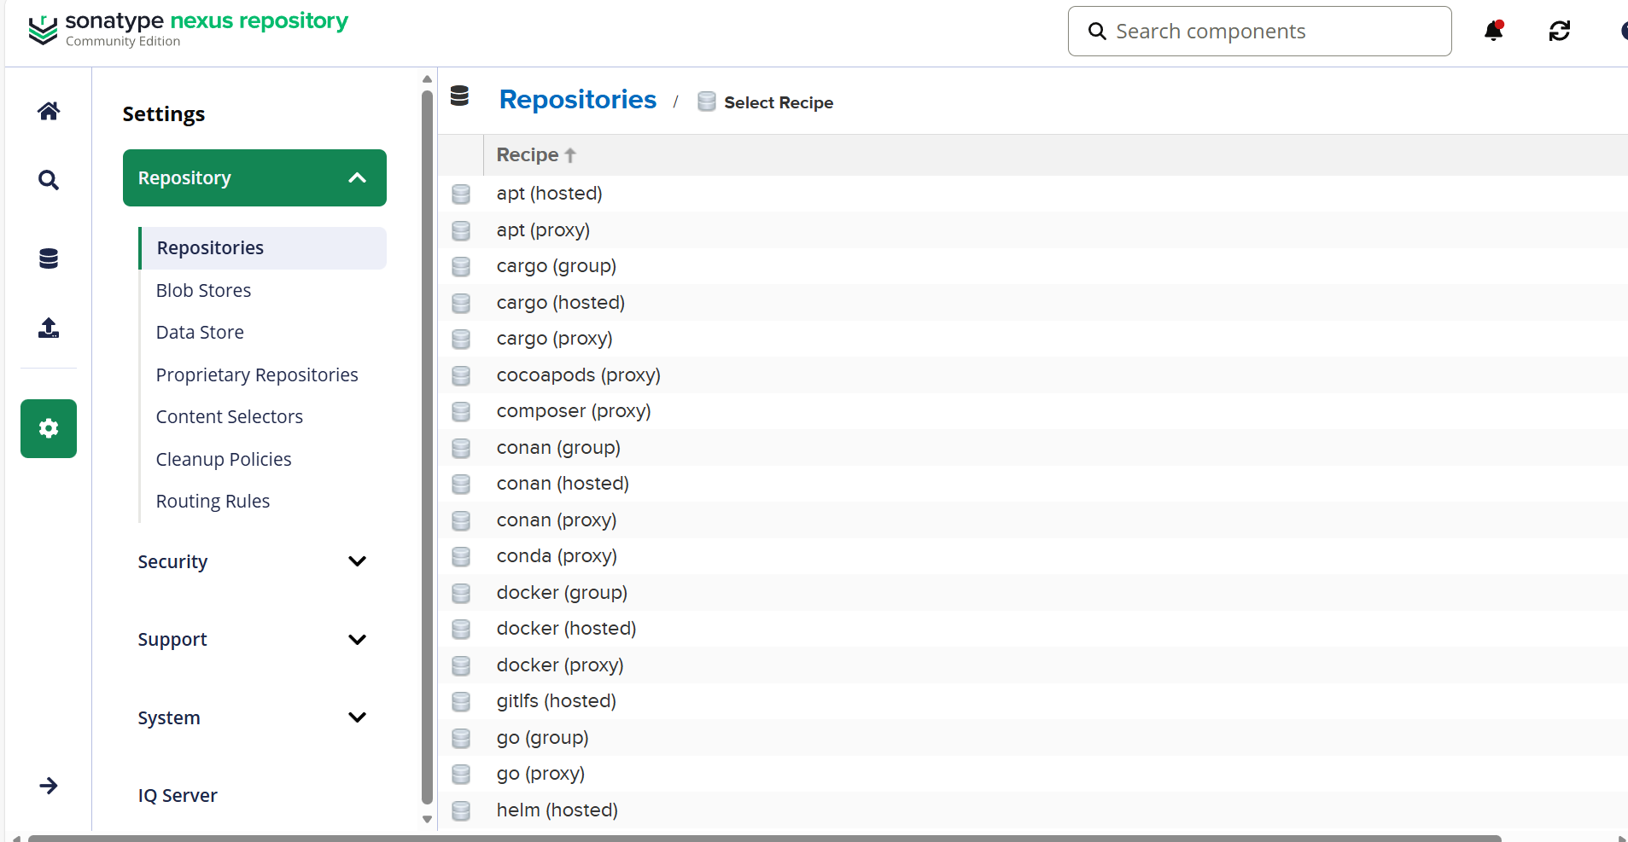

- Selected ‘maven2 (hosted) repository
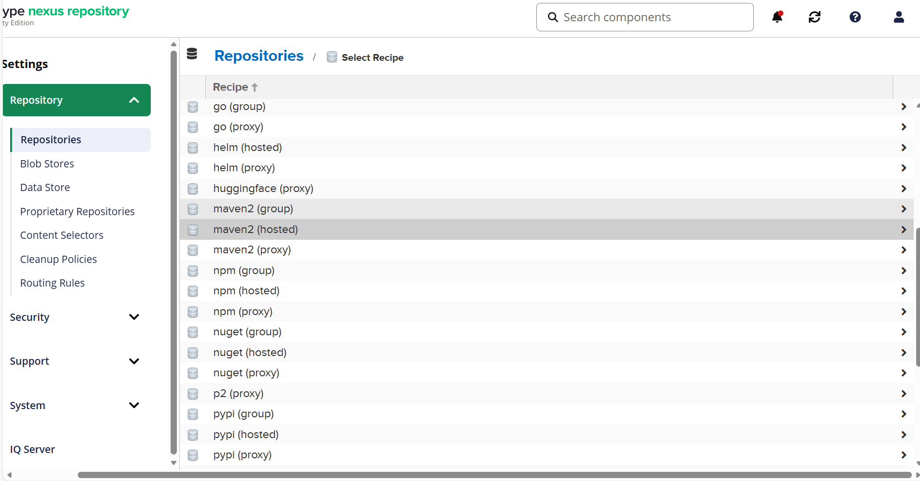

- Name – hiring-app
- Repo store- Mixed
- Layout policy – Permissive
- Content Disposition- Inline
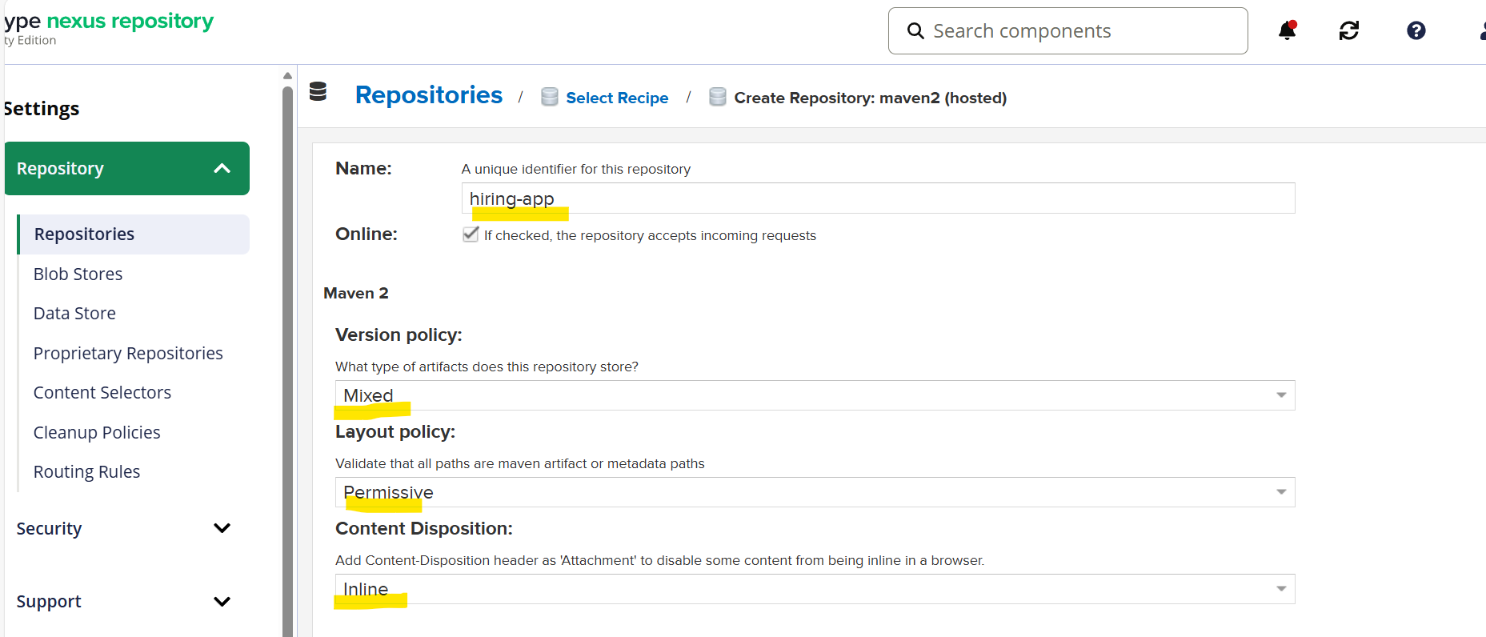

- Bob store- Default
- Deployment- Allow redeploy
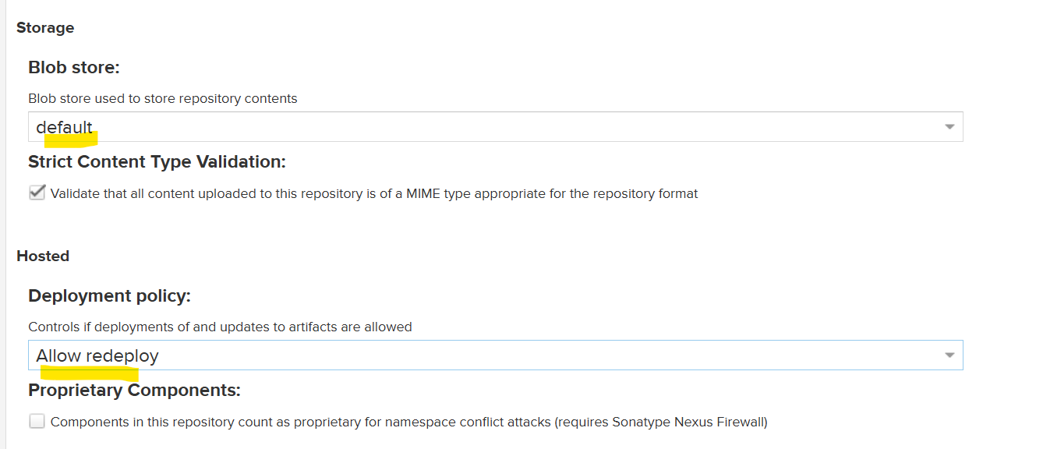

- Hiring app- repository created in Nexus.

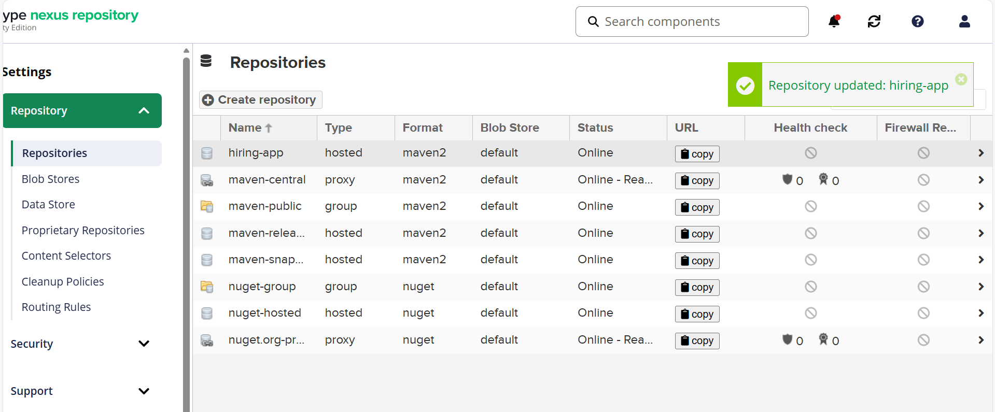

Step 23: Now, navigate back to Jenkins GUI Jenkins-04 job
- Repository- Update the URL Copy paste from created repository.
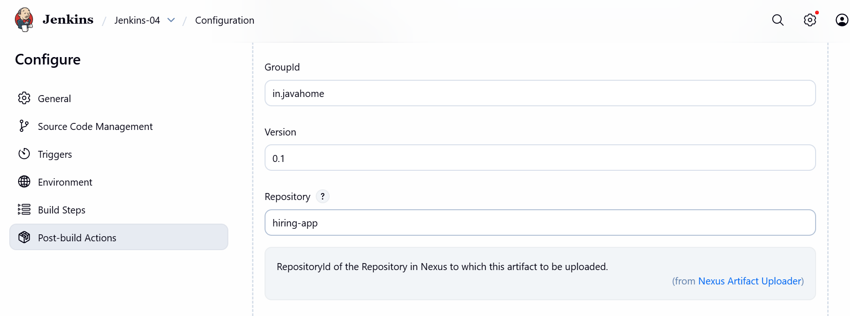
- Create a artifact and in the File tab- target/hiring.war
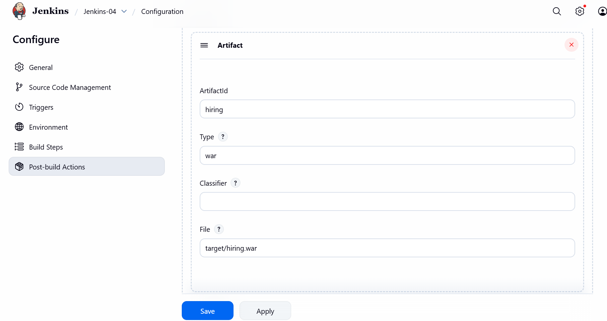

Step 24: We are all set. Now, lets build the job.
- Success- stage completed with Nexus artifacts.

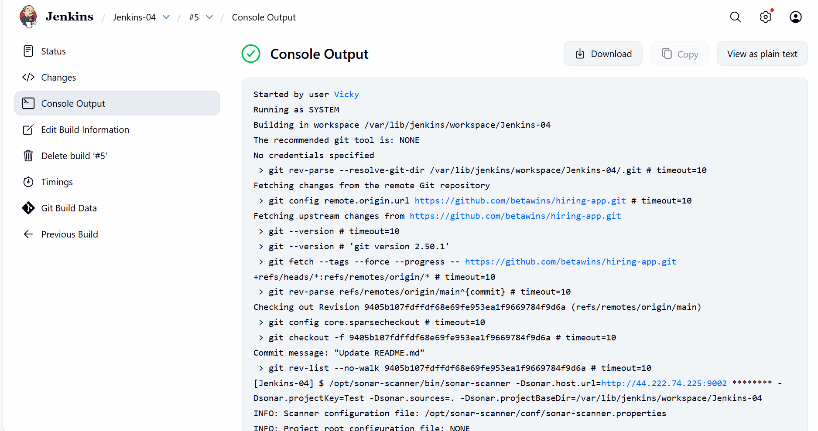

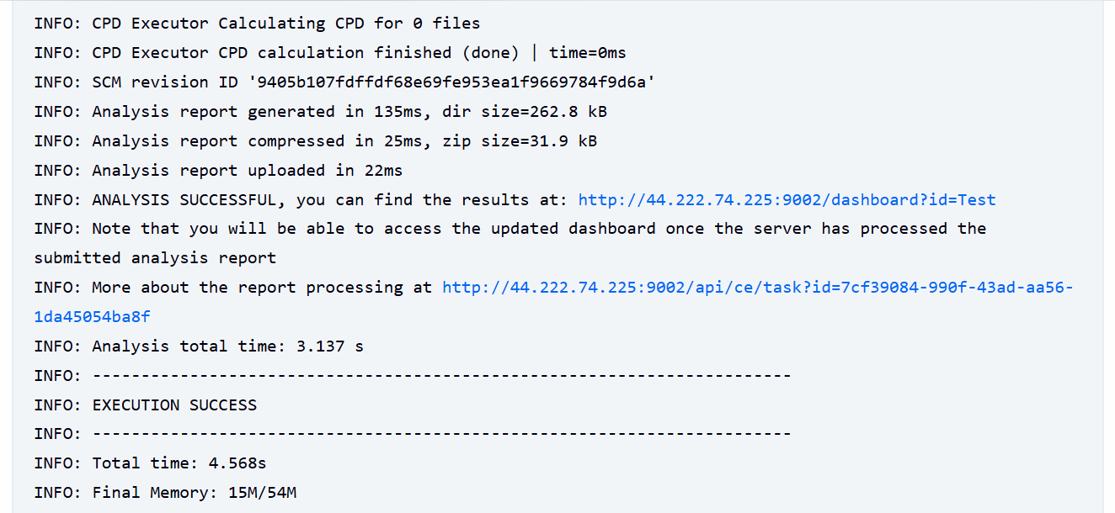

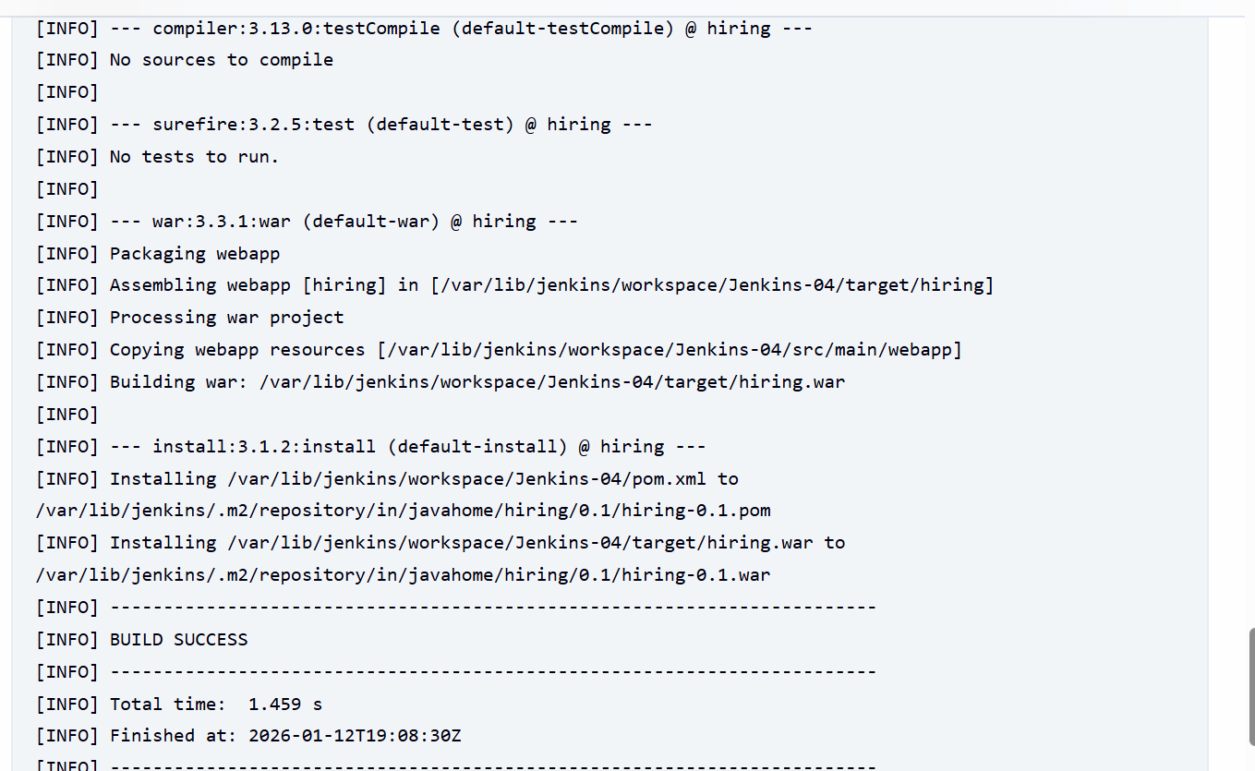
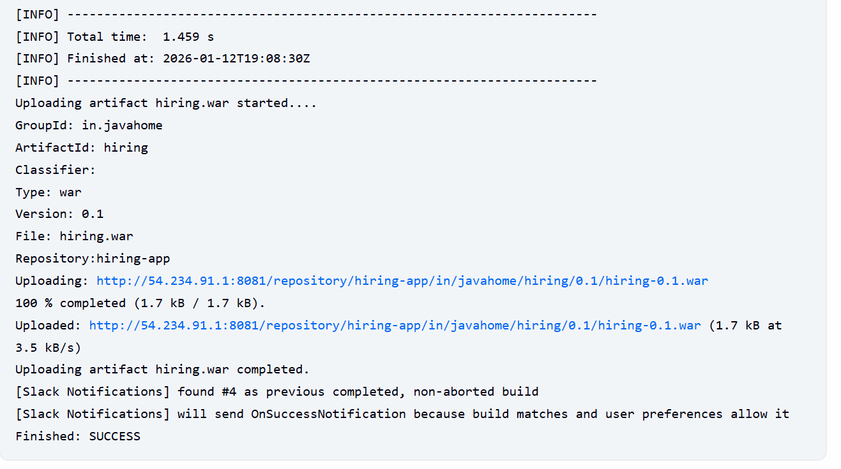

Step 25: Verified in the Nexus GUI as well.

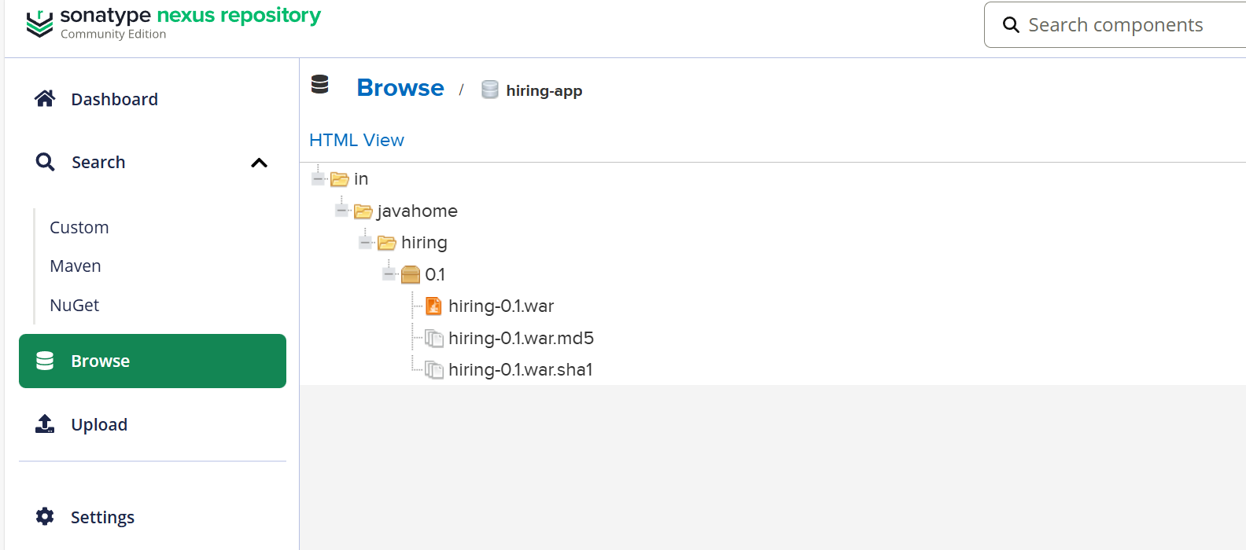

Step 26: Verify in the Slack if the notification is sent over.

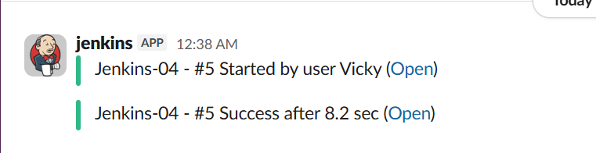

Stage 6-

Step 27: Tomcat Deployment

Let’s launch a new instance for tomcat deployment.

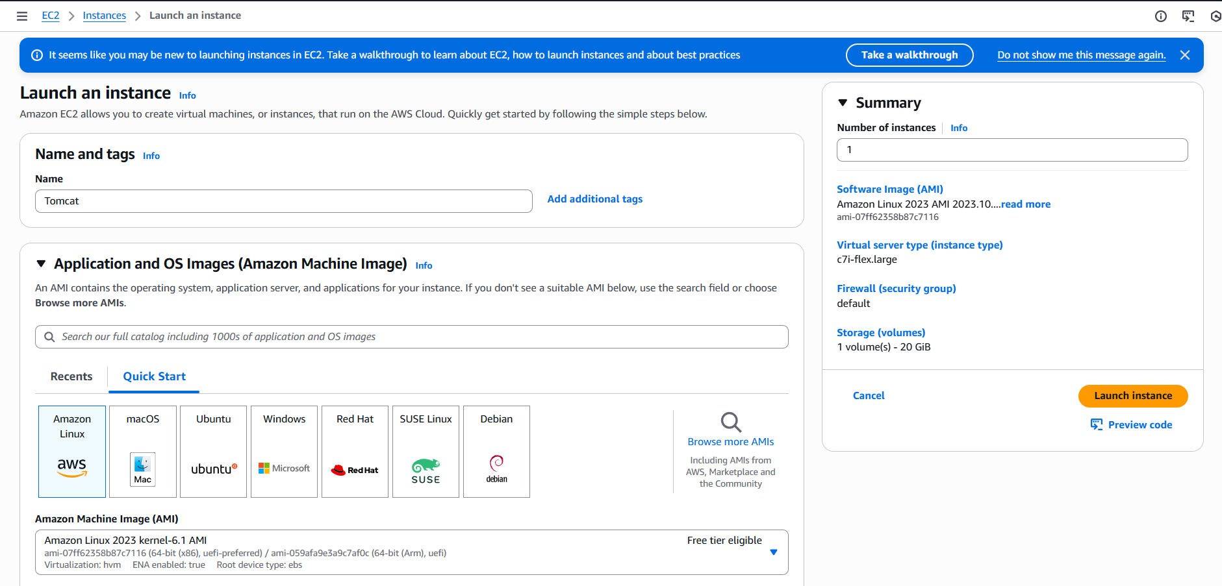

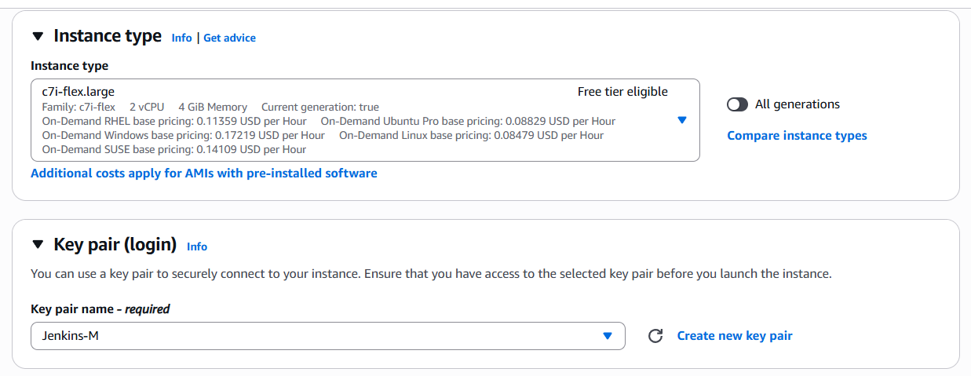
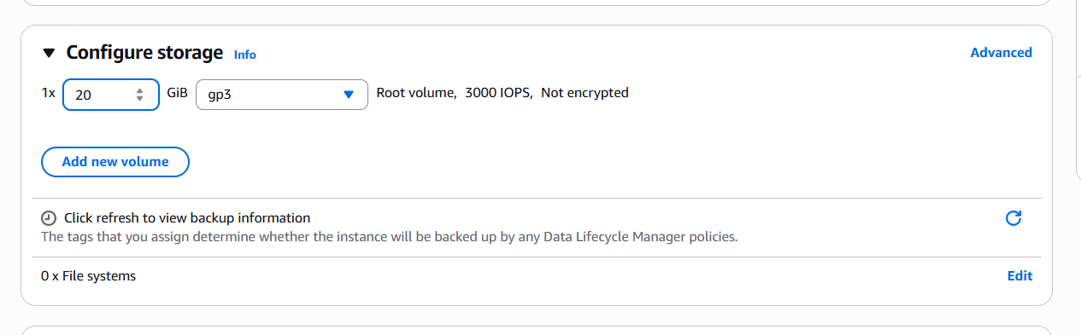

- Instance launched.

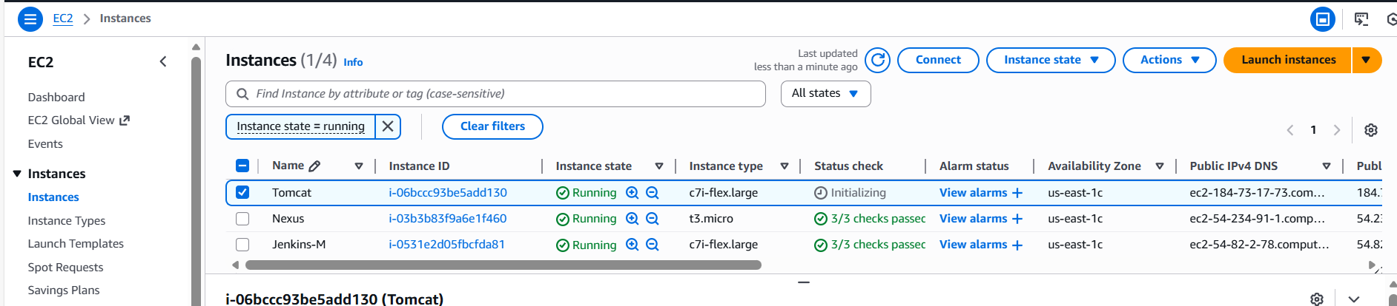

Step 28: Install java-17 version for Tomcat dependency.

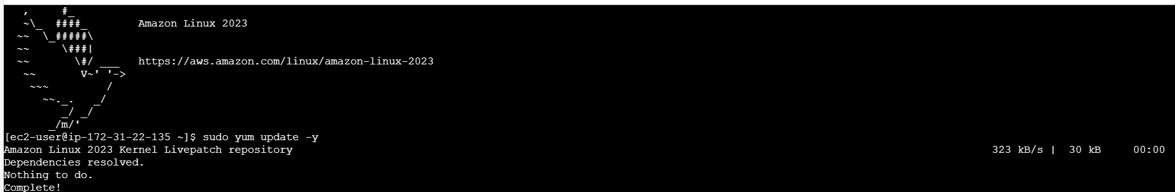

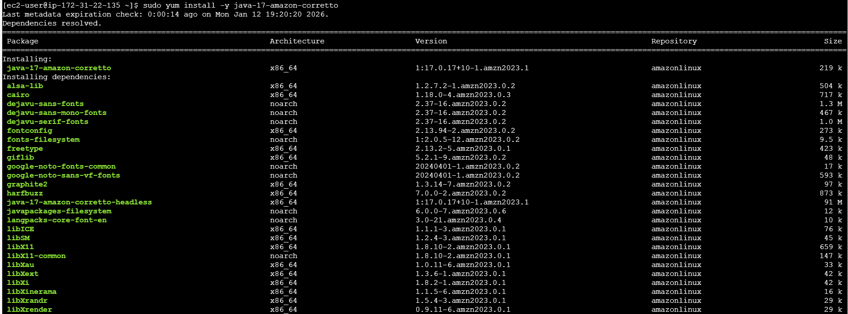

Step 29: Install Tomcat
cd /opt/
sudo wget https://dlcdn.apache.org/tomcat/tomcat-9/v9.0.113/bin/apache-tomcat-9.0.113.tar.gz
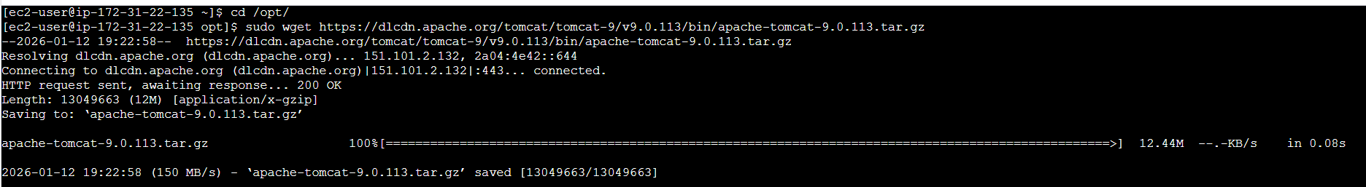

- sudo tar xvf apache-tomcat-9.0.113.tar.gz
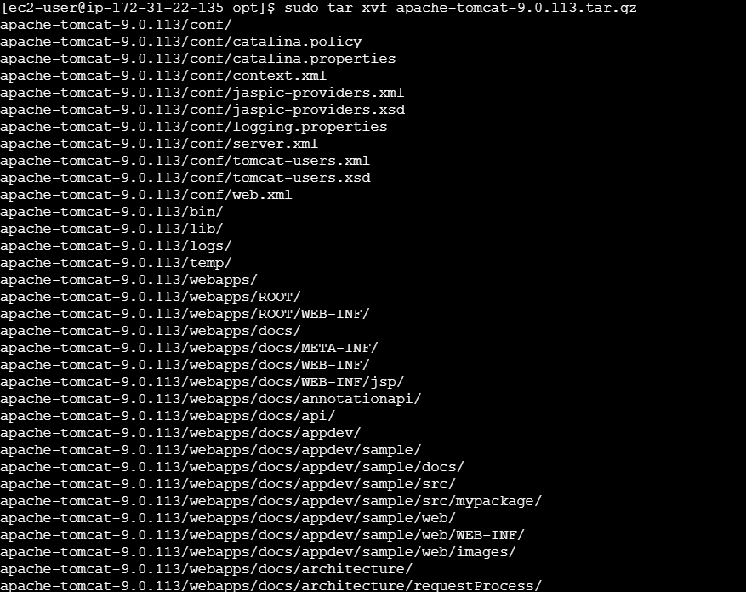

- cd /opt/
- ll
- cd /opt/apache-tomcat-9.0.113/bin/
- ll
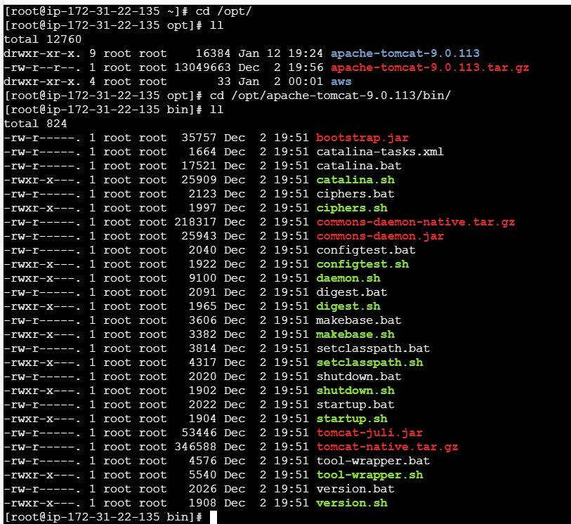
- ./startup.sh start to start the Tomcat
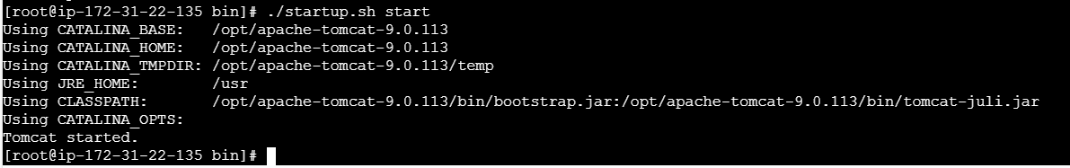

Step 30: Verified in the browser with URL and port 8080.
Success- Tomcat is up and running.
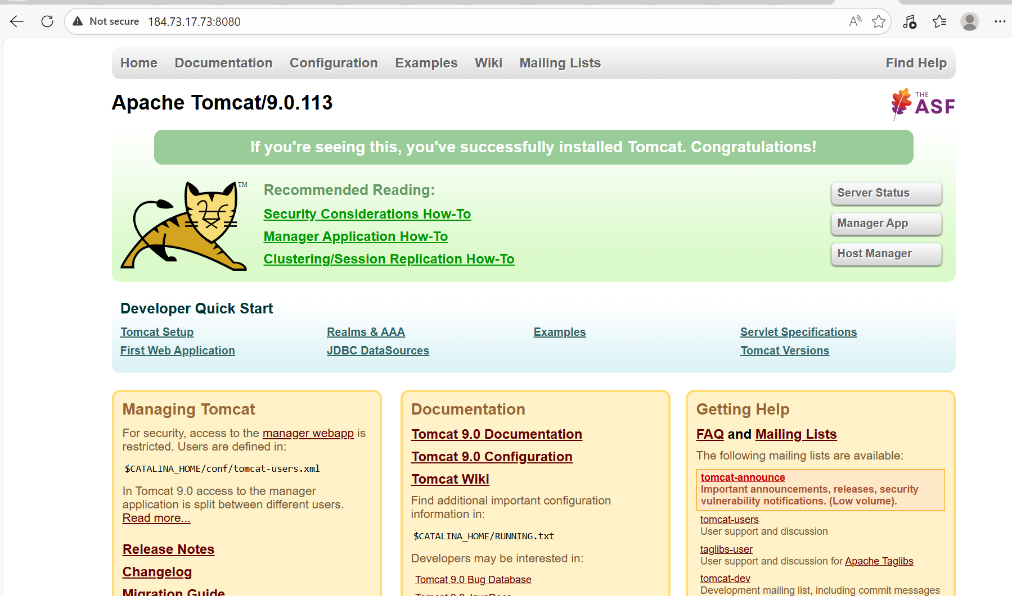

Step 31: Navigate to Jenkins GUI and install a plugin Deploy to Container.

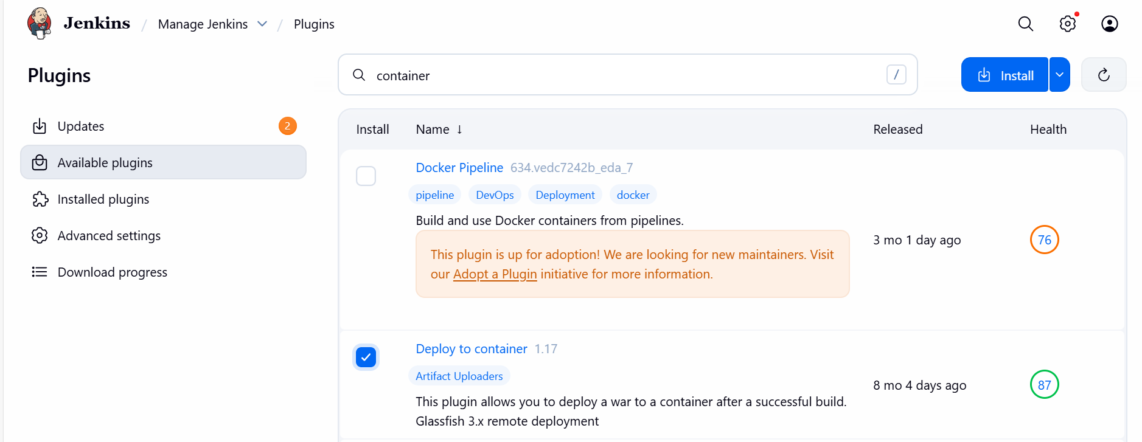

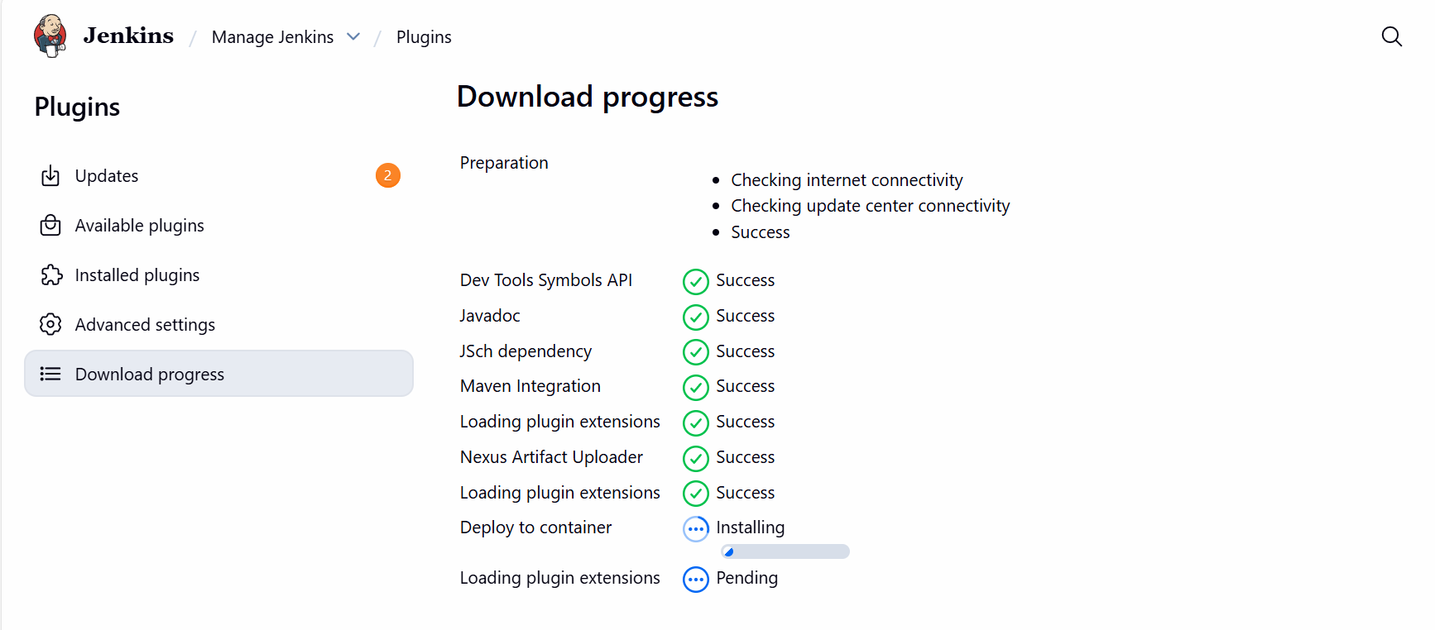

Step 31: Navigate to Tomcat server and update the below script in the vi tomcat.users.xml Cd /opt/
Cd apache-tomcat-9.0.113/conf/tomcat-users.xml
Vi tomcat-users.xml
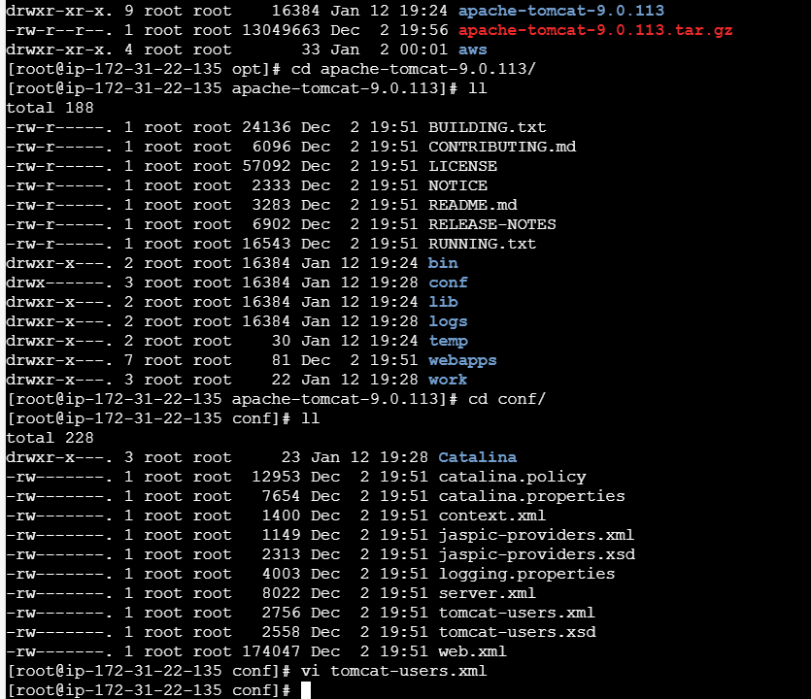

<?xml version="1.0" encoding="UTF-8"?>
<tomcat-users>

<role rolename="manager-gui"/>
<role rolename="manager-script"/>

<user username="admin"
password="admin123"
roles="manager-gui,manager-script"/>

</tomcat-users>
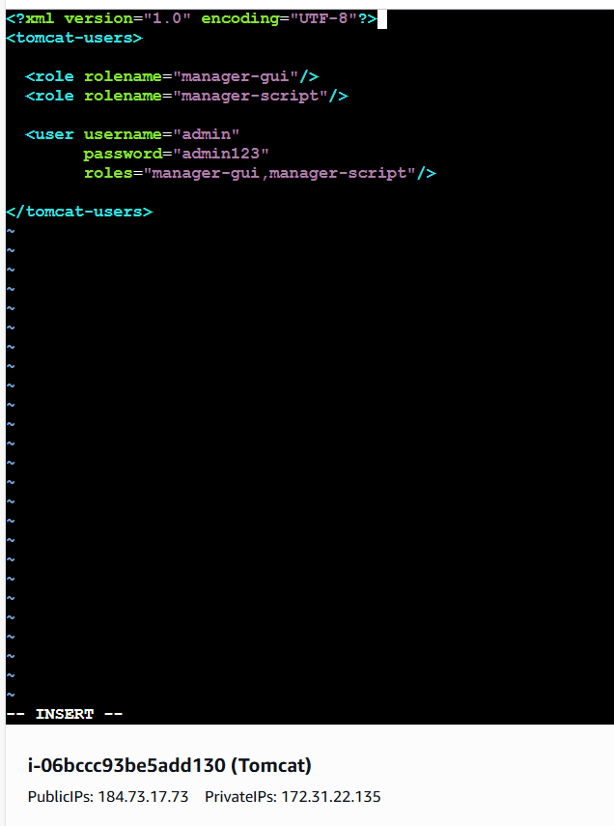
Step 32: Navigate back to Jenkins GUI and scroll to post-build Actions and select Deploy war/ear to a container.

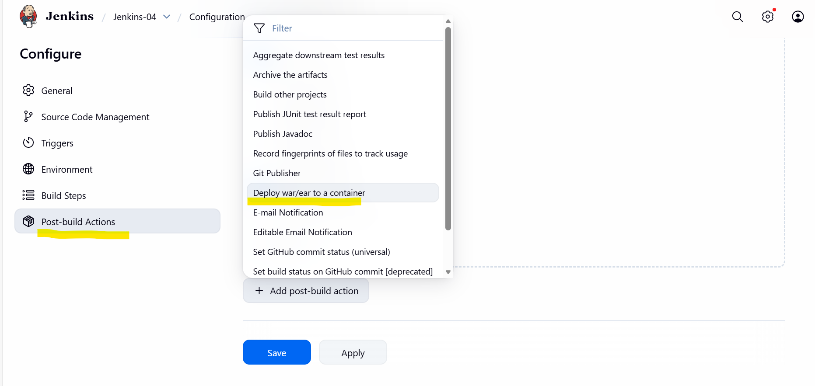

- Create a credential with username- admin
- Pass- admin123 as per user.xml file.
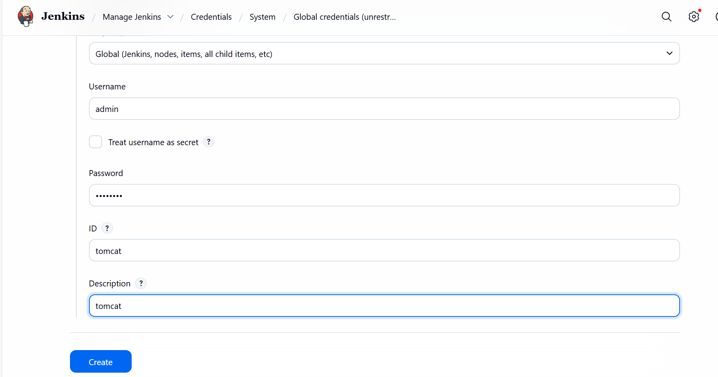

- Navigate to Jenkins-04 job and create a container in post build Actions under Deploy to war/ear.
- Paste the Tomcat URL and update the credential created earlier in Tomcat.

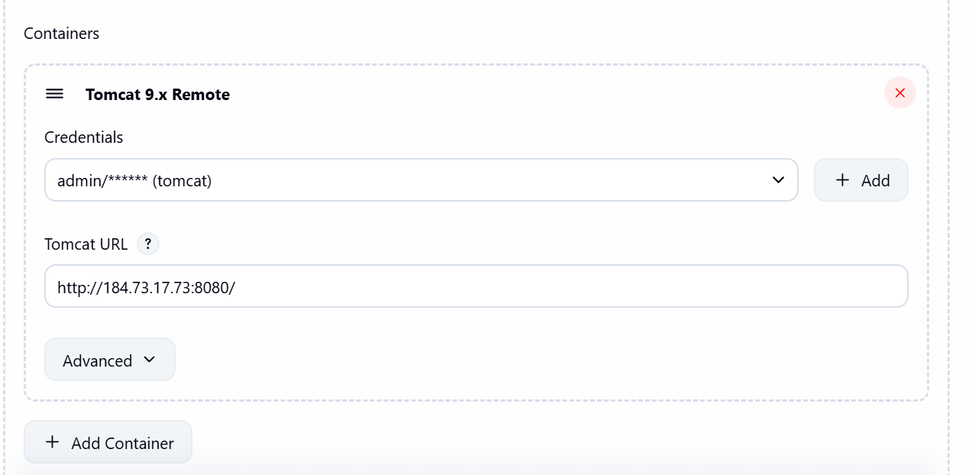

Step 33: Navigate back to Tomcat server and create 2 files with below commands and insert the data as per below screenshot.
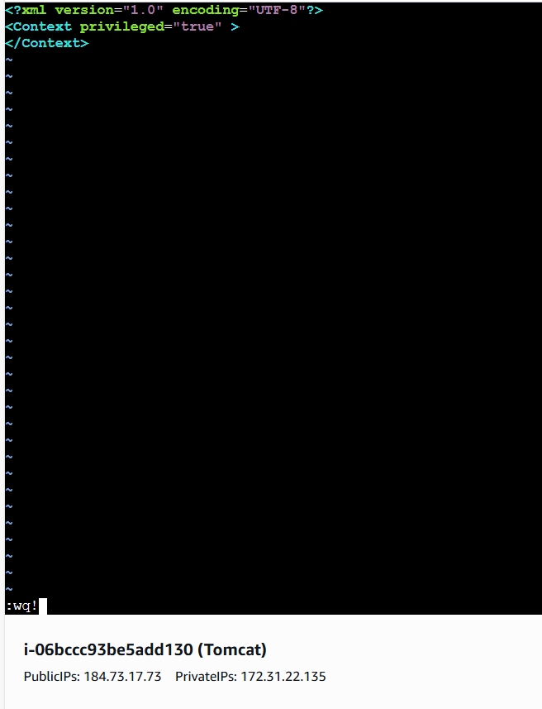
- Create 2nd file and insert the same data and save.

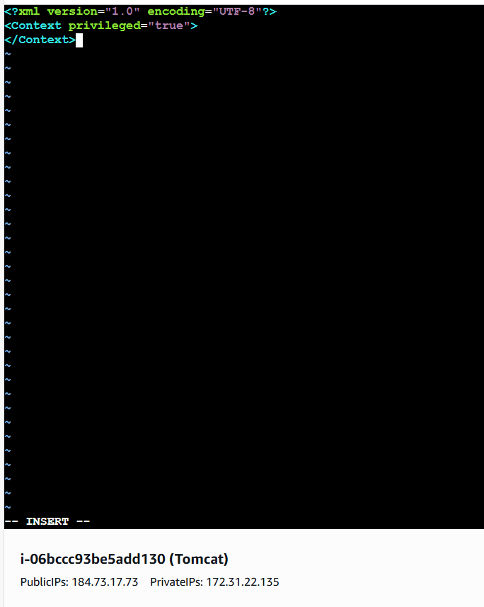

Step 34: Security Manager may be enabled via JVM option.

Use command- grep -n “java.security.manager” /opt/apache-tomcat-9.0.113/bin/Catalina.sh

- Then, we shall open in vi and add a # comment symbol and save for all 3 security manager.

- This is how it looks like, once comment # symbol added.

- Below is the security manager where, # comment is added for security manager.
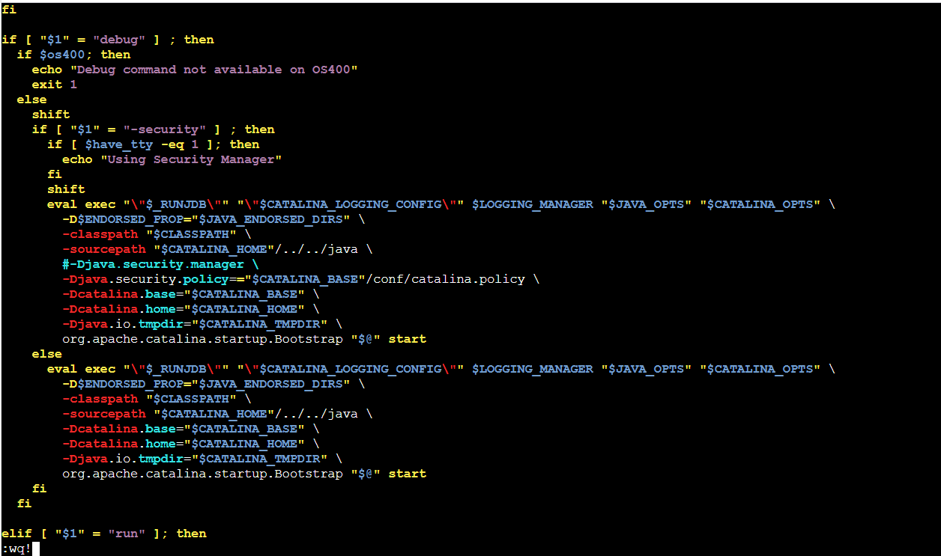

Step 35: Access the Tomcat web application manager using command- Tomcat URL/manager/html
- Use credentials created earlier-
  - Username- admin
  - Pass- admin123

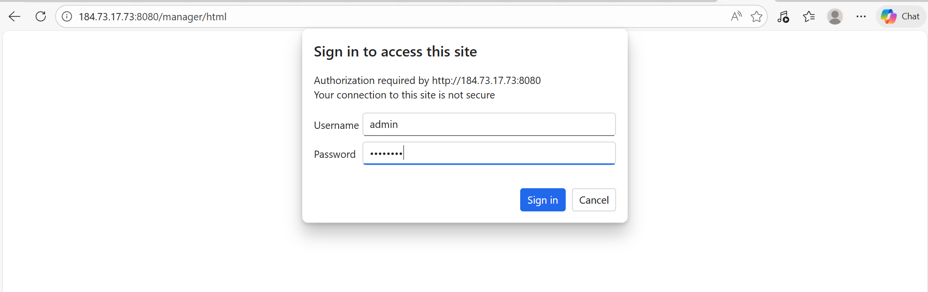

- Successfully verified Tomcat Web Application Manager.

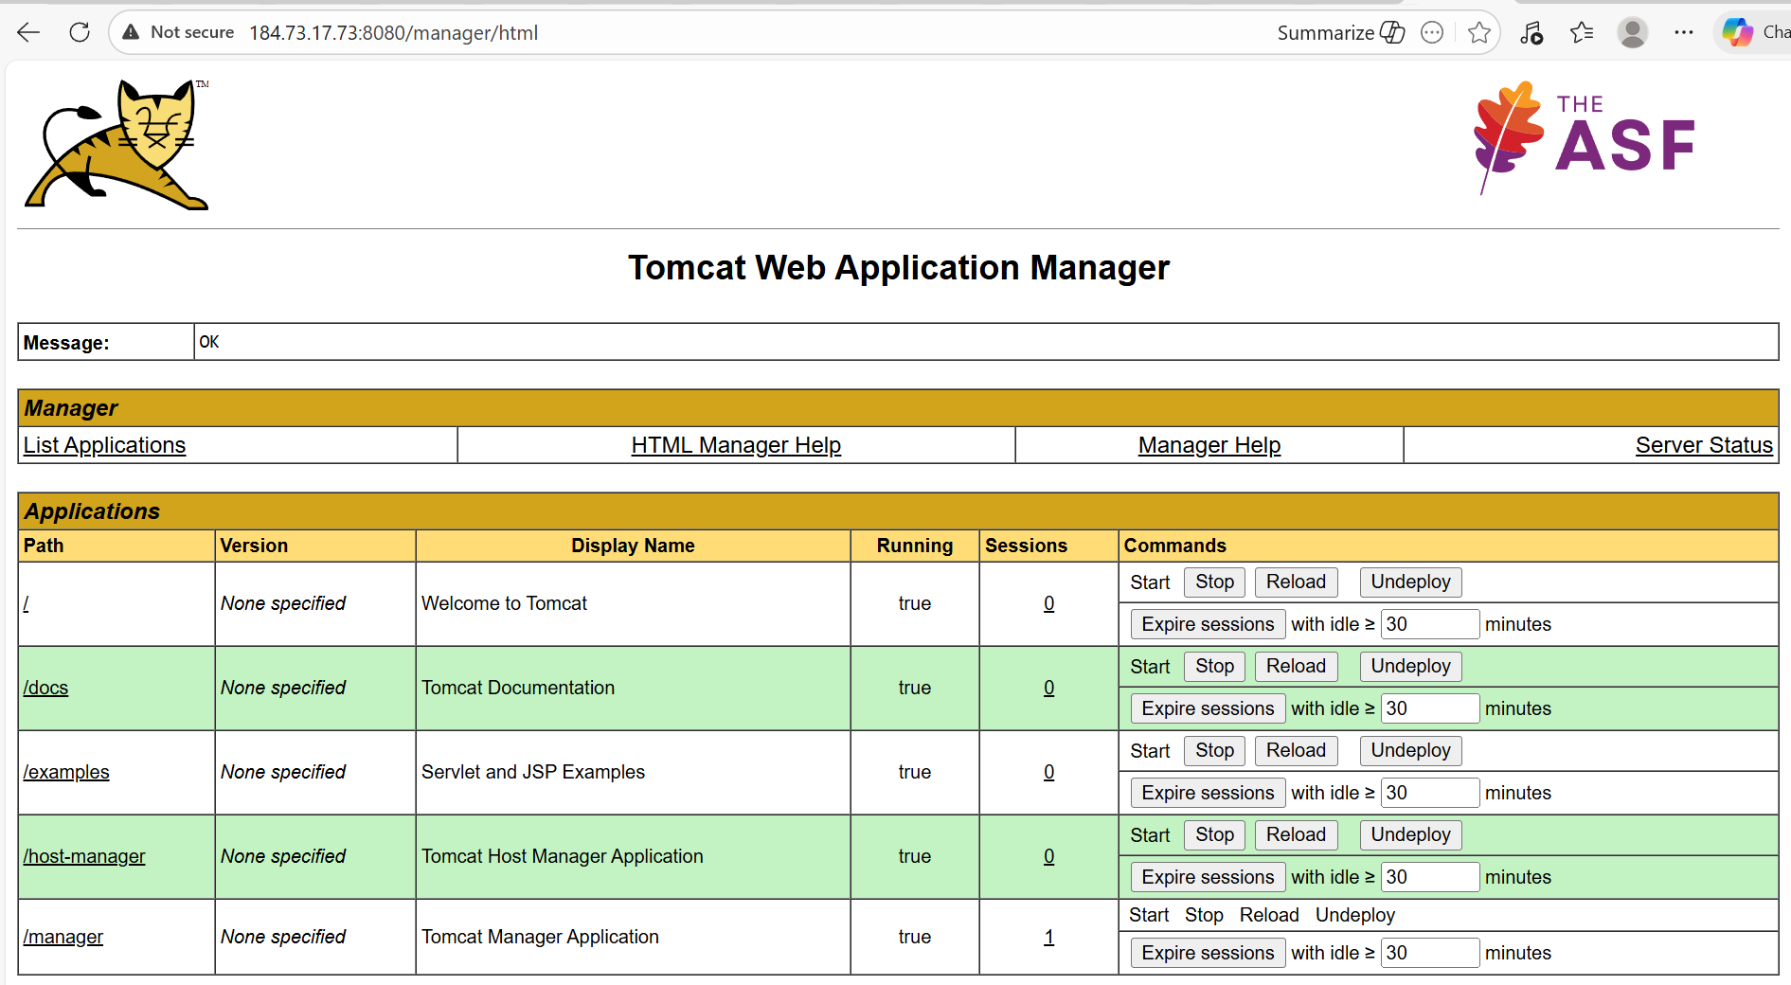

Step 36: Let’s Build and verify if its passing and Deployment is successful.

- Success. We were finally able to deploy successfully.
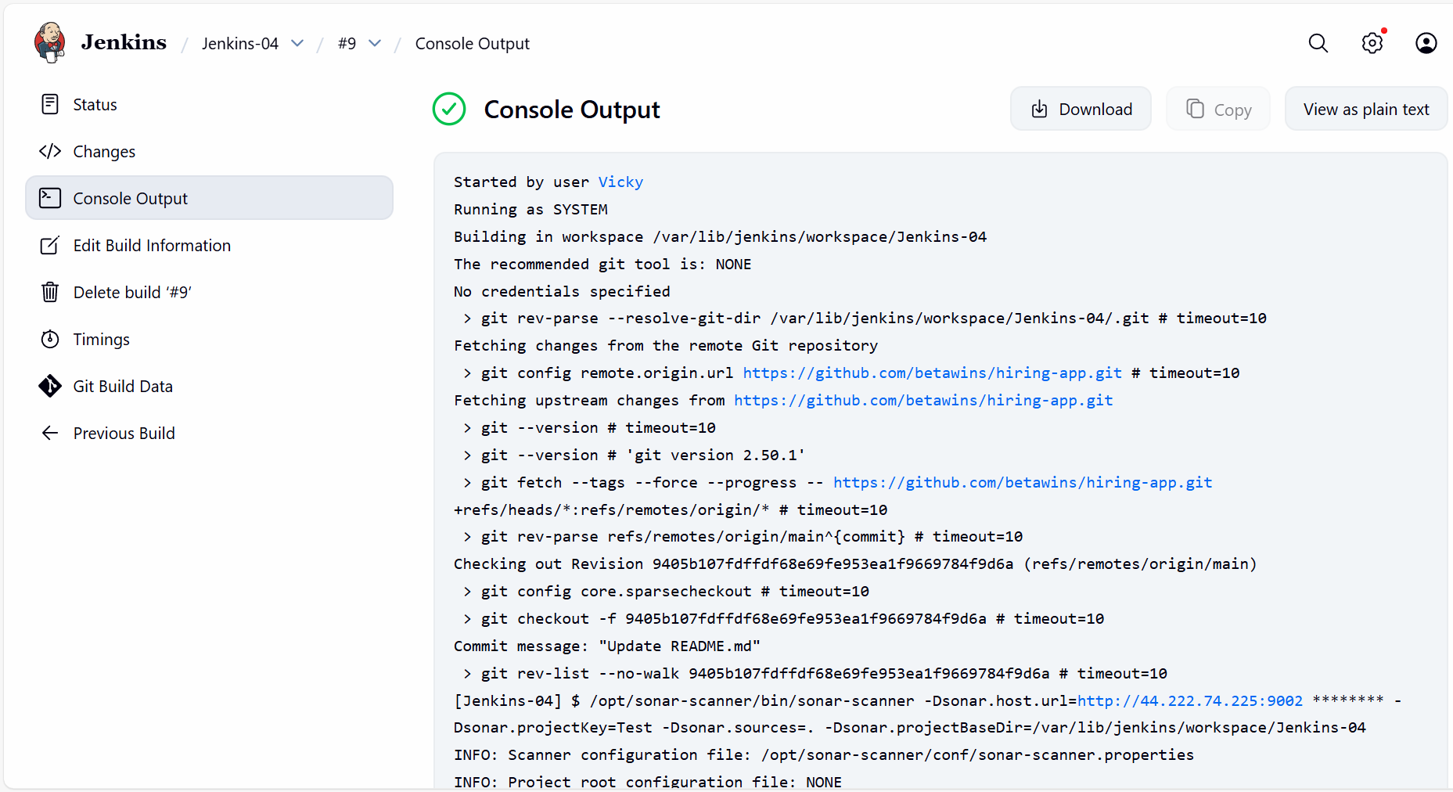

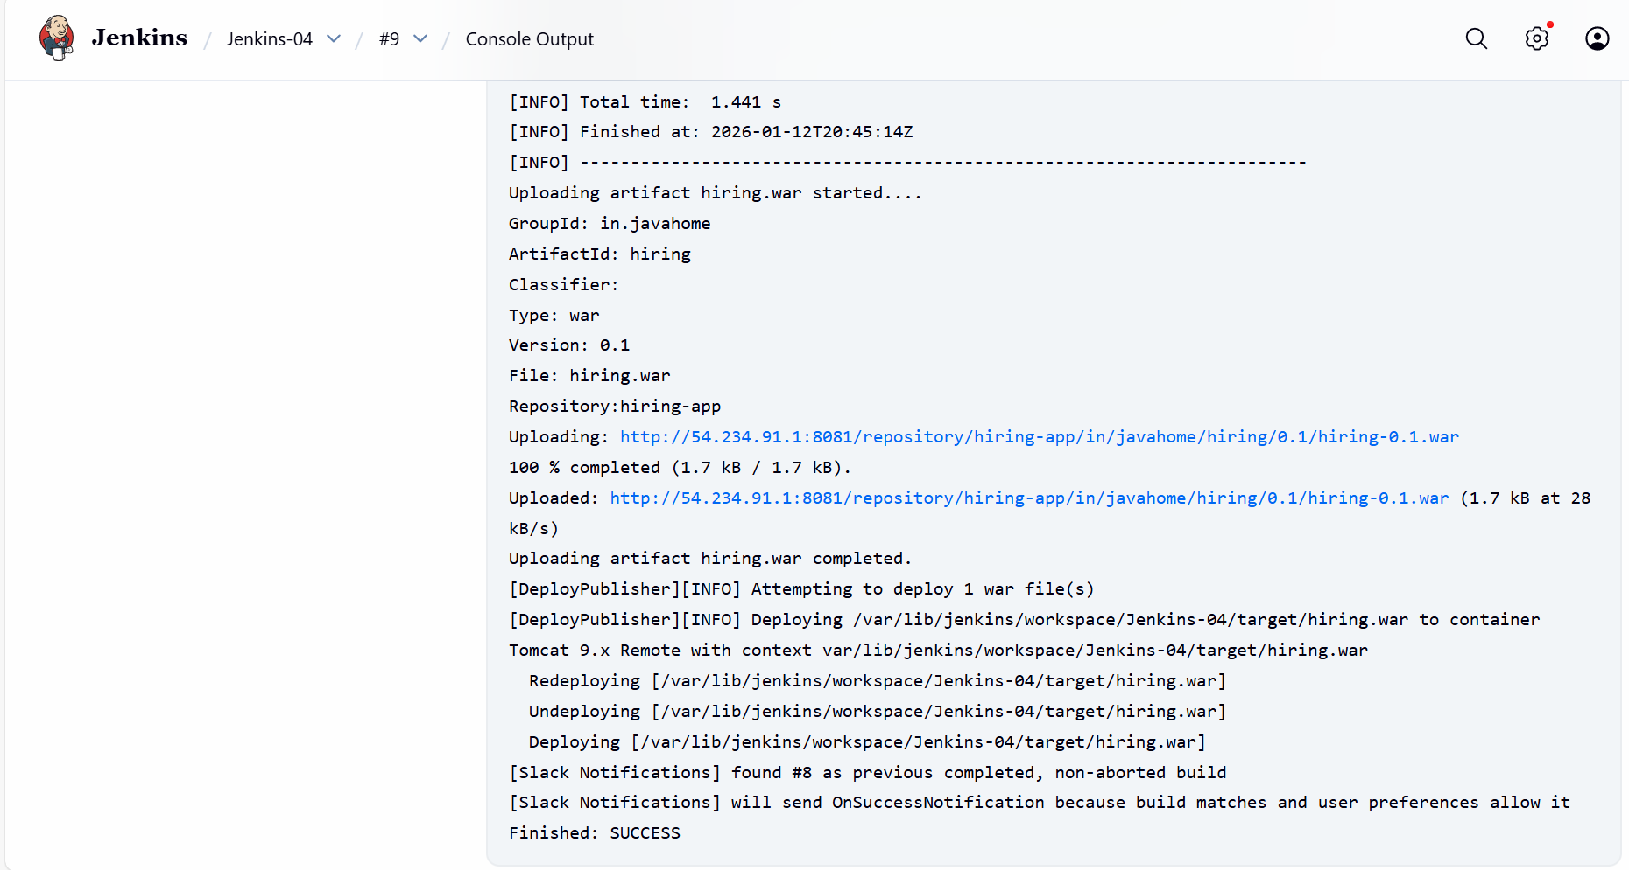

Step 37: Let’s verify in Jenkins server, if the application is available.

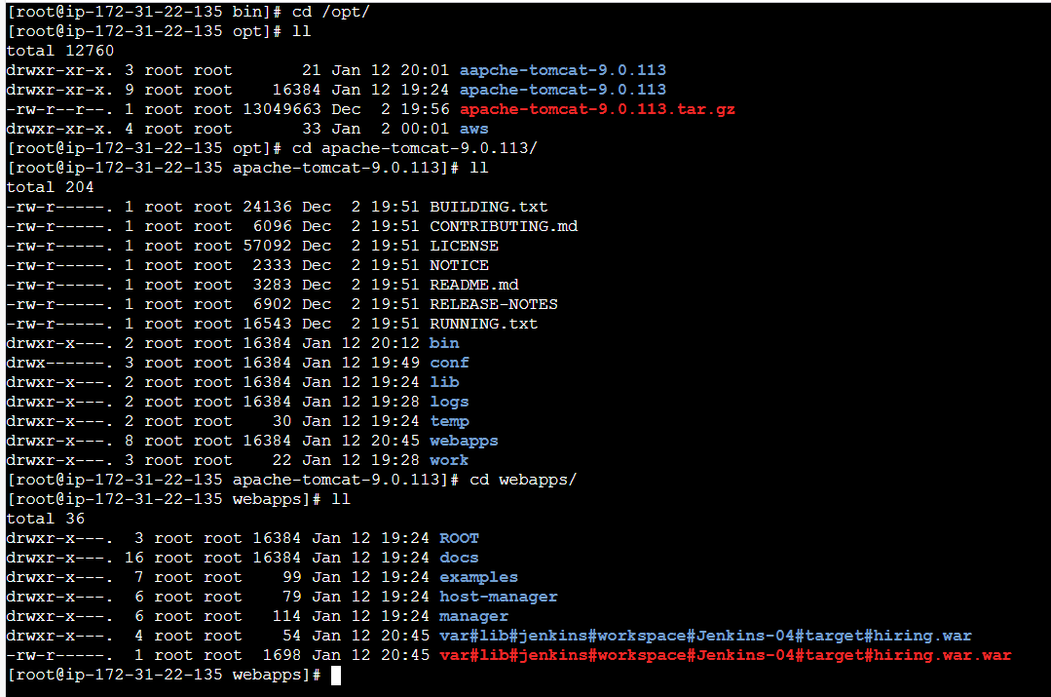

Step 38: Verify in slack, if the notification was passed on.
Yes, we verified successfully.

All stages are completed successfully.
