Terraform-01

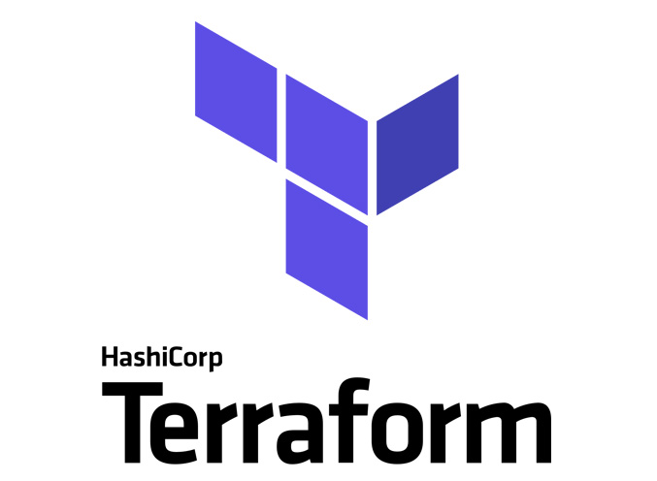

Terraform is a tool for IAC
IAC Infrastructure as co Code.
- Terraform is a tool to create ec2’s, VPC’s, Databases etc. without any manual intervention.
- Terraform is developed by HashiCorp.
- Terraform uses HCL Language (HashiCorp Language)
- Terraform official platform is – Terraform Registry

Alternative to Terraform?
Ans. CloudFormation in AWS

Difference between Terraform and CloudFormation in AWS?
- CloudFormation- It is used/restricted in AWS
- Terraform- It is used to provision on multiple cloud providers.

Different providers who provide Terraform on Cloud are:
- AWS
- Azzure
- Alibaba Cloud
- Google Cloud Provider (GCP)
- Kubernetes
- Oracle
The above are the providers who provides Terraform infrastructure.
Install Terraform:
We shall install Terraform for now on Windows
- Install – Windows 386
- Extract and paste in C directory
- Open settings system variables env variables edit change the path to C terraform
- Open Gitbash and search for Terraform -V (so that, we will know, Terraform is available, from the Windows location).

How a Terraform configuration looks like?
<block> <resource_type> {
Option 1
Option 2
}

Navigate to Visual Studio create a folder in Desktop In VS code extension (search Hashi.Corp) and Install
.tf extension for the Terraform resource files
.tf is a plugin.

Let’s create a small Terraform configuration for testing:
Resource “local_file” “my_pet” {
Filename = “pets.txt”
Content = “I love pets!”
}

Resource – Block
Local – Provider
Type – type of resource
My_pet – name of Terraform
Filename and Content – attributes used for the resource

Terraform provider:
It is a complete package of API calls to communicate with our resource.
- Any provider- AWS, Azzure etc.
- Resource- “local_file”

Visual Studio-
Navigate to Terminal we have created the local path in C directory and Terraform is present.
- Terraform init this is initializing Terraform
- Terraform plan Before executing the script, to verify, we can use plan
- Terraform apply Executing the script
- Terraform destroy to remove the file created
- Terraform fmt to organize our syntax automatically.
Note:
- Idempotent when there is no change made, it will execute as idempotent.
How terraform will understand everything?
- Through terraform.tfstate
- State file will have complete Terraform.
Task- Install Terraform on your PC
Step by step Implementation:
Step 1: Navigate to browser and install Terraform from Registry
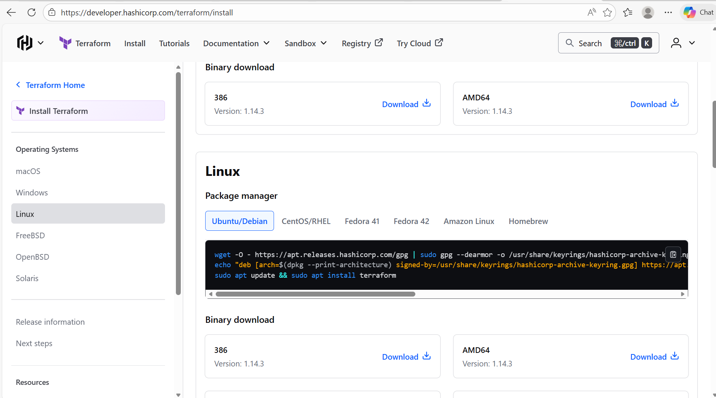

Step 2: Navigate to downloads and extract the downloaded package.
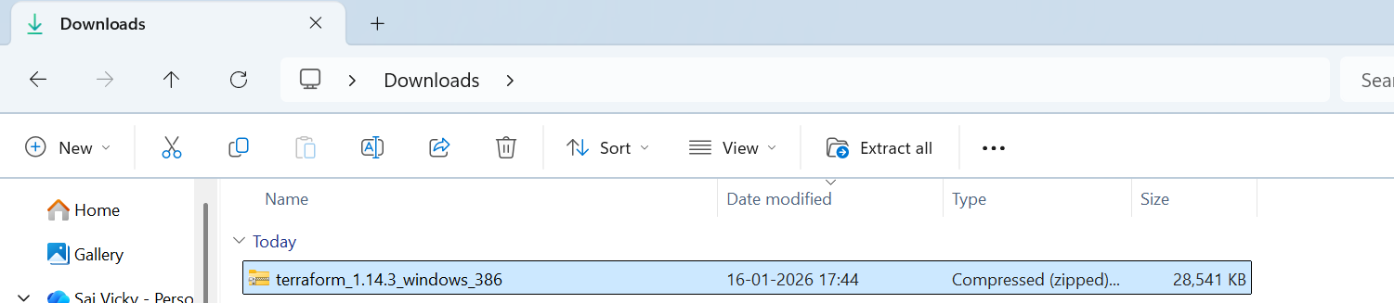

- Right click on the package installed and Extract All.
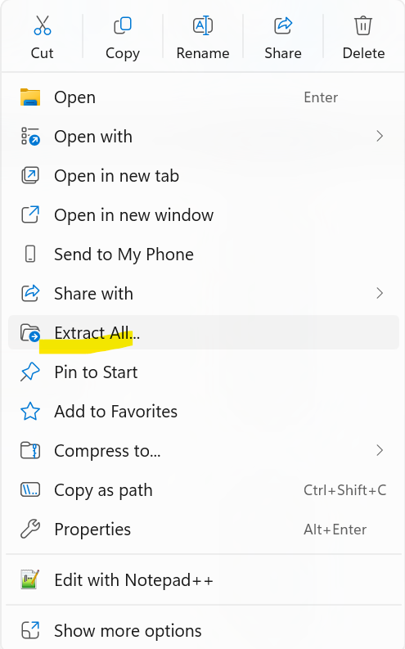
- Once extracted, it looks like below.
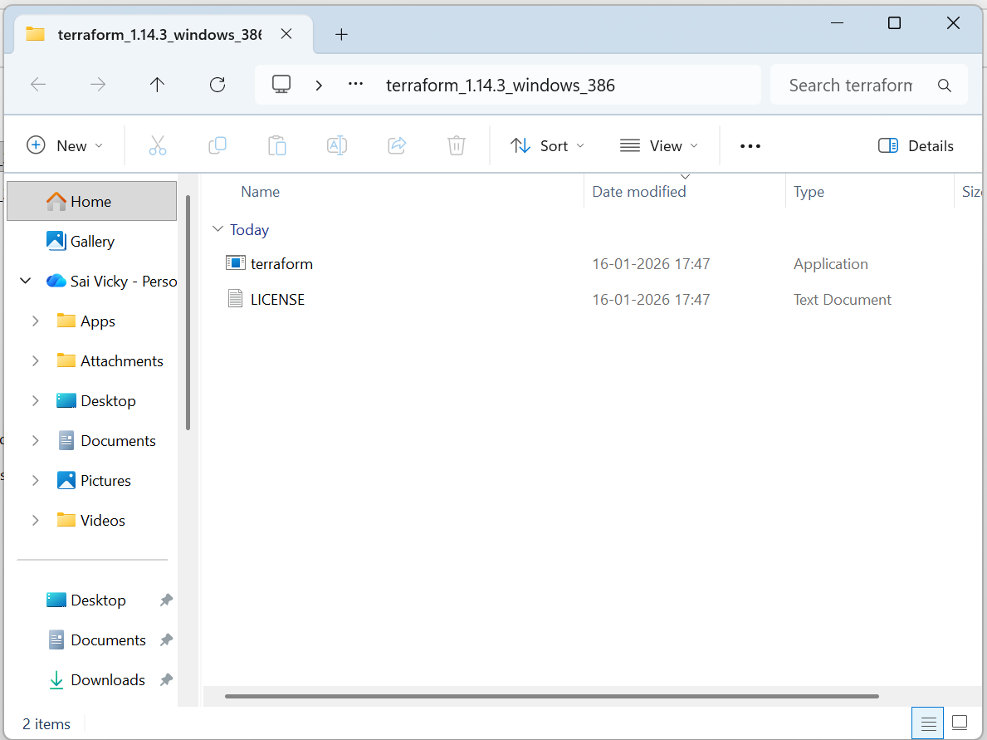
- Copy the terraform.exe navigate to This PC and go to Windows C drive Program files Create a folder called – Terraform Paste the copied terraform.exe file
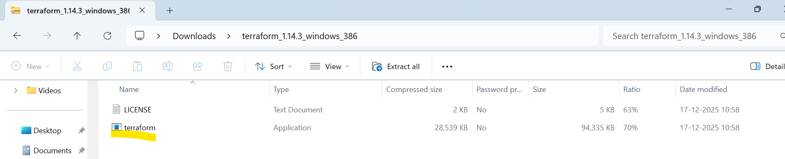

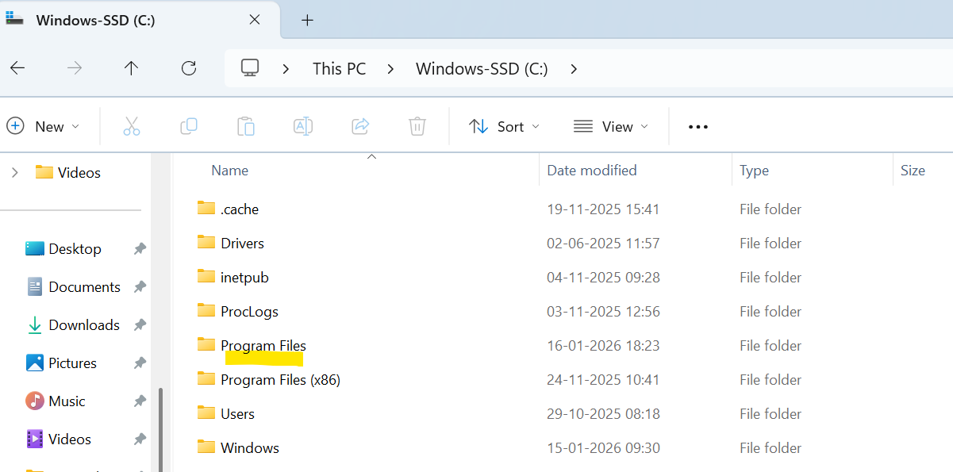

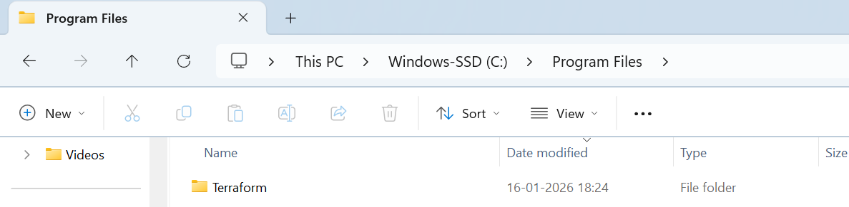

Step 3: Now, navigate to settings Edit system environment variables Create a new variable Terraform and variable will be our pasted Terraform.exe location (Windows C drive)
- Save

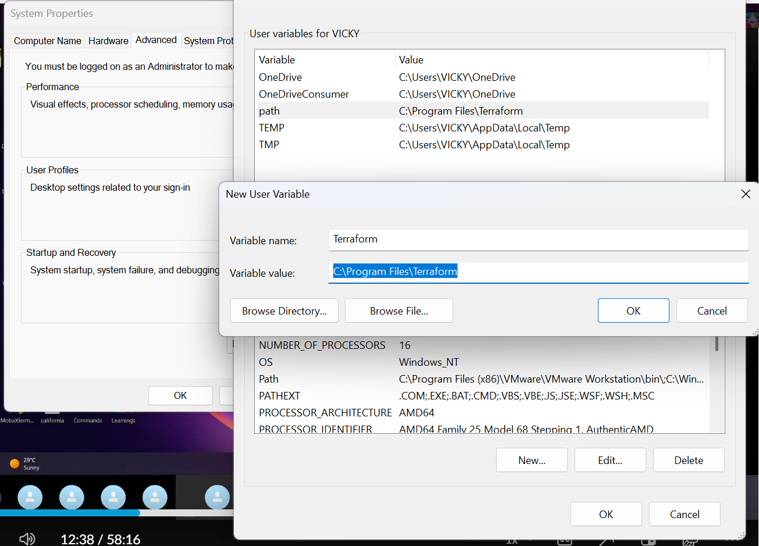

Step 4: Navigate to desktop and open Gitbash
- Command- terraform -v
- If the command threw a error then, our terraform globally extracted version is not created properly.
- Success- we configured properly and version details available.
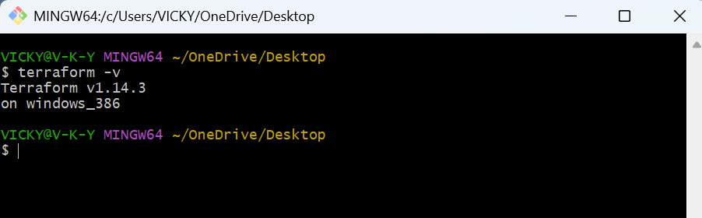

Conclusion: Successfully installed terraform in our system.
Task 2: Execute all the templates shown in video.
- Note down below points, Terraform Init Terraform Plan Terraform Apply Terraform Provider.
- Terraform Init, Terraform Plan, Terraform Apply, Terraform Provider.
- terraform init → Initializes a working directory, downloads providers, and sets up the backend.
- terraform plan → Previews the changes Terraform will make to your infrastructure.
- terraform apply → Executes the plan and actually provisions or updates resources.
- Terraform Provider → A plugin that lets Terraform interact with a specific platform (e.g., AWS, Azure, GCP).

Step by step Implementation:
Step 1: Navigate to Visual Studio code and install the extension of terraform.
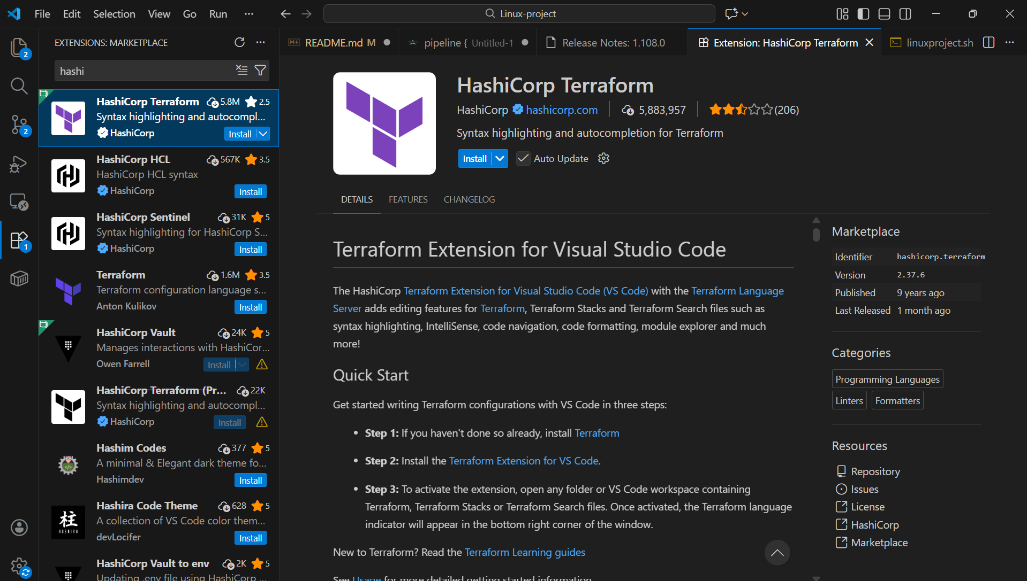

Step 2: Create a directory named- Terraform basic in Desktop and create a file named- main.tf
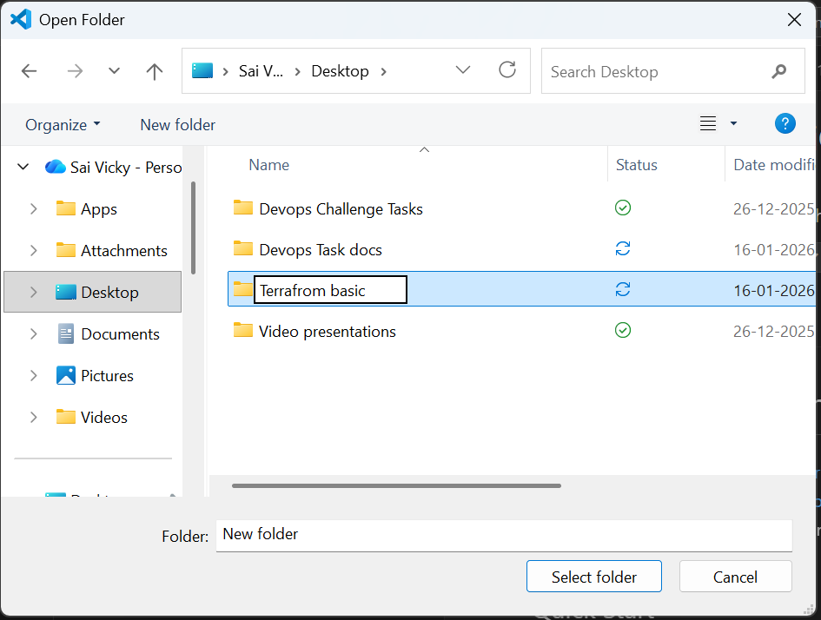

- Main.tf file created.
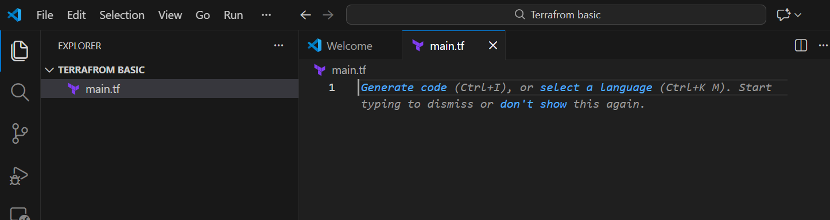
- In local desktop main.tf file is ready.
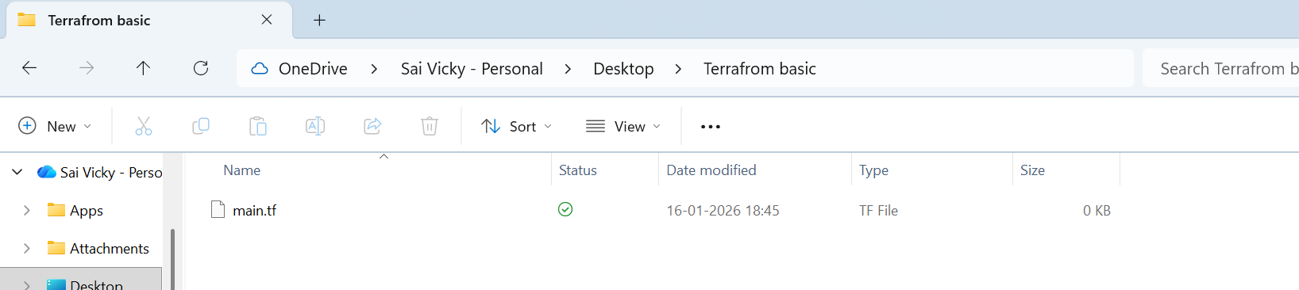

Step 3: Create a file called main.tf the configuration file to create a file in local
resource --> Block name
local -->provider
file -->resource type (What needs to be created)
my_pet --> it is a logical name to identify by terraform and can be named anything.
********************************************************
Example syntax
resource "local_file" "my_pet" {
filename = "pets.txt"
content = "I love pets!"
}

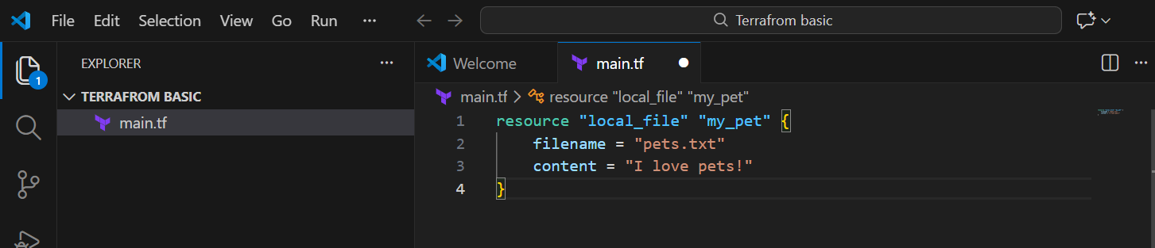

- We have inserted the data and example script is ready.

Step 4: Let’s scroll to the terminal below in VS code and execute some basic commands

- Executed basic command- terraform init- this will initialize terraform in the terminal.
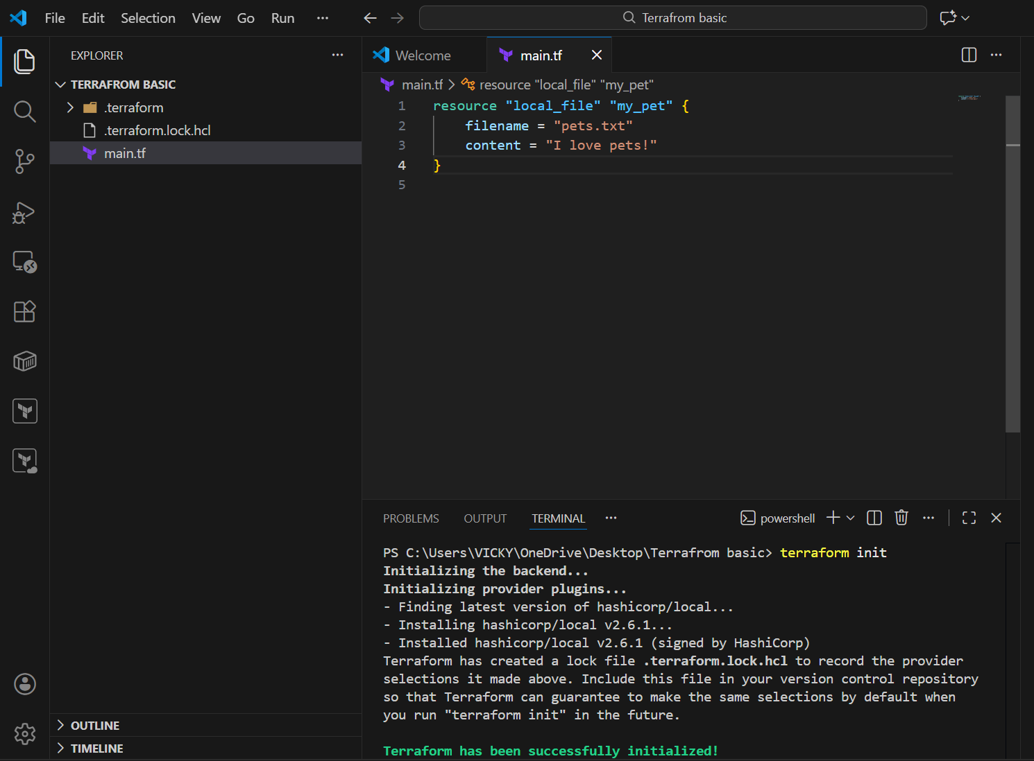

- Terraform plan- Before we execute the script added, we shall verify if the script is ready for execution without errors.
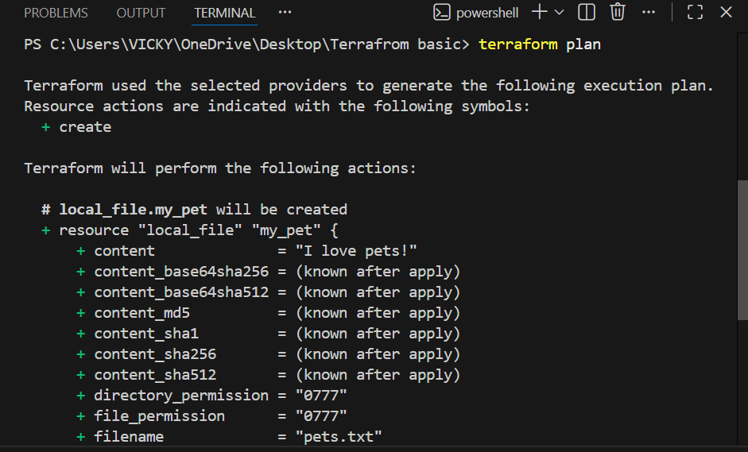
- Terraform apply- Its time for executing the script.

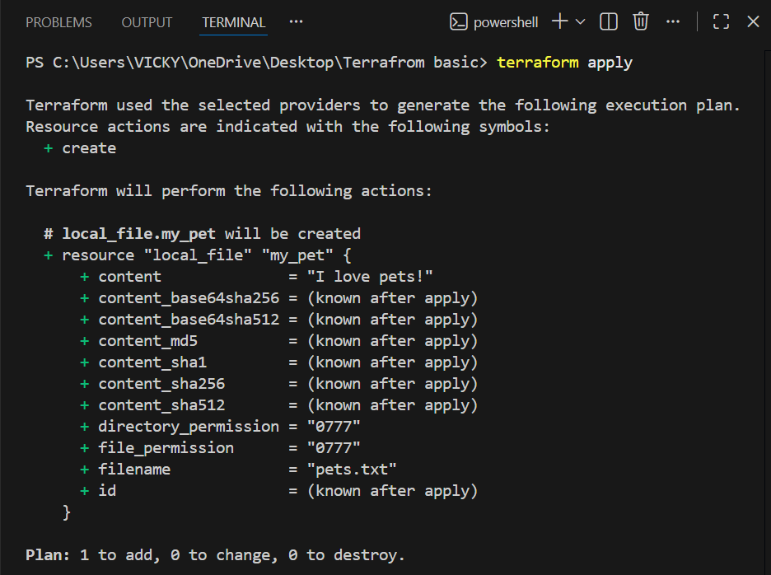
  - It will ask a question? Enter a value- yes.
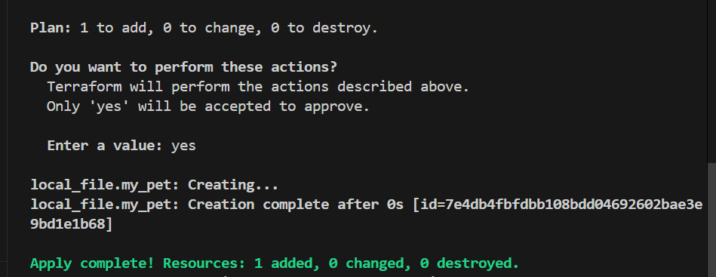

- Terraform destroy- This will remove the file created- local_file.my_pet
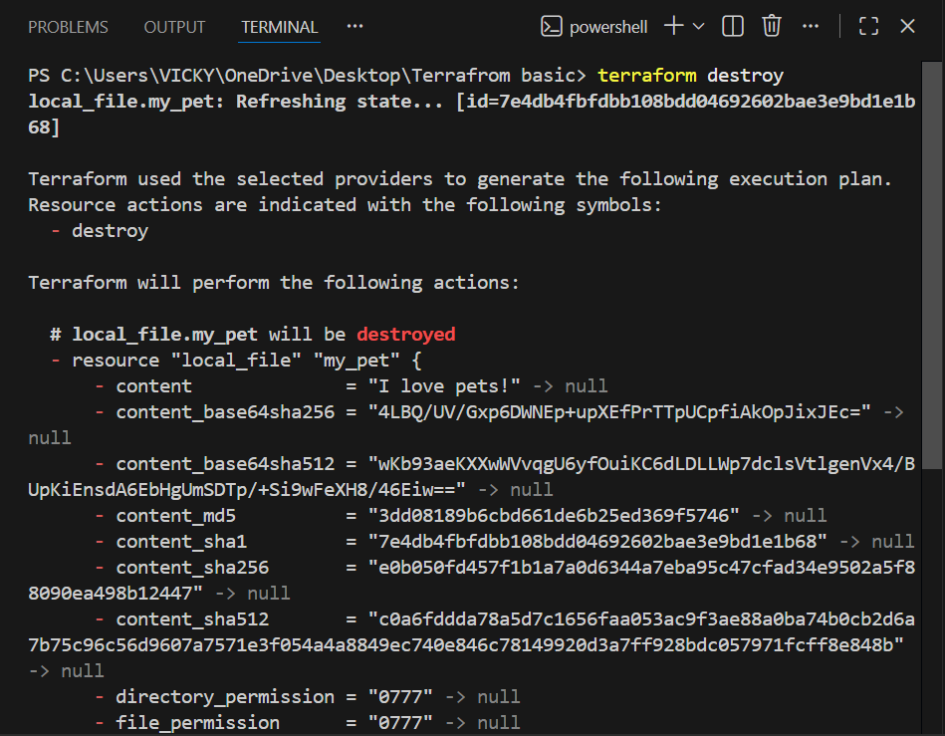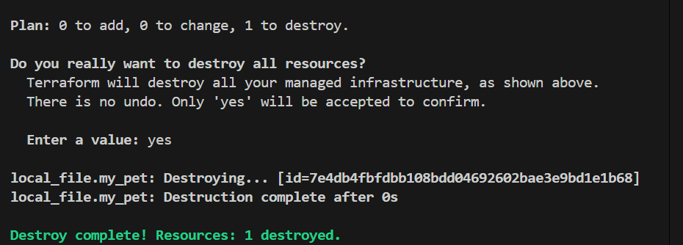

- Terraform fmt- This command will organize our syntax automatically.
  - Now, our syntax is ready.
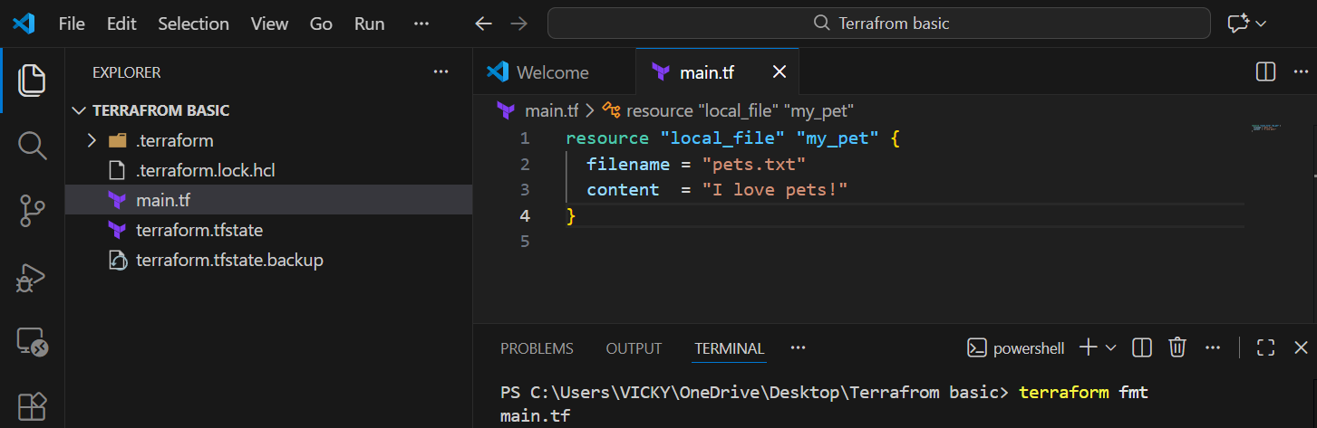

- Once the file is destroyed, then we need to come back from start-
  - Terraform init terraform plan terraform apply terraform fmt

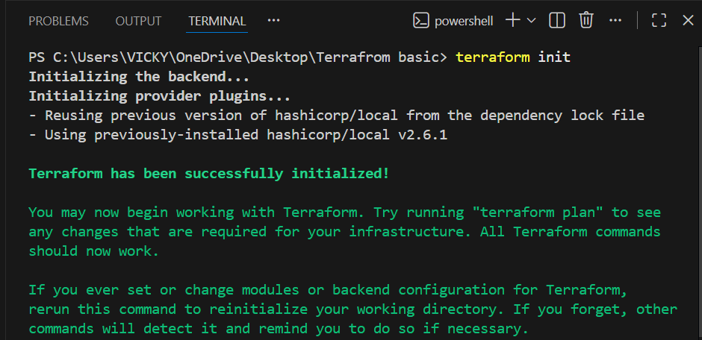

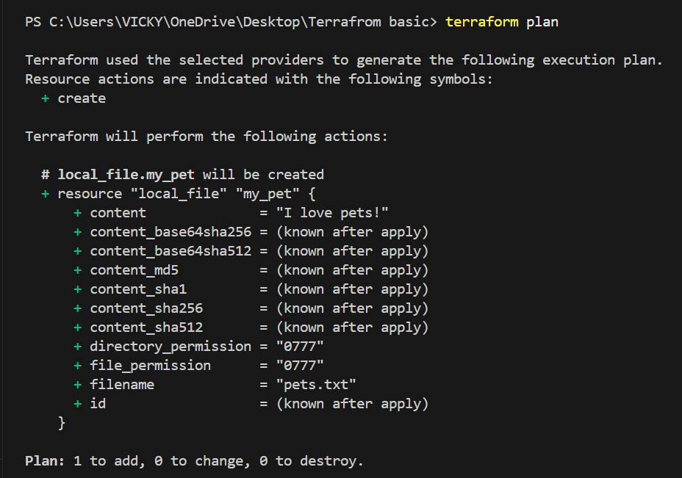
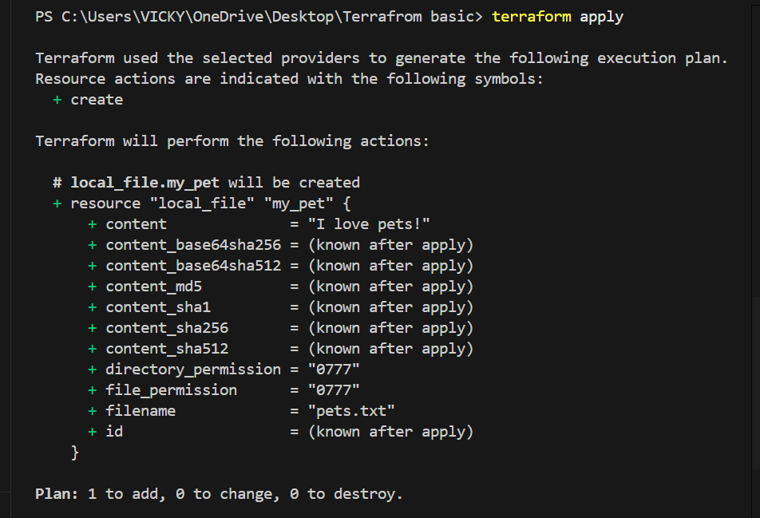
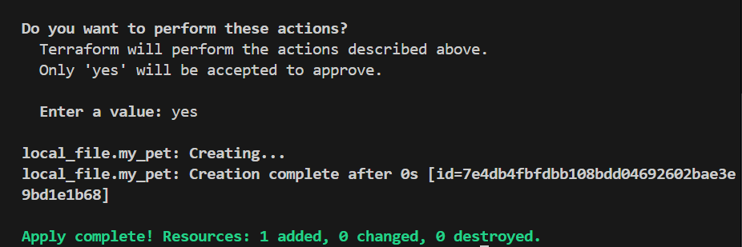

- Command- terraform show
  - Will help us to view the details of the file.
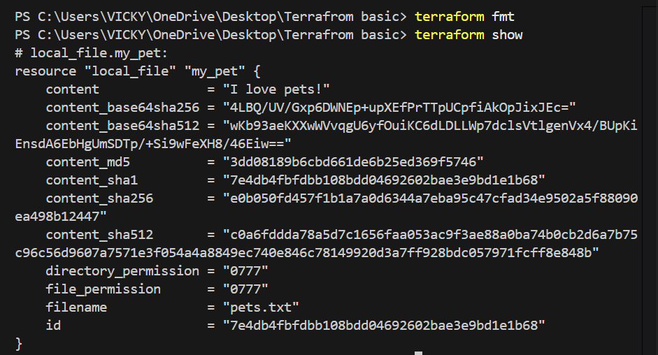
- Terraform provider
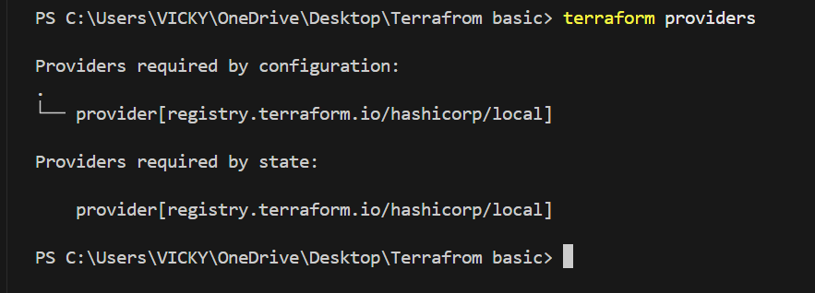

Step 5: To get the formal or reference syntax of terraform navigate to website and check in registry
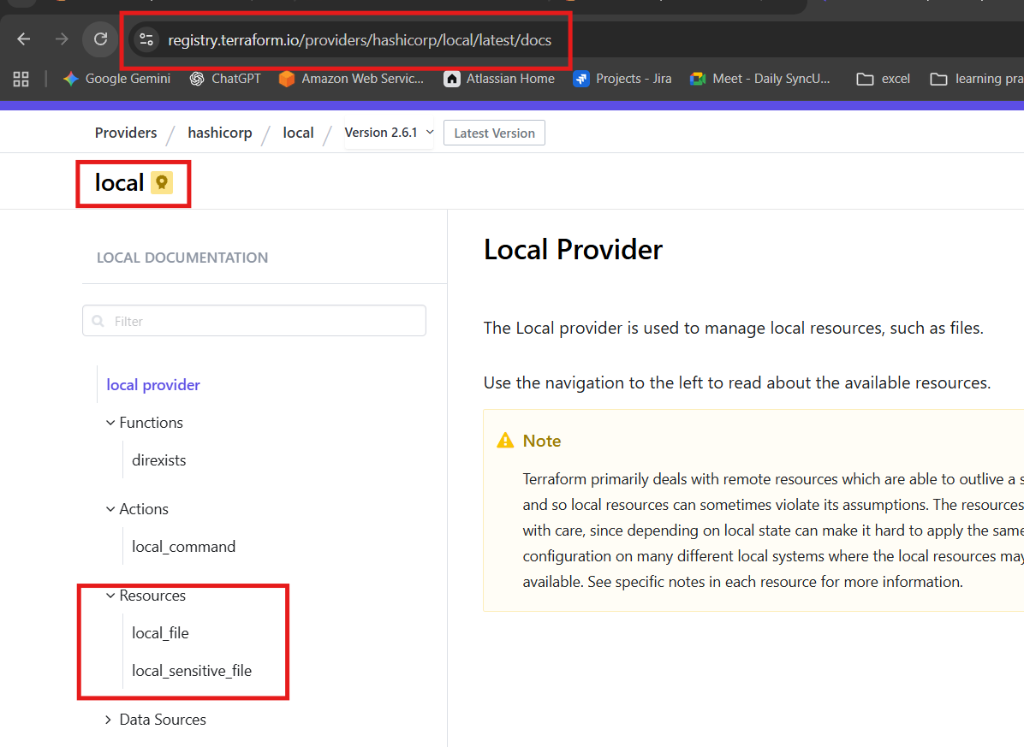
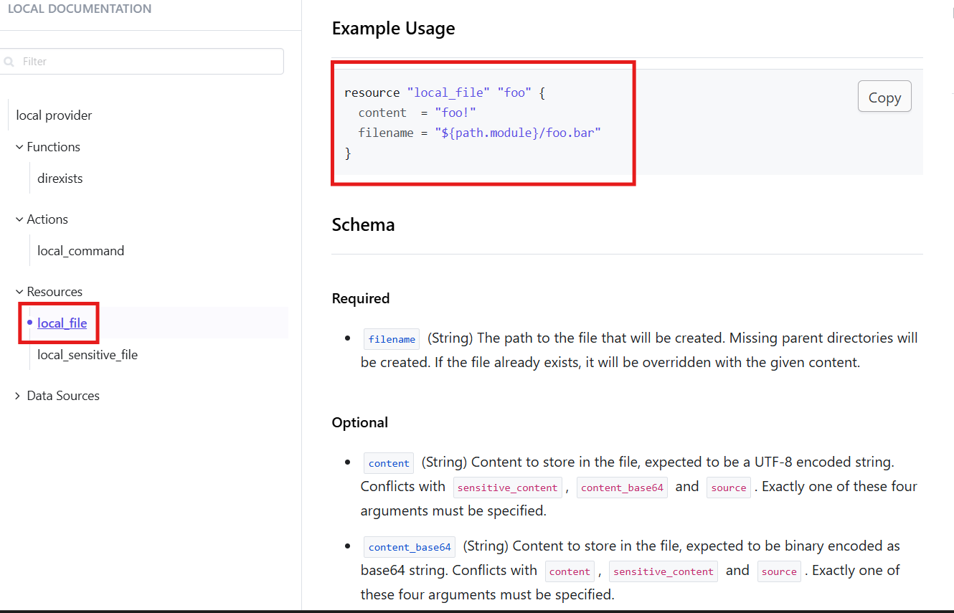

Step 6: Now, lets make a change in our script and execute.
Changed content- Pets Pet
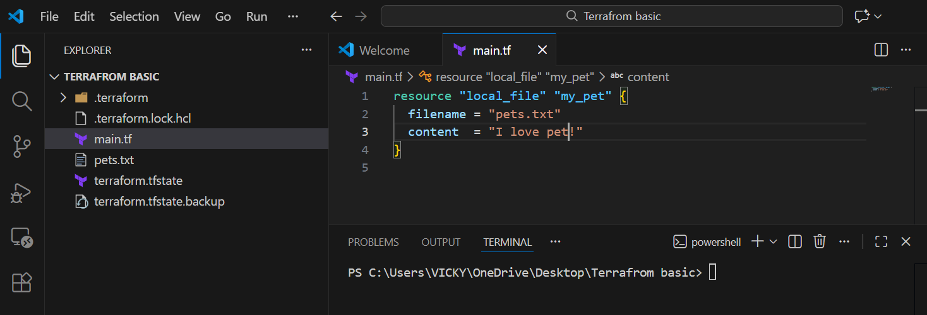
- Command- terraform plan (We can see the file has been replaced)
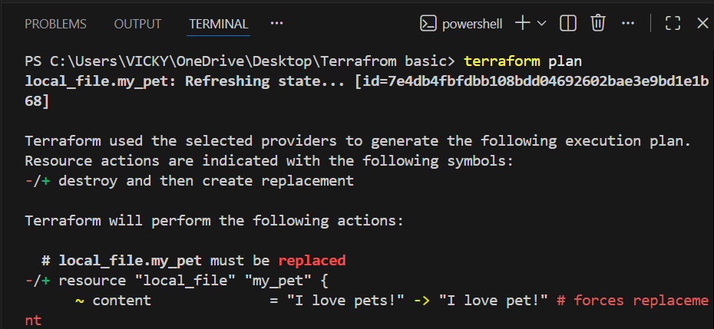

- Terraform apply- to save the changed version.
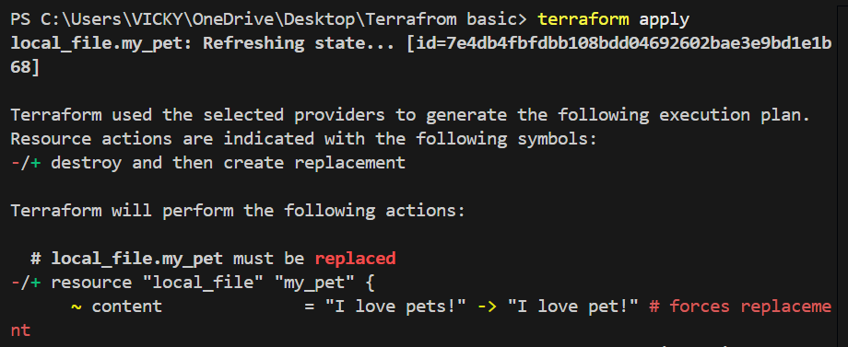
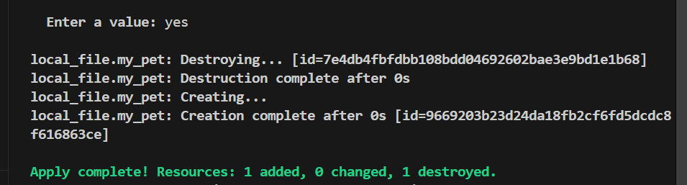
- Terraform show to verify the recent change.
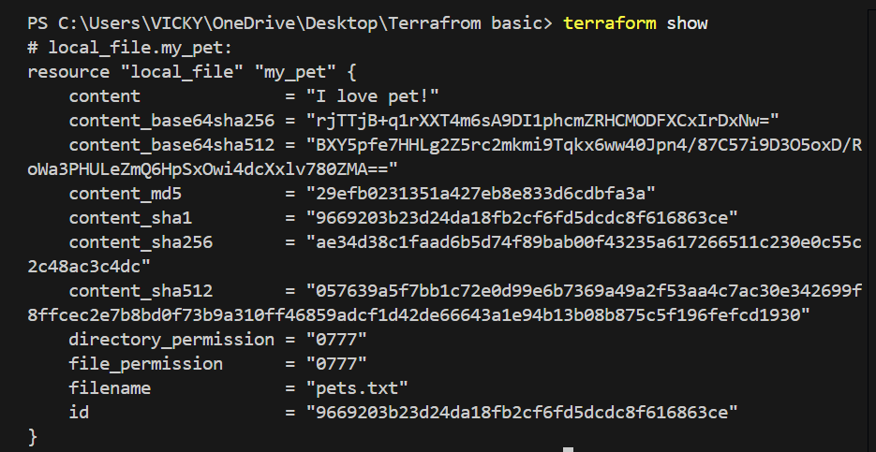

Conclusion- Executed all commands in Vs code and got basic knowledge how it works.

Task 3: Integrate a sample Terraform template in Jenkins.

Step by step Implementation:
Step 1: Navigate to AWS ec2 and launch Jenkins server.
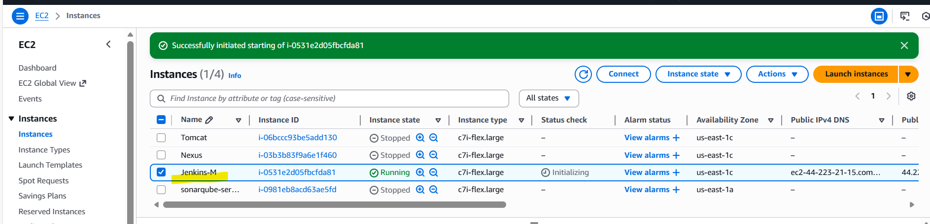
- Connect to the instance
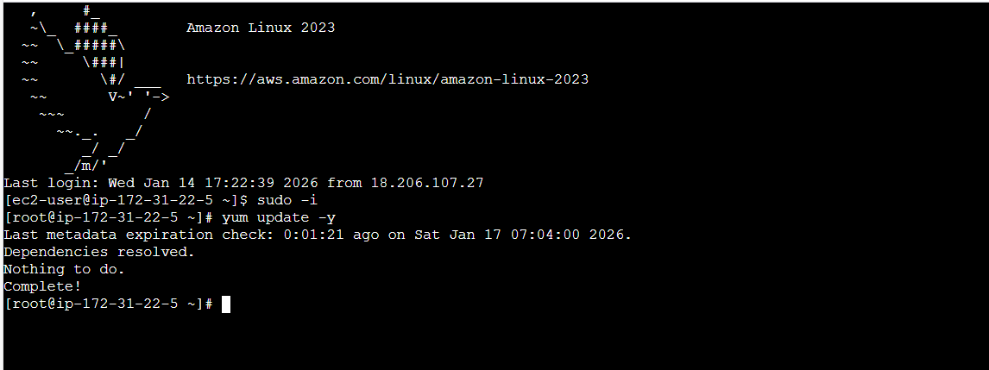

Step 2: Navigate to Terraform registry and install Terraform for Amazon Linux.
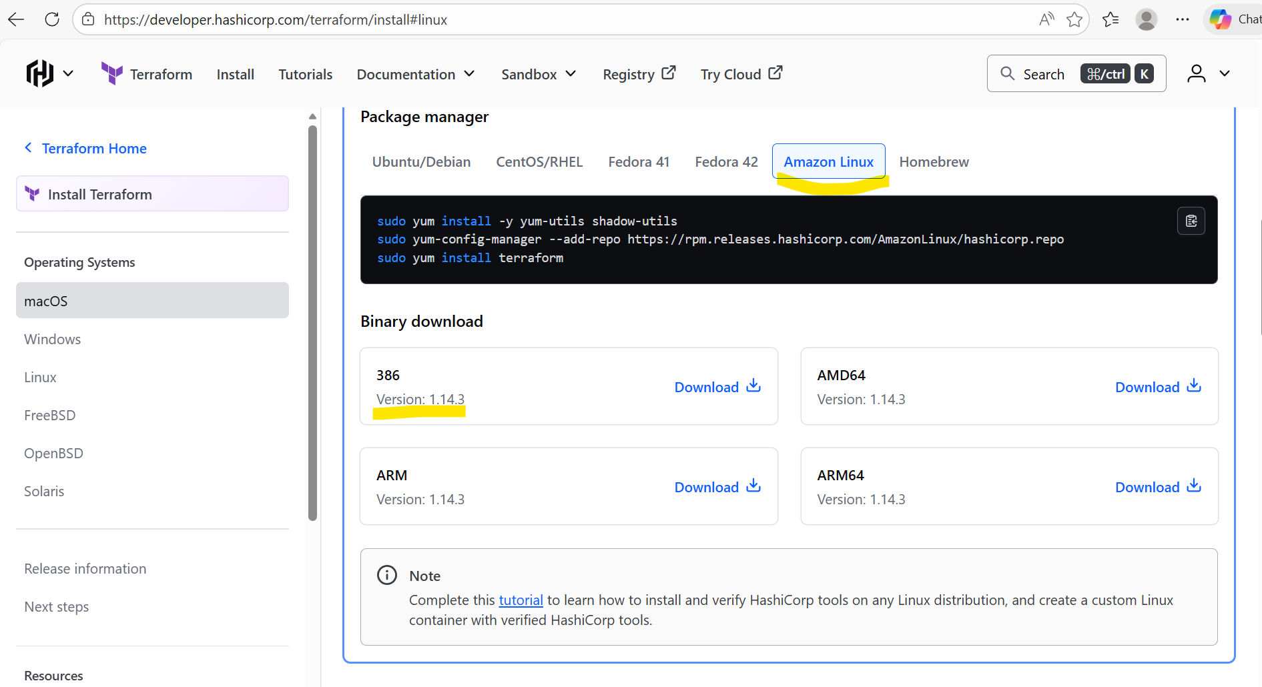

- Installed the packaged manager in Jenkins server.
sudo yum install -y yum-utils shadow-utils
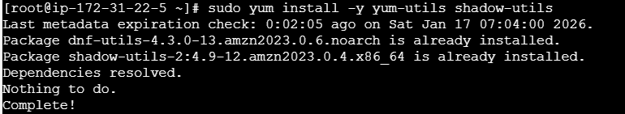

sudo yum-config-manager --add-repo https://rpm.releases.hashicorp.com/AmazonLinux/hashicorp.repo
sudo yum install terraform
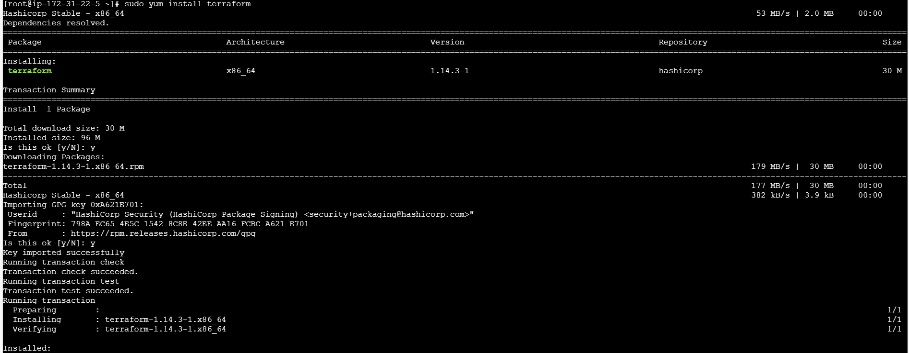
- Verify if Jenkins is active or restart Jenkins if required.
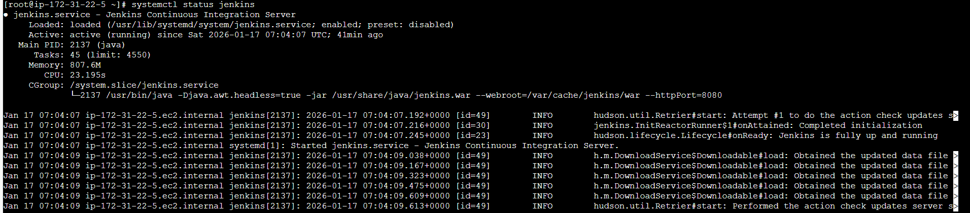

Step 3: Navigate to Jenkins GUI and install plugin Terraform
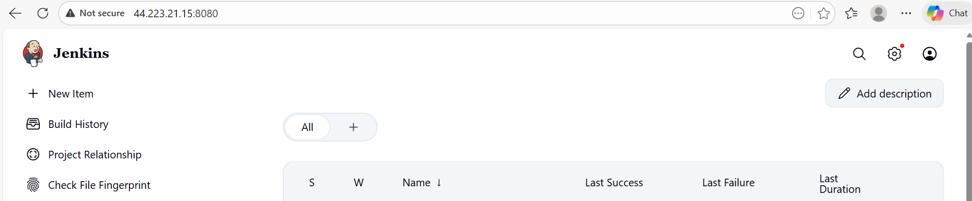
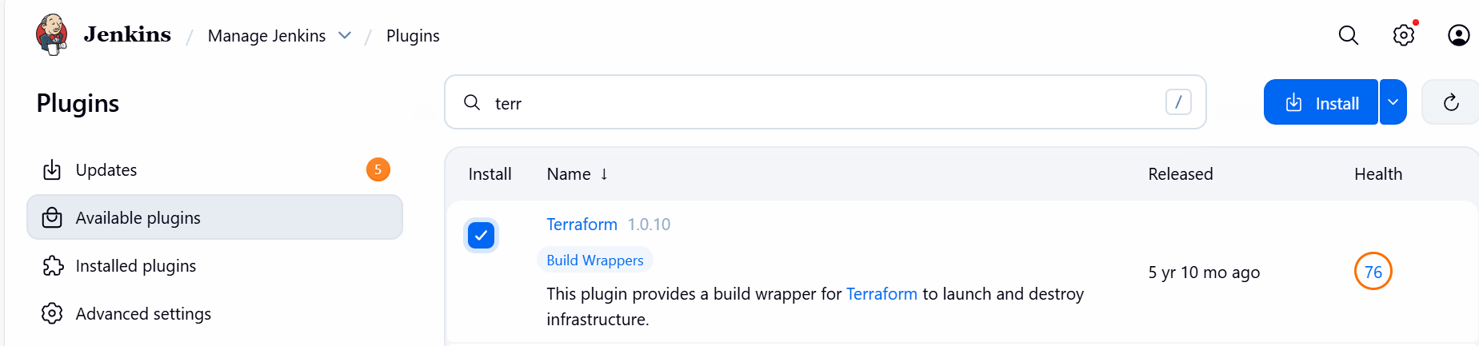
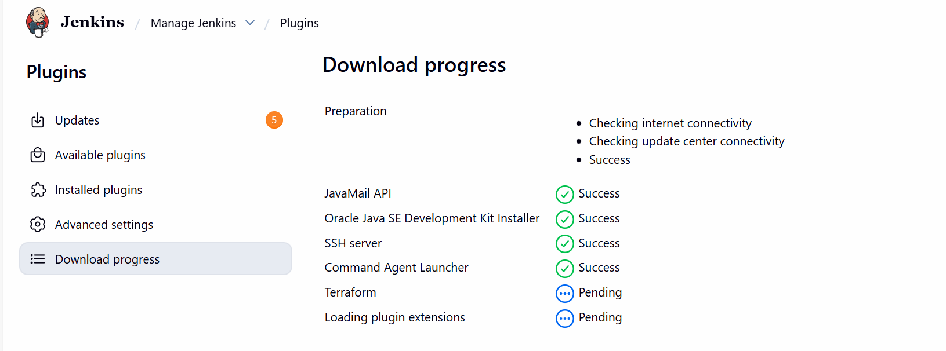

Installed
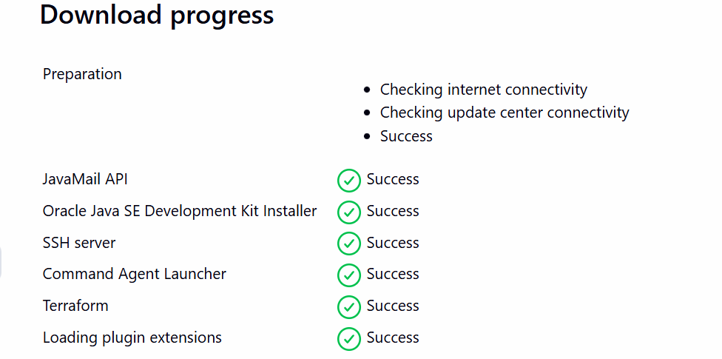

Step 4: Navigate to Manage Jenkins and add Terraform under Tools
Version: Terraform 51203 darwin (amd64)
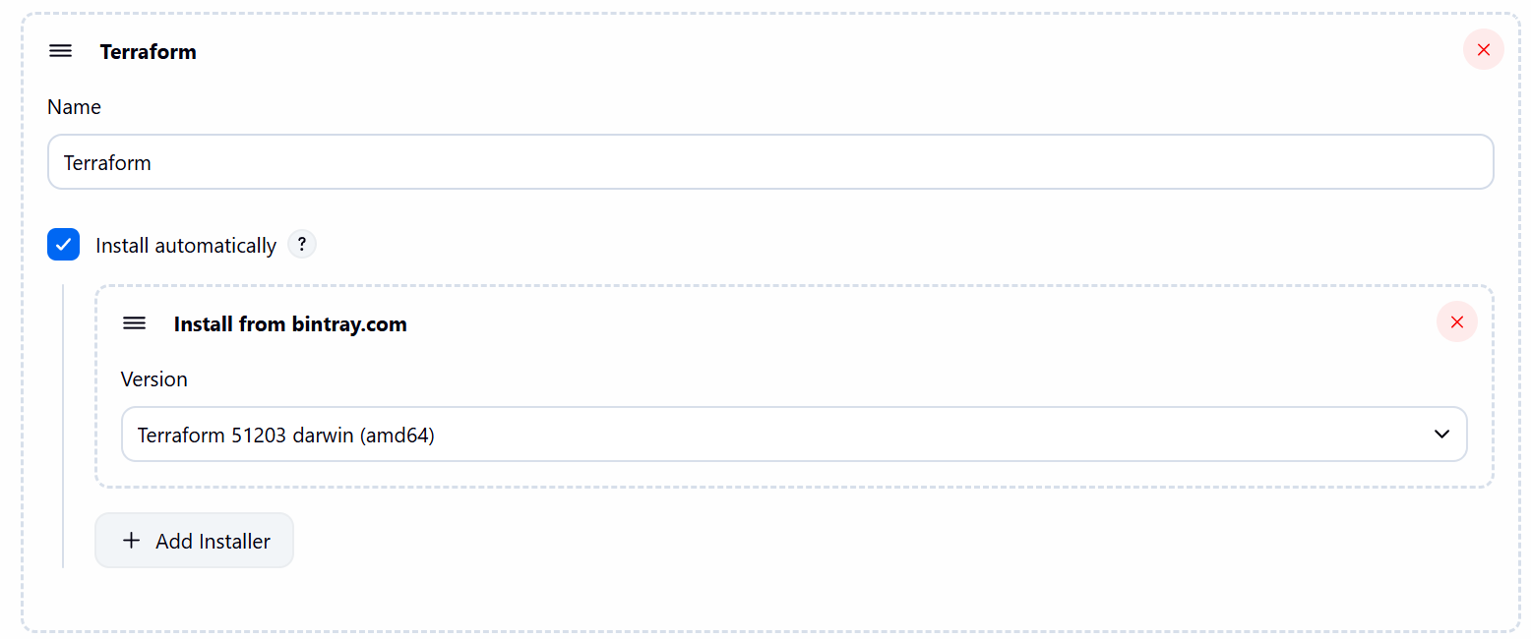

Step 5: Navigate to GitHub and create a repo- Terraform
- Mark Readme as required
- Visibility- Public
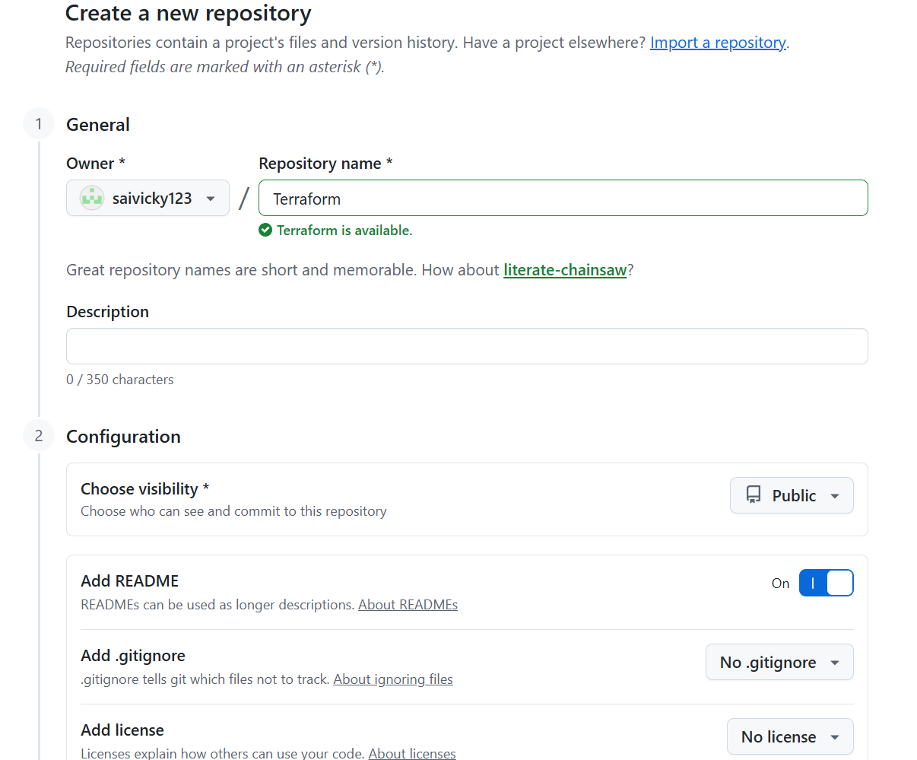

Step 6: Navigate to repo created and write a sample script to execute

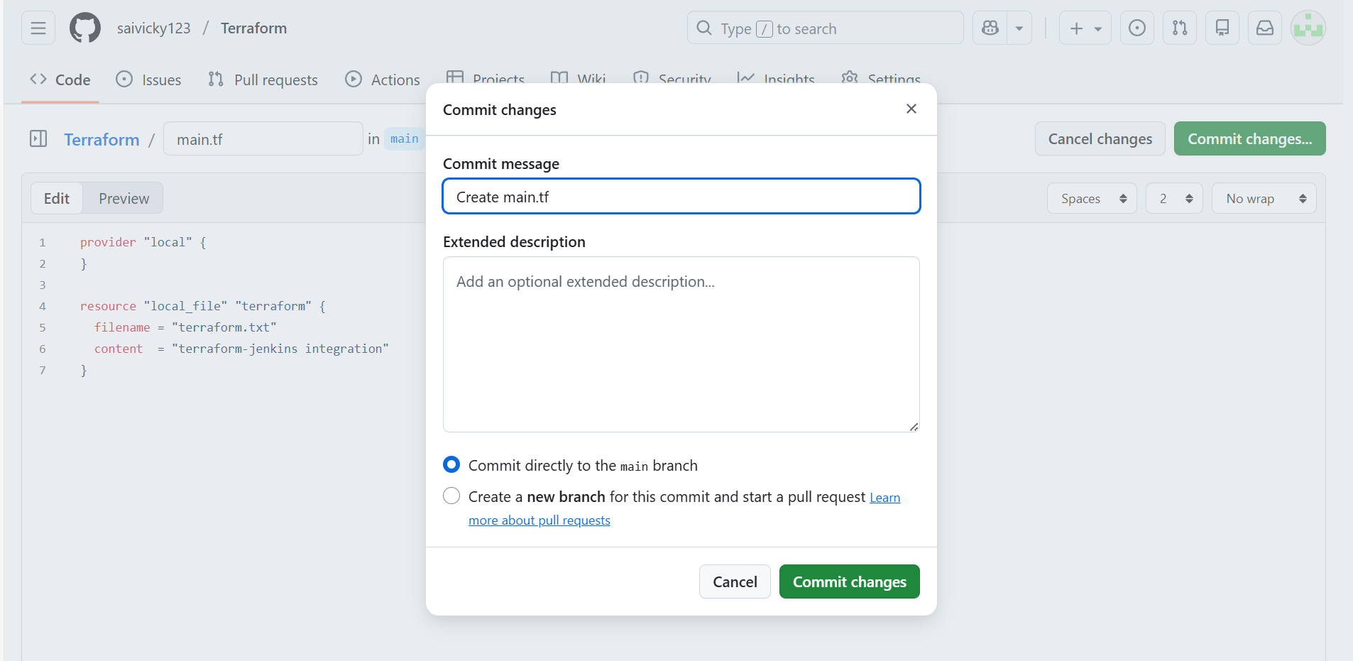
- Main.tf file created and script uploaded.
provider "local" {
}

resource "local_file" "terraform" {
filename = "terraform.txt"
content = "terraform-jenkins integration"
}
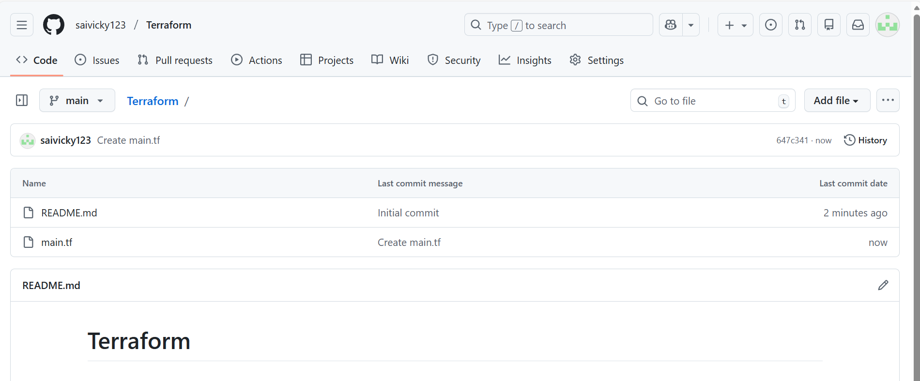

Step 7: Create a new job and write a script for Terraform
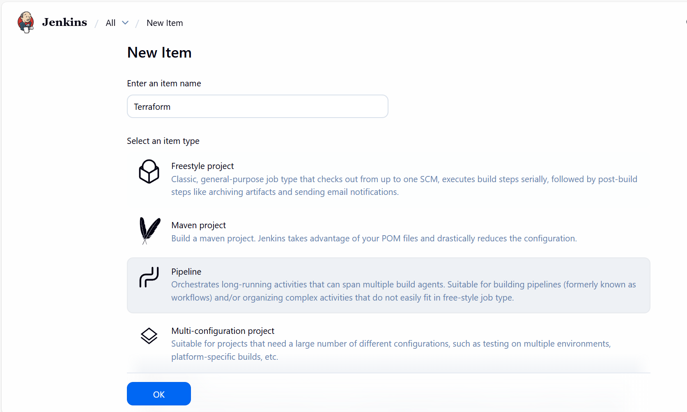

- Script updated and build now.
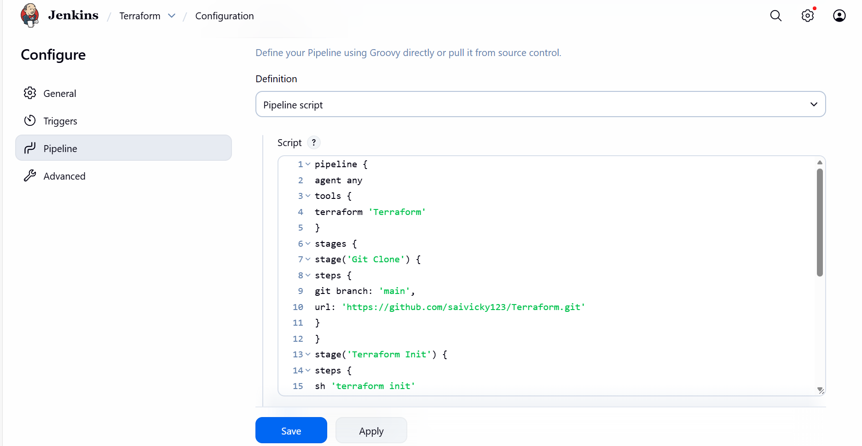

Ready for build
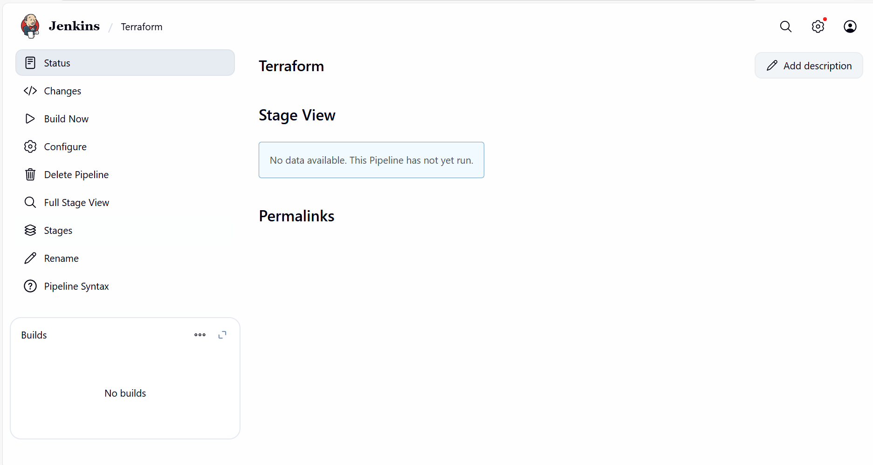

Step 8: Build completed and success.
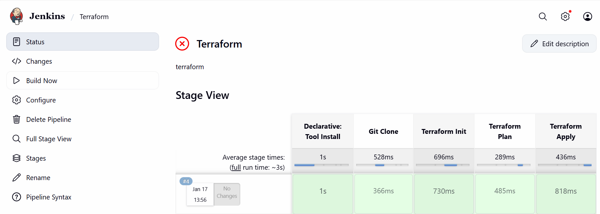

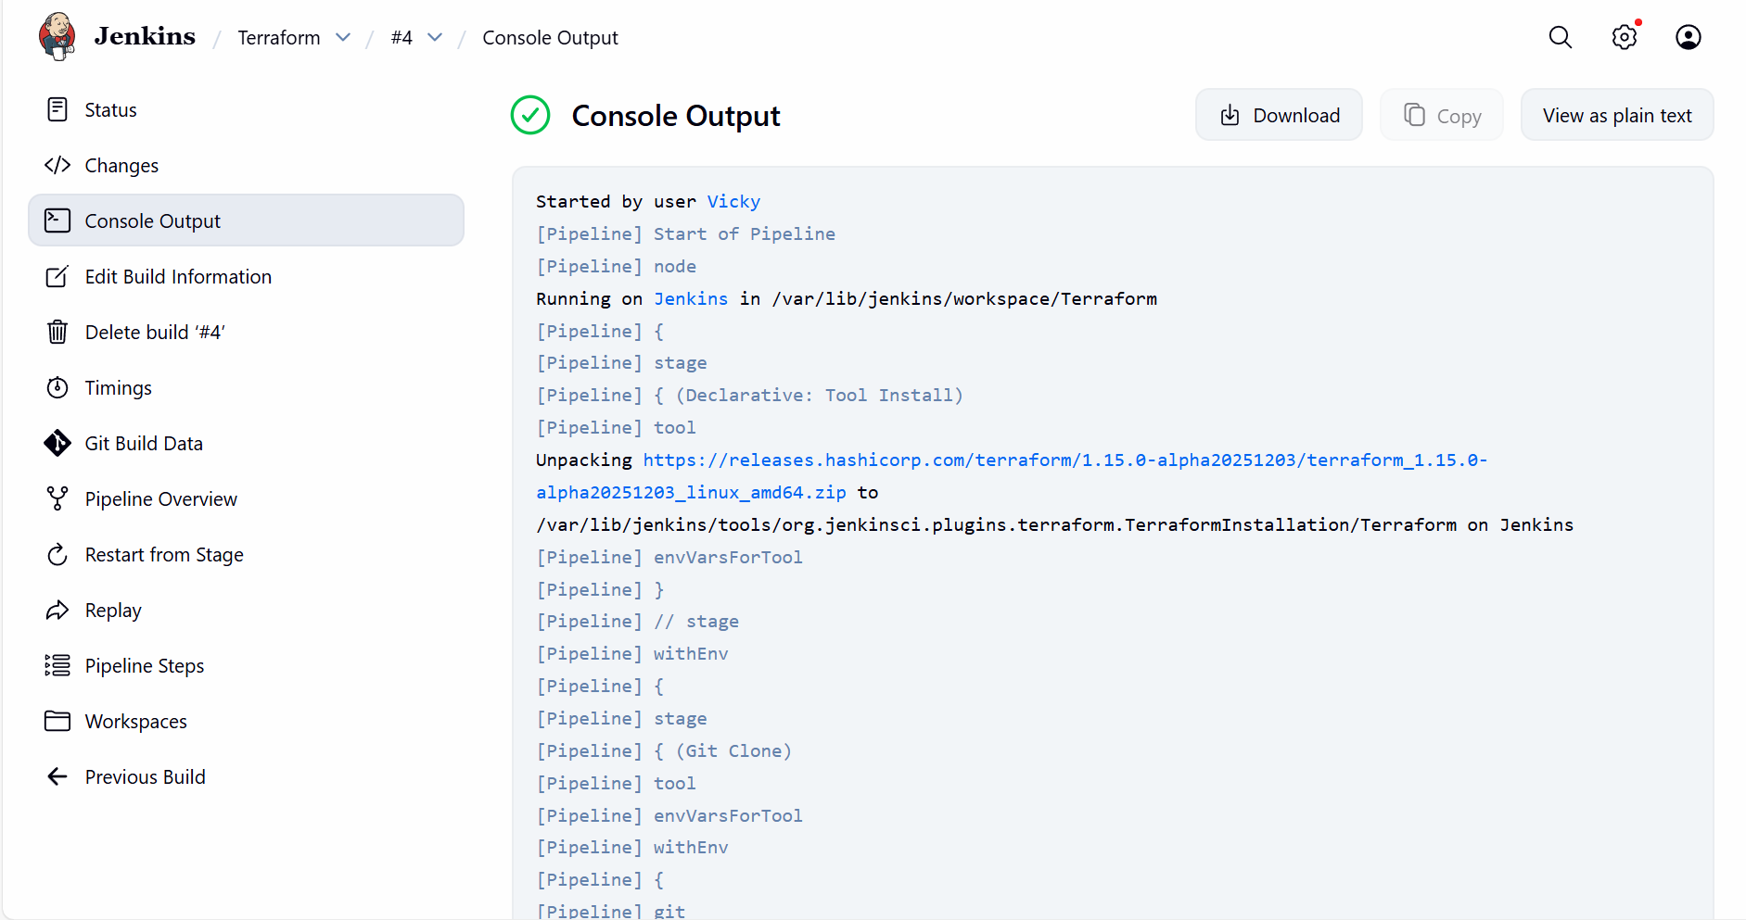

Issued faced:
While creating Terraform Manage Jenkins Tools
The version shouldn’t be automatically selected as build will have syntax error.
We should select Linux and amd64

My Pipeline script for Terraform:
pipeline {
agent any
tools {
terraform 'Terraform'
}
stages {
stage('Git Clone') {
steps {
git branch: 'main',
url: 'https://github.com/saivicky123/Terraform.git'
}
}
stage('Terraform Init') {
steps {
sh 'terraform init'
}
}
stage('Terraform Plan') {
steps {
sh 'terraform plan'
}
}
stage('Terraform Apply') {
steps {
sh 'terraform apply -auto-approve'
}
}
}
}

