Terraform-02

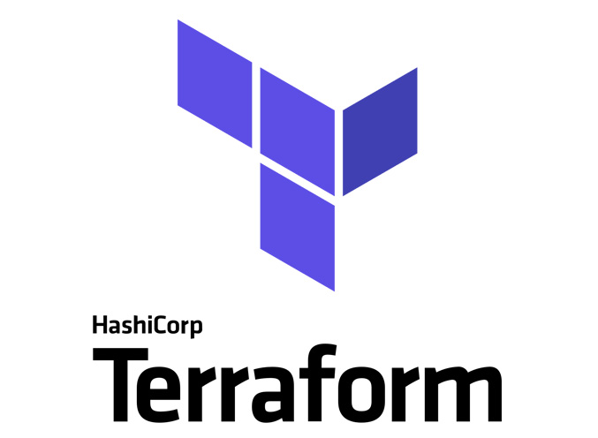

General tips for the Task below.
Task Title
Terraform-02
Objective
The objective of this task is to watch the Terraform-02 video posted on slack with and worked on executing templates shown in video.
Prerequisites
List all requirements before starting:
- AWS
- Visual studio code
- HashiCorp installed on both ec2 server and Windows
- Jenkins plugin- Terraform
Issues Faced: Briefly mention issues and how you fixed them. Posted below in the last.
Conclusion
Conclusion has been provided for every task at the end.
TASK 1- Watch the Terraform-02 video.
Execute all the templates shown in the video.

Providers of Terraform:
- Official – provided by Terraform
- Partner – provided by third party vendors
- Community – individual who can create

- Whenever we execute “terraform init” a .terraform will be created.
- Then, .terraform.lock.hel will be created as a Backup file.

Terraform.tfstate This will be created automatically when “Terraform apply” is executed.
- This is a blueprint and a metadata created by Terraform
- This will have the exact and complete information of our infrastructure
- This state file is our true source of data and by state file itself the execution is done.

Multiple ways to create a provider:
- Either, we can continue writing in the same directory and execute. Or else,
- We can create a new directory main.tf use a new provider.

In our case, we are going to continue writing in the same file.
- We are using a new provider- “random pet”
- So random is like, state file will randomly create a Name, ID etc.

Let’s create a small Terraform configuration (random) for testing:
resource "random_pet" "petname" {
prefix = "MR"
separator = "."
length = "1"
}
- A basic random provider configuration is updated in the same main.tf file.
- Always after writing the script do ctrl +s to save
- Then execute the below commands.
- Now, we shall do terraform init terraform plan terraform apply
- Let’s verify if the execution is getting executed.
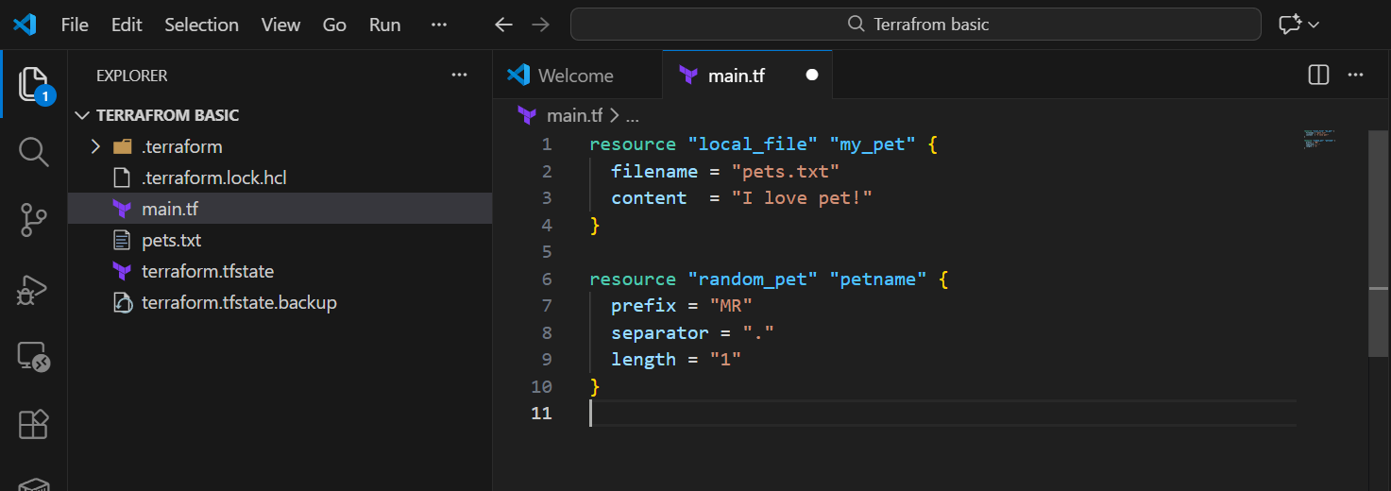
- Terraform init executed
- We can verify the versions of local provider and random provider is available.
- We can even use previous versions as well.
- Terraform will always use the latest version when “terraform init” is executed.
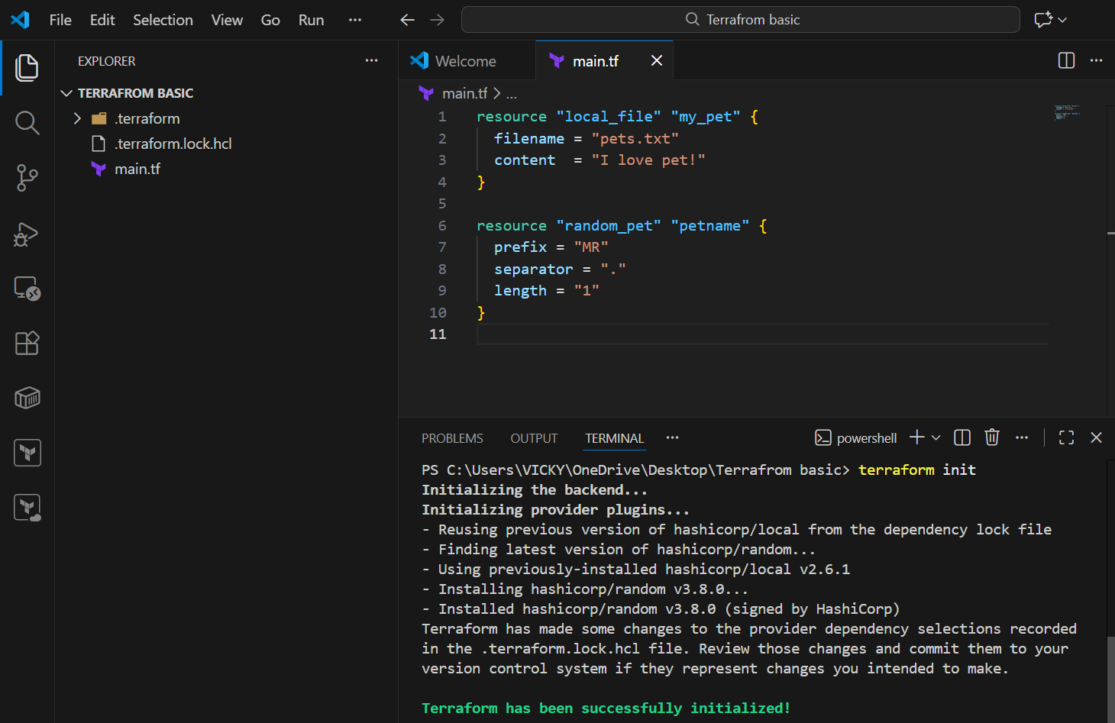

Terraform plan – Its now, ready for execution.
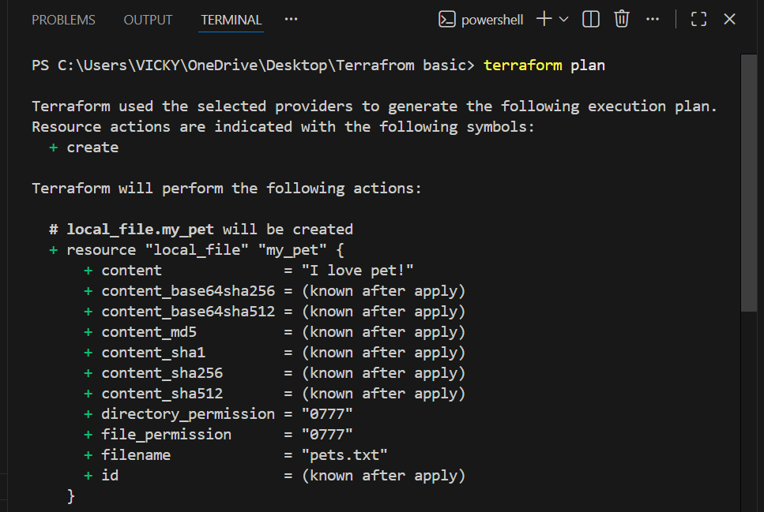
Terraform apply – Let’s execute the configuration provided for random provider.
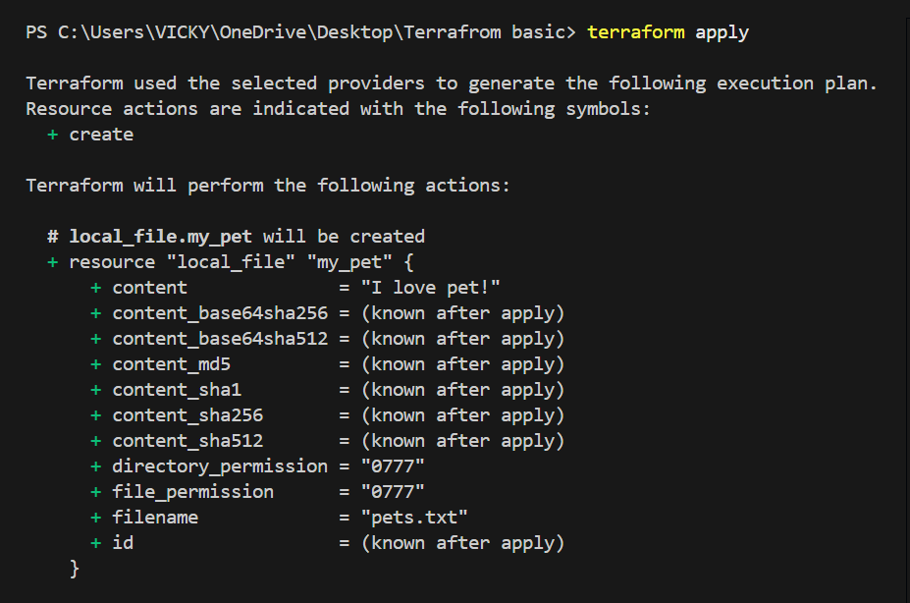
- 2 providers have been added to the main.tf
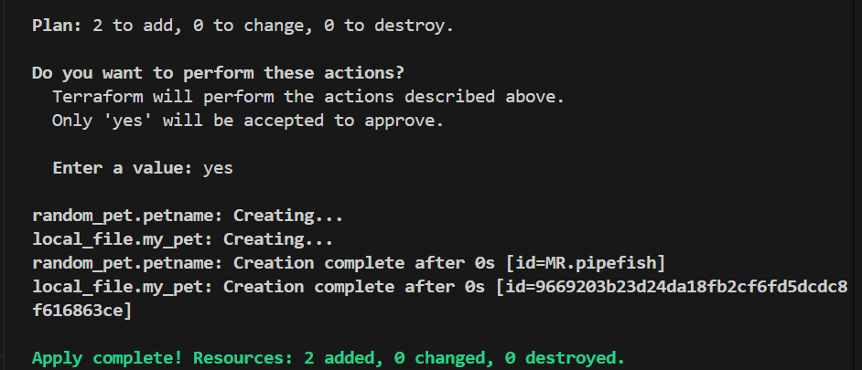

- If we need to verify the random names automatically provided by terraform we can find in the .tfstate file.
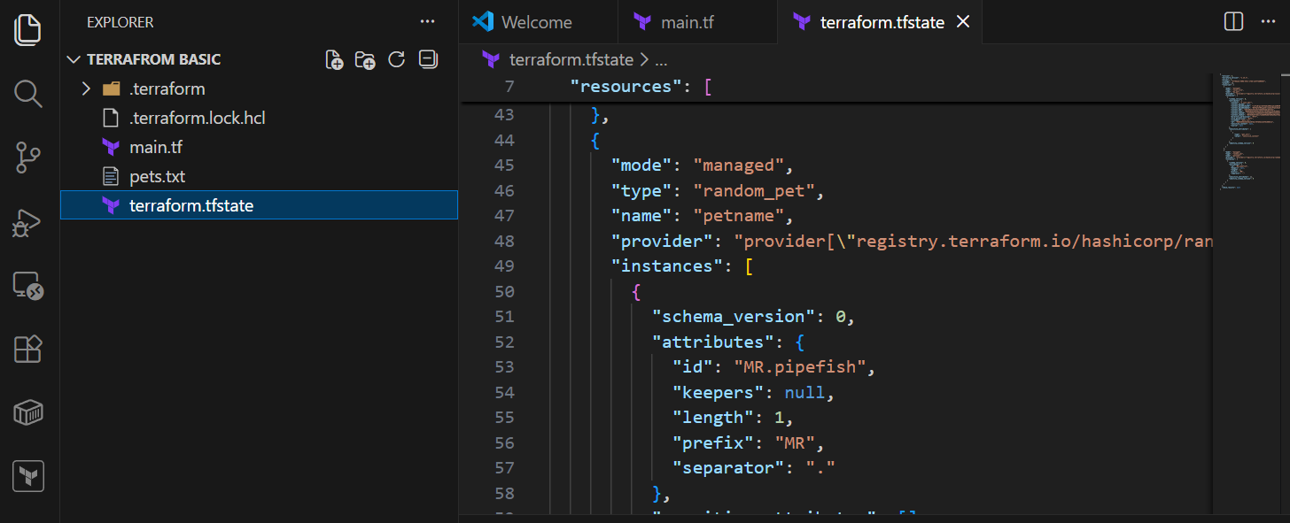

- Second most important to execute and verify is backup file.
- Even .tfstate file will have backup created, when there is a change to the existing state file.
- Let’s make a change to the existing state file.

- We changed content from pet dog in 1st provider
- We changed resource from petname dog in 2nd provider.
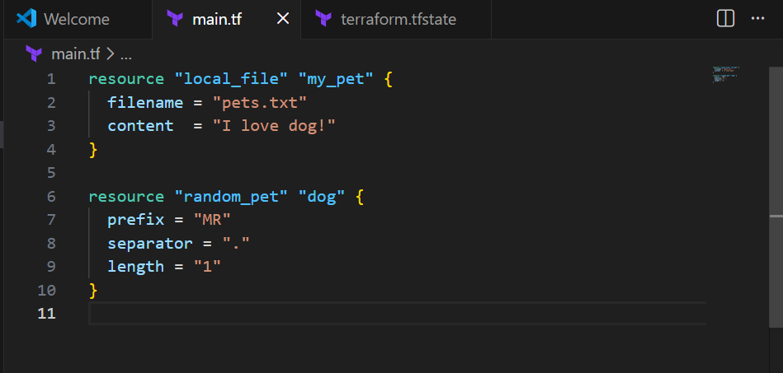

Let’s execute this state file and verify if backup. tfstate file is created?
Executed terraform plan
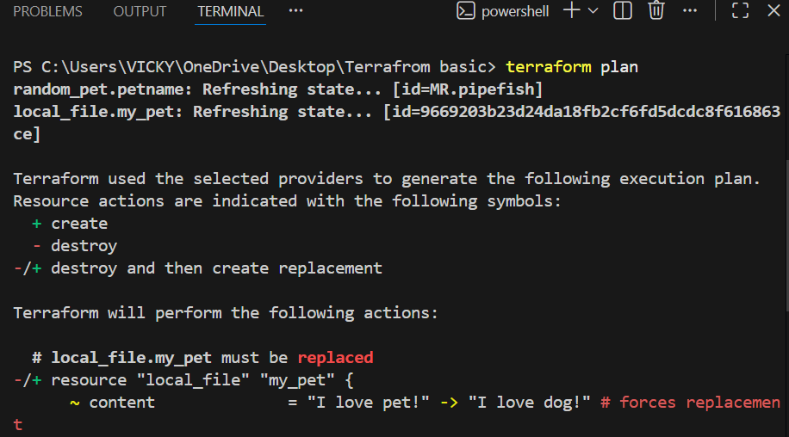
- We can see in the below screenshot that, 2 to add and replacing the changes being made.
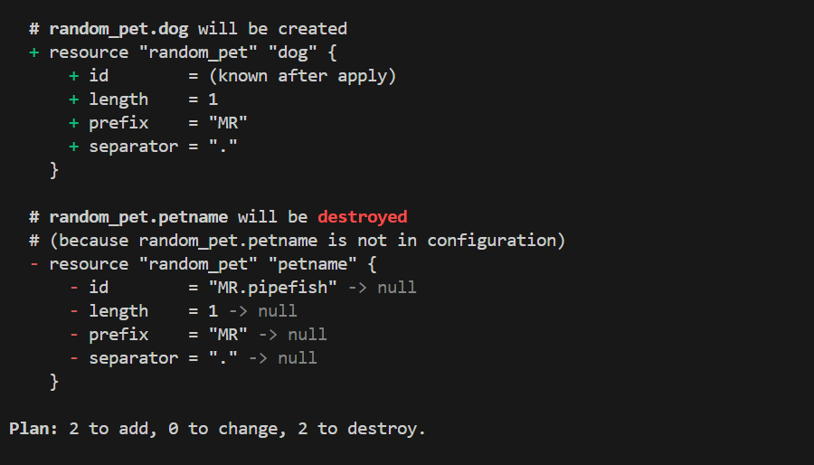
- Terraform apply executed and changed the modification.
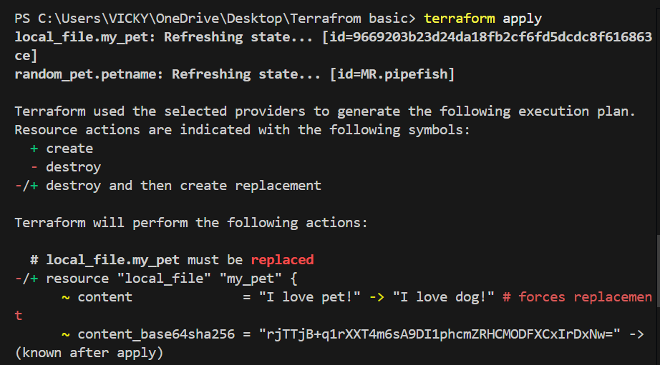

- We can verify in the below that the changes made to the configuration is destroyed and created with updates made.
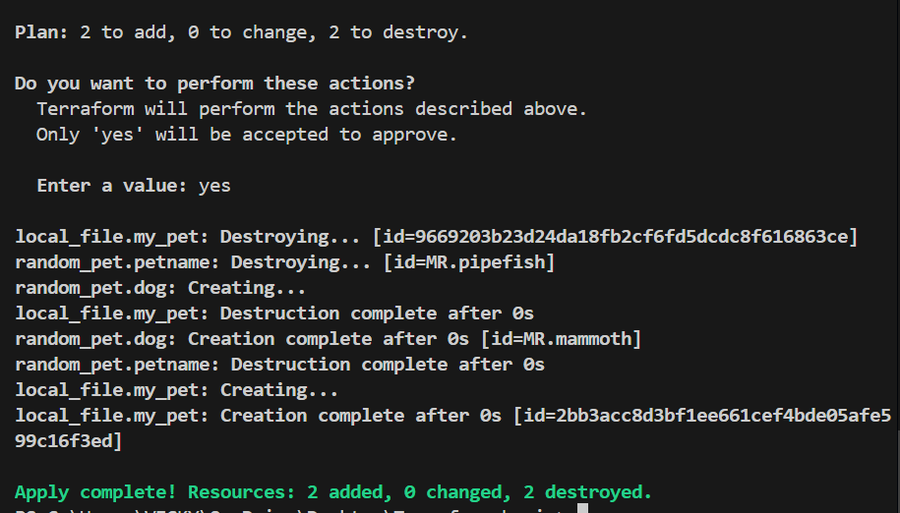

- Let’s verify if the .tfstate backup created?
- Terraform.tfstate. backup created automatically when a change made to the existing. tfstate file.
- It’s always best to make changes in the provider, not in the .tfstate file.
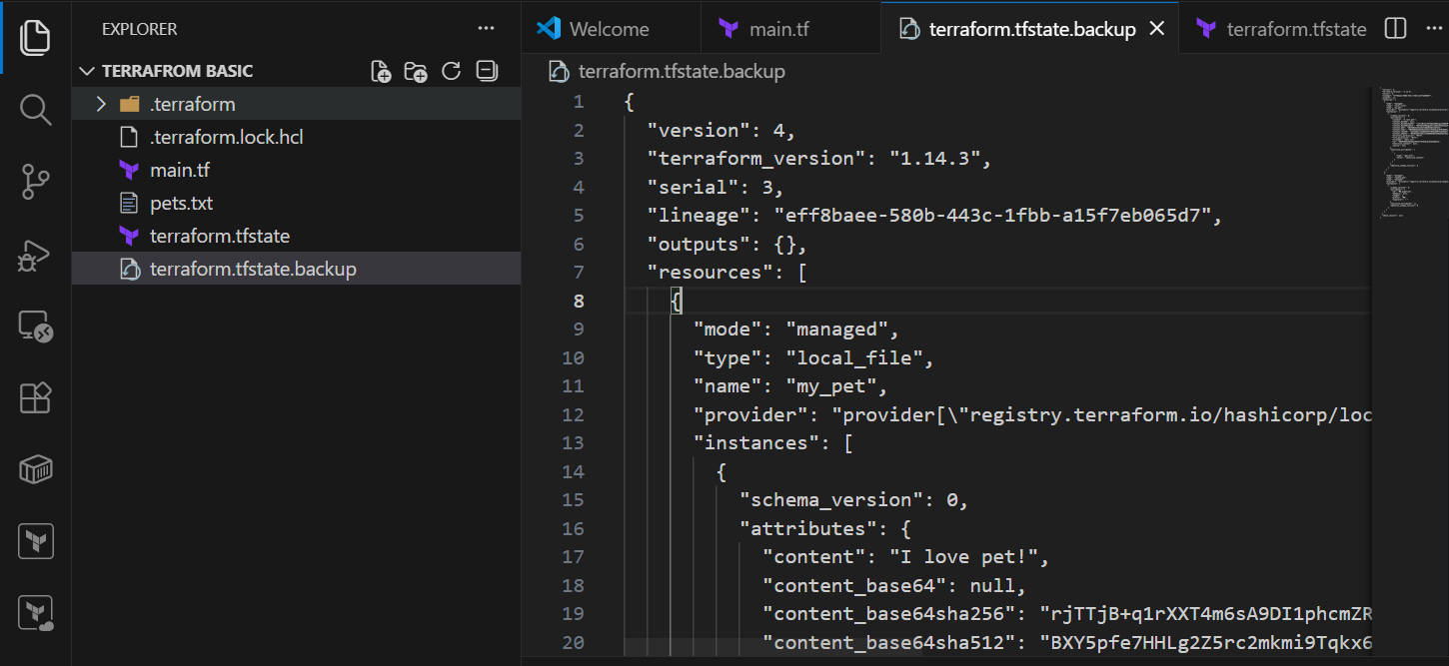

Configuration Directory:
- Main.tf – main configuration file containing resource
- Variables.tf – contains variable declaration
- Output.tf – contains outputs from resources
- Provier.tf – contains the provider definition

- Mainly, we will be using main.tf and variables.tf in Terraform.

- Terraform Immutable vs Mutable infrastructure:

Immutable: Immutable means deleted the one infrastructure and creating a new one.
Mutable: Mutable means using the same existing infrastructure and updating the system with newer version.

- Terraform uses Immutable infrastructure by destroying the previous version and creating a new one.
- Example, if there is a new version if nginx is available, then the previous version of server will be destroyed and new server will be launched.
- This is how Immutable infrastructure works.

Next Topic
Lifecycle Rules- Terraform

There are 3 lifecycle rules in Terraform
- Create_before_destroy
- Prevent_destroy
- Ignore_changes

- Let’s perform an example of create_before_destroy
- Below, in the existing provider – we added lifecycle and create_before_destroy = true
- Changed content from dog cat
- Now, we shall verify if the execution happens creating first and destroying next.
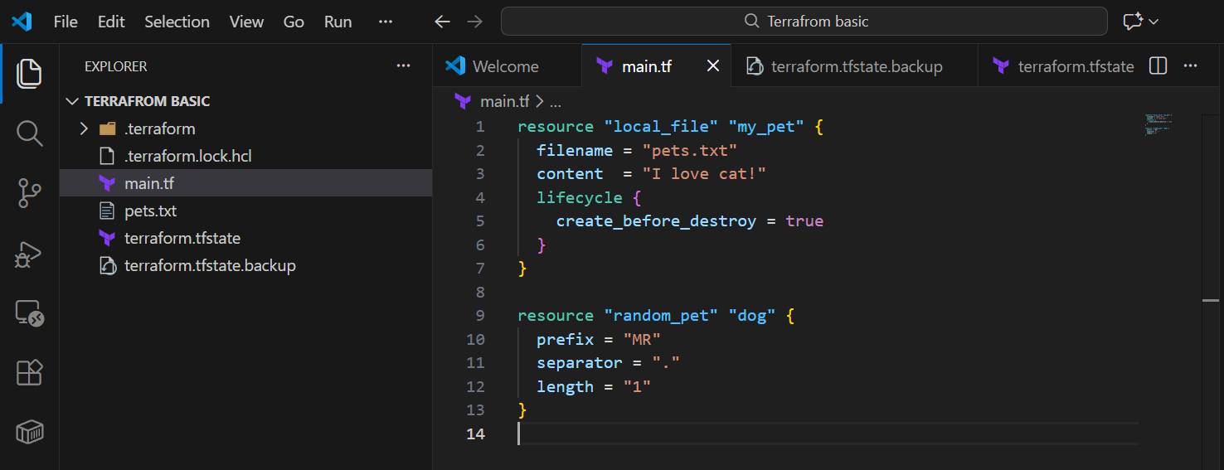
- Here, we executed the changes made- terraform apply
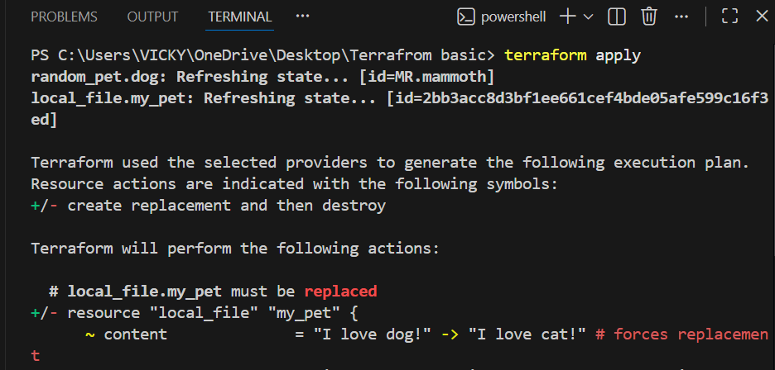
- We can see here that, the changes made was first created and destroyed later.
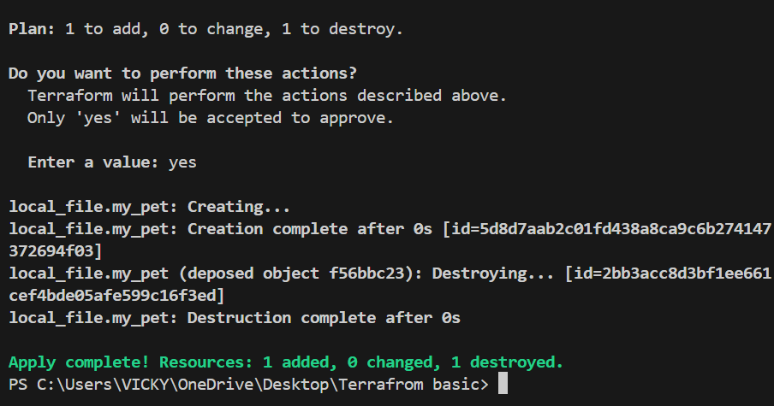

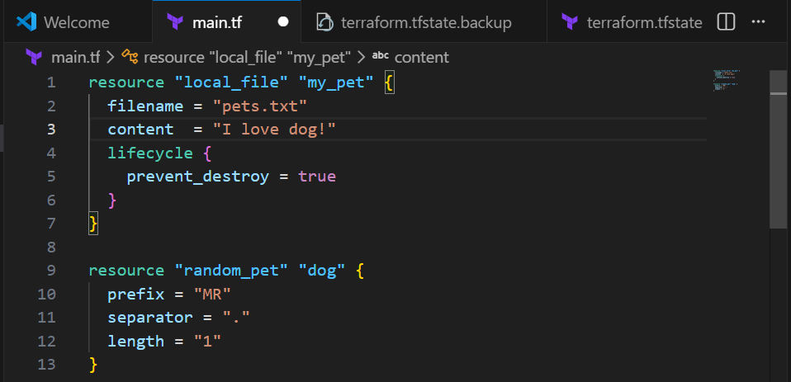

- Let’s create an example for “prevent_destroy”

- Below, in the existing provider – we added lifecycle and prevent_destroy = true
- Changed content from cat dog
- Now, we shall verify if the execution happens

Why do we need to use this life cycle rule
Ans. When someone is trying to destroy/apply to the existing configuration, an error should pop up stating this configuration has set-up prevent_destroy.

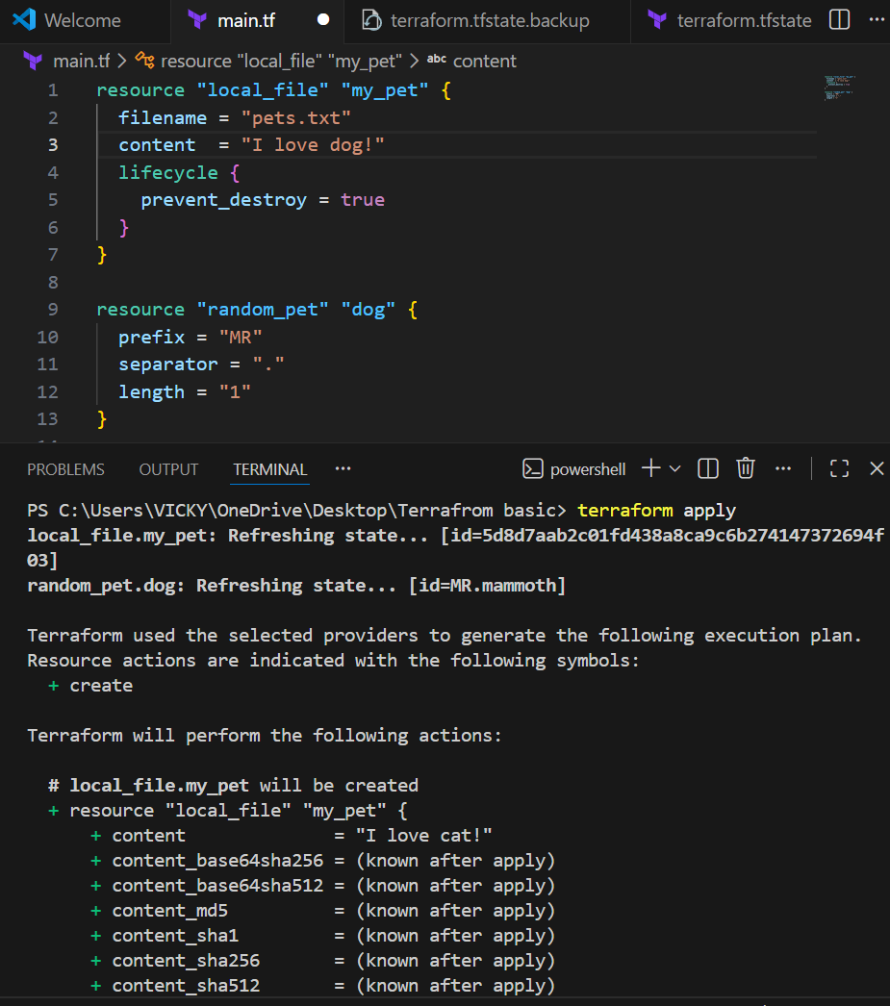

- We can see in the below screenshot that, one to add, 0 to change, 0 to destroy.
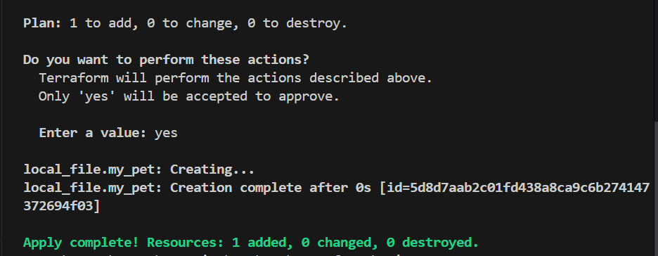
- Now, we made a change to content from cat parrot and executed “terraform apply”.
- We can see an error popped up, that to disable prevent_destroy.
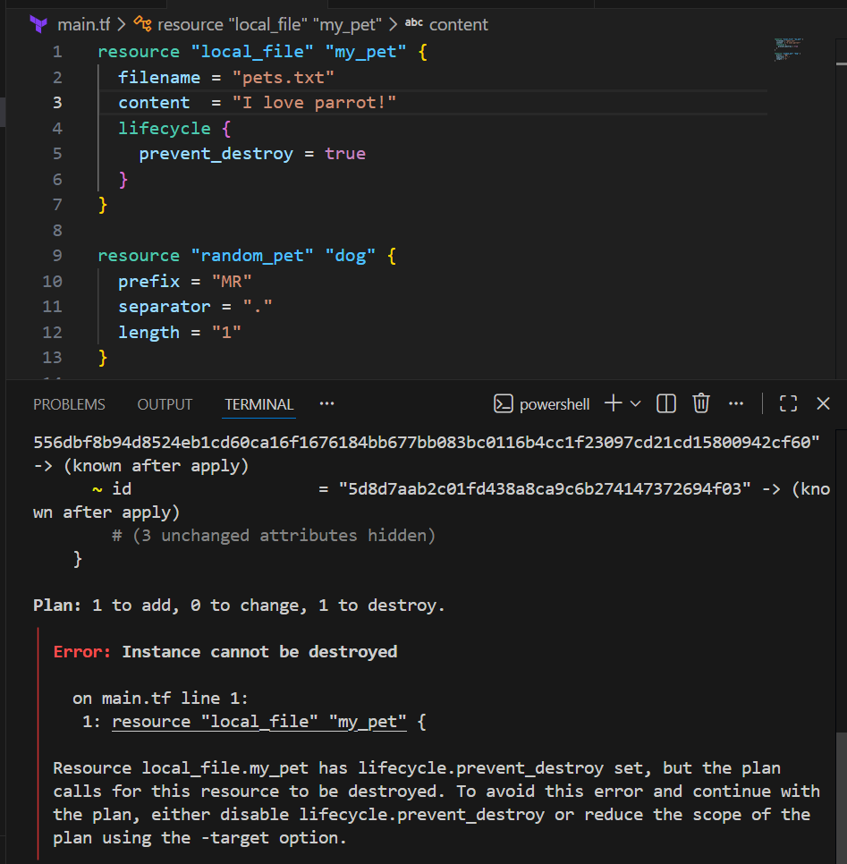
- Below, in the existing provider – we added lifecycle and ignore changes = [ content ]
- Changed content from cat dog
- Changed content in .tfstate file as well.
- Now, we shall verify if the execution happens – terraform apply

Success – we can see that, no changes.
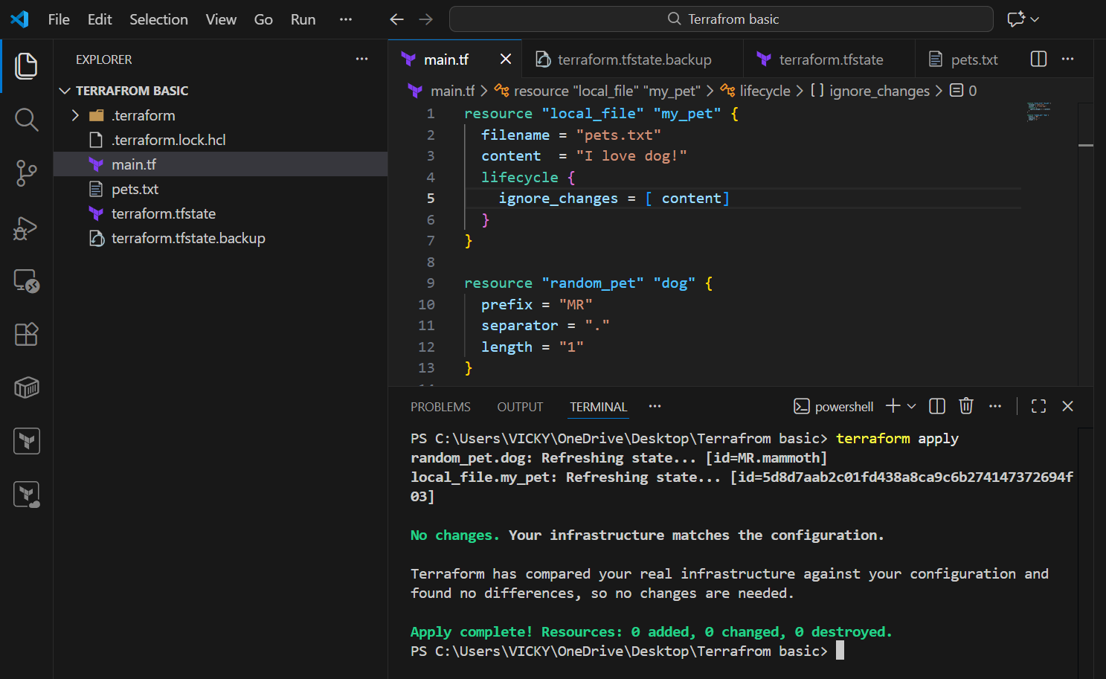

Next Topic
Hard coded vs Soft coded

Hard coded:
What is hard coded?
Ans. It’s always not a best practice to make all the changes in main.tf file
Instead, we need to create a file – variables.tf and soft code and make all the changes in the variables.tf file, not on main.tf file.
That is the difference between Hard coded and Soft coded.

Let’s perform an example in VS Code.
- Created a file name – variables.tf
- Updated the below variables “filename” and “content”

variable "filename" {
default = "pets.txt"
type = string
}
variable "content" {
default = "I love DOGS"
}

- Made changes to main.tf

resource "local_file" "my_pet" {
filename = var.filename
content = var.content
}
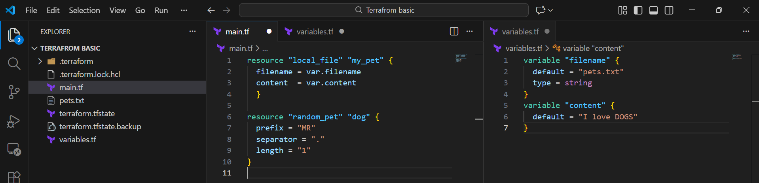

- Execute command- terraform apply
- Verified- pets.txt file got created automatically.
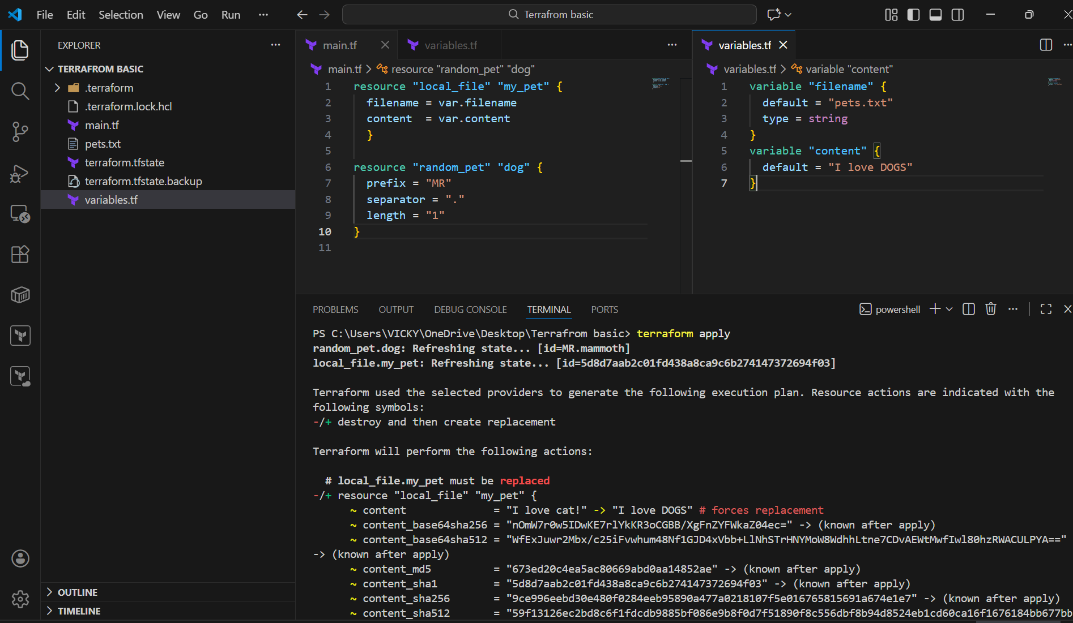

Updated the variables.tf and main.tf
Updated for second provider- random conf.
- Added variable “prefix” and “length”
- Updated main.tf for “prefix” and “length”
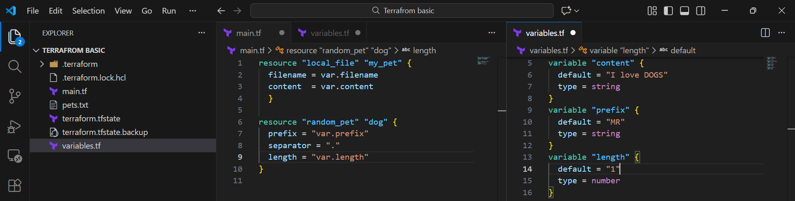

- It’s time for execution.

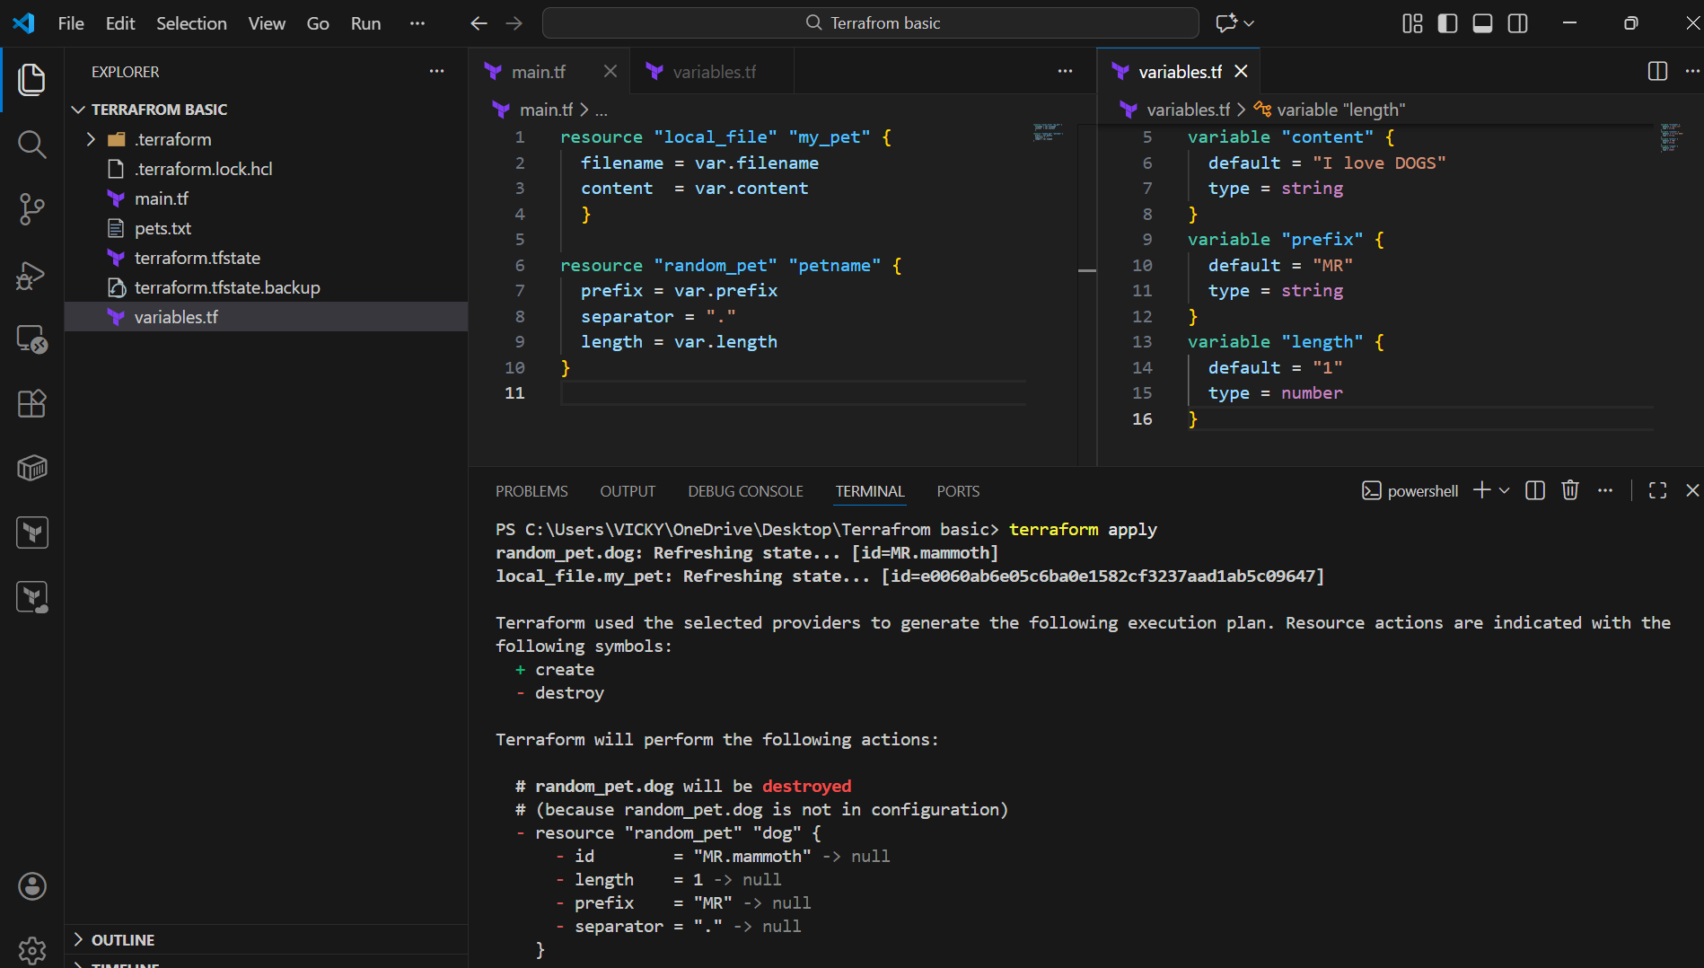
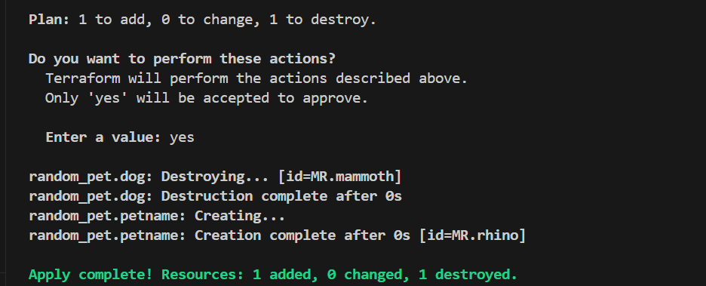

- We saw how variables work when soft coded.

- We shall now see, how to use variables with no content.
- Please refer to below screenshot.
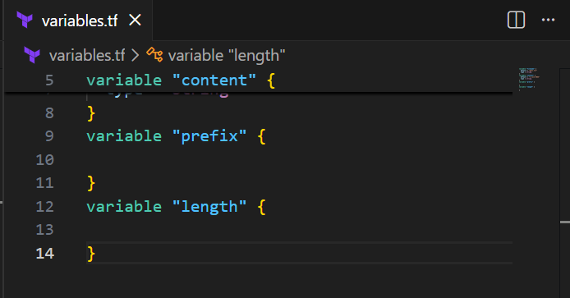
- Terraform apply
- I changed the value from length- 2 and prefix- MRS
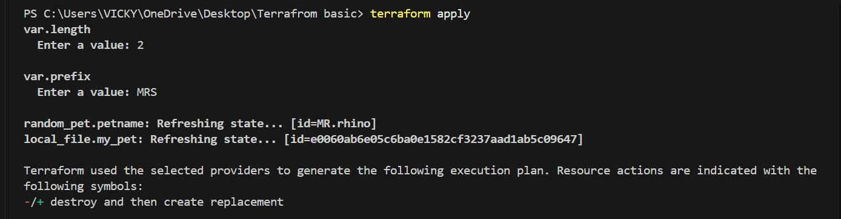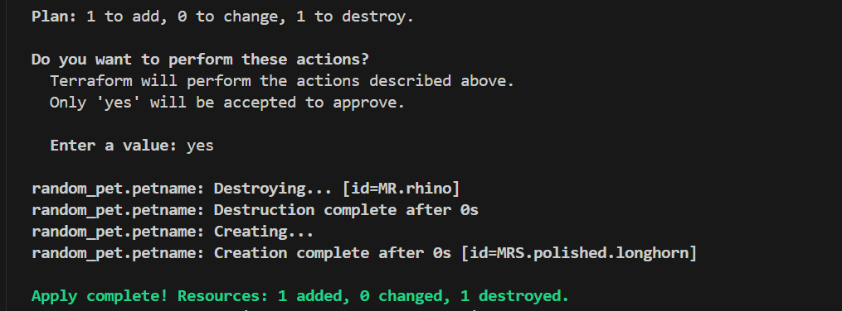

- We have an alternative method of running the variable without content by using below command- terraform apply -var “filename=wild.txt” -var “content=I love tiger”
- Filename and content used is an example.
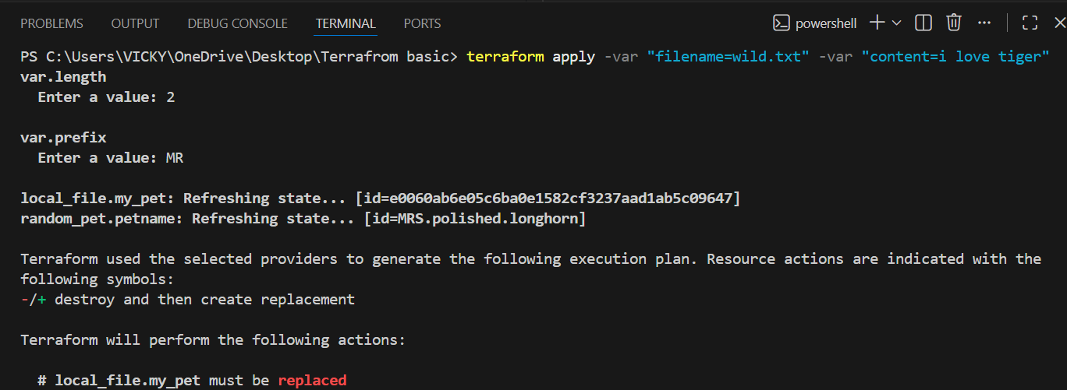

TASK 2- Integrate Terraform in Jenkins using the Terraform plugin.
Step by step Implementation:
Step 1: Navigate to AWS ec2 and launch Jenkins server.
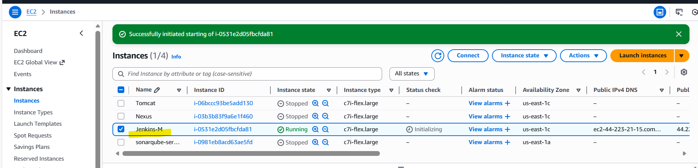
- Connect to the instance
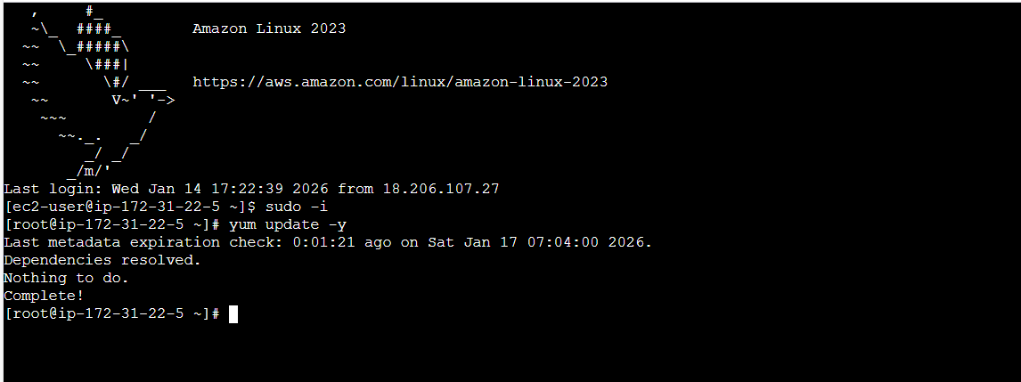

Step 2: Navigate to Terraform registry and install Terraform for Amazon Linux.
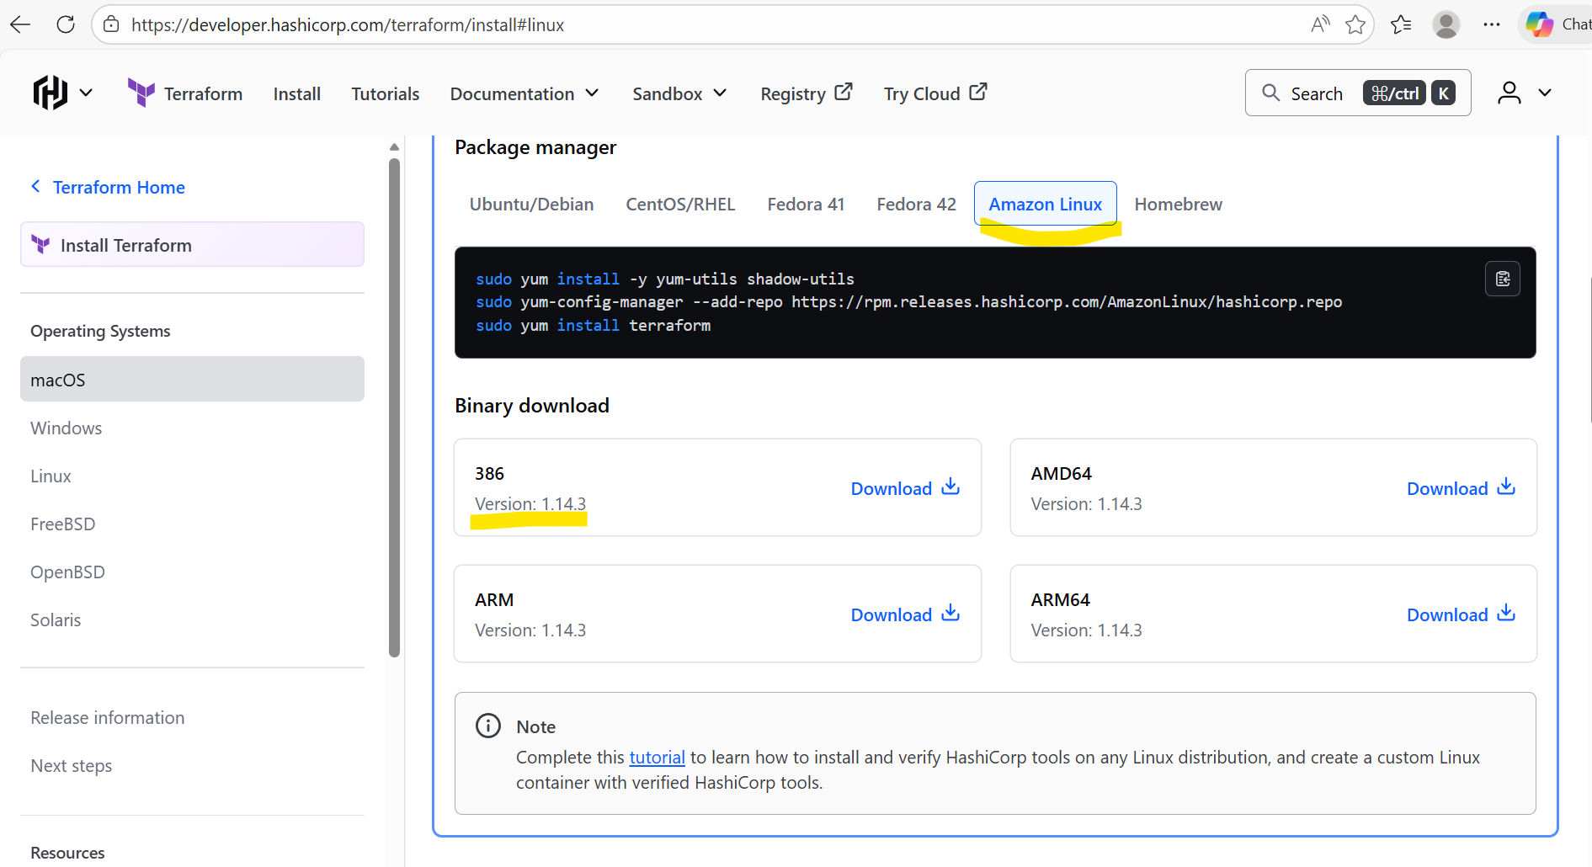

- Installed the packaged manager in Jenkins server.
sudo yum install -y yum-utils shadow-utils
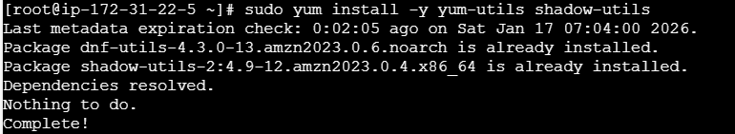

sudo yum-config-manager --add-repo https://rpm.releases.hashicorp.com/AmazonLinux/hashicorp.repo
sudo yum install terraform
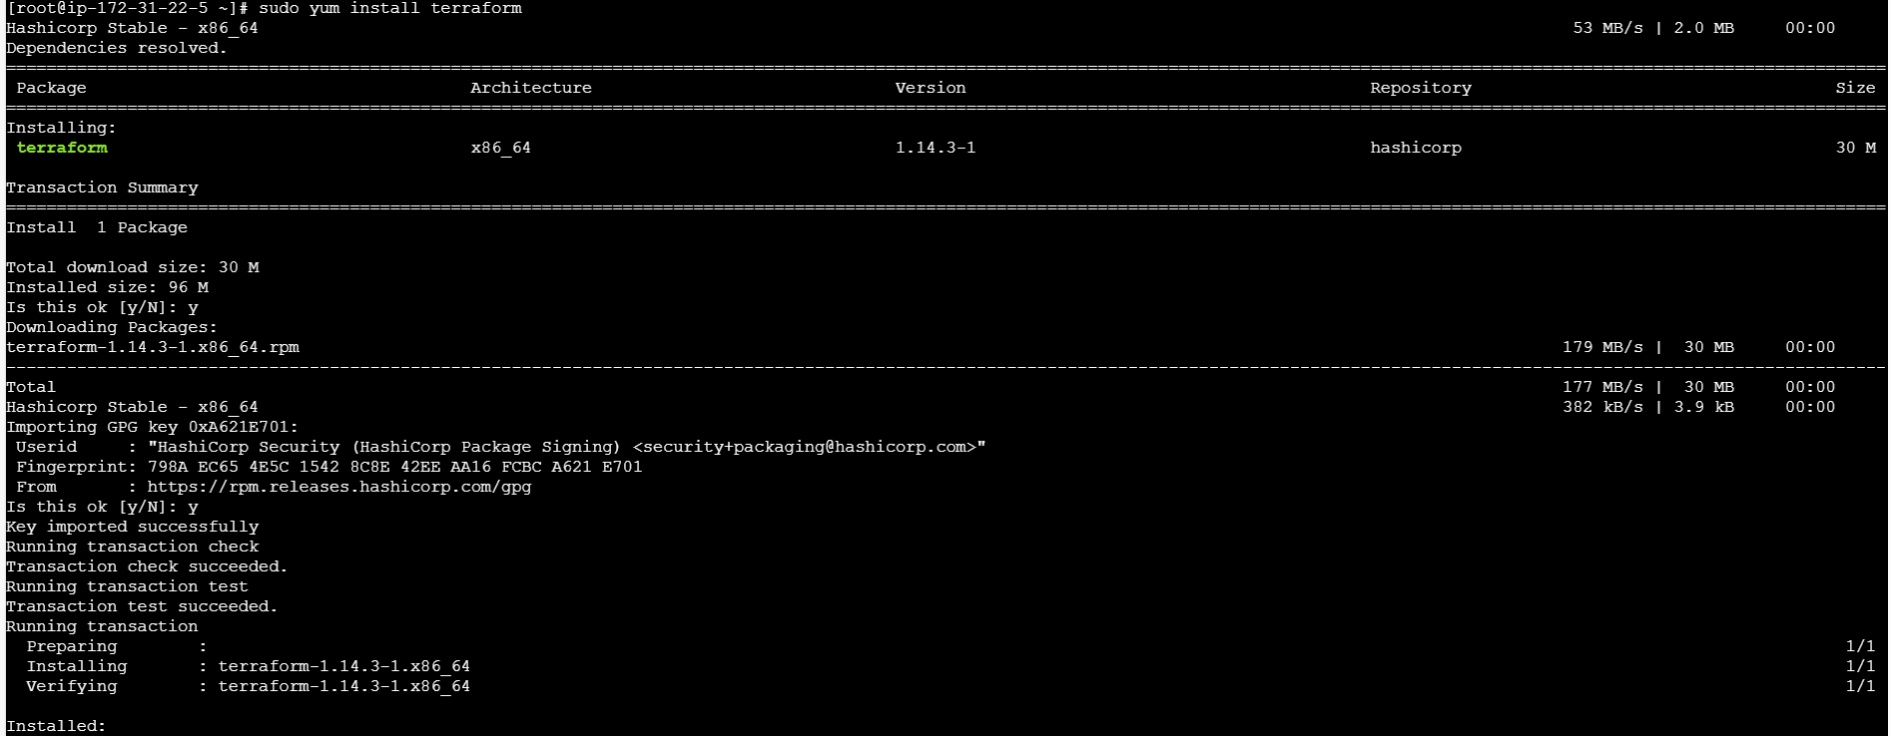
- Verify if Jenkins is active or restart Jenkins if required.
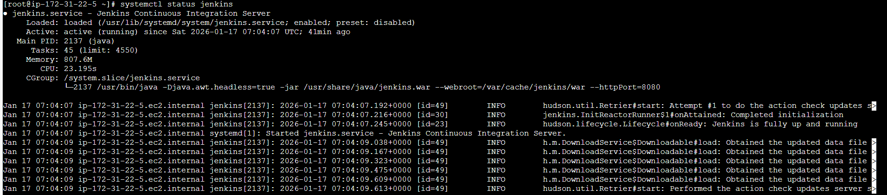

Step 3: Navigate to Jenkins GUI and install plugin Terraform
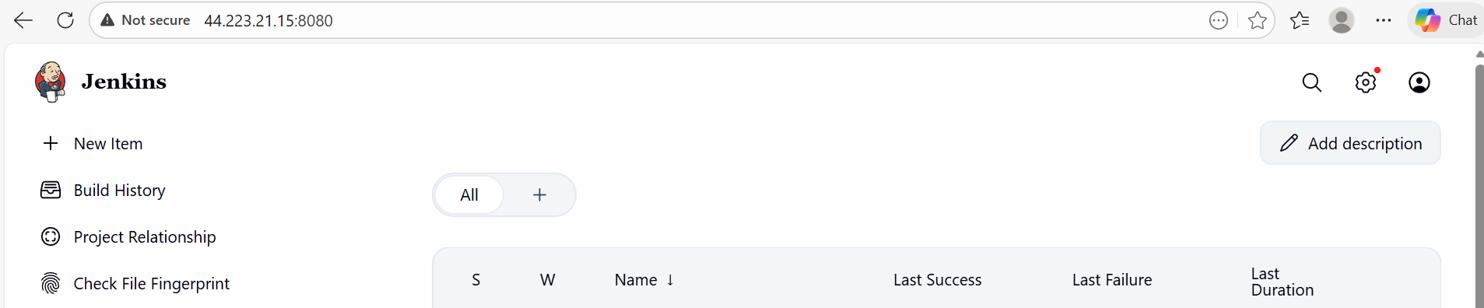
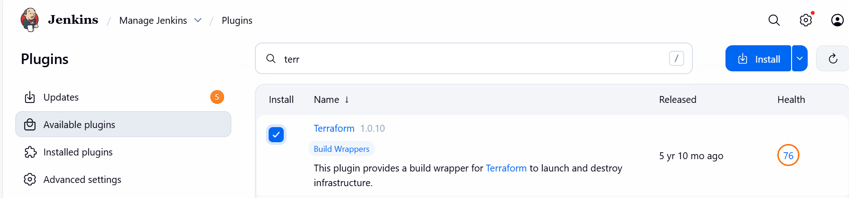
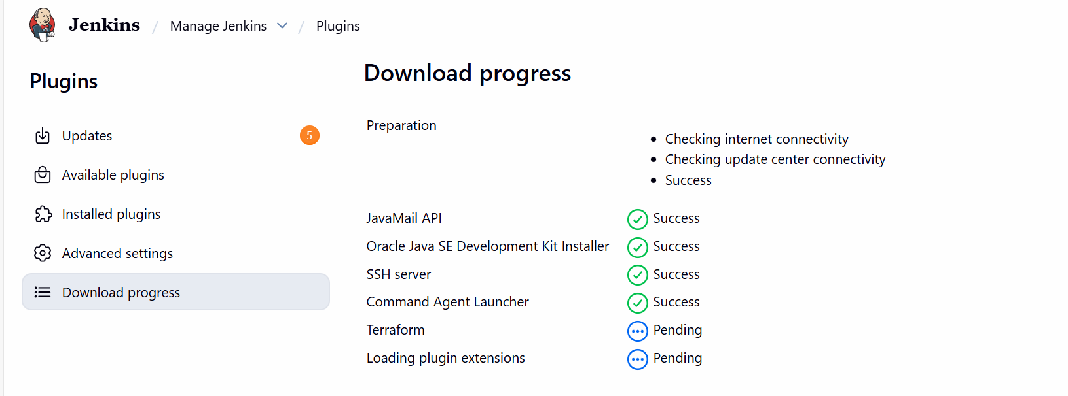

Installed
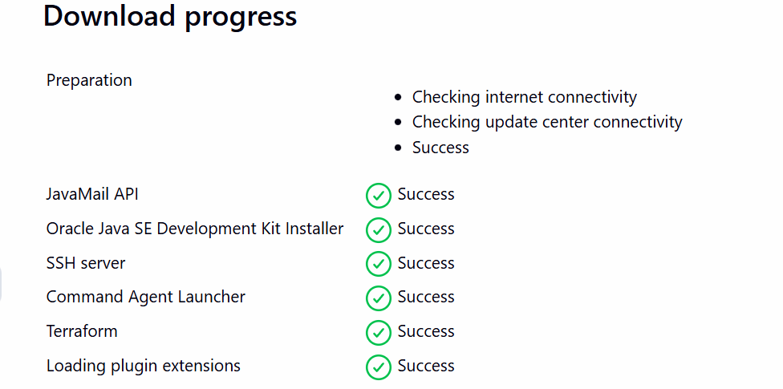

Step 4: Navigate to Manage Jenkins and add Terraform under Tools
Version: Terraform 51203 darwin (amd64)
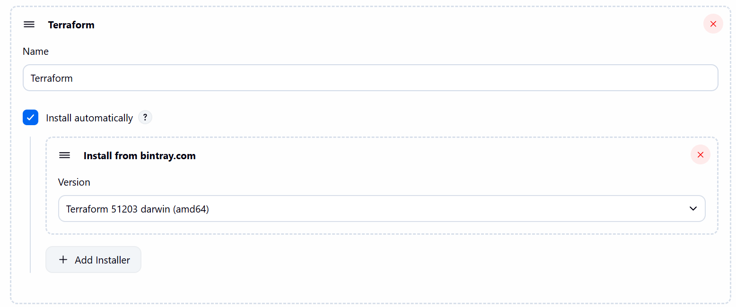

Step 5: Navigate to GitHub and create a repo- Terraform
- Mark Readme as required
- Visibility- Public
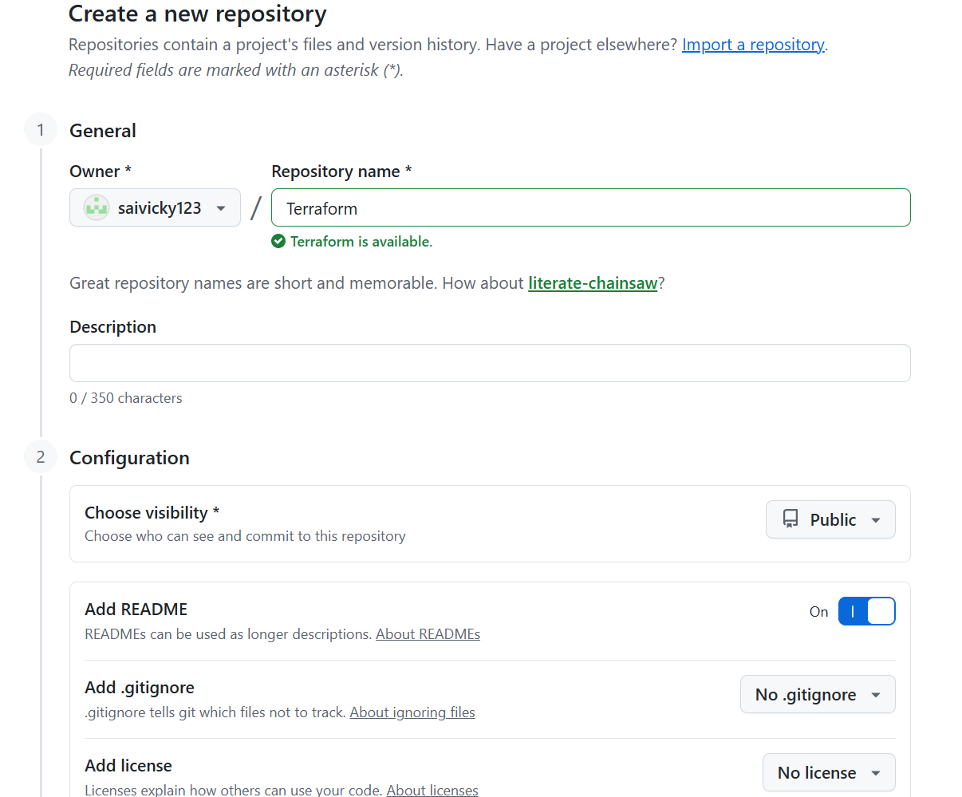

Step 6: Navigate to repo created and write a sample script to execute

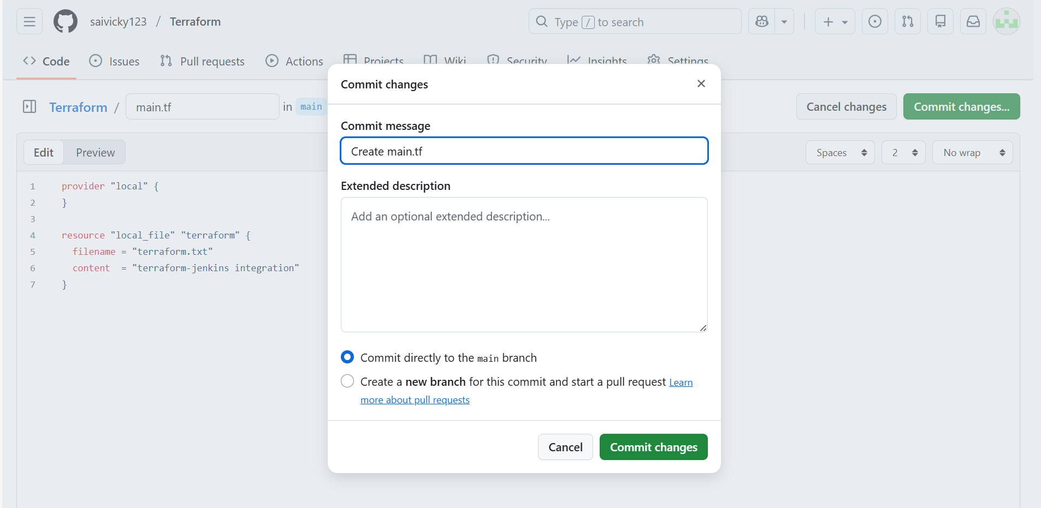
- Main.tf file created and script uploaded.
provider "local" {
}

resource "local_file" "terraform" {
filename = "terraform.txt"
content = "terraform-jenkins integration"
}
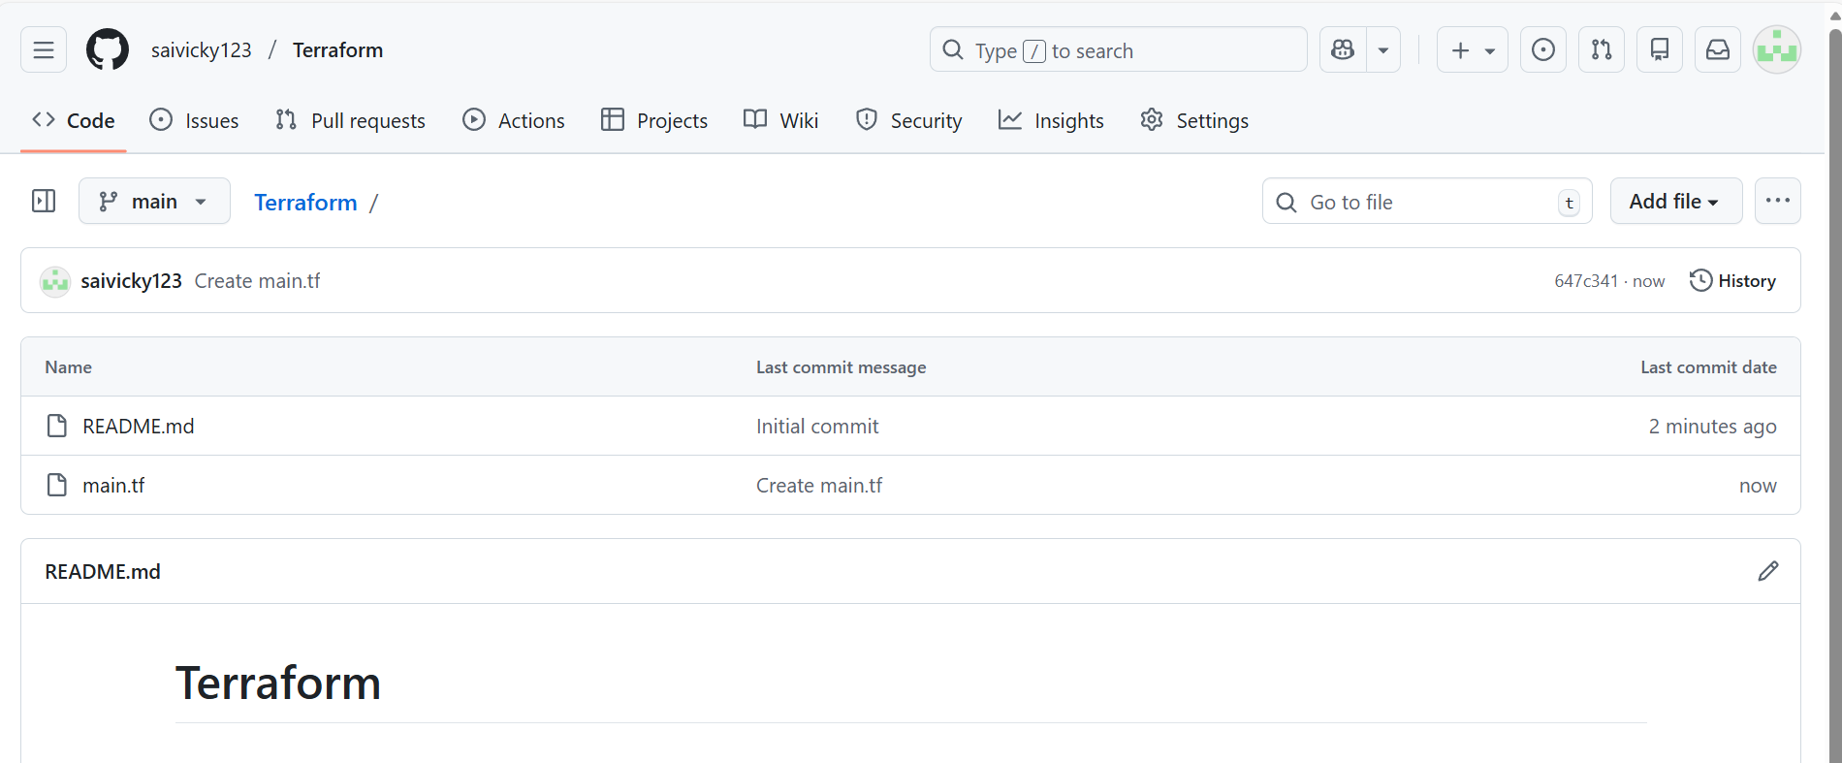

Step 7: Create a new job and write a script for Terraform
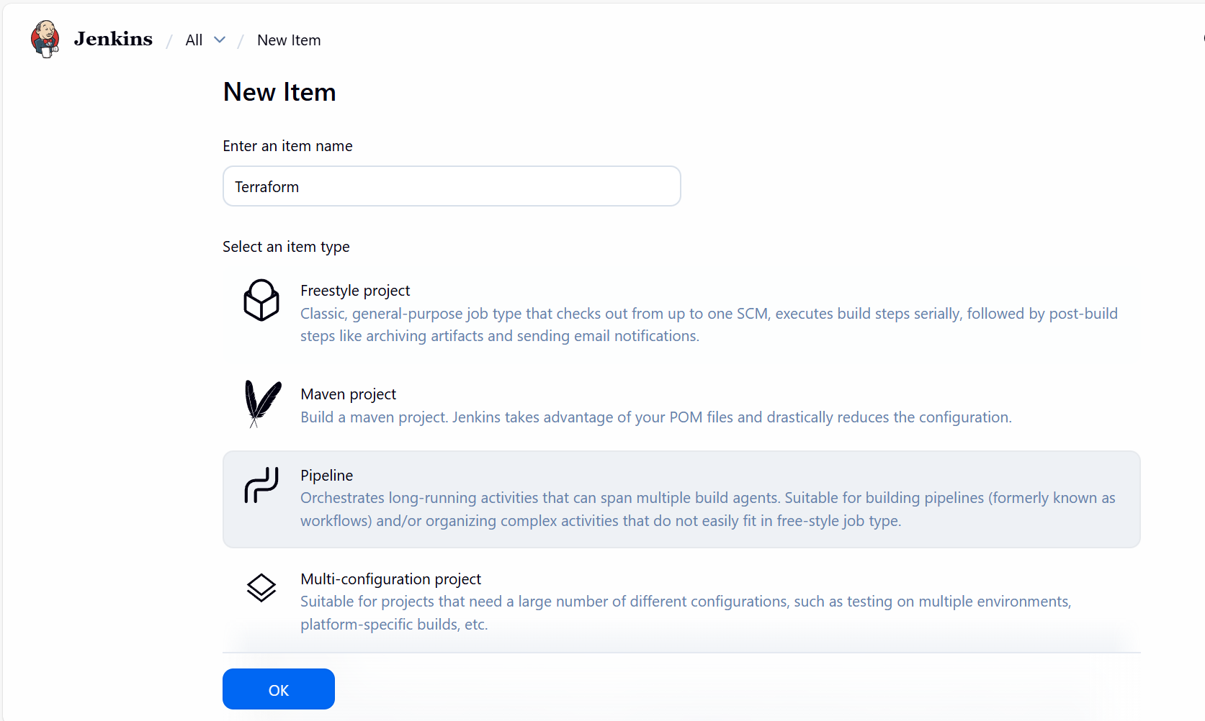

- Script updated and build now.
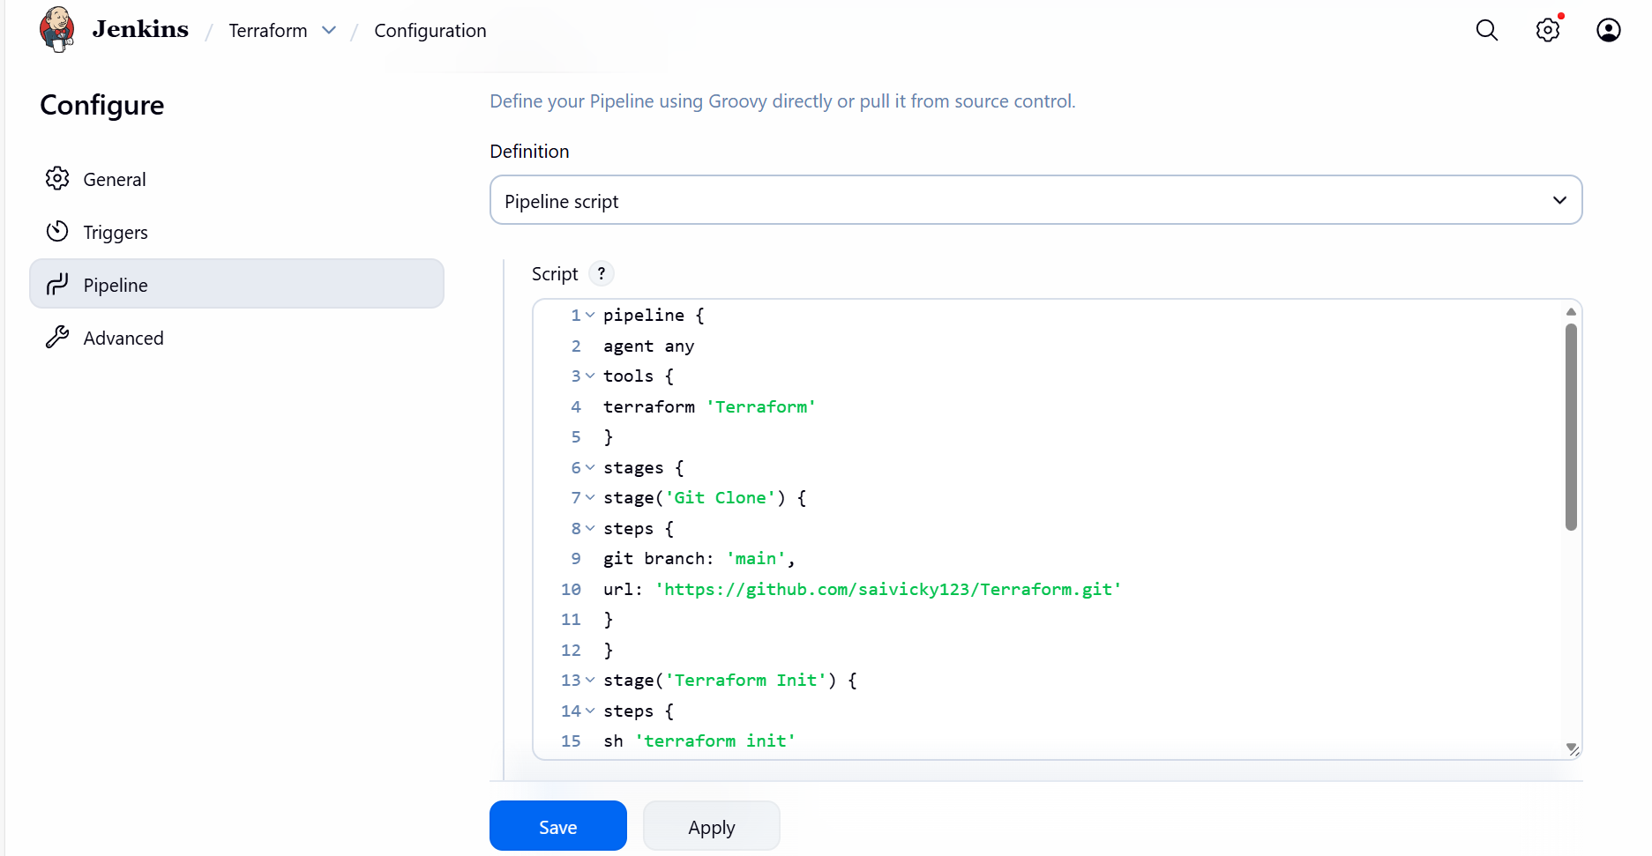

Ready for build
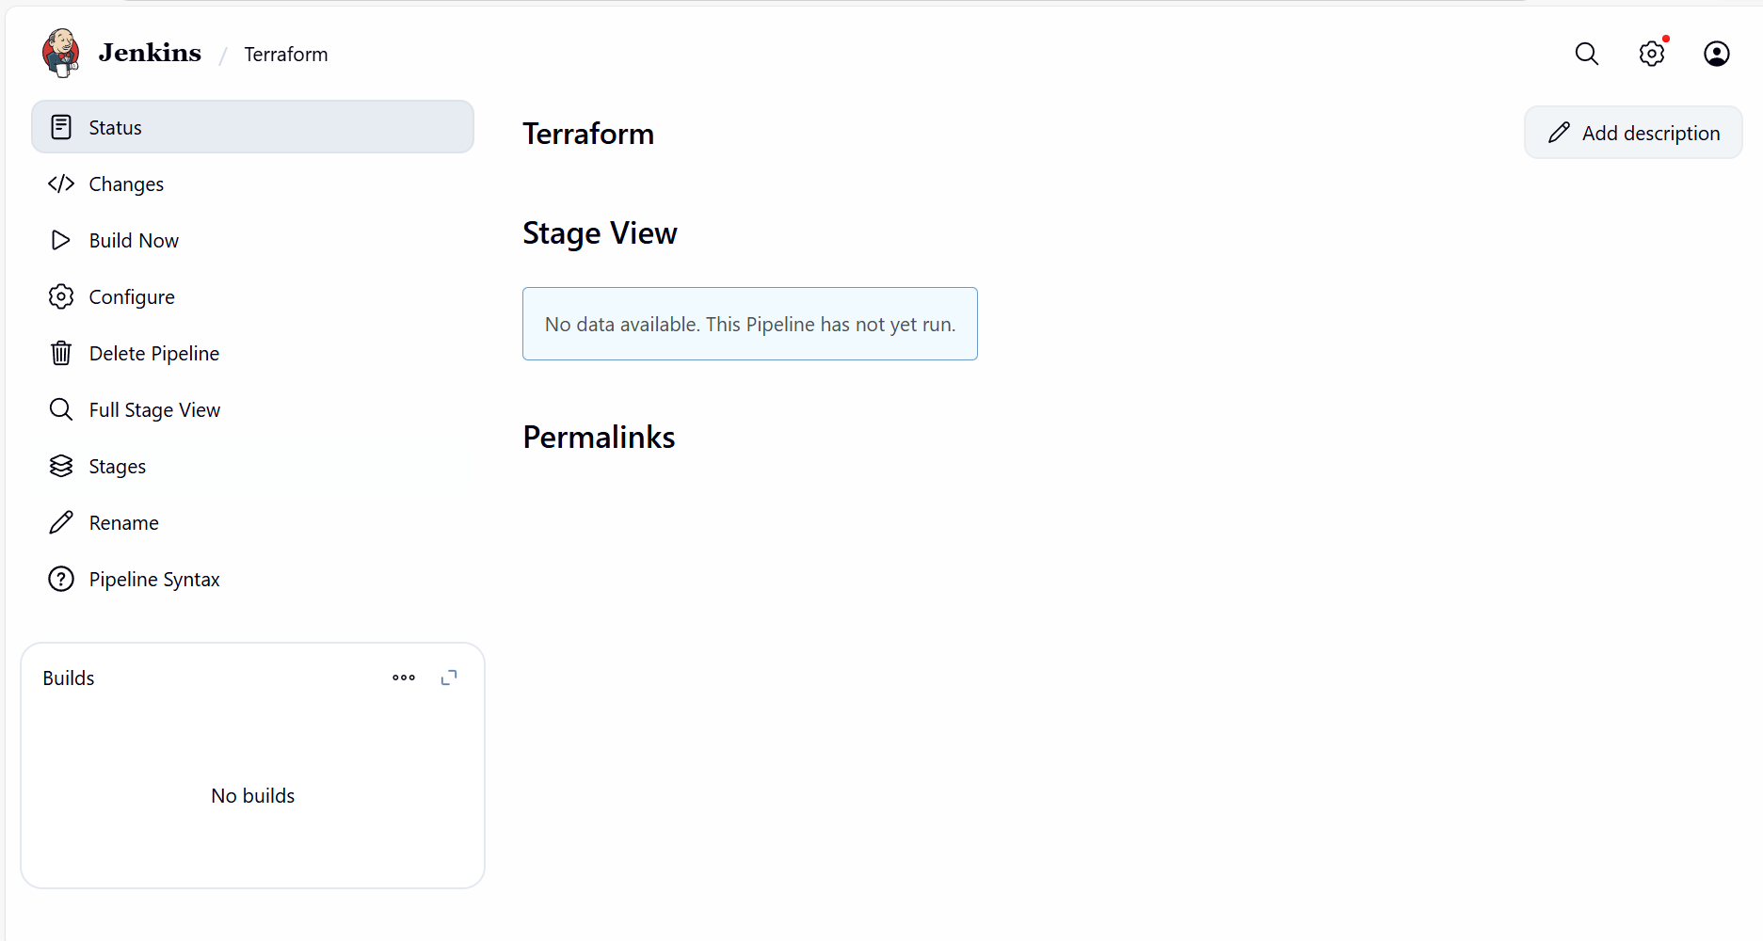

Step 8: Build completed and success.
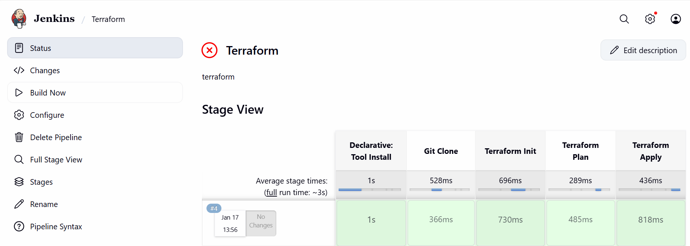

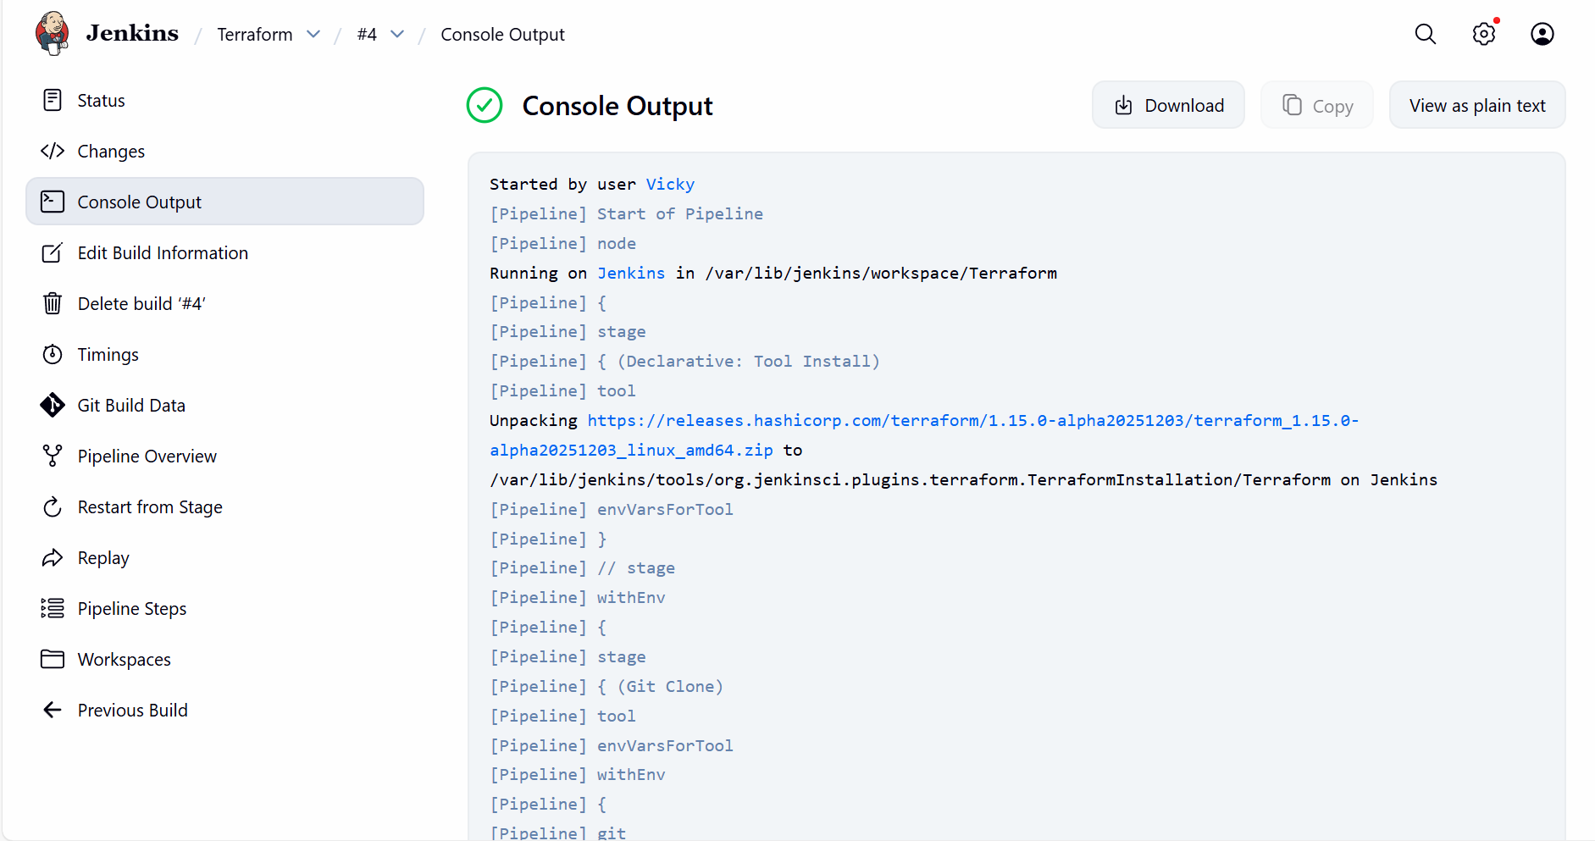

Issued faced:
While creating Terraform Manage Jenkins Tools
The version shouldn’t be automatically selected as build will have syntax error.
We should select Linux and amd64

My Pipeline script for Terraform:
pipeline {
agent any
tools {
terraform 'Terraform'
}
stages {
stage('Git Clone') {
steps {
git branch: 'main',
url: 'https://github.com/saivicky123/Terraform.git'
}
}
stage('Terraform Init') {
steps {
sh 'terraform init'
}
}
stage('Terraform Plan') {
steps {
sh 'terraform plan'
}
}
stage('Terraform Apply') {
steps {
sh 'terraform apply -auto-approve'
}
}
}
}

