Terraform-03

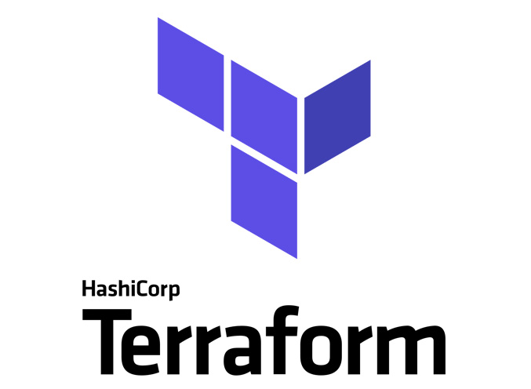

General tips for the Task below.
Task Title
Terraform-03
Objective
The objective of this task is to watch the Terraform-03 video posted on slack with and worked on executing templates shown in video.
Prerequisites
List all requirements before starting:
- AWS
- Visual studio code
- Jenkins plugin- Terraform
- Parameters
- Maven Integration Plugin
- Pipeline build- Job
Issues Faced: Briefly mention issues and how you fixed them. Posted below in the last.
Conclusion
Conclusion has been provided for every task at the end.
Watch the Terraform-03 video.
Execute the script shown in the video.

Types of Variables:

- By using variables.tf
  - We can use soft coded instead of hard coded using variables.tf by creating a new file variables.tf and pass the content from main.tf to variables.tf
  - In main.tf, we have to update the filename and content to var.filename and var.content
  - In variables.tf, we have to update default= filename and type = matching variable.
  - Terraform apply and we can see 2 added and 2 destroyed.

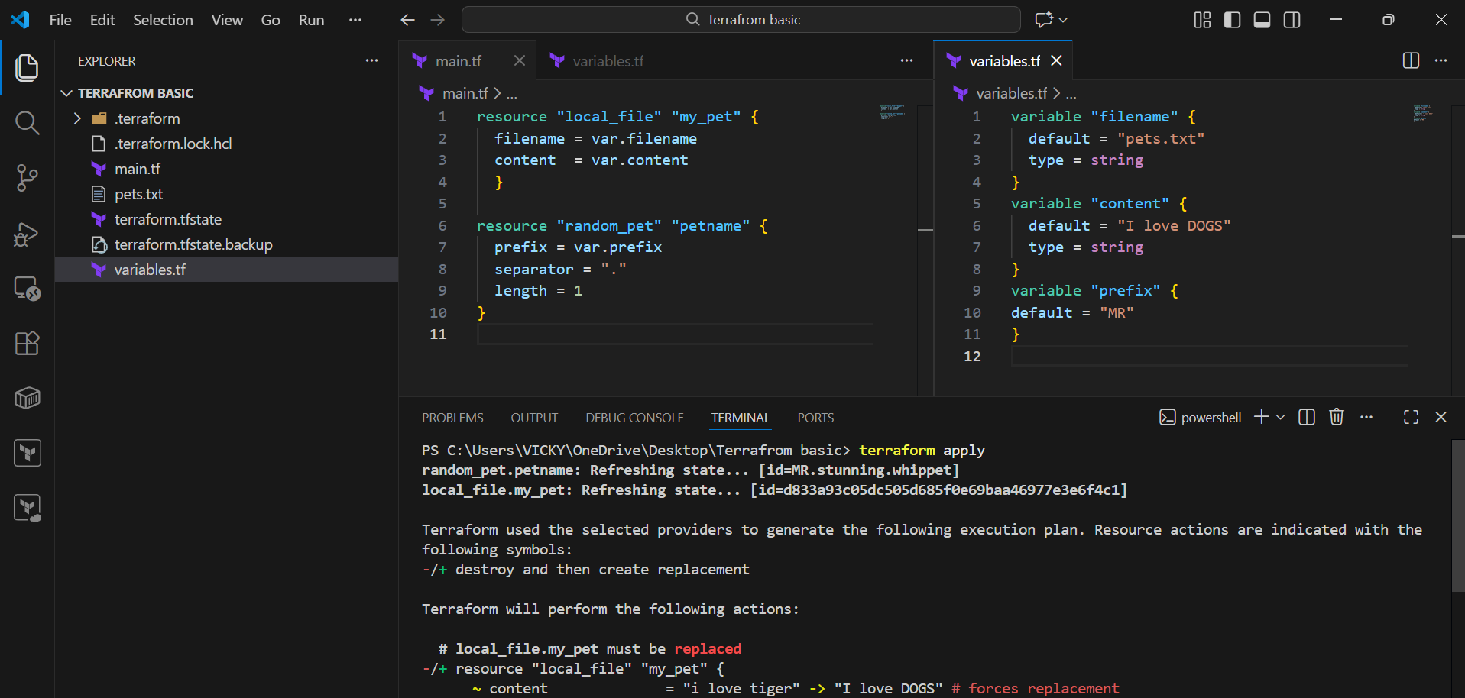
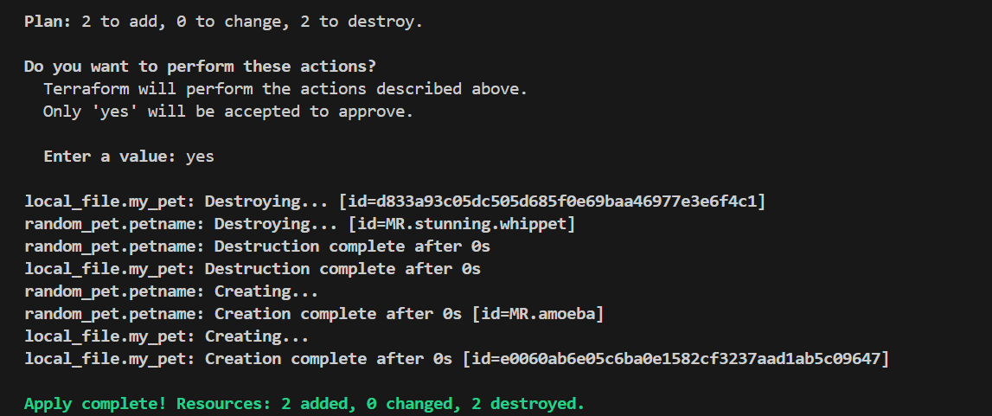
- By using interactive mode (this will get activated if we don’t pass values in variable.tf)

- Once, we have varibales.tf file created and soft coded, we can use this type.
- Removed the contents in variable.tf and its empty now.
- If we have executed terraform apply, then, we will be asked to enter the content.
- This is interactive mode.
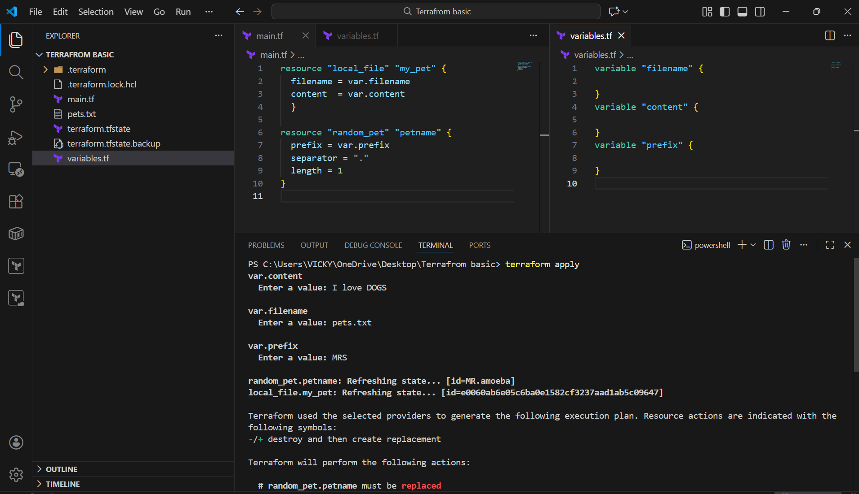
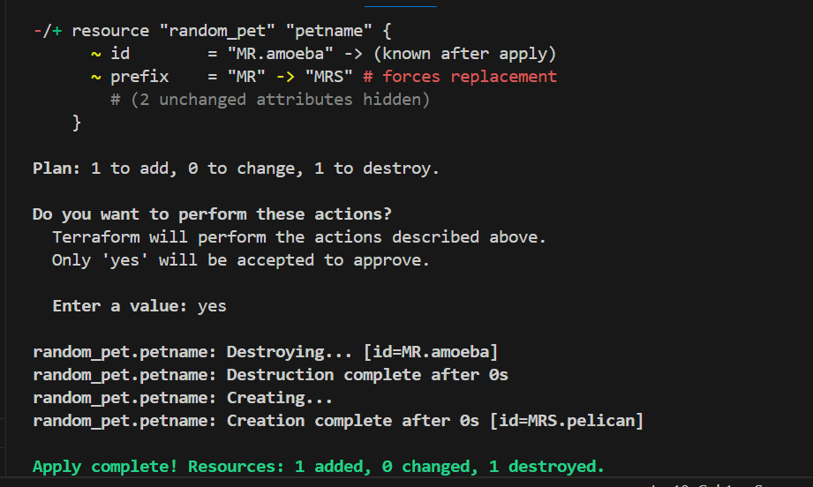
- Command line flags (terraform apply -var “filename=pets.txt” -var “content=I hate dogs” -var “prefix=MRS”)
- Instead of using interactive mode entering all content at each step, we can enter in 1 step using command- terraform apply -var “filename=pets.txt” -var “content=I hate dogs” -var “prefix=MRS”
- This is command line flags.
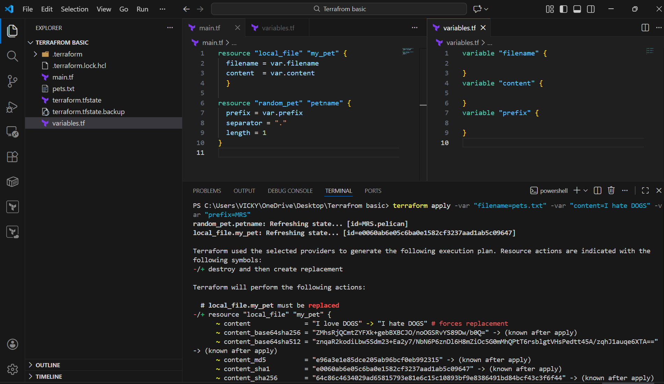
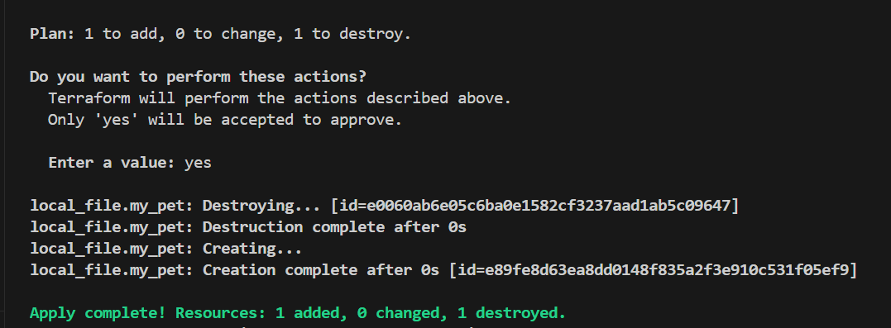

- Environmental Variable
- This is used when we are using some secrets like username/password, which we don’t want to expose to outside world
- Environmental variable are temporary, once we reboot/close the VS code, the content will be removed.
- There are two ways to use these environmental variables by commands:
  - Linux
  - Windows
- Linux- export TF_VAR_filename= “pets.txt”
- Windows- Set-Item -Path env:TF_VAR_filename -Value ‘pets.txt’

Here, we used Windows and executed terraform apply.
Success
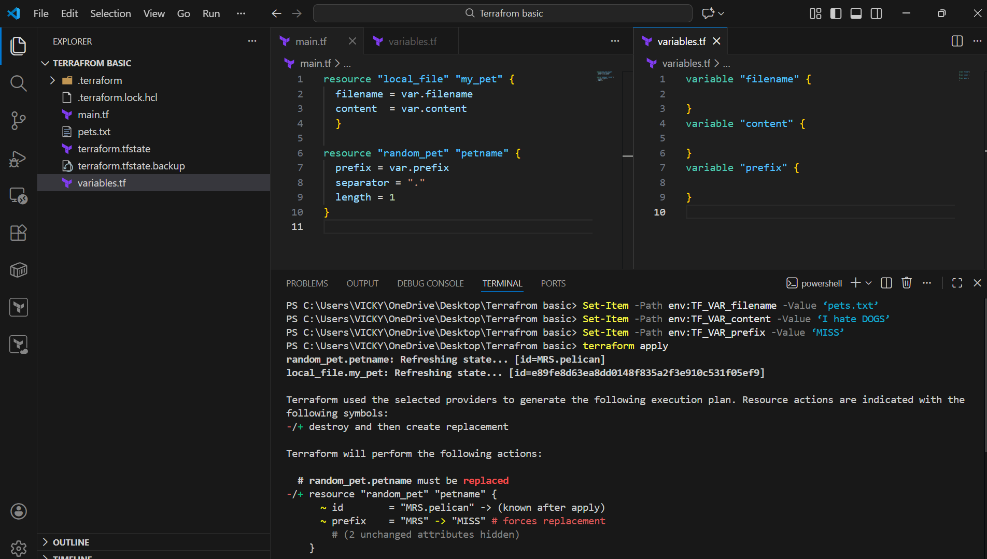
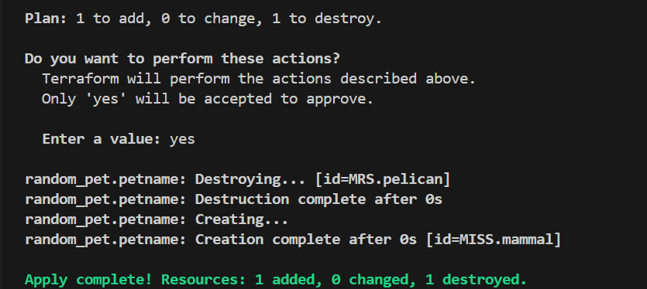

- variable definition file (Should be end with terraform.tfvars/terraform.tfvars.json)
--> for automatically loaded file name *.auto.tfvars/*.auto.tfvars.json
--> if we are saving the file with other name like varible.tfvars then we need to pass this in CLI
--> terraform apply -var-file terraform.tfvars
>>>No CLI flag needed — Terraform picks these up automatically.

- We just performed terraform apply and executed, where we didn’t automate.
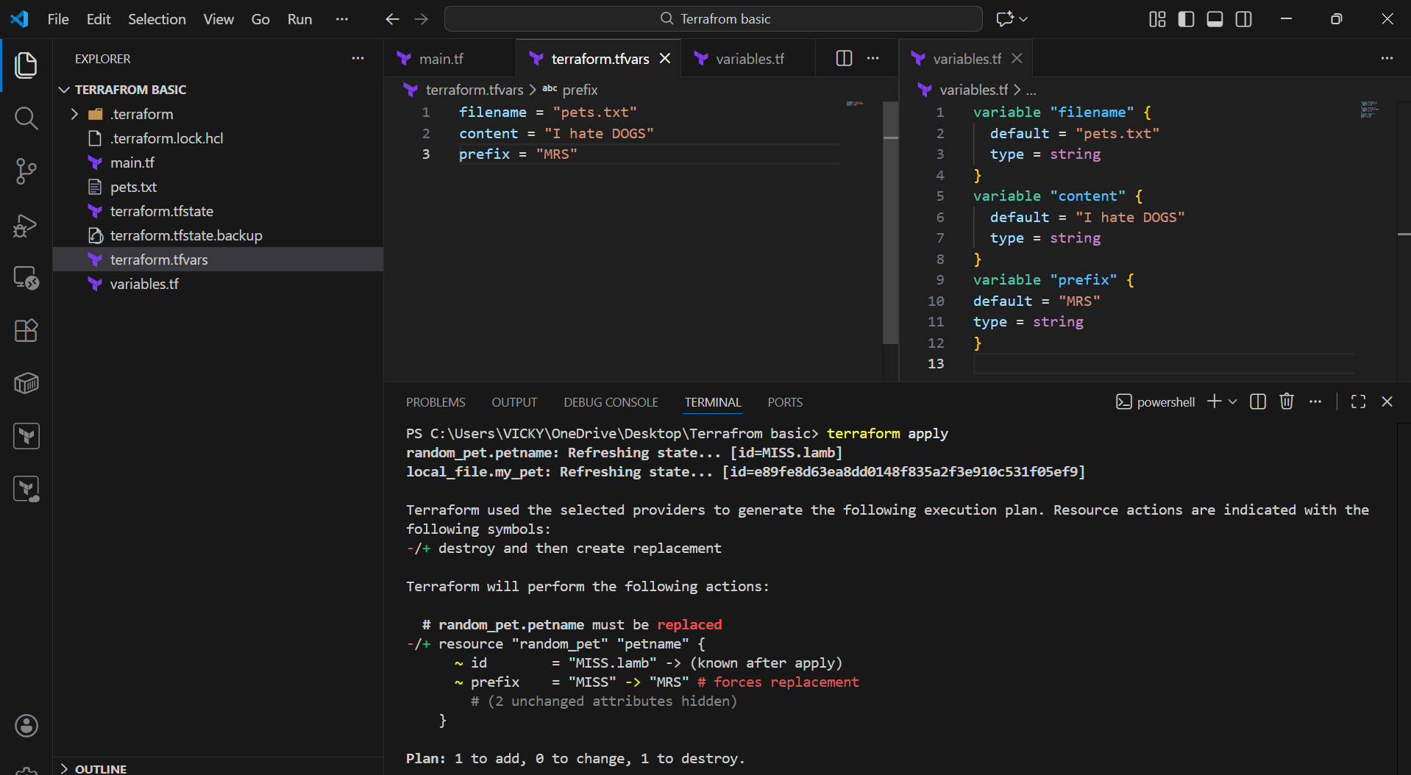
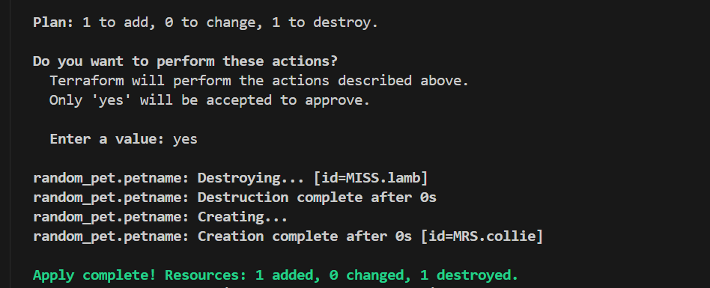

- Here, we did terraform apply -var-file terraform.tfvars
- success
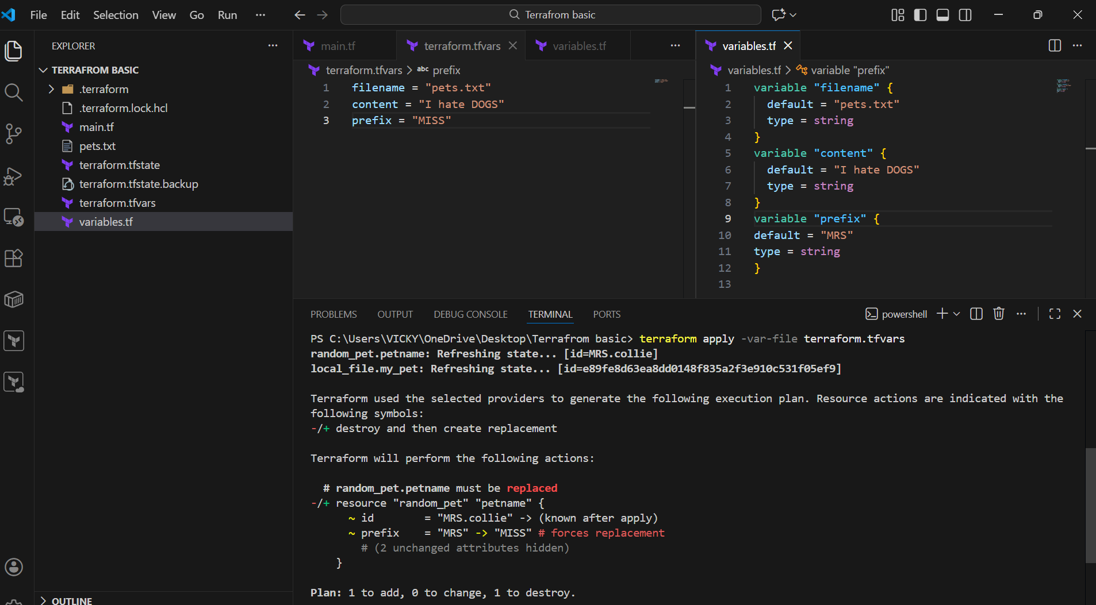
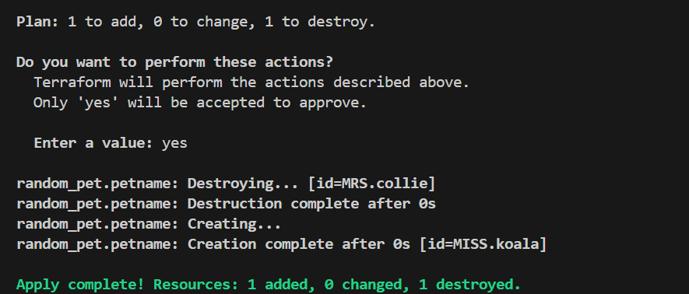

Let’s perform a custom named variable
- Here, in this case, we need to manually pass, because of its custom name.tfvars.
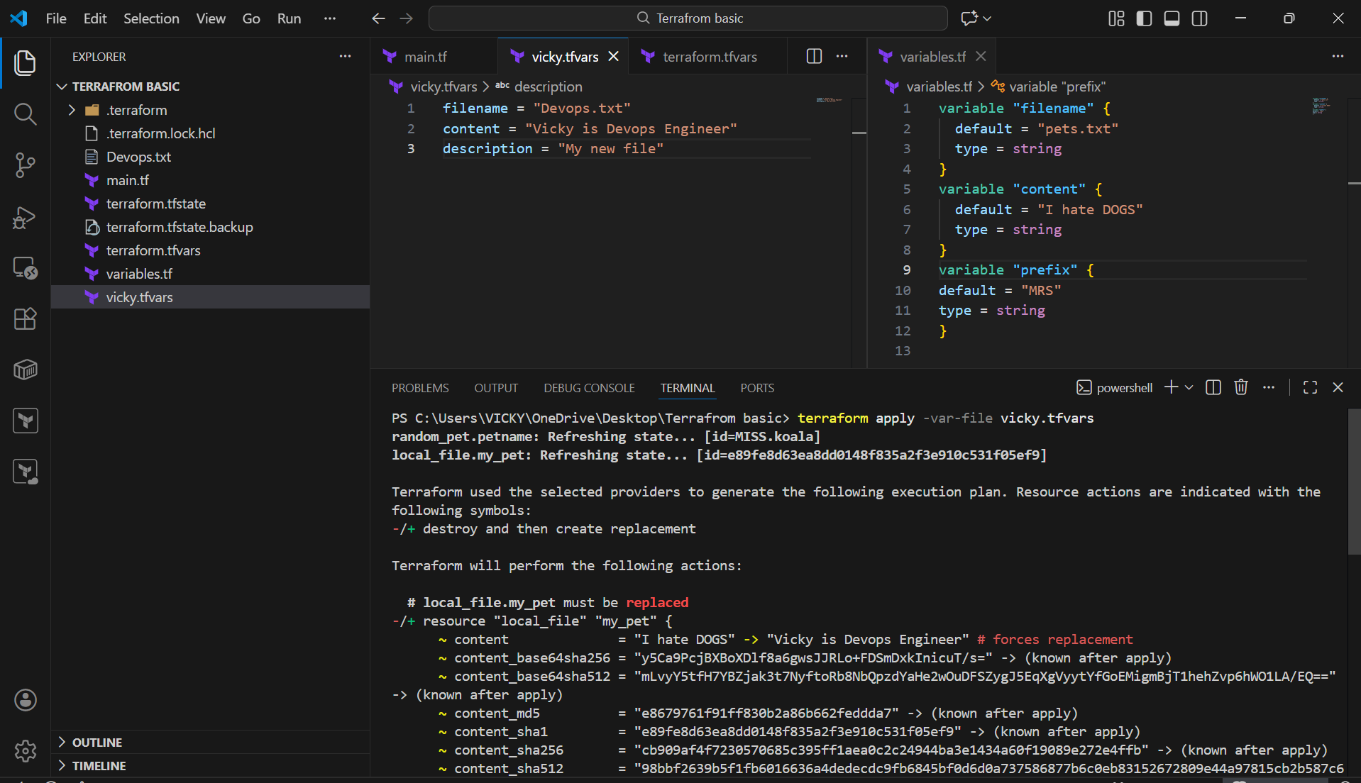
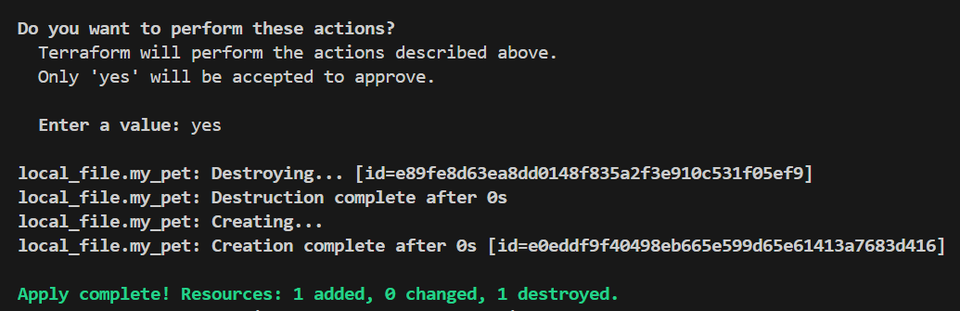

Inline CLI override
We are providing file name and content from cli at same time
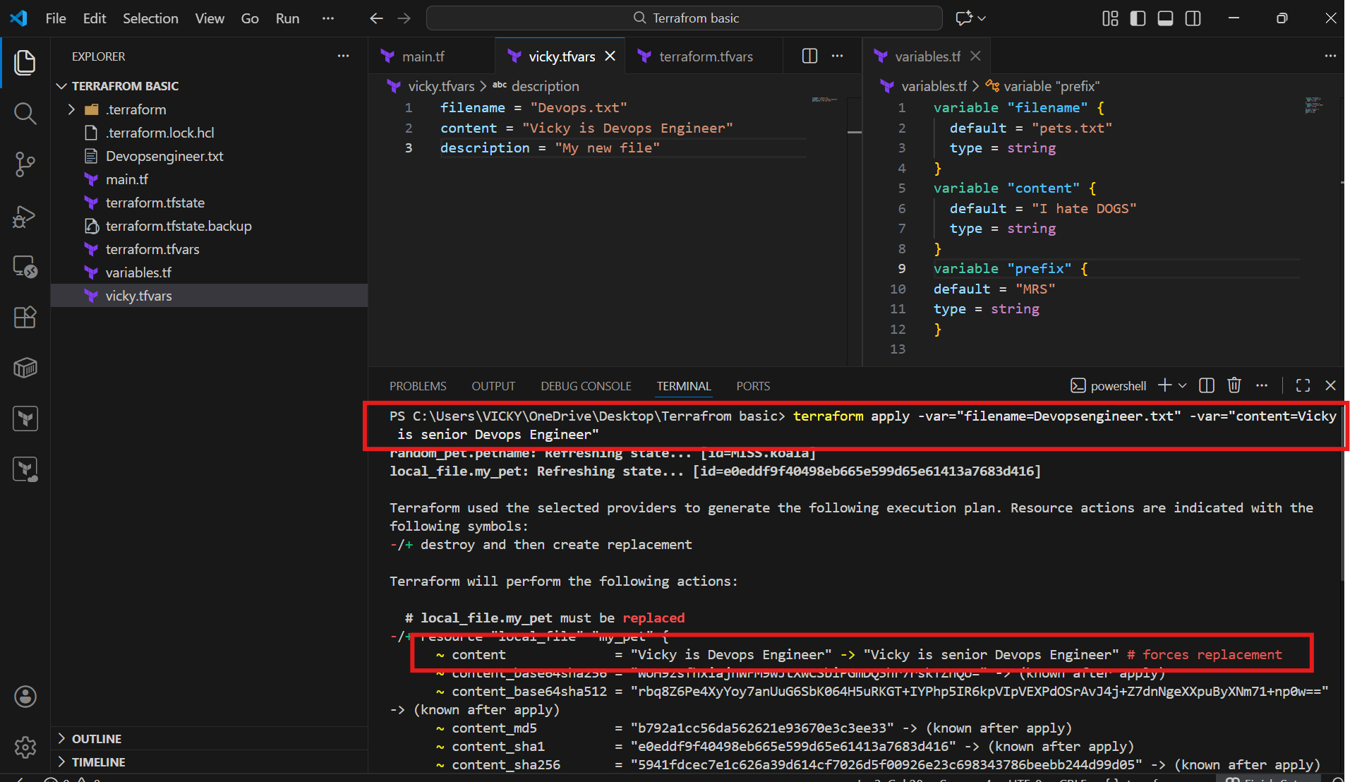
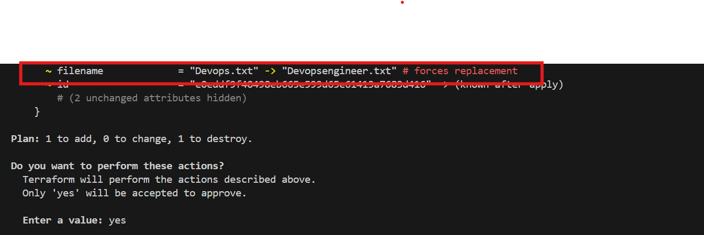
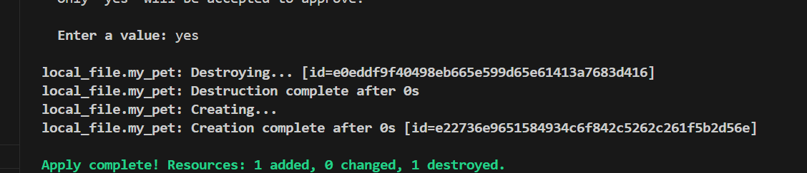

Terraform auto-loads terraform.tfvars, .tfvars.json, and *.auto.tfvars files. For custom names, use -var-file in CLI.

PRECEDENCE ORDER:
Order  1 | Option  Environment variables
2 | Terraform.tfvars
3  4 | *.auto.tfvars(alphabetical order)  -var or -var-file (Command line flags)

Use case scenario:
- We have removed all the state file, tf.vars, backup file, everything except the main.tf and variable.tf.
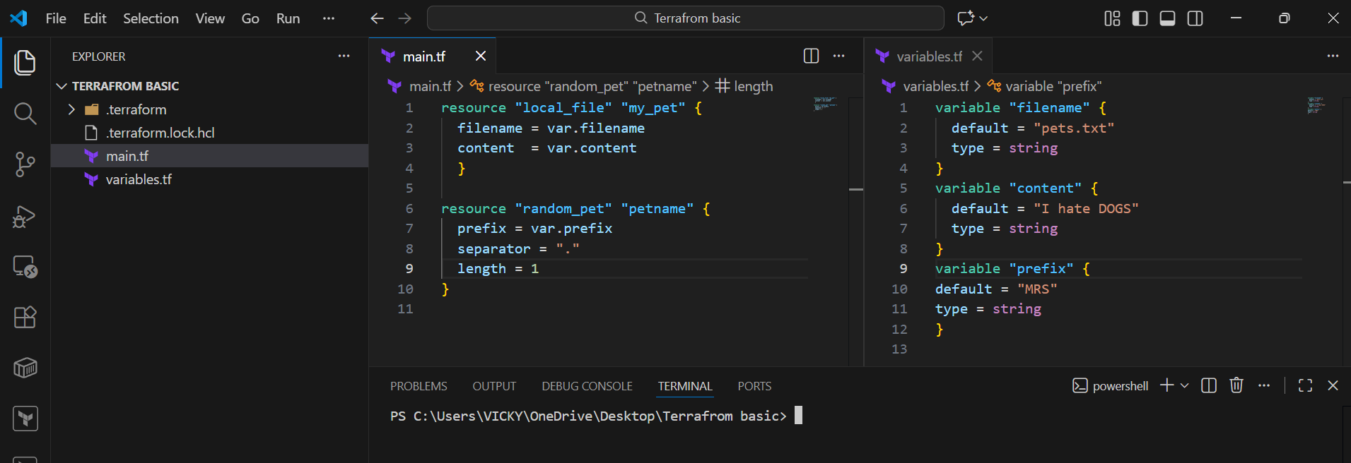

- Now, let’s execute few commands including command line flags and environment variables.
- We used 2 different variable commands and executed all once.
- But according to terraform, it will pick the last command entered that’s command line flags.
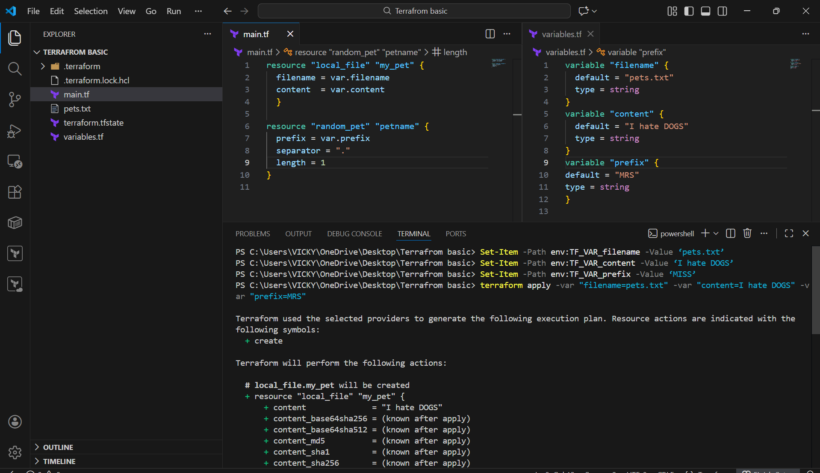
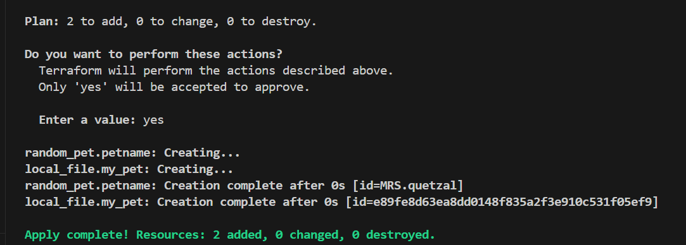

Resource Attribute reference:
============================
If i want to link two rerouces together by using resource attributes.
When we execute terraform apply it will create random id with pet name,
now i want to add this pet name in my content file (using output of one resource as input for another resource).
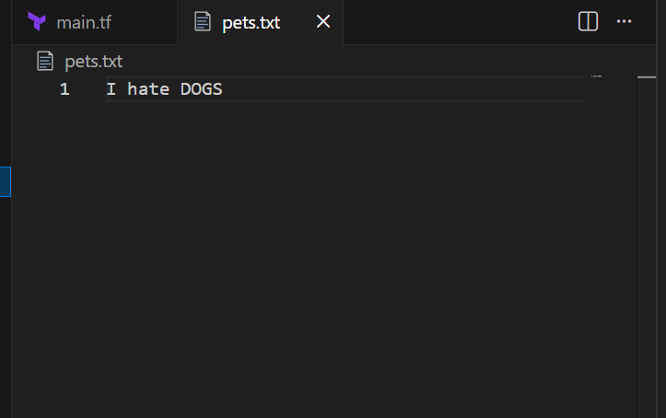

Mapping two resources (local provider and random provider)
Like taking output of one resource and providing name to another resource
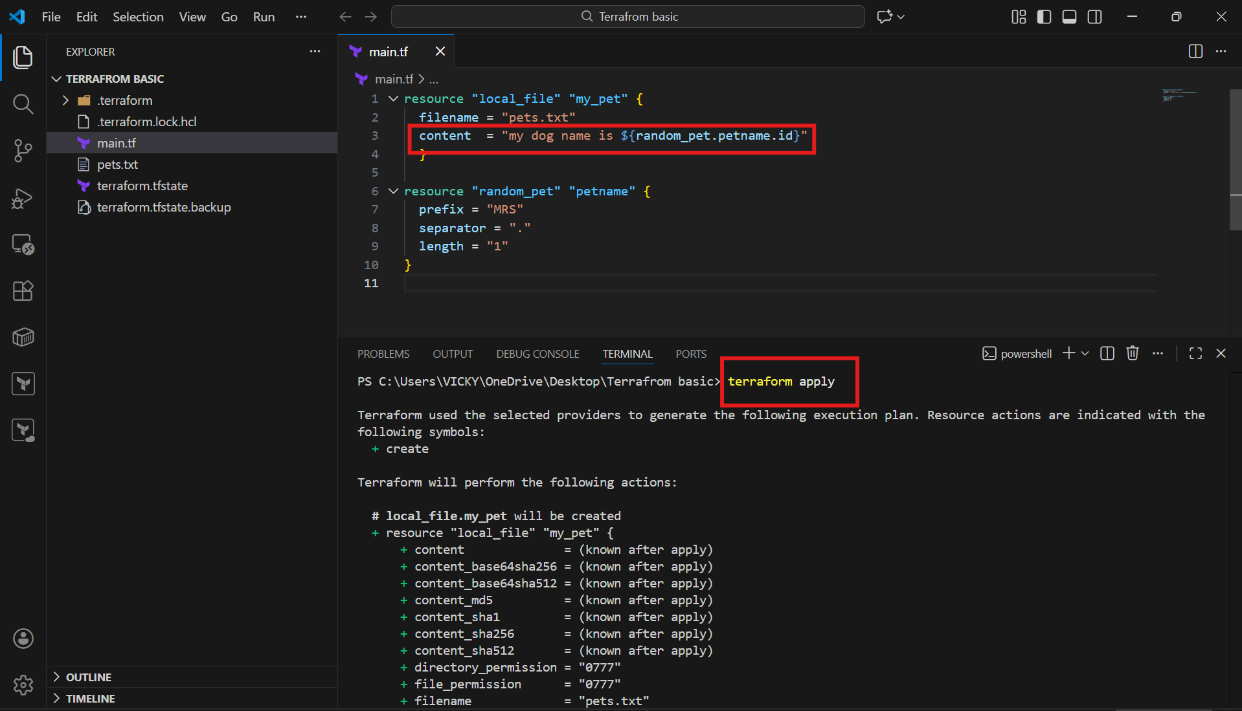
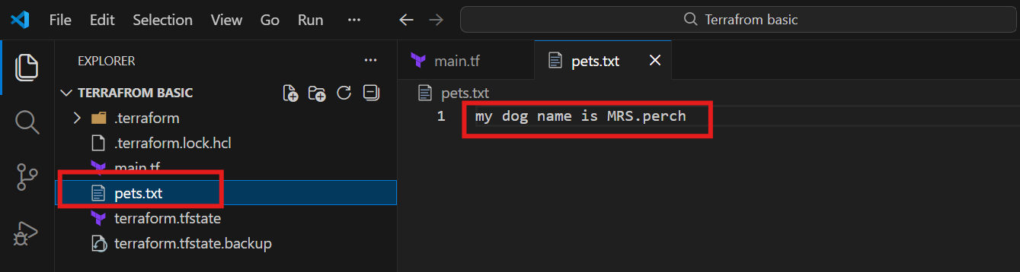

Resource Dependencies:
From the above main.tf we have local_file which is dependent on random_pet resource.
We are not mentioning that anywhere but still terraform will figure that out, we call them as implicit dependency.
Still, we can define the dependency explicit by ourself using "depends on" module
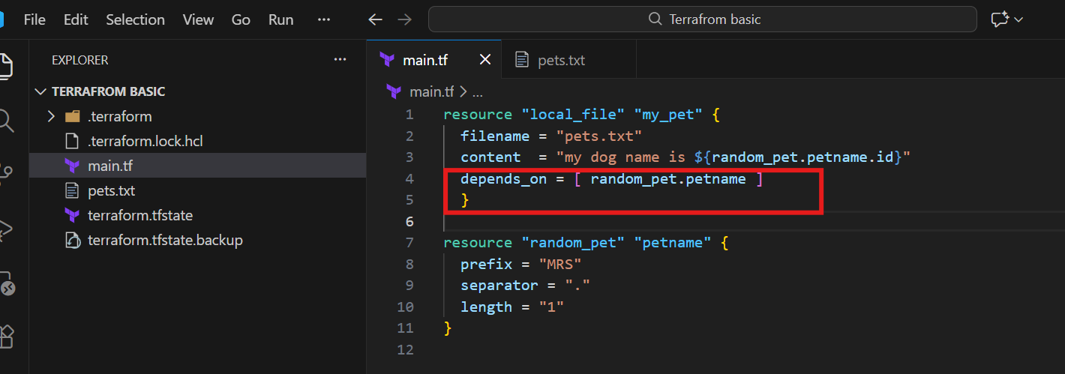

Output variables:
These are used to display the output of the resources.

We have executed one output as an example. Please see below.
output "petname" {
value = random_pet.petname.id

Then terraform apply
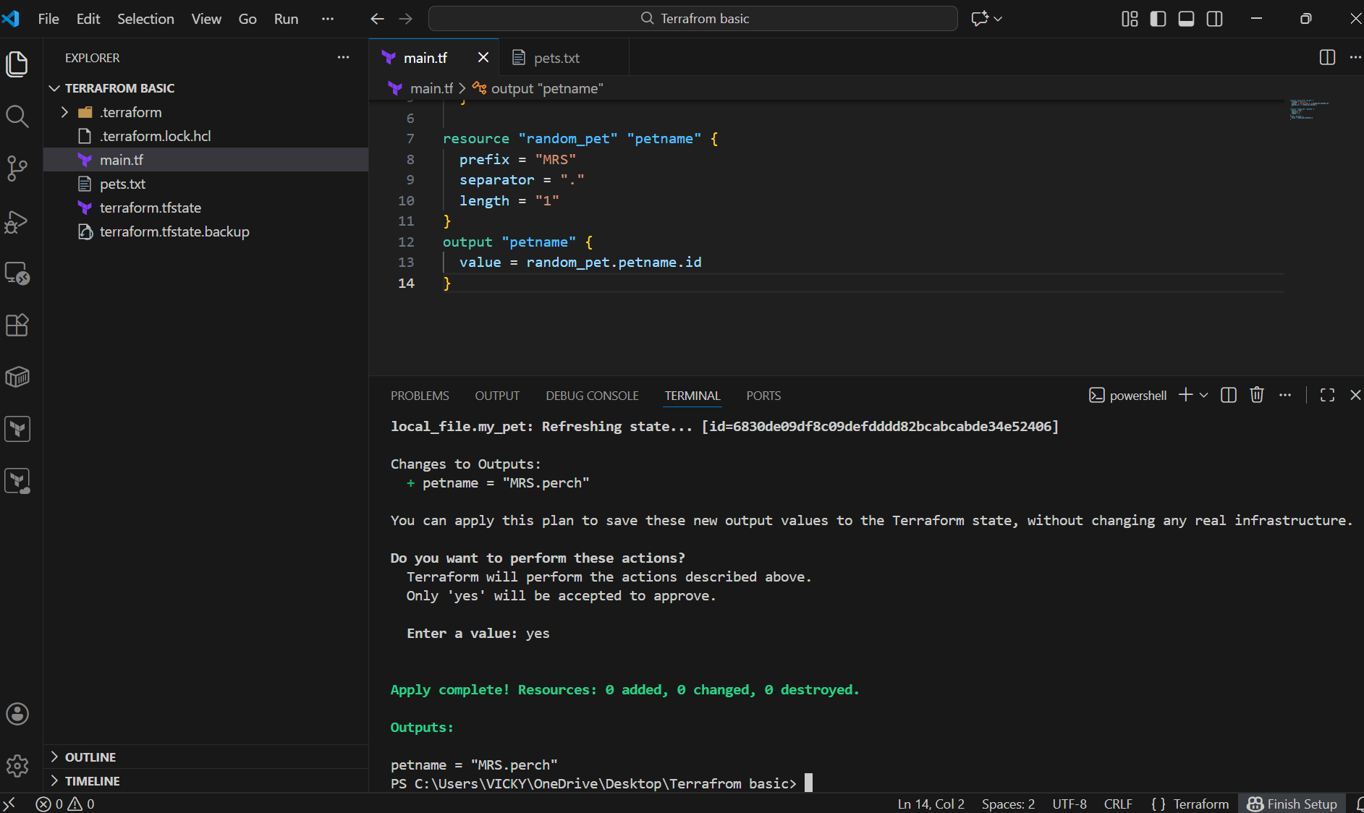

- Using the command- terraform output as well, we can view the output name.
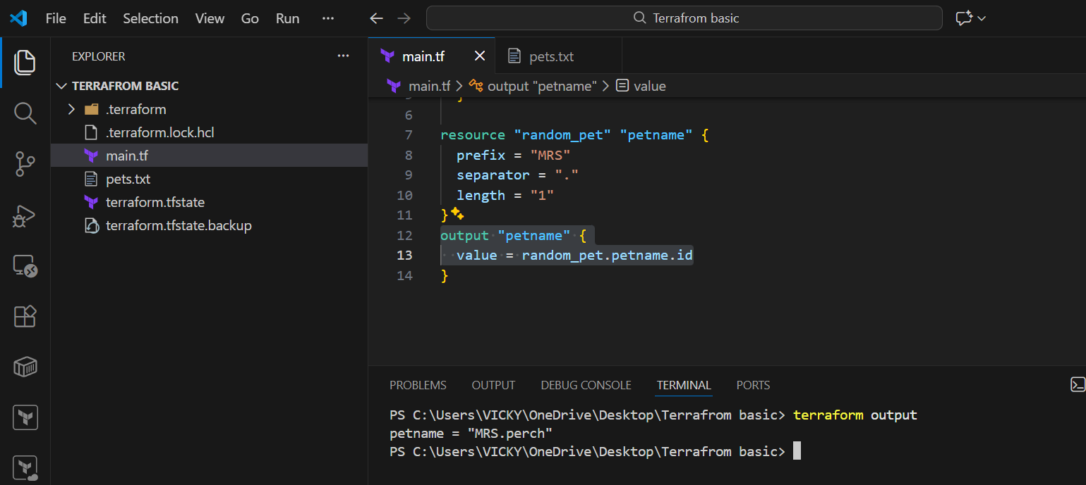

Terraform show command will show the output of the file
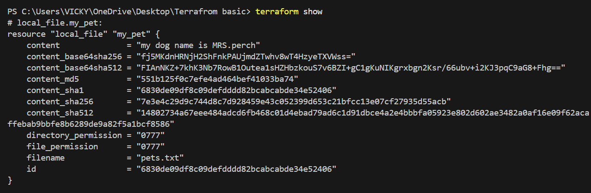

Task-1- Integrate Terraform in Jenkins using the Terraform plugin.

Step by step Implementation:
Step 1: Navigate to AWS ec2 and launch Jenkins server.
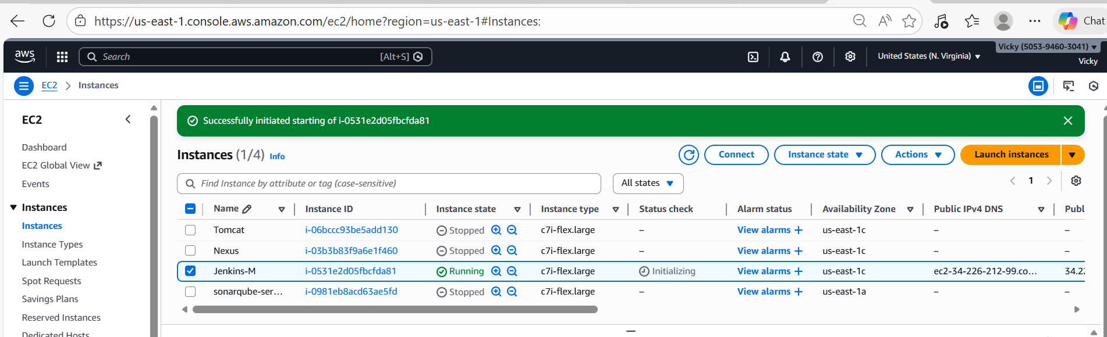

- Connect to the instance
- Run the systemctl status jenkins to verify if Jenkins is up and running.
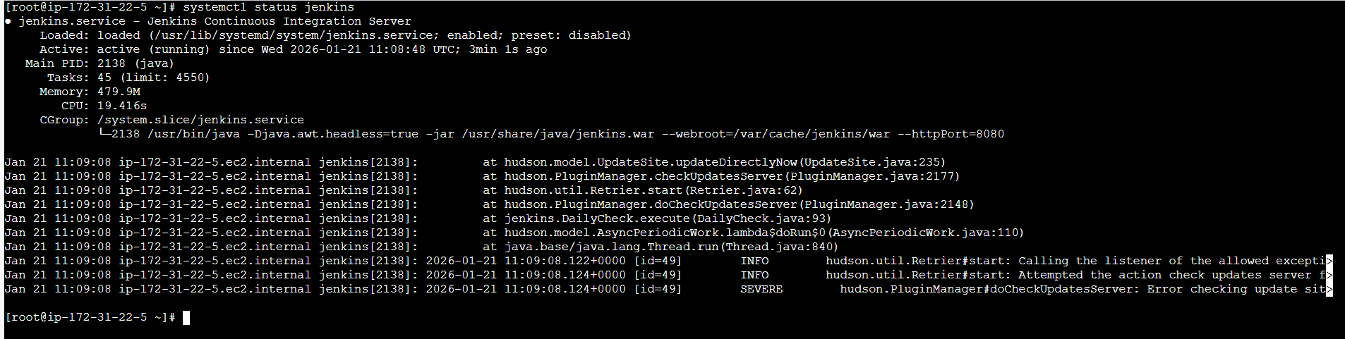
Step 2: Navigate to Terraform registry and install Terraform for Amazon Linux.
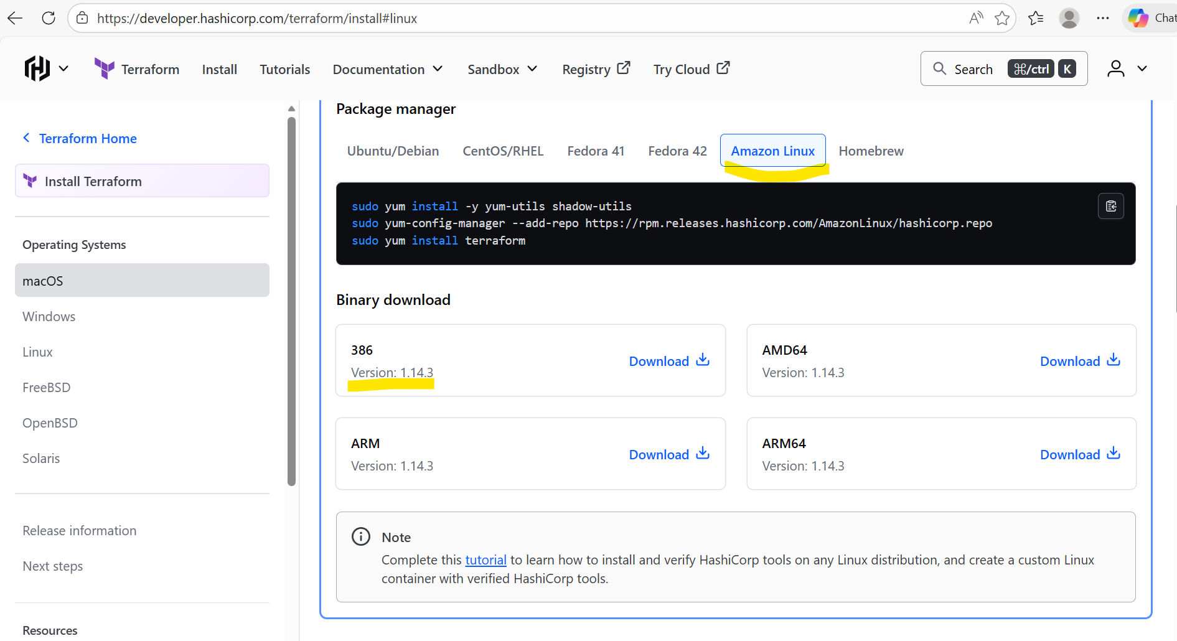

- Installed the packaged manager in Jenkins server.
sudo yum install -y yum-utils shadow-utils
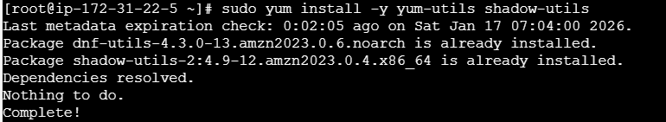

sudo yum-config-manager --add-repo https://rpm.releases.hashicorp.com/AmazonLinux/hashicorp.repo
sudo yum install terraform
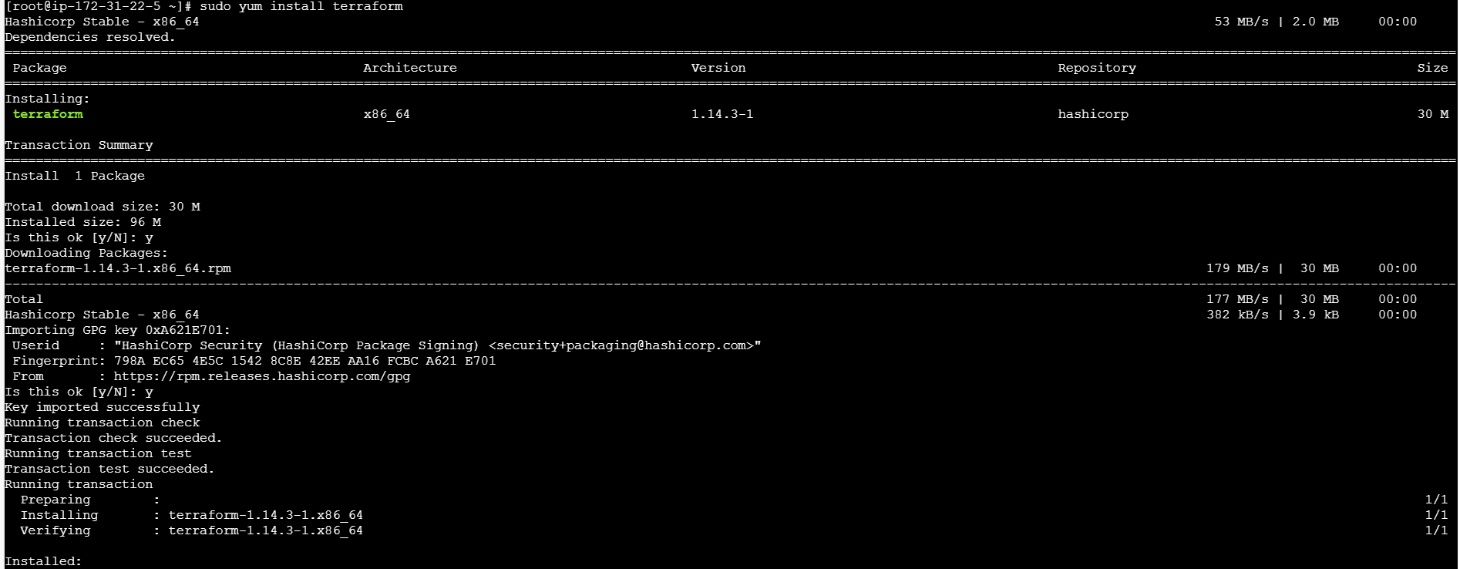

Step 3: Navigate to Jenkins GUI and install plugin Terraform
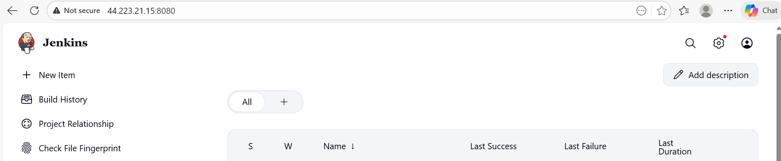
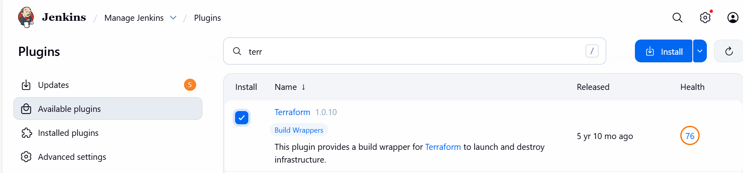
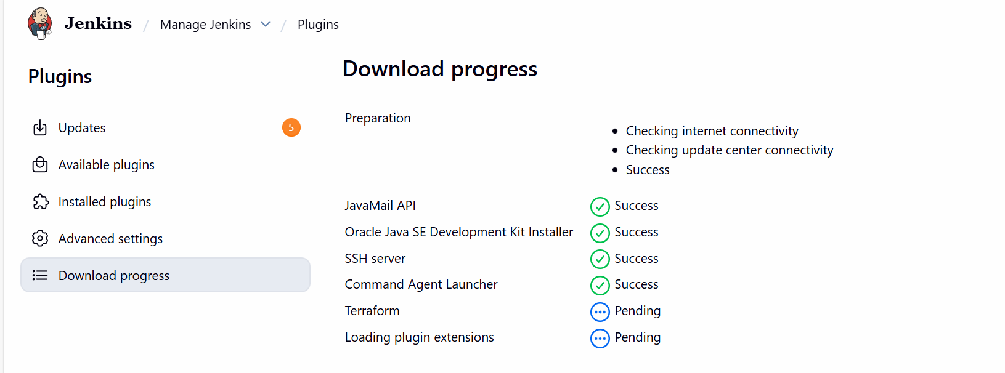

Installed
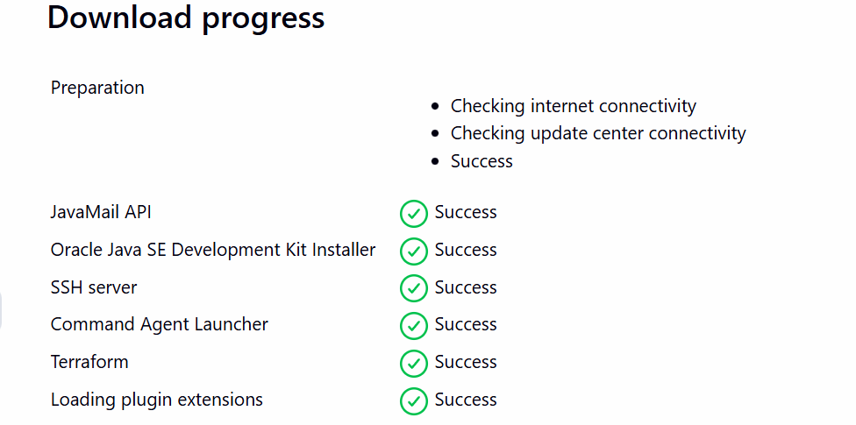

Step 4: Navigate to Manage Jenkins and add Terraform under Tools
Version: Terraform 51203 darwin (amd64)
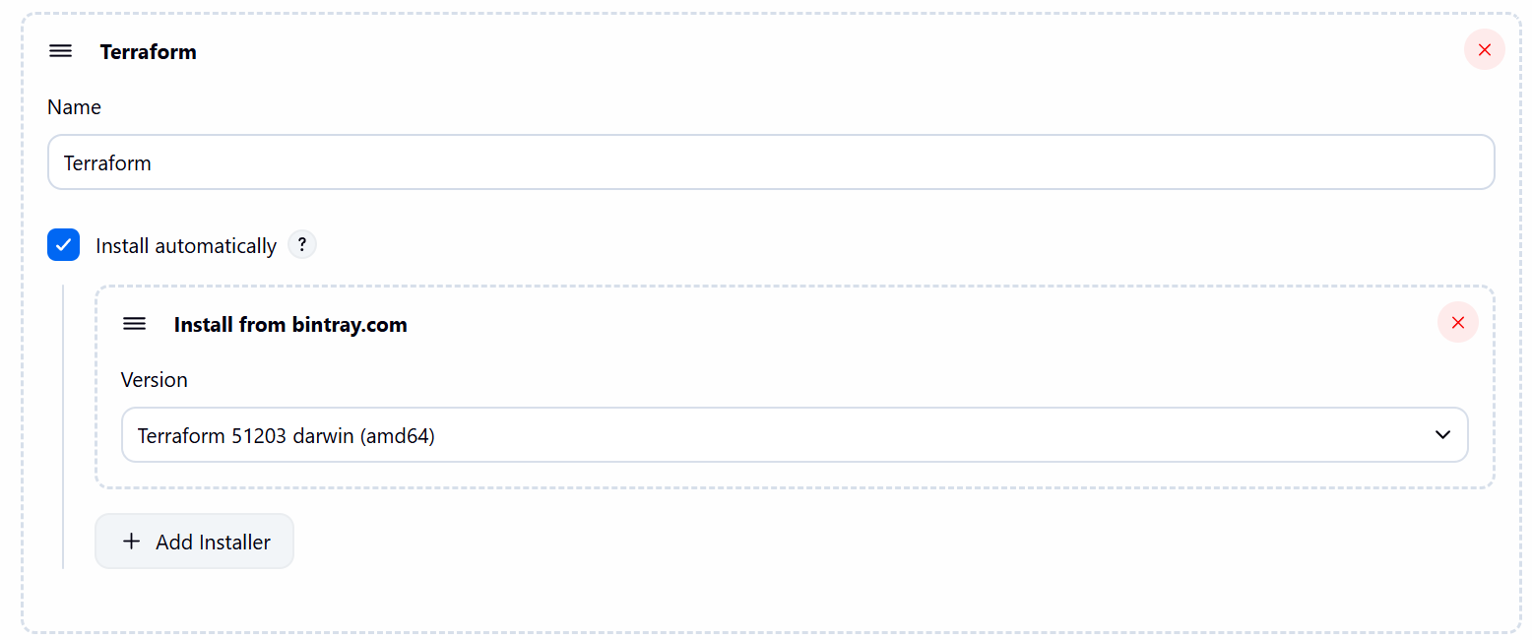

Step 5: Navigate to GitHub and create a repo- Terraform
- Mark Readme as required
- Visibility- Public
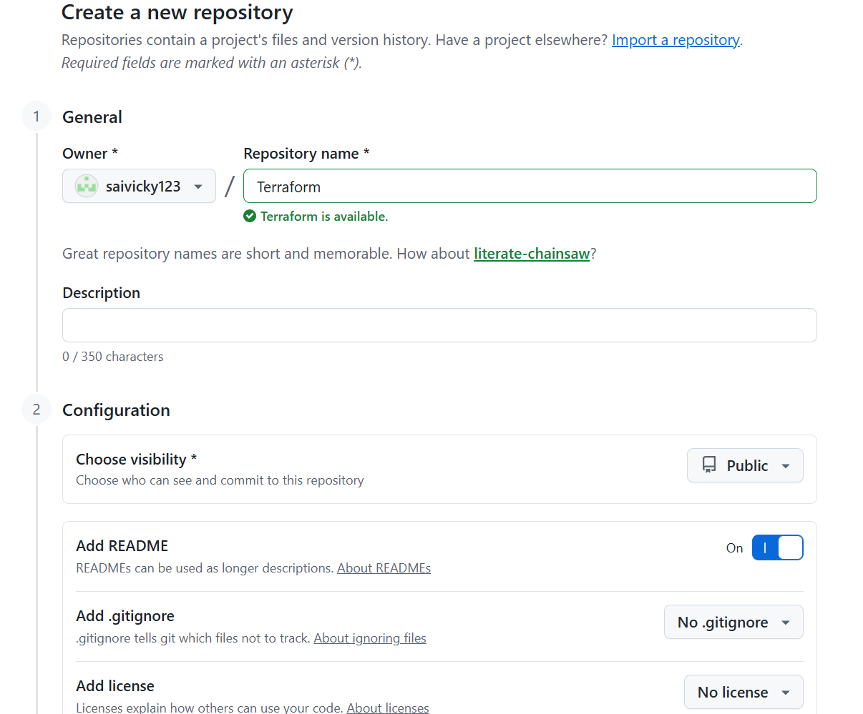

Step 6: Navigate to repo created and write a script to execute based on the Terraform-03 video executions.
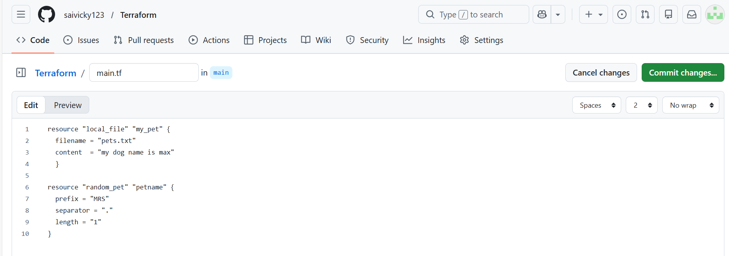

resource "local_file" "my_pet" {
filename = "pets.txt"
content = "my dog name is max"
}

resource "random_pet" "petname" {
prefix = "MRS"
separator = "."
length = "1"
}

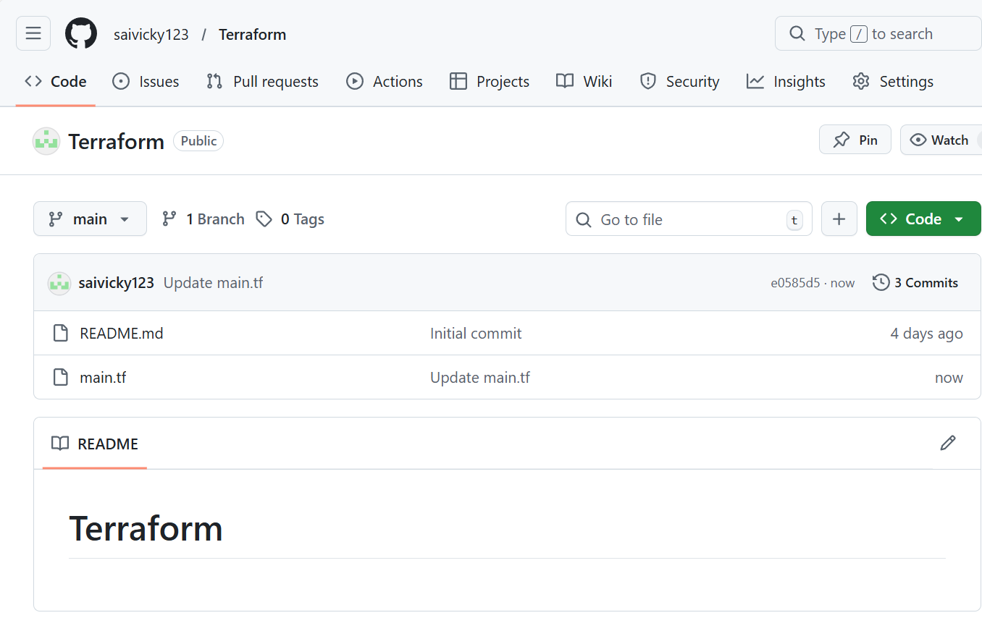

Step 7: Create a new job and write a script for Terraform
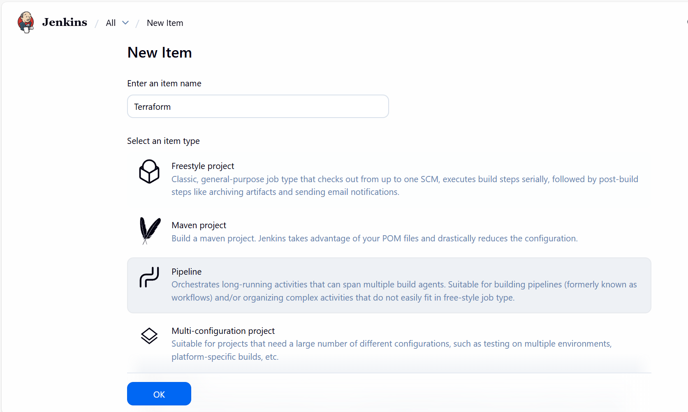

- Script updated and build now.
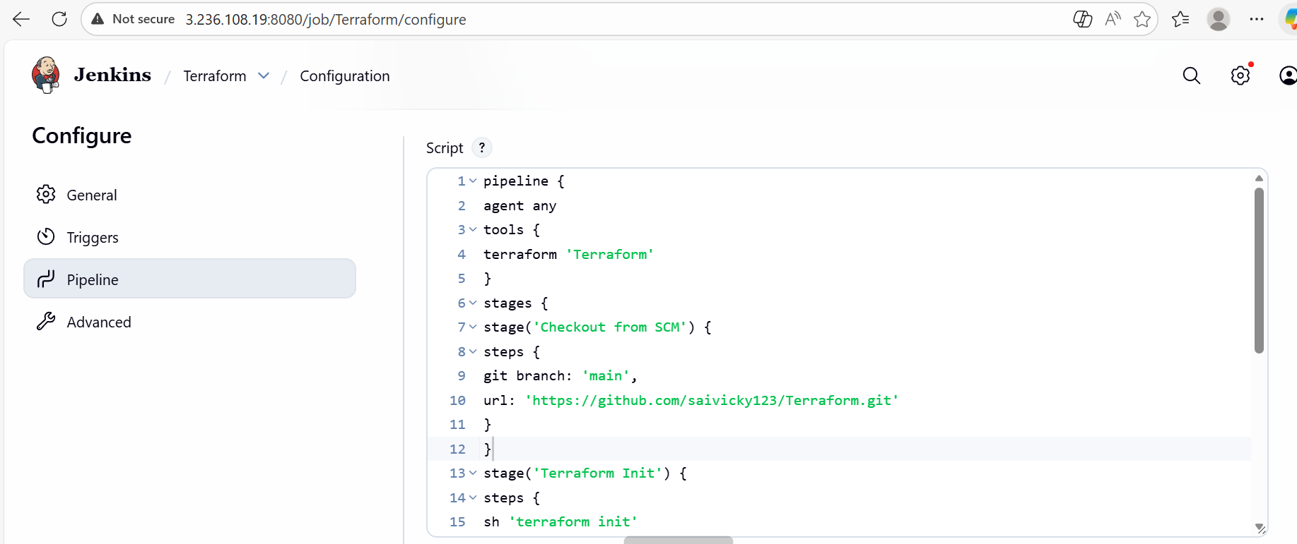

Ready for build

Step 8: Build completed and success.

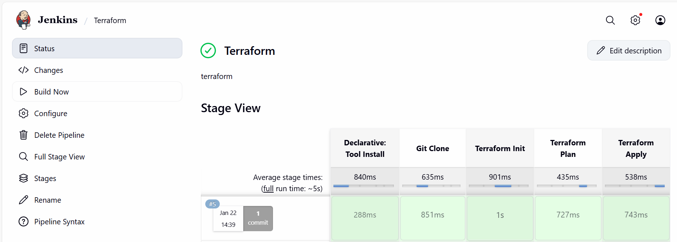

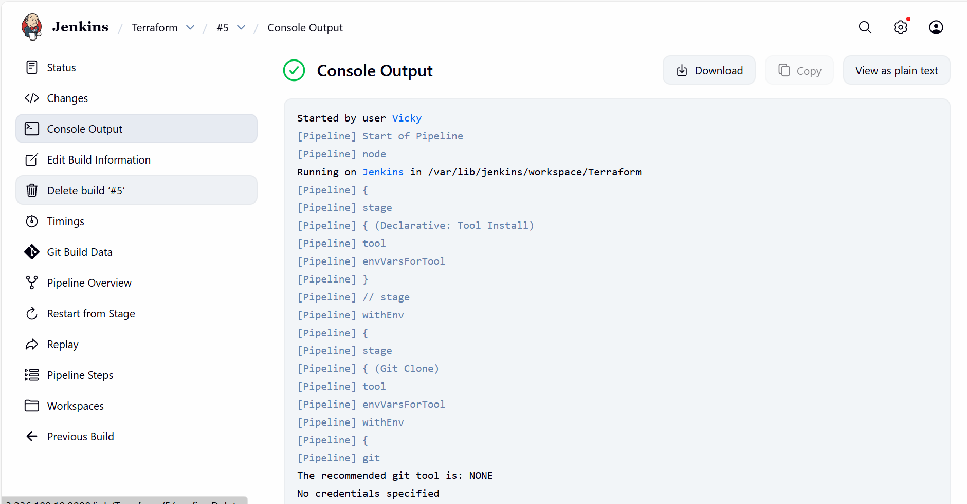

- We can verify from server level as well.
- Success.
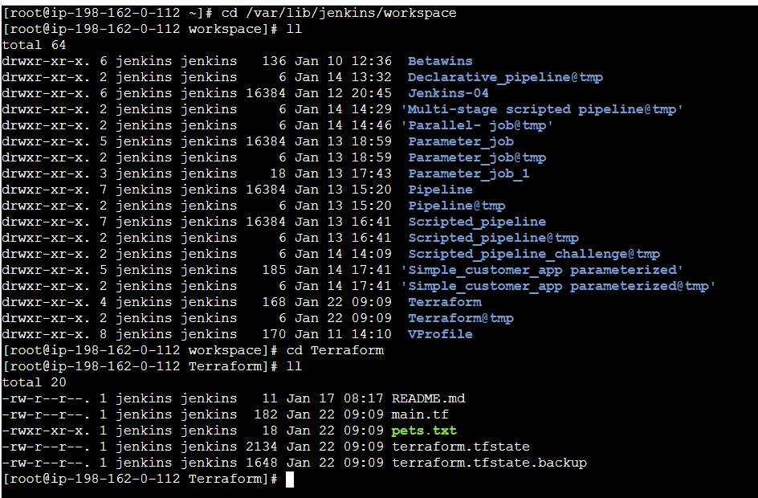

Task-2- Create one Jenkins job using Maven Project for the code below with two stages:
Stage 1: Git clone
Stage 2: Maven Compilation Code: https://github.com/betawins/java-Working-app.git

Step by step Implementation:
Step 1: Navigate to Manage jenkins Plugins Install Maven Integration

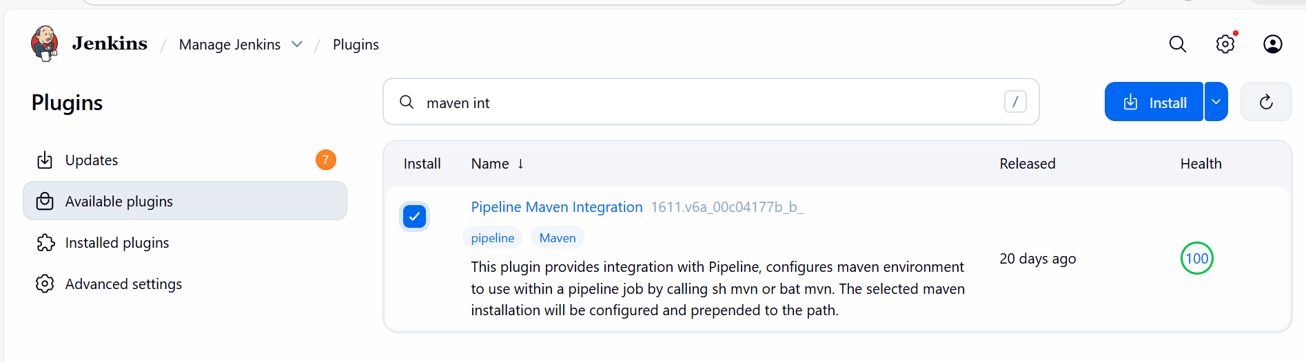
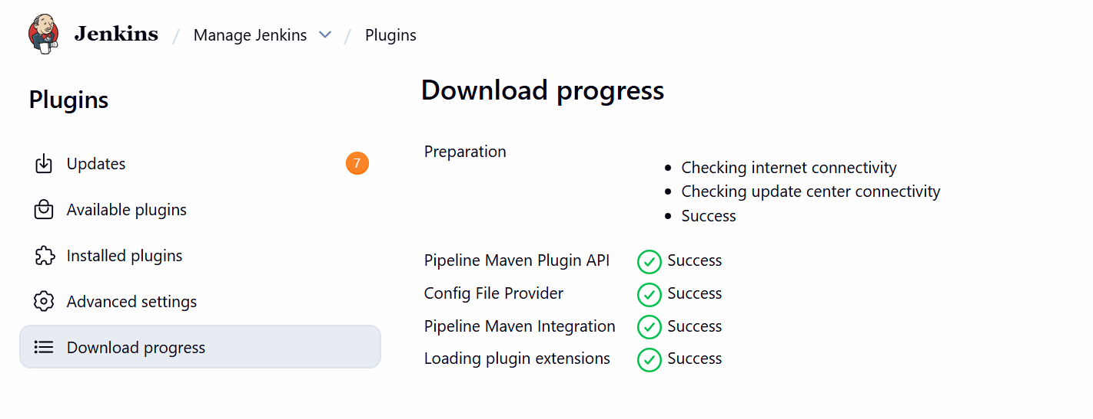

Step 2: Create a new job.
Job - Maven Project
Type – Maven Project
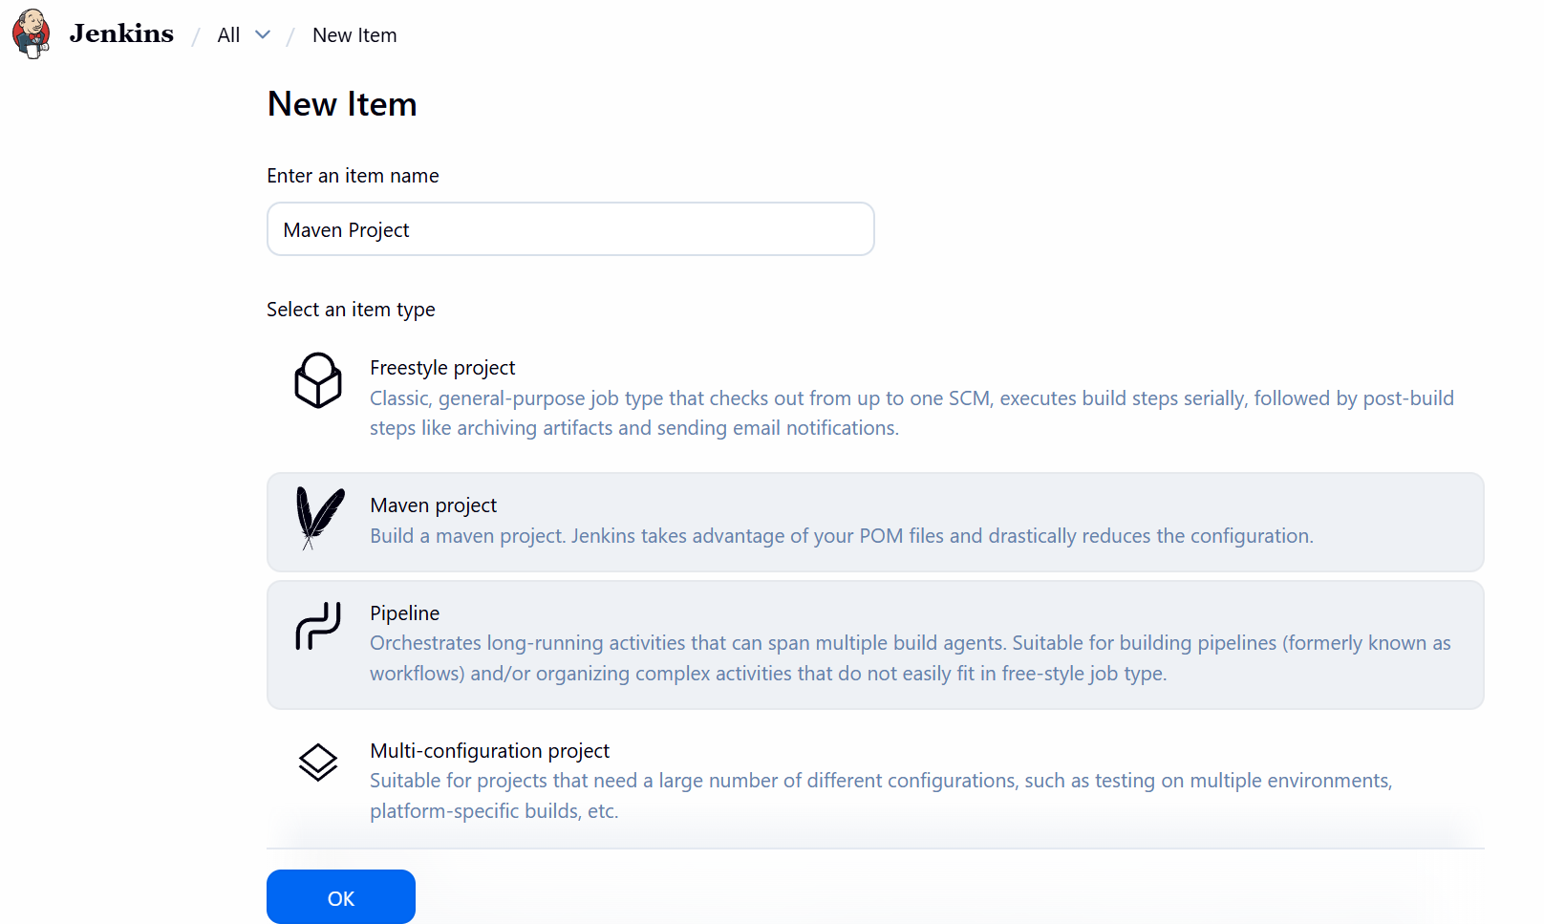
- Inside the project: configure source code as provided in the task details.
  - https://github.com/betawins/java-Working-app.git
  - save

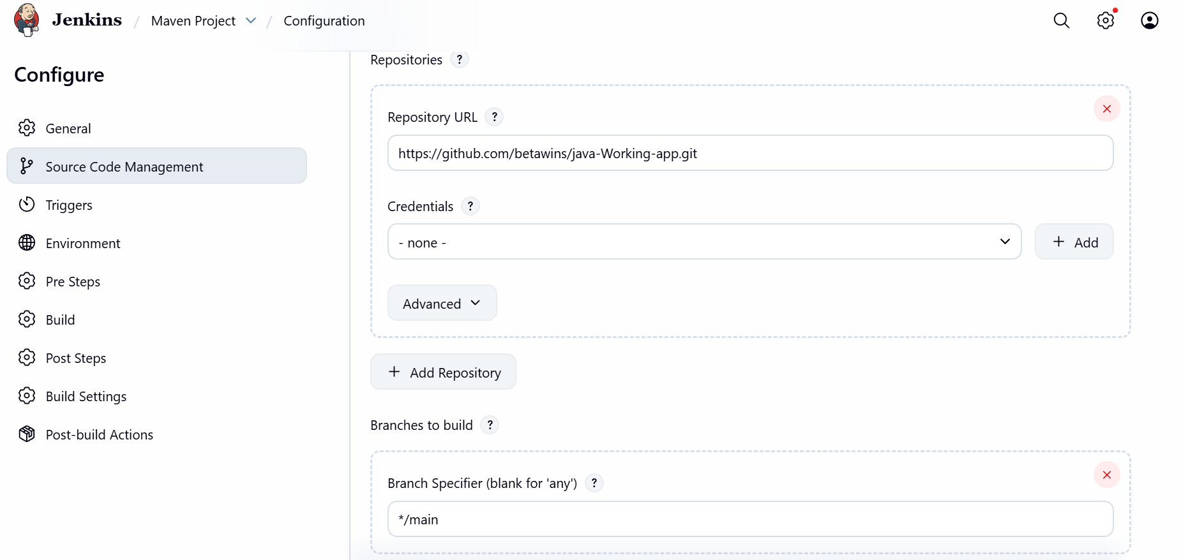

Step 3: Navigate to Manage Jenkins Tools
Add a Maven and name- maven-02
Version- install automatically
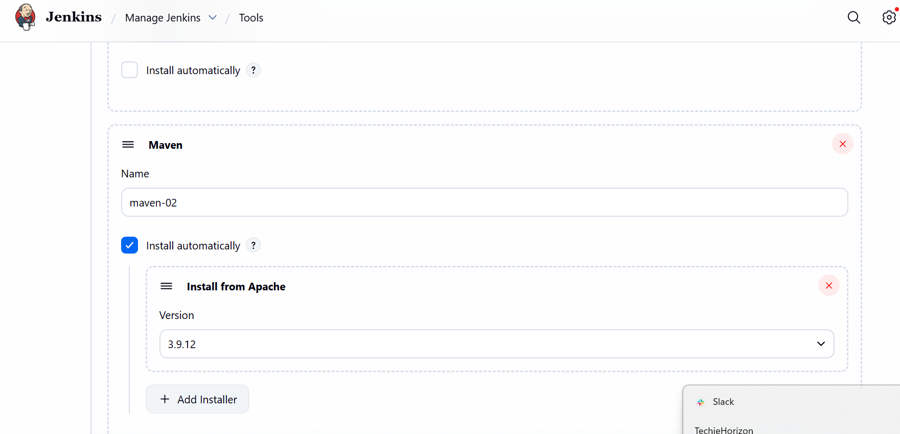

Step 4: Navigate to Maven project job
Goals and options: clean package
Jenkins will run Maven using the installed Maven tool.
—> save
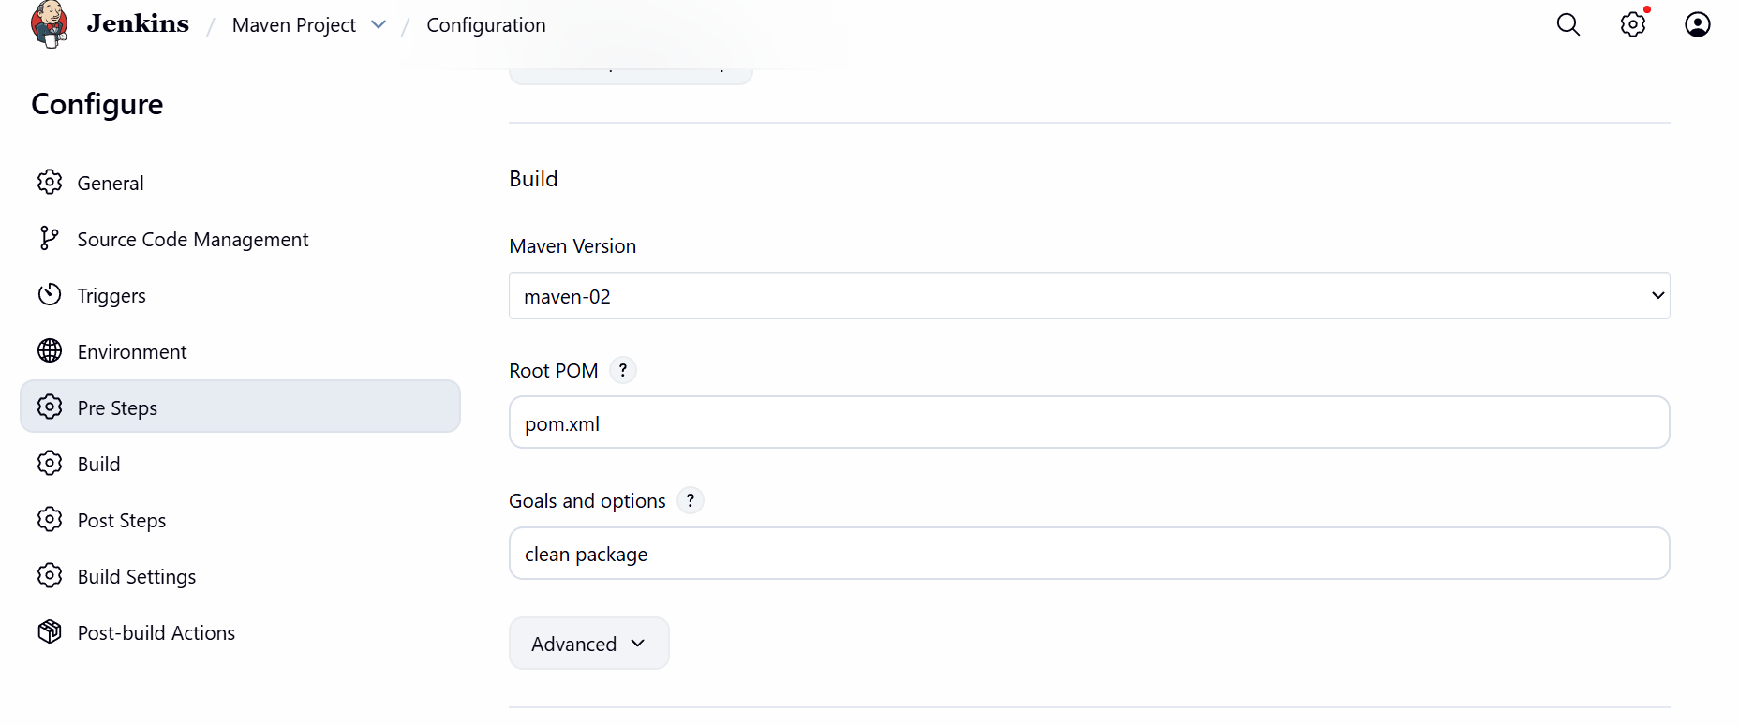
Step 5: Ready for build.
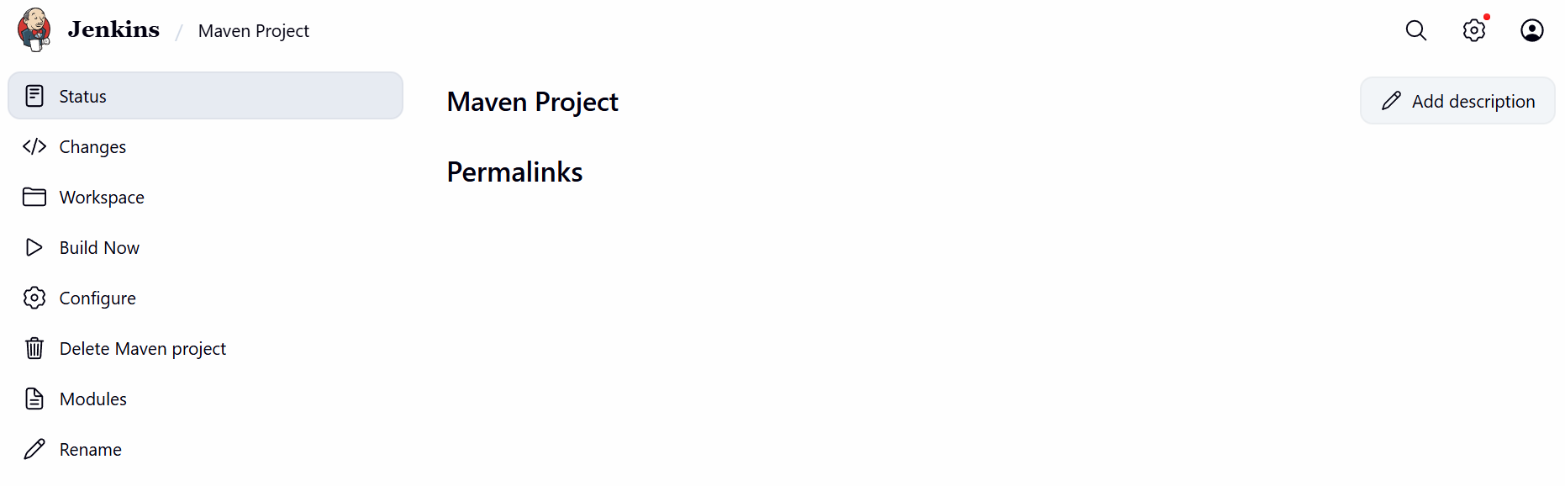

- Success
- Maven Project is built successfully with URL provided and Maven set-up plugin installed and configured.
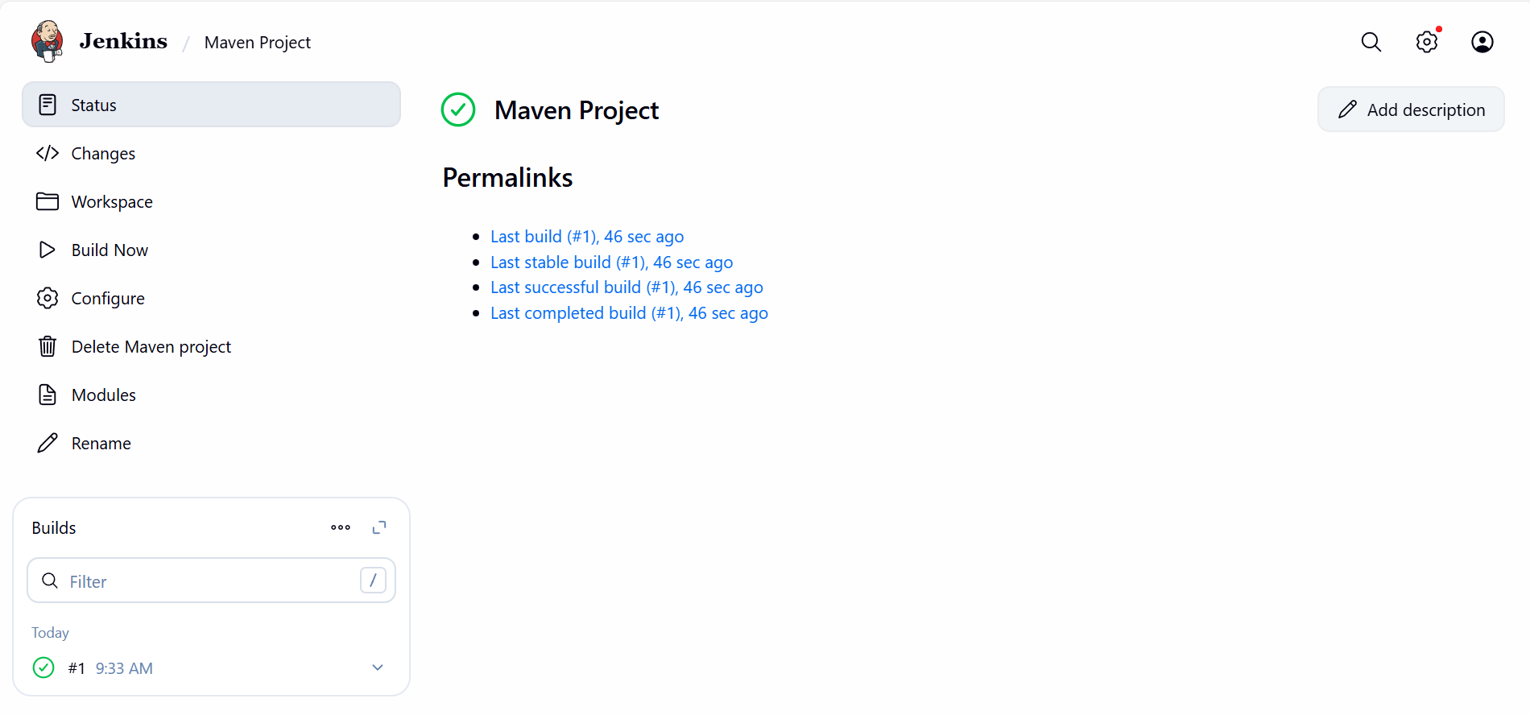
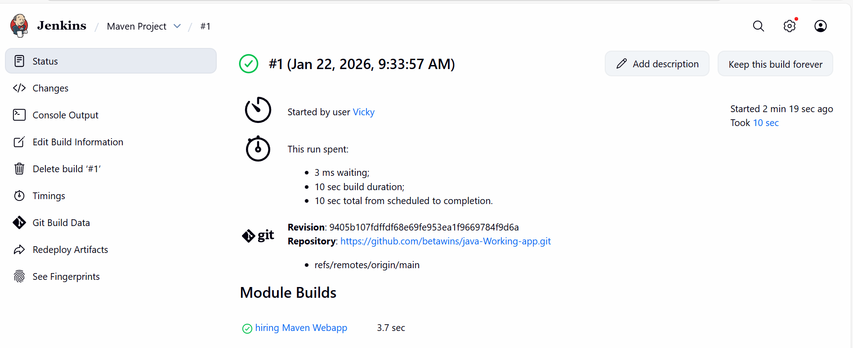

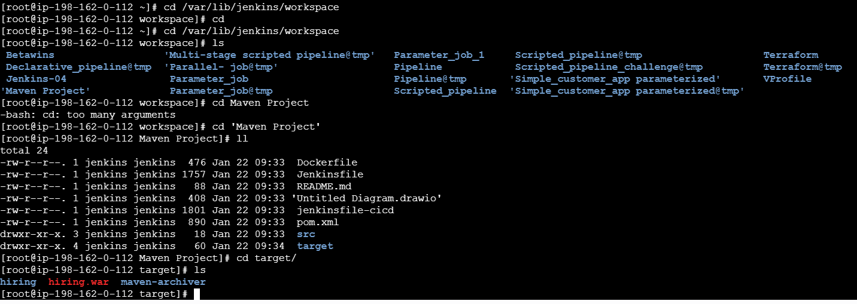

Task-3- Use the same code and create a parameterized job in Jenkins with two stages:

Stage 1: Git clone
Stage 2: Maven Compilation Code: https://github.com/betawins/java-Working-app.git

Step by step Implementation:
Step 1: Create a new job- Parameterized job
Item type- Pipeline

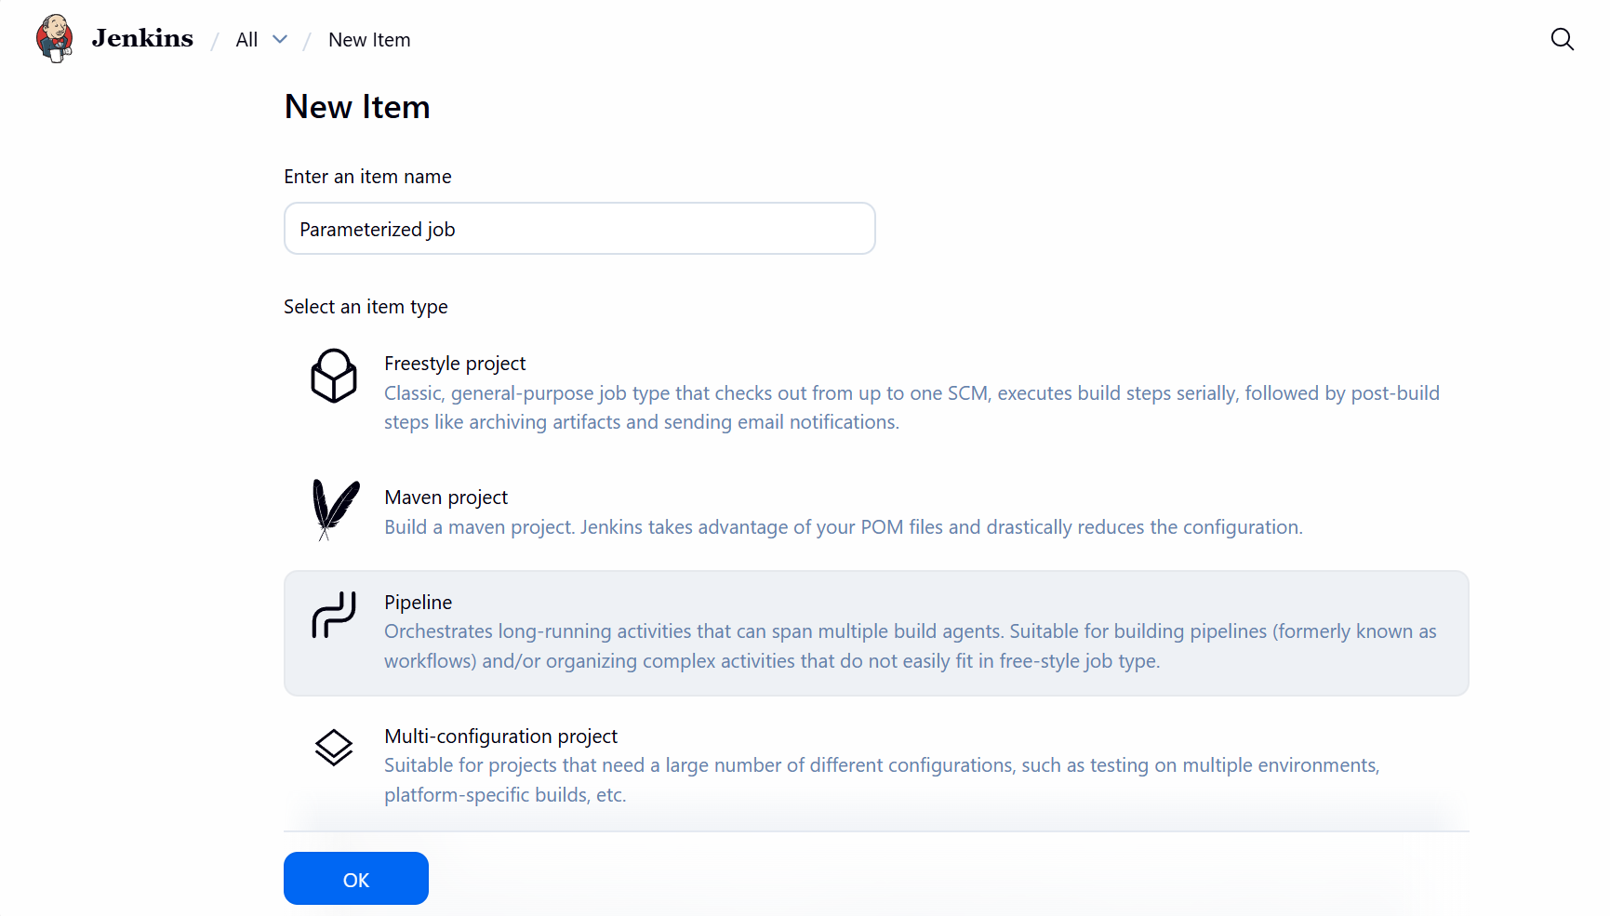

Step 2: Go to configurations and select This job is parametrized
From options select – String parameters
String parameters- Name:GIT_REPO, Default: https://github.com/betawins/java-Working-app.git, Description: Git Repository URL
String parameters- Name: BRANCH, Default: main, Description: Branch Name
String parameters- Name: MVN_GOAL, Default: clean compile, Description: Maven goals
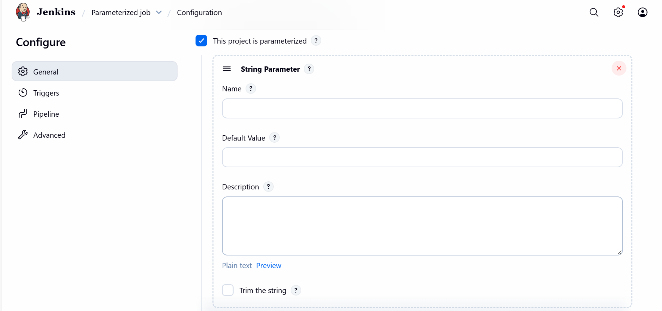

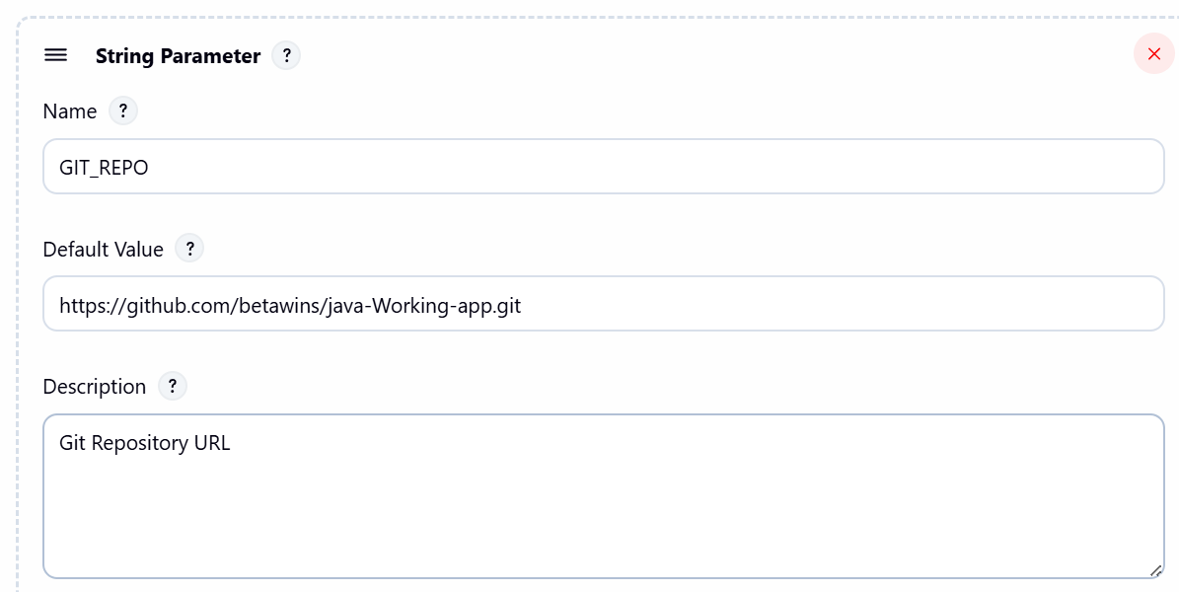
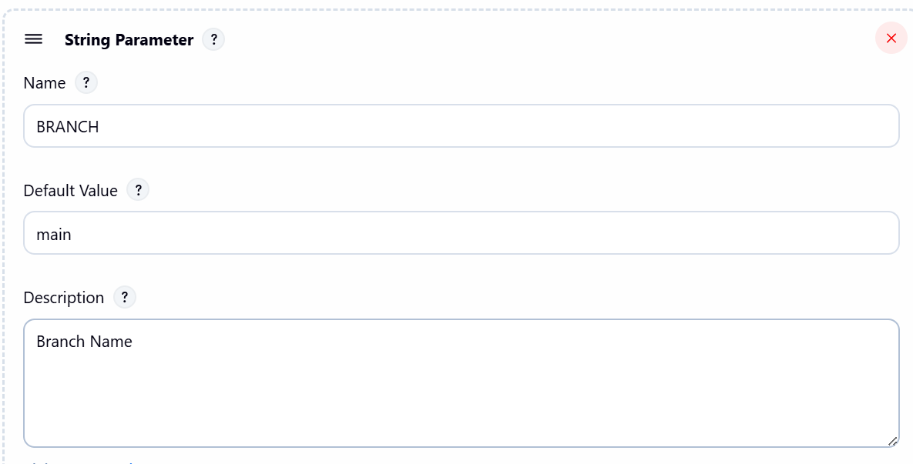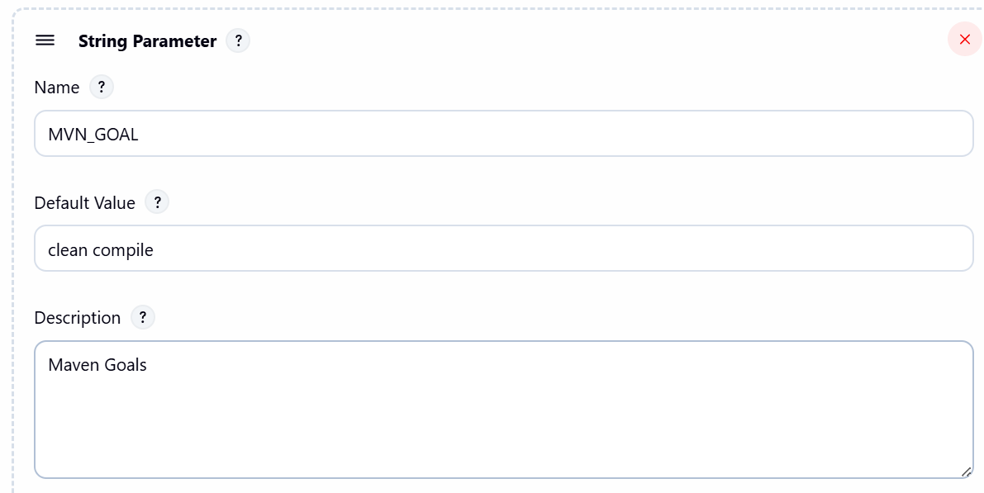

Step 3: Add pipeline script code
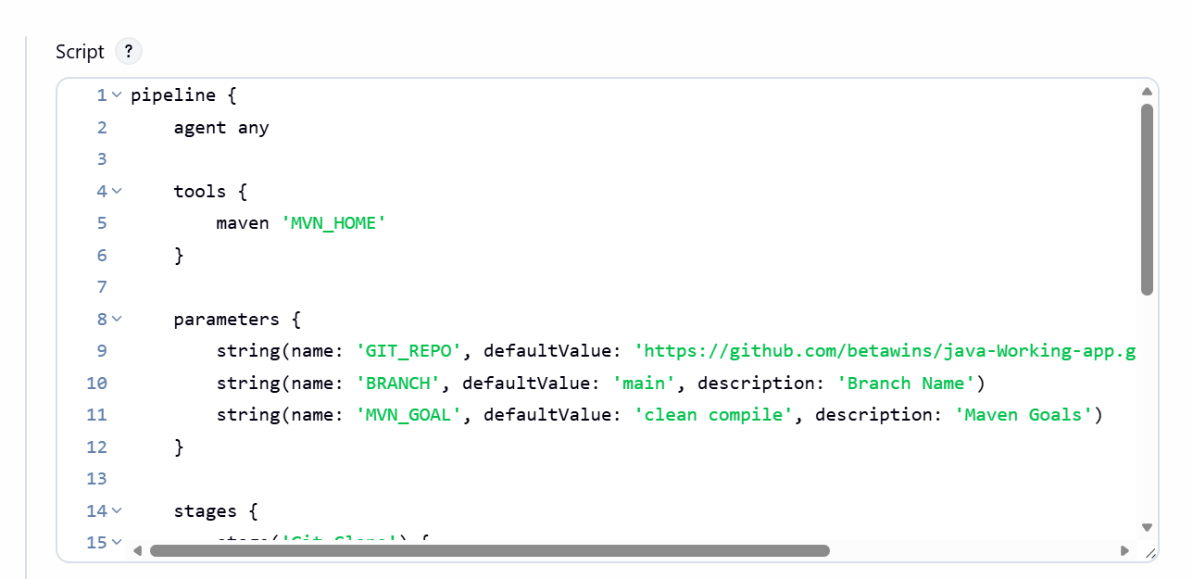

pipeline {
agent any

tools {
maven 'MVN_HOME'
}

parameters {
string(name: 'GIT_REPO', defaultValue: 'https://github.com/betawins/java-Working-app.git', description: 'Git Repository URL')
string(name: 'BRANCH', defaultValue: 'main', description: 'Branch Name')
string(name: 'MVN_GOAL', defaultValue: 'clean compile', description: 'Maven Goals')
}

stages {
stage('Git Clone') {
steps {
echo "Repo: ${params.GIT_REPO}"
echo "Branch: ${params.BRANCH}"

git branch: params.BRANCH, url: params.GIT_REPO
}
}

stage('Maven Compilation') {
steps {
sh "mvn ${params.MVN_GOAL}"
}
}
}
}

Step 4: Build with Parameters
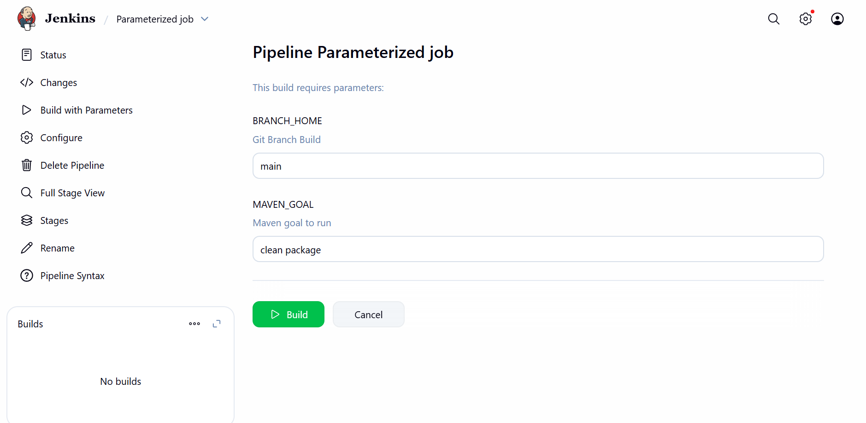

Step 5: Success
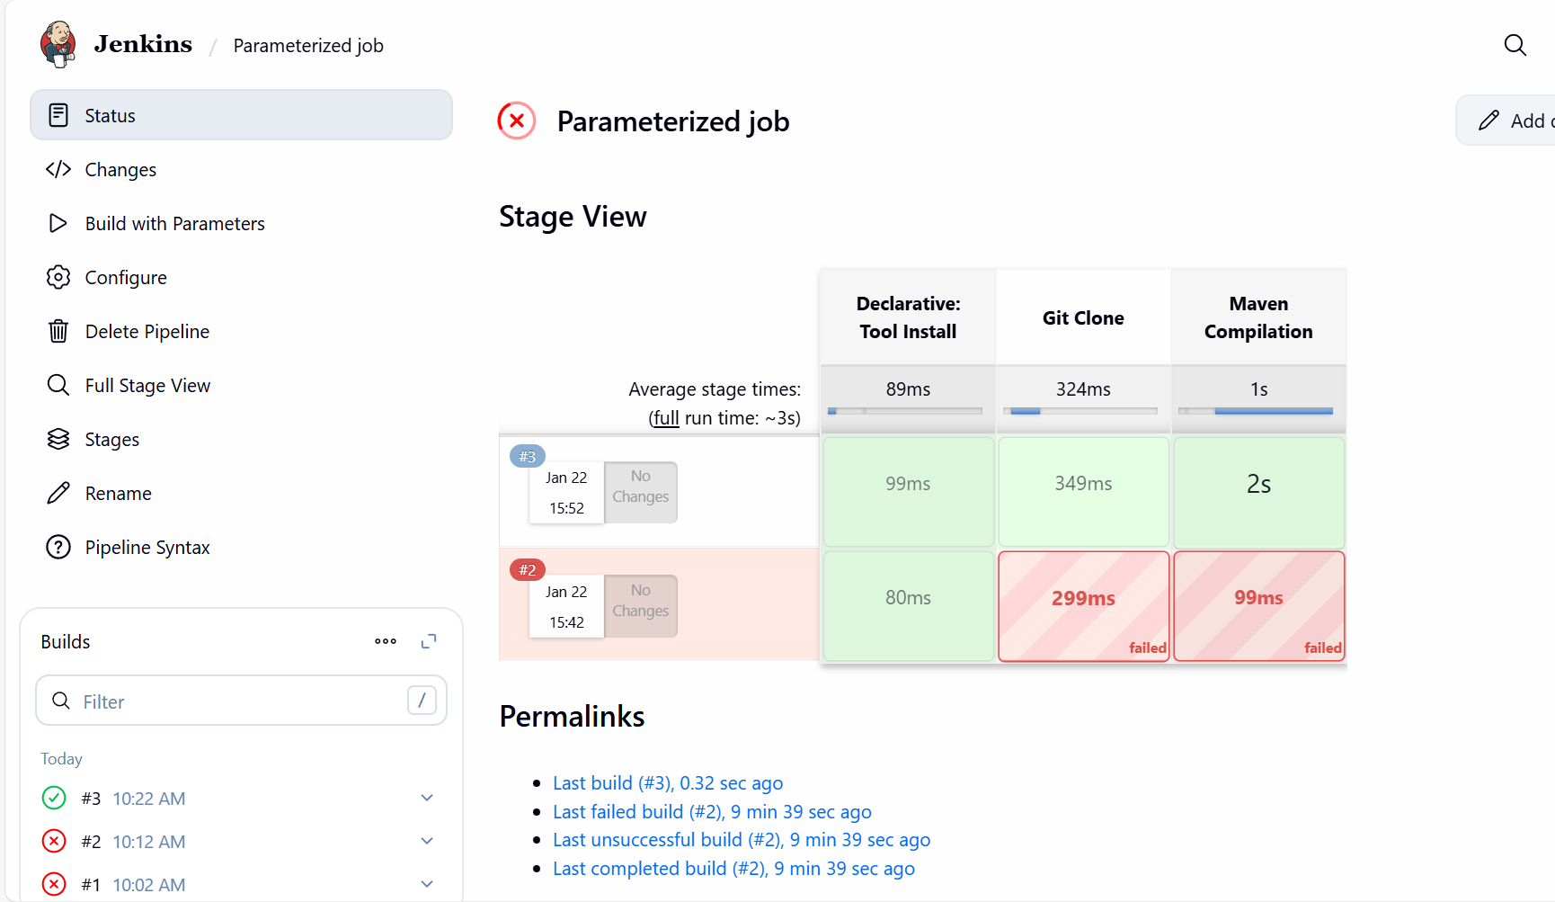

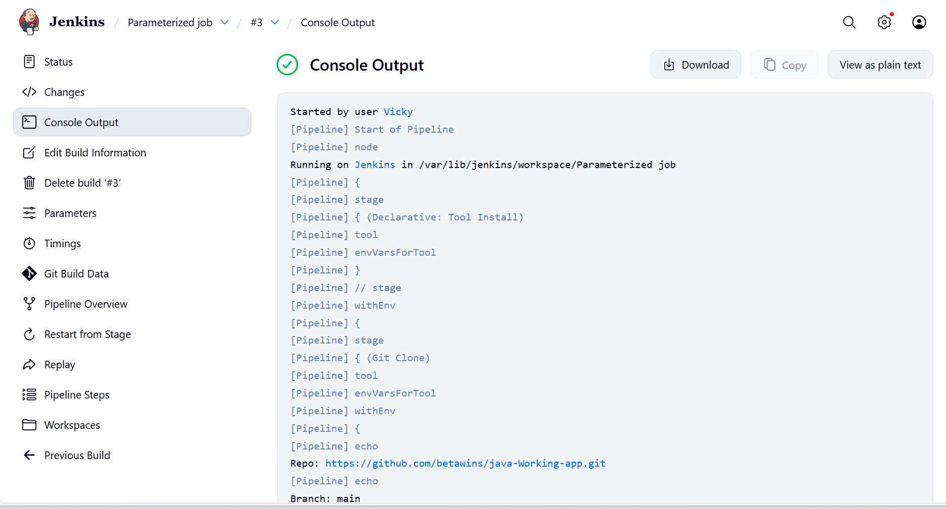

Task-3- What are the global variables in Jenkins?
Global Variables in Jenkins
1. Environment Variables
These are available to all jobs and pipelines:
- BUILD_NUMBER → Current build number (e.g., 15).
- BUILD_ID → Unique build ID (timestamp).
- JOB_NAME → Name of the job (e.g., MyPipeline).
- WORKSPACE → Path to the job’s workspace directory.
- JENKINS_HOME → Path to Jenkins installation directory.
- NODE_NAME → Name of the agent/node running the build.
- EXECUTOR_NUMBER → Executor slot number on the node.
- GIT_COMMIT → Commit hash (if using Git plugin).
- GIT_BRANCH → Branch name (if using Git plugin).
2. Pipeline Global Variables
In Declarative Pipelines, Jenkins provides built-in variables:
- env → Access to environment variables (env.BUILD_NUMBER, env.JOB_NAME).
- params → Access to build parameters (params.VERSION).
- currentBuild → Metadata about the current build (result, duration, etc.).
- scm → Refers to the SCM configuration of the pipeline.
- docker → Provides Docker-related helpers (docker.image('nginx').run()).
- pipeline → Declarative pipeline context.
User-Defined Global Variables
- Defined in Manage Jenkins → Configure System → Global properties.
- You can add custom environment variables here, available to all jobs.
- Example:
environment {
MY_GLOBAL_VAR = "Vicky"
}

