Terraform-04

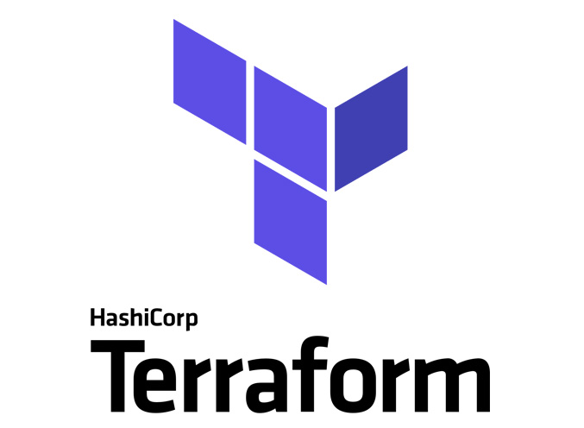

General tips for the Task below.
Task Title
Terraform-04
Objective
The objective of this task is to watch the Terraform-04 video posted on slack with and worked on executing templates shown in video.
Prerequisites
List all requirements before starting:
- AWS
- Visual studio code
- Jenkins plugin- Terraform
- NodeJS
- Maven Commands
Issues Faced: Briefly mention issues and how you fixed them. Posted below in the last.
Conclusion
Conclusion has been provided for every task at the end.

- Watch Terraform-04 video.
- Execute the script shown in the video.

Step by step Implementation:

- Git init-
- Once code is updated and executing “Git Init”, then the latest version of the provider will get installed.
- Now, we have updated code and shall use command- “git init”
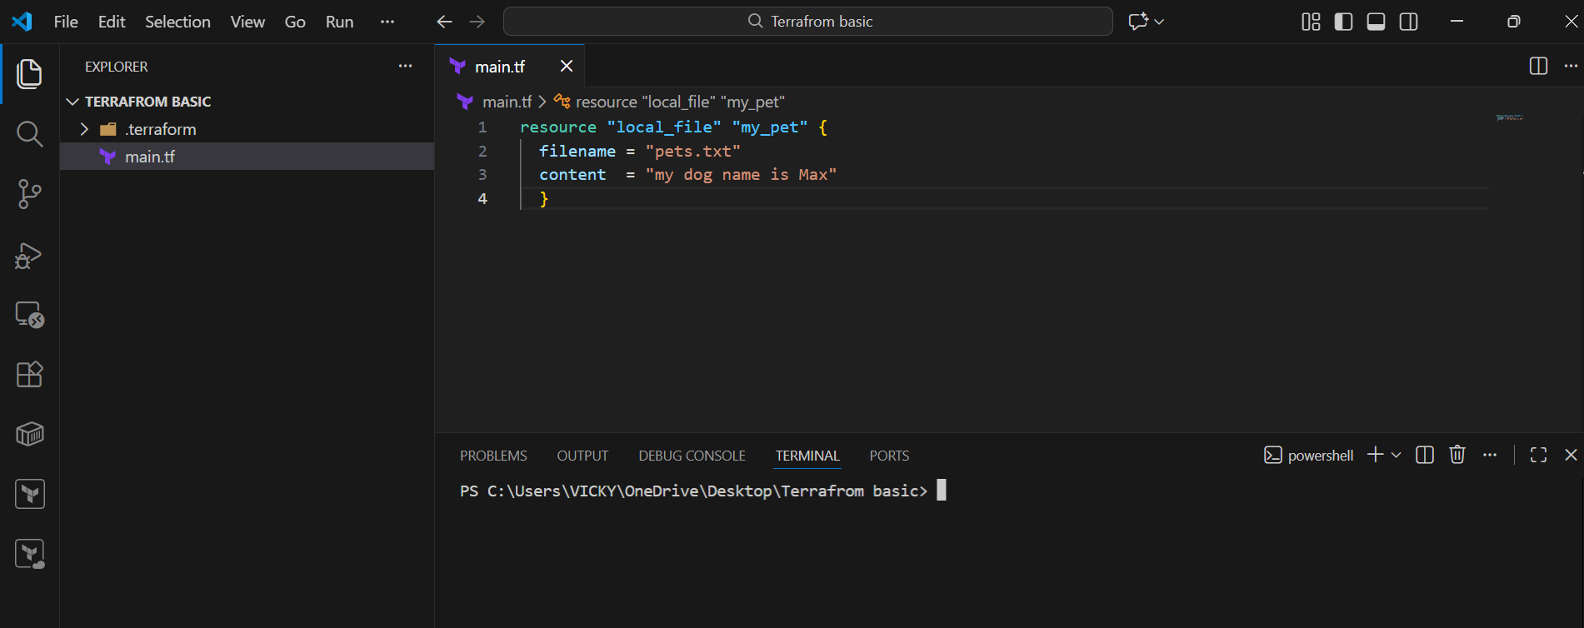

- Now, the latest version is downloaded- local v2.6.1
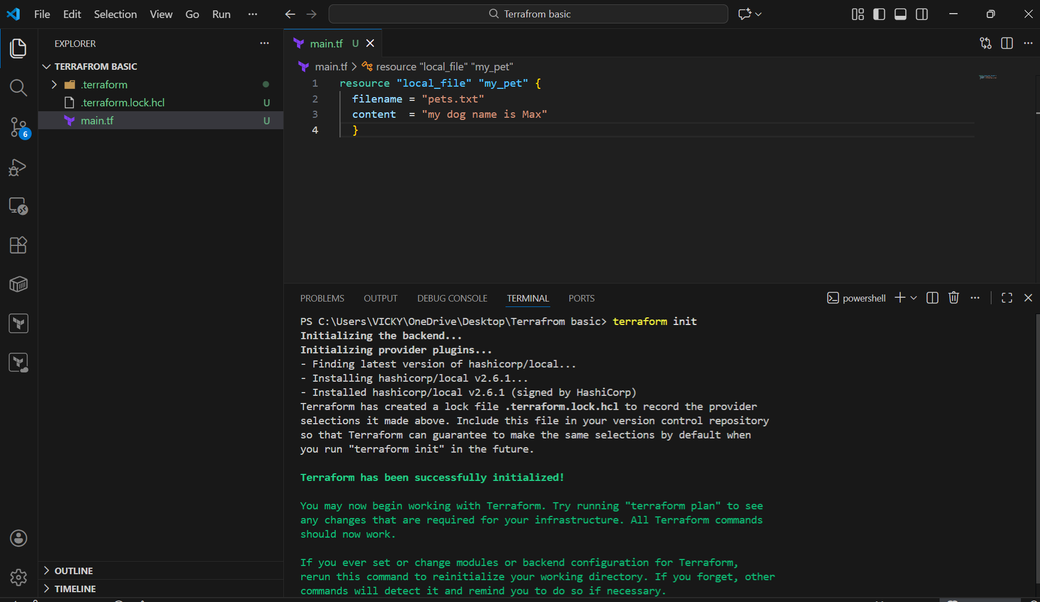
- In some use case scenario, we need to use dedicated version, so that in future, even if we need to work on the same file, then, it will be helpful.
  - For that, we shall navigate Terraform registry
  - Search local
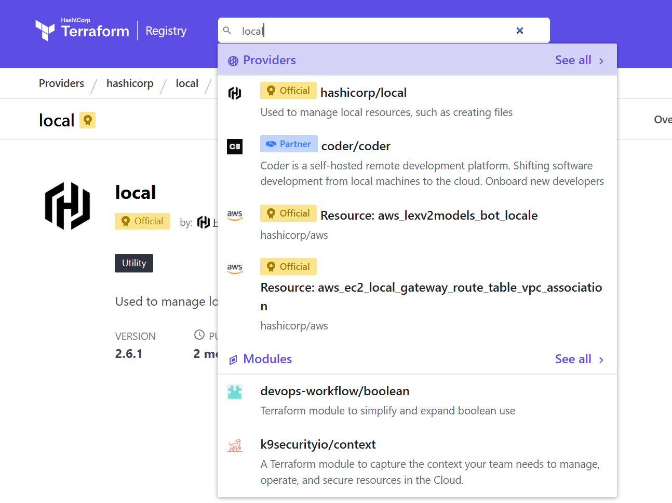
  - We can see below, there are multiple versions and we can choose any.
  - We can use previous versions as well to use dedicated one.
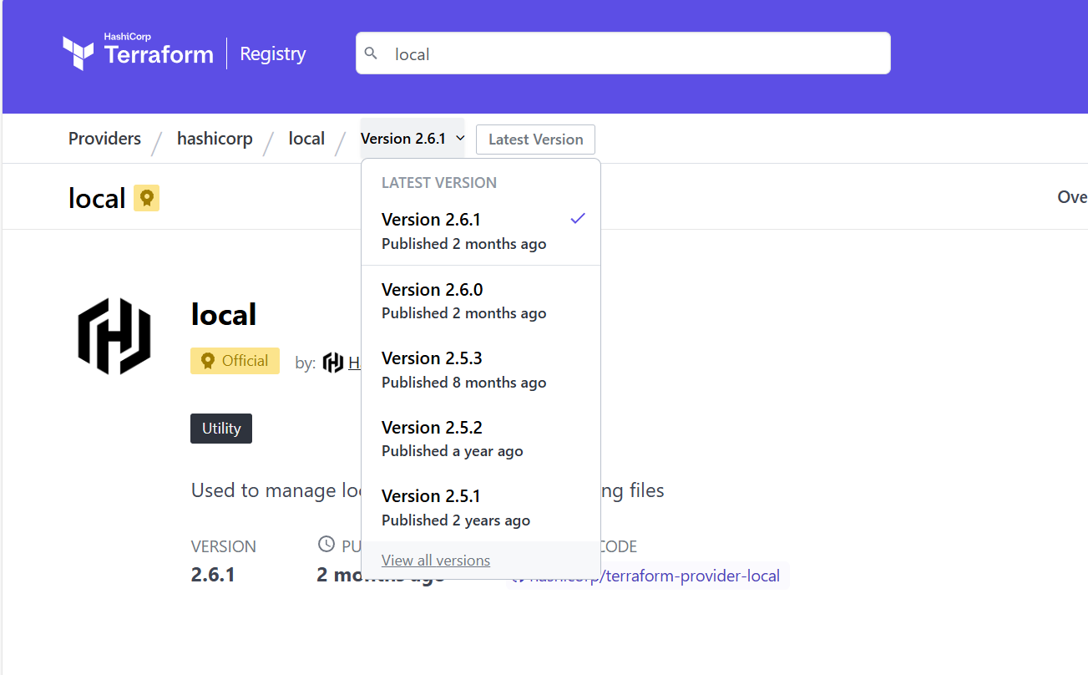
- We can see in the right we have the dedicated version details, that should be passed on to the vs code for windows.
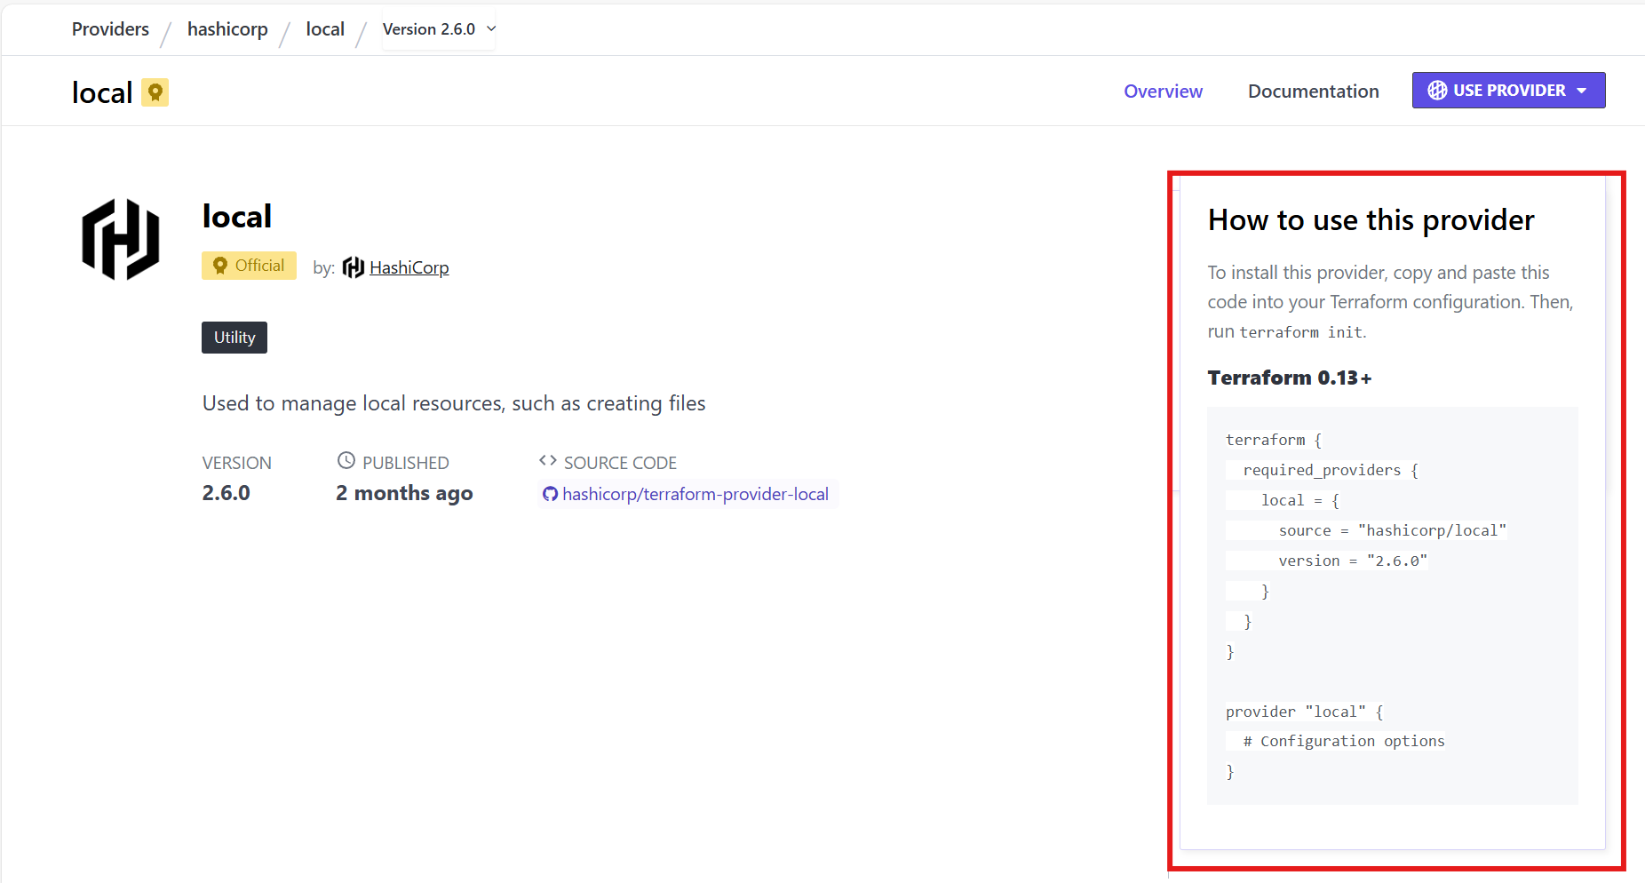
- We pasted the code to our windows vs code and shall execute “terraform init”
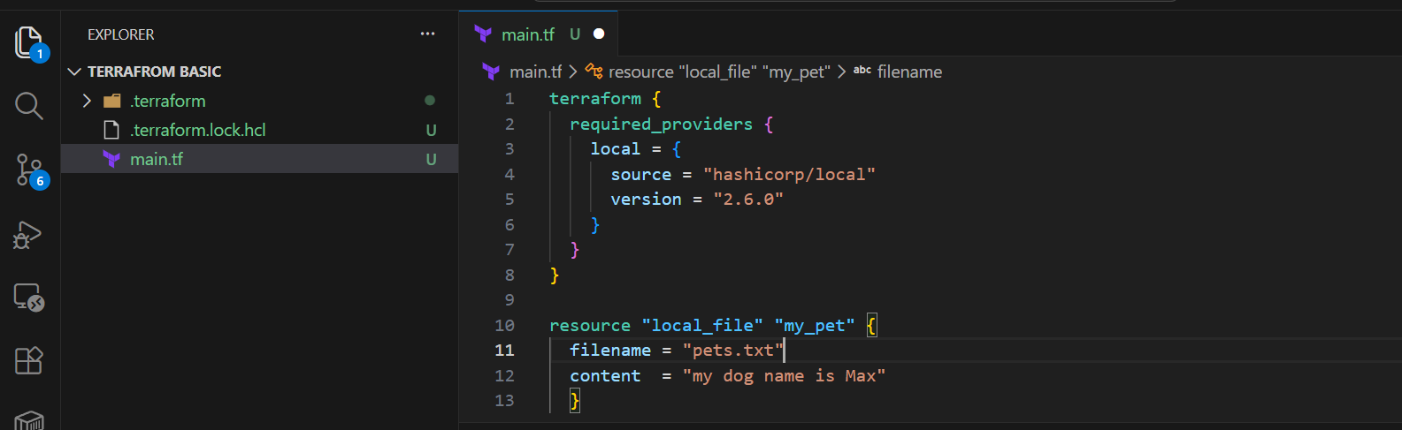

- We saved the page and let’s perform “terraform init”
- Now, we can see the version 2.6.0, the previous version is installed.
- By this way, we can install the dedicated version and use the version until the file exists.
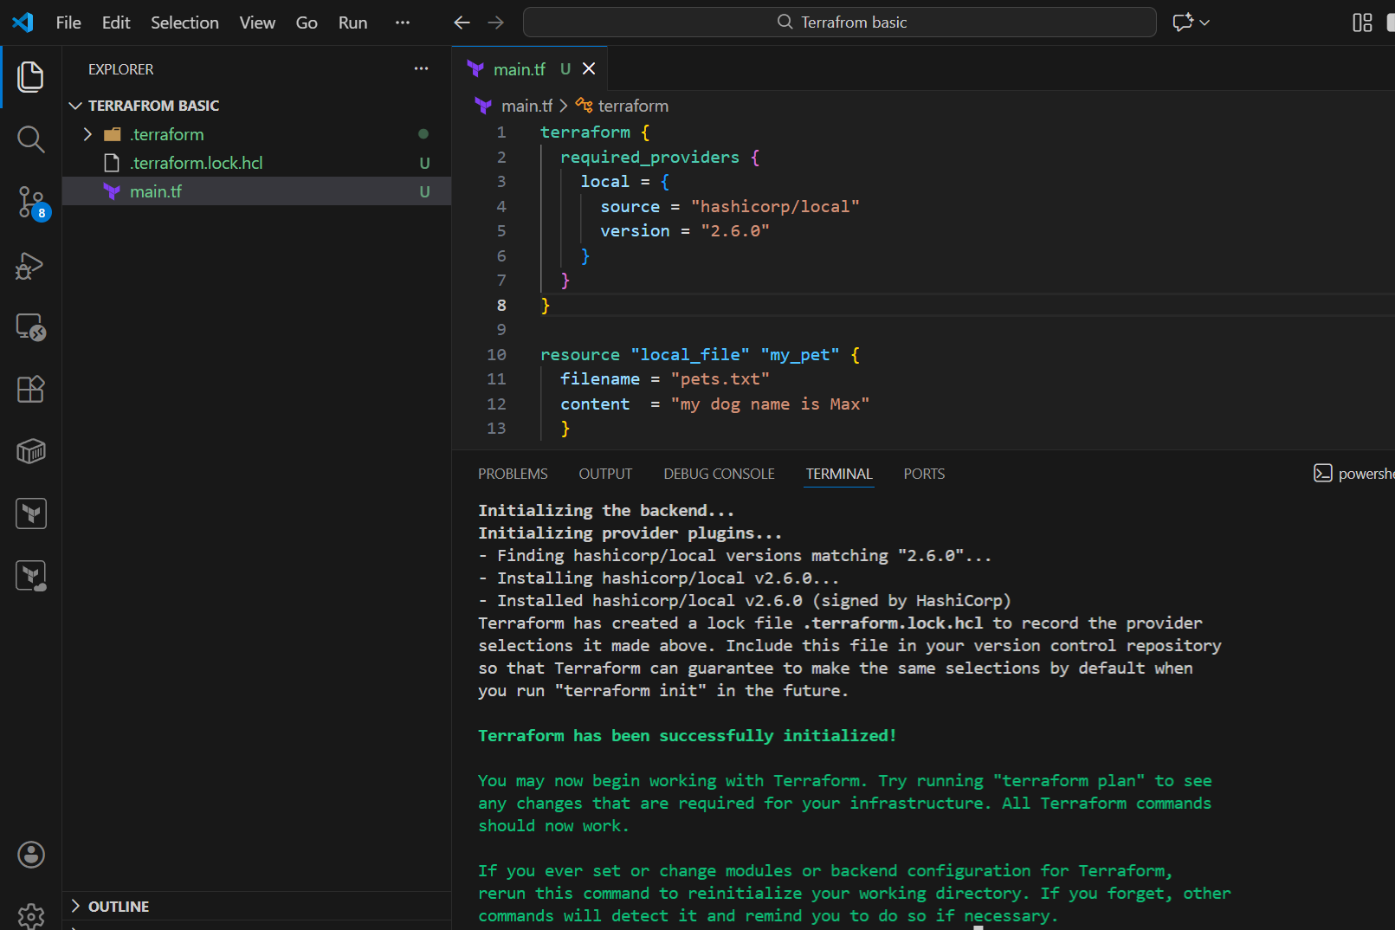

- Now, we have got a situation and need to change the version from 2.6.0 to 2.5.3
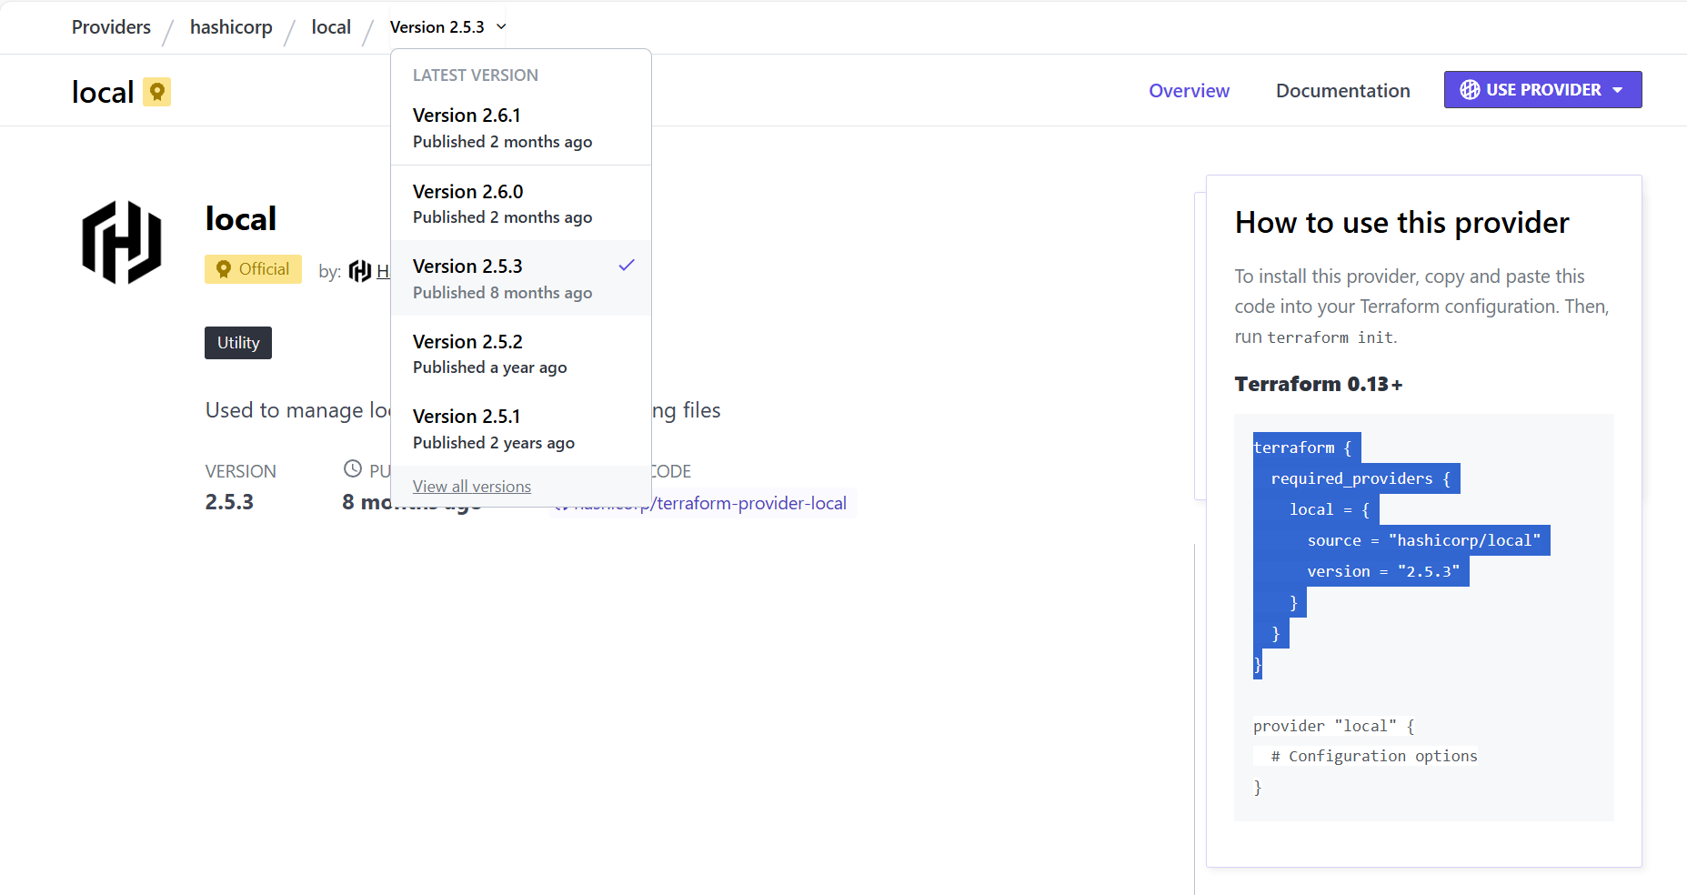

  - We can see in the below screenshot, an error threw up, stating to use command- terraform init -upgrade
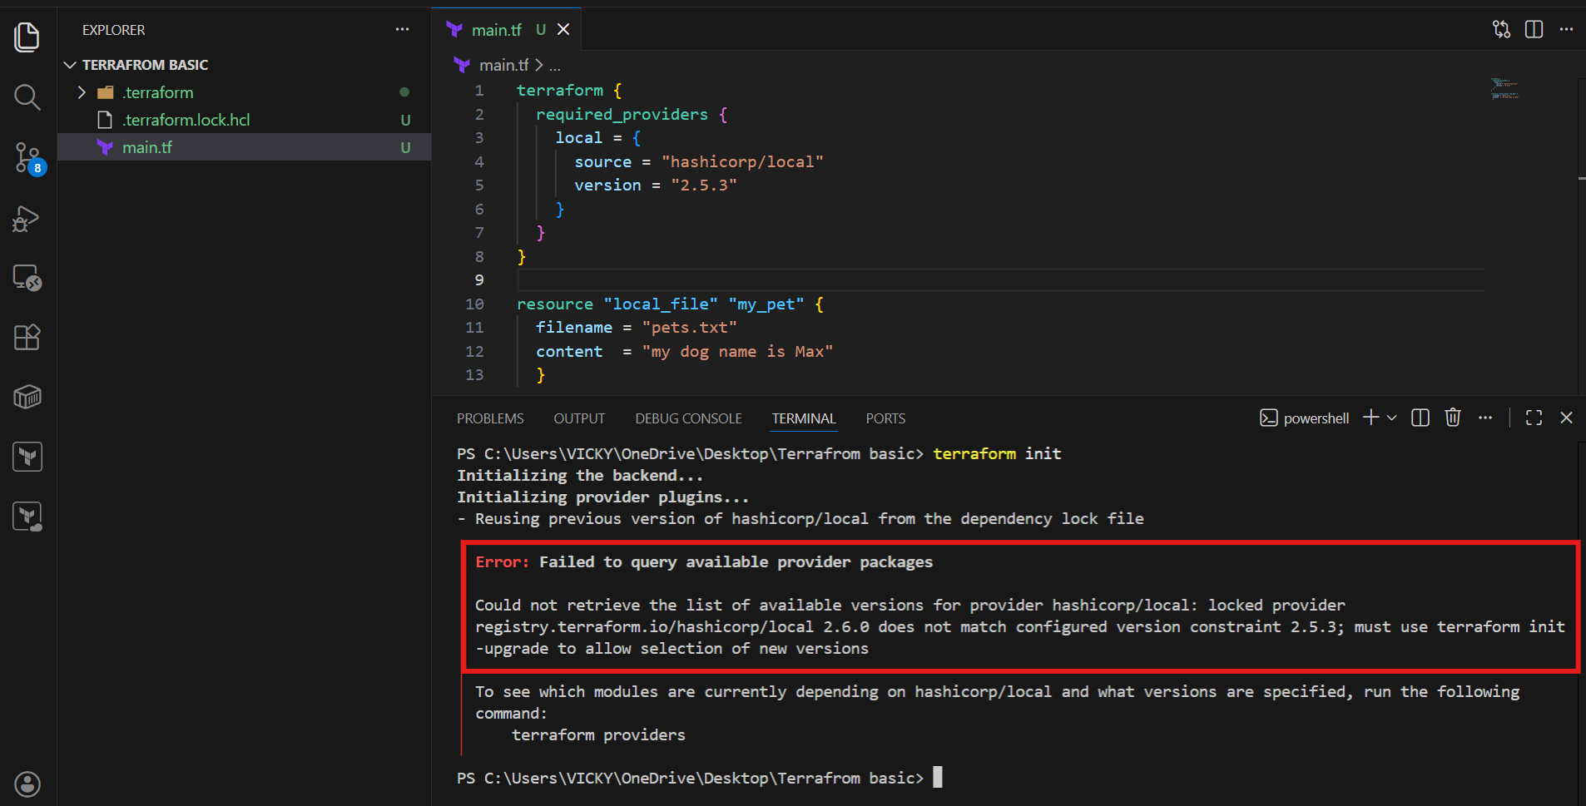
  - Terraform init -upgrade executed and dedicated version- 2.5.3 is our current version.
  - This way, we can use dedicated versions in terraform.
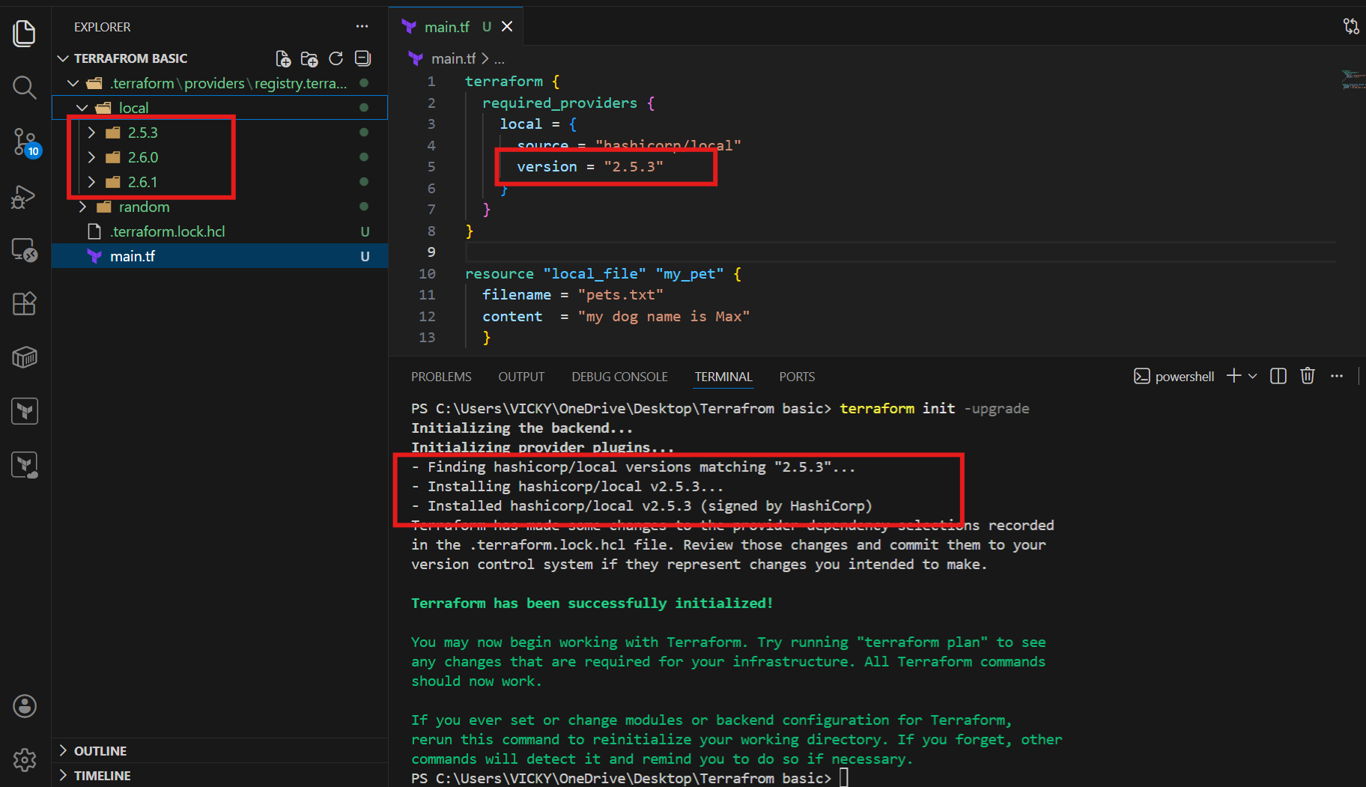

- Now, we shall how to use different commands to use versions.

Version = “2.3.0” --> download the exact version
Version = “!=2.3.0” -->will not use the mentioned version
Version = “< 2.3.0” -->lesses than the mentioned version
Version = “> 2.3.0” -->greater than the given version
Version = “~> 2.3.0” -->specific version or higher version.

We have already tested the exact version, so let’s test next.

I have removed state file terraform.tf file and backup files as well.
The reason for removing is to test the different versions of how to install terraform.init
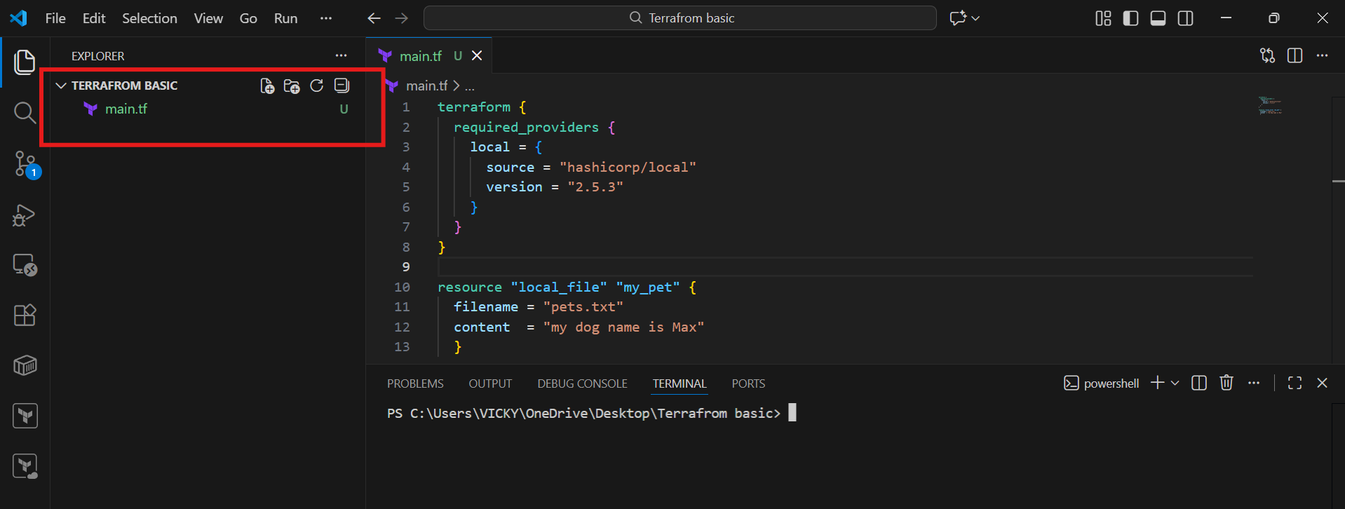

- Version = “!=2.3.0” -->will not use the mentioned version
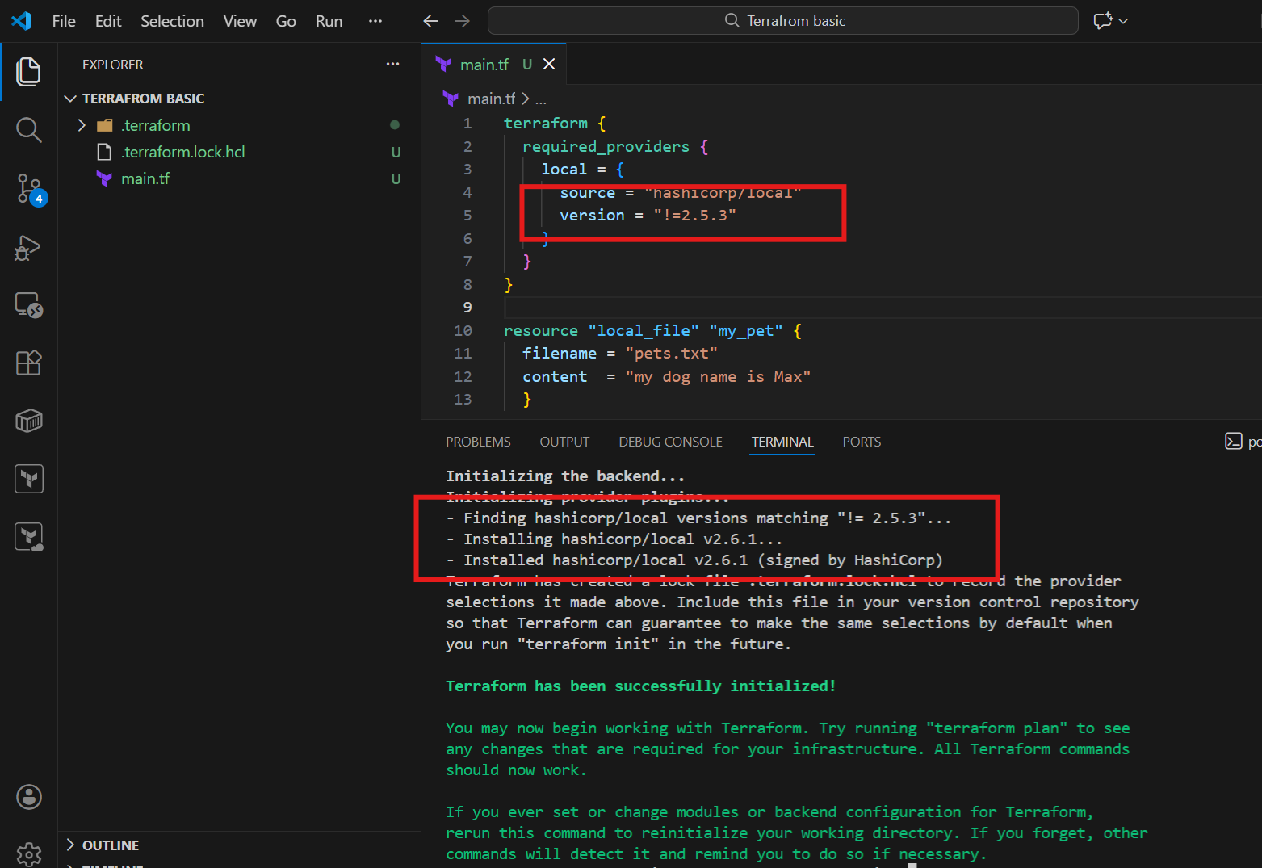
Version = “< 2.3.0” -->lessees than the mentioned version
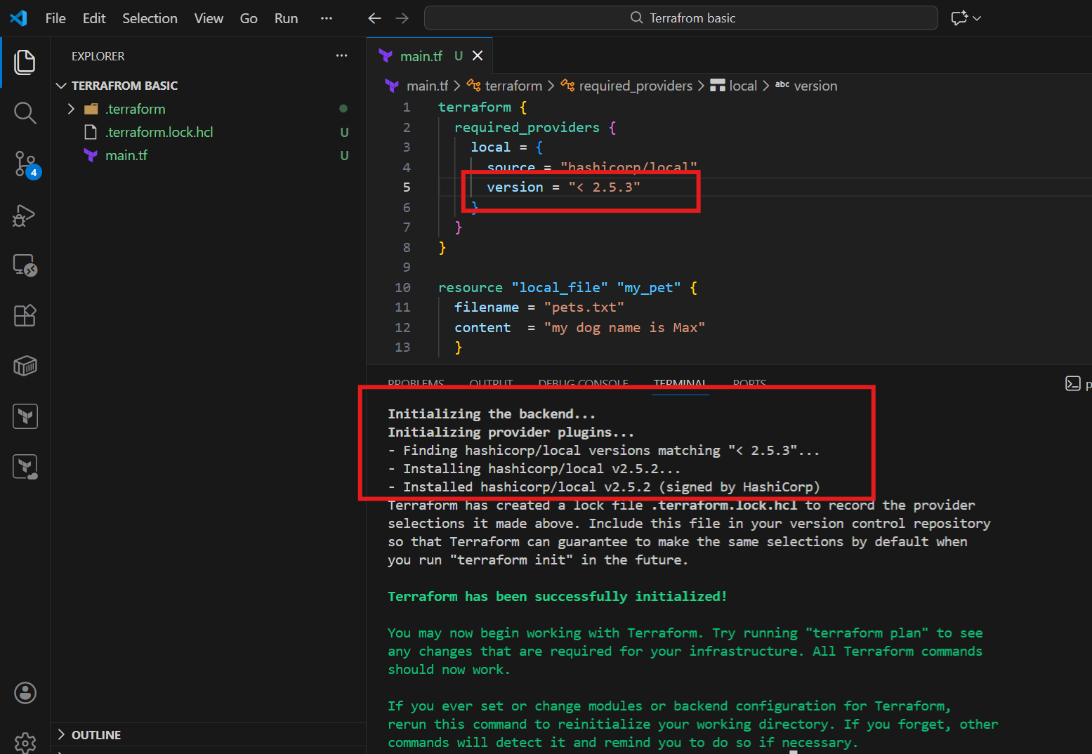
Version = “> 2.3.0” -->greater than the given version
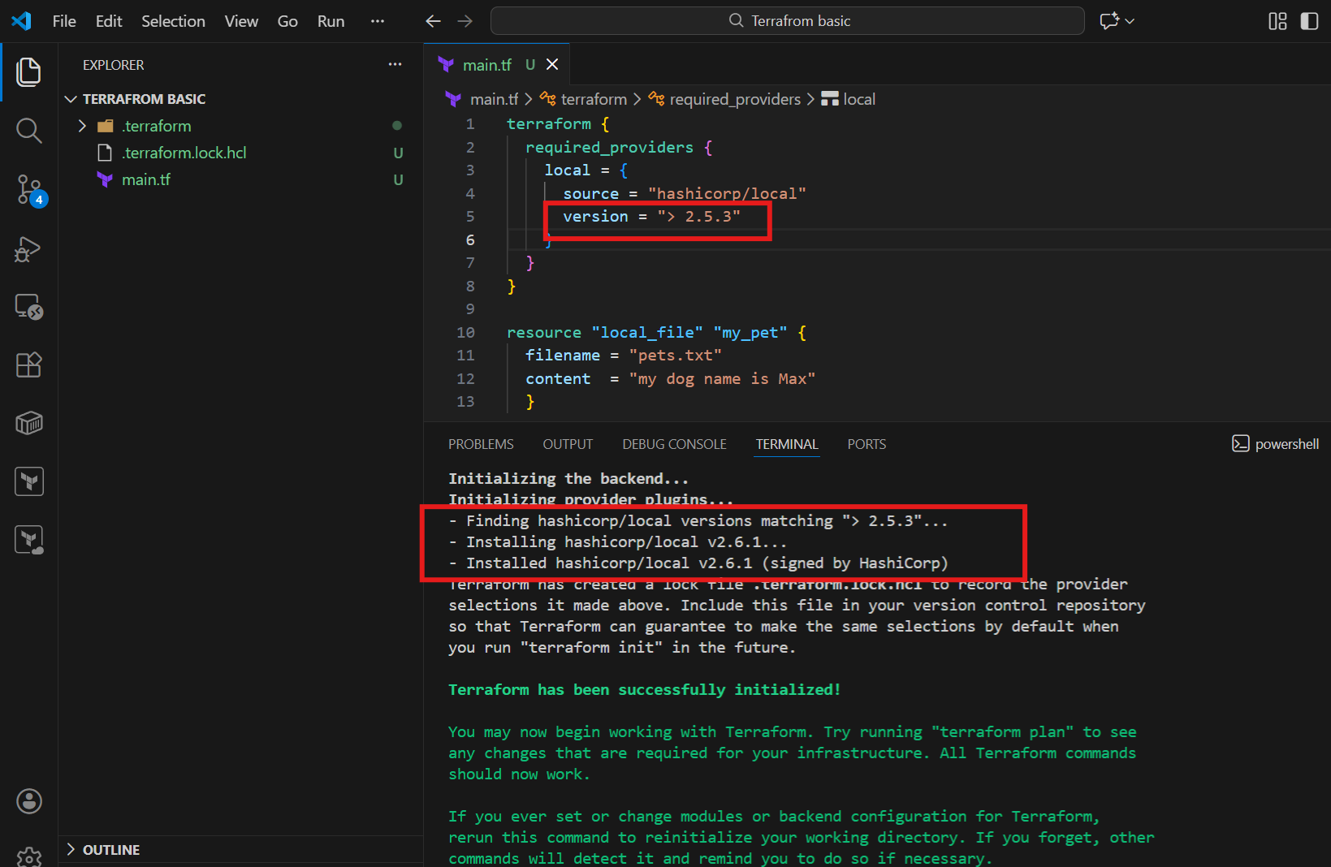
Version = “~> 2.3.0” -->specific version or higher version.
This will help us to install specific or higher here, it installed the same version.
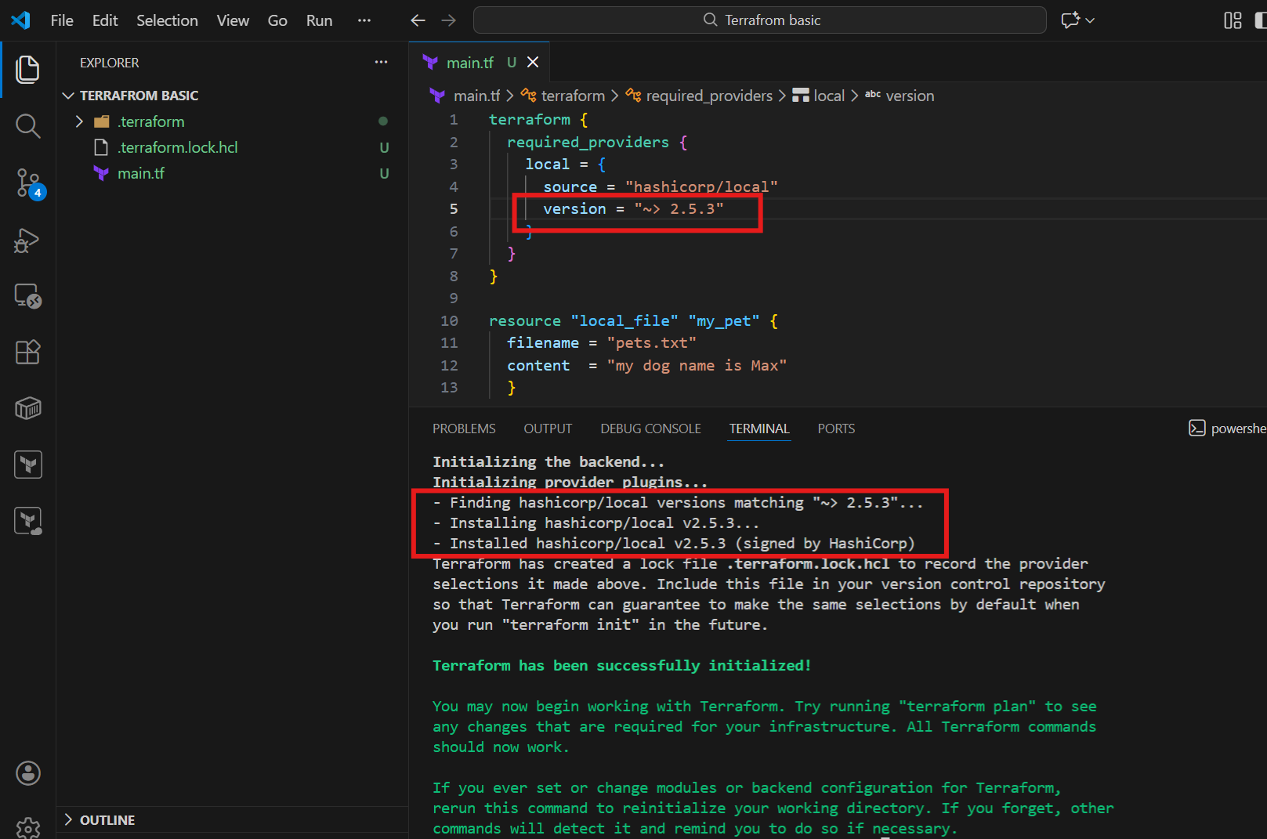
Data Sources

Data block is to only read the content of the main infrastructure.
Using data source
We will call the content of the file using file name not by hardcoding the data in command line.
  - We removed the terraform block which we created earlier and used command- terraform apply.
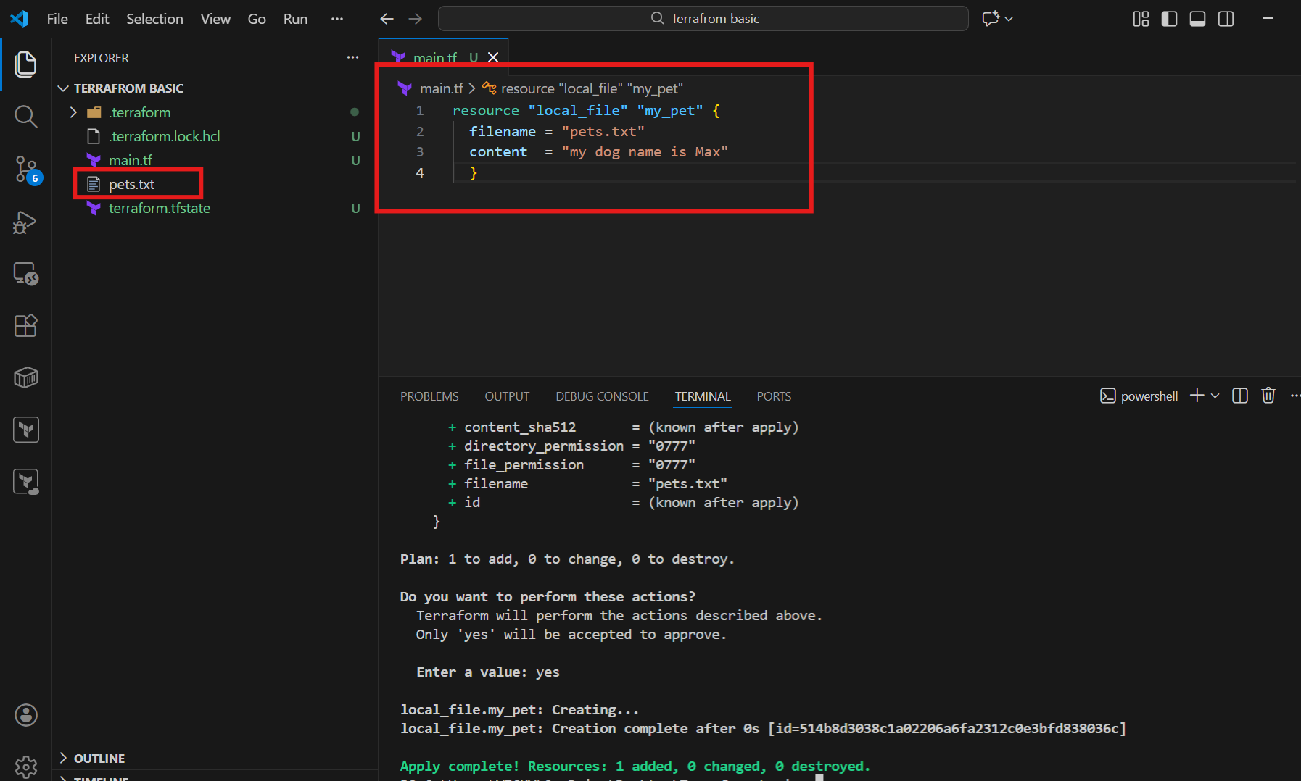

Now, we shall create a file called- dogs.txt for using data block.
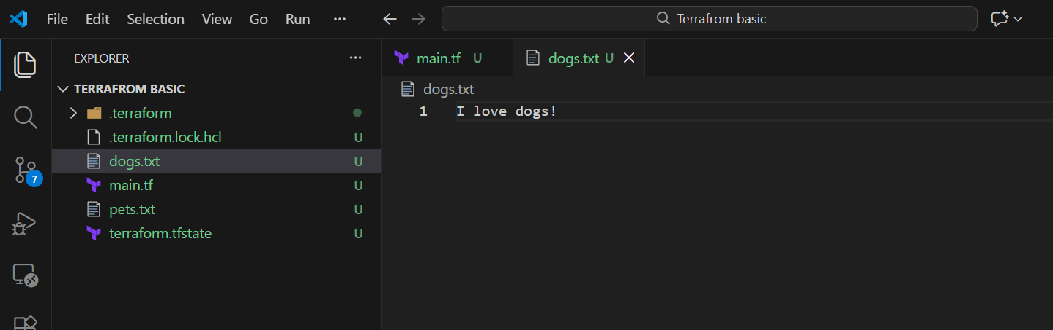

We shall create a data block now in the main.tf
  - Created data block as per below screenshot
  - Changed content and executed the code.
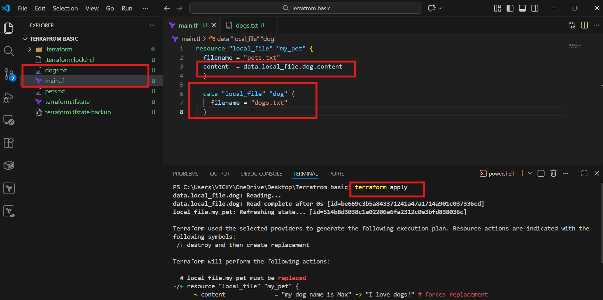
  - We can verify that, now in pets.txt we can see the data block is able to read the local provider.
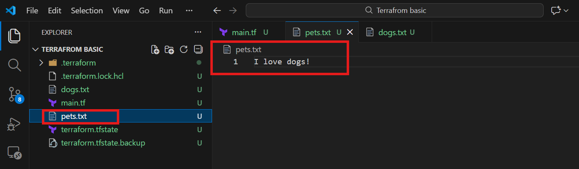

Meta-Arguments

Meta Arguments are used to create multiple resources and to change the behaviour of the resources.
Examples of meta-arguments:
  - Depends_on
  - Lifecycle rules
  - Count
  - For_each

We are using Count – Meta Argument here.
So, we created a file- variables.tf
Updated code to variables.tf and saved.
Updated code to main.tf according to variables.tf and save
Terraform init – we removed all state file and terraform file as well.
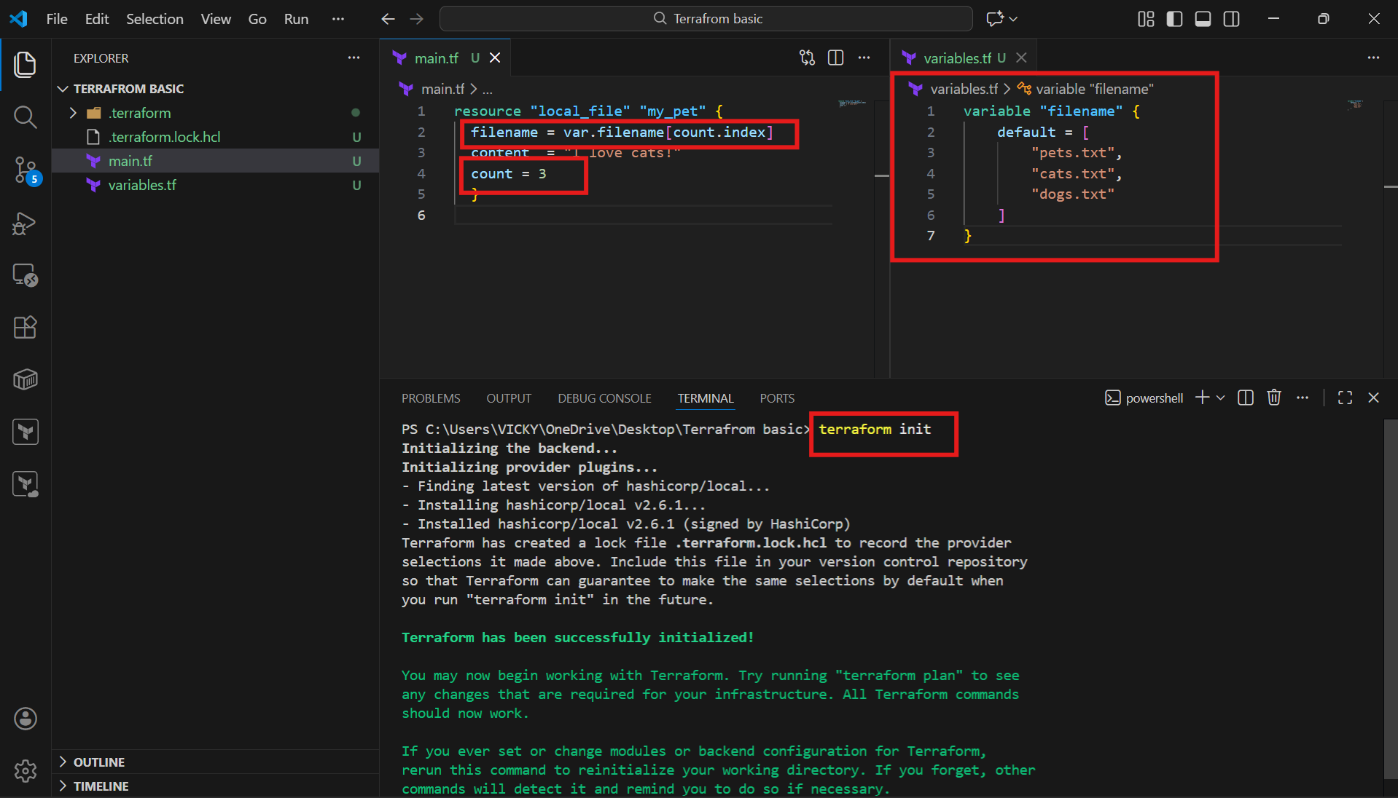

Terraform apply – we verified that, 3 files got created with this type of code.
This will help us to create multiple files by creating variables.tf

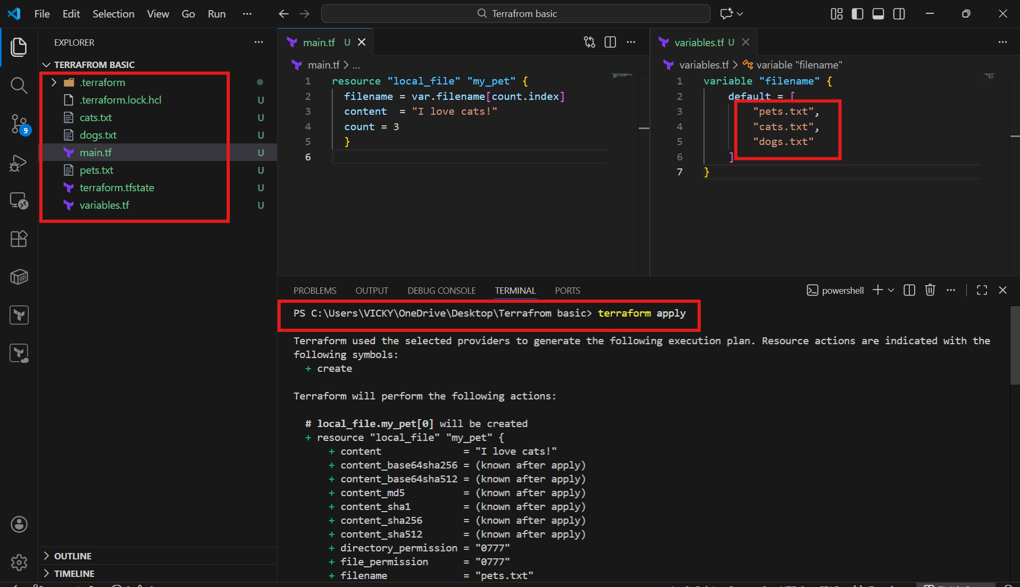
We can see here, 3 files have been created.
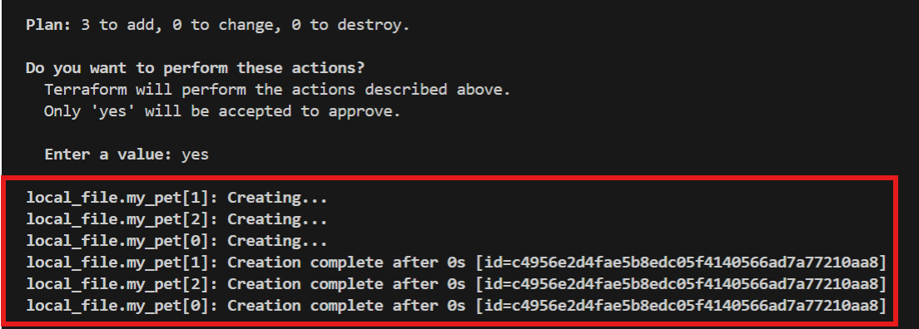

- There might be errors, when we don’t provide the count correctly in main.tf.
  - To overcome this situation, we can write a code under count in mian.tf – count = length(var.filename)
  - This way, it will automatically take the count from variables.tf

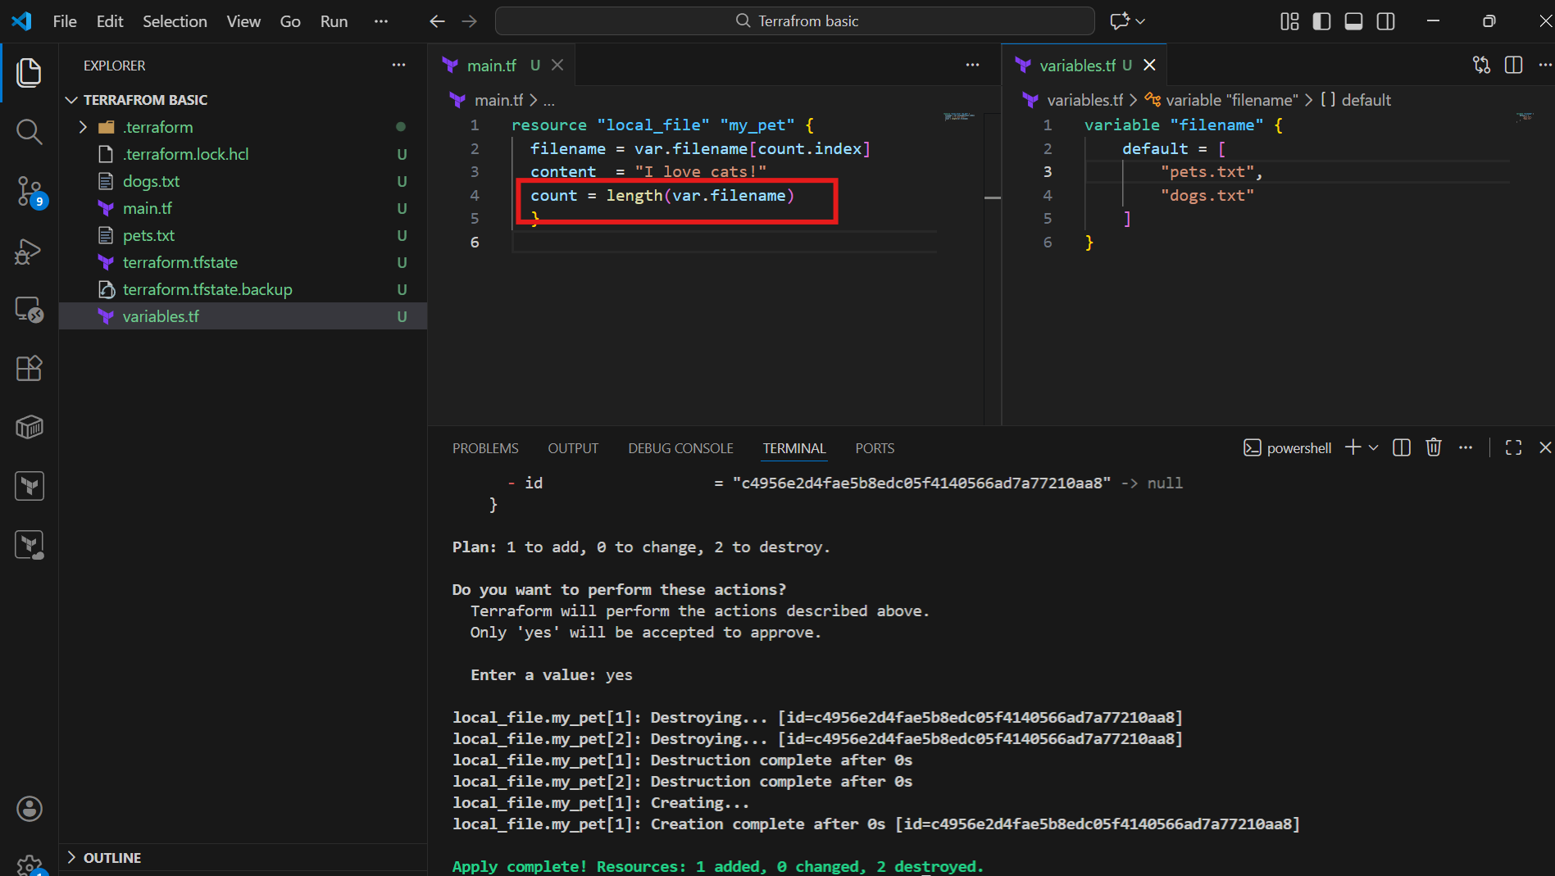

For_each Meta-Argument

In this method, we do not require to provide “count” in main.tf, instead, we can add “for_each”
  - This way, it will create the files without count.
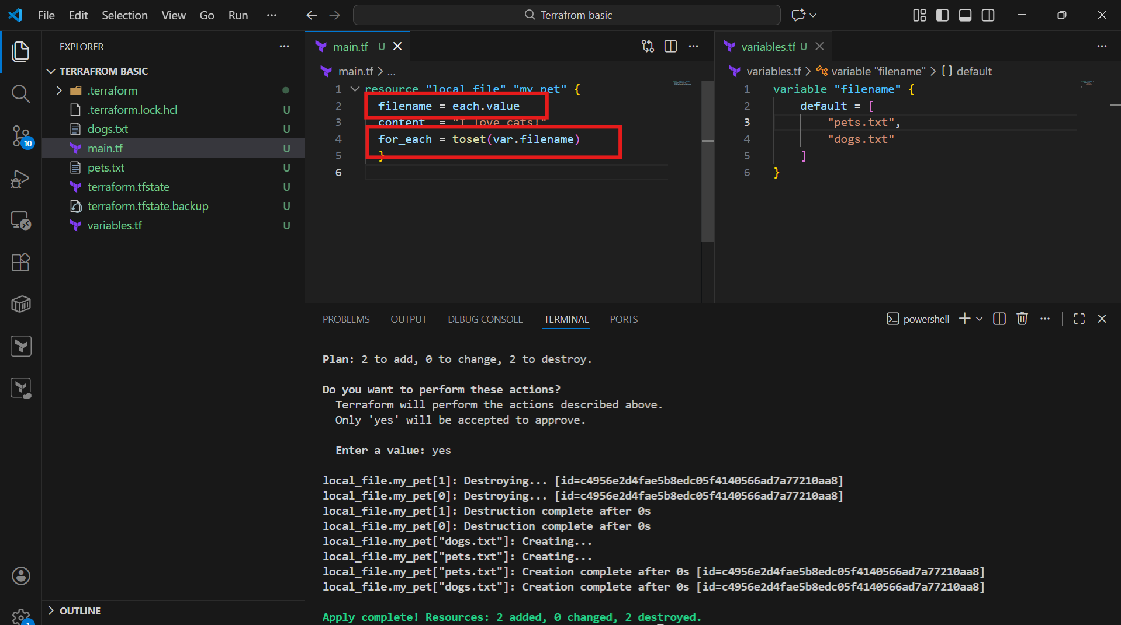
IAM User creation with Terraform

Step 1: Navigate to aws and create access key in IAM Security credentials
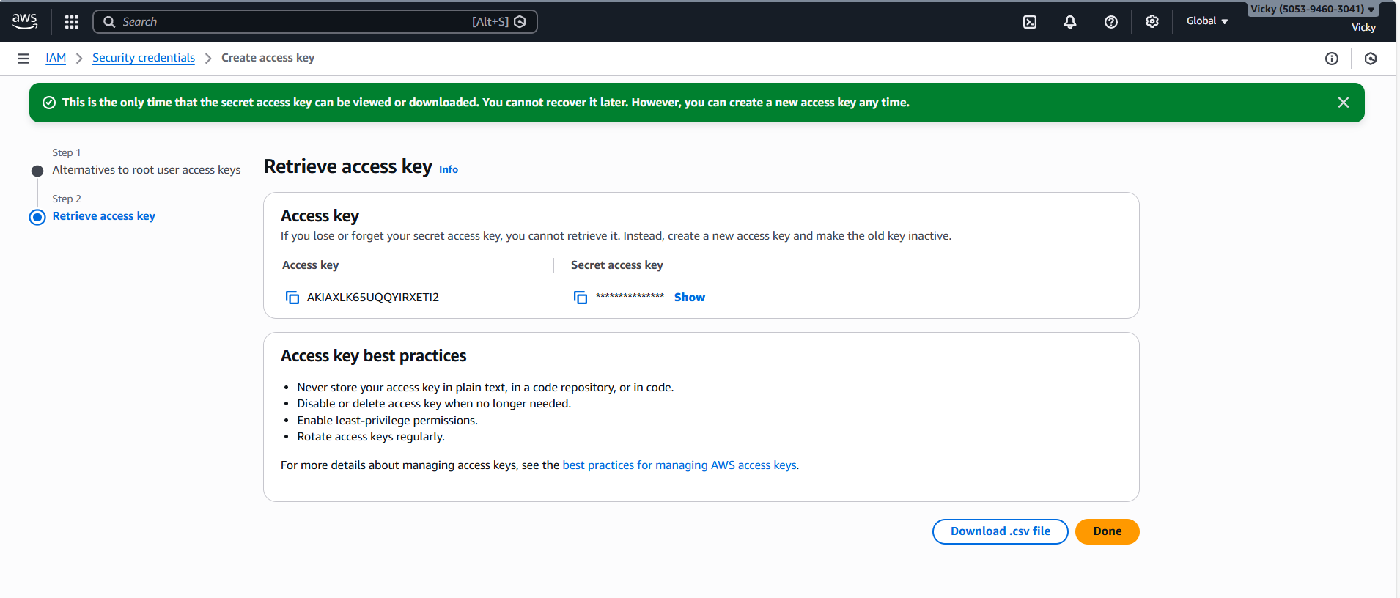

Step 2: Navigate back to VS code and create a code to create one IAM user in aws.

resource "aws_iam_user" "Admin-user" {
name = "vicky"
tags = {
"description" = "Senior Devops Lead"
}
}
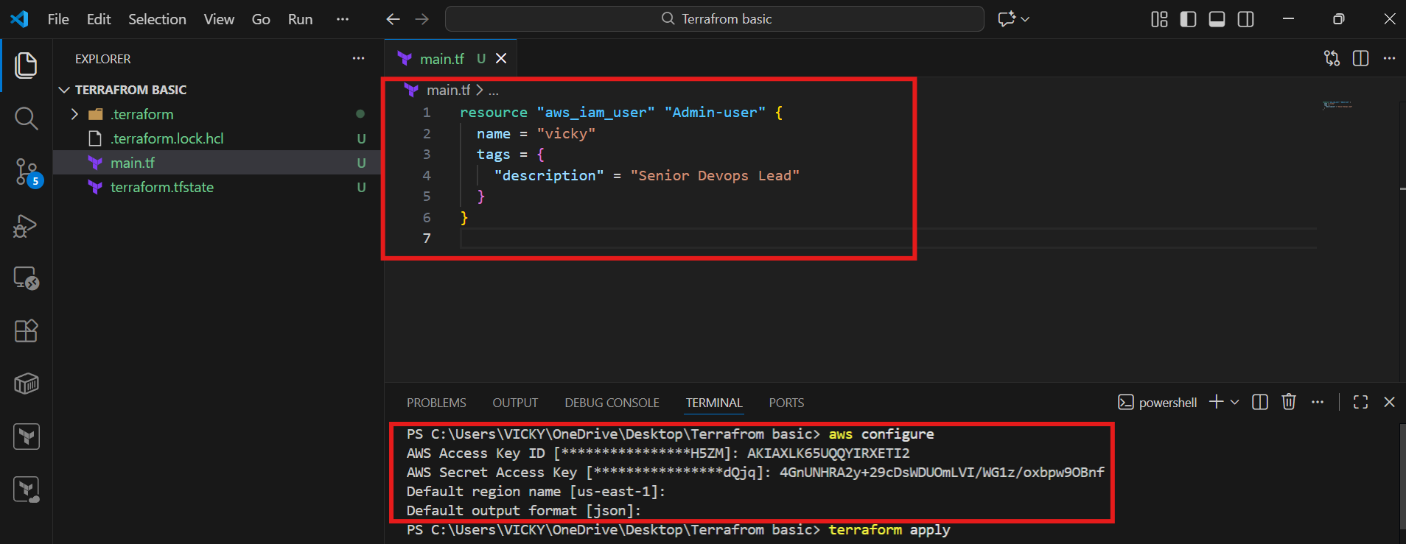
Step 3: command- aws configure and update the credentials to sync with our aws account.
  - Command- terraform apply and we can see one aws user has been created in our aws account.

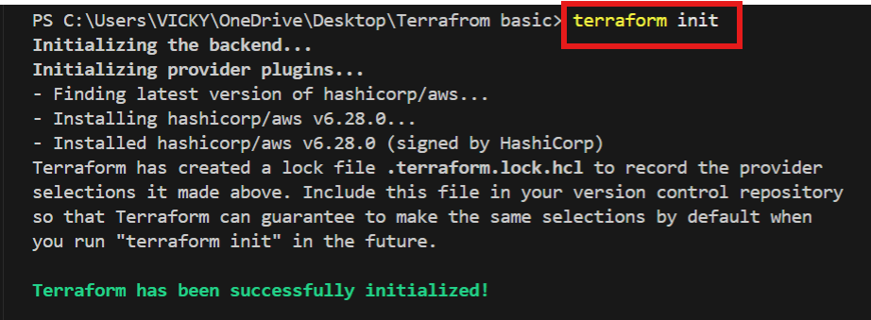
  - Terraform apply
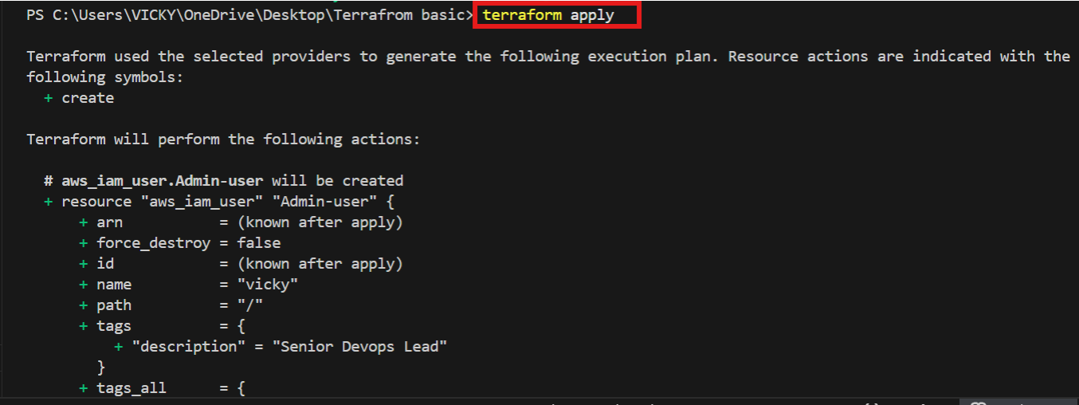
  - We can see that, one aws user has been created.
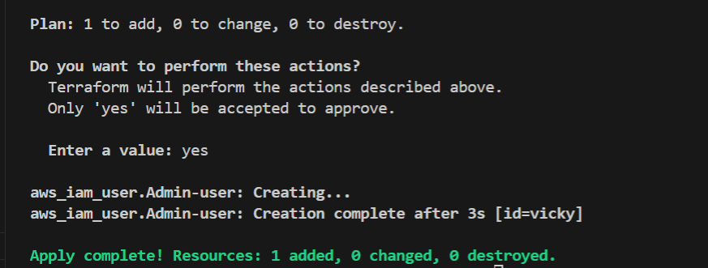
Success- we can see that, one aws user has been created- vicky
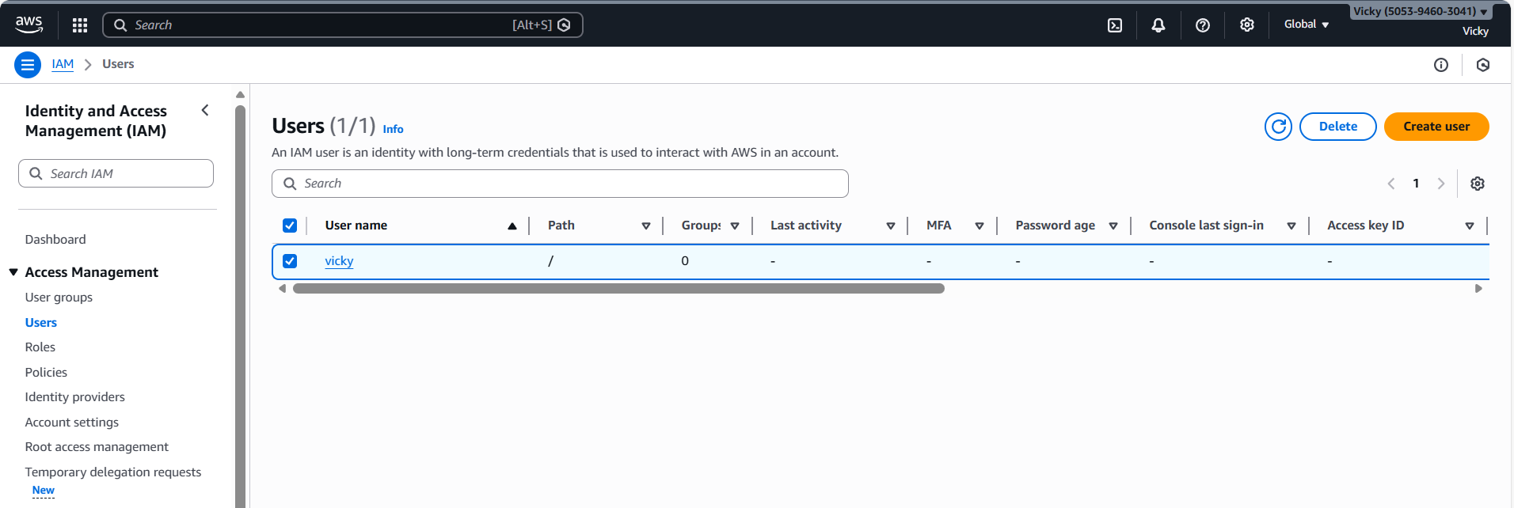

We haven’t attached any policies to vicky user in aws
So, we used command- terraform destroy to remove the user and provide policies in the next step.
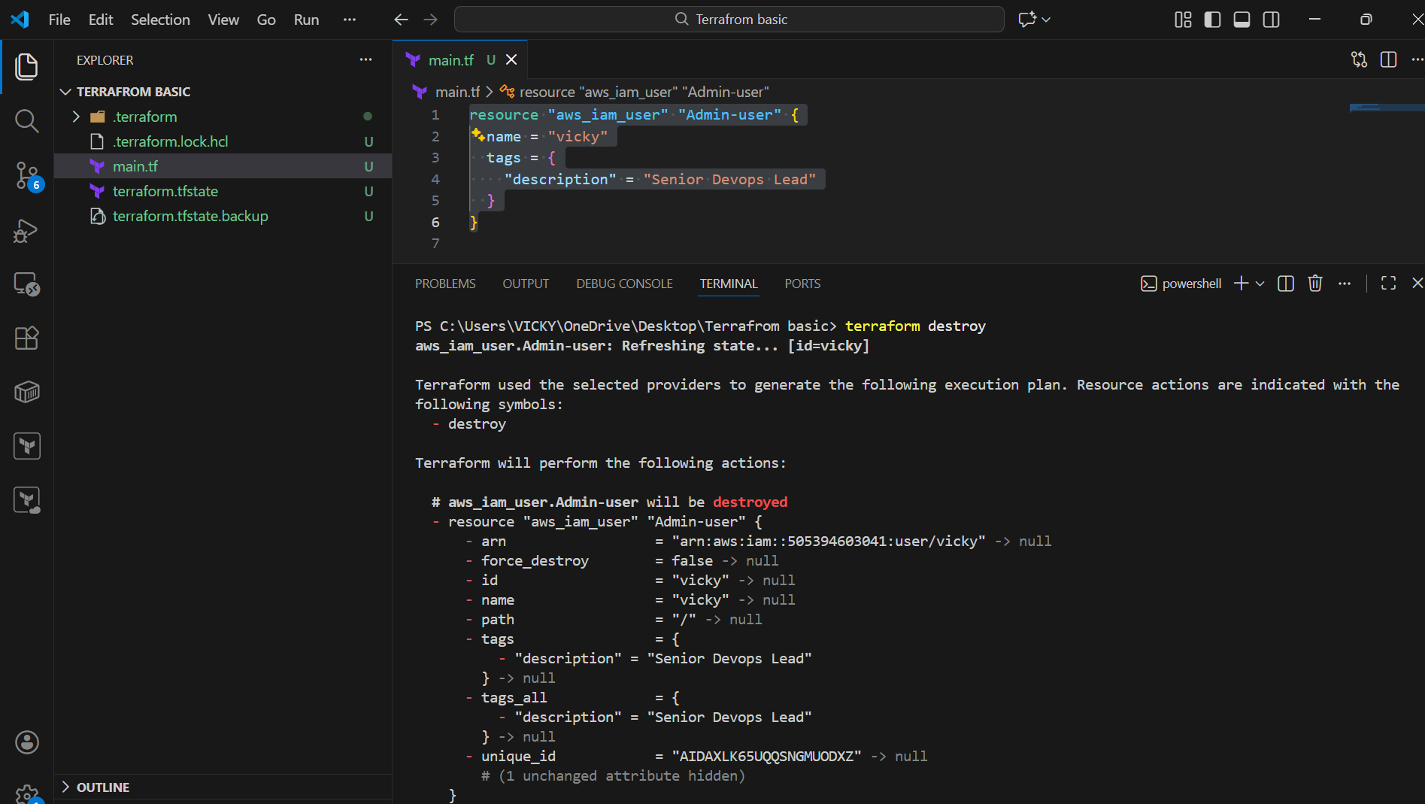

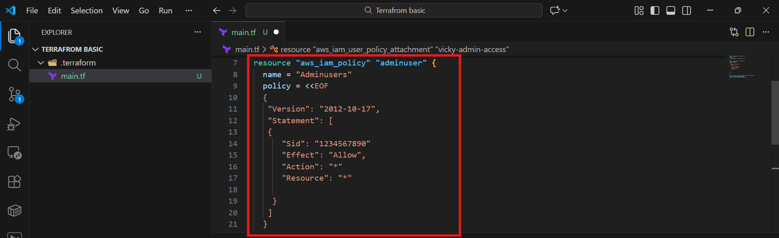
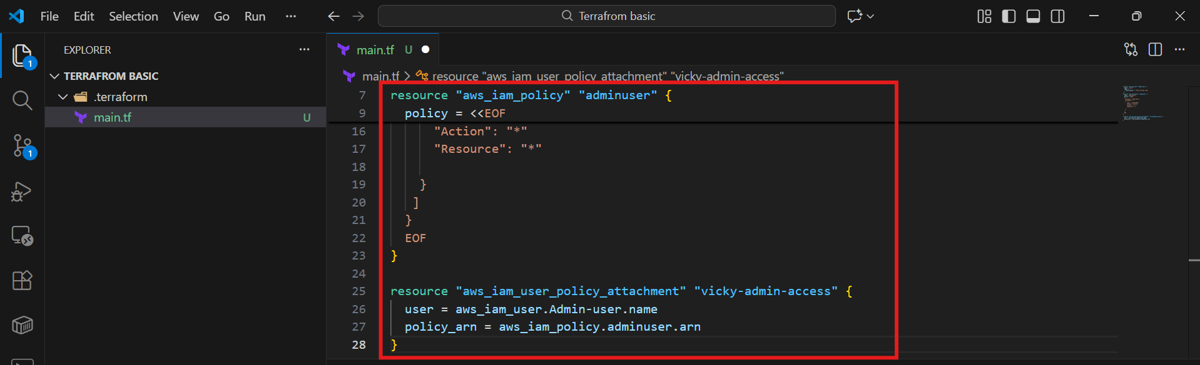

This is the user creation and policy attached to the user

resource "aws_iam_user" "Admin-user" {
name = "max_max"
tags = {
"description" = "Senior Devops Lead"
}
}
resource "aws_iam_policy" "adminuser" {
name = "Adminuserss"
policy = <<EOF
{
"Version": "2012-10-17",
"Statement": [
{
"Sid": "1234567890"
"Effect": "Allow",
"Action": "*"
"Resource": "*"

]
}
}
EOF
}

resource "aws_iam_user_policy_attachment" "vicky-admin-access" {
user = aws_iam_user.Admin-user.name
policy_arn = aws_iam_policy.adminuser.arn
}

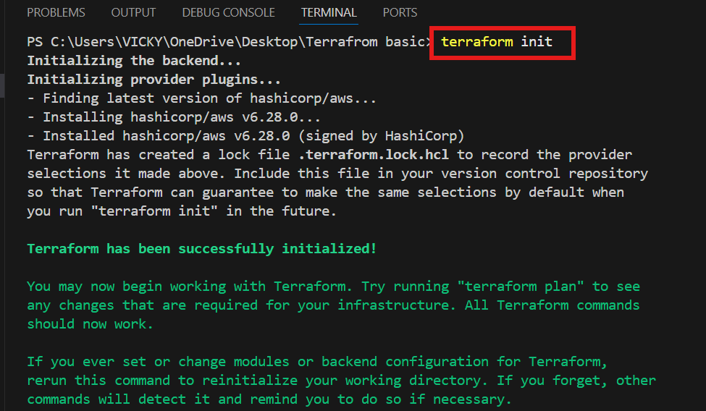

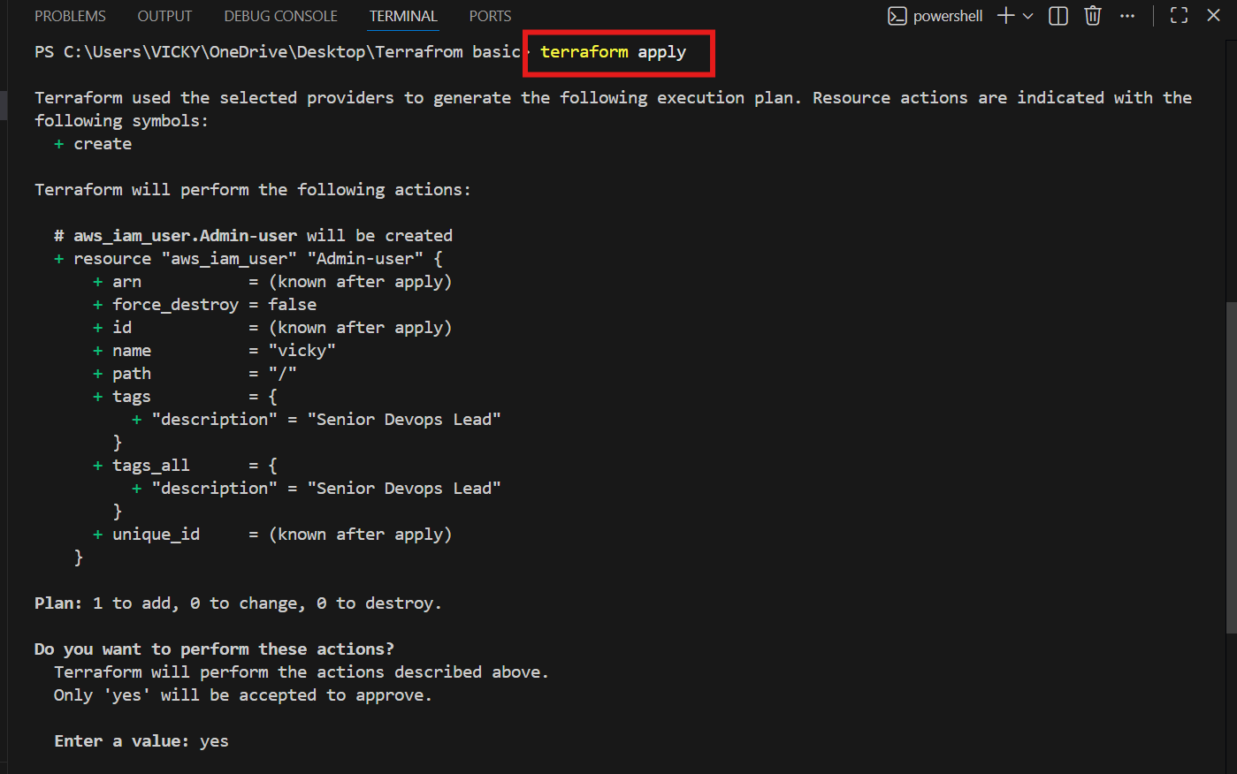

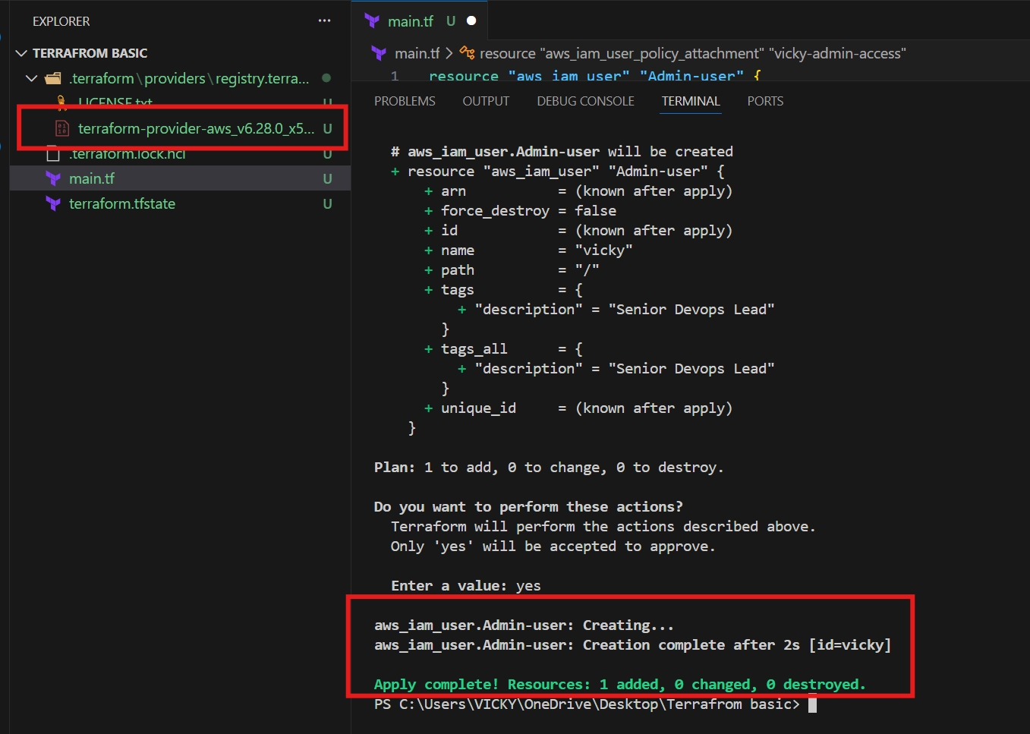

3. Integrate Terraform in Jenkins using the Terraform plugin.
Step by step Implementation:
Step 1: Navigate to AWS ec2 and launch Jenkins server.
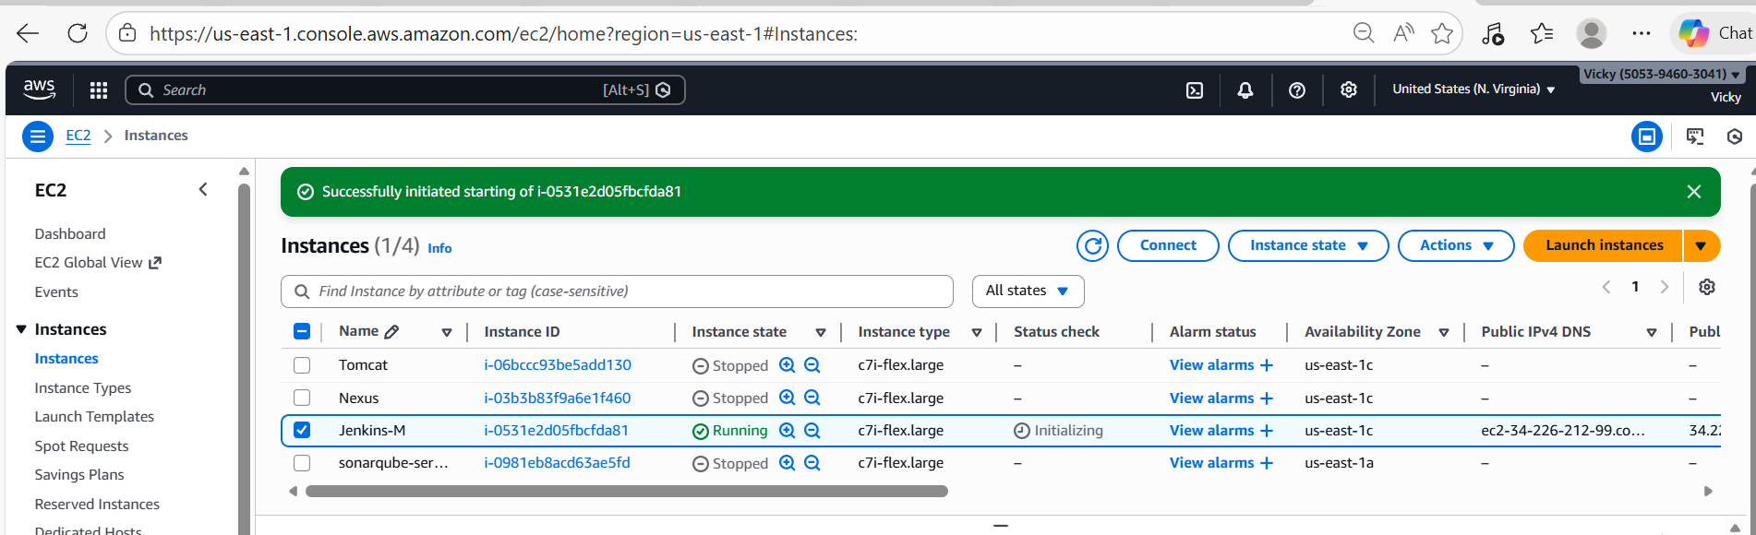

- Connect to the instance
- Run the systemctl status jenkins to verify if Jenkins is up and running.
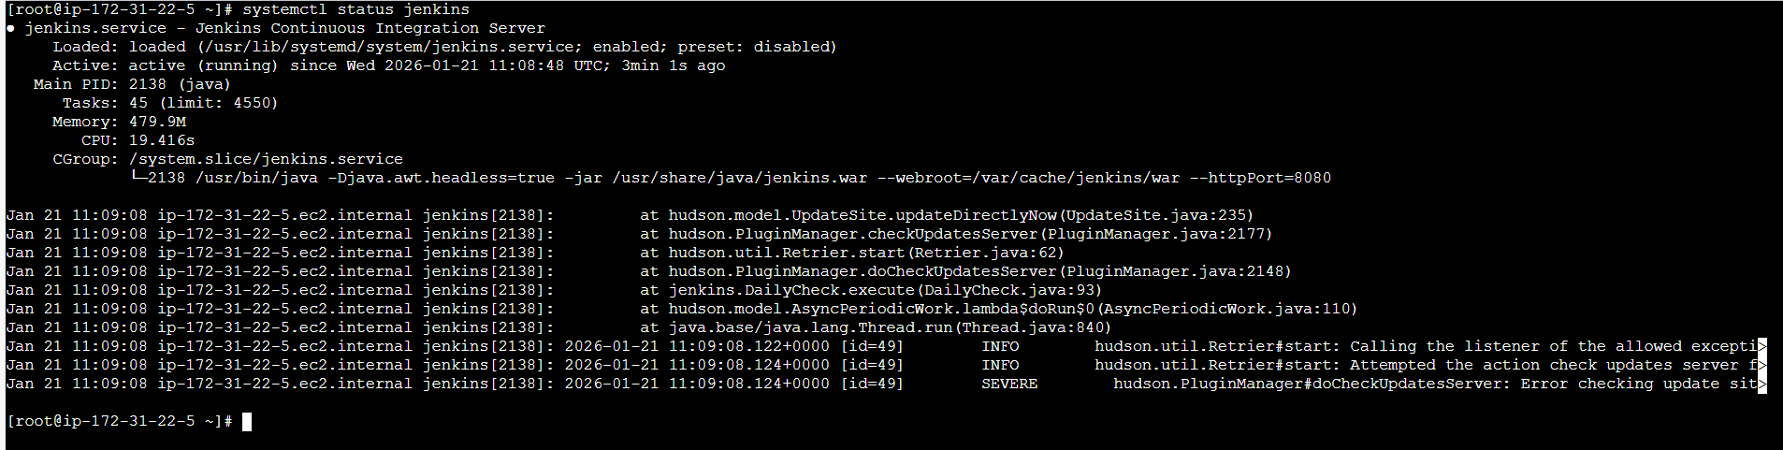
Step 2: Navigate to Terraform registry and install Terraform for Amazon Linux.
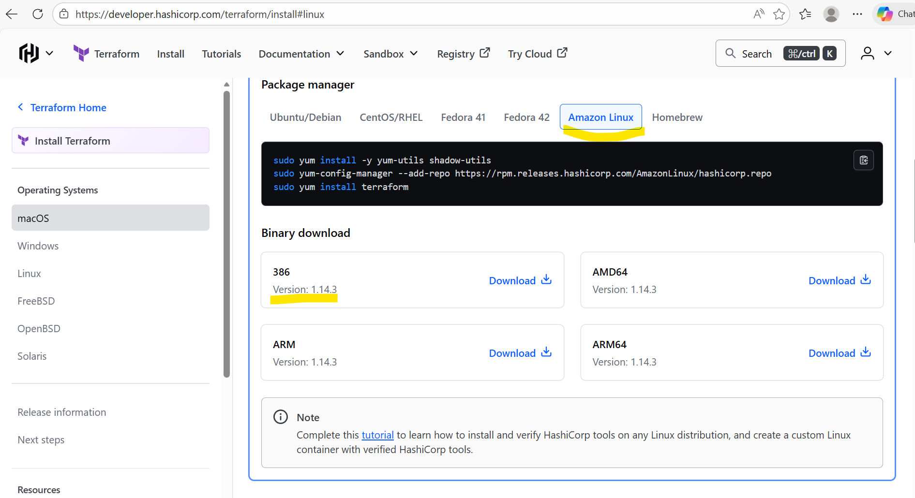

- Installed the packaged manager in Jenkins server.
sudo yum install -y yum-utils shadow-utils
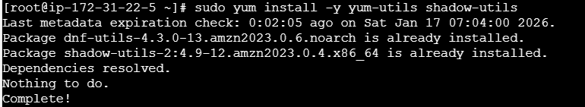

sudo yum-config-manager --add-repo https://rpm.releases.hashicorp.com/AmazonLinux/hashicorp.repo
sudo yum install terraform
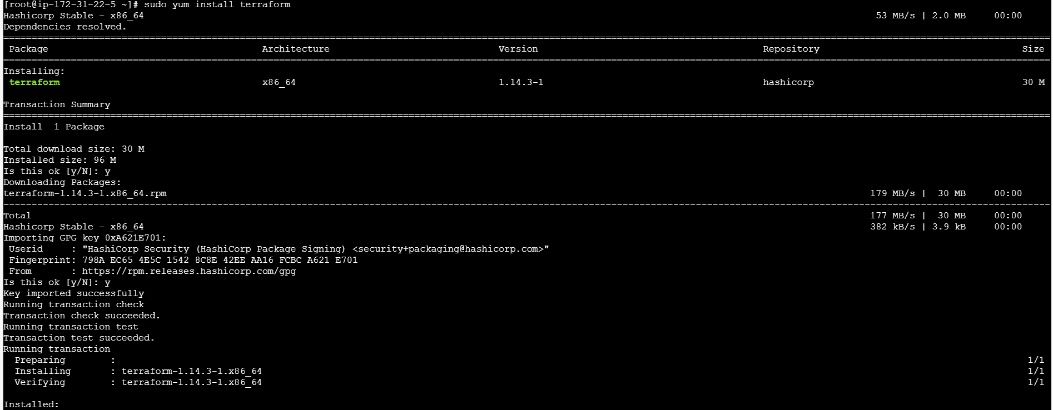

Step 3: Navigate to Jenkins GUI and install plugin Terraform
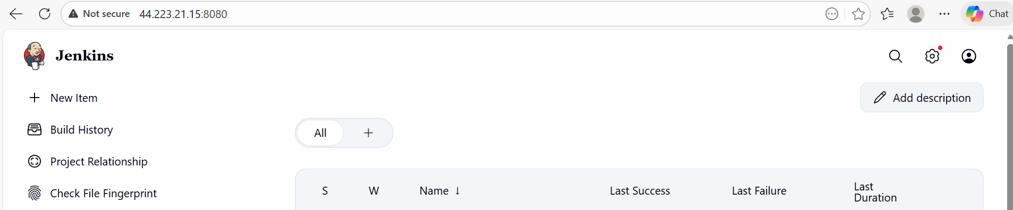
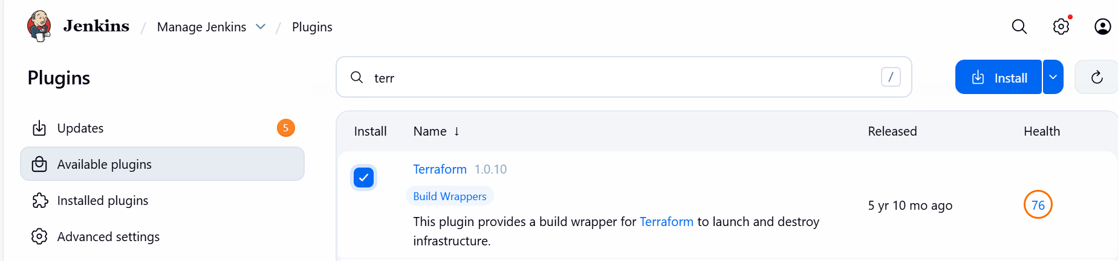
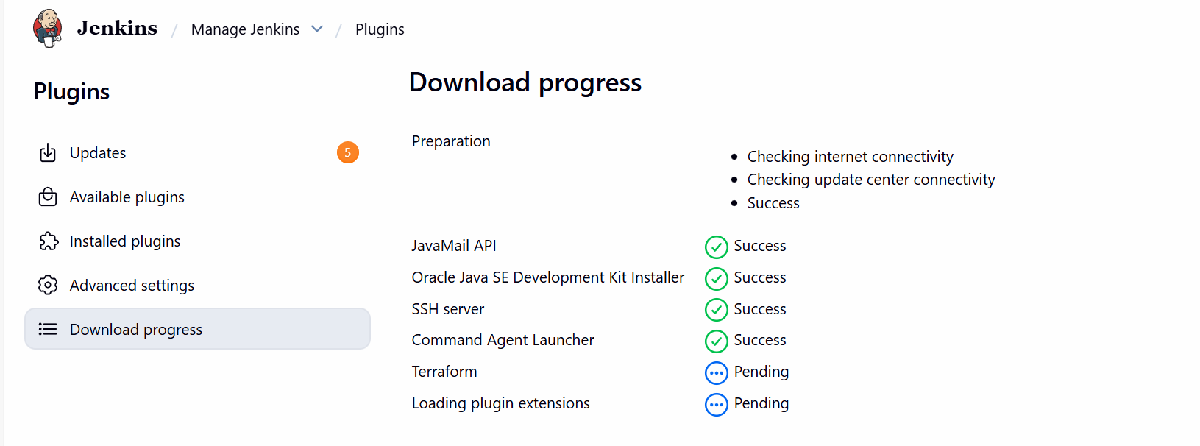

Installed
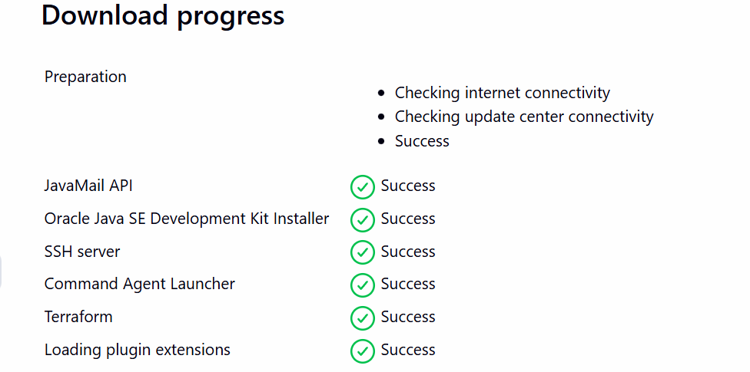

Step 4: Navigate to Manage Jenkins and add Terraform under Tools
Version: Terraform 51203 darwin (amd64)
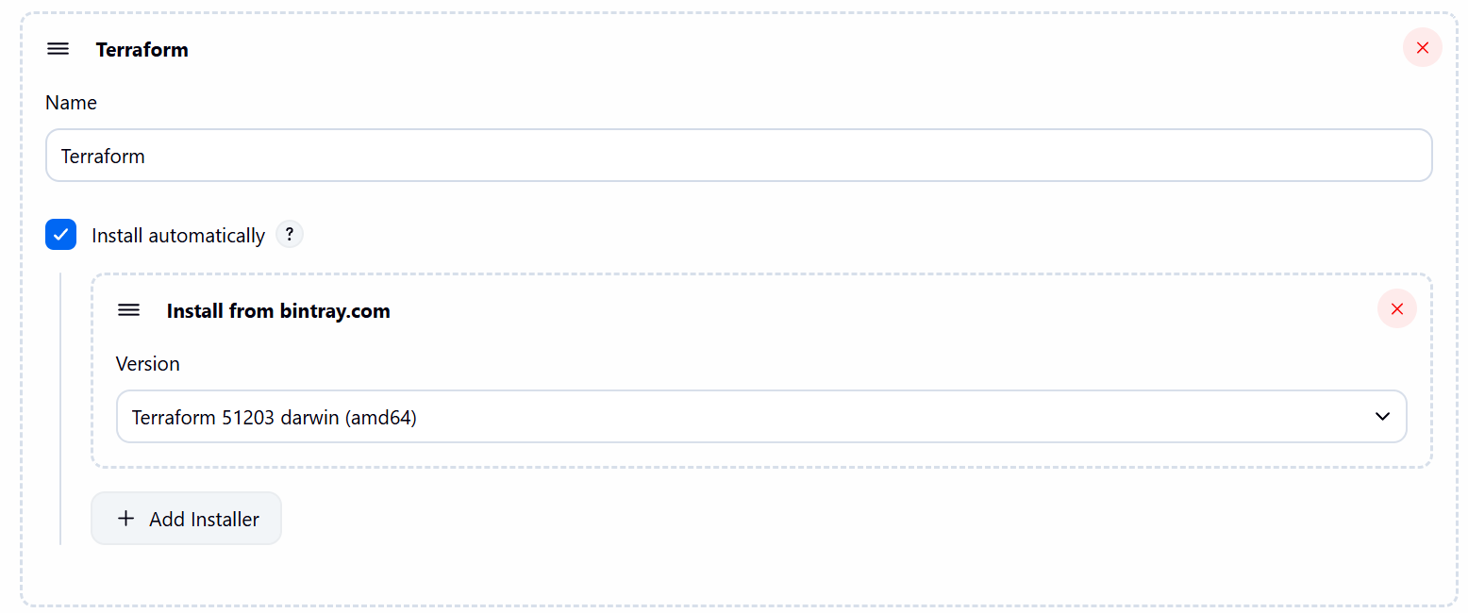

Step 5: Navigate to GitHub and create a repo- Terraform
- Mark Readme as required
- Visibility- Public
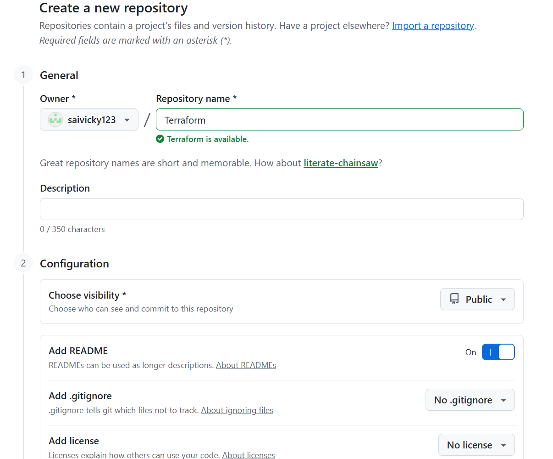

Step 6: Navigate to repo created and write a script to execute based on the Terraform-03 video executions.
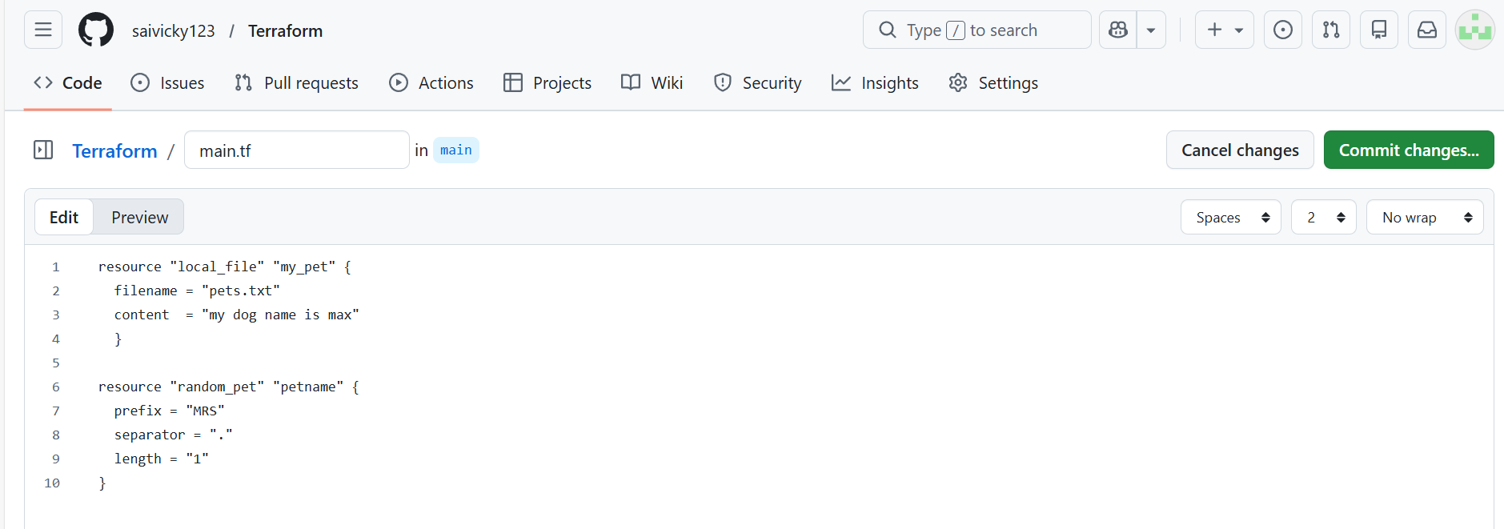

resource "local_file" "my_pet" {
filename = "pets.txt"
content = "my dog name is max"
}

resource "random_pet" "petname" {
prefix = "MRS"
separator = "."
length = "1"
}

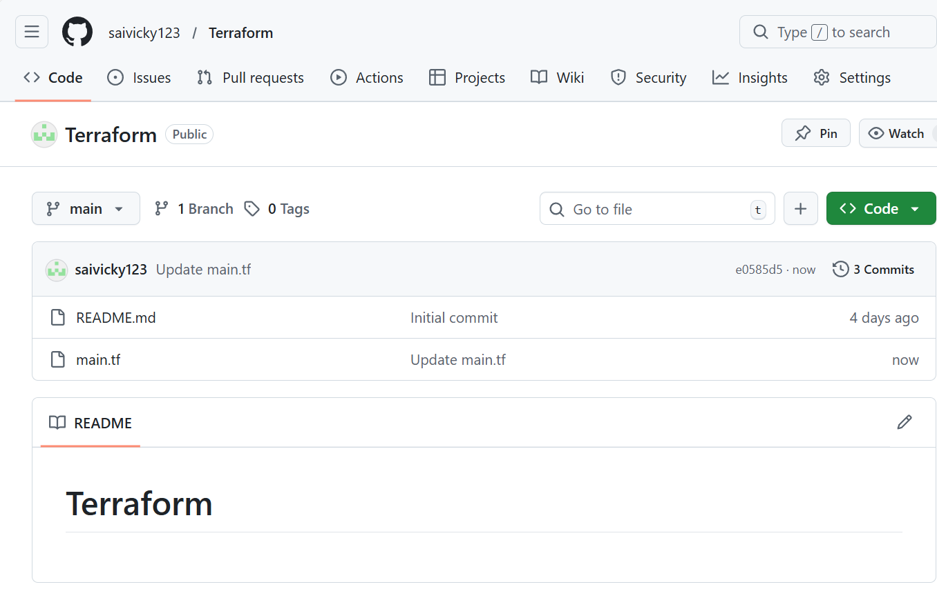

Step 7: Create a new job and write a script for Terraform
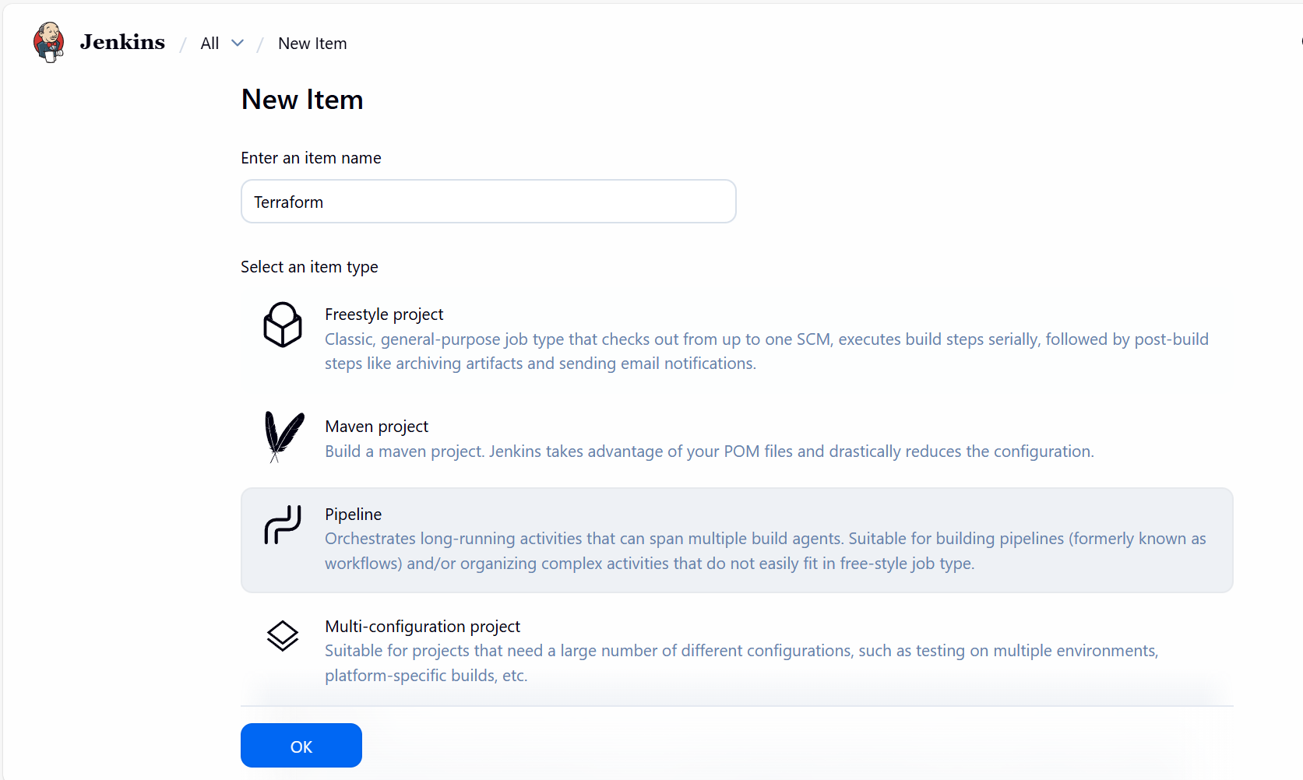

- Script updated and build now.
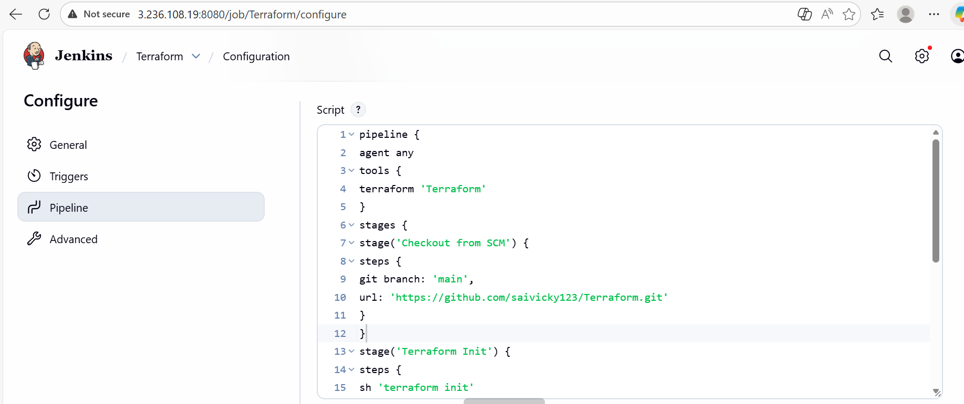

Ready for build

Step 8: Build completed and success.

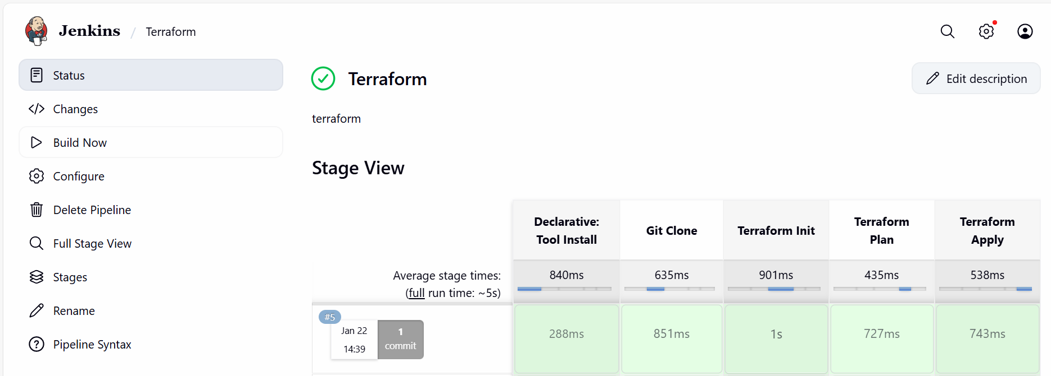

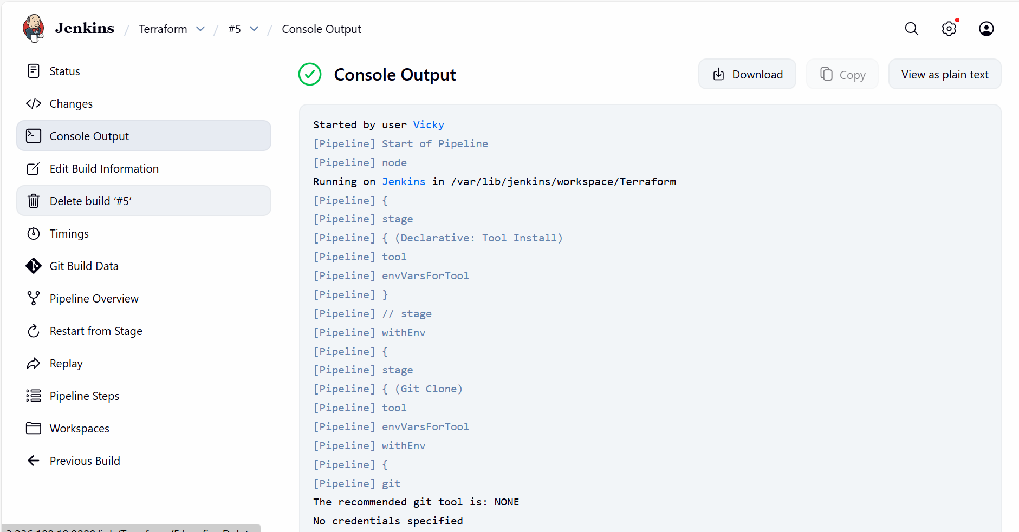

- We can verify from server level as well.
- Success.
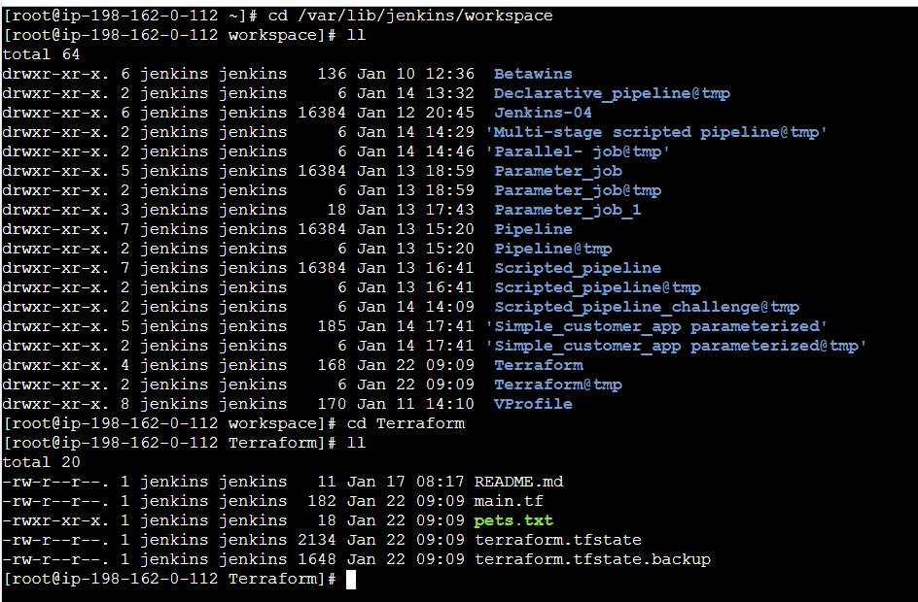

4. Create a CI/CD pipeline for a Nodejs Application: https://github.com/betawins/Trading-UI.git

Step by step Implementation:
Step 1: Navigate to Jenkins GUI Manage Plugins Install Nodejs
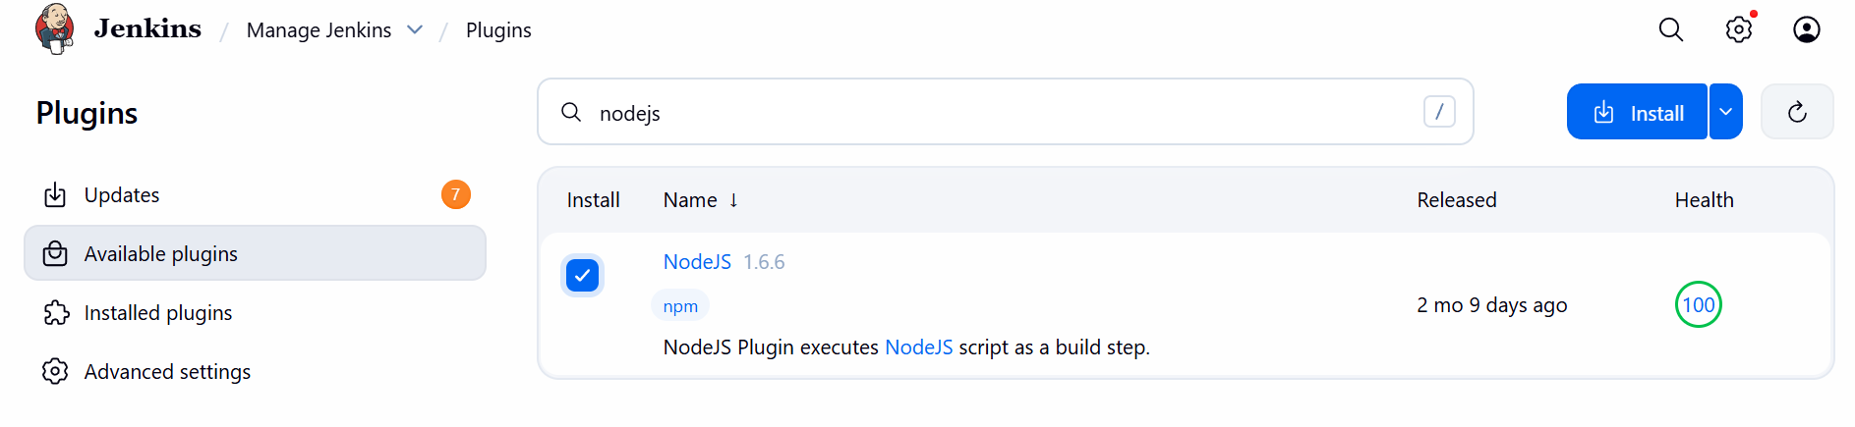
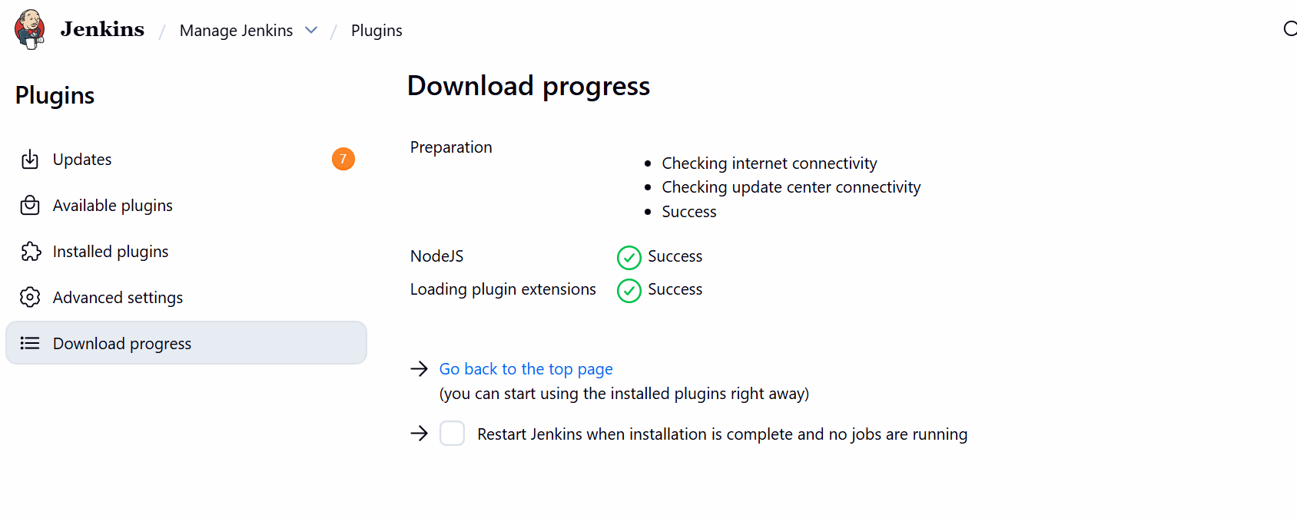

Step 2: Add the details of nodejs in tools and select the suitable version to your repo
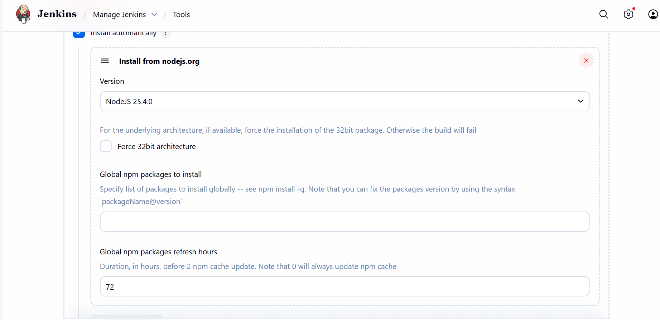

Step 3: Fork the repo TRADING-UI and edit the Jenkins file and commit the changes
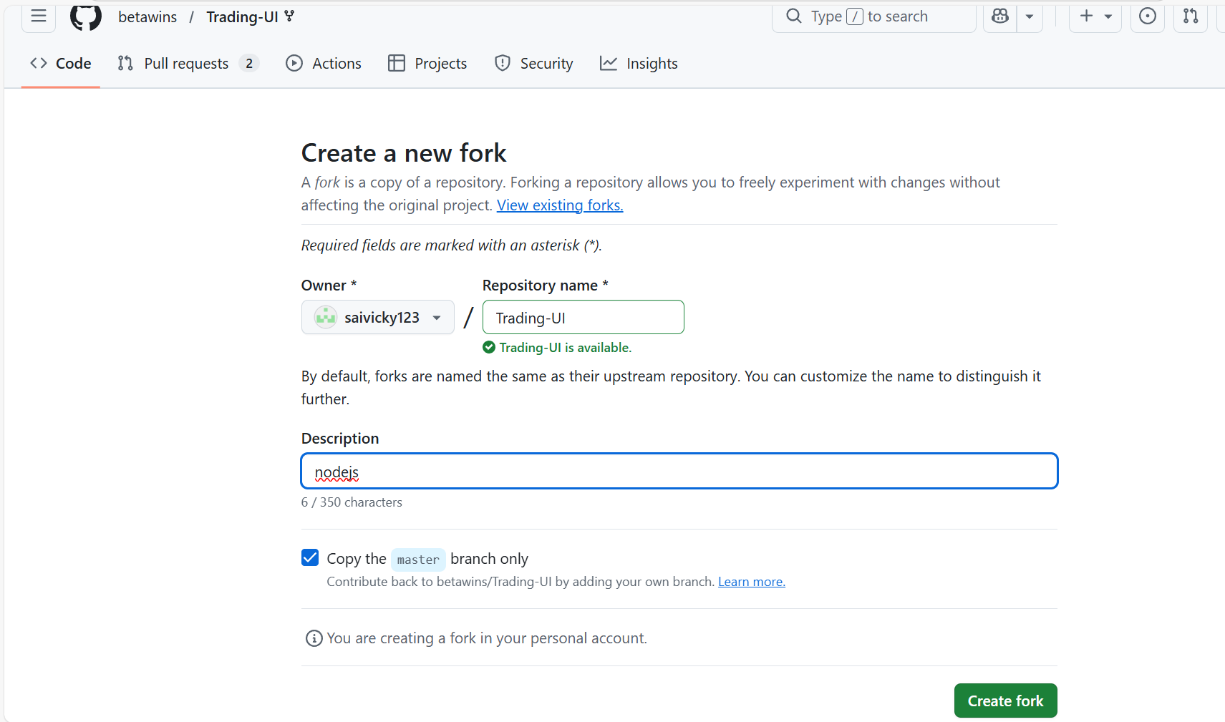
Repo forked and we shall now edit the jenkins file with our pipeline script.
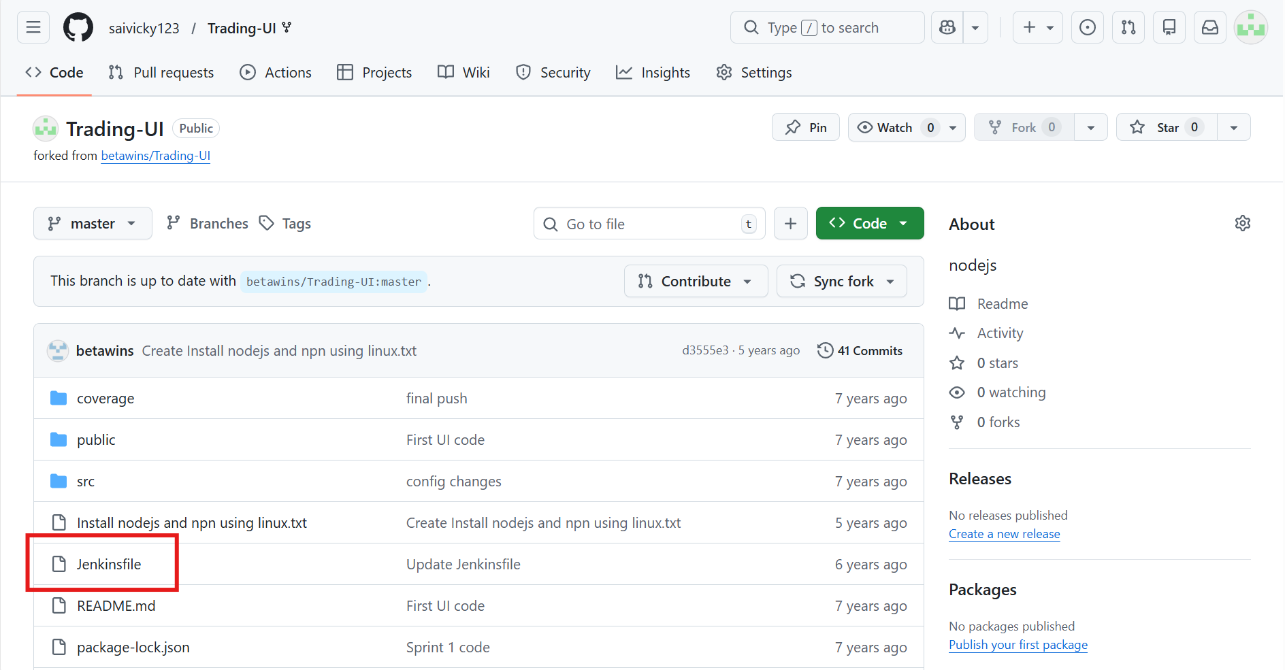

Step 4: Jenkins file updated with our pipeline
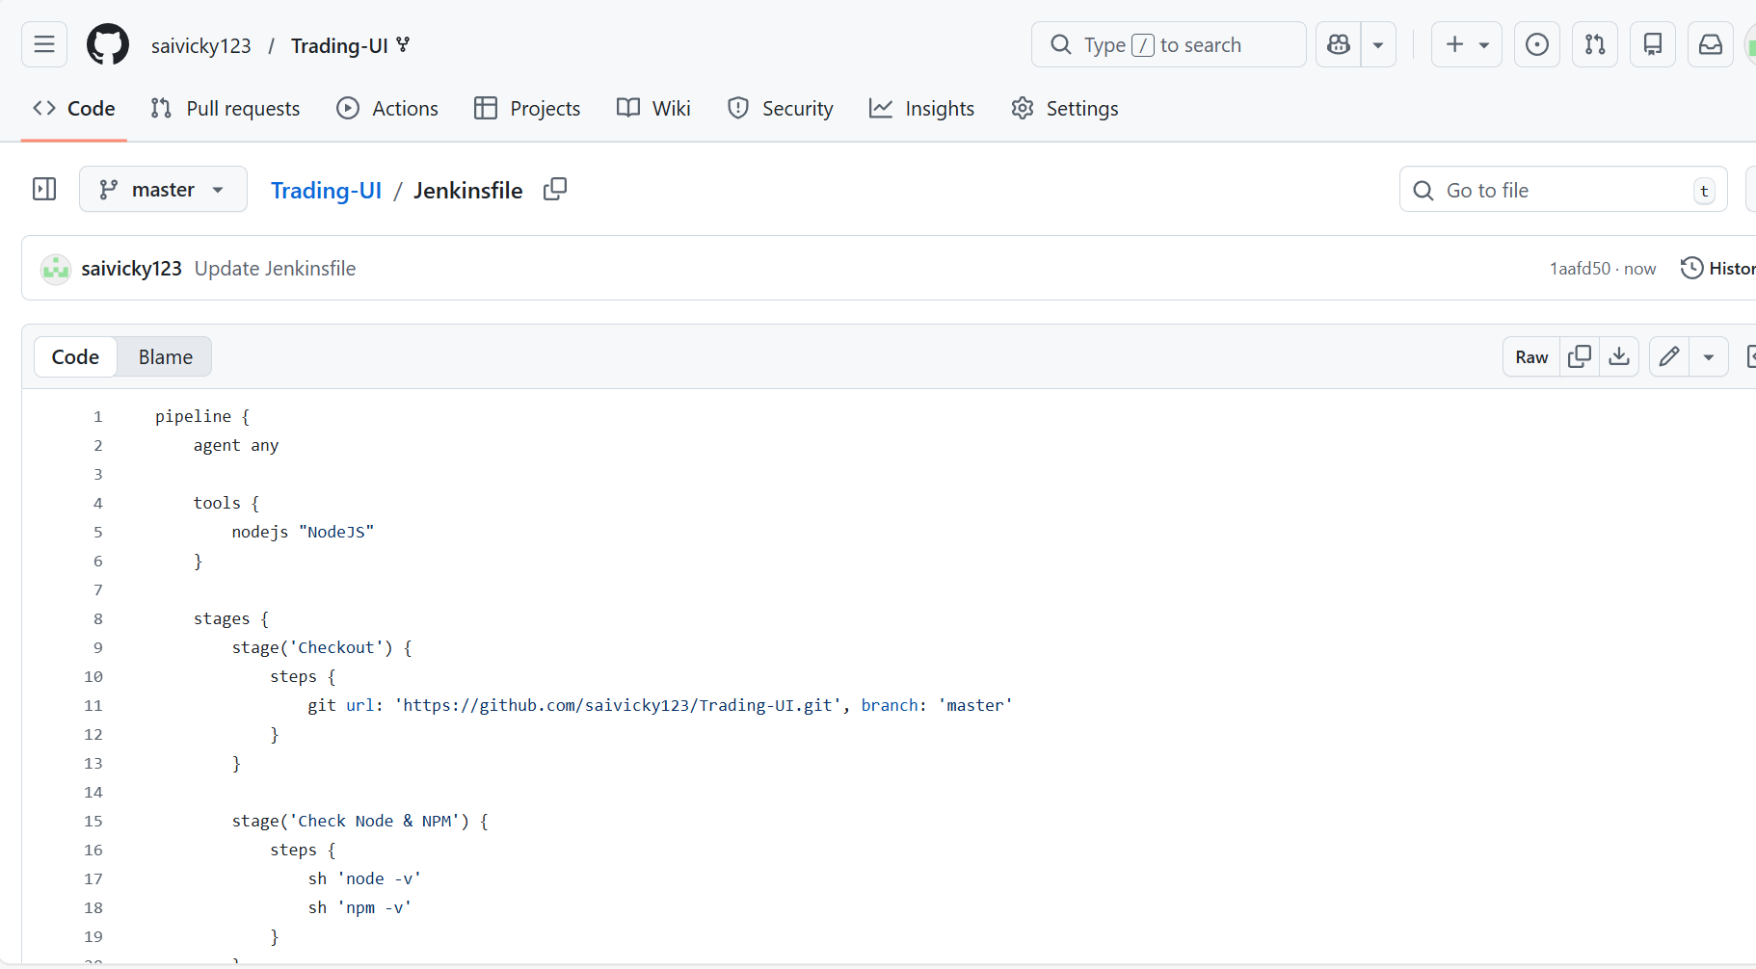

Step 5: After that create a job using pipeline and select the option in pipeline as pipeline as scm and enter the details and click on save

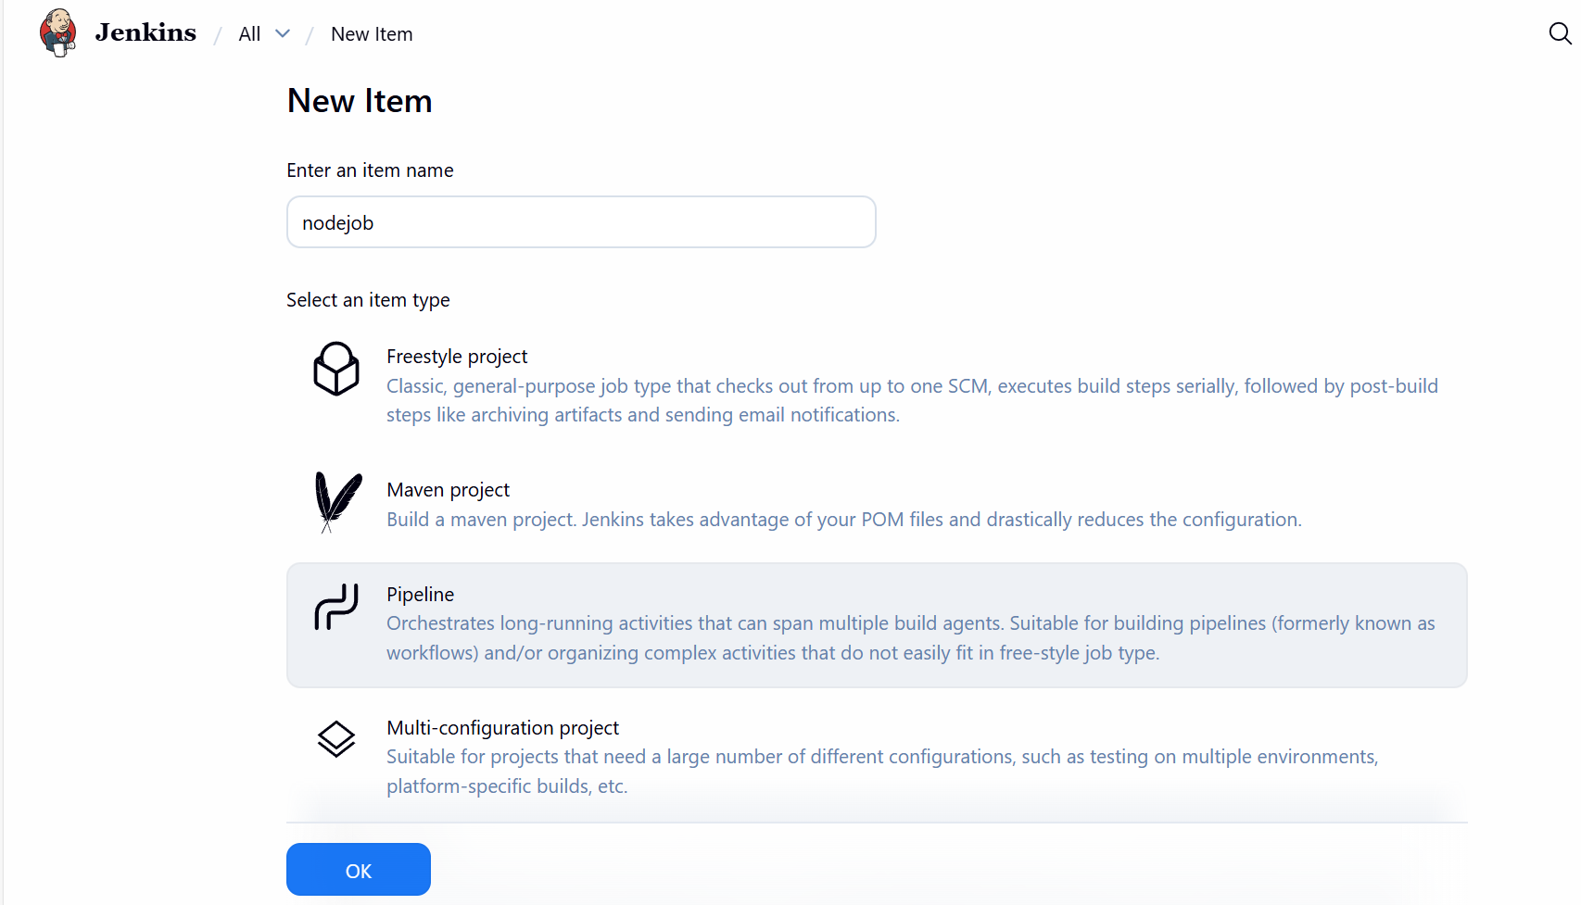

Step 6: Navigate back to Jenkins GUI and update Pipeline SCM
Repo – forked repo
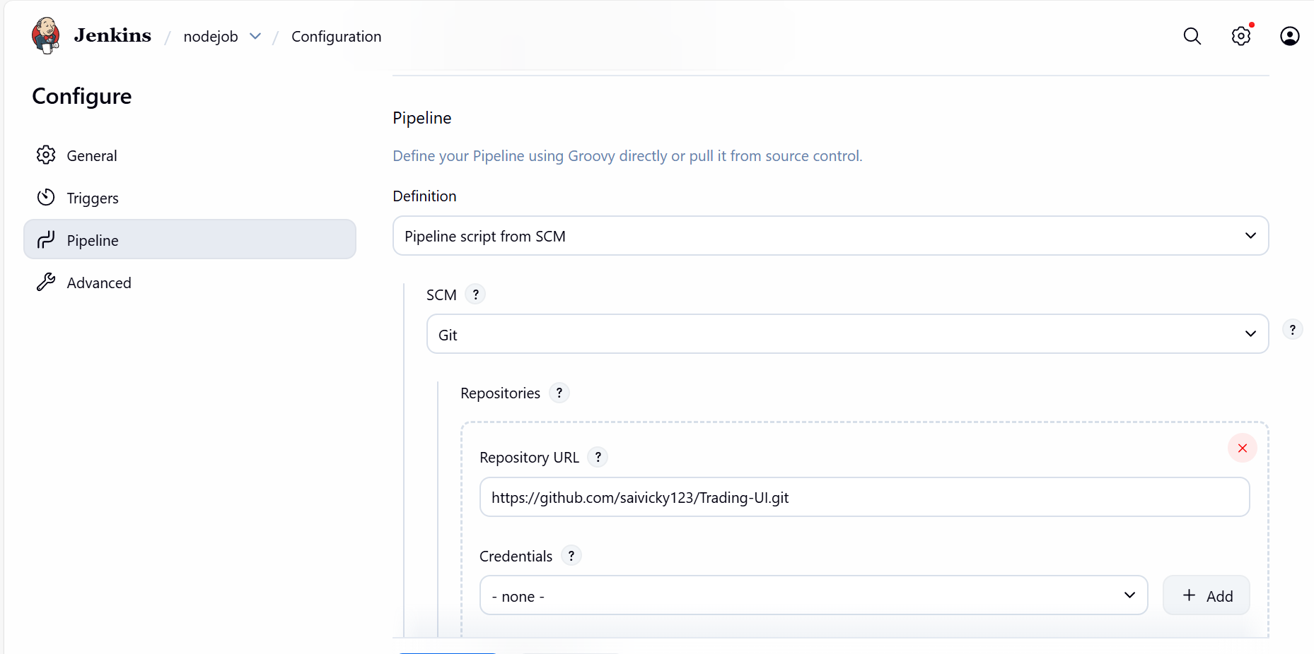

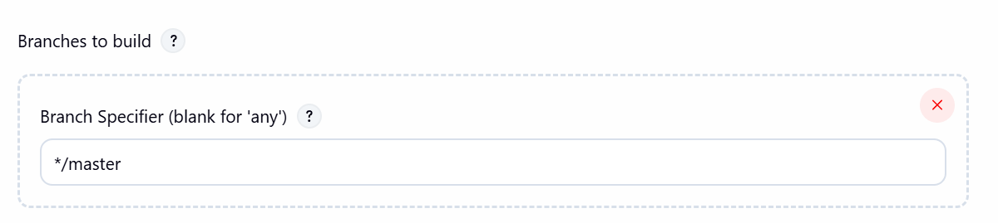
  - Script path is available.
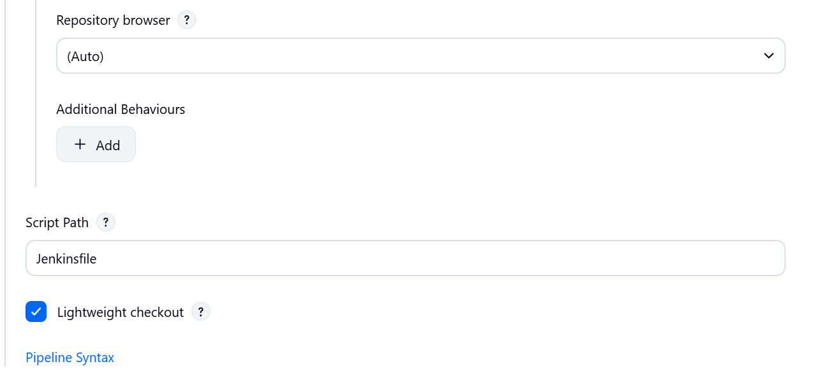
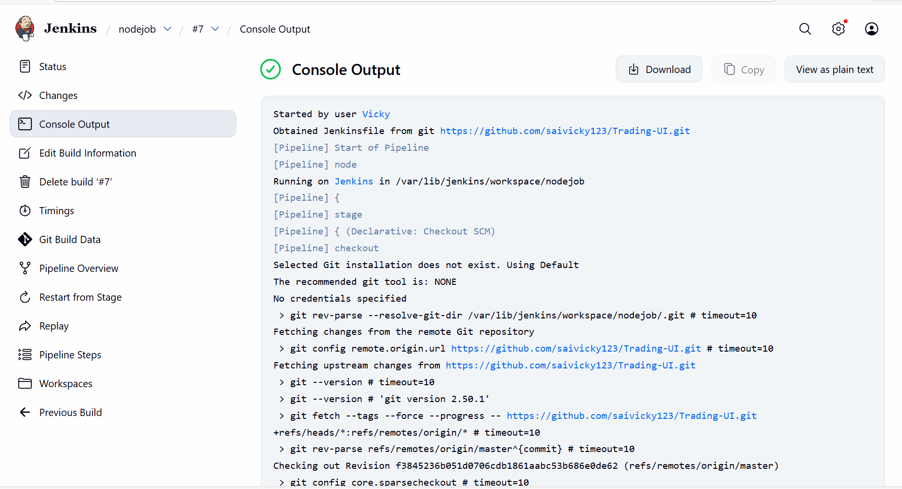

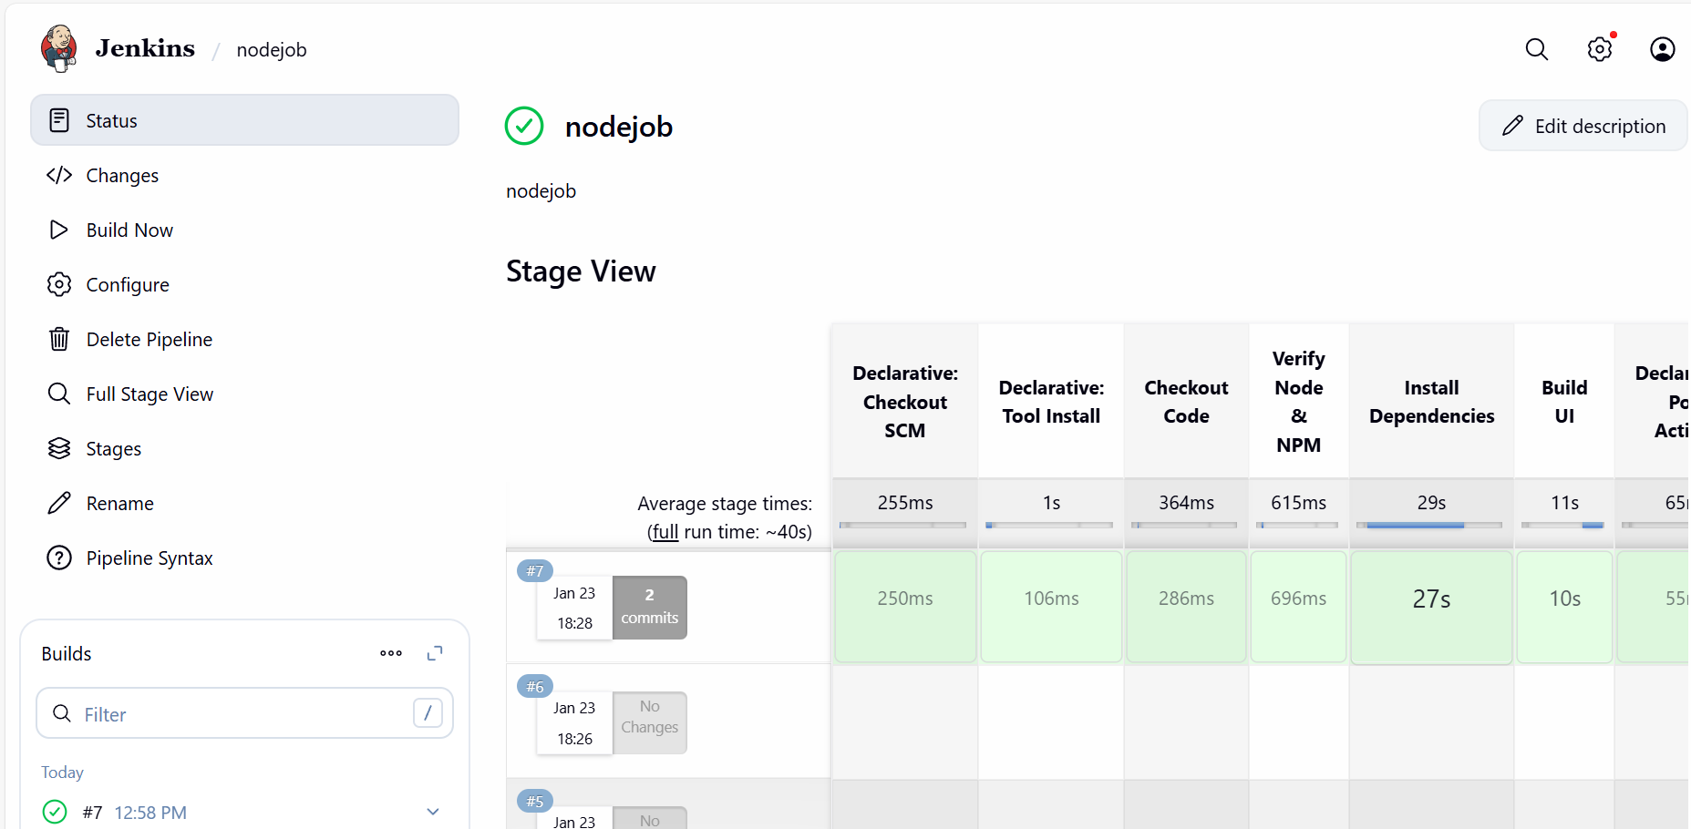

Pipelines used to update in repo.

pipeline {
agent any

tools {
nodejs 'nodejs'
}

stages {

stage('Checkout Code') {
steps {
git branch: 'master',
url: 'https://github.com/saivicky123/Trading-UI.git'
}
}

stage('Verify Node & NPM') {
steps {
sh 'node -v'
sh 'npm -v'
}
}

stage('Install Dependencies') {
steps {
sh 'npm install'
}
}

stage('Build UI') {
steps {
sh 'CI=false npm run build'
}
}
}

post {
success {
echo ‘UI build completed successfully'
}
failure {
echo 'UI build failed'
}
}
}

5. Explain 10 Maven commands.
1. mvn clean
- Purpose: Deletes the target directory (where compiled code and build artifacts are stored).
- Usage:
- Ensures a fresh build without leftover files.
2. mvn compile
- Purpose: Compiles the source code of the project.
- Usage:
- Generates .class files in target/classes.
3. mvn test
- Purpose: Runs unit tests using frameworks like JUnit/TestNG.
- Executes tests in src/test/java.
4. mvn package
- Purpose: Packages compiled code into a distributable format (JAR/WAR).
- Usage:
- Output stored in target/.
5. mvn install
- Purpose: Installs the package into the local Maven repository (~/.m2/repository).
- Usage:
- Makes the artifact available for other local projects.
6. mvn deploy
- Purpose: Deploys the artifact to a remote repository (e.g., Nexus/Artifactory).
- Usage:
- Used in CI/CD pipelines for sharing builds.
7. mvn site
- Purpose: Generates a project documentation site.
- Usage:
- Creates HTML reports in target/site.
8. mvn dependency:tree
- Purpose: Displays the dependency hierarchy of the project.
- Usage:
- Helps identify conflicts and transitive dependencies.
9. mvn verify
- Purpose: Runs integration tests and verifies the project meets quality standards.
- Usage:
- Ensures the build is valid before deployment.
10. mvn archetype:generate
- Purpose: Creates a new Maven project from a template (archetype).
- Usage:
- Interactive command to bootstrap new projects.

