Terraform-05



General tips for the Task below.
Task Title
Terraform-05
Objective
The objective of this task is to watch the Terraform-05 video posted on slack with and worked on executing templates shown in video.
Prerequisites
List all requirements before starting:
- AWS
- Visual studio code
- S3- backend
- Dynamo DB- state locking
- Ec2
Issues Faced: Briefly mention issues and how you fixed them. Posted below in the last.
Conclusion
Conclusion has been provided for every task at the end.
- Watch the Terraform-05 video.
Execute the script shown in the video.

- Executed a basic script – resource block provider- local_file
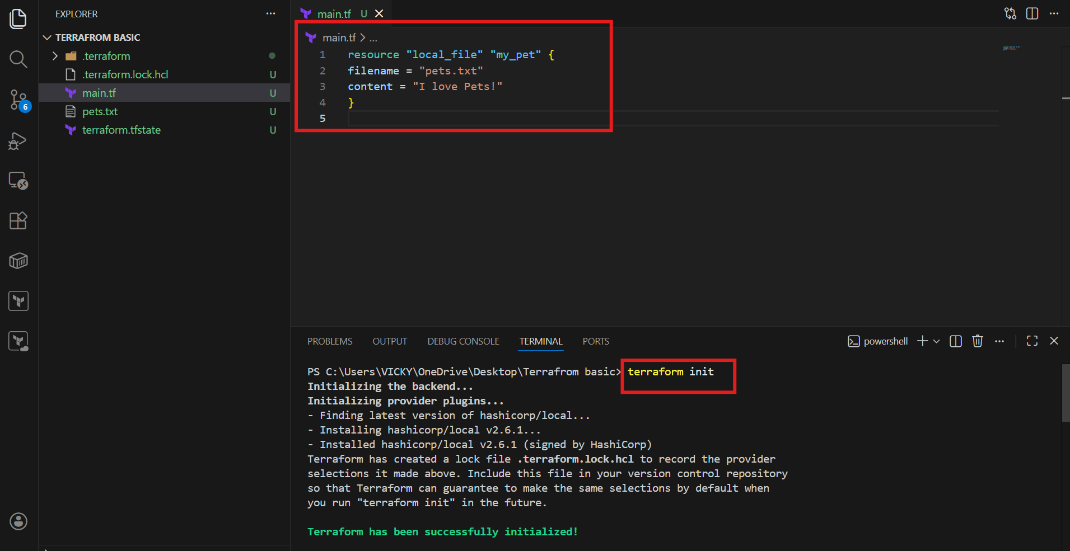

- If we want to auto-approve, then we can use command – auto-approve
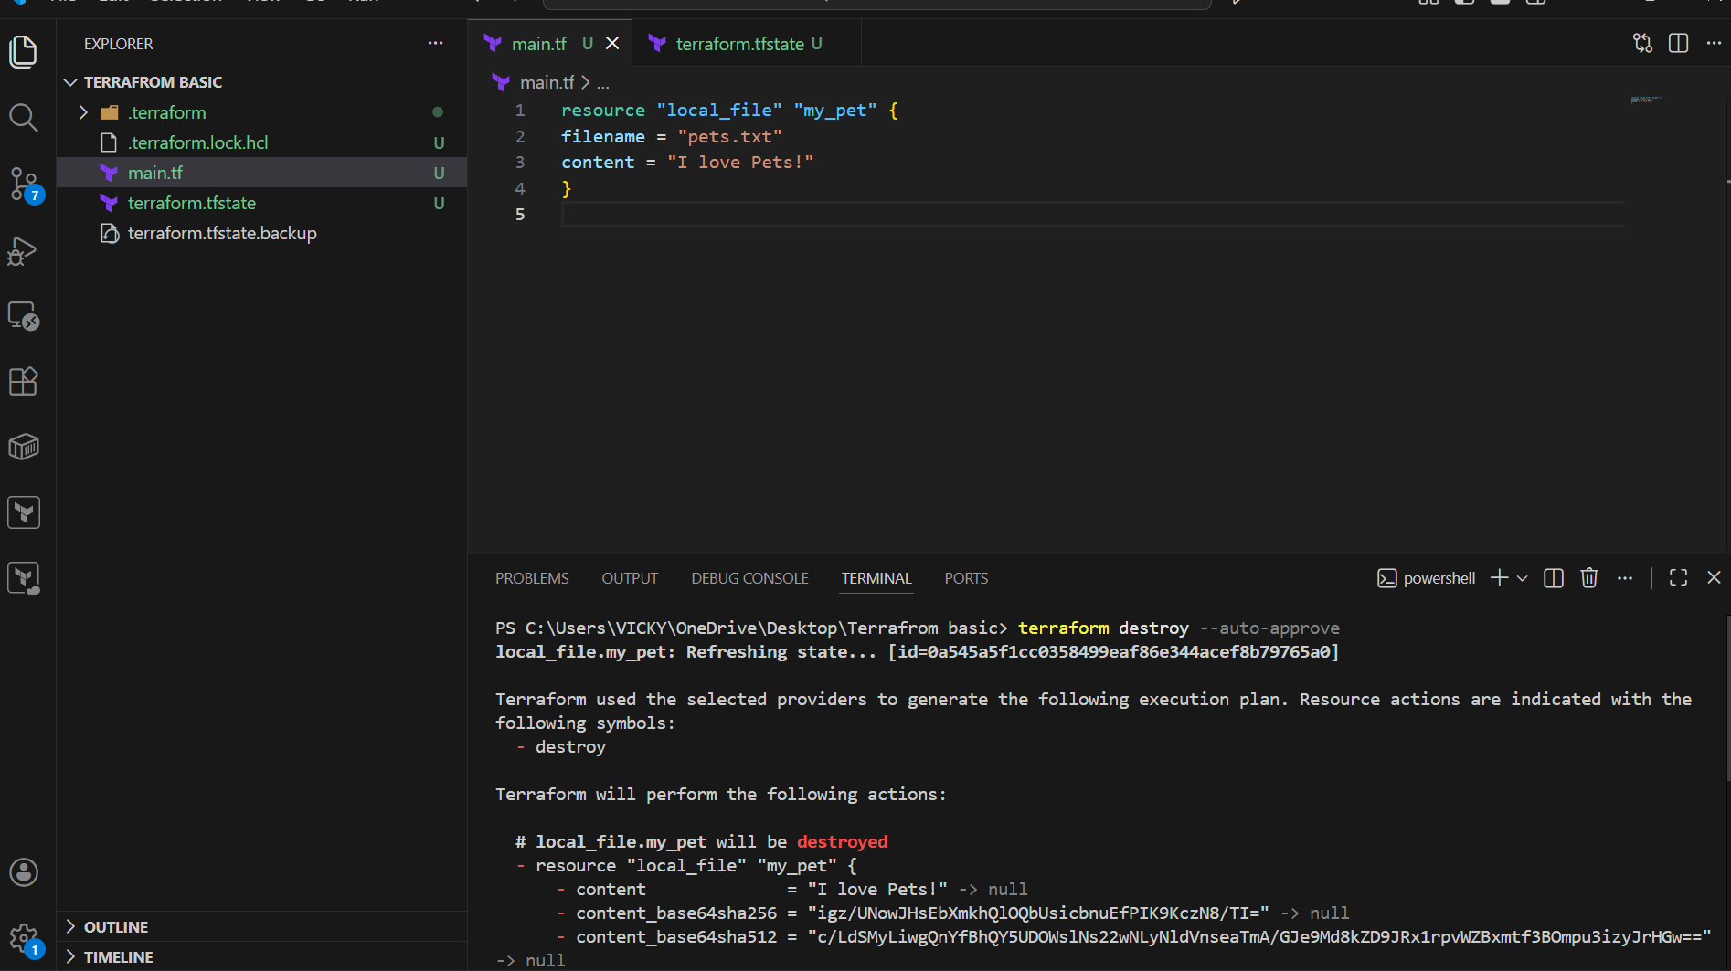

Terraform Remote State and State Locking:

To store our Terraform configuration files and state file we can store in S3, terraform storage, harshicorp consul to store the state file.

State Locking:
State Locking is used to lock the statefile, so that no two users can execute the statefile the same point of time.

Remote Backend:
We will use S3 for remote backend.
State Locking:
We will use DynamoDB for State Locking.
===============================================================
To auto-approve:
Use command- --auto-approve
===============================================================
Create S3 using terraform

provider "aws" {
region = "us-east-1"
}
resource "aws_s3_bucket" "s3_bucket" {
bucket = "vicky-terraform-backend-ap-south-1-001"
}

Note: The acl argument is deprecated — switch to bucket policies or IAM roles for secure, modern access control in Terraform.

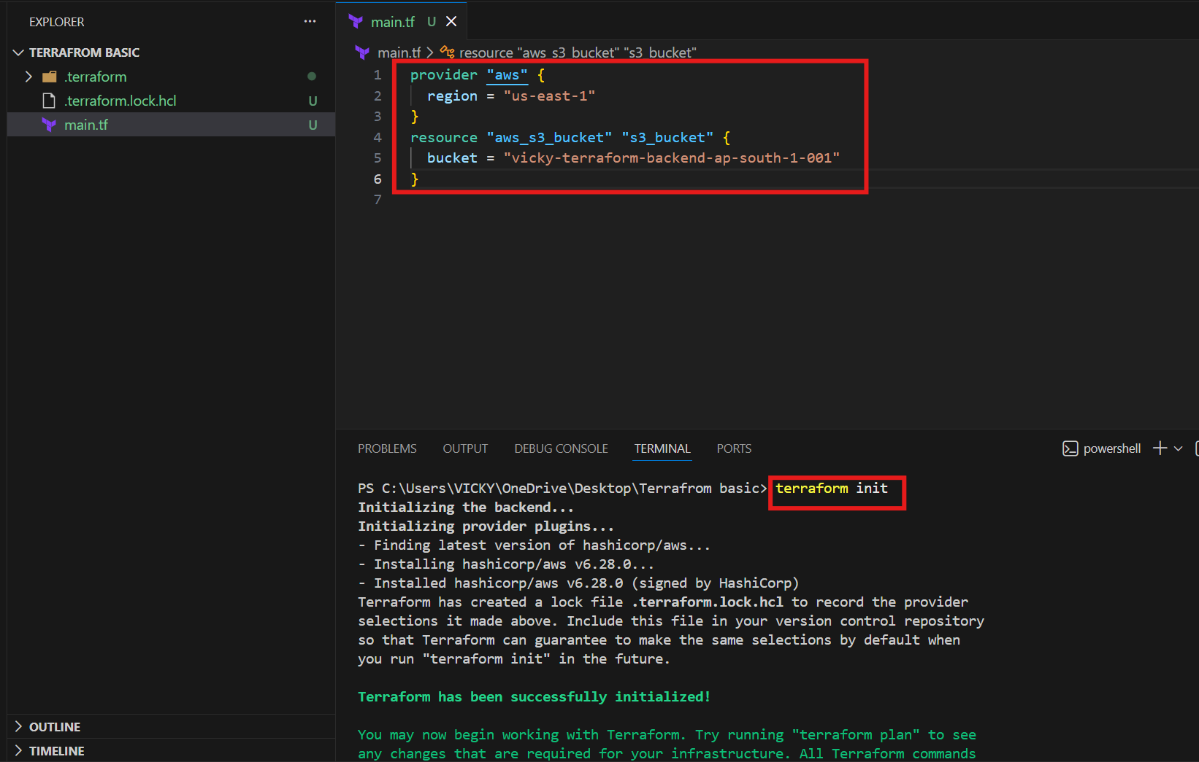

- We updated the bucket name and terraform apply

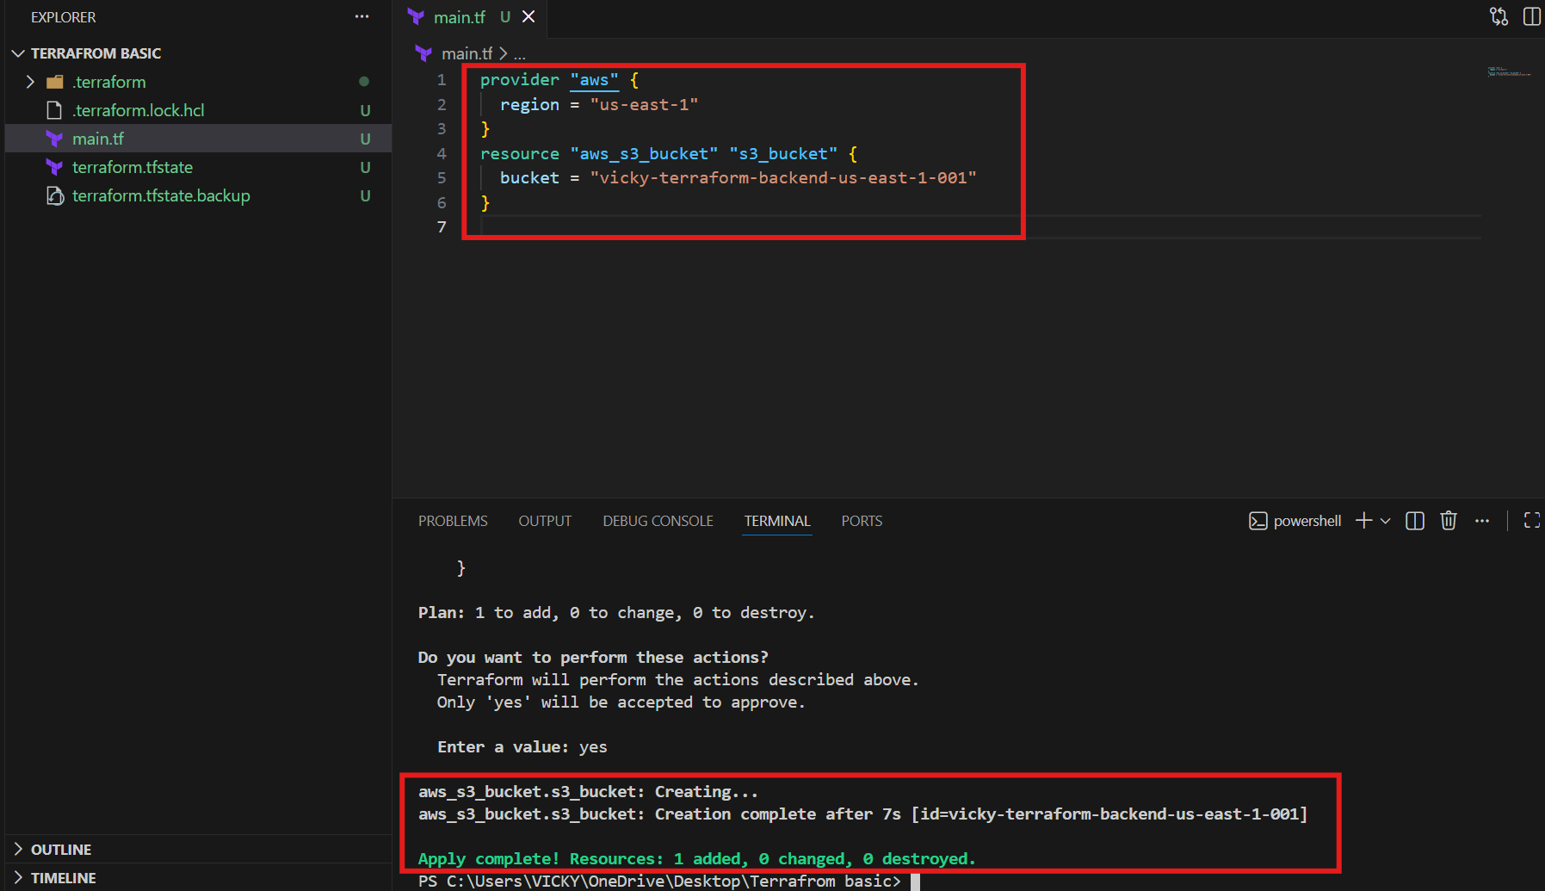

Verified in aws console
S3 bucket has automatically got created with terraform.
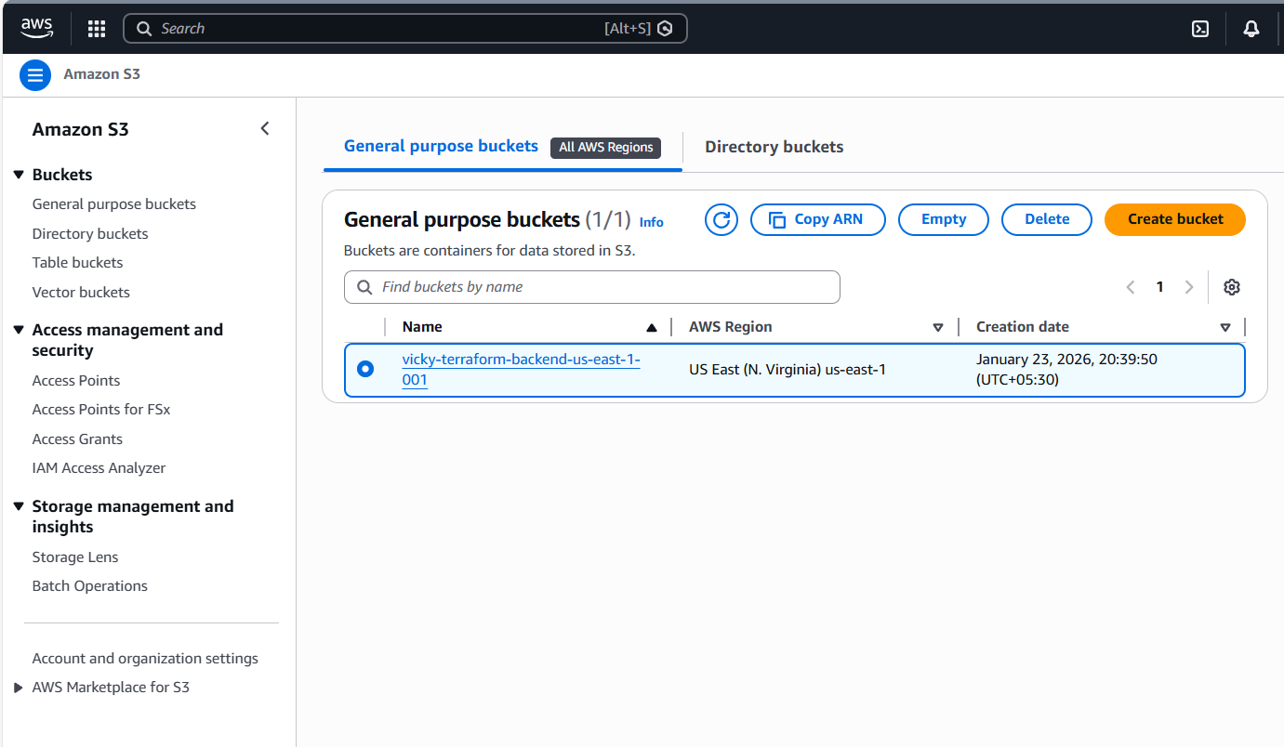

Next topic- State Locking using Dynamo DB

We used below code to create a Dynamo DB in aws

resource "aws_dynamodb_table" "dynamodb-terraform-state-lock" {
name = "terraform-state-lock-dynamo"
hash_key = "LockID"
read_capacity = 20
write_capacity = 20

attribute {
name = "LockID"
type = "S"
}

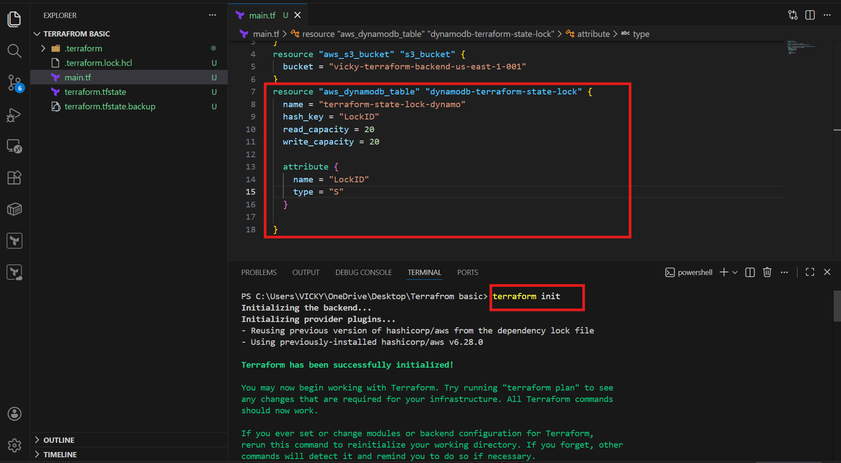
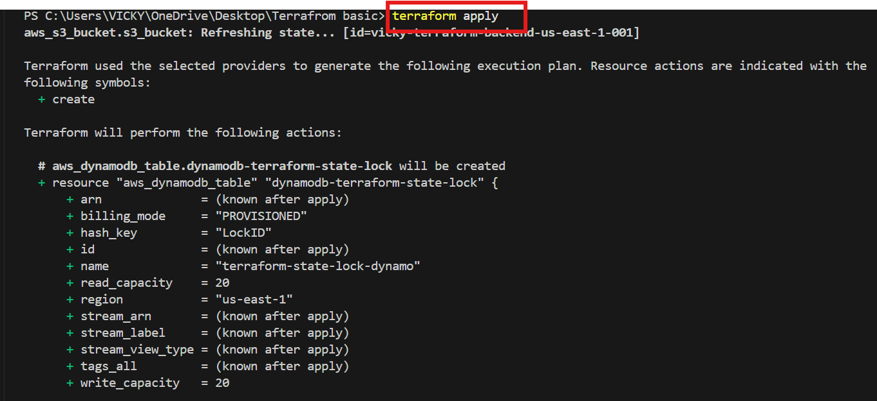
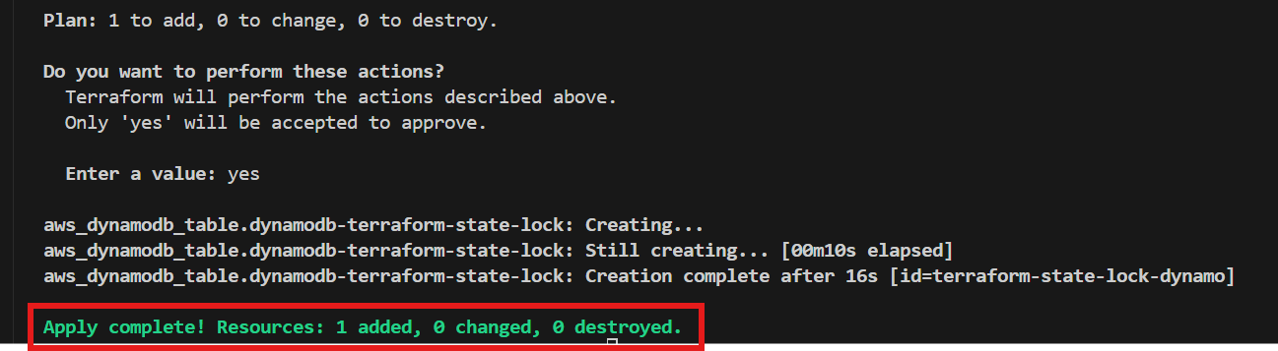

- We can verify in the Dynamo DB that, 1 table has been created for us and it’s an empty table.
- Next, we, need to perform S3 backend to integrate with DynamoDB.
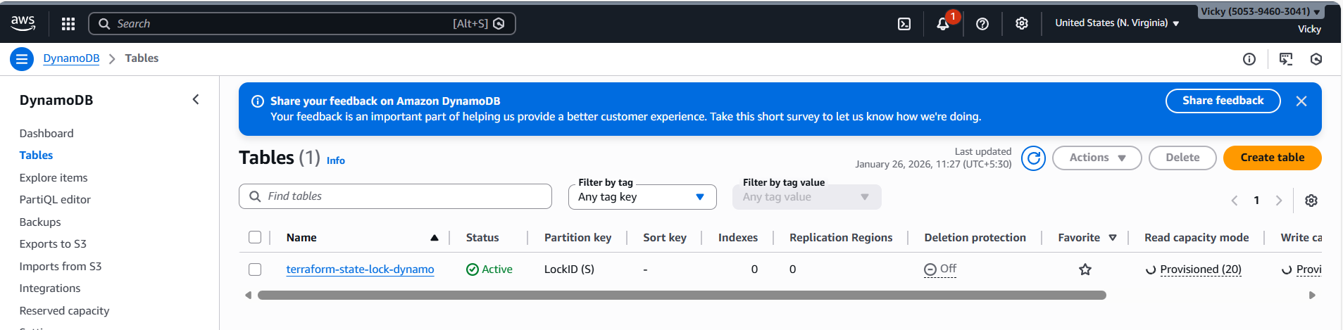

Now, we updated a code, where, s3 will communicate with DynamoDB and perform the state locking to prevent multiple users to execute the same point of time.

terraform {
backend "s3" {
bucket = "vicky-terraform-backend-us-east-1-001"
dynamodb_table = "terraform-state-lock-dynamo"
key = "terraform.tfstate"
region = "us-east-1"
}
}

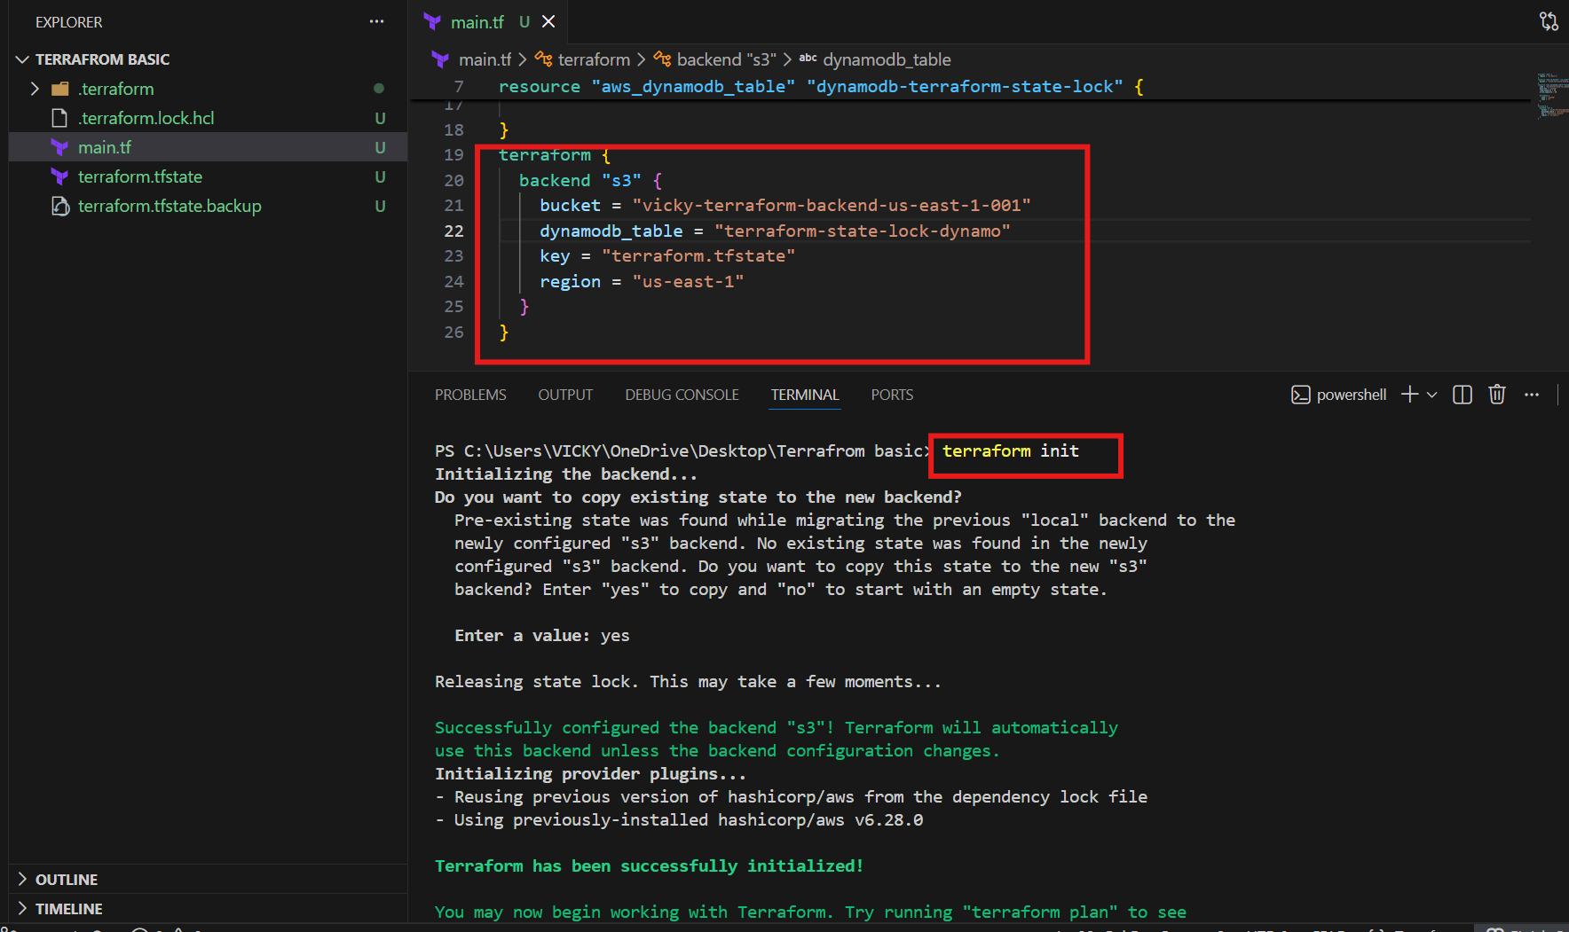

Let’s verify in the aws, if the terraform.tfstate is present in s3.
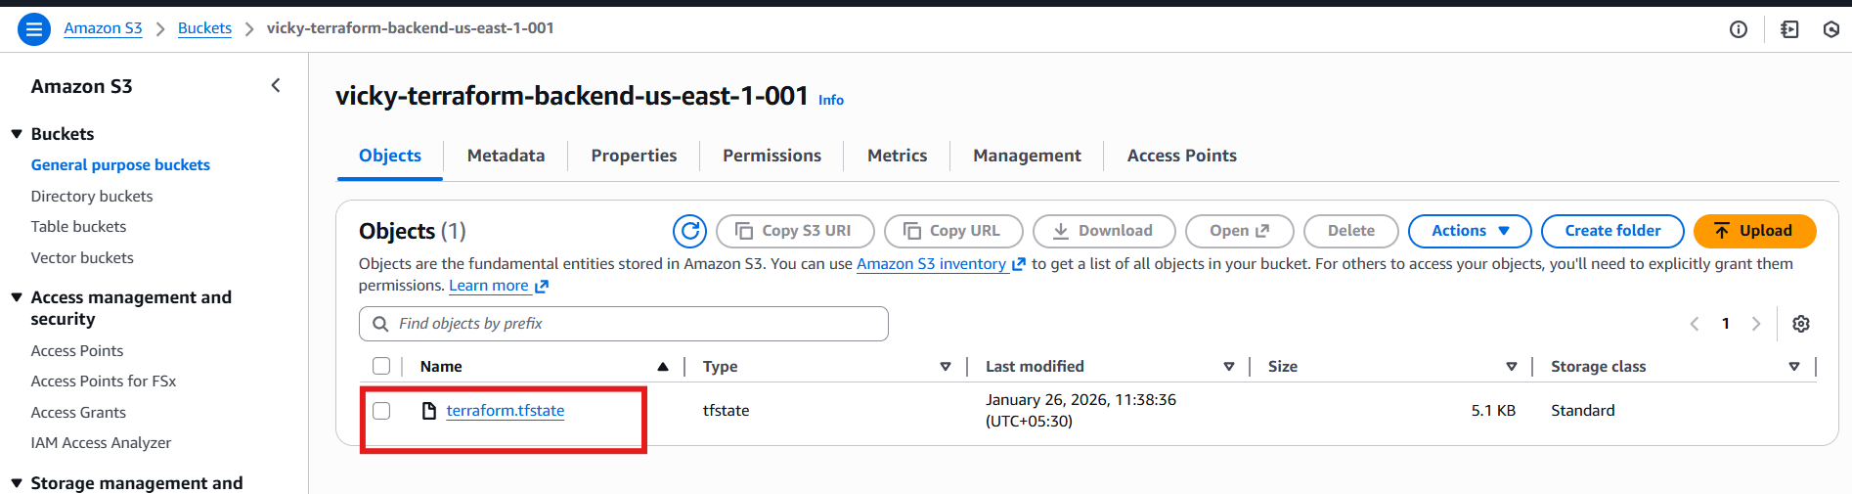
Let’s verify in the Dynamo DB, if the tables are present which we created in Terraform.
One lock ID has been created for us in Dynamo DB.
Success.
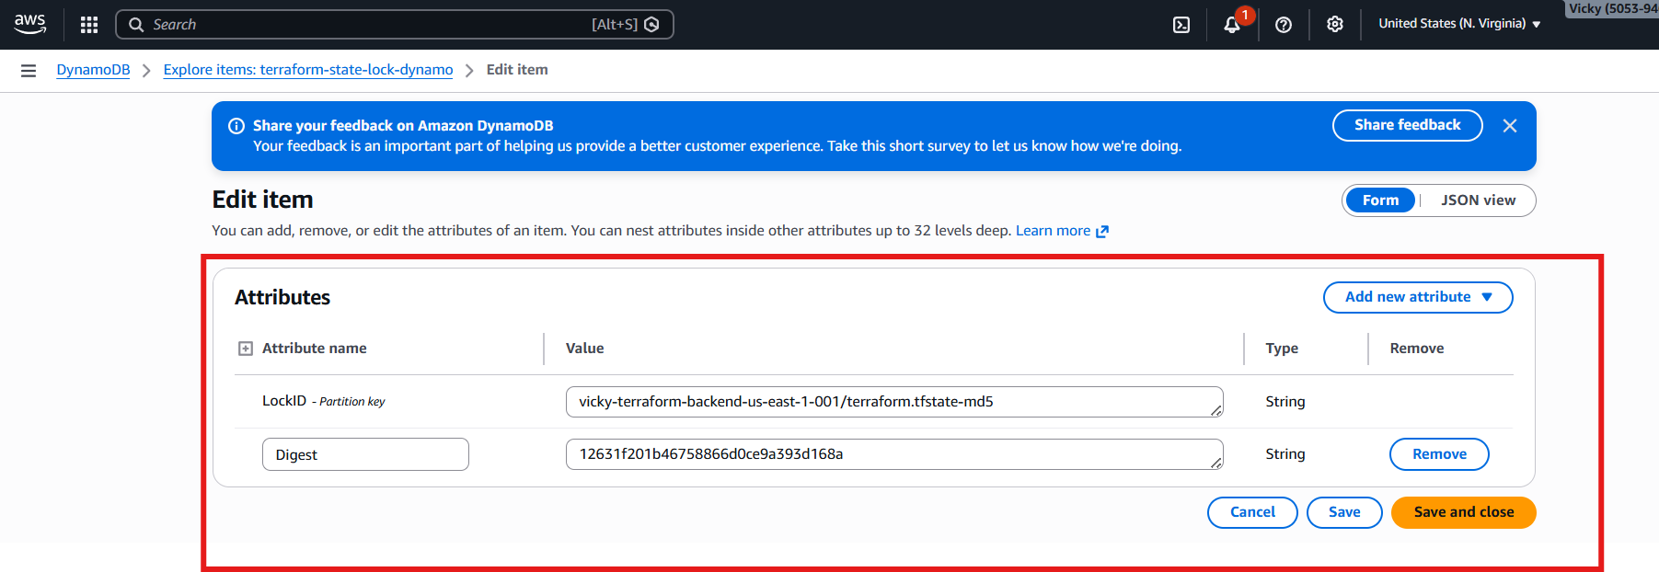

Yet, we haven’t applied- terraform apply in VS code.
Now, we shall update a code for local_file provider and see what’s happening in the backend.
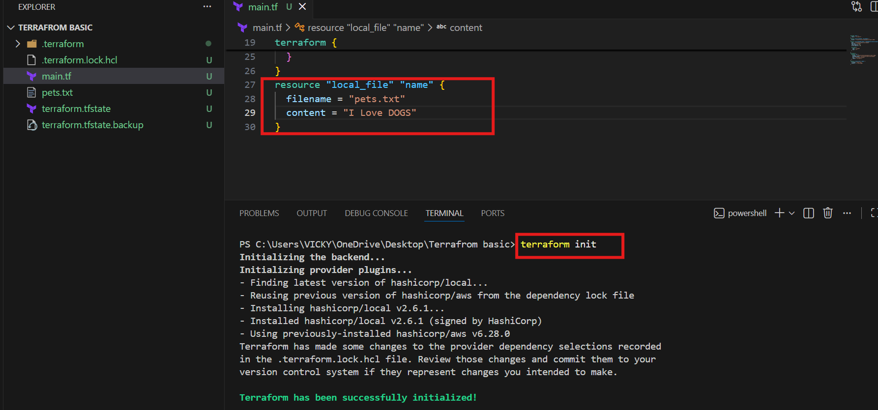

Now, when we hit terraform apply – we should see terraform locking should be starting.
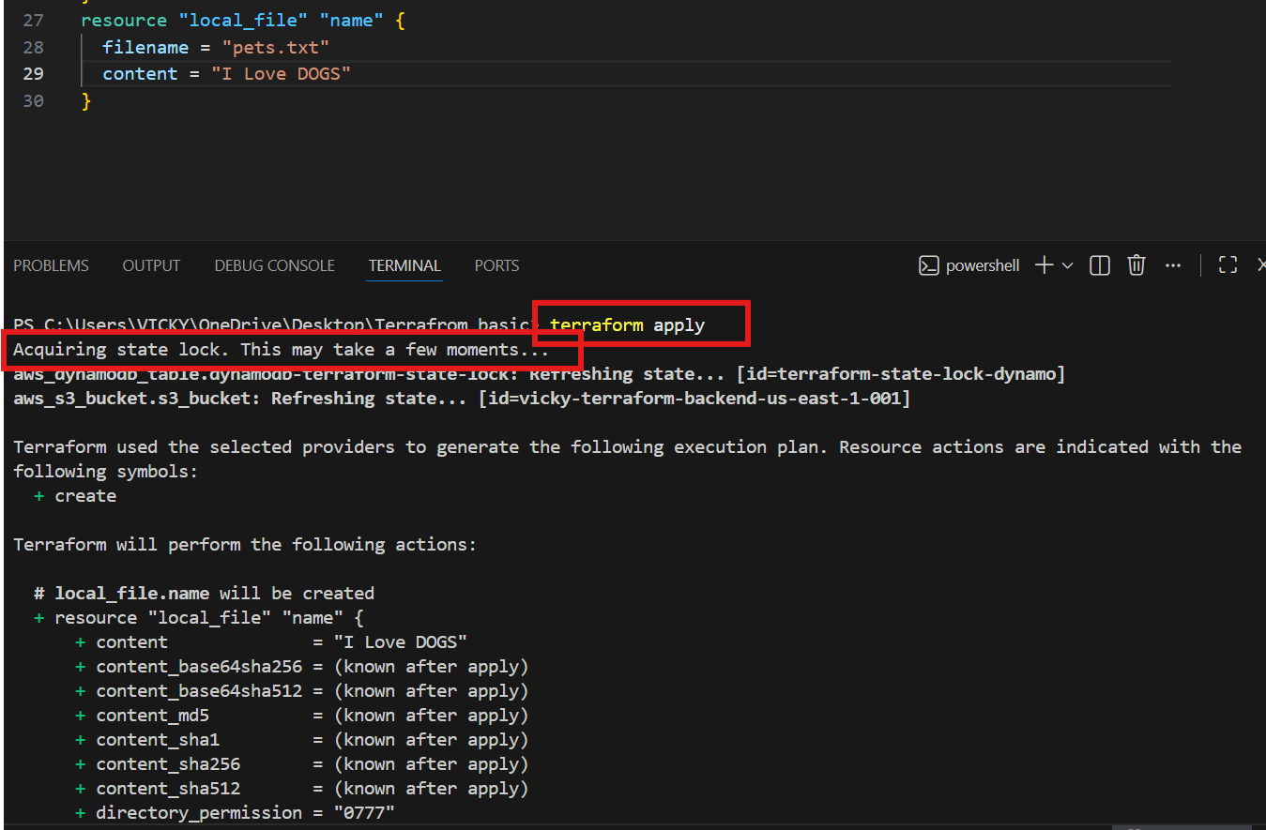
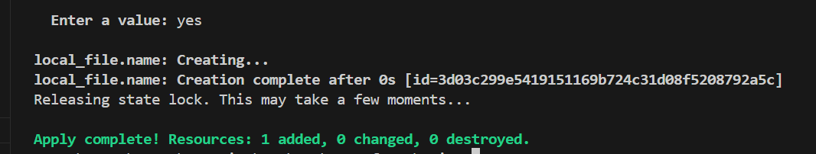

Bucket Versioning enabled, so we can have multiple versions of tf.state files available.
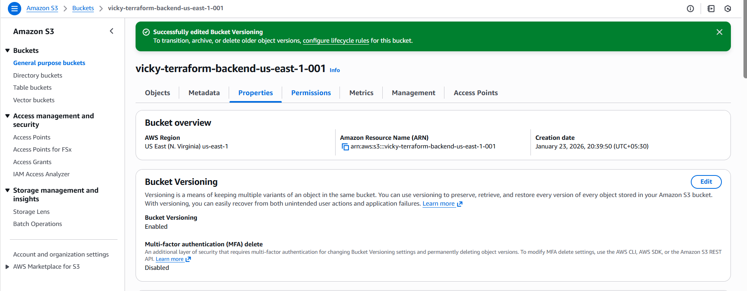

Interview Question?

If we have used Terraform and why?
- We used Terraform to provision aws services by creating
  - VPC
  - Ec2
  - Route 53
  - CloudWatch Monitoring
  - S3
  - RDS

- We have used s3 as our backend and DynamoDB for state locking, so that we can push our tf.statefile to s3 without manual intervention
- Used DynamoDB, so that, no multiple users can execute at the same point of time.

Create basic ec2 instance

resource "aws_instance" "terraform" {
ami = "ami-0532be01f26a3de55"
instance_type = "t3.micro"
key_name = "Jenkins-M"
tags = {
Name = "terraform-instance"
}
}

Terraform init
Terraform apply
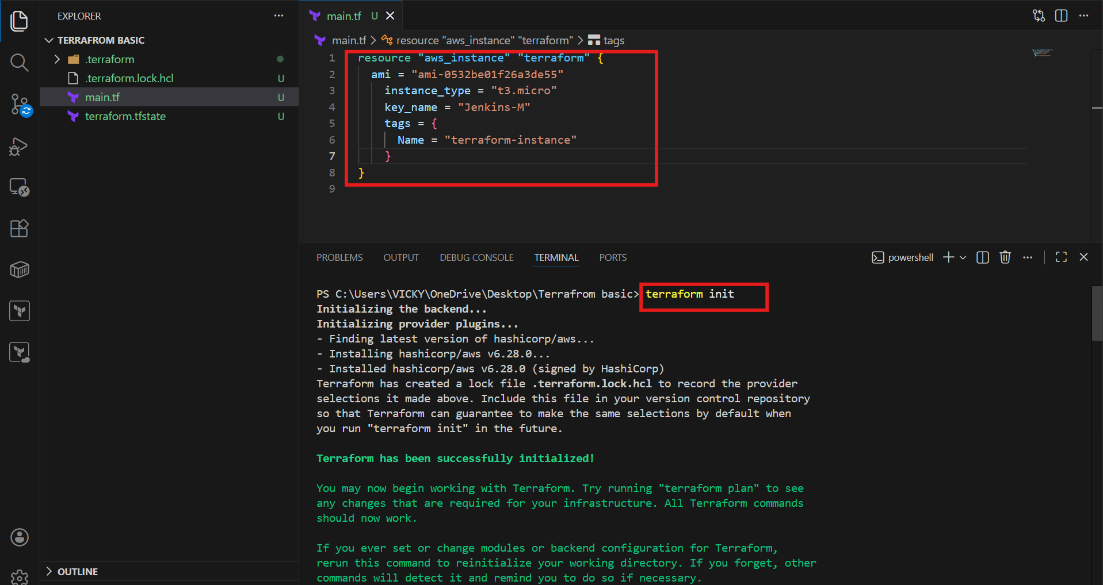
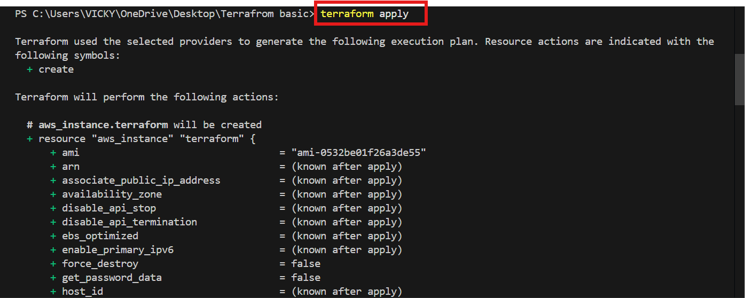
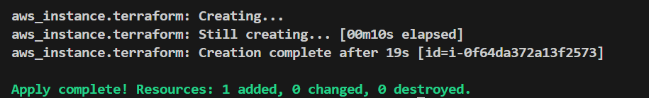

Let’s verify in aws ec2 instances
Instance has been created automatically by terraform and its up and running.
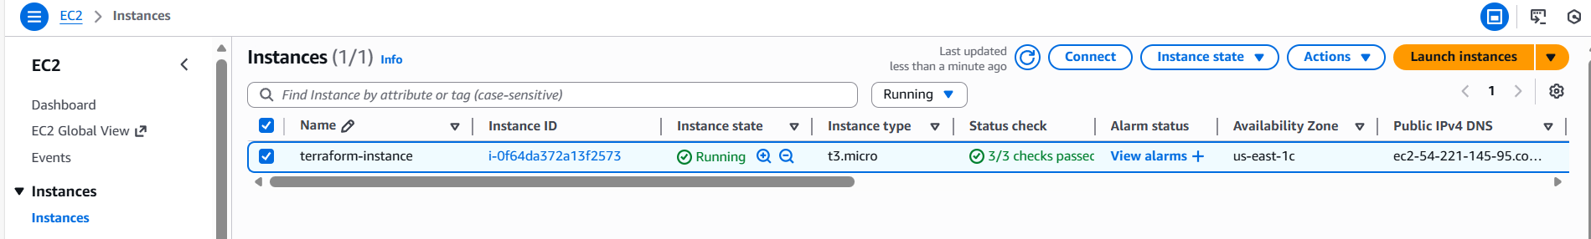

Terraform Provisioners

- We have two provisioners
  - Remote Provisioners
  - Local Provisioners

For testing purposes, we have removed the ec2 instance, which we created earlier.
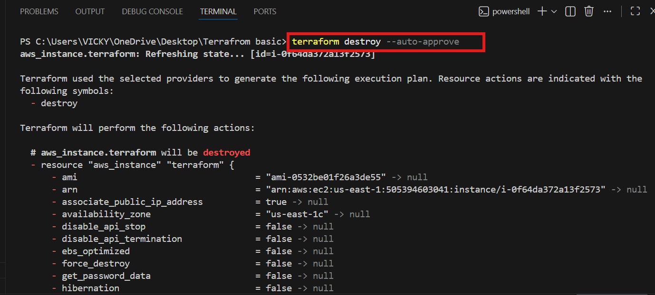

- Now, we shall add a local provisioner

provisioner "local-exec" {
command = "echo ${aws_instance.terraform.public_ip} > ip_address.txt"
}
}
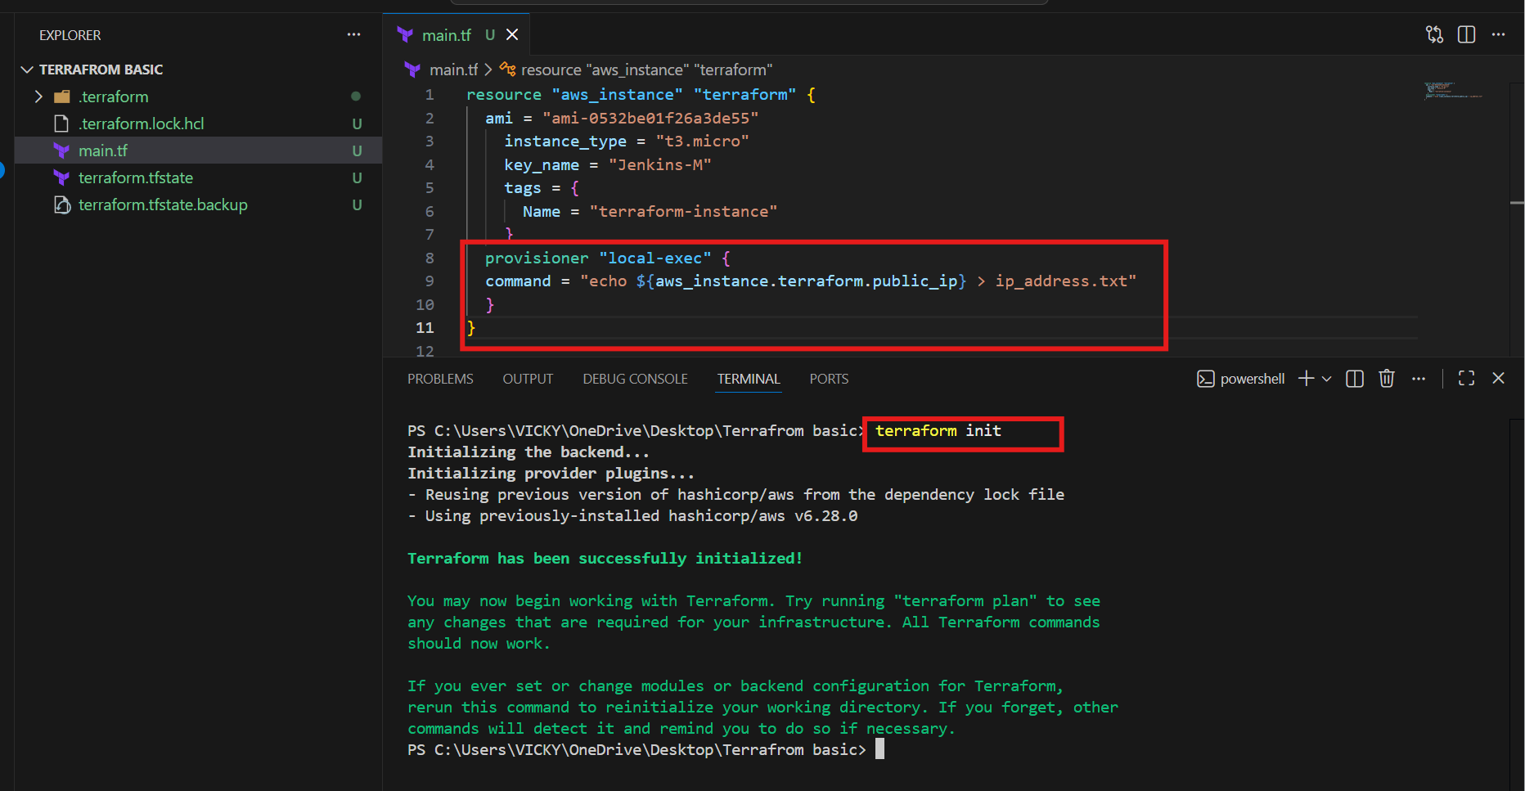

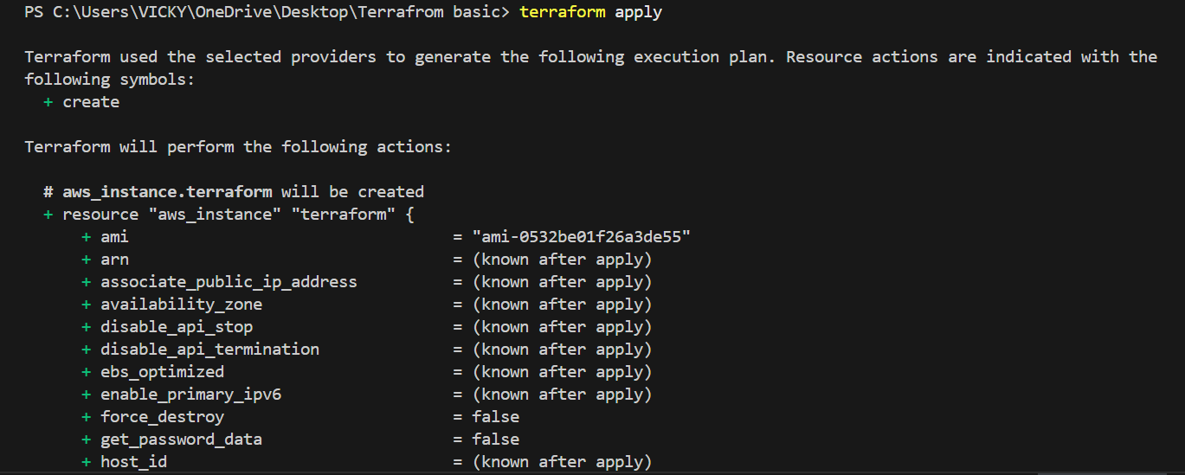
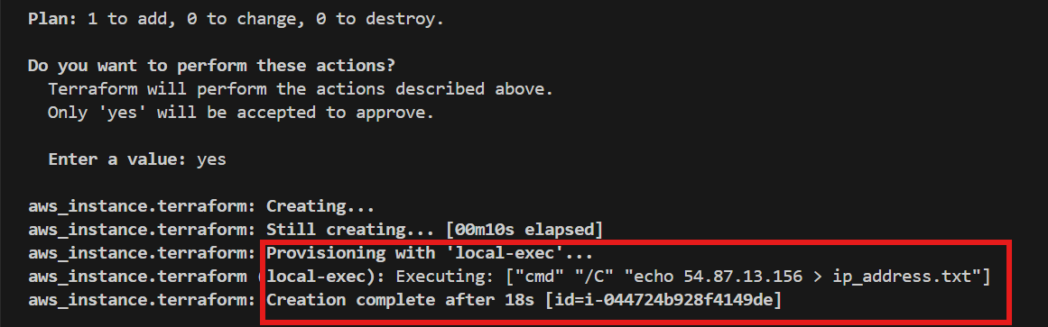
- If we see, 1 file has been created “ip_address.txt” and Ip is available from instance. ======same IP is present in the instance as well.
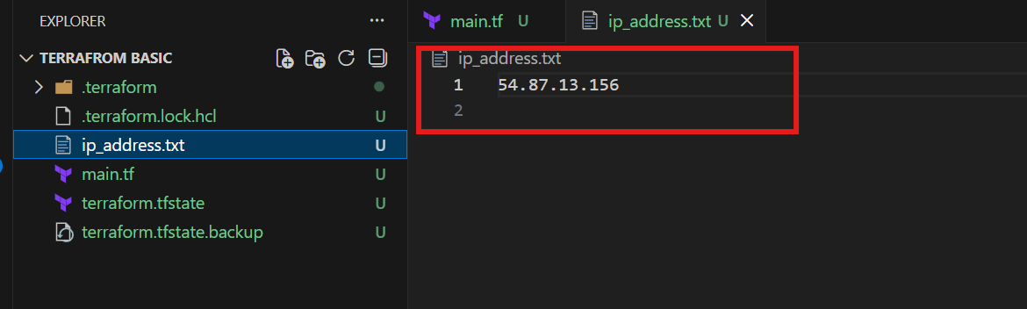
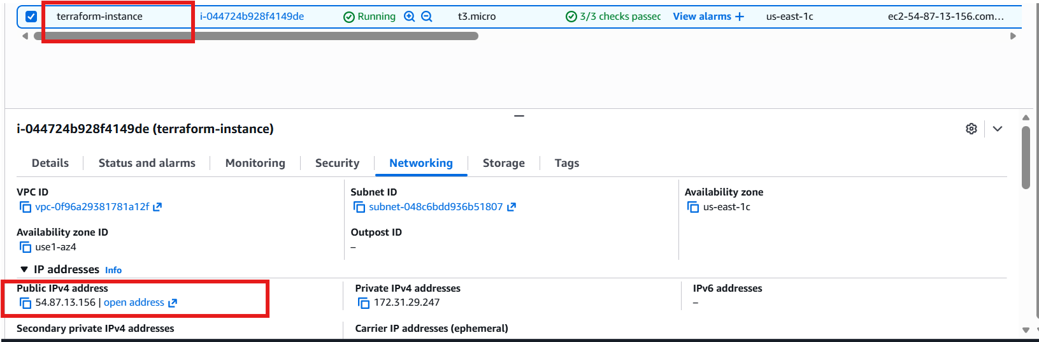
2. Create one EC2 instance with httpd installed using a Terraform script.

Step by step Implementation:
Syntax:
resource "aws_instance" "httpd" {
ami = " ami-0532be01f26a3de55"
instance_type = "t3.micro"
key_name = "Jenkins-M"
user_data = <<-EOF
#!/bin/bash
sudo yum update -y
sudo yum install -y httpd
sudo systemctl start httpd
sudo systemctl enable httpd
echo "HTTPD working successfully from $(hostname -f)" > /var/www/html/index.html
EOF
tags = {
Name = "httpd-instance"
}
provisioner "local-exec" {
command = "echo ${aws_instance.httpd.public_ip} > ip_address.txt"
}
}

Terraform init
Terraform apply
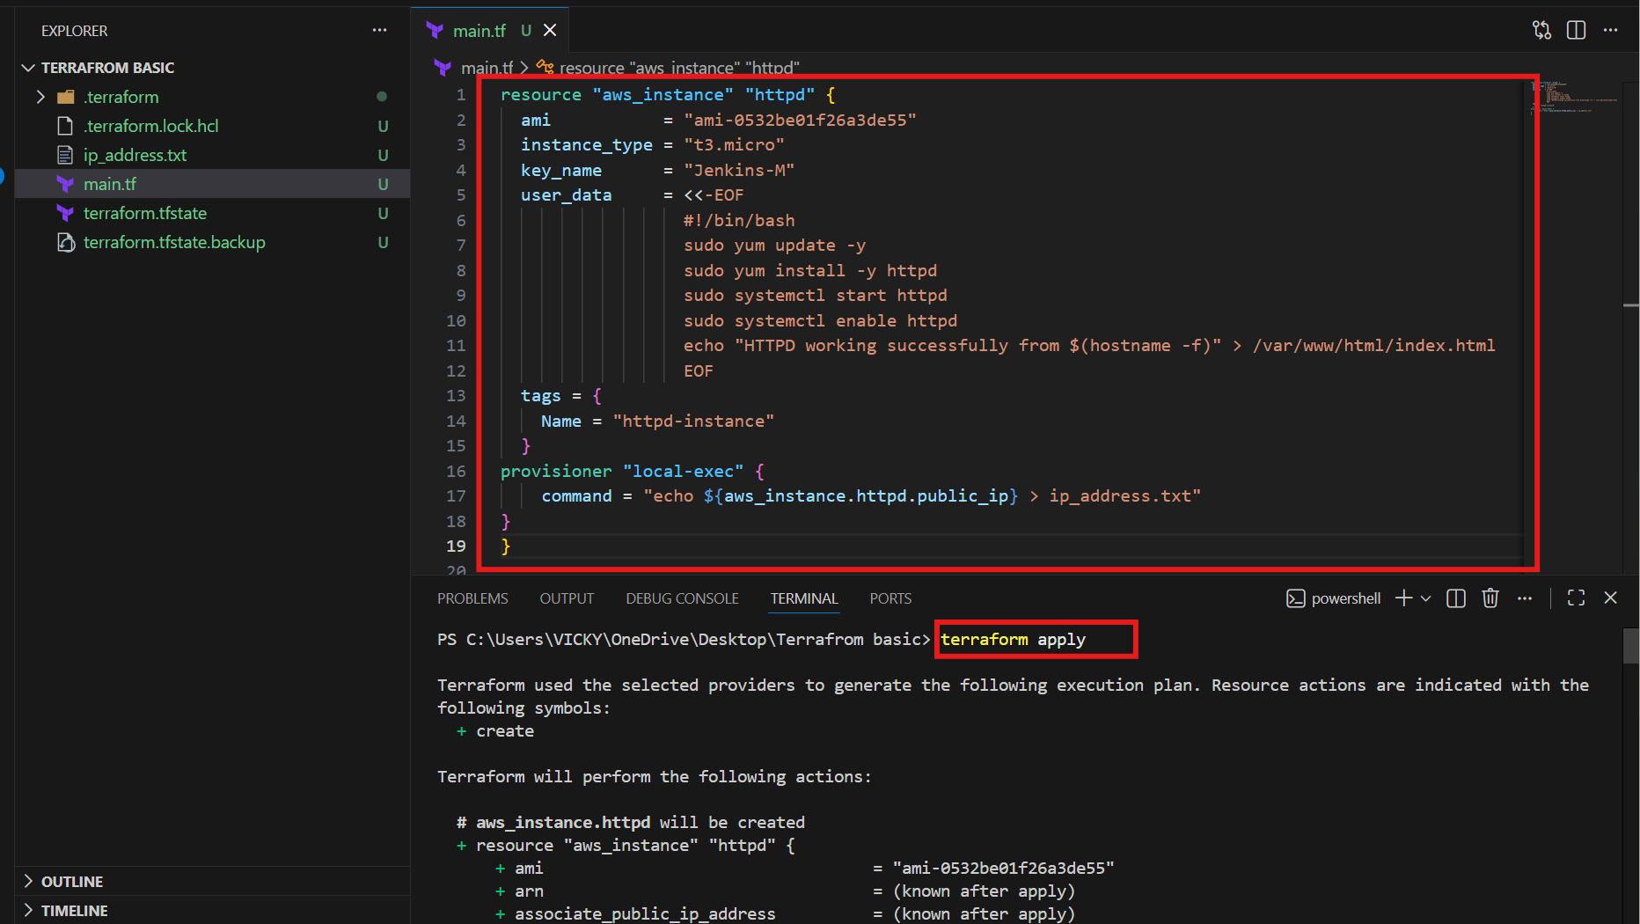
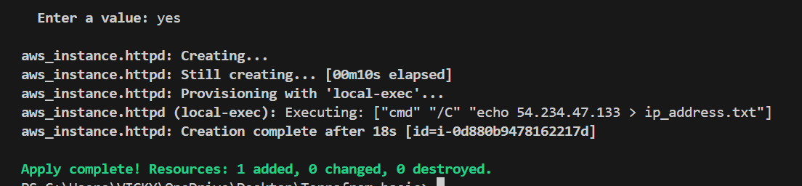

- One IP address has been created as per Provisioners
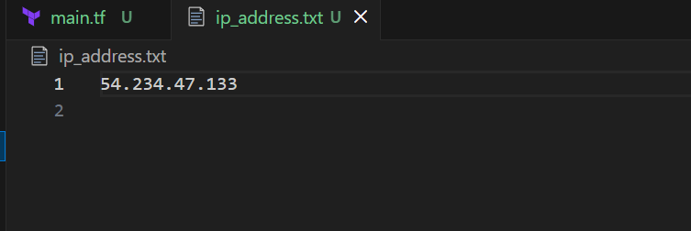

- Verified in ec2 instance has been created
- IP has been generated and a file has been created in local machine as well.
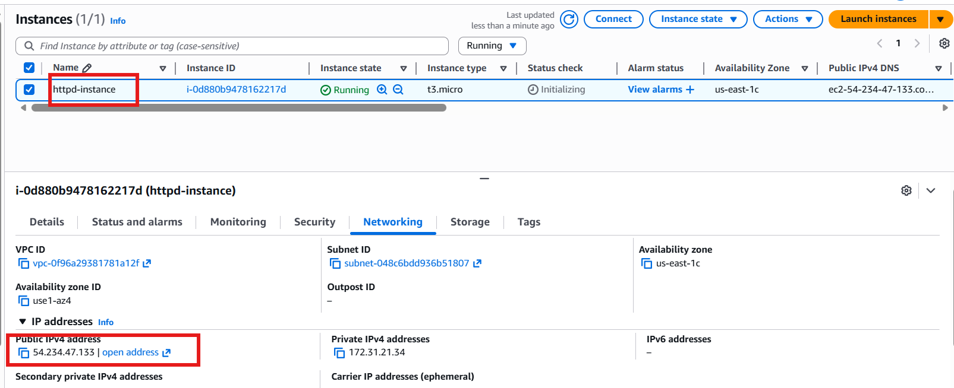

- Now, let’s verify in browser, if httpd is installed.

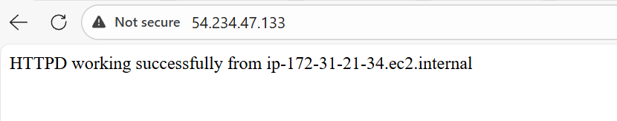

Task successful

3. Set up S3 as backend for task 2.

Syntax:
resource "aws_instance" "httpd" {
ami = "ami-0532be01f26a3de55"
instance_type = "t3.micro"
key_name = "Jenkins-M"
user_data = <<-EOF
#!/bin/bash
sudo yum update -y
sudo yum install -y httpd
sudo systemctl start httpd
sudo systemctl enable httpd
echo "HTTPD working successfully from $(hostname -f)" > /var/www/html/index.html
EOF
tags = {
Name = "httpd-instance"
}
provisioner "local-exec" {
command = "echo ${aws_instance.httpd.public_ip} > ip_address.txt"
}

}

resource "aws_s3_bucket" "s3_bucket" {
bucket = "vicky-s3-bucket-techie-horizon"
}

Terraform apply
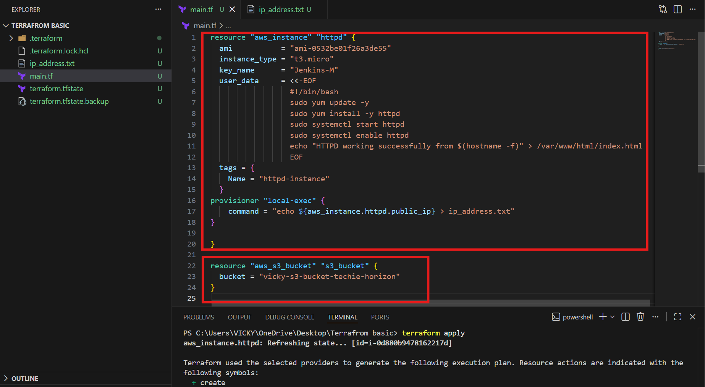
S3 bucket has been created.
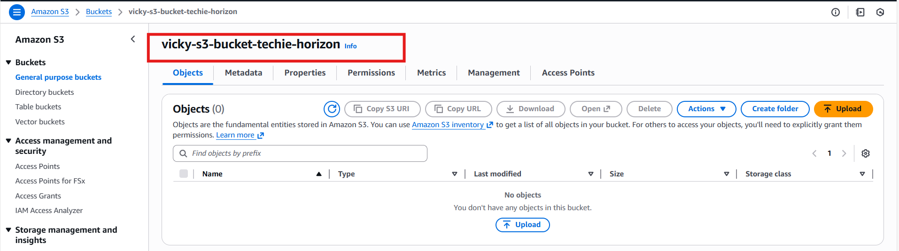

- Now, we shall do the s3 backend with below codes.

terraform {
backend "s3" {
bucket = "vicky-s3-bucket-techie-horizon"
key = "terraform.tfstate"
region = "us-east-1"
}
}
Terraform init
Terraform apply
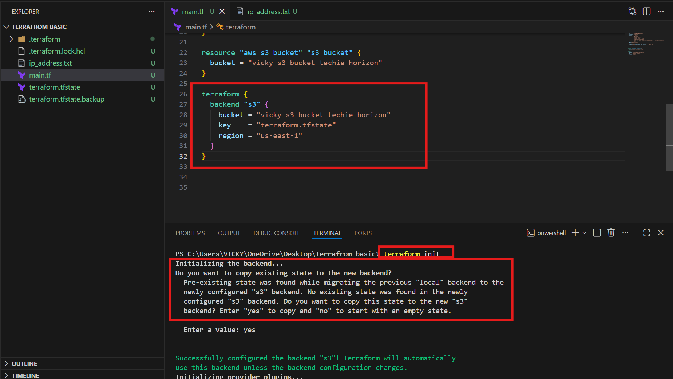
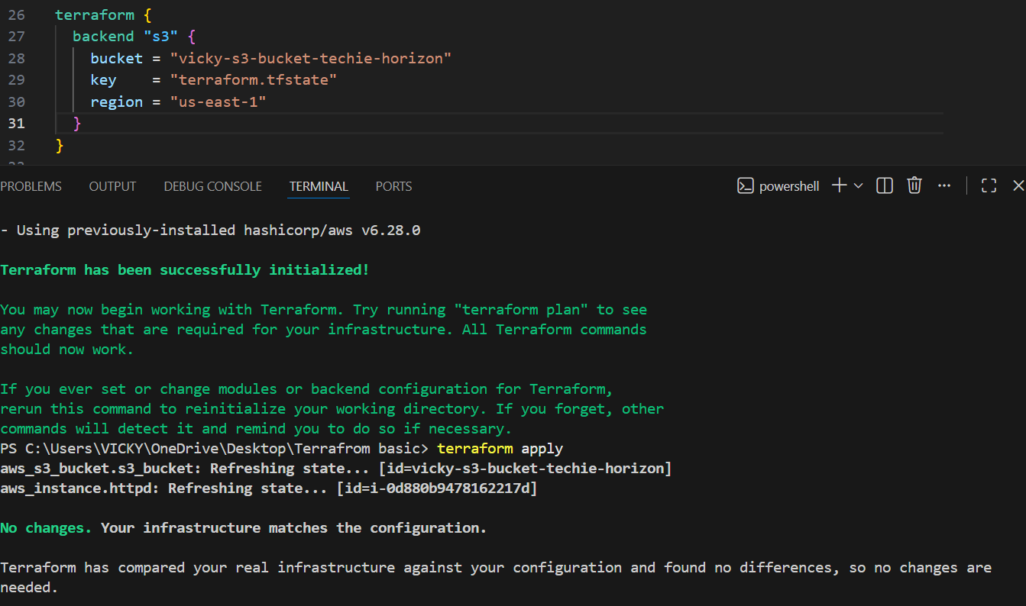
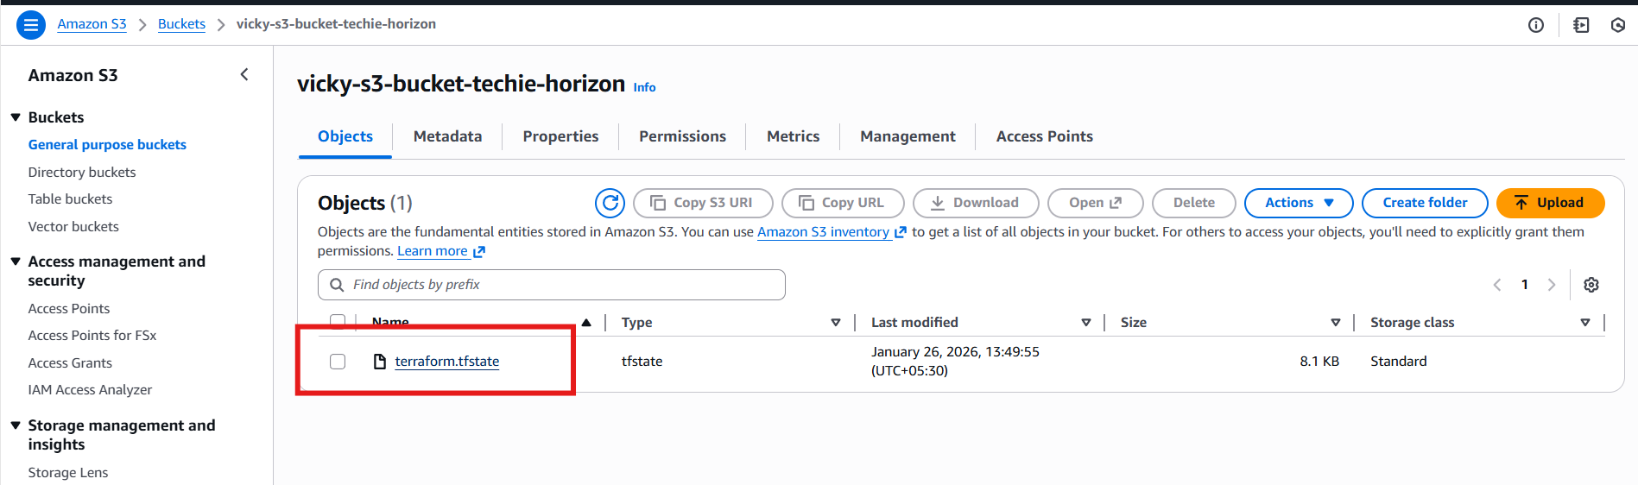
4. Set up DynamoDB locking for task 2.

Please attach the below syntax to the earlier main.tf file.
Syntax:

resource "aws_dynamodb_table" "vicky-terraform-backend" {
name = "vicky-terraform-backend"
hash_key = "LockID"
read_capacity = 20
write_capacity = 20
attribute {
name = "LockID"
type = "S"
}
}

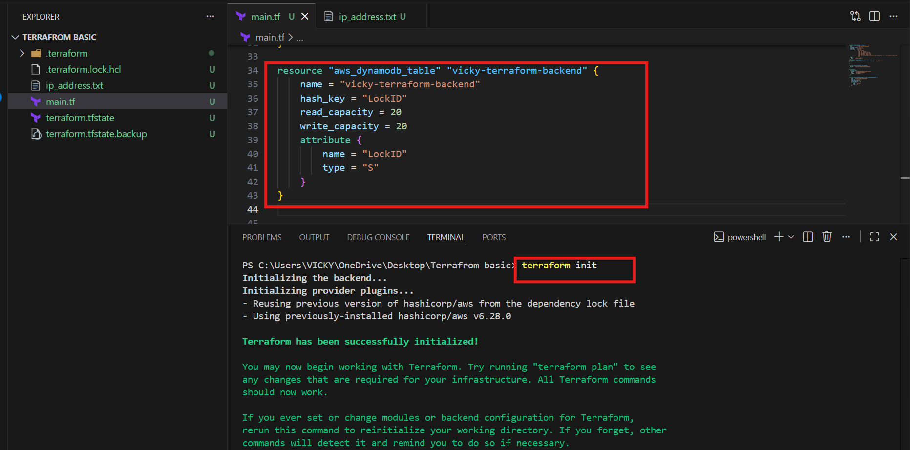
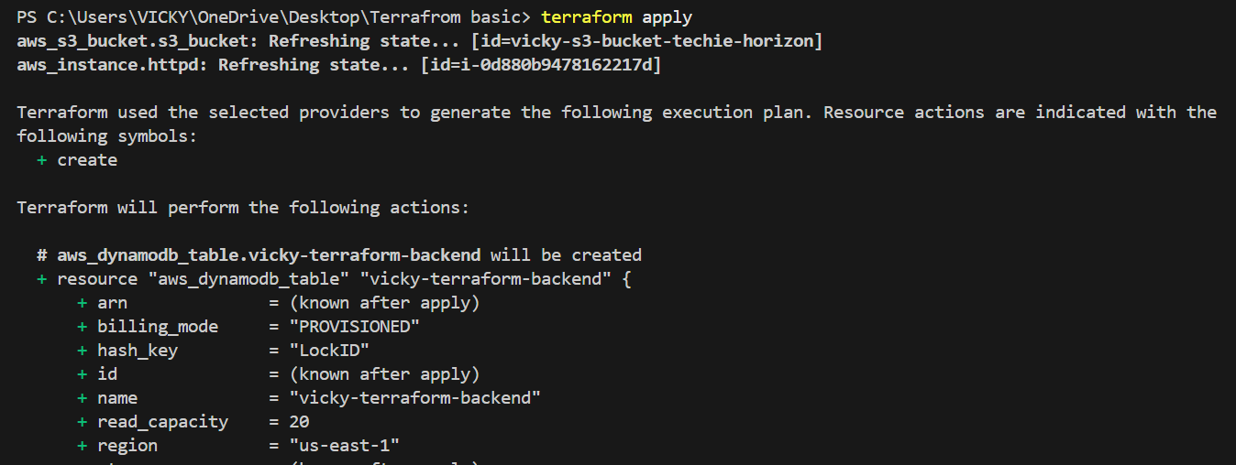
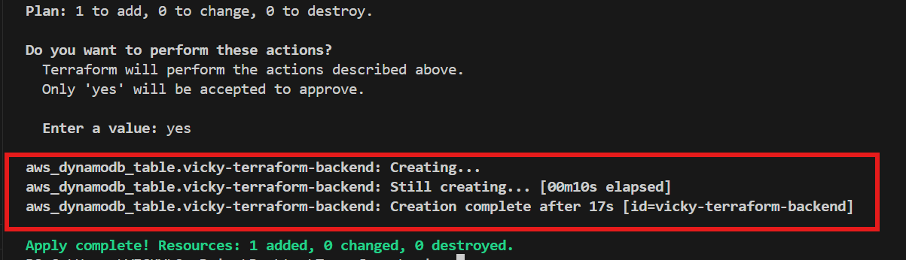

- State locking is active now with Dynamo DB.
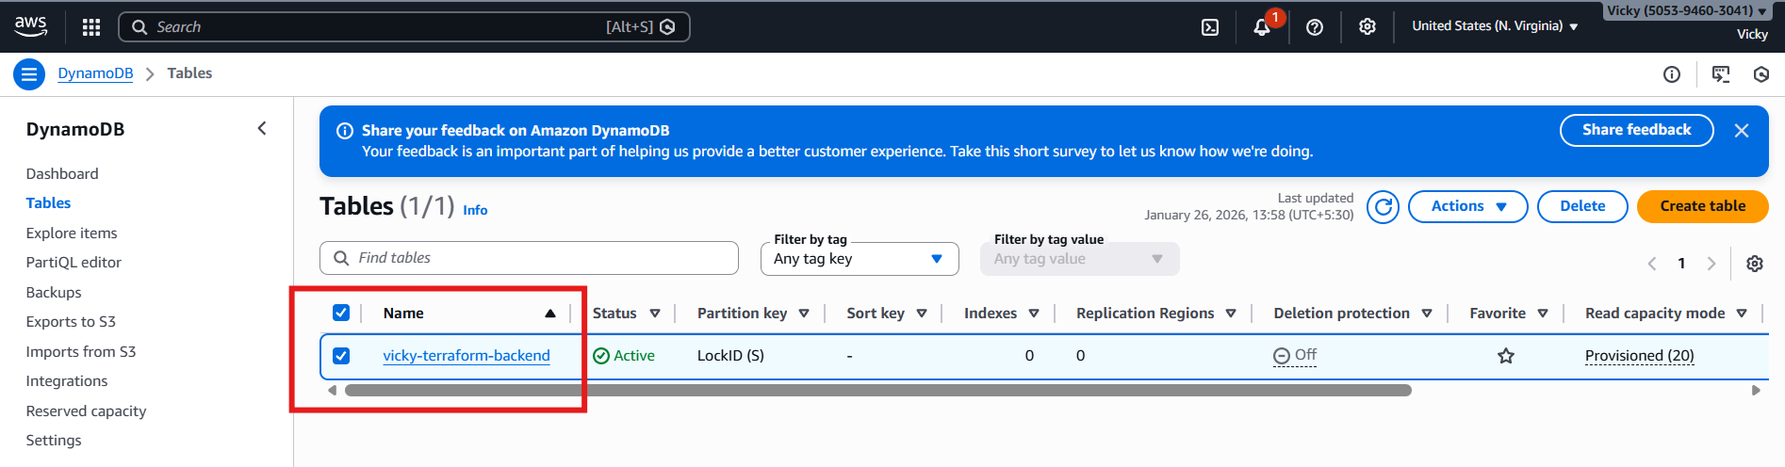

Now, we updated a code, where, s3 will communicate with DynamoDB and perform the state locking to prevent multiple users to execute the same point of time.
terraform {
backend "s3" {
bucket = "vicky-s3-bucket-techie-horizon"
dynamodb_table = "vicky-terraform-backend"
key = "terraform.tfstate"
region = "us-east-1"
}
}

- Now, s3 will automatically use this backend and state locking is in place.
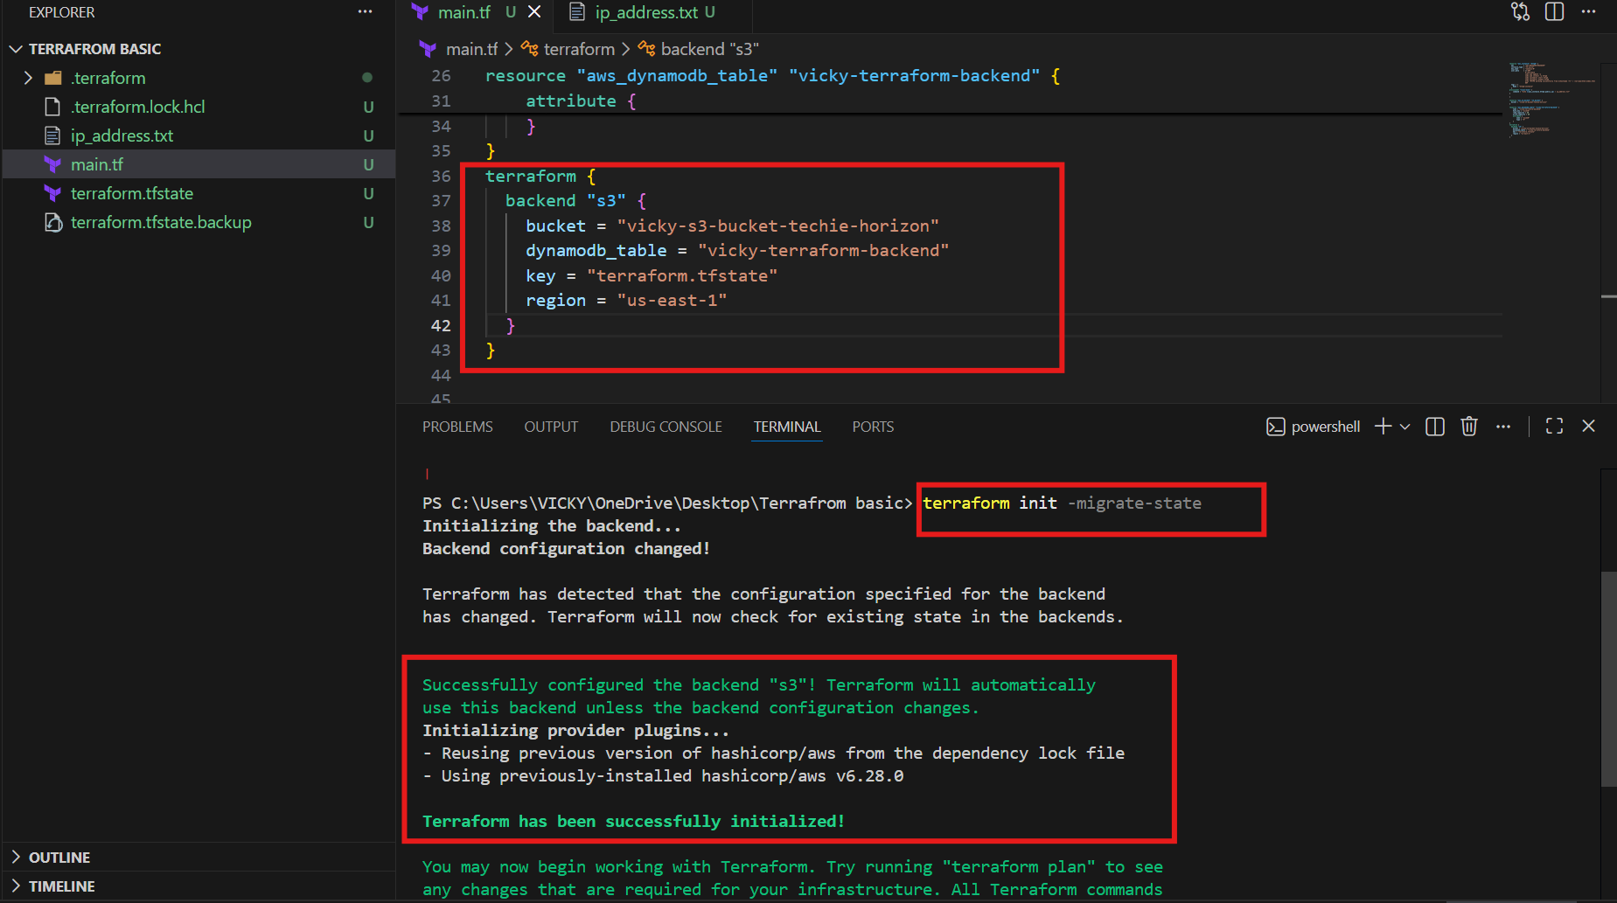

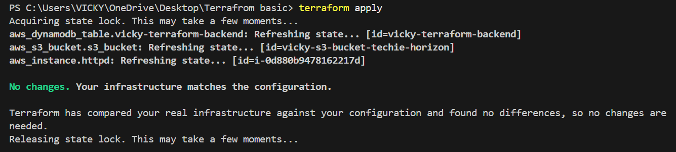

- Let’s verify in the aws DynamoDB, if state locking table is created.
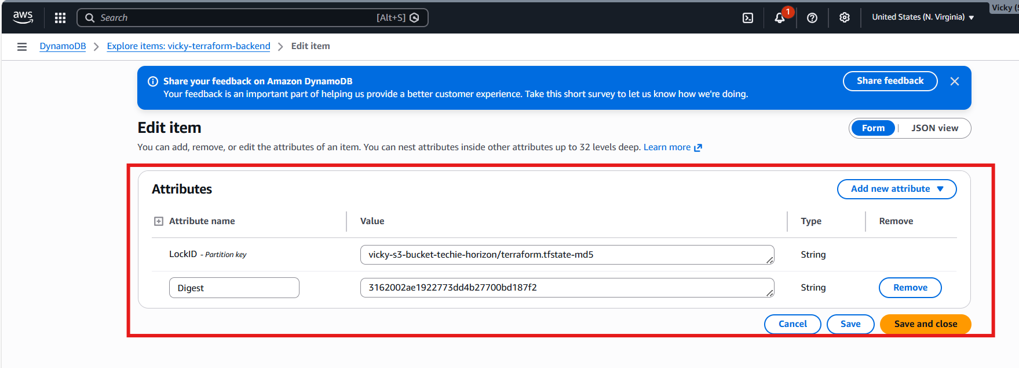

Final Syntax:

resource "aws_instance" "httpd" {
ami = "ami-0532be01f26a3de55"
instance_type = "t3.micro"
key_name = "Jenkins-M"
user_data = <<-EOF
#!/bin/bash
sudo yum update -y
sudo yum install -y httpd
sudo systemctl start httpd
sudo systemctl enable httpd
echo "HTTPD working successfully from $(hostname -f)" > /var/www/html/index.html
EOF
tags = {
Name = "httpd-instance"
}
provisioner "local-exec" {
command = "echo ${aws_instance.httpd.public_ip} > ip_address.txt"
}

}

resource "aws_s3_bucket" "s3_bucket" {
bucket = "vicky-s3-bucket-techie-horizon"
}

resource "aws_dynamodb_table" "vicky-terraform-backend" {
name = "vicky-terraform-backend"
hash_key = "LockID"
read_capacity = 20
write_capacity = 20
attribute {
name = "LockID"
type = "S"
}
}
terraform {
backend "s3" {
bucket = "vicky-s3-bucket-techie-horizon"
dynamodb_table = "vicky-terraform-backend"
key = "terraform.tfstate"
region = "us-east-1"
}
}

