Terraform-06

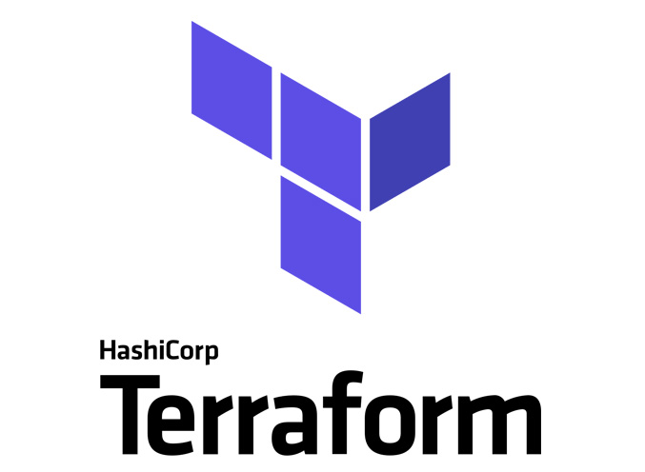

General tips for the Task below.
Task Title
Terraform-06
Objective
The objective of this task is to watch the Terraform-05 video posted on slack with and worked on executing templates shown in video.
Prerequisites
List all requirements before starting:
- AWS
- Visual studio code
- Terraform Modules
- Terraform Workspaces
Issues Faced: Briefly mention issues and how you fixed them. Posted below in the last.
Conclusion
Conclusion has been provided for every task at the end.

Watch the Terraform-06 video.
1. Execute the script shown in the video.
Terraform Modules:
What is Terraform Modules- Terraform modules is a collection of configuration files in a directory.
For example: If we want to create two ec2 instances in 2 different environments, then we can create a directory for aws_instance configuration.

We shall see the process below how to create a directory for aws_instance and call from different environments.
My main workspace- aws_instance
It’s an empty directory, now we shall create one new directory—aws_instance.
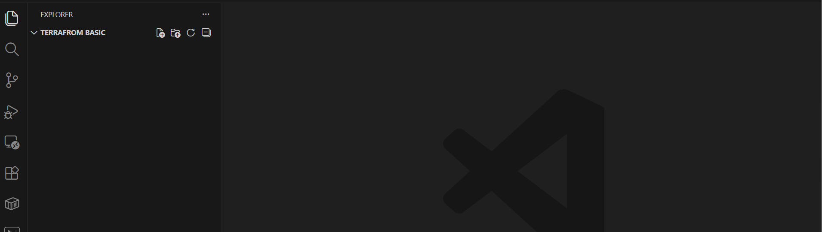
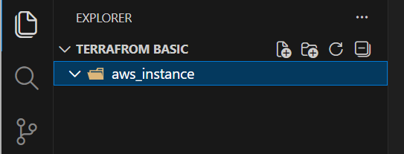

It’s time to create 2 files – main.tf and variables.tf
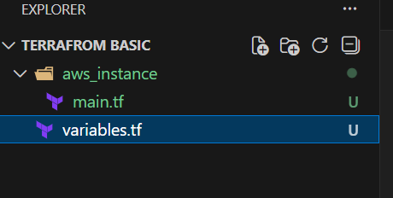
Now, it’s time to create our environment directories. We shall create one named- Development.
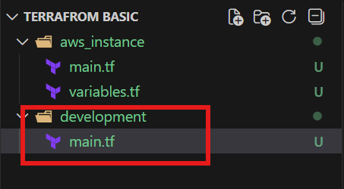

We have created folders and files required. Now, we shall insert the scripts in aws_instance and development folders.
resource "aws_instance" "webserver" {
ami = var.ami
instance_type = "t3.micro"
}
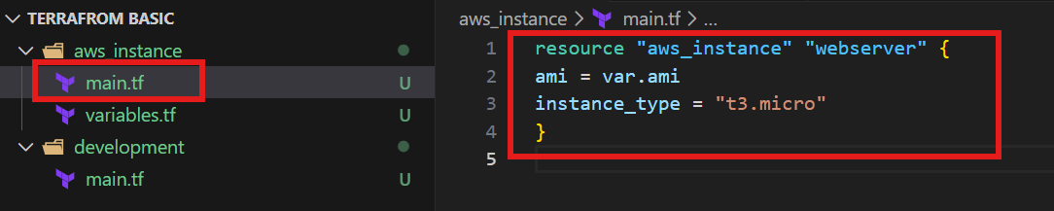
Insert the variables.tf to pick the variable “ami” from main.tf
variable "ami" {
}
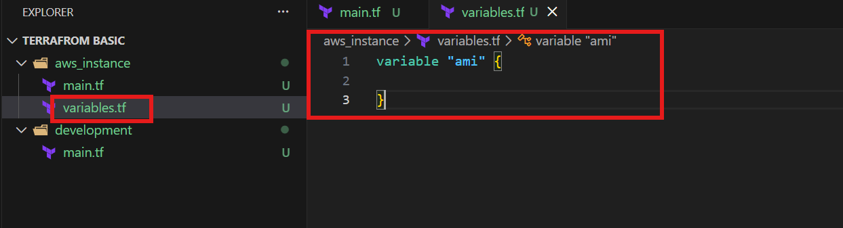

Now, we shall add a script to development directory under main.tf file such as ami and source.

The source is the path of aws_instance directory.
module "dev-webserver" {
source = "../aws_instance"
ami = "ami-0532be01f26a3de55"
}
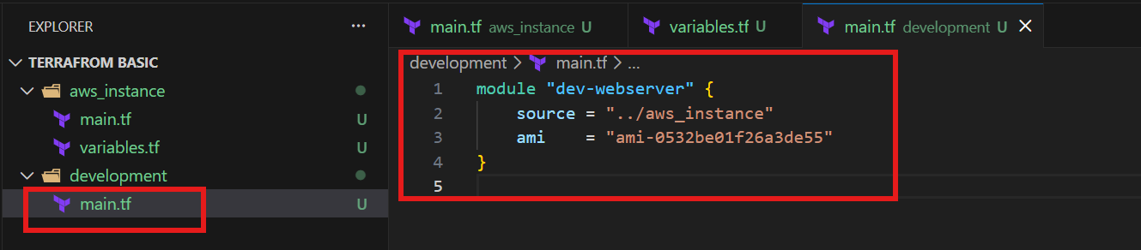

Change the directory to development
cd .\development\
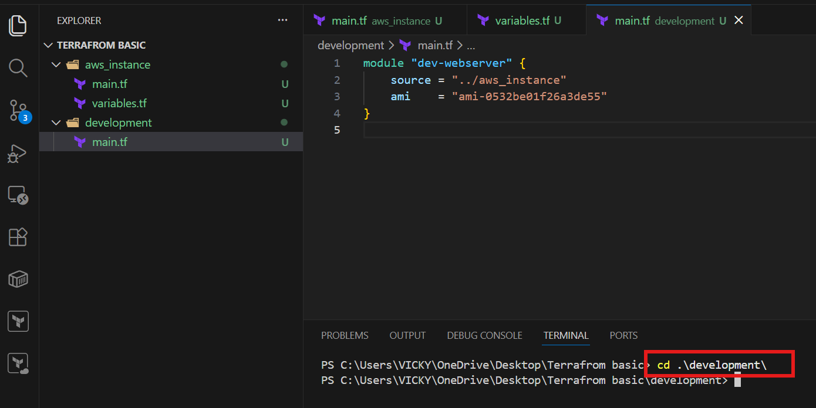
Now, let’s execute the code.
As we are executing from development directory, the details are fetching from aws_instance directory, that’s root module and ec2 gets launched.
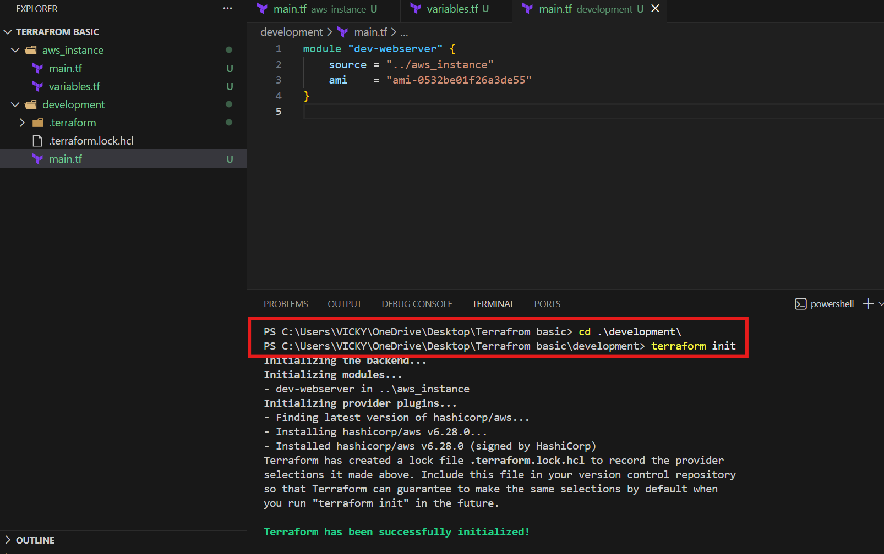
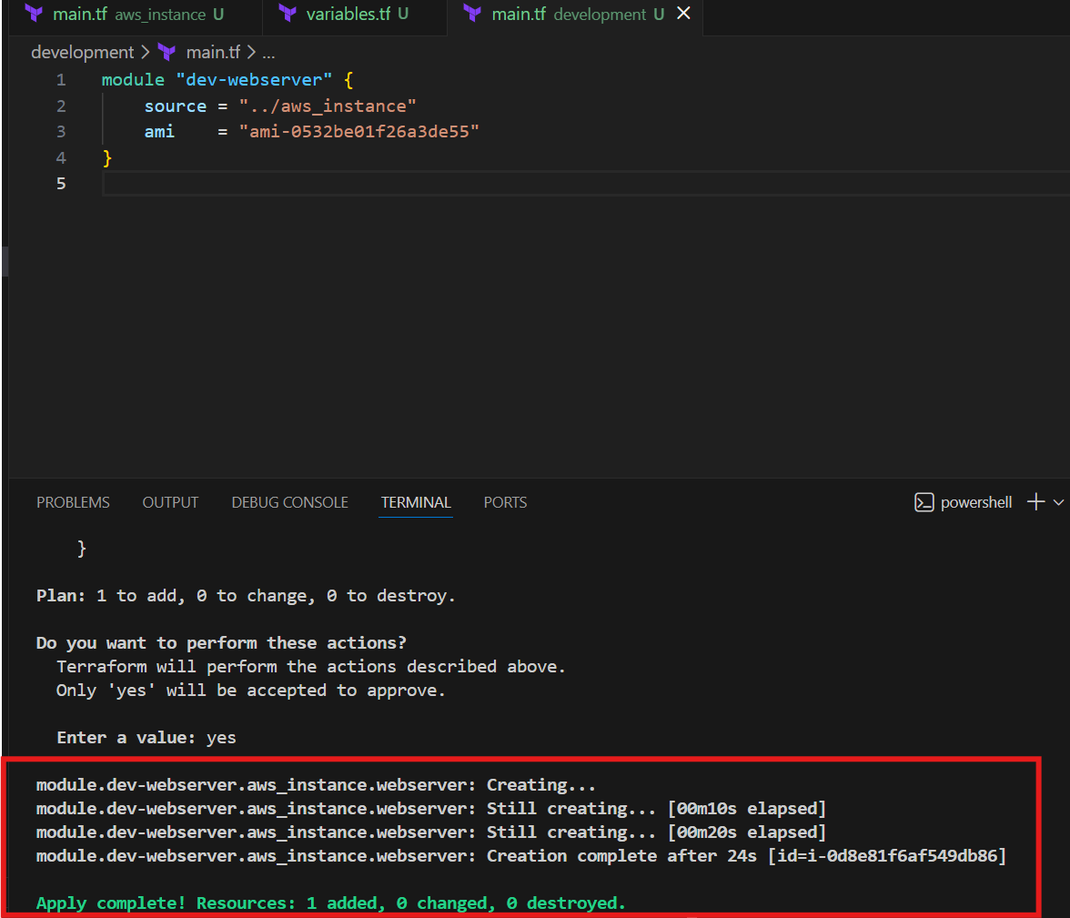
Let’s verify in aws ec2 instances.
Success.
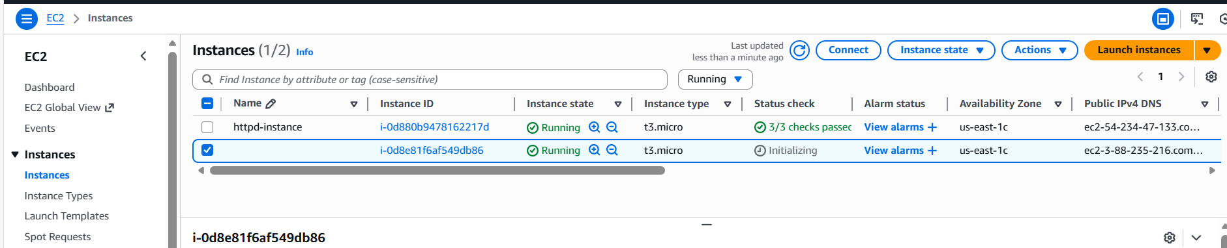

This way, we can create sub-directories (environments) and fetch the details from aws_instance (main.tf) directory.
So that, we don’t need to create instances every single time.

Workspaces

Terraform Workspaces
This is similar to Terraform modules, there is a simple difference between them, where we do not require to create separate directories (environments). Instead, we can create them in aws_instance directory itself through Workspace.
In main.tf
resource "aws_instance" "webserver" {
ami = var.ami [ProjectA]
instance_type = "t3.micro"
}
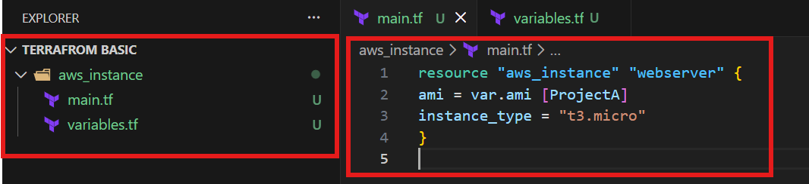

In Variables.tf
variable "ami" {
type = map(string)
description = "A map of AMI IDs for different regions"
default = {
"ProjectA" = "ami-0532be01f26a3de55"
"ProjectB" = "ami-0532be01f26a3de55"
}
}

One new workspace created named dev
Command- terraform workspace new dev
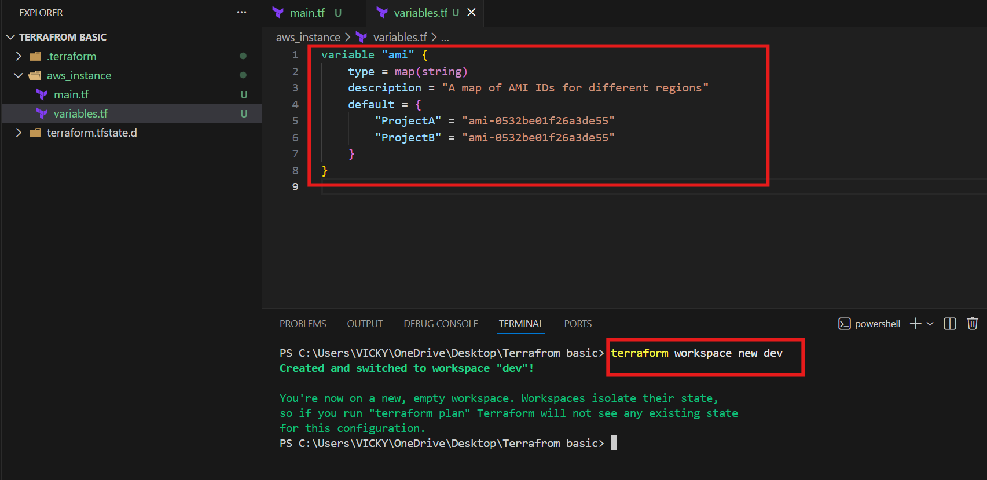
We can see dev workspace is created and switched to dev.
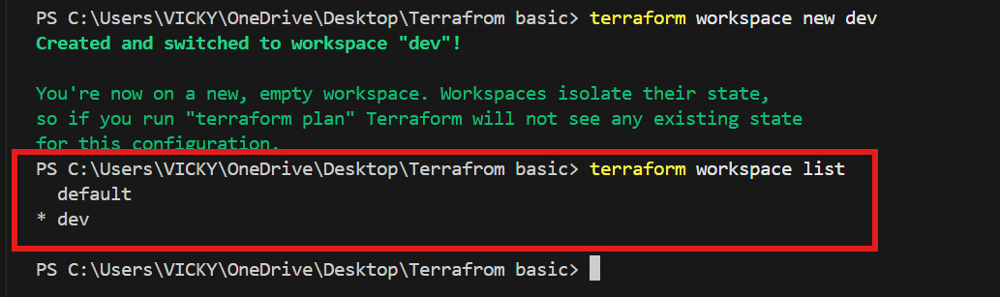
We can verify in the directory that, one new terraform.tfstate.d\dev has been created.
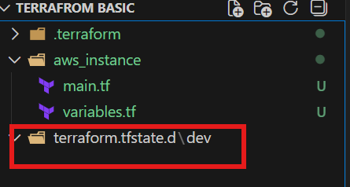
We initialized after saving the script updated to launch a new ec2 instance for development.
cd .\aws_instance\ to checkout to directory.
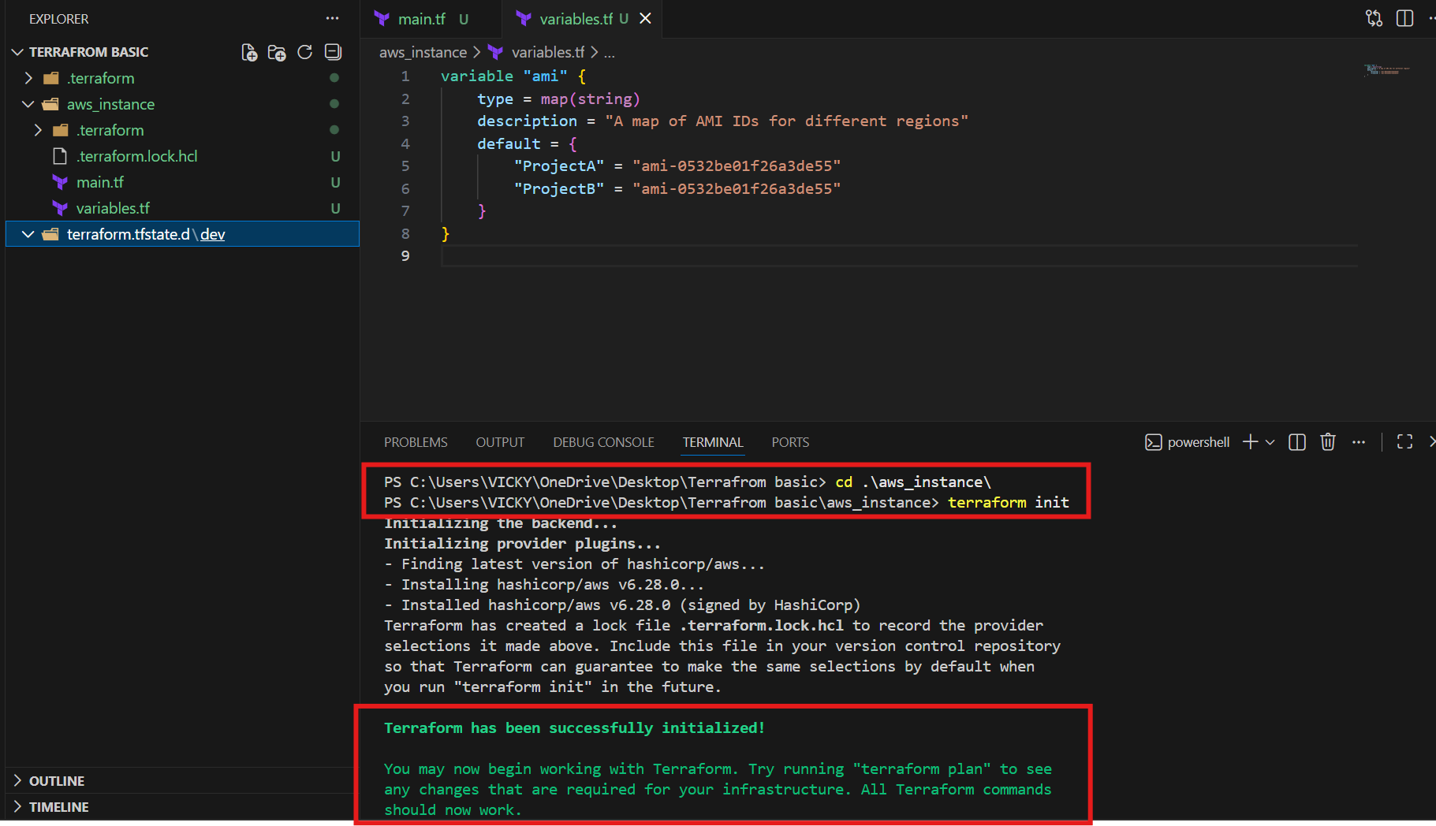

Terraform apply
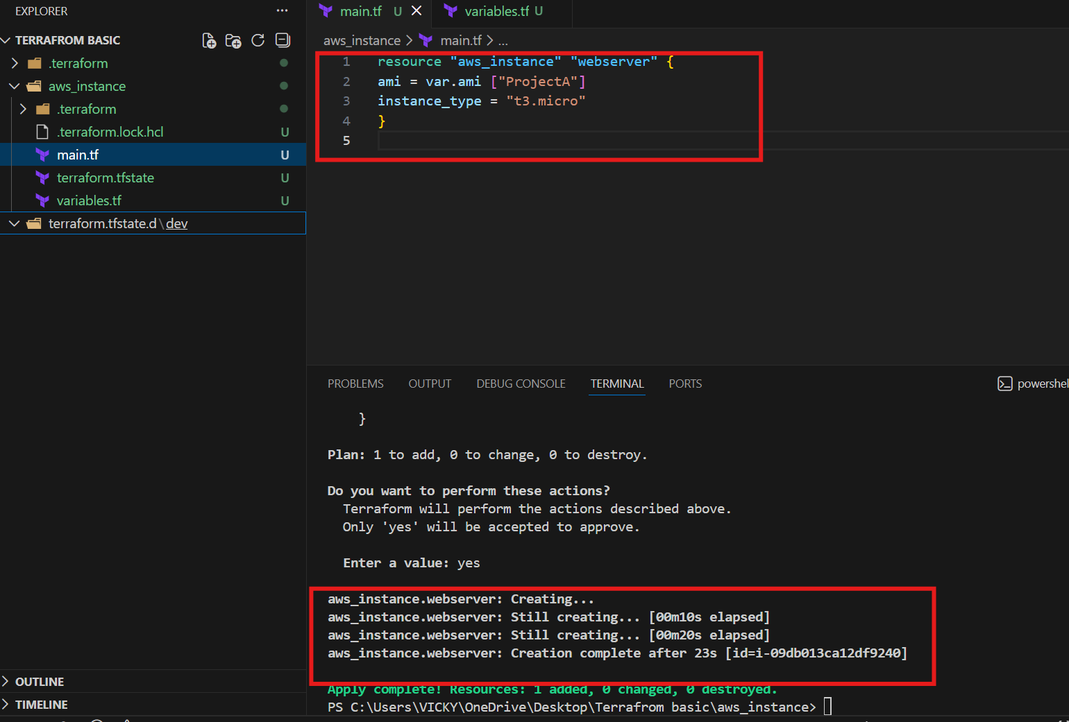

Let’s verify in the aws instances
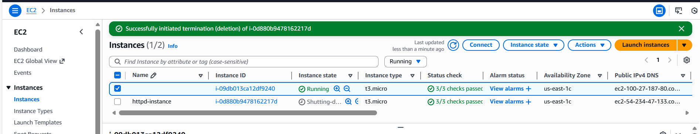

2. Provision EC2, S3, and VPC using Terraform modules.

Created a directory aws_instance and two files- main.tf and variables.tf

Paste the Syntax in main.tf

terraform {
required_version = ">= 1.3.0"

required_providers {
aws = {
source = "hashicorp/aws"
version = "~> 5.63"
}
}
}

provider "aws" {
region = "us-east-1"
}

module "vpc" {
source = "terraform-aws-modules/vpc/aws"
version = "5.1.2"
name = "my-vpc"
cidr = "192.168.0.0/20"
azs = ["us-east-1a", "us-east-1b", "us-east-1c"]
public_subnets = ["192.168.1.0/28", "192.168.2.0/28", "192.168.3.0/28"]
private_subnets = ["192.168.4.0/28", "192.168.5.0/28", "192.168.6.0/28"]

enable_dns_hostnames = true
enable_nat_gateway = true
single_nat_gateway = true

tags = {
Terraform = "true"
Environment = "dev"
}
}

module "ec2" {
source = "terraform-aws-modules/ec2-instance/aws"
version = "4.5.0"

name = "terraform provisioned EC2 instance"
ami = "ami-0532be01f26a3de55"
instance_type = "t3.micro"

subnet_id = module.vpc.public_subnets[0]
associate_public_ip_address = true

vpc_security_group_ids = [module.vpc.default_security_group_id]

tags = {
Terraform = "true"
Environment = "dev"
}

}

module "s3" {
source = "terraform-aws-modules/s3-bucket/aws"
version = "3.7.0"

bucket = "vicky-007-terraform-techiehorizon"
tags = {
Terraform = "true"
Environment = "dev"
}

}

output "vpc_id" {
value = module.vpc.vpc_id

}
output "ec2_public_ip" {
value = module.ec2.public_ip
}
output "s3_bucket_name" {
value = module.s3.s3_bucket_id
}

Cd directory to aws_instance

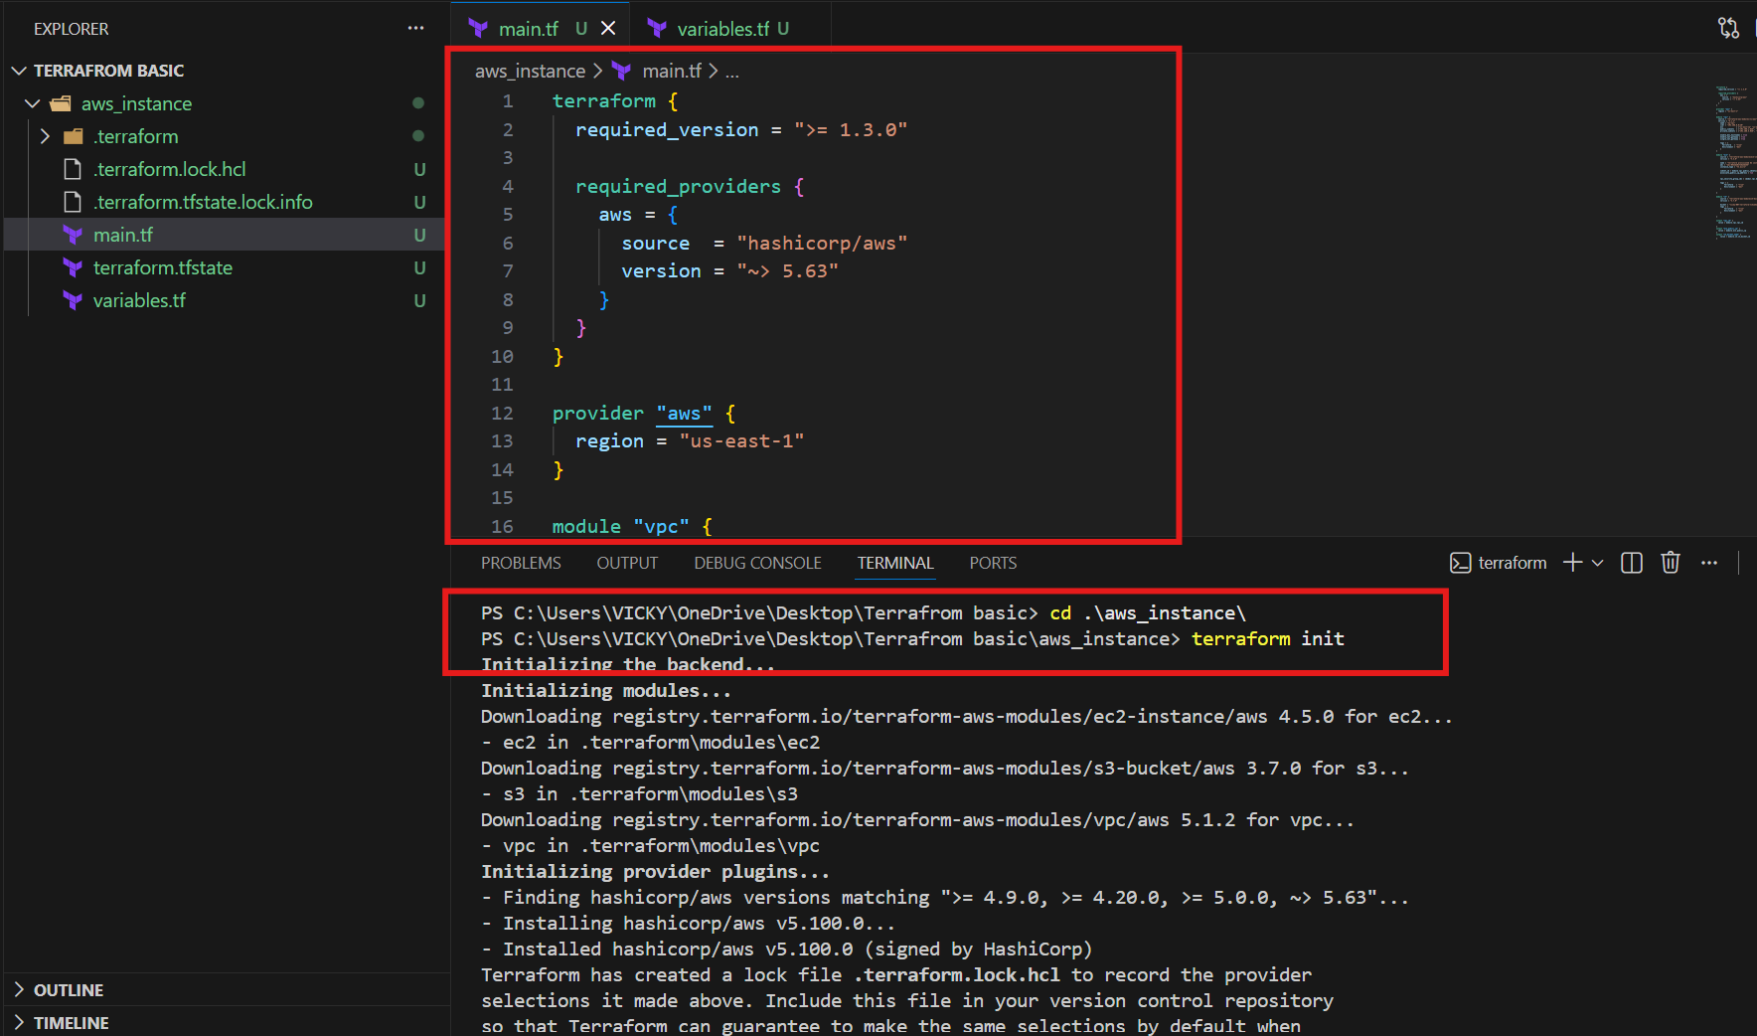
Terraform apply
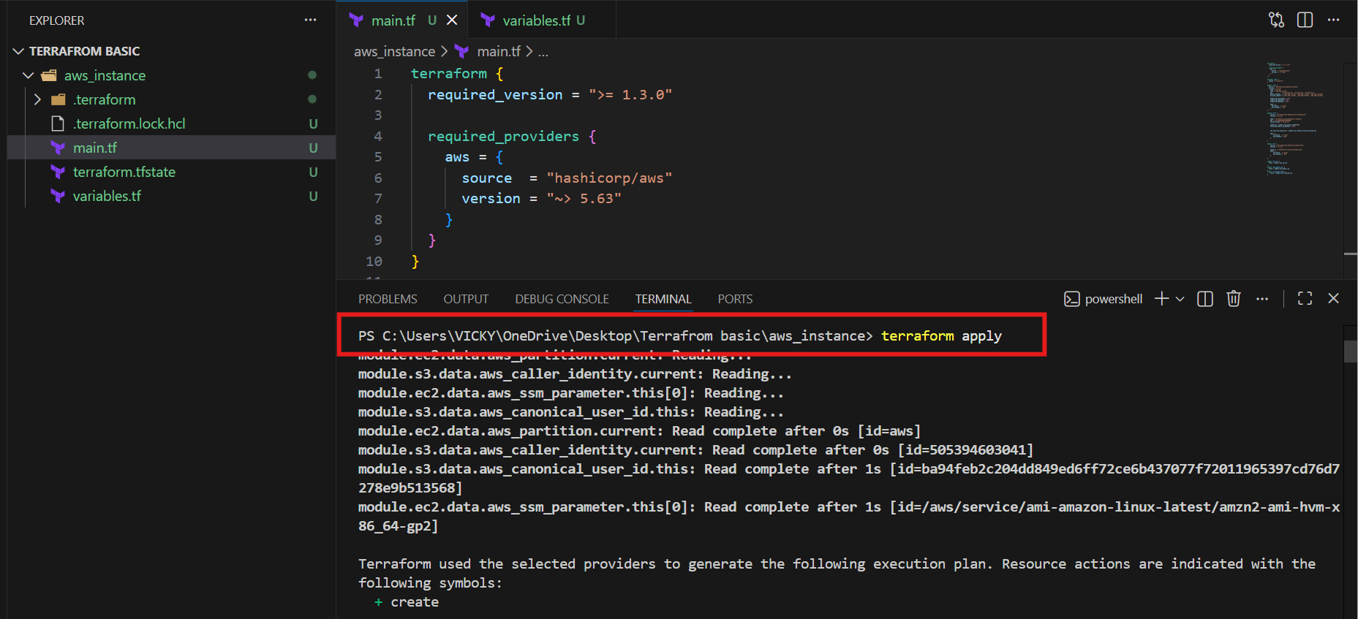

We can see that, 26 added and we shall verify if all 3 VPC’s, ec2 and s3 created.
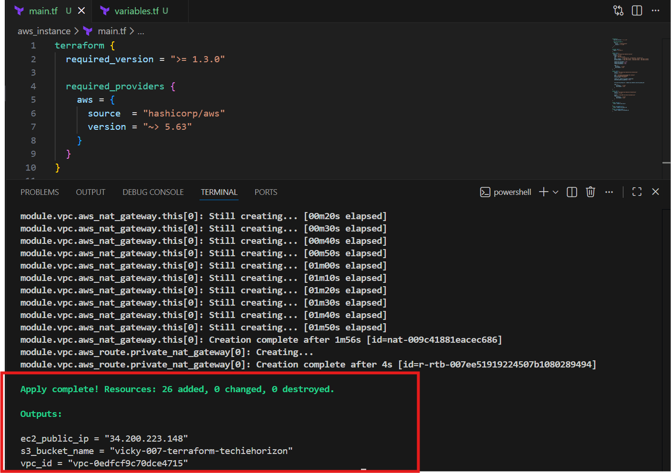

Ec2:
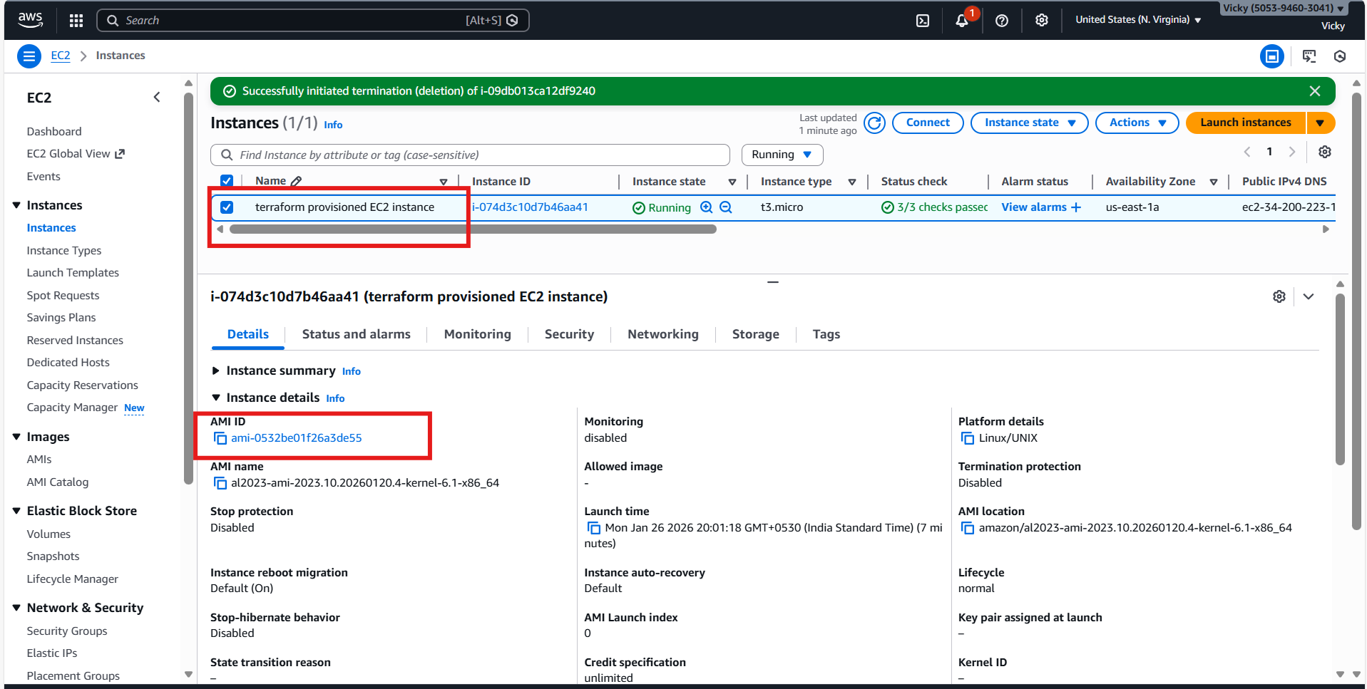

VPC
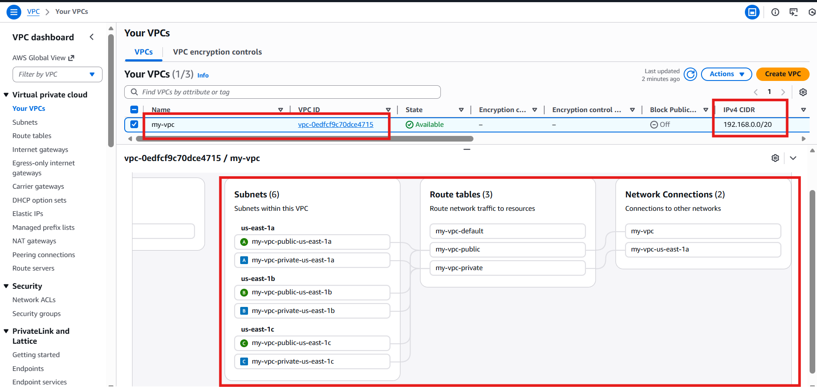
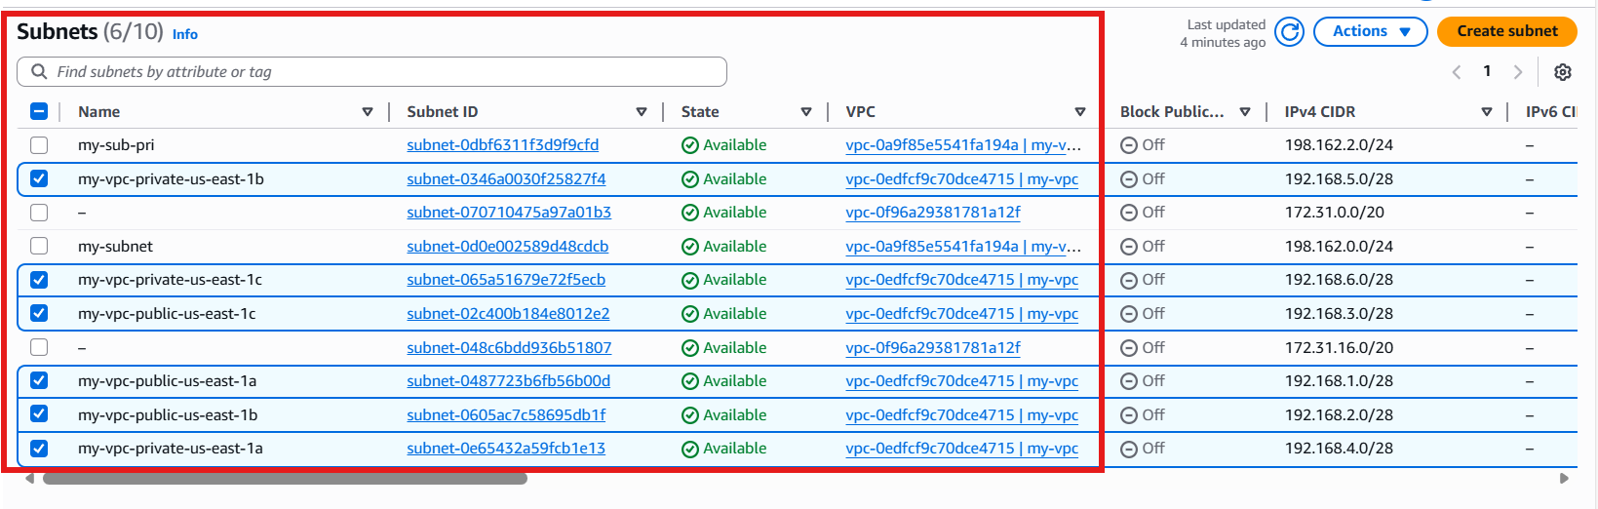
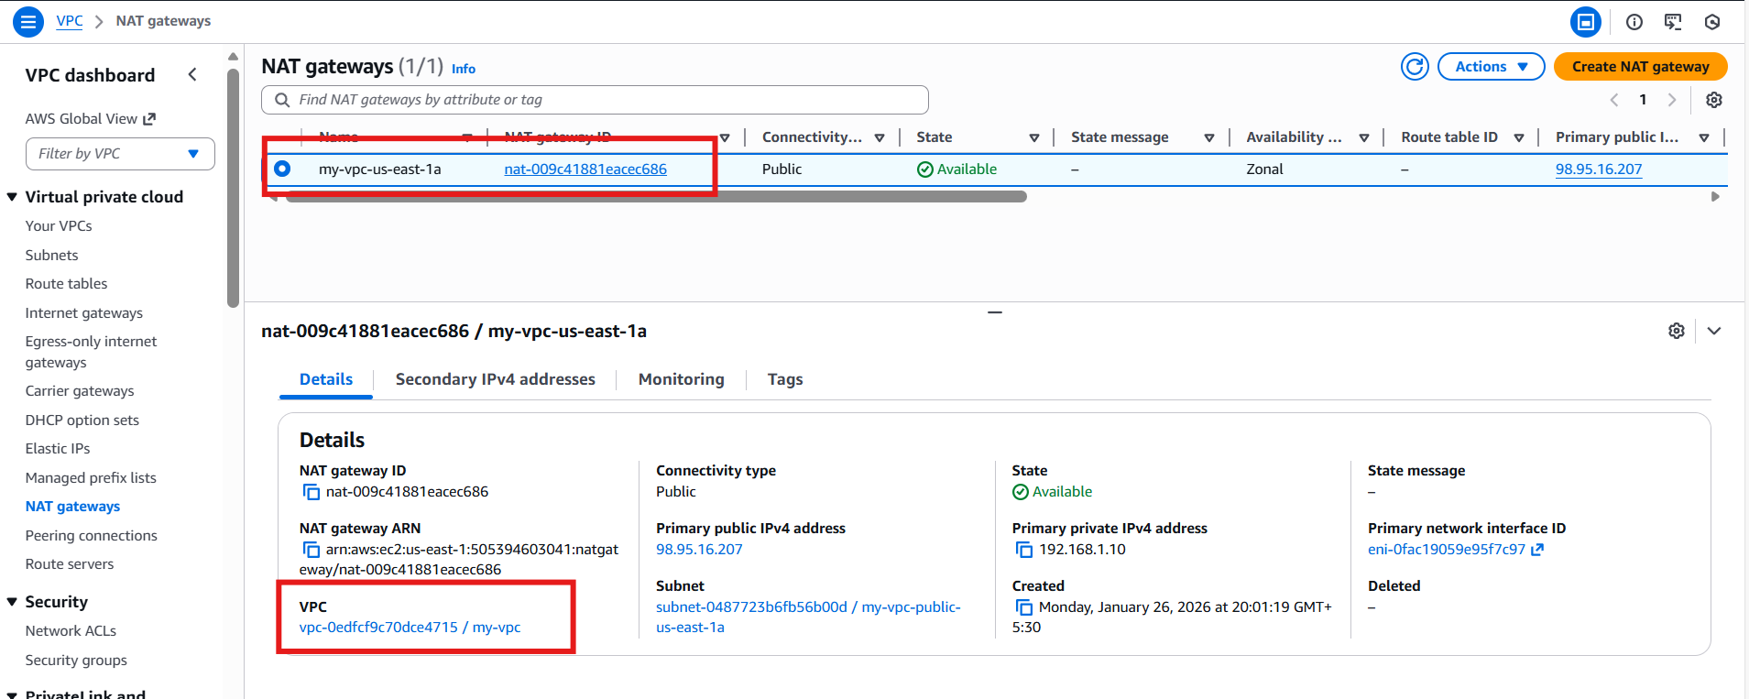

S3
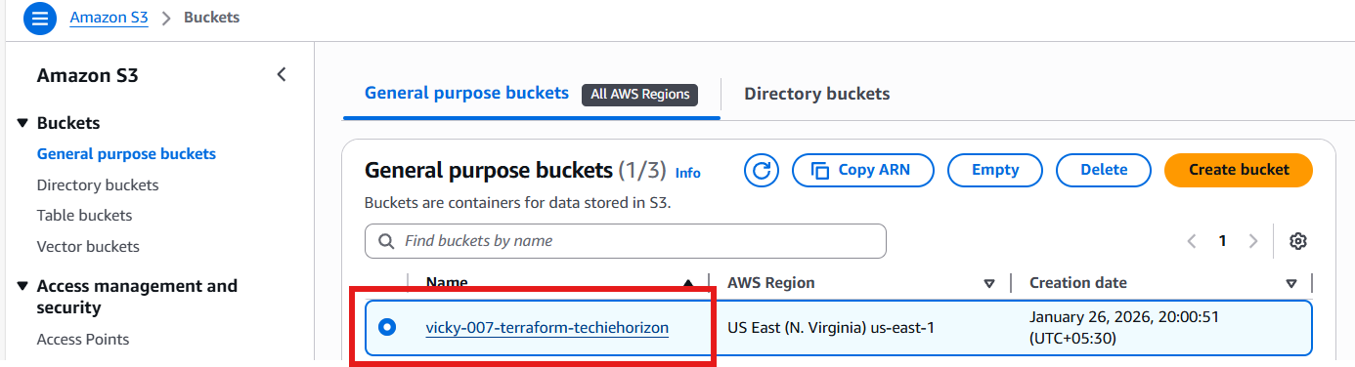

Task Completed

3. Provision EC2 for 3 different environments (Dev, Staging, and Prod) using Terraform workspaces.

Syntax:

terraform {
required_version = ">= 1.3.0"
required_providers {
aws = {
source = "hashicorp/aws"
version = "~> 5.63"
}
}
}
provider "aws" {
region = "us-east-1"
}
locals {
env = terraform.workspace
instance_type_map = {
dev = "t3.micro"
staging = "t3.small"
prod = "t3.medium"
}
instance_name_map = {
dev = "dev-ec2"
staging = "staging-ec2"
prod = "prod-ec2"
}
}
# Default VPC
data "aws_vpc" "default" {
default = true
}
# Default Subnet
data "aws_subnets" "default" {
filter {
name = "vpc-id"
values = [data.aws_vpc.default.id]
}
}
# Security Group
resource "aws_security_group" "sg" {
name = "${local.env}-sg"
description = "Security group for ${local.env} "
vpc_id = data.aws_vpc.default.id
tags = {
environment = local.env
}
}
# EC2 Instance
resource "aws_instance" "app" {
ami = "ami-0532be01f26a3de55"
instance_type = local.instance_type_map[local.env]
subnet_id = data.aws_subnets.default.ids[0]
vpc_security_group_ids = [aws_security_group.sg.id]
tags = {
Name = local.instance_name_map[local.env]
environment = local.env
}
}
output "environment" {
value = local.env
}
output "instance_type" {
value = aws_instance.app.instance_type
}
output "public_ip" {
value = aws_instance.app.public_ip
}

Terraform init

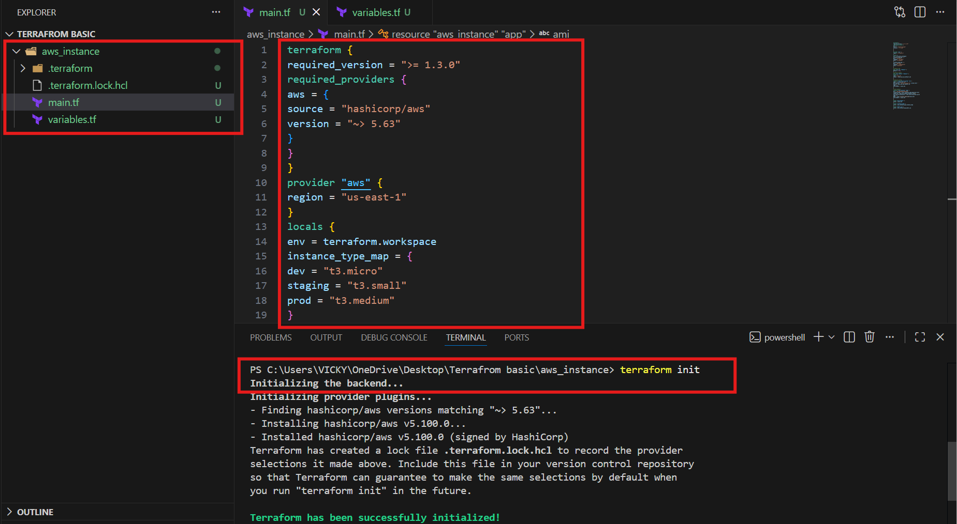

Now, create a workspace
1st let’s start with dev environment

Command- terraform workspace new dev
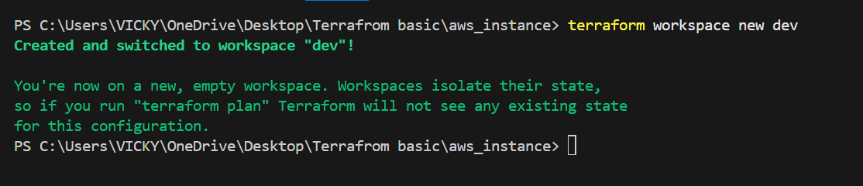

- Dev ec2 instance created with default vpc, default subnets, default security groups.
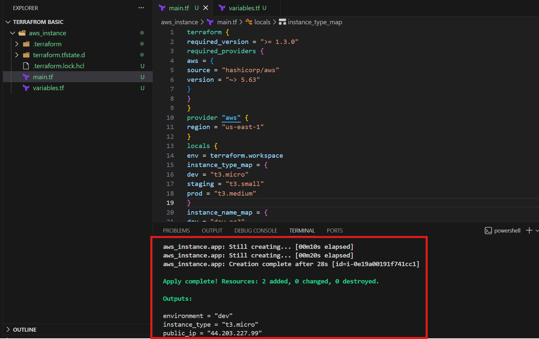

Verified in aws ec2 instances
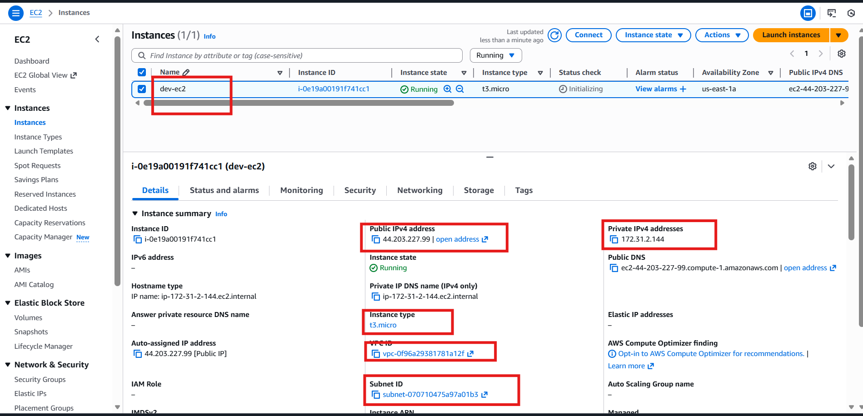

Security groups created as well.
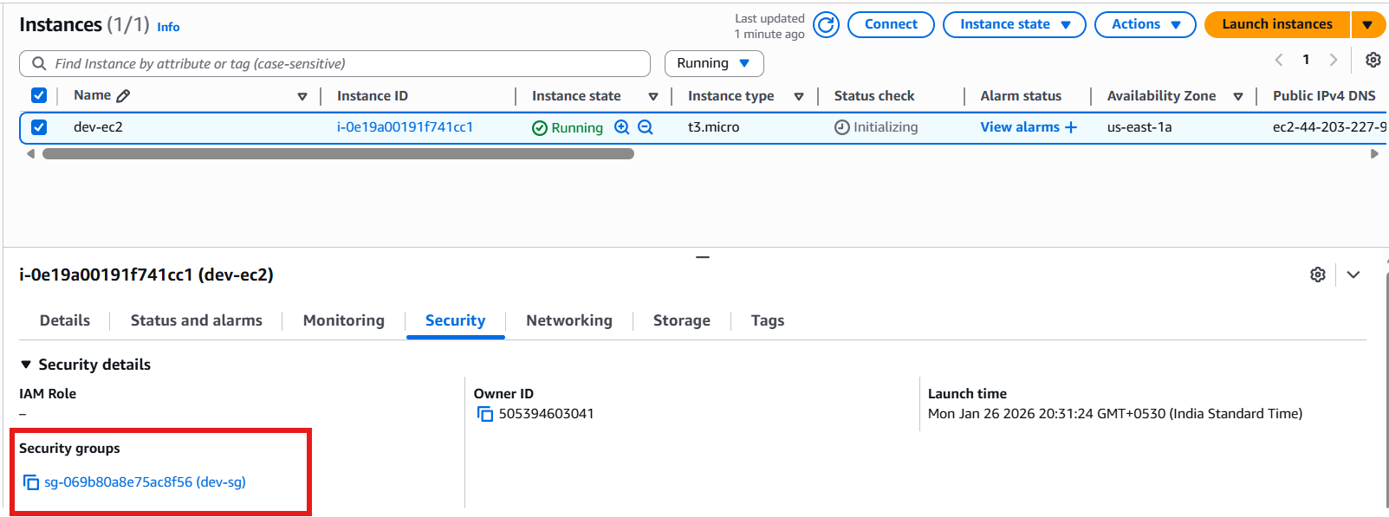

Same steps repeat for other environments.
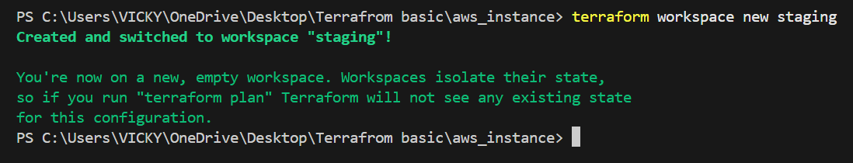
Instance created in staging environment.
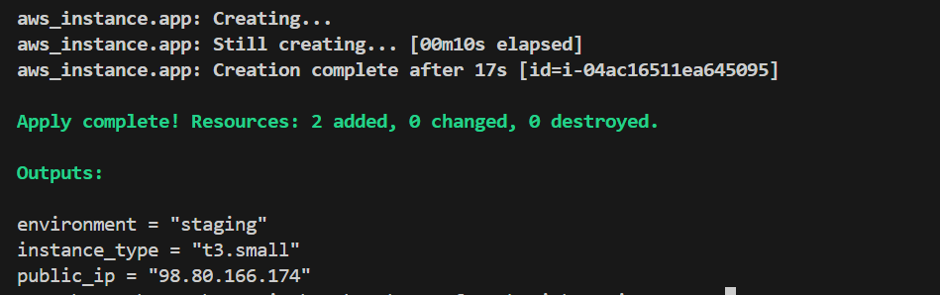

Verify in ec2 instances
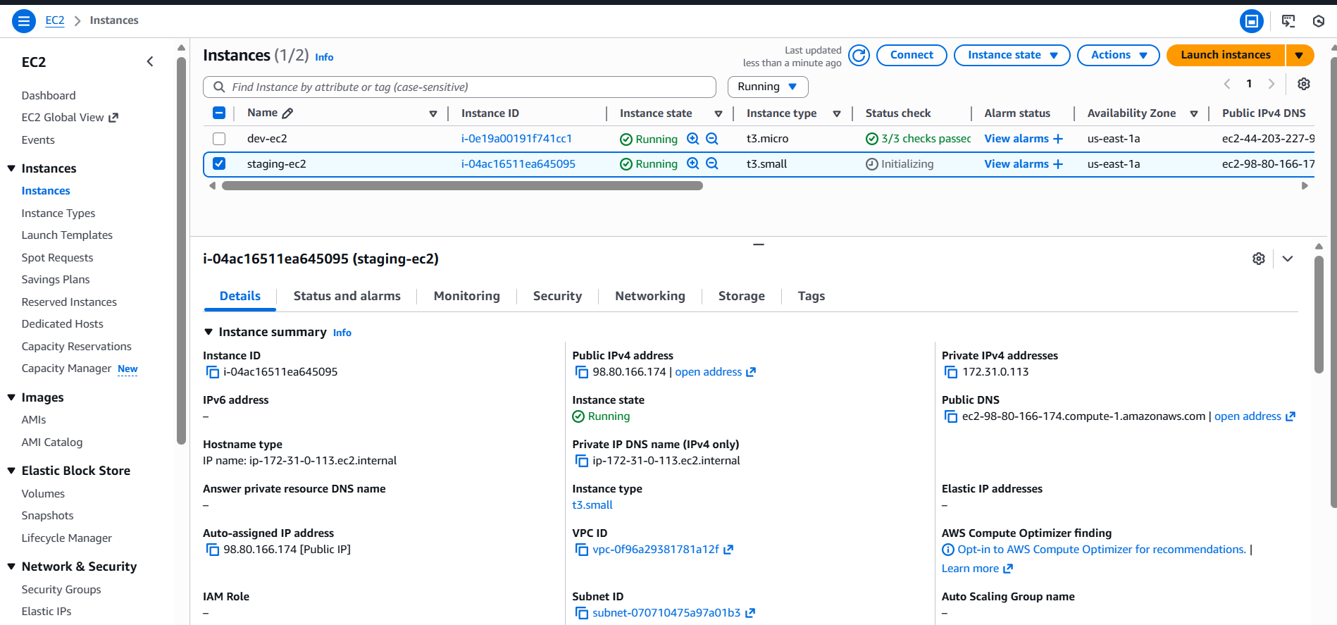

Let’s complete creating in prod environment
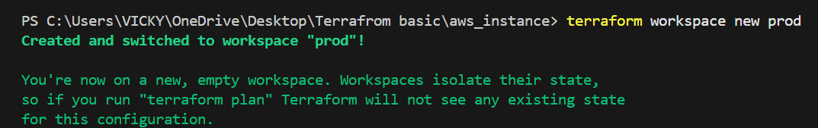
Prod ec2 created successfully.
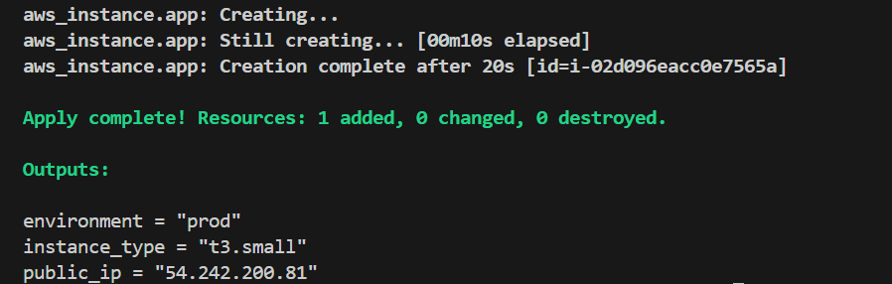

Verified in ec2 instances as well.
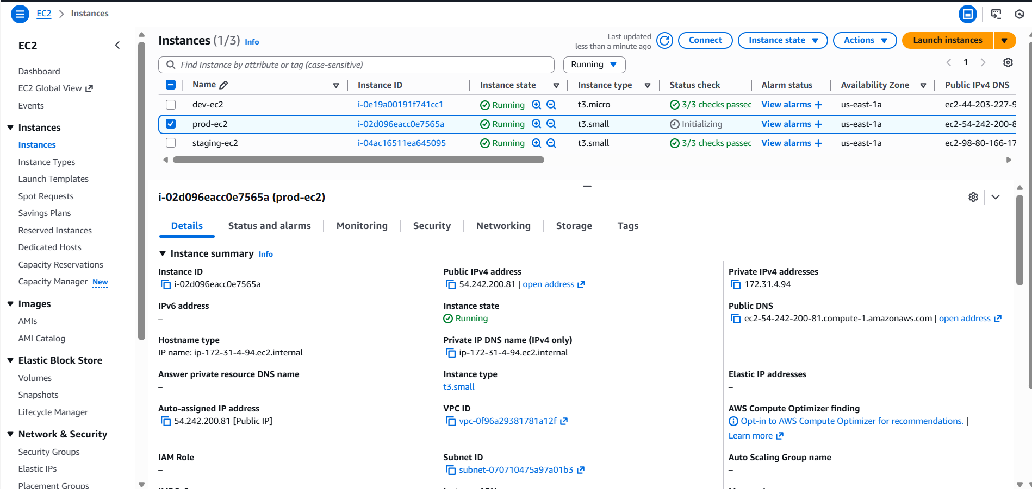

Let’s verify all environments present in cli
Command- terraform workspace list
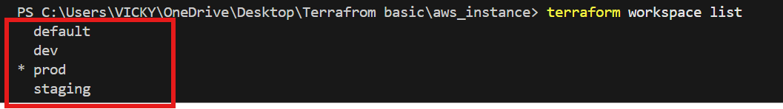

Task completed successfully.

