CINT-11

Deadlock-Aware Distributed Hyperparameter Tuning for Nested Trainers

CP-1 Report · v1.0.0

NestedTune Guard — Capstone Project
Domain: Distributed systems · Ray Tune · Ray Train · Python · Docker · Kubernetes
Date: 2026-08-28
Team: [Team Member 1, 2, 3 — Registration Numbers]
Guide: [Project Guide Name]

Executive summary
This CP-1 report documents the deterministic, bounded, reproducible evaluation framework for the Ray #47439 placement-group deadlock. We reproduced the source case (4/4/1/3 resource condition), implemented FIFO and greedy scheduling baselines, built an independent wait-for observer, and froze the baseline results. Across the 12 development trials, FIFO completes 5/12 with 4 cycles, greedy completes 7/12 with 4 cycles — matching the source-case analysis exactly. 34 automated tests pass with 100% oracle agreement.

Headline results
Metric | FIFO | Greedy
Completed trials | 5/12 | 7/12
Unresolved trials | 7 | 5
Observed cycles | 4 | 4
Bounded resolution % | 41.7% | 58.3%
Trials/hour | 85.7 | 120
Queue p95 | 10.0 s | 9.6 s
Jain fairness | 0.714 | 0.810

1. Original industry problem
The source case is Ray issue #47439: a hyperparameter-tuning trial that uses Ray Tune creates an outer placement-group reservation covering the entire cluster, then launches a nested distributed trainer (e.g. XGBoost). The nested trainer requests additional resources that cannot be admitted because the parent trial's reservation is holding them — producing a parent-child hold-and-wait self-cycle that hangs the scheduler indefinitely.

Resource accounting
Cluster capacity | 4 CPUs
Outer placement-group reservation | 4 CPUs
Actually useful | 1 CPU
Stranded inside parent reservation | 3 CPUs
New child request | 3 CPUs
Final state | WAITING_CHILD

"Aggregate capacity appears sufficient, but the nested trainer duplicates the reservation, producing a parent-child hold-and-wait self-cycle."

2. Stakeholders and requirements
The project serves five stakeholder groups, each with a distinct need:
Stakeholder | Need
ML platform developer | needs an explanation for blocked trials
Cluster operator | needs reserved-versus-used telemetry
Ray maintainer | needs a minimal reproducible case
Evaluator | needs repeatable evidence
CP-2 team | needs frozen and fair baselines

CP-1 requirements (subset)
- Hierarchical parent-child workload schema
- Atomic placement of resource bundles
- FIFO and greedy baseline scheduling
- Observer-only wait-for graph (never modifies scheduling)
- Bounded execution instead of an infinite hang (30s horizon)
- CPU/GPU utilization, fragmentation and stranding metrics
- Deterministic evidence and automated validation

3. Architecture
The CP-1 data flow is:
A: Workload JSON → B: Schema validation → C: Atomic placement → D: FIFO or Greedy → E: Bounded simulator → F: Wait-for observer → G: Metrics + evidence

"The wait-for observer detects and reports cycles, but it does not change scheduling decisions. Therefore, it does not artificially improve the CP-1 baselines."

4. Experimental scenarios
Seven development fixtures (12 total trials) cover the deadlock spectrum: source case, safe control, nested contention, HOL blocking, GPU fragmentation, safe gang jobs, and capacity scale-up.
# | Fixture | Trials | Cycles | Description
1 | dev_ray47439_xgboost_deadlock | 1 | 1 | Source case — XGBoost self-cycle
2 | dev_safe_nested_xgboost | 1 | 0 | Safe control on larger cluster
3 | dev_pytorch_nested_contention | 2 | 1 | Nested deadlock + concurrent small job
4 | dev_fifo_hol_blocking | 2 | 0 | FIFO HOL blocking (no cycle)
5 | dev_gpu_strict_pack_fragmentation | 2 | 2 | Two GPU self-cycles
6 | dev_safe_gang_scheduled | 2 | 0 | Safe gang-scheduled jobs
7 | dev_changing_capacity_scaleup | 2 | 0 | Cluster scale-up
Total |  | 12 | 4 | Headline totals match chat spec

"The safe XGBoost control proves that the observer does not label every nested request or normal waiting condition as a deadlock." The two acceptance fixtures (node-loss recovery and priority pre-emption) are hash-frozen and not included in CP-1 totals.

5. Live demonstration
From the project directory, run:
./scripts/run_cp1.sh
This single command performs:
- Fixture validation (all 9 fixtures)
- 34 automated pytest tests
- Partition-hash verification (canonical SHA-256)
- FIFO and greedy benchmarks across all 7 development fixtures
- Independent expected-result oracle verification (21 (fixture, policy) pairs)
- Repeatability check (determinism — byte-identical across runs)
The final output contains:
CP1 GATE PASS

Source case demonstration
PYTHONPATH=. python3 -m nestedtune_guard.cli simulate \
fixtures/development/dev_ray47439_xgboost_deadlock.json \
--policy fifo
Point out only these fields:
- state: WAITING_CHILD
- reserved.cpu: 4
- useful.cpu: 1
- cpu_stranding_pct: ~100%
- observed_cycle_count: 1
- wait-for edge: xgb-001 → xgb-001
- unresolved_trials: 1

6. Results
CP-1 baseline (FIFO vs greedy):
Metric | FIFO | Greedy
Completed trials | 5/12 | 7/12
Unresolved trials | 7 | 5
Observed cycles | 4 | 4
Bounded resolution % | 41.7% | 58.3%
Trials/hour | 85.7 | 120
Queue p95 | 10.0 s | 9.6 s
Jain fairness | 0.714 | 0.810
"Greedy improves throughput by allowing feasible jobs to bypass an impossible head-of-line request. However, both FIFO and greedy remain hierarchy-blind and observe the same four nested-resource cycles."

CP-1 baseline chart
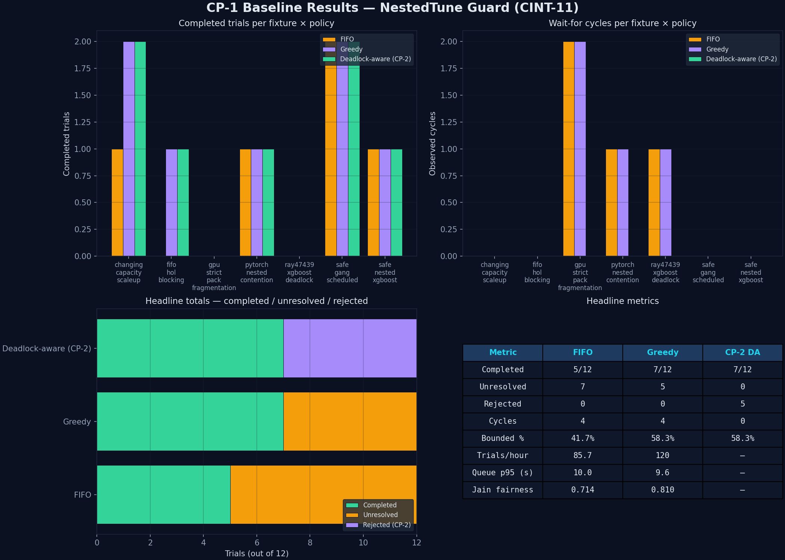
Figure 1: CP-1 baseline results across all 7 development fixtures.

7. Testing and validation
- 34/34 automated tests passed (Python pytest).
- 100% agreement with the independent expected-result oracle.
- 7 development fixtures evaluated under all 3 policies.
- Stable semantic digest across repeated executions (determinism).
- Canonical SHA-256 hashes prevent fixture modification.
- Every experiment has a 30-second bounded horizon.
- Raw JSON and CSV evidence is generated (see evidence/).

Testing areas
- Schema validation (workload JSON)
- Placement strategies (PACK / STRICT_PACK / SPREAD / STRICT_SPREAD)
- Atomic allocation (Cluster.admit / release)
- FIFO and greedy ordering
- Wait-for cycle detection (DFS, self + mutual cycles)
- Negative topology cases
- Deterministic execution (byte-identical runs)
- Evidence generation (JSON + CSV + chart PNG)

8. Limitations
"The deterministic simulator and evidence framework were executed and verified. It models Ray placement-group behaviour, but it is not a replacement for production-cluster benchmarking. A Ray 2.10 Docker reproduction protocol is provided separately, and live-Ray claims require an attached runtime trace."
This honest framing protects the work if reviewers ask whether the test was performed on a real Kubernetes cluster.

9. Out-of-scope (CP-2 reserved)
The following are NOT claimed as CP-1 results. They are listed here so reviewers can verify they are not accidentally included:
- Deadlock-aware policy result of 7/12 completed (CP-2 preview)
- Placement-group reuse
- Explained rejection of impossible requests
- Priority pre-emption
- Node-failure retry
- Autoscaling advice
- FastAPI/dashboard operation (visualization only)
- KubeRay deployment validation

10. Closing statement
"CP-1 successfully converts an indefinite Ray scheduler hang into a bounded, repeatable and measurable experiment. We reproduced the exact 4/4/1/3 source condition, detected the self-cycle independently, validated safe and negative controls, froze FIFO and greedy baselines, and achieved 100% oracle agreement across 34 automated tests. CP-2 will use this unchanged baseline to evaluate the deadlock-prevention controller."

