Optimizing User, Group, and Role Management in ServiceNow for Agile Projects

**Project Overview:**

The project **User, Group, and Role Management with Access Control and Workflows** was developed to address inefficiencies in task accountability and access control within a small project management team. The team consists of a Project Manager (Alice) and a Team Member (Bob), both of whom require clear role definitions and structured workflows to manage tasks effectively.

Without proper access control and workflow automation, task assignments become ambiguous, progress tracking is inconsistent, and accountability suffers. This project leverages ServiceNow’s capabilities to define roles, enforce permissions, and automate task lifecycle processes.

**Objectives:**

➢ To configure a ServiceNow instance tailored for small team project management

➢ To define and manage **Users**, **Groups**, and **Roles** for clear accountability

➢ To create custom **Task Assignment** and **Role Mapping** tables

➢ To implement **Access Control Lists (ACLs)** for secure, role-based data visibility

➢ To streamline task assignment and progress tracking with structured process flows

➢ To ensure modular deployment and version control using **Update Sets**

**Tools and Technologies Used:**

## **ServiceNow Platform Modules:**

➢ Platform: ServiceNow (Developer Instance)

➢ Modules Used: Users, Groups, Roles, Tables, Forms, ACLs,

Update Sets, Flow Designer

➢ Access Control: ACLs, Role-based Permissions, Application Access Settings

➢ Deployment: Update Sets for modular configuration migration

**Skills Used:**

➢ User & Group Configuration – Creating and managing users, assigning them to logical groups

➢ Role Definition & Assignment – Designing roles and mapping them to users/groups for RBAC

➢ Custom Table Creation – Building tables for task assignment, role mapping, and access tracking

➢ Form Design – Structuring forms for intuitive data entry and visibility control

➢ Access Control Lists (ACLs) – Implementing granular access rules based on roles and conditions

➢ Application Access Settings – Controlling cross-application visibility and permissions

➢ Workflow Automation – Designing task lifecycle flows using Flow Designer

➢ Client Scripts (JavaScript) – Automating field population and enforcing validation logic

➢ Update Sets – Packaging and migrating configurations across instances for modular deployment

➢ Process Flow Structuring – Defining task status transitions and approval checkpoints

# **Process Kick off:**

**Milestone 1: Creating Users in ServiceNow**

**Step 1: Access the Users Module**

* Open ServiceNow.
* In the left-hand navigation pane, click on All.
* Use the search bar to type Users.
* Under System Security, select Users.

**Step 2: Create a New User**

* Click the New button.
* Fill in the required user details (e.g., Name, User ID, Email, etc.).
* Click Submit to save the new user.

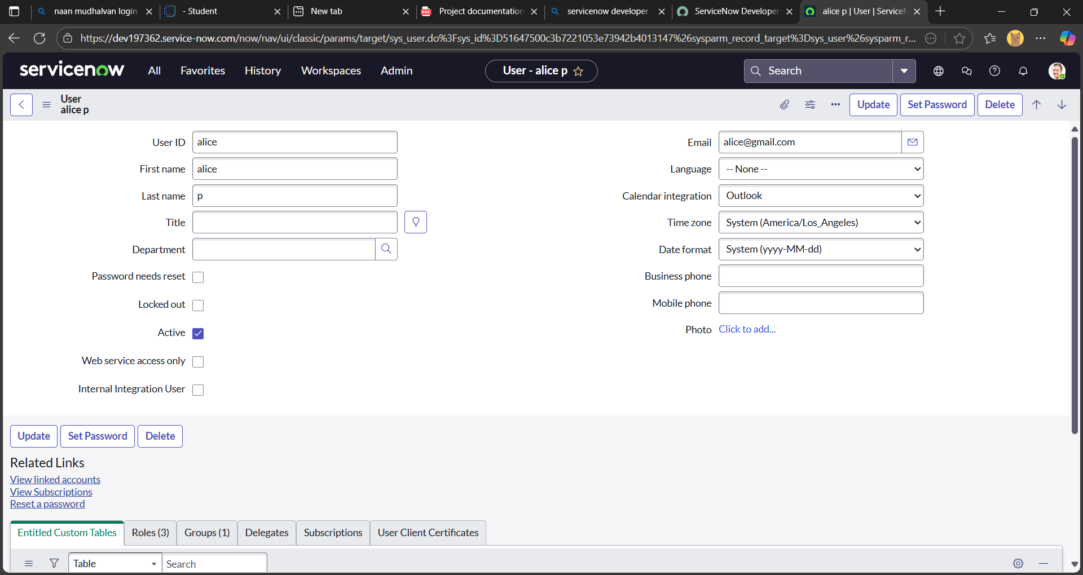

**Step 3: Create Another User**

* Repeat the process:
  + Click New again.
  + Enter the details for the second user.
  + **Click Submit.**

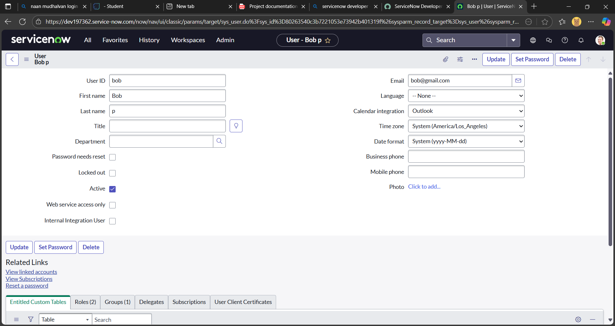

**Milestone 2: Creating Groups in ServiceNow**

**Step 1: Navigate to the Groups Module**

* Open ServiceNow.
* In the left-hand navigation pane, click on All.
* Use the search bar to type Groups.
* Under System Security, select Groups.

**Step 2: Create a New Group**

* Click the New button.
* Fill in the required group details (e.g., Name, Description, Manager, etc.).
* Click Submit to save the group.

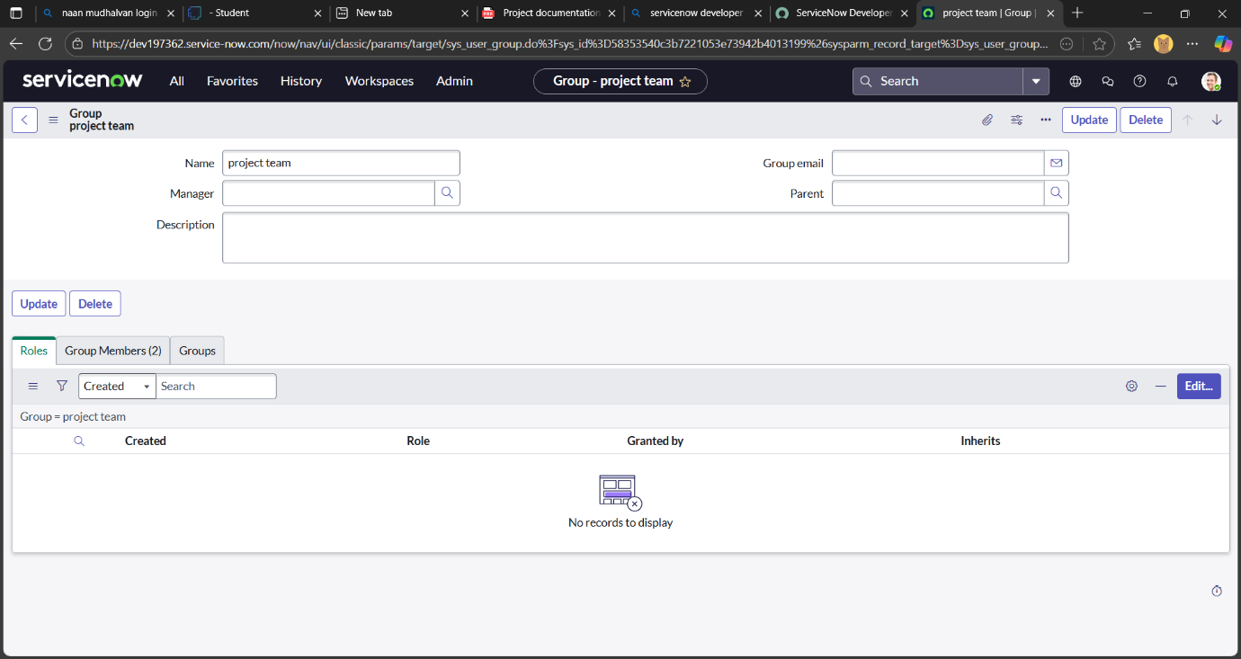

**Milestone 3: Creating Roles in ServiceNow**

**Step 1: Navigate to the Roles Module**

* Open ServiceNow.
* In the left-hand navigation pane, click on All.
* Use the search bar to type Roles.
* Under System Security, select Roles.

**Step 2: Create a New Role**

* Click the New button.
* Fill in the required role details (e.g., Name, Description, etc.).
* Click Submit to save the role.

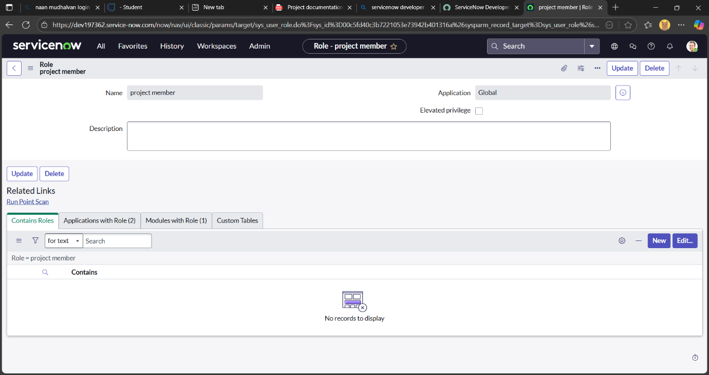

**Step 3: Create Another Role**

* Click New again.
* Enter the details for the second role:
  + Name: Team member
  + (Add other relevant fields as needed.)
* Click Submit.

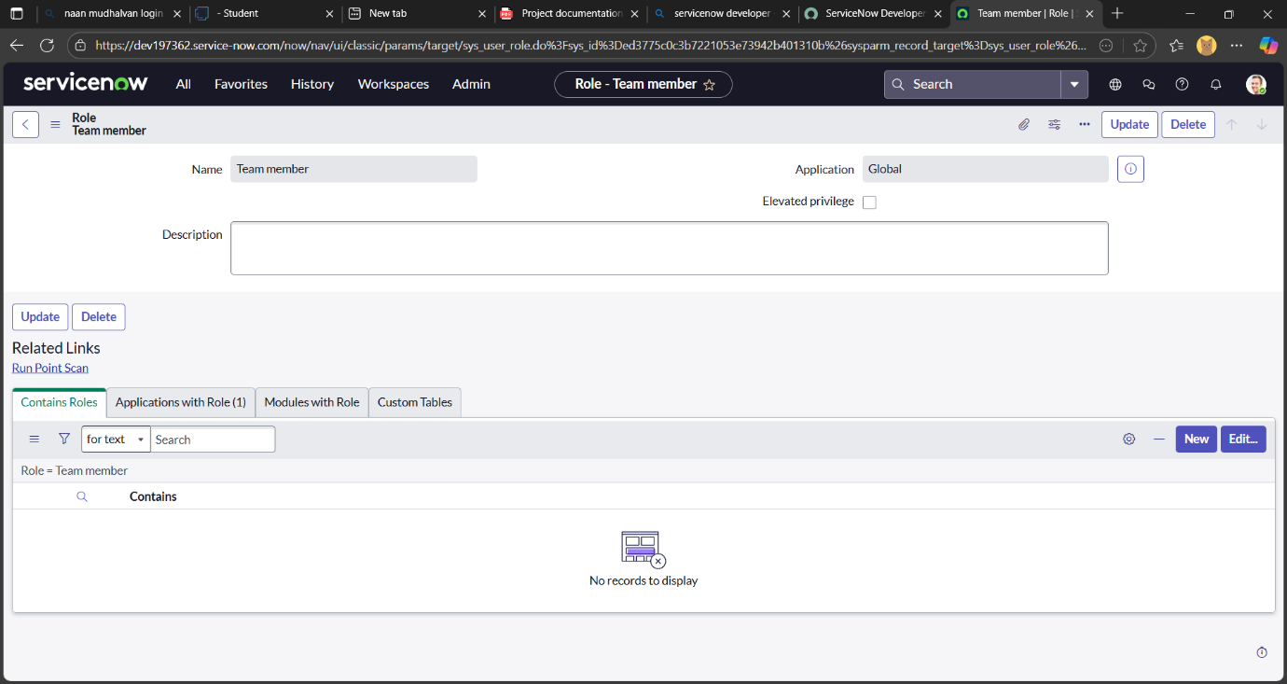

**Milestone 4: Creating Tables in ServiceNow**

**Step 1:** **Navigate to the Tables Module**

* Open ServiceNow.
* In the left-hand navigation pane, click on All.
* Use the search bar to type Tables.
* Under System Definition, select Tables.

**Step 2: Create the First Table – *Project Table***

* Click the New button.
* Fill in the following details:
  + Label: Project Table
  + Check the boxes:
    - Create module
    - Create mobile module
  + New Menu Name: Project Table
  + Under Table Columns, define the required columns (e.g., Project Name, Start Date, Status, etc.).
* Click Submit to save the table.

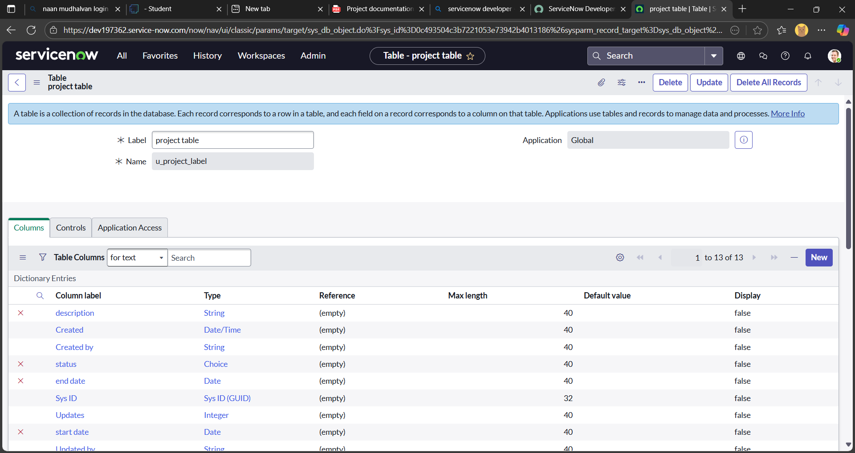

**Step 3: Create Another Table – *Task Table 2***

* Click New again.
* Fill in the following details:
  + Label: Task Table 2
  + (Repeat the same module and menu settings if needed.)
  + Add relevant columns under Table Columns (e.g., Task Name, Assigned To, Due Date, etc.).
* Click Submit to save the second table.

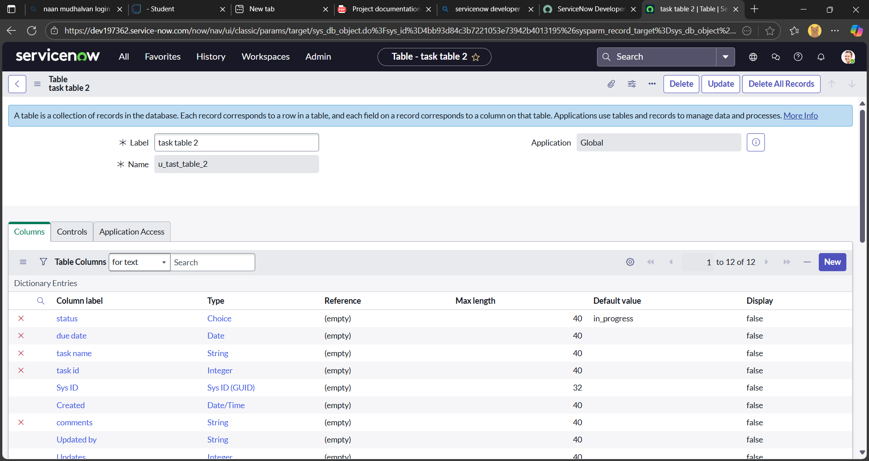

**Milestone 5: Assigning Users to the *Project Team* Group in ServiceNow**

**Step-by-Step Instructions:**

1. Open ServiceNow.
2. In the left-hand navigation pane, click on All.
3. Use the search bar to type Groups.
4. Under System Definition, select Groups.
5. Locate and select the group named Project Team.
6. Scroll down to the Group Members section.
7. Click Edit to modify the group membership.
8. In the user selection window, choose:
   * Alice P
   * Bob P
9. Click Save to confirm the changes**.**

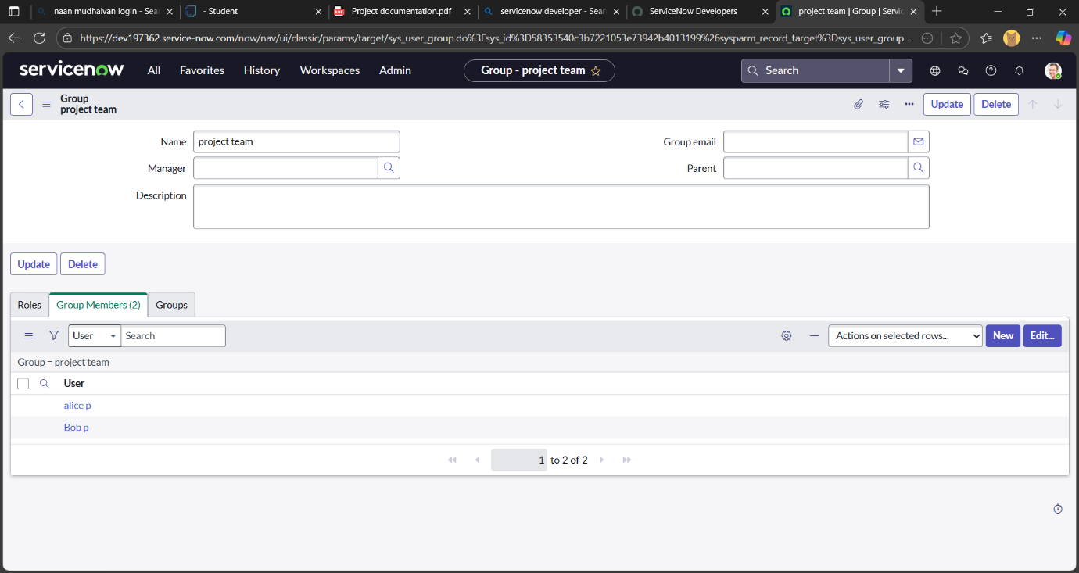

**Milestone 6: Assigning Roles to Users in ServiceNow**

**Assigning Roles to *alice p* in ServiceNow**

**Step-by-Step Instructions:**

1. Open ServiceNow.
2. In the left-hand navigation pane, click on All, then search for Users.
3. Under System Definition, select Tables (if you're navigating via table-level access).
4. Locate and select the user record for Alice (designated as *Project Manager*).
5. Scroll to the Roles section within the user profile.
6. Click Edit to modify role assignments.
7. In the role selection window:
   * Add the role: project_member
   * Click Save
8. Click Edit again to add custom roles:
   * Add: u_project_table
   * Add: u_task_table
9. Click Save and then Update the user form to finalize changes.

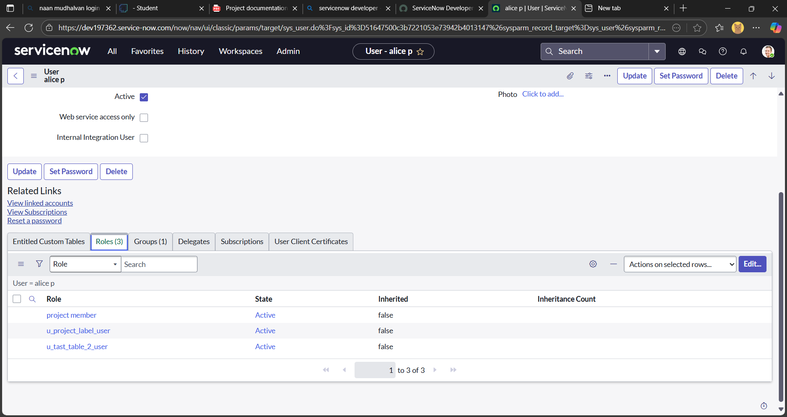

**Assigning Roles to *Bob P* in ServiceNow**

**Step-by-Step Instructions**

1. Open ServiceNow.
2. In the left-hand navigation pane, click on All, then search for Users.
3. Under System Definition, select Tables (if navigating via table-level access).
4. Locate and select the user record for Bob P.
5. Scroll to the Roles section within the user profile.
6. Click Edit to modify role assignments.
7. In the role selection window:
   * Add the role: team_member
   * Add relevant table access roles (e.g., u_task_table)
   * Click Save
8. Click on the Profile Icon and select Impersonate User → choose Bob P.
9. While impersonating Bob, verify that Task Table 2 is visible and accessible in the application navigator.

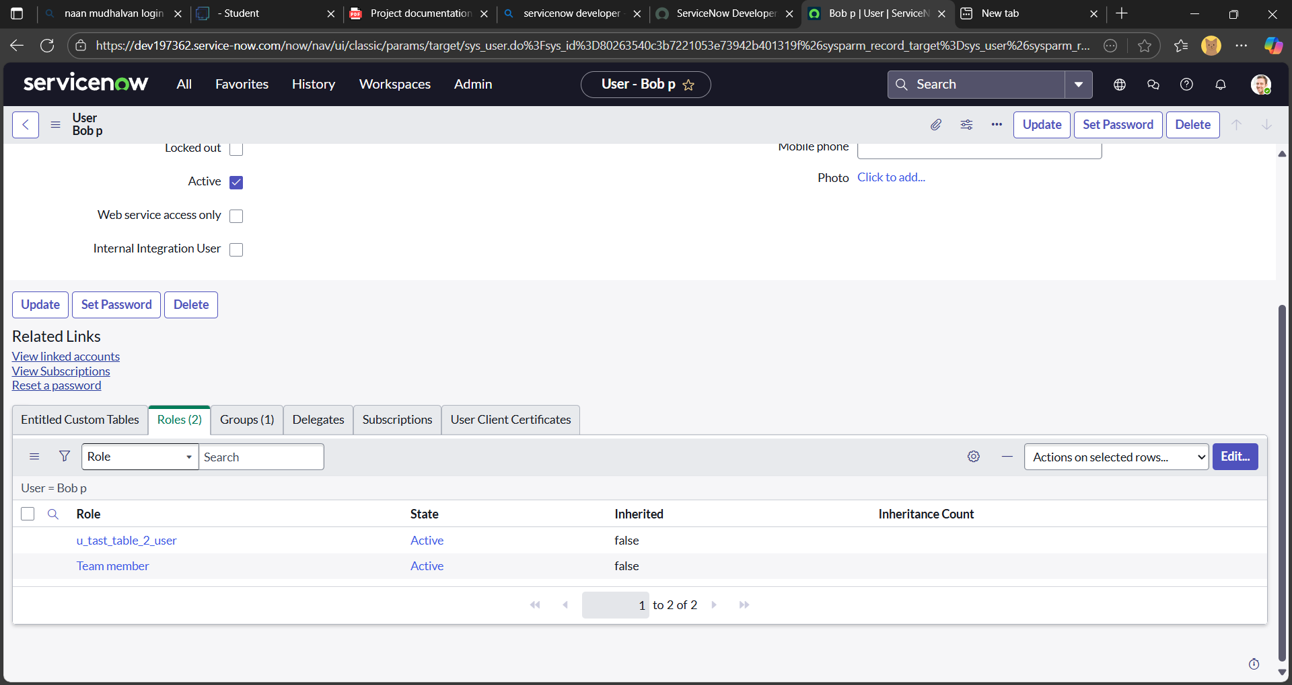

**Milestone 7: Assigning Table Access to Applications in ServiceNow**

**Context:**

When you create a new table in ServiceNow, it automatically generates:

* A **Scoped Application**
* A **Module** under that application

To ensure users with specific roles (like project_member or team_member) can access these tables via the application UI, you’ll need to edit the application and module settings.

**Step-by-Step Instructions**

**For the Project Table Application:**

1. **Open Application Navigator**.
2. Search for the **Project Table Application**.
3. Click on the **Edit Module**.
4. In the **Roles** field, add:
   * project_member
5. Save the module configuration.

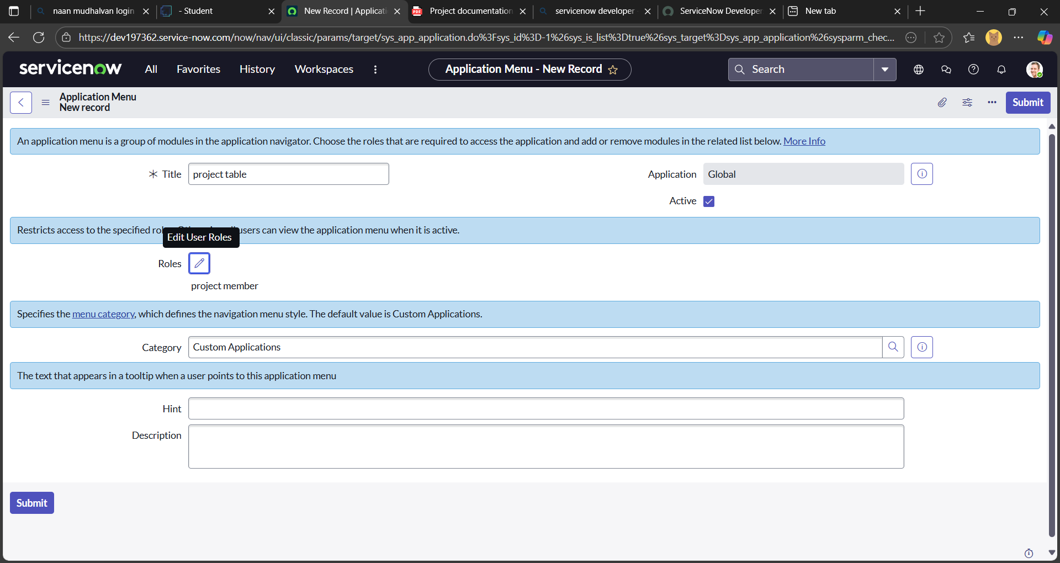

**For the Task Table 2 Application:**

1. Search for **Task Table 2** in the Application Navigator.
2. Click on **Edit Application**.
3. In the **Roles** section, assign:
   * project_member
   * team_member
4. Save the application settings.

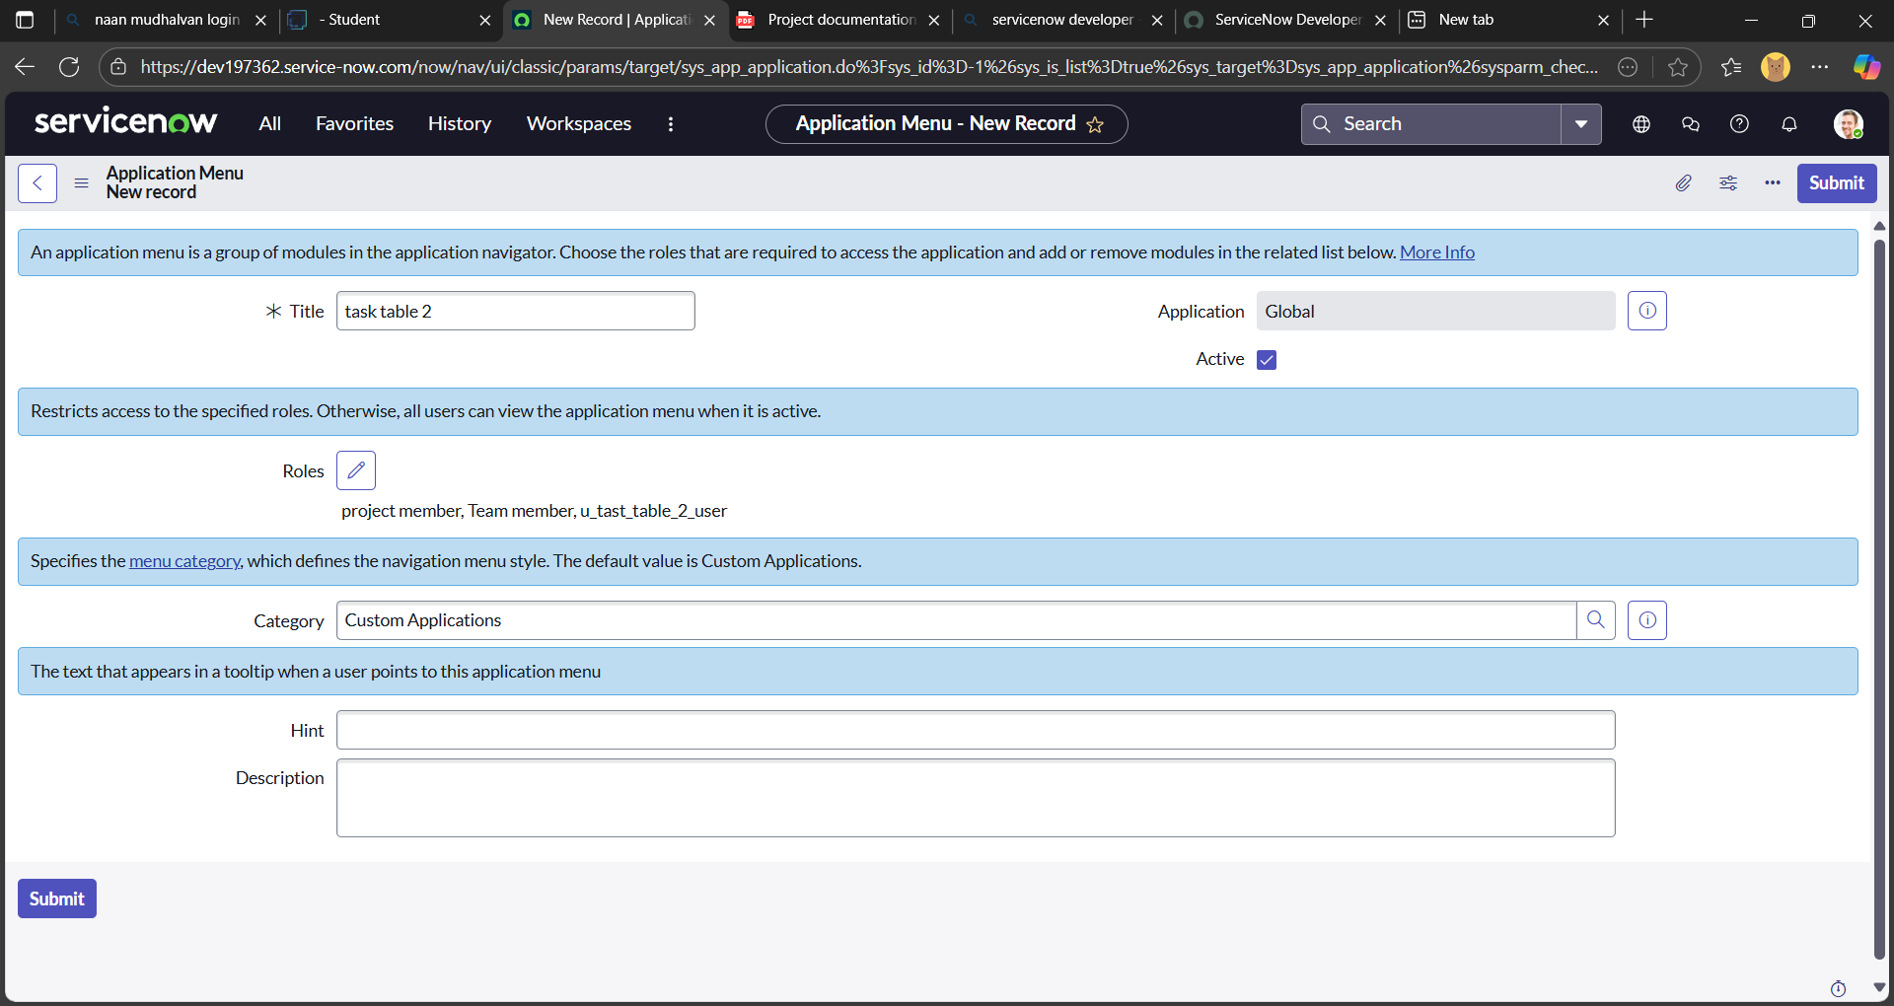

**Milestone 8: Creating ACLs for Task Table and Field-Level Access in ServiceNow**

**Step-by-Step Guide:**

1. Open ServiceNow.
2. In the Application Navigator, click on All, then search for ACL.
3. Select Access Control (ACL) under System Security.
4. Click Elevate Role to gain security_admin privileges.
5. Click New to create a new ACL.
6. Fill in the required details:
   * Set the Type to record.
   * Choose the Operation (e.g., read, write, create, or delete).
   * Set the Name to task or u_task_table2 depending on your scoped table.
7. Scroll down to the Requires Role section.
8. Double-click Insert a new row and add the team_member role.
9. Click Submit to save the ACL.

Next, repeat the process to create four additional ACLs for specific fields. For each one:

* Set the Type to field.
* Choose the appropriate Operation (typically write).
* Specify the field name (e.g., comment, status, etc.).
* Assign the team_member role under Requires Role.
* Submit each ACL individually.

Once all ACLs are created:

1. Click on the Profile Icon in the top-right corner.
2. Select Impersonate User and choose Bob P.
3. In the Application Navigator, go to All, then select Task Table
4. Open a record and verify that the Comment and Status fields are editable.

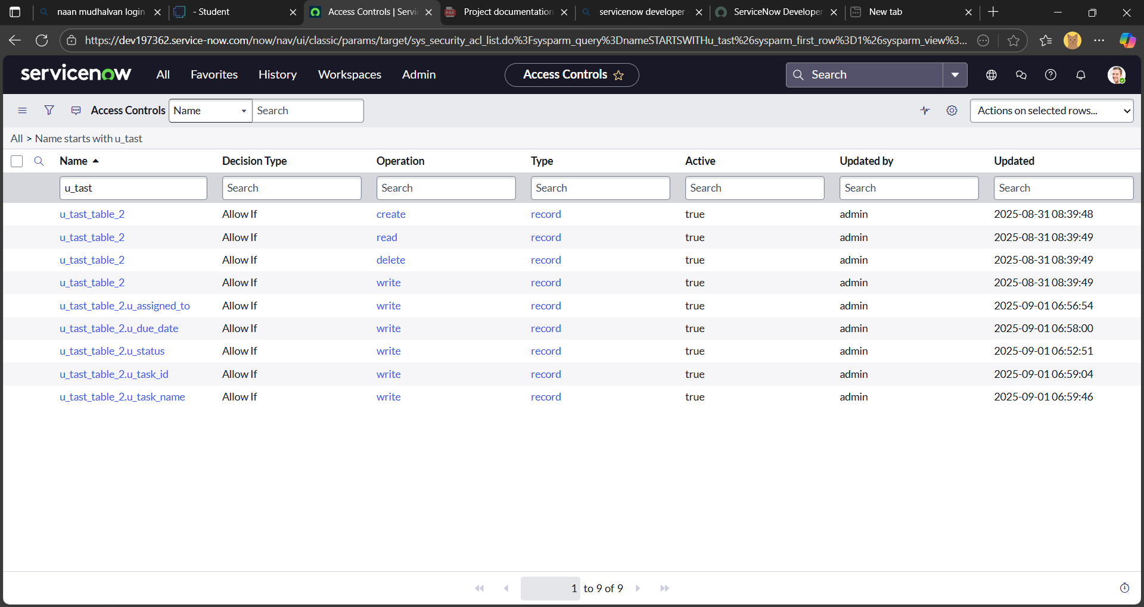

**Milestone 9: Creating a Flow to Assign Operations Tickets in ServiceNow**

**Step 1: Launch Flow Designer**

1. Open **ServiceNow**.
2. In the Application Navigator, click on **All**, then search for **Flow Designer**.
3. Select **Flow Designer** under **Process Automation**.
4. Click **New**, then choose **Flow**.
5. In the **Flow Properties**:
   * **Flow Name**: Task Table
   * **Application**: Global
6. Click **Build Flow** to proceed.

**Step 2: Add a Trigger**

1. Click **Add a Trigger**.
2. Search for and select **Create Record**.
3. Configure the trigger:
   * **Table Name**: Task Table
   * **Conditions**:
     + Field: status → Operator: is → Value: in progress
     + Field: comments → Operator: is → Value: feedback
     + Field: assigned to → Operator: is → Value: bob
4. Click **Done**.

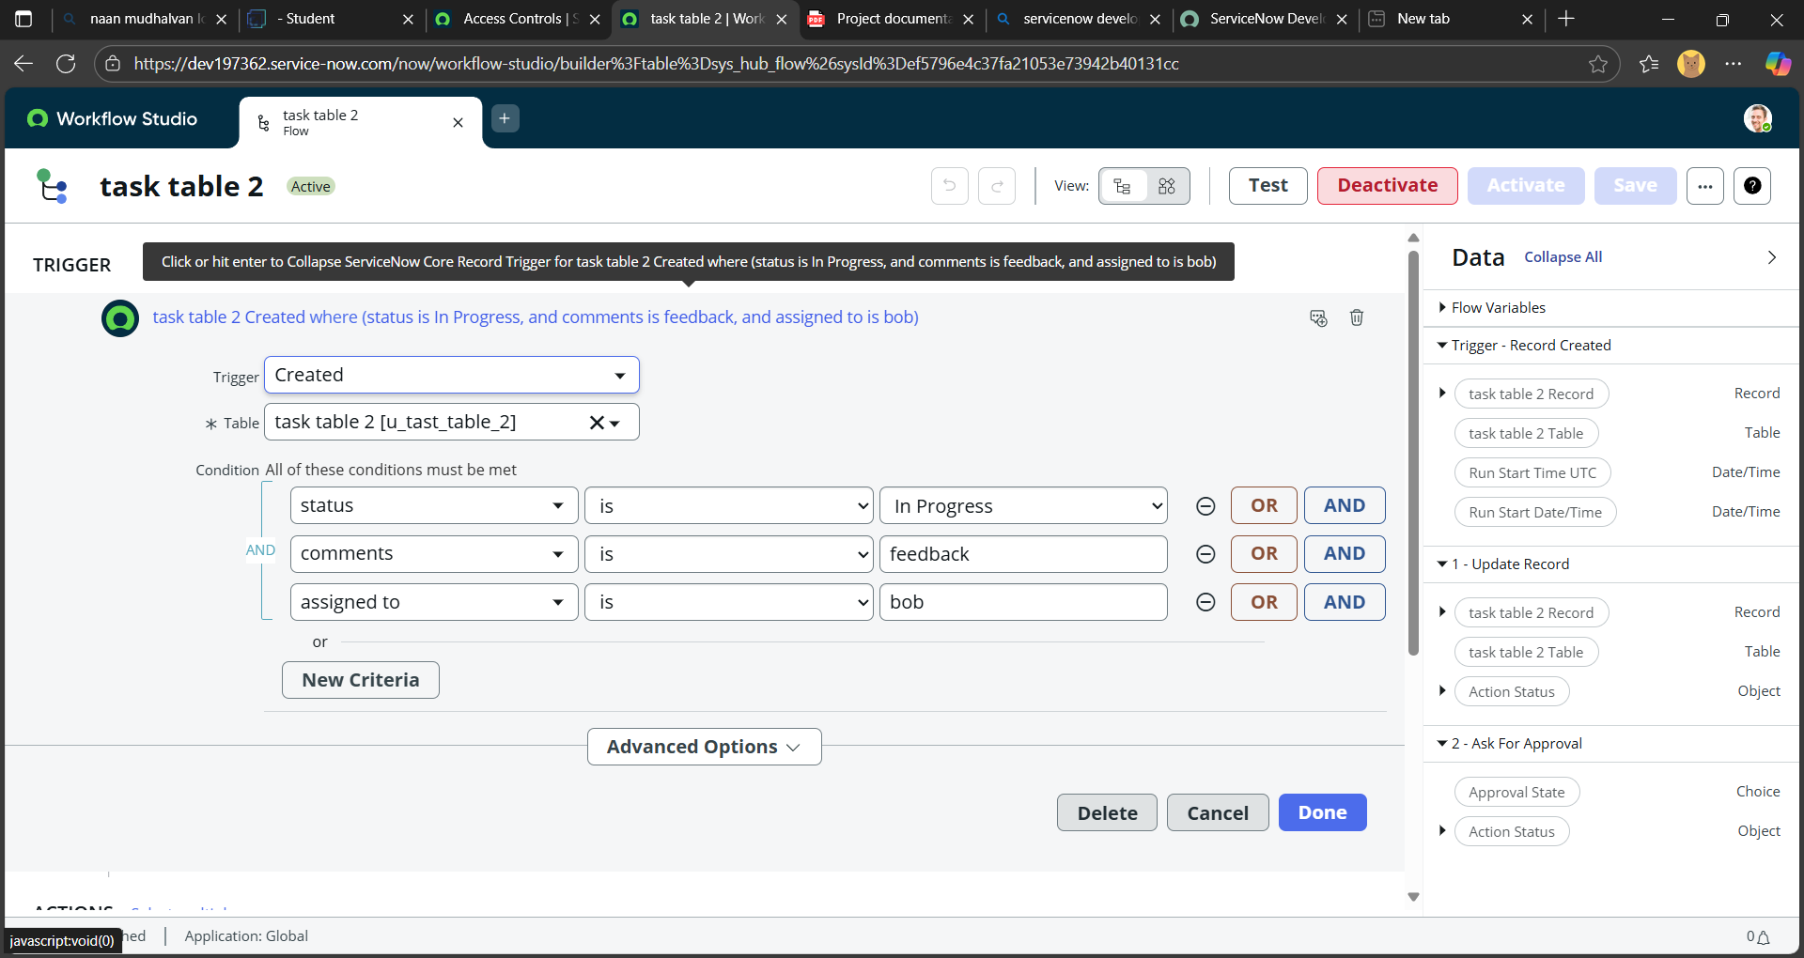

**Step 3: Add an Action – Update Record**

1. Click **Add an Action**.
2. Search for and select **Update Record**.
3. In the **Record** field, drag the appropriate data pill from the right-hand panel.
4. The **Table** will auto-populate.
5. Add the following field update:
   * Field: status → Value: completed
6. Click **Done**.

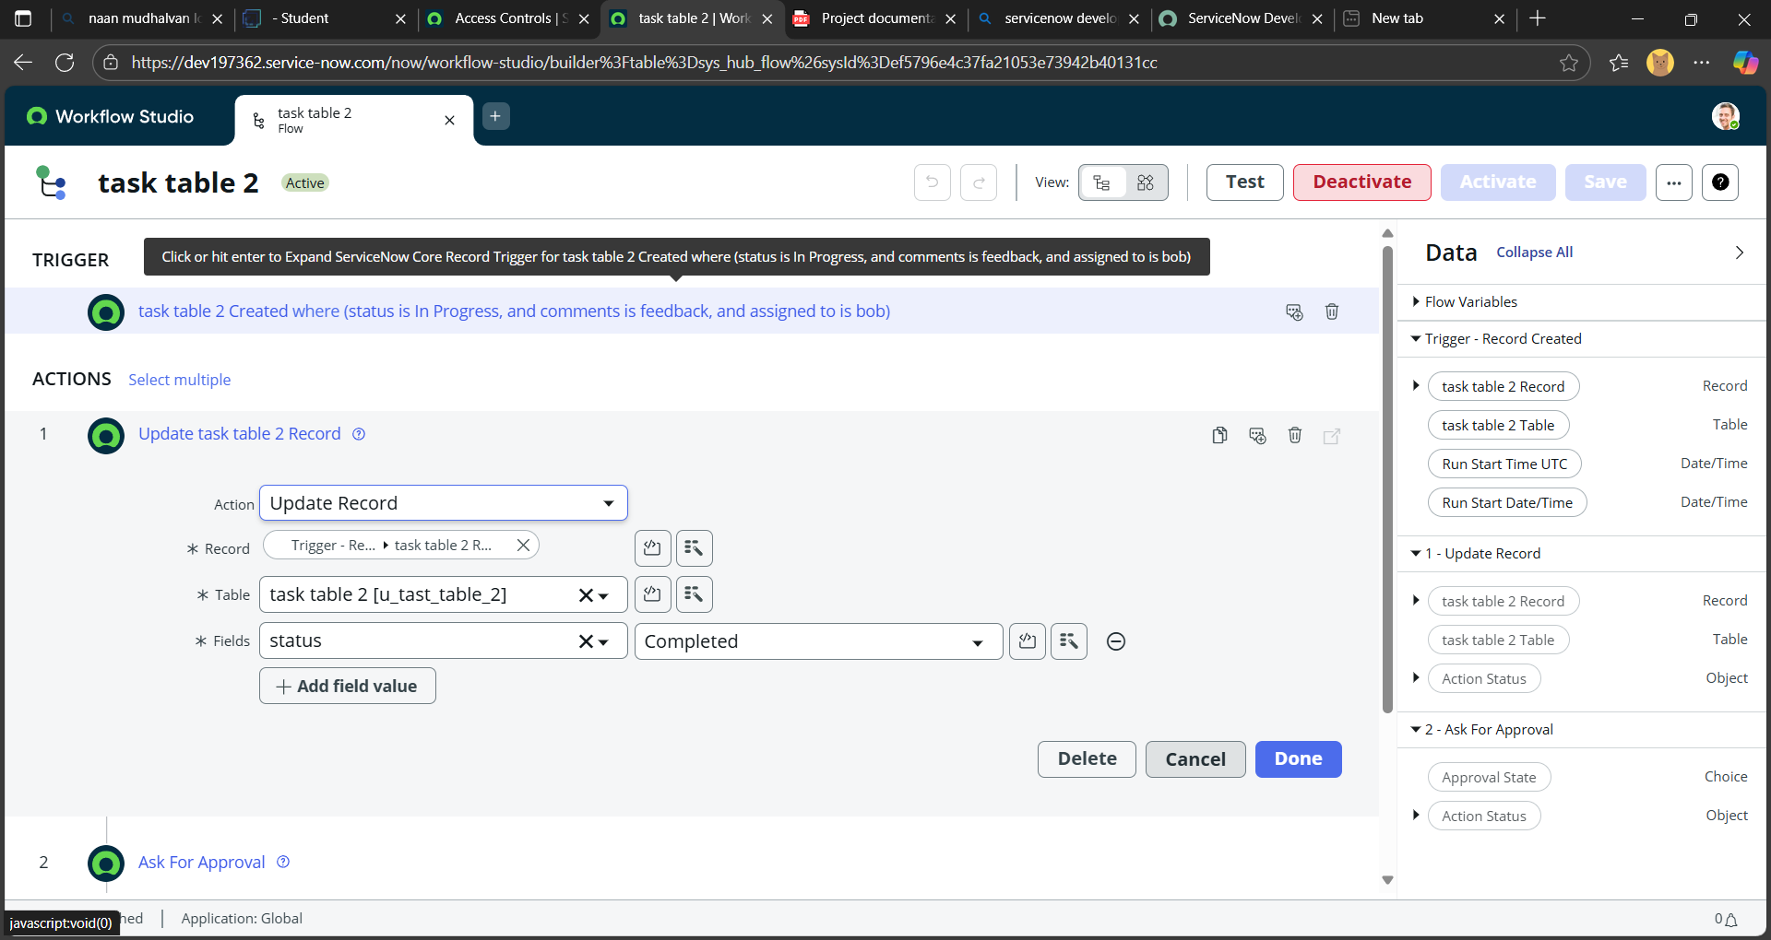

**Step 4: Add an Action – Ask for Approval**

1. Under **Actions**, click **Add an Action**.
2. Search for and select **Ask for Approval**.
3. In the **Record** field, drag the data pill from the right-hand panel.
4. The **Table** will auto-populate.
5. Configure the approval:
   * **Approval Field**: status
   * **Approver**: Alice P
6. Click **Done**.

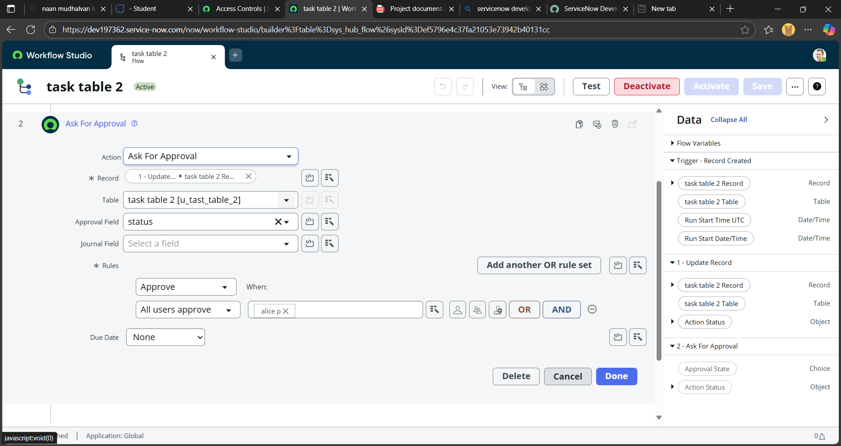

**Step 5: Verify Flow Execution**

1. In the Application Navigator, search for **Task Table**.
2. Confirm that the **Status** field has been updated to completed.
3. Search for **My Approval** in the Application Navigator.
4. Click on **My Approval** under **Service Desk**.
5. Verify that **Alice P** received the approval request.
   * Right-click on the request and select **Approved**.

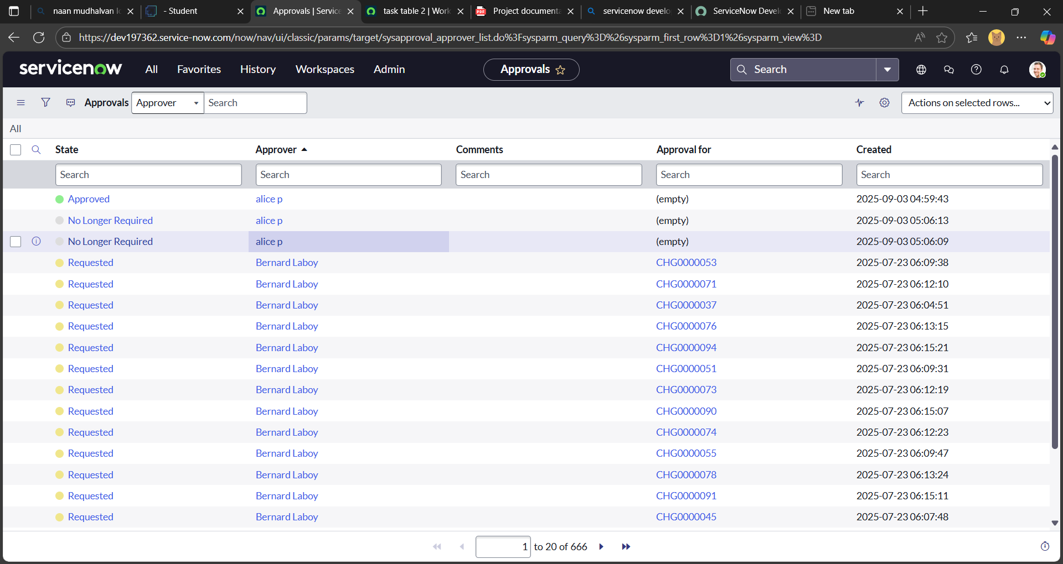

**Conclusion:**

This workflow demonstrates a systematic approach to task management, emphasizing clear role assignments and collaborative execution. With **Alice** overseeing approvals and **Bob** handling task execution, the process ensures both accountability and efficiency. The structured use of tables and flow logic enables seamless tracking of task status, comments, and assignments. By integrating automated updates and approval mechanisms, the system fosters transparent communication and drives successful project outcomes.