Agile Teams and Design Importance

Sai Vinay Gangadharabhatla  
 MS in Software Engineering  
 Arizona State University  
 Tempe AZ USA  
 sganga10@asu.edu

Naga Sai Krishna Gurram  
 MS in Software Engineering  
 Arizona State University  
 Tempe AZ USA  
 ngurram1@asu.edu

ABSTRACT

In this paper we discuss the importance of communication amongst two or more agile teams corresponding to the same project. Where communication is given a higher priority over documentation in agile methodologies. For people face-to-face communication and documentation goes hand in hand. Communication is the vital source in exchange of information between people that maybe within a team or between two or more agile teams. That is between developers and end users or developers and database team and management team. With strong agile architecture and proper communcation that supports the DevOps mindset, which allows the system to continuously evolve over periods of time while supporting the users using the system currently.

KEYWORDS

Agile, Design, conversation, communication.

1 Agile Teams Communication

In Agile, Software Development provides various methods and modes of communication between the team, people can choose any mode of communication when working together depending on the results produced by the mode of communication and richness of the channel used by people. The two arcs are fascinating, the left-most one listing communications options for when you are documenting and the other communication options for when you are modeling. These relative values of these options are situational dependent: sometimes video conversation is called as video conferencing which is better and produce more results than a face-to-face conversation.

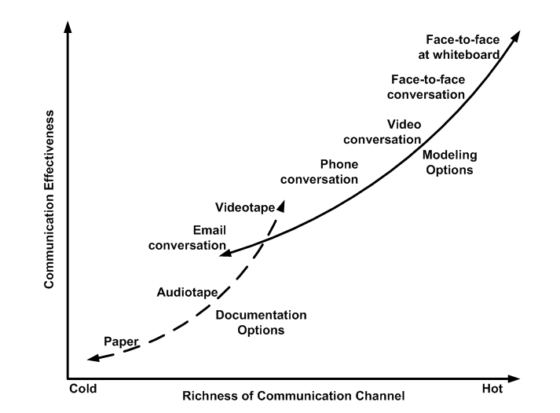

If the conversation involves a shared medium such as Paper, index cards or white board then person-to-person, face-to-face conversation yields better results

Sometimes by removing the shared medium or by no longer being face-to-face you experience some less effectiveness in communication. As the richness of your communication channel

gives the benefit of loosing the physical proximity and some clues that proximity provides. You also lose the benefit of multiple modalities such as the ability to communicate through techniques other than words such as gestures and facial expressions. People usually communicate with the tone of the words which will change the meaning of what they say. We will lose this advantage of the communication which may lead drop in the effectiveness of communication. Cockburn points out that a speaker may highlight what they are saying, thus changing the way they are communicating, by speeding up, slowing down, pausing, or changing tones. Finally, the ability to ask questions and answer them in real time will be lost, asking questions will always lead to better understanding and sometimes it may lead to the foundation of new ideas. This mode provides a proof of what is understood by the listener.

Implications of Figure 1:

1. **Strive to follow the most effective communication technique applicable to your situation**. If you are working together in a same location where you can be easily commuted or located in the same room, building it is always better to have a face-to-face conversation with paper and whiteboard which gives the best and effective results. If that is not the case the only way we have is to make up with a video conference and share media such as online word document. Travelling to them periodically would be a great idea to see the progress of the project and communication. See Figure 2 and the article Choose the Right Communication Technique for more thoughts.
2. **Be prepared to vary your approach throughout a project**. Team dynamics will change throughout a project, so the method of communication you used earlier might not give you the same results today. For instance, the daily progress meeting which you did at the beginning of the project may no longer be needed because you have better modes of communication with less cost and better richness in the mode of communication. The goal is that you should regularly ask yourselves that whatever you are following to communicate gives you the best result or is there any other mode that gives you better results. This should be followed for every iteration of the project.

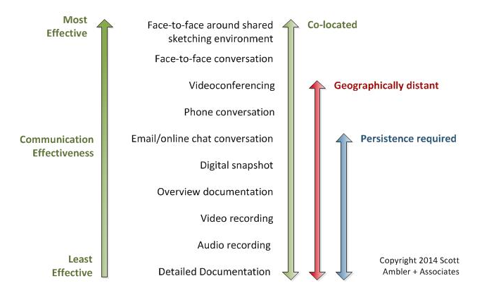

### Factors Effecting Communication

There are various reasons that could have an toll on communication :

1. **Physical proximity**. Pair programming where people can sit next to each other at their workstations and on the other hand where the proximity is that of being buildings apart. The chances for a better mode of communication would be when people are closer to one another be it within the same team or on different agile teams.
2. **Temporal proximity**. A lot of times one of the major reasons that affect communication is the factor of time itself. It may be as such that two or more co-workers are separated due to different time zones for an example, where multinational companies based in the United States outsources work to European countries or Asian countries like India or China or this can also happen when there is simply different work shifts between teams. A lot of times in such situations it is important to meet at a middle ground and come up with a common point in time so that there is a possibility of a closer proximity in communication.
3. **Amicability**. The purity of a conversation that is without any malice against one another while speaking and very ability to listen to each other with good will. The stronger the amicability there is stronger quality of information exchanged and less of it being hidden from within or on different teams. This can also viewed as metric of trust between the team and a sense of community they share amongst themselves. In other cases the same amicability can be costly as well where the same colleagues are too friendly and are afraid of offend the opposite person or afraid to disagree on a key aspect of decision making and not confront them with issues that affect the team and also lack of initiative to make a disagreement due to fear of work hierarchy.

Osmotic communication is a situation where people with close proximity both temporal and physically close where an indirect transfer of information taking place while over hearing or through observation around the work place happening around. Osmotic communication can be a type of benefit, unknowingly picking up some valuable information can helpful when having to communicate with different teams on the same project. While in the same way osmotic communication can be very dangerous as well in the same situation when working with various other teams on the same project where other teams have malicious intent by spreading false information or rumors regarding the management or the project itself.

## 1.1 Improving Inter-Team Communication with User Stories

Even without the right roles we can coordinate with teams working with each other by ensuring there is not any throwing user stories/requirements at one another but rather exchange user stories that should be make way for direct communication amongst team members and amongst different teams as well.

For example, if a project team building a new application needs database services, the user story may be stated in such a way :

As a website user,

I want the database to return the items on my cart

So that I can place an order.

This story can be shared with the database team to which the product owner can place on the backlog and priority the given product backlog item according to coordination between both teams web team and database team.

Apart from that, the user story is a initial point for both the teams, the web team and the database team to start a conversation between them. This user story can be used as a common point between both the teams used as a common frame of reference as the two can work on the implementation part of it.

1.1 Agile Design

Agile architecture is practice, values that support the active design and system architecture. This architecture also supports the DevOps mindset, which allows the system to continuously evolve over periods of time while supporting the users using the system currently. Over the large scale design of the system and the nature being that of start-stop this in turn avoids delays and any possible overhead associated with the system with the phase-gate processes and Big Up front Design (BUFD). Agile architecture supports agile development practices like simplicity, efficient collaboration, evolutionary architecture and design. The agile architecture encourages design for availability, maintainability, testability, deployability and releasability. More-over support can wide spread over features like domain modeling, rapid prototyping and decentered innovation.

The system architecture can be responsible for both slowing down or even increasing the speed to provide frequent and releases that are independent for the business objectives. Agile architects encourage business alignment to improve the design to support the end-to-end stream. Business aligns to optimize the architecture to support the end-to-end systems. The aim of the business is to reach to goal continuously in shorter periods of time. The ever- changing business needs are met by the agile designers by leading the process for the architectural runway. To remove the bottlenecks in the system the agile designers refactor the system by continuously investing in legacy modern applications. In business needs the technical goals are effectively conversed between teams. Agile architecture and continuously delivery pipeline by evolving over time to avoid delays and any possible overhead associated with the system with the phase-gate process and Big Up front Design (BUFD). These techniques makes sure that the system is always in the running state. The emergent design balances the system view across the full value stream

ACKNOWLEDGMENTS

A big thank you to professor Findler who is the drive and motivation in writing this paper. The articles found on agile modeling and scaled agile framework web sites have helped a lot in giving direction and proper understanding of the concepts covered in the paper.

REFERENCES

[1]<https://pm.stackexchange.com/questions/10327/communicating-between-agile-project-teams-and-shared-services>

[2] <http://www.agilemodeling.com/essays/communication.htm>

[3]<http://www.scaledagileframework.com/agile-architecture/>

Conference Name:ACM Woodstock conference

Conference Short Name:WOODSTOCK’18

Conference Location:El Paso, Texas USA

ISBN:978-1-4503-0000-0/18/06

Year:2018

Date:June

Copyright Year:2018

Copyright Statement:rightsretained

DOI:10.1145/1234567890

RRH: F. Surname et al.

Price:$15.00