- Screenshot of CLI PostgreSQL connection
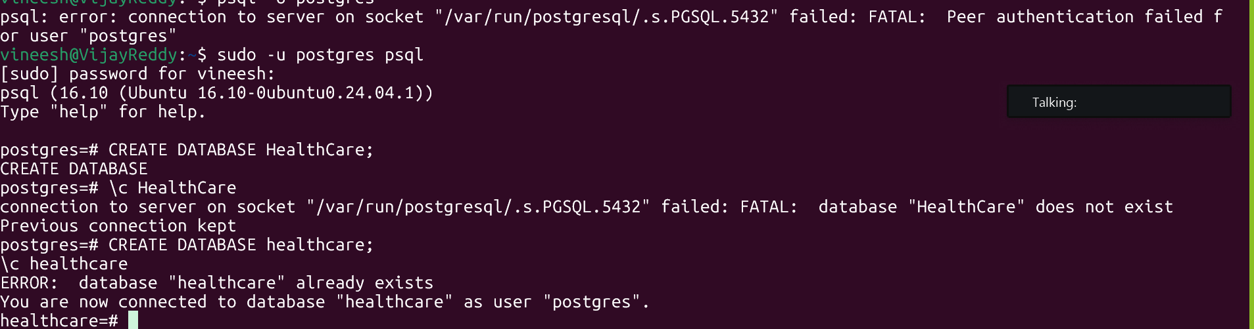
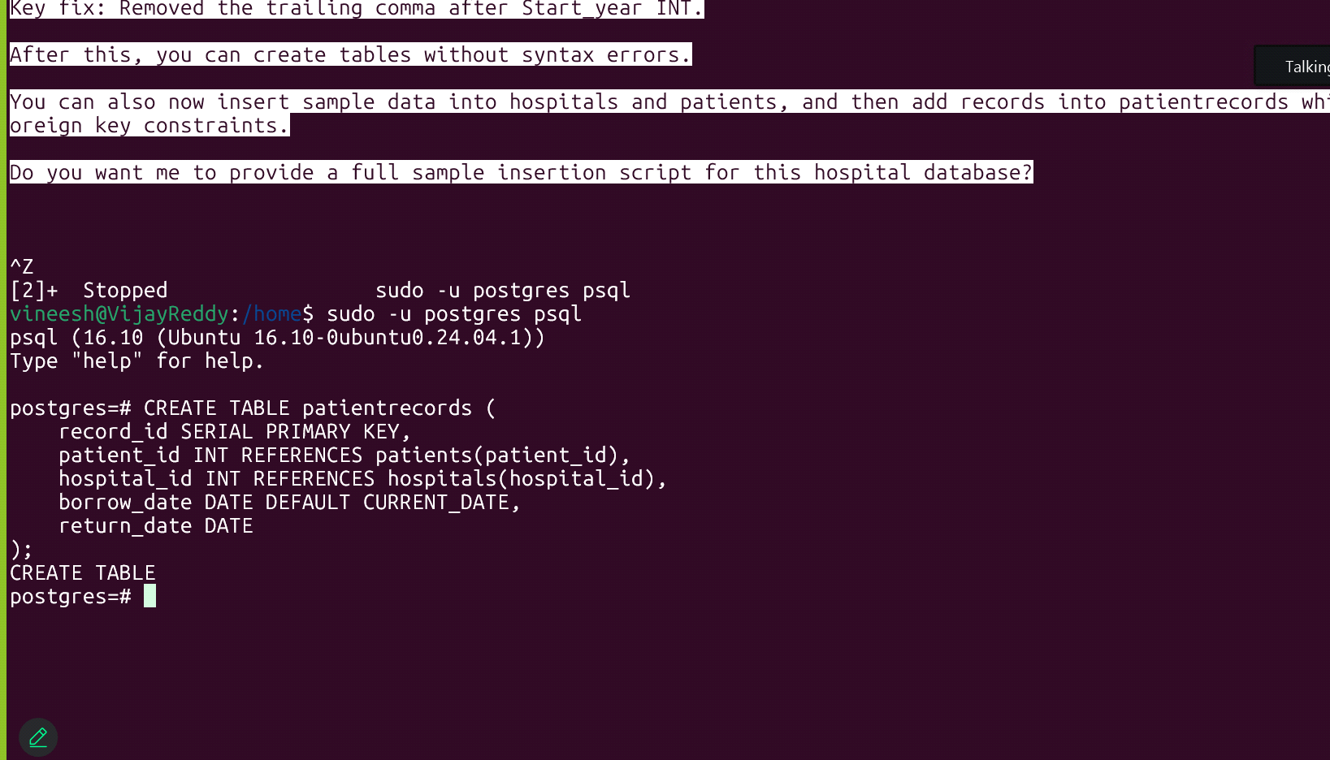

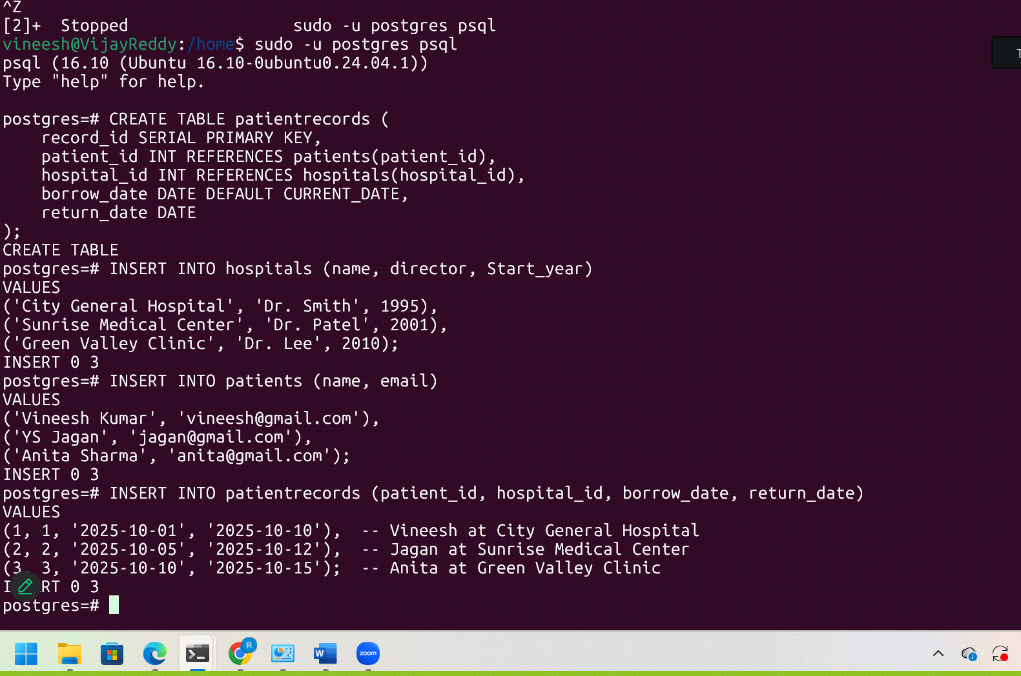
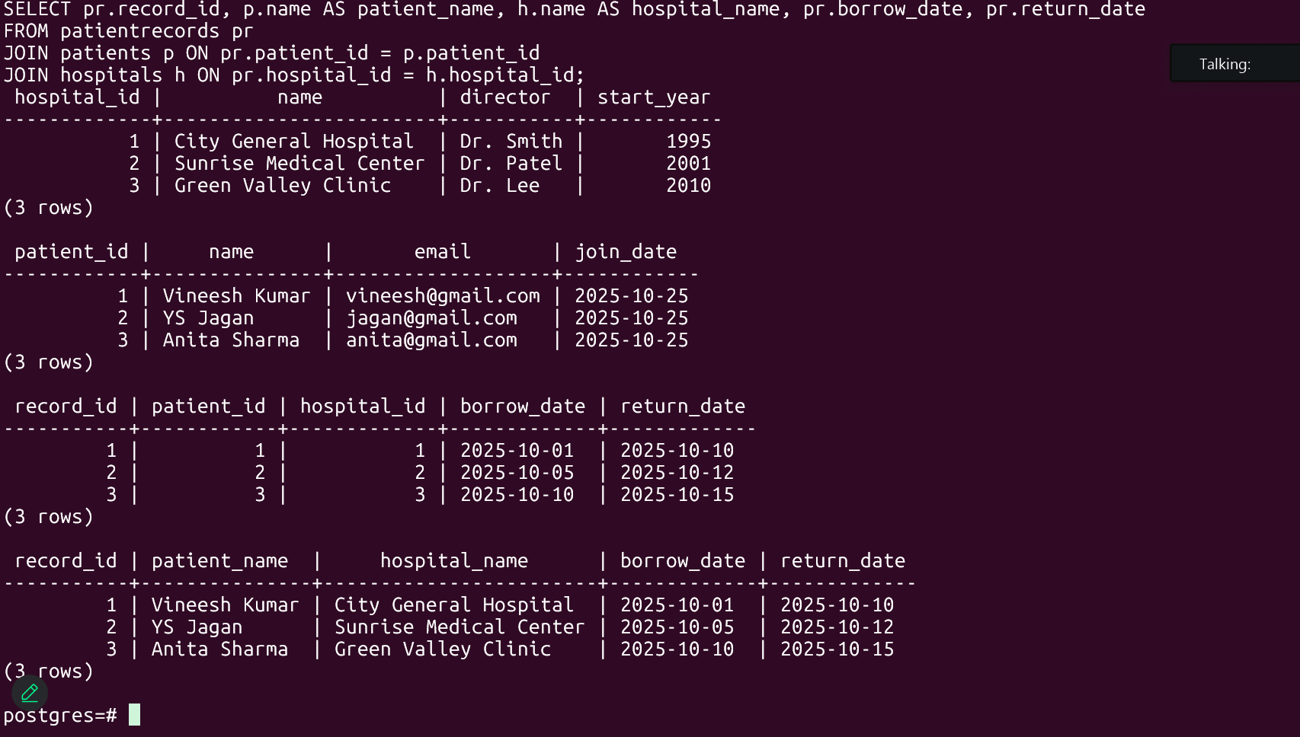
2. 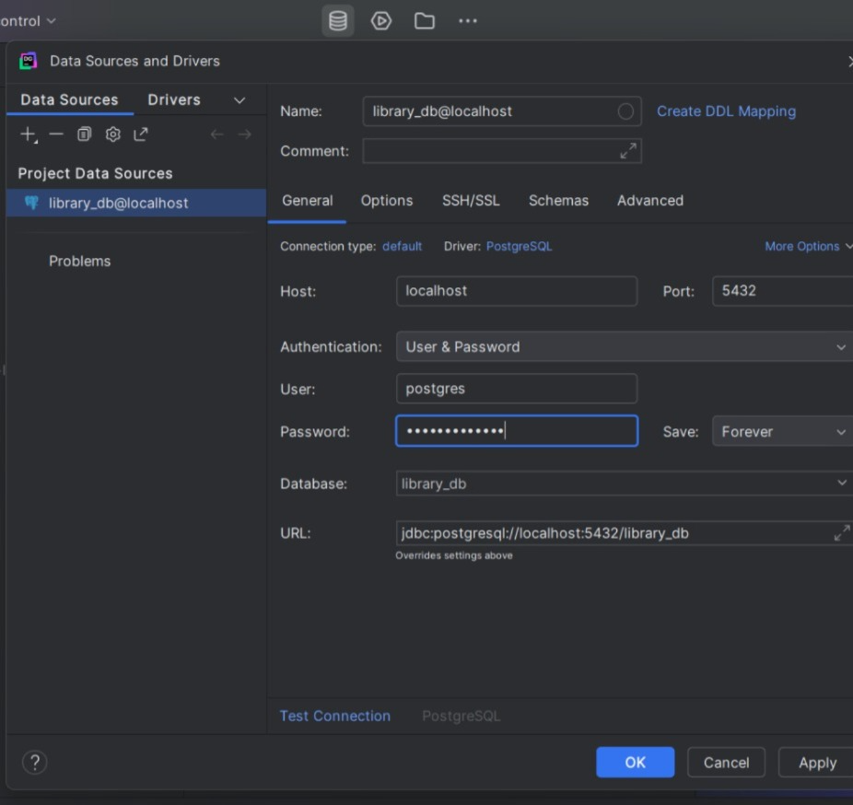

ER Daigram

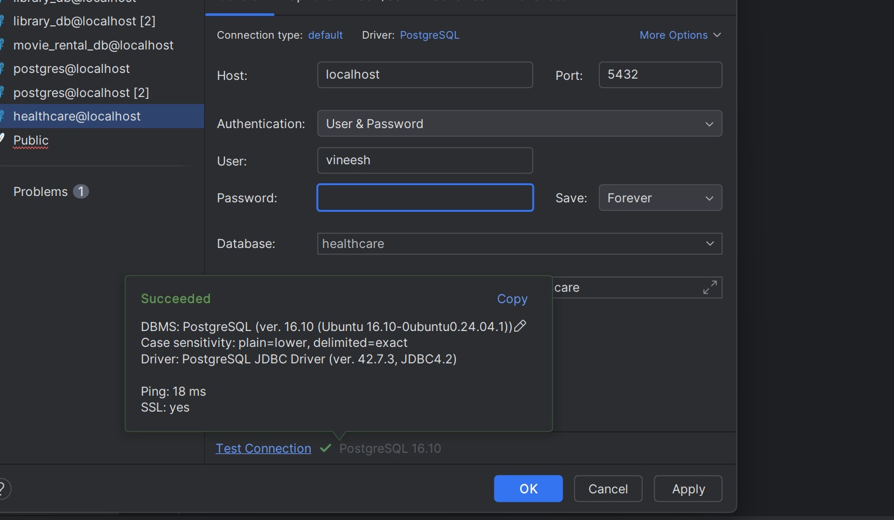
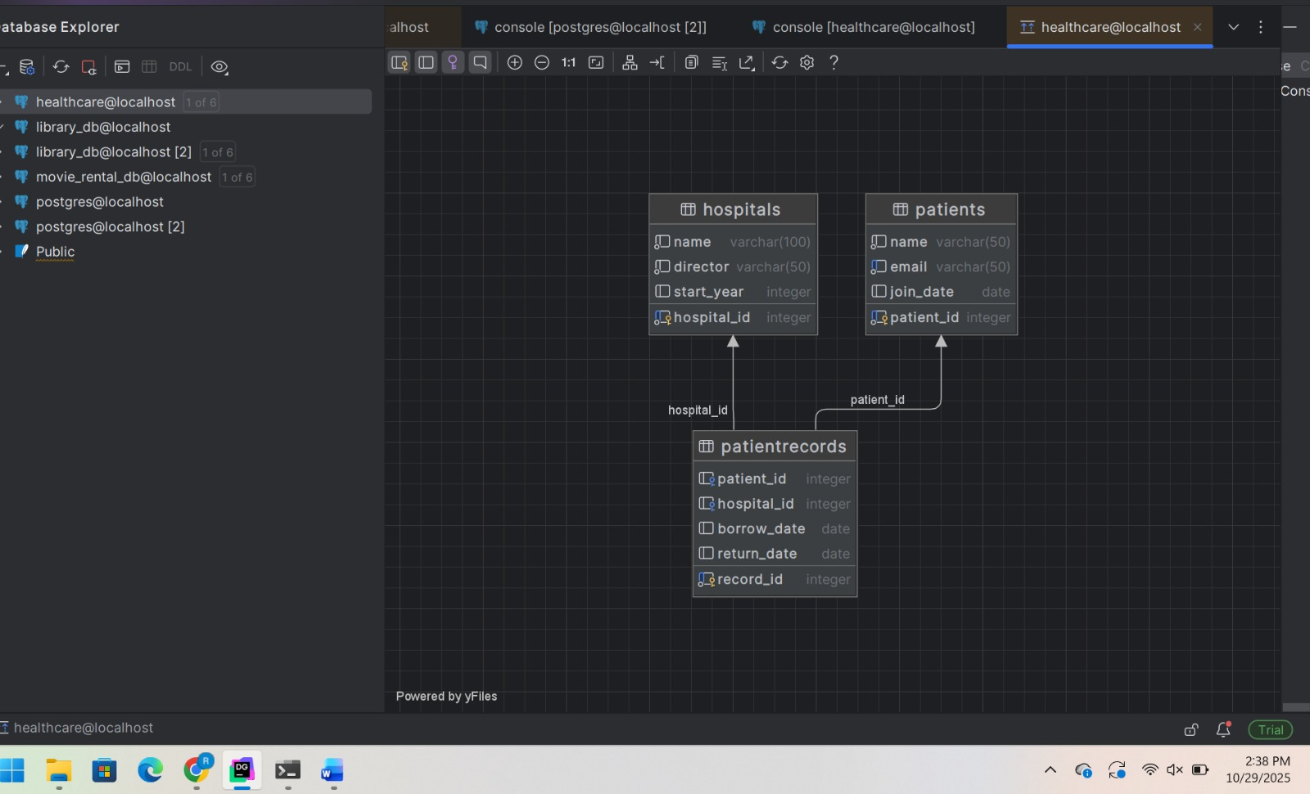
Hospital Query:
CREATE TABLE
postgres=# CREATE TABLE hospitals (
hospital_id SERIAL PRIMARY KEY,
name VARCHAR(100) NOT NULL,
director VARCHAR(50) NOT NULL,
Start_year INT
);
Patient Table
CREATE TABLE
postgres=# CREATE TABLE patients (
patient_id SERIAL PRIMARY KEY,
name VARCHAR(50) NOT NULL,
email VARCHAR(50) UNIQUE NOT NULL,
join_date DATE DEFAULT CURRENT_DATE
);
Patient Records
postgres=# CREATE TABLE patientrecords (
record_id SERIAL PRIMARY KEY,
patient_id INT REFERENCES patients(patient_id),
hospital_id INT REFERENCES hospitals(hospital_id),
borrow_date DATE DEFAULT CURRENT_DATE,
return_date DATE
);
Insert Statements
postgres=# INSERT INTO hospitals (name, director, Start_year)
VALUES
('City General Hospital', 'Dr. Smith', 1995),
('Sunrise Medical Center', 'Dr. Patel', 2001),
('Green Valley Clinic', 'Dr. Lee', 2010);
INSERT 0 3
postgres=# INSERT INTO patients (name, email)
VALUES
('Vineesh Kumar', 'vineesh@gmail.com'),
('YS Jagan', 'jagan@gmail.com'),
('Anita Sharma', 'anita@gmail.com');
INSERT 0 3
postgres=# INSERT INTO patientrecords (patient_id, hospital_id, borrow_date, return_date)
VALUES
(1, 1, '2025-10-01', '2025-10-10'), -- Vineesh at City General Hospital
(2, 2, '2025-10-05', '2025-10-12'), -- Jagan at Sunrise Medical Center
(3, 3, '2025-10-10', '2025-10-15'); -- Anita at Green Valley Clinic
INSERT 0 3
postgres=# SELECT * FROM hospitals;
SELECT * FROM patients;
SELECT * FROM patientrecords;

JION Statements
SELECT pr.record_id, p.name AS patient_name, h.name AS hospital_name, pr.borrow_date, pr.return_date
FROM patientrecords pr
JOIN patients p ON pr.patient_id = p.patient_id
JOIN hospitals h ON pr.hospital_id = h.hospital_id;
hospital_id | name | director | start_year
-------------+------------------------+-----------+------------
1 | City General Hospital | Dr. Smith | 1995
2 | Sunrise Medical Center | Dr. Patel | 2001
3 | Green Valley Clinic | Dr. Lee | 2010
(3 rows)

patient_id | name | email | join_date
------------+---------------+-------------------+------------
1 | Vineesh Kumar | vineesh@gmail.com | 2025-10-25
2 | YS Jagan | jagan@gmail.com | 2025-10-25
3 | Anita Sharma | anita@gmail.com | 2025-10-25
(3 rows)

record_id | patient_id | hospital_id | borrow_date | return_date
-----------+------------+-------------+-------------+-------------
1 | 1 | 1 | 2025-10-01 | 2025-10-10
2 | 2 | 2 | 2025-10-05 | 2025-10-12
3 | 3 | 3 | 2025-10-10 | 2025-10-15
(3 rows)

record_id | patient_name | hospital_name | borrow_date | return_date
-----------+---------------+------------------------+-------------+-------------
1 | Vineesh Kumar | City General Hospital | 2025-10-01 | 2025-10-10
2 | YS Jagan | Sunrise Medical Center | 2025-10-05 | 2025-10-12
3 | Anita Sharma | Green Valley Clinic | 2025-10-10 | 2025-10-15
(3 rows)

Reflection
5.Brief reflection (200 words) on setup challenges
PostgreSQL environment setup and linking it to DataGrip was infuriating but exhilarating. There were issues during initial installation as well as setting up the correct database connection properties such as host, port, and authentication. Environment setup of the PATH on Windows also required debugging before the psql command started working. When I had them linked together, it was simple enough to establish tables, but before long I discovered that PostgreSQL is very particular about syntax and foreign key constraints. A thoughtlessly misplaced trailing comma or misordered sequence of data introduced befuddling errors. These forced me to be more careful about being meticulous about adhering to details and having an understanding of how table relationships function in a relational database. Having DataGrip as an included feature boosted the learning process.

Glancing through the ER diagram allowed me to easily understand how tables are connected to each other via primary and foreign keys. Performing SQL queries inside the IDE was more pleasant to the eyes and fun compared to the CLI. Overall, the process got me exposed to hands-on learning in data modeling, SQL querying, and database administration. And at the end, I not only felt sure of implementing PostgreSQL but also that I understood how to design structured data relationships mirroring actual systems.

