**Link to Challenge 8 GitHub page:**

<https://github.com/saivineethkumar/DACSS-601-GitHubSetUp-Challenge8>

**Task3:**

We can see that few changes are made:

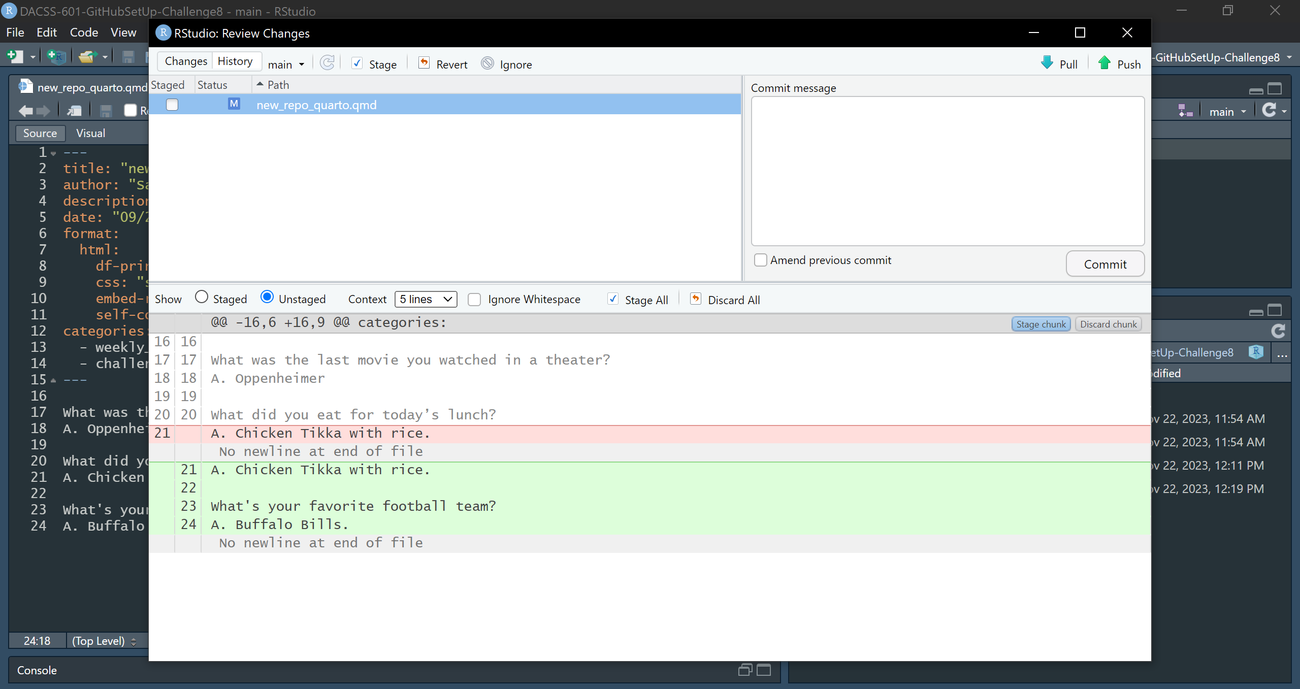

When we press revert, we will see the following dialog asking whether to continue with the revert process:

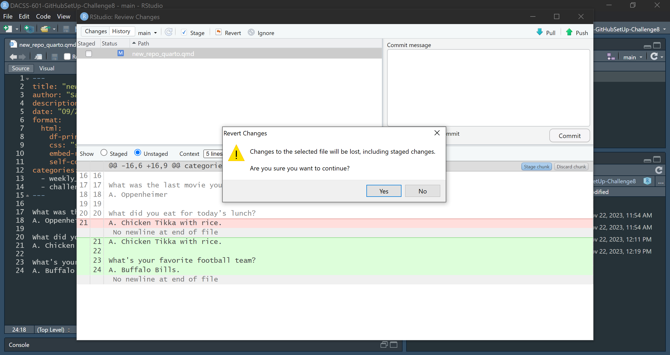

Once we press “Yes”, the changes are reverted and there will be no more changes:

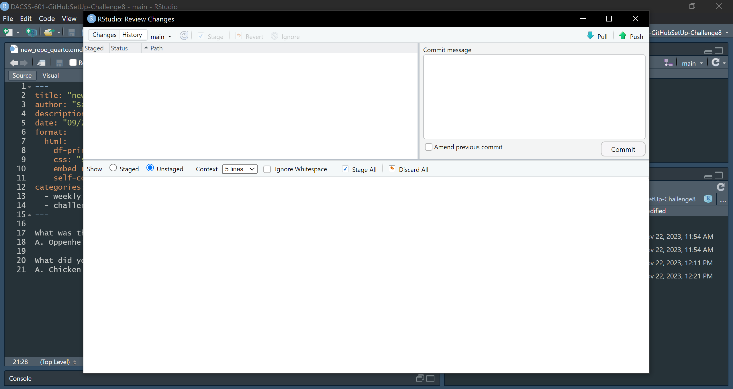

**Optional#1:   
  
Link to DACSS 601 projects GitHub page:**<https://github.com/saivineethkumar/DACSS-601-Projects-Fall23>

**Optional#2: Using GitHub Desktop.**

Below we can see the challenge 8 repo in GitHub Desktop. This is a convenient visual way to interact with remote GitHub repos from local desktop.

