**Link to GitHub page:**

<https://github.com/saivineethkumar/DACSS-601-GitHubSetUp-Challenge8>

**Task3:**

We can see that few changes are made:

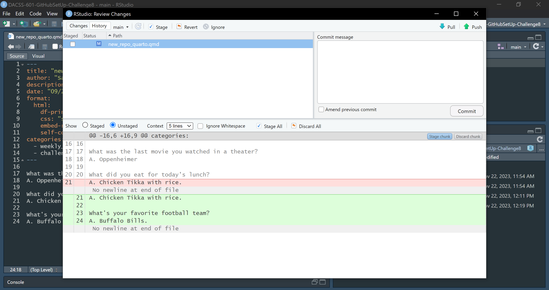

When we press revert, we will see the following dialog asking whether to continue with the revert process:

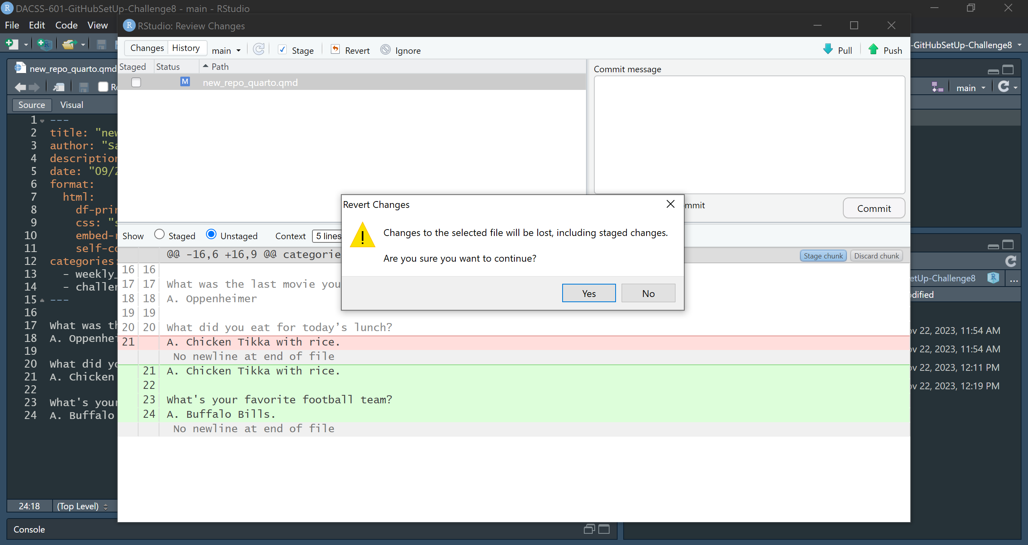

Once we press “Yes”, the changes are reverted and there will be no more changes:

