CYBERSECURITY LAB
Threat Detection & Analysis Report
ATTACK-1: NMAP RECONNAISSANCE
DETECTION GAP ANALYSIS

Date | April 18, 2026
Target IP | 10.0.10.5 (ubuntu-victim / Oracle VirtualBox)
Attack Type | Network Reconnaissance — Nmap -sV -sC Scan
Attacker | Kali Linux machine (lab environment)
SIEM | Wazuh — ubuntu-victim agent
Severity | MEDIUM — Partial Detection (Gap Identified)

1. Executive Summary

This report documents Attack-1, a network reconnaissance scan performed using Nmap (-sV -sC) against a Ubuntu Linux virtual machine (10.0.10.5) in a controlled cybersecurity lab environment. The purpose of the exercise was to simulate an attacker's initial footprinting phase and evaluate the detection capability of the Wazuh SIEM.
The scan successfully enumerated an open SSH port (22/tcp) running OpenSSH 9.6p1, fingerprinted host keys, and identified the operating system as Ubuntu Linux. While Wazuh generated a burst of alerts at the time of the scan, analysis reveals a detection gap: the SIEM flagged post-scan authentication and audit events rather than the scan itself, indicating the absence of dedicated port-scan detection rules or a network intrusion detection system (NIDS).

2. Attack Details

2.1 Command Executed
nmap -sV -sC 10.0.10.5

2.2 Scan Options
Flag | Description
-sV | Service and version detection — probes open ports to determine running software and version
-sC | Default NSE script scanning — runs scripts for fingerprinting, vulnerability checks, and info gathering

2.3 Scan Results
Port | State | Service | Version
22/tcp | OPEN | SSH | OpenSSH 9.6p1 Ubuntu 3ubuntu13.15
1-999 | CLOSED | (999 ports) | TCP reset — no service running

2.4 Additional Information Gathered
- MAC Address: 08:00:27:DE:2C:D5 — identified as Oracle VirtualBox virtual NIC
- SSH Host Key (ECDSA): 8d:32:ee:4b:20:f7:7d:70:3a:21:6d:47:86:36:c9:17
- SSH Host Key (ED25519): 6c:98:41:45:82:ad:53:b2:d7:4a:94:29:2a:6d:17:09
- OS: Linux — CPE: cpe:/o:linux:linux_kernel
- Scan completed in 1.54 seconds (host up, 0.0019s latency)

2.5 Screenshot — Nmap Scan Output
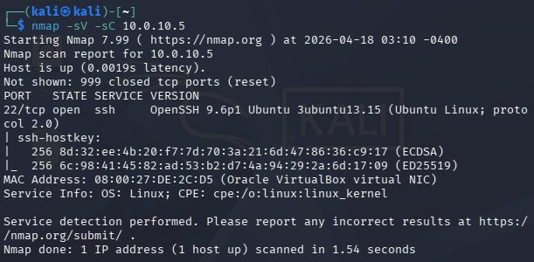
Figure 1: Nmap -sV -sC scan results from Kali Linux against 10.0.10.5

3. Wazuh SIEM Alert Analysis

3.1 Alert Activity
The Wazuh dashboard for the ubuntu-victim agent recorded a sharp spike in security events at approximately 12:50:00, coinciding precisely with the Nmap scan execution. Prior to this time, no notable activity was recorded. The burst was brief, confined to a 30-second window, and triggered multiple rule groups simultaneously.

3.2 Top Alerts Generated
Alert Description | Significance
Auditd: SELinux permission denied | Audit subsystem flagged probe-triggered access attempts
PAM: Login session closed | SSH probe caused PAM session lifecycle events
PAM: Login session opened | Nmap -sC scripts triggered SSH authentication interaction
Successful sudo to ROOT | May indicate script-triggered privilege escalation probe
CIS Ubuntu Linux 24.0 compliance | Compliance benchmark rule violations detected

3.3 Top Rule Groups Triggered
Rule Group | Description
sca | Security Configuration Assessment — system hardening checks
syslog | System log events including kernel and service messages
pam | Pluggable Authentication Module events — login sessions
audit | Linux audit subsystem events — syscalls and file access
audit_selinux | SELinux policy enforcement events via audit daemon

3.4 PCI DSS Requirements Triggered
Requirement | Description
10.2.5 | Use of and changes to identification and authentication mechanisms
2.2 | Develop configuration standards for all system components
10.6.1 | Review logs and security events for anomalies at least daily
10.2.2 | Actions taken by any individual with root or administrative privileges
10.2.6 | Initialization, stopping, or pausing of the audit logs

3.5 Screenshot — Wazuh Dashboard
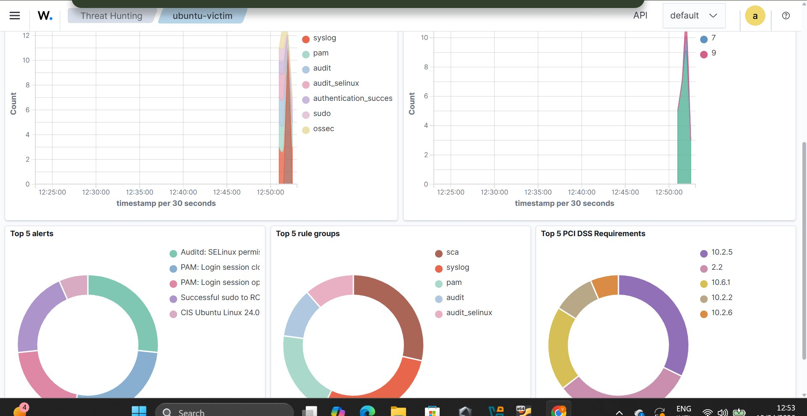
Figure 2: Wazuh Threat Hunting dashboard showing alert spike at 12:50:00 during Nmap scan

4. Detection Gap Analysis

4.1 What Was Detected
Wazuh successfully detected secondary effects of the Nmap scan — specifically the PAM session events triggered by Nmap's default SSH scripts (-sC) interacting with the SSH daemon, as well as audit and SELinux events caused by the probe activity. This represents indirect detection.

4.2 What Was NOT Detected
The core reconnaissance activity — the TCP port scan itself — was NOT directly detected. Wazuh, configured as a host-based intrusion detection system (HIDS), lacks native port scan detection rules in its default configuration. The following gaps were identified:
- No Wazuh alert specifically identified an Nmap port scan signature
- No rule fired for rapid sequential TCP connection attempts to multiple ports
- No network-layer detection — Wazuh operates on logs, not raw network packets
- The attacker's IP address (Kali machine) was not logged or correlated in any alert
- No geo-IP or threat-intelligence enrichment on the source of the probe

4.3 Gap Summary Table
Detection Capability | Status | Notes
TCP SYN scan detection | ❌ MISSING | No NIDS or packet capture in place
Nmap signature detection | ❌ MISSING | No Snort/Suricata/Zeek integrated
Port sweep pattern detection | ❌ MISSING | No threshold-based scan rule active
Attacker IP identification | ❌ MISSING | Source IP not captured in any Wazuh alert
SSH probe detection (indirect) | ✅ PARTIAL | PAM/auth events flagged due to -sC scripts
Audit/SELinux event detection | ✅ DETECTED | Auditd rules fired on probe-triggered access
PCI DSS compliance alerting | ✅ DETECTED | Multiple PCI DSS rules triggered correctly

5. Recommendations

5.1 Immediate Actions
- Deploy Suricata or Snort as a NIDS and integrate with Wazuh to detect network-layer scans
- Enable Wazuh's active response module to automatically block IPs triggering scan thresholds
- Add custom Wazuh rules to detect repeated TCP resets or connection patterns indicative of port scanning
- Configure SSH to log all connection attempts (including refused) for better visibility

5.2 Long-Term Improvements
- Integrate a network packet capture tool (Zeek/Bro) for behavioral analysis of network flows
- Enable threat intelligence feeds in Wazuh to flag known scanner IP ranges
- Implement iptables/nftables rules to rate-limit SYN connections from single IPs
- Schedule regular purple team exercises to identify evolving detection gaps
- Configure geo-IP enrichment to flag scans from unusual geographic locations

6. Conclusion

The Nmap -sV -sC reconnaissance scan against the Ubuntu victim machine (10.0.10.5) demonstrated a significant detection gap in the current Wazuh HIDS configuration. While the SIEM successfully captured secondary events triggered by Nmap's default scripts — particularly PAM authentication and audit subsystem events — the primary reconnaissance activity (TCP port scan) was not directly detected.
This highlights the fundamental limitation of relying solely on a host-based detection system: without network-level visibility via a NIDS (e.g., Suricata), an attacker can silently enumerate open ports and gather service information without triggering any specific scan-detection alert. The Wazuh dashboard's spike at 12:50:00 provides a temporal indicator but not a definitive scan identification.
Closing this detection gap requires integrating network-layer intrusion detection capabilities with the existing Wazuh deployment, supplemented by active response mechanisms and threshold-based alerting for connection rate anomalies.

— End of Report —

