CYBERSECURITY LAB
Threat Detection & Analysis Report
ATTACK-2: SSH BRUTE FORCE
HYDRA — SUCCESSFULLY DETECTED

Date | April 18, 2026 — 03:45:08 to 03:45:14
Target | 10.0.10.5 — ubuntu-victim (SSH port 22)
Attack Tool | THC-Hydra (github.com/vanhauser-thc/thc-hydra)
Attacker | Kali Linux machine (lab environment)
Target Account | analyst
Cracked Password | Lab@1234 (7th attempt — successful)
SIEM Detection | ✅ DETECTED — Rule 40112 (Level 12), Rule 5763 (Level 10)
Total Alerts | 42 alerts | 24 auth failures | 7 auth successes | 1 Level-12 alert

1. Executive Summary

This report documents Attack-2, an SSH brute-force credential attack executed using THC-Hydra against the Ubuntu victim machine (10.0.10.5) in a controlled cybersecurity lab environment. Unlike Attack-1 (Nmap reconnaissance), this attack was successfully detected by the Wazuh SIEM with high-severity alerts.
Hydra attempted 7 password combinations against the 'analyst' SSH account over a 6-second window. After 6 failures, the 7th attempt with the password 'Lab@1234' succeeded, granting SSH access. Wazuh detected the brute-force pattern, fired a Level-12 critical alert (Rule 40112: Multiple authentication failures followed by a success), and a Level-10 brute-force alert (Rule 5763), demonstrating effective detection of credential stuffing attacks.
This represents a FULL DETECTION scenario — the attack was identified, classified correctly, and high-severity alerts were raised in real time.

2. Attack Details

2.1 Tool & Command
hydra -l analyst -P /path/to/wordlist.txt ssh://10.0.10.5:22

2.2 Attack Parameters
Parameter | Value
Protocol | SSH (port 22)
Username | analyst
Max Tasks | 4 parallel tasks per server
Total Tries | 7 login attempts (l:1/p:7)
Start Time | 2026-04-18 03:45:08
End Time | 2026-04-18 03:45:14 (6 seconds total)
Children | child 0, child 1, child 2, child 3 (4 parallel threads)

2.3 Password Attempts Sequence
# | Username | Password Tried | Child | Result
1 | analyst | password | child 0 | FAILED
2 | analyst | 123456 | child 1 | FAILED
3 | analyst | admin | child 2 | FAILED
4 | analyst | root | child 3 | FAILED
5 | analyst | letmein | child 1 | FAILED
6 | analyst | password123 | child 2 | FAILED
7 | analyst | Lab@1234 | child 0 | ✅ SUCCESS

2.4 Screenshot — Hydra Attack Output
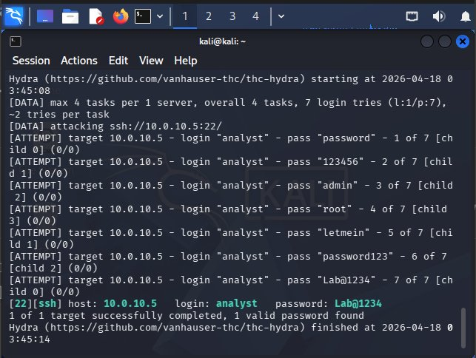
Figure 1: THC-Hydra brute-force output — 6 failures followed by successful login with 'Lab@1234'

3. Wazuh SIEM Detection Analysis

3.1 Alert Overview
Metric | Value
Total Alerts | 42
Level 12+ (Critical) Alerts | 1 — Rule 40112 (brute force + successful login)
Authentication Failures | 24
Authentication Successes | 7
Detection Window | 13:04:36 to 13:34:36 (Wazuh report window)
Alert Spike | 13:15:00 — sharp burst in sshd + auth_failed events

3.2 Alerts Summary — Full Rule Breakdown
Rule ID | Description | Level | Count
5760 | sshd: authentication failed. | 5 | 11
5503 | PAM: User login failed. | 5 | 7
5501 | PAM: Login session opened. | 3 | 2
5502 | PAM: Login session closed. | 3 | 2
5551 | PAM: Multiple failed logins in a small period of time. | 10 | 1
5763 | sshd: brute force trying to get access to the system. Authentication failed. | 10 | 1
5715 | sshd: authentication success. | 3 | 1
40112 | Multiple authentication failures followed by a success. [CRITICAL] | 12 | 1

3.3 Rule Groups Triggered
Group | Event Count
syslog | 26
authentication_failed | 18
sshd | 13
pam | 12
authentication_success | 3
authentication_failures | 2
attacks | 1

3.4 PCI DSS Requirements Triggered
Requirement | Description
10.2.5 | Use of and changes to identification and authentication mechanisms
10.2.4 | Invalid logical access attempts
10.2.2 | Actions by individuals with root or administrative privileges
11.4 | Use of intrusion detection/prevention techniques to detect and prevent intrusions

4. Detection Assessment

4.1 What Was Detected
Wazuh successfully identified the Hydra brute-force attack through multiple correlated rules. The SIEM detected the rapid sequence of SSH authentication failures (Rules 5760, 5503), escalated to brute-force classification (Rules 5551, 5763), and critically identified the eventual successful login after failures with Rule 40112 (Level 12 — the highest severity in this incident).

4.2 Detection Capability Assessment
Detection Capability | Status | Evidence
SSH auth failure detection | ✅ YES | Rule 5760 — 11 events
Brute force pattern recognition | ✅ YES | Rule 5763 (Level 10) fired
Multiple failures in short time | ✅ YES | Rule 5551 (Level 10) fired
Credential success after failure | ✅ YES | Rule 40112 (Level 12) — CRITICAL
Attacker IP identification | ⚠️ PARTIAL | IP present in sshd logs but not surfaced in Wazuh dashboard view
Automatic attacker IP blocking | ❌ NO | Active response not configured — no auto-block triggered
Account lockout enforcement | ❌ NO | SSH allows repeated attempts; no pam_tally2/faillock configured
Real-time alerting/notification | ⚠️ PARTIAL | SIEM alerted but no external notification configured

4.3 MITRE ATT&CK Mapping
Tactic | Technique | Description
Credential Access | T1110.001 | Brute Force: Password Guessing via SSH
Initial Access | T1078 | Valid Accounts — successful SSH login with cracked credentials
Discovery | T1046 | Network Service Discovery — preceded by Nmap scan (Attack-1)

5. Attack Timeline

Time | Event
03:10 (prior) | Attack-1 — Nmap scan discovers port 22/tcp open, OpenSSH 9.6p1
03:45:08 | Hydra brute-force initiated — 4 parallel threads, 7 password attempts
03:45:08–13 | Attempts 1–6 fail: password, 123456, admin, root, letmein, password123
03:45:14 | Attempt 7 succeeds — 'Lab@1234' accepted for user 'analyst'
13:15:00 | Wazuh alert spike — Rules 5760, 5503, 5551, 5763, 40112 all fire
13:15:00 | Rule 40112 Level-12 CRITICAL alert raised — brute force success confirmed

6. Recommendations

6.1 Immediate Actions
- Enable Wazuh Active Response to auto-block IPs triggering Rule 5763 or 40112
- Configure SSH to use key-based authentication only — disable password authentication
- Enable pam_faillock or pam_tally2 to lock accounts after 3–5 failed attempts
- Implement fail2ban as a complementary layer to block brute-force IPs at the firewall level
- Change the 'analyst' account password immediately; audit for unauthorized access post-compromise

6.2 Hardening Recommendations
- Restrict SSH access to specific trusted IPs using iptables or UFW firewall rules
- Change SSH from default port 22 to a non-standard port to reduce automated attack exposure
- Enable multi-factor authentication (MFA) for SSH using TOTP/Google Authenticator
- Configure Wazuh email/Slack alerting for Level 10+ alerts to ensure real-time SOC notification
- Implement a honeypot SSH service to detect and track brute-force attackers

6.3 Detection Improvements
- Tune Rule 40112 to trigger an automated incident response workflow in Wazuh
- Add threat intelligence enrichment to identify known brute-force tool signatures (Hydra user-agent)
- Correlate Attack-1 (Nmap) and Attack-2 (Hydra) as a single kill-chain incident in Wazuh
- Enable Wazuh's vulnerability detector to flag weak SSH configurations proactively

7. Conclusion

The Hydra SSH brute-force attack (Attack-2) against ubuntu-victim (10.0.10.5) represents a successful end-to-end attack chain: the attacker leveraged reconnaissance data from Attack-1 (Nmap) to identify an SSH service, then executed a targeted credential attack that successfully compromised the 'analyst' account with the password 'Lab@1234' in just 6 seconds and 7 attempts.
Unlike Attack-1, the Wazuh SIEM performed well in this scenario. The brute-force pattern was correctly identified through correlated rules (5760, 5503, 5551, 5763), and the critical Rule 40112 (Level 12) fired to flag the high-risk condition of multiple failures followed by a successful login — the most dangerous authentication pattern.
However, detection alone is insufficient. The attack succeeded and the session was established before any defensive action was taken. The primary remediation gap is the absence of automated response: no IP block, no account lockout, and no real-time alerting reached a human operator. Closing these gaps must be the priority following this exercise.

— End of Report —

