INCIDENT INVESTIGATION REPORT
Attack 4 — Registry Run Key Persistence
MITRE ATT&CK: T1547.001 — Boot or Logon Autostart: Registry Run Keys / Startup Folder

Report Date | April 20, 2026
Analyst | Security Operations Team
Target Host | Windows Endpoint (PS C:\WINDOWS\system32)
Attack Vector | Registry modification via reg.exe in elevated PowerShell session
MITRE Tactic | Persistence / Privilege Escalation (TA0003 / TA0004)
MITRE Technique | T1547.001 — Registry Run Keys / Startup Folder
Registry Key | HKCU\Software\Microsoft\Windows\CurrentVersion\Run
Payload Path | C:\Windows\Temp\malware.exe
Severity | HIGH
Detection Tool | Wazuh SIEM (Sysmon EID 13, Registry FIM, Custom Rules)
Status | Detected & Logged

1. Executive Summary
On April 20, 2026, a threat actor modified the Windows Registry to establish persistence by adding a malicious entry to the HKCU Run key. A value named "WindowsUpdate" was registered pointing to C:\Windows\Temp\malware.exe, ensuring the payload executes automatically every time the compromised user logs on. This technique — MITRE ATT&CK T1547.001 — is one of the most prevalent and well-known Windows persistence methods.

The attack was executed via the native reg.exe utility through an elevated PowerShell session, allowing it to masquerade as a legitimate Windows update process. Wazuh SIEM detected the modification through Sysmon Event ID 13 (RegistryEvent - Value Set), FIM, and custom rule 92302, which specifically identifies logon-triggered registry modifications.

2. Attack Description & Technique

2.1 Technique Overview
ATT&CK ID | T1547.001
ATT&CK Tactic | Persistence (TA0003) / Privilege Escalation (TA0004)
Platform | Windows
Registry Key Used | HKCU\Software\Microsoft\Windows\CurrentVersion\Run
Data Sources | Windows Registry, Process, Command
Masquerading | Value named "WindowsUpdate" disguises malware as a Windows update

2.2 Commands Executed
Step 1 — Add Run key registry entry pointing malware.exe to auto-execute on logon:
reg add "HKCU\Software\Microsoft\Windows\CurrentVersion\Run" /v "WindowsUpdate" /t REG_SZ /d "C:\Windows\Temp\malware.exe" /f
Step 2 — Verify the registry entry was successfully written:
reg query "HKCU\Software\Microsoft\Windows\CurrentVersion\Run" /v "WindowsUpdate"

The query output confirmed the entry:
HKEY_CURRENT_USER\Software\Microsoft\Windows\CurrentVersion\Run
WindowsUpdate REG_SZ C:\Windows\Temp\malware.exe

2.3 Attack Logic
Run Key Mechanics:
- HKCU\...\Run values execute automatically when the current user logs on — requiring no elevated privileges to write.
- The value name "WindowsUpdate" is a deliberate masquerading tactic — it blends in visually with legitimate Windows entries in registry editors.
- The payload path C:\Windows\Temp\malware.exe places the executable in a writable system temp directory, allowing it to survive without Admin rights while still appearing trustworthy.
- Type REG_SZ stores the path as a plain string, which Windows interprets as an executable path at logon.

3. Forensic Evidence

3.1 Screenshot Evidence
The following screenshots were captured during the attack and from the Wazuh SIEM console:

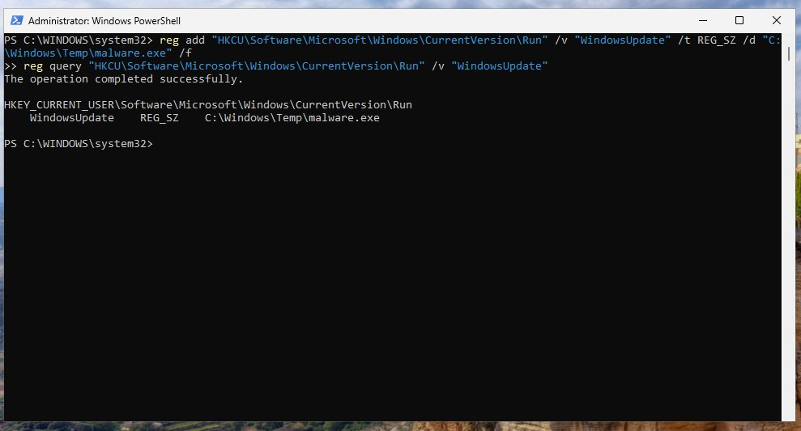
Figure: Screenshot 1 — PowerShell: reg add and reg query confirming malware.exe registered under WindowsUpdate Run key
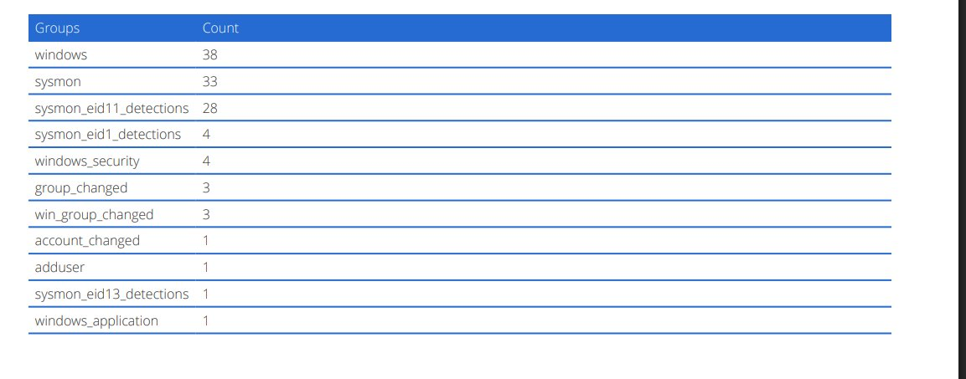
Figure: Screenshot 2 — Wazuh Alert Groups showing sysmon_eid13_detections, group_changed, account_changed, and adduser events
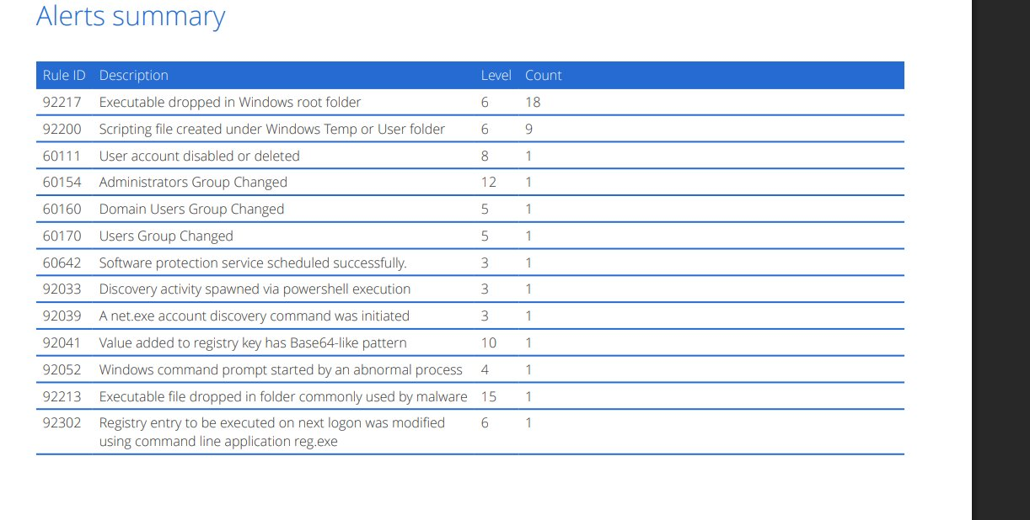
Figure: Screenshot 3 — Wazuh Alerts Summary with all triggered rules including Rule 92302 and Rule 92041

3.2 Registry Entry Details
Attribute | Value | Significance
Registry Hive | HKCU (HKEY_CURRENT_USER) | Writeable without Admin rights; persists per-user
Registry Path | Software\Microsoft\Windows\CurrentVersion\Run | Classic auto-run persistence location
Value Name | WindowsUpdate | Masquerades as a legitimate Windows update entry
Value Type | REG_SZ | Plain string path — executed directly at logon
Value Data | C:\Windows\Temp\malware.exe | Payload staged in writable Temp directory
Execution Trigger | User logon | Runs automatically every time the user logs in
Created Via | reg.exe (reg add) | Native Windows binary — LOLBin usage

4. SIEM Detection Analysis (Wazuh)

4.1 Alert Groups Triggered
The following Wazuh alert groups were observed, indicating the breadth of detection coverage:

Alert Group | Count | Significance
windows | 38 | General Windows event log activity
sysmon | 33 | Broad Sysmon telemetry coverage
sysmon_eid11_detections | 28 | Sysmon EID 11 — file creation events (malware.exe drop)
sysmon_eid1_detections | 4 | Sysmon EID 1 — process creation (reg.exe, PowerShell)
windows_security | 4 | Windows Security event logs
group_changed | 3 | Group membership change detected
win_group_changed | 3 | Windows group modification event
account_changed | 1 | User account attribute modification
adduser | 1 | New user addition event (from Attack 3 residual)
sysmon_eid13_detections | 1 | Sysmon EID 13 — registry value set (Run key modification)
windows_application | 1 | Windows application event log

4.2 Alert Rules Summary
Rule ID | Description | Level | Count
92217 | Executable dropped in Windows root folder | 6 | 18
92200 | Scripting file created under Windows Temp or User folder | 6 | 9
60111 | User account disabled or deleted | 8 | 1
60154 | Administrators Group Changed | 12 | 1
60160 | Domain Users Group Changed | 5 | 1
60170 | Users Group Changed | 5 | 1
60642 | Software protection service scheduled successfully | 3 | 1
92033 | Discovery activity spawned via PowerShell execution | 3 | 1
92039 | A net.exe account discovery command was initiated | 3 | 1
92041 | Value added to registry key has Base64-like pattern | 10 | 1
92052 | Windows command prompt started by an abnormal process | 4 | 1
92213 | Executable file dropped in folder commonly used by malware | 15 | 1
92302 | Registry entry to be executed on next logon was modified using reg.exe | 6 | 1

4.3 Key Rule Analysis
Rule 92302 — Registry Entry Modified for Next Logon Execution via reg.exe (Level 6):
This rule directly maps to the attack. Wazuh detected that reg.exe was used to write a value that will execute on next logon — precisely what the attacker intended. This is the primary detection indicator for T1547.001.

Rule 92041 — Registry Key Value Has Base64-like Pattern (Level 10):
A high-severity indicator suggesting the registry value data may encode an obfuscated payload path or command. This warrants further analysis — the malware.exe payload may contain an encoded command line rather than a plain path.

Rule 60154 — Administrators Group Changed (Level 12):
Critical alert indicating the Administrators group membership was modified — corroborating the Attack 3 activity (hacker account added) that preceded this persistence mechanism.

Rule 92213 — Executable Dropped in Malware-Common Folder (Level 15 — CRITICAL):
Confirms that malware.exe was physically dropped into C:\Windows\Temp before the Run key was set. This is the staging step of the attack chain — the executable exists on disk and will execute at next logon.

Sysmon EID 13 Group (sysmon_eid13_detections — 1 hit):
Sysmon Event ID 13 specifically logs registry value set operations. This directly corresponds to the reg add command and provides the ground-truth telemetry for the registry modification.

Sysmon EID 11 Group (sysmon_eid11_detections — 28 hits):
High volume of file creation events detected — consistent with malware.exe being written to disk plus any ancillary files created during the attack session.

5. Attack Chain Context
This attack forms part of a coordinated multi-stage intrusion chain. The sequence observed across Attack 3 and Attack 4 is consistent with a standard post-exploitation playbook:

Stage | Attack | Technique | Purpose
1 | Attack 3 | T1136.001 — Create Local Account | Backdoor admin user "hacker" created for re-entry
2 | Attack 3 | T1078.001 — Valid Accounts | Admin group membership grants full local privilege
3 | Attack 4 | T1547.001 — Registry Run Key | Payload auto-executes on every user logon
4 | Attack 4 | T1036 — Masquerading | "WindowsUpdate" value name evades casual inspection
5 | Attack 4 | T1105 — Ingress Tool Transfer | malware.exe staged in C:\Windows\Temp before Run key set

6. MITRE ATT&CK Mapping
Tactic | Technique | Sub-Technique | Evidence
Persistence | T1547 — Boot/Logon Autostart | T1547.001 — Registry Run Keys | HKCU\...\Run\WindowsUpdate → malware.exe
Defense Evasion | T1036 — Masquerading | T1036.005 — Match Legitimate Name | Value named "WindowsUpdate" mimics Windows update
Execution | T1059.001 — PowerShell | — | reg.exe invoked from PowerShell session
Defense Evasion | T1218 — System Binary Proxy | reg.exe LOLBin usage | Native binary used to avoid detection
Discovery | T1012 — Query Registry | — | reg query used to verify persistence entry

7. Impact Assessment
Impact Category | Assessment | Risk
Persistence | malware.exe executes automatically at every user logon — survives reboots | CRITICAL
Execution | Payload executes in user context with current user's permissions | HIGH
Defense Evasion | "WindowsUpdate" name evades casual registry review | HIGH
Privilege Escalation | If malware.exe contains privilege escalation code, elevation possible | HIGH
Lateral Movement | Persistent shell enables subsequent network-based lateral movement | HIGH
Remediation Complexity | Run key easy to overlook; may persist through partial incident response | MEDIUM

8. Recommendations

8.1 Immediate Actions
- Delete the malicious registry entry: reg delete "HKCU\Software\Microsoft\Windows\CurrentVersion\Run" /v "WindowsUpdate" /f
- Delete the payload: del C:\Windows\Temp\malware.exe
- Sandbox-analyse malware.exe before deletion to understand full payload capabilities.
- Audit all Run/RunOnce keys across HKCU and HKLM for additional persistence entries.
- Revoke the "hacker" account and audit all Administrators group memberships (linked Attack 3 remediation).

8.2 Detection Hardening
- Ensure Sysmon EID 13 (RegistryEvent - Value Set) is captured and forwarded to Wazuh.
- Create FIM rules in Wazuh for HKCU\...\Run and HKLM\...\Run key monitoring.
- Alert on any new values added to Run/RunOnce keys pointing to Temp, AppData, or ProgramData paths.
- Monitor reg.exe process creation (Sysmon EID 1) with command-line logging enabled.

8.3 Preventive Controls
- Apply Windows AppLocker or WDAC policies to block execution of unsigned executables from C:\Windows\Temp.
- Restrict write access to HKLM Run keys for non-administrative users via Group Policy.
- Deploy Autoruns (Sysinternals) scanning via endpoint management to detect Run key additions.
- Enable Windows Defender Attack Surface Reduction (ASR) rule: Block persistence through WMI event subscription and registry.

9. Conclusion
This investigation confirmed a successful Registry Run Key persistence attack (T1547.001) on a Windows endpoint. The attacker used native reg.exe via PowerShell to register a malicious executable (malware.exe) under a deceptively named "WindowsUpdate" value in the HKCU Run key — ensuring automatic execution at every user logon.

Wazuh detected the attack through multiple overlapping detection chains: Sysmon EID 13 for registry modification, Rule 92302 for logon-execution persistence, and Rule 92213 (Level 15) for the executable drop. The co-occurrence with Attack 3 indicators (Rule 60154 — Administrators Group Changed) confirms these attacks are part of a coordinated intrusion sequence.

Immediate removal of both the registry entry and the payload file, combined with full forensic analysis of malware.exe, are required before the host can be returned to production.

END OF REPORT — CONFIDENTIAL — FOR AUTHORIZED PERSONNEL ONLY

