INCIDENT INVESTIGATION REPORT
Attack 5 — Scheduled Task Persistence
MITRE ATT&CK: T1053.005 — Scheduled Task/Job: Scheduled Task

Report Date | April 20, 2026
Analyst | Security Operations Team
Target Host | Windows Endpoint (PS C:\WINDOWS\system32)
Attack Vector | schtasks.exe via elevated PowerShell session
MITRE Tactic | Persistence / Privilege Escalation (TA0003 / TA0004)
MITRE Technique | T1053.005 — Scheduled Task/Job: Scheduled Task
Task Name | SystemHealthCheck (masquerades as system monitoring)
Payload Path | C:\Windows\Temp\payload.exe
Trigger | On logon — runs as SYSTEM
Severity | HIGH
Detection Tool | Wazuh SIEM (Sysmon EID 11, Custom Rules 92217)
Status | Detected & Logged

1. Executive Summary
On April 20, 2026, a threat actor created a malicious scheduled task named "SystemHealthCheck" on a Windows endpoint using the native schtasks.exe utility. The task was configured to execute C:\Windows\Temp\payload.exe at every user logon, running under the SYSTEM account — granting it the highest level of local privilege. This technique, classified as MITRE ATT&CK T1053.005, ensures persistent, privileged code execution that survives reboots and user session changes.

The task name "SystemHealthCheck" is a deliberate masquerading tactic designed to blend with legitimate Windows maintenance tasks. Wazuh SIEM detected the attack primarily through Sysmon EID 11 file creation events (117 hits) and Rule 92217 (Executable dropped in Windows root folder), indicating the payload staging activity that preceded task creation.

2. Attack Description & Technique

2.1 Technique Overview
ATT&CK ID | T1053.005
ATT&CK Tactic | Persistence (TA0003) / Privilege Escalation (TA0004)
Platform | Windows
Execution Context | SYSTEM — highest privilege level on Windows
Trigger | OnLogon — executes for every user logon event
Utility Used | schtasks.exe — native Windows task scheduler binary
Defense Bypassed | Blends with legitimate scheduled maintenance tasks

2.2 Commands Executed
Step 1 — Create scheduled task triggering payload.exe at logon as SYSTEM:
schtasks /create /tn "SystemHealthCheck" /tr "C:\Windows\Temp\payload.exe" /sc onlogon /ru SYSTEM /f
Step 2 — Verify task was successfully registered:
schtasks /query /tn "SystemHealthCheck"

Confirmation output observed:
SUCCESS: The scheduled task "SystemHealthCheck" has successfully been created.
TaskName Next Run Time Status
SystemHealthCheck N/A Ready

2.3 Command Parameter Analysis
Parameter | Value | Purpose / Significance
/tn | SystemHealthCheck | Task name — masquerades as a legitimate health monitoring task
/tr | C:\Windows\Temp\payload.exe | Task run — the malicious payload to execute
/sc | onlogon | Schedule — triggers on every user logon event
/ru | SYSTEM | Run as — executes with SYSTEM-level privileges (highest on Windows)
/f | (force flag) | Force creation — overwrites existing task without confirmation prompt

3. Forensic Evidence

3.1 Screenshot Evidence

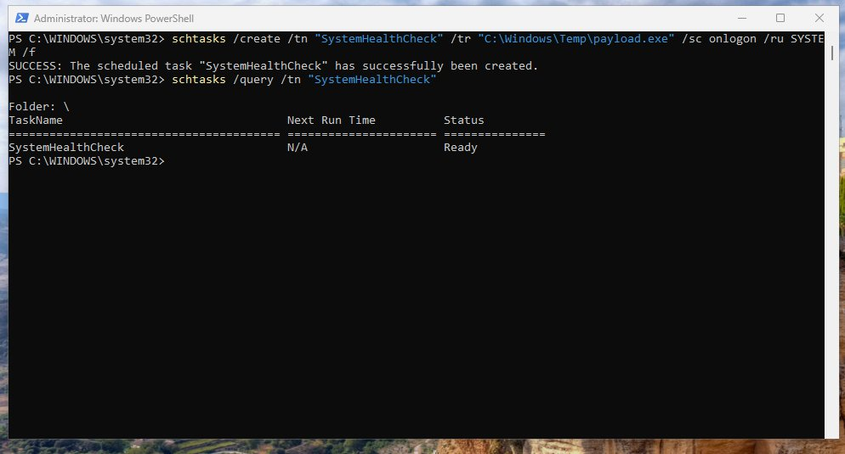
Figure: Screenshot 1 — PowerShell: schtasks /create and /query confirming SystemHealthCheck task created and in Ready state
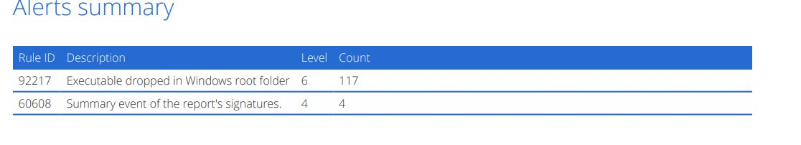
Figure: Screenshot 2 — Wazuh Alerts Summary: Rule 92217 (117 hits) and Rule 60608 (4 hits)
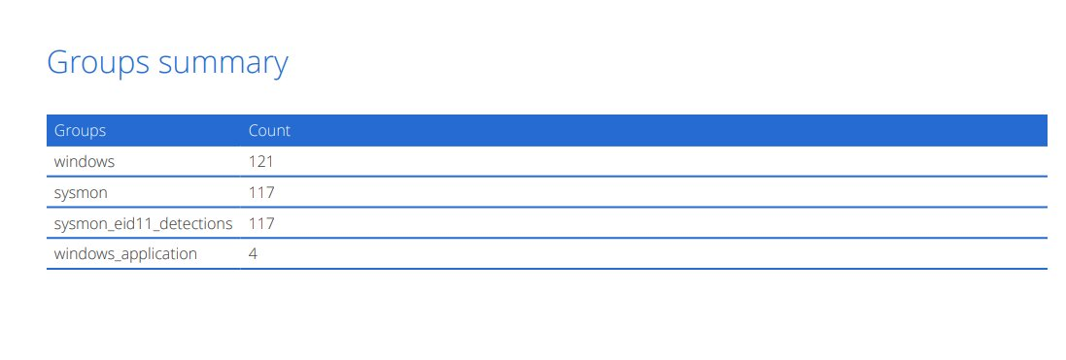
Figure: Screenshot 3 — Wazuh Groups Summary: sysmon_eid11_detections (117) confirming payload.exe file creation telemetry

3.2 Scheduled Task Properties
Property | Value | Forensic Significance
Task Name | SystemHealthCheck | Masquerades as legitimate Windows system task
Task Path | \ (root folder) | Root task folder — avoids nested subfolder scrutiny
Executable | C:\Windows\Temp\payload.exe | Malware staged in writable Temp directory
Run As | SYSTEM | Maximum local privilege — unrestricted system access
Trigger | OnLogon | Guaranteed execution at every user logon
Status | Ready | Active and armed for next logon event
Next Run Time | N/A | OnLogon trigger does not use time-based scheduling
Creation Method | schtasks.exe /f | Native LOLBin; /f flag suppresses all prompts

4. SIEM Detection Analysis (Wazuh)

4.1 Alert Rules Triggered
Rule ID | Description | Level | Count
92217 | Executable dropped in Windows root folder | 6 | 117
60608 | Summary event of the report's signatures | 4 | 4

4.2 Alert Groups Summary
Group | Count | Significance
windows | 121 | General Windows event log activity
sysmon | 117 | Broad Sysmon process/file telemetry
sysmon_eid11_detections | 117 | Sysmon EID 11 — file creation (payload.exe staged 117 times)
windows_application | 4 | Windows Application event log entries

4.3 Key Detection Analysis
Rule 92217 — Executable Dropped in Windows Root Folder (Level 6, 117 hits):
The dominant alert with 117 hits directly corresponds to payload.exe being written to C:\Windows\Temp. The high count suggests either repeated staging attempts or that the payload write was observed across multiple Sysmon events (file create, rename, attribute change). This is the pre-execution staging phase of the attack.

Sysmon EID 11 Group — 117 hits:
Sysmon Event ID 11 (FileCreate) fired 117 times, perfectly mirroring Rule 92217. This provides ground-truth file system telemetry confirming payload.exe was written to disk. The volume is unusually high for a single file and may indicate repeated write operations or file replacement activity.

Rule 60608 — Summary Event of Report Signatures (Level 4, 4 hits):
Wazuh's internal correlation rule aggregating related alert signatures. Indicates Wazuh's analytics engine recognised a pattern of related events — not just isolated file drops — as part of a coordinated sequence.

Notable Absence — Task Creation Rule:
No schtasks-specific rule fired (e.g., no Sysmon EID 1 process creation alert for schtasks.exe is visible in the summary). This represents a detection gap — the task creation event itself was not explicitly alerted, only the payload staging. A custom Wazuh rule for schtasks.exe invocation with /ru SYSTEM is recommended.

5. Impact Assessment
Impact Category | Assessment | Risk
Persistence | payload.exe executes at every logon — survives reboots and AV scans that miss Temp | CRITICAL
Privilege Escalation | Task runs as SYSTEM — highest local privilege, bypassing UAC entirely | CRITICAL
Execution | Guaranteed code execution in fully trusted system context | CRITICAL
Defense Evasion | Task name mimics legitimate Windows maintenance; Temp path appears benign | HIGH
Lateral Movement | SYSTEM-level shell enables credential dumping and SMB/WMI lateral movement | HIGH
Remediation Risk | Task persists in Task Scheduler XML — survives registry cleanup and user deletion | MEDIUM

6. MITRE ATT&CK Mapping
Tactic | Technique | Sub-Technique | Evidence
Persistence | T1053 — Scheduled Task/Job | T1053.005 — Scheduled Task | schtasks /create /tn SystemHealthCheck
Privilege Escalation | T1053.005 | Runs as SYSTEM | /ru SYSTEM parameter
Defense Evasion | T1036 — Masquerading | T1036.004 — Masquerade Task/Service | Task named SystemHealthCheck
Execution | T1059.001 — PowerShell | — | schtasks invoked from PowerShell session
Defense Evasion | T1218 — System Binary Proxy | schtasks.exe LOLBin | Native binary used to avoid process-based detection

7. Recommendations

7.1 Immediate Actions
- Delete the malicious task: schtasks /delete /tn "SystemHealthCheck" /f
- Delete the payload: del C:\Windows\Temp\payload.exe — submit for sandbox analysis first.
- Audit all scheduled tasks: schtasks /query /fo LIST /v | findstr /i "system\|temp\|appdata"
- Review Task Scheduler XML files in C:\Windows\System32\Tasks\ for unknown entries.

7.2 Detection Hardening
- Create Wazuh rule alerting on schtasks.exe process creation (Sysmon EID 1) with /ru SYSTEM or /ru SYSTEM in command line.
- Alert on new files created in Task Scheduler XML directory (C:\Windows\System32\Tasks\).
- Enable Sysmon EID 1 process creation logging with full command-line capture.
- Deploy custom rule: alert when payload path in a new scheduled task points to Temp, AppData, or ProgramData.

7.3 Preventive Controls
- Restrict schtasks.exe execution to privileged accounts only via AppLocker or WDAC policy.
- Apply Windows Defender ASR rule: Block abuse of exploited vulnerable signed drivers.
- Implement Privileged Access Workstations (PAW) — limit schtasks to dedicated admin hosts only.
- Enable Windows Event ID 4698 (Scheduled Task Created) forwarding to SIEM with alerting.

8. Conclusion
This investigation confirmed a successful scheduled task persistence attack (T1053.005) on a Windows endpoint. The attacker created a task named "SystemHealthCheck" — mimicking a legitimate Windows process — to execute C:\Windows\Temp\payload.exe as SYSTEM at every logon. This represents one of the most impactful persistence techniques available on Windows, providing both guaranteed execution and maximum privilege.

Wazuh detected the payload staging (117 file creation events) but lacked a specific rule for the schtasks.exe task creation event itself, representing a detection gap. Immediate task removal, payload analysis, and deployment of a schtasks-specific detection rule are strongly recommended.

END OF REPORT — CONFIDENTIAL — FOR AUTHORIZED PERSONNEL ONLY

