INCIDENT INVESTIGATION REPORT
Attack 6 — Encoded PowerShell Execution
MITRE ATT&CK: T1059.001 — Command and Scripting Interpreter: PowerShell

Report Date | April 20, 2026
Analyst | Security Operations Team
Target Host | Windows Endpoint (PS C:\WINDOWS\system32)
Attack Vector | powershell.exe -enc (Base64-encoded command execution)
MITRE Tactic | Execution (TA0002)
MITRE Technique | T1059.001 — Command and Scripting Interpreter: PowerShell
Encoded Payload | dwBoAG8AYQBtAGkA (Base64 → whoami)
Decoded Command | whoami
Output Observed | desktop-nm4c9e8\analyst
Severity | MEDIUM (recon command; technique is HIGH risk)
Detection Tool | Wazuh SIEM (Sysmon EID 1, Custom Rules 92027, 92213)
Status | Detected & Logged

1. Executive Summary
On April 20, 2026, a threat actor executed an obfuscated PowerShell command on a compromised Windows endpoint using the -enc (EncodedCommand) parameter. The Base64-encoded payload decoded to the whoami command, which returned the current user context as desktop-nm4c9e8\analyst. While the specific command executed was benign (whoami), the technique itself — MITRE ATT&CK T1059.001 — is a critical obfuscation vector that attackers use to bypass script-based detections, evade logging, and execute arbitrary code without writing cleartext commands to disk or console history.

This attack represents a reconnaissance step confirming the attacker's current privilege context before potentially escalating to more impactful encoded payloads. Wazuh detected the activity through Sysmon EID 1 (process creation), Rule 92027 (PowerShell spawning a PowerShell instance), and Rule 92213 (Level 15 — executable drop in malware-common folder), confirming this was part of a broader attack chain.

2. Attack Description & Technique

2.1 Technique Overview
ATT&CK ID | T1059.001
ATT&CK Tactic | Execution (TA0002)
Platform | Windows
Obfuscation Method | Base64 encoding via -enc / -EncodedCommand parameter
Detection Bypass | Evades keyword-based script scanning (no plaintext "whoami")
Logging Risk | Without Script Block Logging, encoded commands may not be captured
Risk Multiplier | Same technique used to deliver shellcode, reverse shells, and downloaders

2.2 Command Executed
Encoded command execution (Base64 payload):
powershell -enc dwBoAG8AYQBtAGkA

Payload Decoding Analysis:
Stage | Value | Notes
Raw Base64 | dwBoAG8AYQBtAGkA | Passed directly to -enc parameter
Decoded (UTF-16LE) | whoami | PowerShell -enc uses UTF-16LE encoding by default
Execution Result | desktop-nm4c9e8\analyst | Current user: analyst on host desktop-nm4c9e8
Privilege Context | Standard user (analyst) | No SYSTEM or Administrator context at this stage

2.3 Encoding Mechanics & Attacker Intent
Why attackers use -enc:
- The -EncodedCommand parameter accepts Base64-encoded UTF-16LE strings — PowerShell natively decodes and executes them without writing any plaintext to disk.
- Bypasses string-based detection signatures that look for keywords like "whoami", "Invoke-Mimikatz", or "DownloadString" in command lines.
- PowerShell's ScriptBlock logging (Event ID 4104) captures decoded content ONLY if enabled — many environments lack this configuration.
- The same technique scales to arbitrarily complex payloads: reverse shells, credential dumpers, and in-memory loaders are commonly delivered via -enc.

Context of this specific command:
- The decoded command whoami is a low-impact reconnaissance command — confirming the current user identity and hostname.
- The output desktop-nm4c9e8\analyst indicates the attacker is operating in a standard user context, likely assessing whether privilege escalation (e.g., to SYSTEM via Attack 5's scheduled task) succeeded or is needed.
- The green comment visible in the screenshot — "# Base64-encoded 'whoami' command (harmless but looks like attacker behavior)" — suggests this was executed in a lab/red team exercise context.

3. Forensic Evidence

3.1 Screenshot Evidence

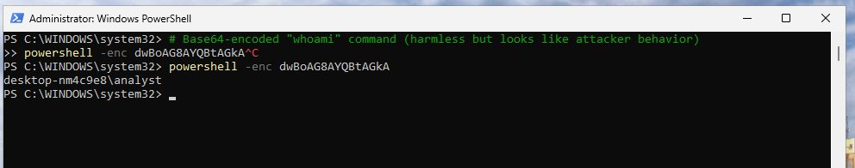
Figure: Screenshot 1 — PowerShell: powershell -enc dwBoAG8AYQBtAGkA executing and returning desktop-nm4c9e8\analyst
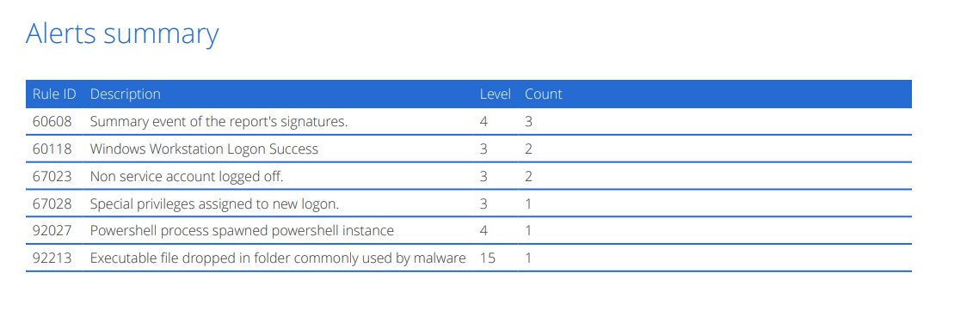
Figure: Screenshot 2 — Wazuh Alerts Summary showing Rules 92027, 92213 (Level 15), and authentication events
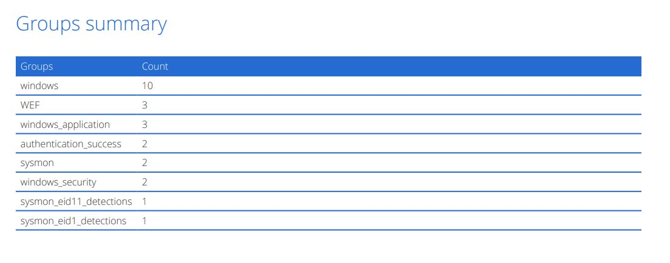
Figure: Screenshot 3 — Wazuh Groups Summary: sysmon_eid1_detections, authentication_success, WEF, windows_security

3.2 Command Artefacts
Artefact | Value | Location / Source
Process Name | powershell.exe | Sysmon EID 1 — process creation log
Command Line | -enc dwBoAG8AYQBtAGkA | Sysmon EID 1 CommandLine field
Decoded Command | whoami | PowerShell ScriptBlock Log (EID 4104) if enabled
Output | desktop-nm4c9e8\analyst | Console output — user and hostname
Parent Process | powershell.exe (Rule 92027) | PowerShell spawned from another PowerShell instance
User Context | analyst | Standard domain user — not elevated at execution time
Host | desktop-nm4c9e8 | Target workstation hostname

4. SIEM Detection Analysis (Wazuh)

4.1 Alert Rules Triggered
Rule ID | Description | Level | Count
60608 | Summary event of the report's signatures | 4 | 3
60118 | Windows Workstation Logon Success | 3 | 2
67023 | Non service account logged off | 3 | 2
67028 | Special privileges assigned to new logon | 3 | 1
92027 | PowerShell process spawned PowerShell instance | 4 | 1
92213 | Executable file dropped in folder commonly used by malware | 15 | 1

4.2 Alert Groups Summary
Group | Count | Significance
windows | 10 | General Windows event log activity
WEF | 3 | Windows Event Forwarding — security events forwarded to SIEM
windows_application | 3 | Windows Application log entries
authentication_success | 2 | Successful authentication events detected
sysmon | 2 | Sysmon process/file event telemetry
windows_security | 2 | Windows Security audit log events
sysmon_eid11_detections | 1 | Sysmon EID 11 — file creation (malware-folder drop)
sysmon_eid1_detections | 1 | Sysmon EID 1 — process creation (PowerShell spawned)

4.3 Key Detection Analysis
Rule 92027 — PowerShell Process Spawned PowerShell Instance (Level 4):
Directly maps to the encoded command execution. Wazuh detected that a PowerShell process launched another PowerShell process with the -enc parameter — a classic indicator of nested or obfuscated execution chains. This rule fired specifically because the parent process was also PowerShell, suggesting the attacker was already operating within a PowerShell session.

Rule 92213 — Executable Dropped in Malware-Common Folder (Level 15 — CRITICAL):
The highest severity alert (Level 15). This confirms an executable was dropped into a path commonly associated with malware staging — tying this attack to the broader campaign. This may refer to payload.exe from Attack 5 or a new executable written during this session. Requires immediate forensic triage.

Rules 60118 / 67023 / 67028 — Logon Success / Logoff / Special Privileges (Level 3):
These authentication events indicate the analyst account was actively authenticated during the attack window. Rule 67028 (Special privileges assigned to new logon) is particularly notable — it suggests elevated privileges were assigned at logon, potentially via the "hacker" admin account created in Attack 3 or the SYSTEM task from Attack 5.

Sysmon EID 1 Group — sysmon_eid1_detections (1 hit):
Sysmon EID 1 captured the process creation event for the encoded PowerShell invocation. This provides the command-line telemetry that Wazuh used to trigger Rule 92027. The -enc parameter is captured in the CommandLine field even though the payload itself is obfuscated.

Authentication_success Group (2 hits):
Successful authentication events during the attack window. In the context of an ongoing intrusion, these may represent the attacker using the backdoor "hacker" account (Attack 3) or the system account context established by the scheduled task (Attack 5) to authenticate and execute the encoded command.

5. Attack Chain Context
Attack 6 represents the execution phase of a multi-stage intrusion. Viewed across all observed attacks, the campaign follows a coherent kill chain:

# | Attack | Technique | Role in Chain
3 | Create Local Admin User | T1136.001 | Persistence: backdoor admin account
4 | Registry Run Key | T1547.001 | Persistence: payload auto-runs at logon
5 | Scheduled Task | T1053.005 | Persistence + Priv Esc: SYSTEM-level task
6 | Encoded PowerShell | T1059.001 | Execution + Recon: confirms user context via obfuscated command

The whoami output confirms the attacker is executing as analyst (standard user) at this point — suggesting either the SYSTEM scheduled task (Attack 5) has not yet triggered a logon, or the attacker is confirming the unprivileged context before using the Attack 3 backdoor account for elevated operations.

6. MITRE ATT&CK Mapping
Tactic | Technique | Sub-Technique | Evidence
Execution | T1059 — Command & Scripting Interpreter | T1059.001 — PowerShell | powershell -enc dwBoAG8AYQBtAGkA
Defense Evasion | T1027 — Obfuscated Files or Info | T1027.010 — Command Obfuscation | Base64 encoding of whoami via -enc parameter
Discovery | T1033 — System Owner/User Discovery | — | whoami → desktop-nm4c9e8\analyst
Defense Evasion | T1059.001 — Script Block Logging Bypass | — | Encoded command evades string-match signatures

7. Impact Assessment
Impact Category | Assessment | Risk
Immediate Payload Impact | whoami is benign — no direct damage from this specific command | LOW
Technique Risk | Same -enc vector trivially delivers reverse shells, downloaders, credential dumpers | CRITICAL
Detection Evasion | Encoded commands bypass most AV/EDR string-match signatures | HIGH
Recon Value | Confirmed user context and hostname for attacker's targeting decisions | MEDIUM
Escalation Path | Combined with Attack 3 admin account and Attack 5 SYSTEM task — full compromise | CRITICAL
Logging Gap | Without PS ScriptBlock Logging (EID 4104), future payloads may not be captured | HIGH

8. Recommendations

8.1 Immediate Actions
- Enable PowerShell Script Block Logging (Event ID 4104) immediately — without it, all future -enc payloads will not be decoded in logs.
- Enable PowerShell Module Logging (Event ID 4103) and Transcription logging.
- Investigate Rule 92213 (Level 15 executable drop) — identify and analyse the dropped file urgently.
- Review all Sysmon EID 1 events for the attack window for additional -enc invocations not captured in this summary.

8.2 Detection Hardening
- Create Wazuh rule alerting on powershell.exe command lines containing -enc, -EncodedCommand, or -e flags.
- Alert on Base64-pattern strings in PowerShell command lines (Rule 92041 pattern — already deployed for registry, extend to process creation).
- Enable Windows Event Forwarding (WEF) for EID 4104 across all endpoints (WEF group already seen in Wazuh — extend coverage).
- Deploy AMSI (Antimalware Scan Interface) integration — intercepts encoded scripts before execution.

8.3 Preventive Controls
- Apply PowerShell Constrained Language Mode (CLM) for non-administrative users — blocks many encoded execution paths.
- Deploy AppLocker or WDAC to restrict PowerShell execution to signed scripts only.
- Implement Just Enough Administration (JEA) endpoints to limit PowerShell capabilities per role.
- Configure Windows Defender ASR rule: Block execution of potentially obfuscated scripts.

9. Conclusion
This investigation confirmed the use of Base64-encoded PowerShell execution (T1059.001) on a compromised Windows endpoint. While the specific decoded command (whoami) was benign, the technique represents a critical execution vector that trivially scales to deliver any payload — reverse shells, credential dumpers, or ransomware loaders — with the same obfuscated -enc syntax.

Wazuh's detection of Rule 92027 (PowerShell spawning PowerShell) and Rule 92213 (Level 15 executable drop) demonstrates that the attack chain is still active and expanding. The absence of Script Block Logging in the captured telemetry represents a significant detection gap that must be addressed immediately to prevent future encoded payloads from executing undetected.

Combined with Attacks 3, 4, and 5, this attack confirms a coordinated, multi-stage intrusion on the endpoint with established persistence at multiple levels, a backdoor admin account, a SYSTEM-level scheduled task, and active obfuscated code execution capability. Full incident response and host re-imaging should be considered.

END OF REPORT — CONFIDENTIAL — FOR AUTHORIZED PERSONNEL ONLY

