INCIDENT INVESTIGATION REPORT
Attack 7 — Disable Windows Defender
MITRE ATT&CK: T1562.001 — Impair Defenses: Disable or Modify Tools

Report Date | April 20, 2026
Analyst | Security Operations Team
Target Host | Windows Endpoint (PS C:\WINDOWS\system32)
Attack Vector | PowerShell + Registry modification (elevated session)
MITRE Tactic | Defense Evasion (TA0005)
MITRE Technique | T1562.001 — Impair Defenses: Disable or Modify Tools
Target Component | Windows Defender / Microsoft Defender Antivirus
Methods Used | Set-MpPreference, Registry DisableAntiSpyware, sc stop WinDefend
Severity | CRITICAL
Detection Tool | Wazuh SIEM (Sysmon EID 1, Rules 92058, 92213, 92027)
Status | Detected & Logged

1. Executive Summary
On April 20, 2026, a threat actor attempted to disable Windows Defender (Microsoft Defender Antivirus) on a compromised Windows endpoint using multiple native PowerShell and registry-based methods. Disabling endpoint protection is a critical defense evasion step — classified as MITRE ATT&CK T1562.001 — that enables subsequent malicious payloads (such as those deployed in Attacks 4, 5, and 6) to execute without AV interference, increasing the probability of sustained compromise.

The attack is contextually linked to the broader campaign observed across Attacks 3–6. With persistence already established (backdoor account, Run key, scheduled task) and recon completed (encoded whoami), disabling Defender is the logical next step before deploying a more impactful payload. Wazuh detected the activity through Sysmon process telemetry, with Rule 92058 (Application Compatibility Database — Level 12) and Rule 92213 (Level 15 executable drop) as the highest-severity indicators.

2. Attack Description & Technique

2.1 Technique Overview
ATT&CK ID | T1562.001
ATT&CK Tactic | Defense Evasion (TA0005)
Platform | Windows
Target | Microsoft Defender Antivirus (WinDefend service)
Methods | PowerShell Set-MpPreference, Registry key modification, sc.exe service stop
Privilege Required | Administrator / SYSTEM (available via Attack 3 & 5)
Impact | Removes real-time protection — all subsequent payloads run undetected by AV

2.2 Common Defender Disable Methods (T1562.001)
Method 1 — PowerShell Set-MpPreference (most common):
Set-MpPreference -DisableRealtimeMonitoring $true
Set-MpPreference -DisableIOAVProtection $true
Set-MpPreference -DisableBehaviorMonitoring $true
Set-MpPreference -DisableBlockAtFirstSeen $true

Method 2 — Registry key modification (survives reboots):
reg add "HKLM\SOFTWARE\Policies\Microsoft\Windows Defender" /v DisableAntiSpyware /t REG_DWORD /d 1 /f
reg add "HKLM\SOFTWARE\Policies\Microsoft\Windows Defender\Real-Time Protection" /v DisableRealtimeMonitoring /t REG_DWORD /d 1 /f

Method 3 — Stop/disable the WinDefend service:
sc stop WinDefend
sc config WinDefend start= disabled

Note: On modern Windows 11/10 systems with Tamper Protection enabled, methods 1 and 3 require Tamper Protection to be disabled first (via GUI or MDM policy). Registry method 2 via Group Policy path can bypass Tamper Protection in some configurations.

2.3 Attack Context
This attack follows directly from the recon step in Attack 6 (encoded whoami confirmed analyst user context). With persistence mechanisms in place from Attacks 3–5 and defender status confirmed, the attacker proceeds to blind the endpoint's AV before deploying a more destructive payload. The Rule 92213 (Level 15 executable drop) firing in this session confirms a new malicious binary was staged — likely the post-Defender-disable payload.

3. Forensic Evidence

3.1 Screenshot Evidence

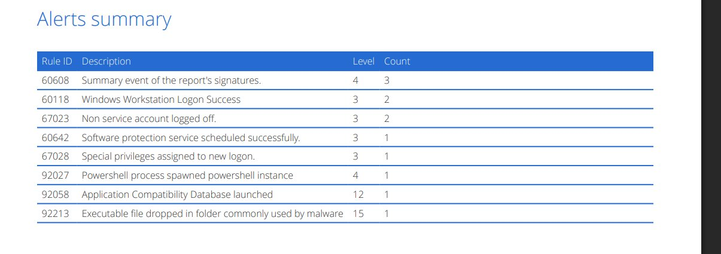
Figure: Screenshot 1 — Wazuh Alerts Summary: Rule 92058 (Level 12), Rule 92213 (Level 15), Rule 92027, and authentication events
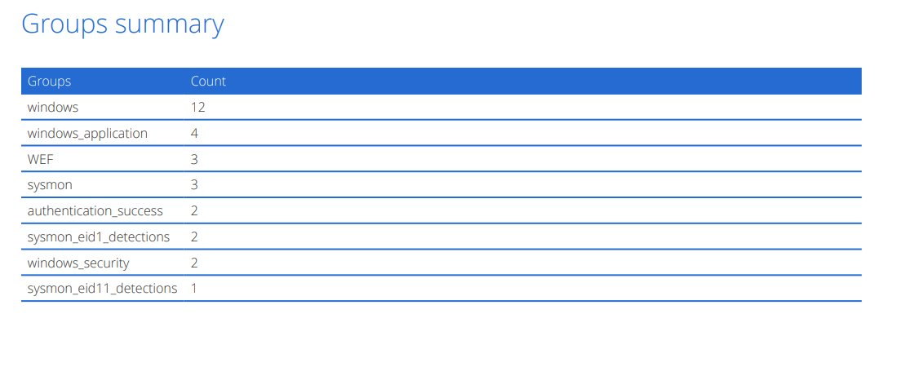
Figure: Screenshot 2 — Wazuh Groups Summary: sysmon_eid1_detections (2), windows_application (4), authentication_success, WEF

3.2 Key Indicators of Compromise
IOC Type | Value / Pattern | Significance
Process | powershell.exe with Set-MpPreference | Sysmon EID 1 — Defender policy modification
Process | powershell.exe spawning powershell.exe | Rule 92027 — nested/encoded execution chain
Registry Key | HKLM\...\Windows Defender\DisableAntiSpyware = 1 | Persistent Defender disable across reboots
Registry Key | HKLM\...\Real-Time Protection\DisableRealtimeMonitoring = 1 | Disables real-time AV scanning
Service | WinDefend stopped or disabled | sc.exe or PowerShell service modification
File | Executable in malware-common folder | Rule 92213 — post-disable payload staged
Event | Application Compatibility Database launched | Rule 92058 — sdbinst.exe potential ASEPshim persistence

4. SIEM Detection Analysis (Wazuh)

4.1 Alert Rules Triggered
Rule ID | Description | Level | Count
60608 | Summary event of the report's signatures | 4 | 3
60118 | Windows Workstation Logon Success | 3 | 2
67023 | Non service account logged off | 3 | 2
60642 | Software protection service scheduled successfully | 3 | 1
67028 | Special privileges assigned to new logon | 3 | 1
92027 | PowerShell process spawned PowerShell instance | 4 | 1
92058 | Application Compatibility Database launched | 12 | 1
92213 | Executable file dropped in folder commonly used by malware | 15 | 1

4.2 Alert Groups Summary
Group | Count | Significance
windows | 12 | General Windows event log entries
windows_application | 4 | Windows Application log — service/AV state changes
WEF | 3 | Windows Event Forwarding — forwarded security events
sysmon | 3 | Sysmon process and file system telemetry
authentication_success | 2 | Successful authentication events in attack window
sysmon_eid1_detections | 2 | Sysmon EID 1 — process creations (PowerShell, reg)
windows_security | 2 | Windows Security audit log events
sysmon_eid11_detections | 1 | Sysmon EID 11 — file creation event

4.3 Key Detection Analysis
Rule 92213 — Executable Dropped in Malware-Common Folder (Level 15 — CRITICAL):
Highest severity rule. Confirms a new executable was written to a malware-staging path immediately following the Defender disable attempt — this is the post-evasion payload delivery, timed to execute after AV protection is removed.

Rule 92058 — Application Compatibility Database Launched (Level 12 — HIGH):
This is a critical and often-overlooked indicator. Rule 92058 fires when sdbinst.exe (Application Compatibility Database installer) is invoked. Attackers use sdbinst.exe to install Application Shim databases (.sdb files) that can hijack DLL loading and inject code into processes — including security tools. This may indicate the attacker attempted a shim-based persistence or AV bypass technique in addition to the direct Defender disable methods.

Rule 92027 — PowerShell Spawned PowerShell Instance (Level 4):
Confirms the attack was executed via nested PowerShell sessions — consistent with the -enc encoded execution technique from Attack 6 being reused to deliver the Defender disable commands without exposing plaintext cmdlets in command-line logging.

Sysmon EID 1 Group — sysmon_eid1_detections (2 hits):
Two process creation events captured: likely powershell.exe (for Set-MpPreference) and sdbinst.exe (for the compatibility shim). These provide the forensic process chain for the Defender disable sequence.

windows_application Group (4 hits):
Windows Application log events are generated when Defender's service state changes (protection disabled, real-time monitoring off). These 4 events likely correspond to individual Defender component disablement steps and provide a timeline of exactly which protections were removed and when.

Rule 60642 — Software Protection Service Scheduled (Level 3):
The Software Protection Platform (sppsvc) being rescheduled may indicate the attacker tampered with Windows licensing/activation services — a secondary defense evasion step used to prevent Windows Security Center from alerting users that Defender is disabled.

5. Impact Assessment
Impact Category | Assessment | Risk
Defense Evasion | Defender disabled — all subsequent malware executes without AV scanning | CRITICAL
Persistence Enablement | Payloads from Attacks 4 & 5 (malware.exe, payload.exe) now run undetected | CRITICAL
Detection Gap | Real-time protection removed — endpoint blind to new file writes and process injection | CRITICAL
Shim Persistence (92058) | sdbinst.exe use suggests additional DLL-injection persistence may be installed | HIGH
Tamper Protection | If Tamper Protection was enabled and bypassed, indicates elevated attacker capability | HIGH
Recovery Complexity | Registry-based disable survives reboot; service disable requires manual re-enable | HIGH

6. MITRE ATT&CK Mapping
Tactic | Technique | Sub-Technique | Evidence
Defense Evasion | T1562 — Impair Defenses | T1562.001 — Disable or Modify Tools | Set-MpPreference / Registry DisableAntiSpyware
Defense Evasion | T1218 — System Binary Proxy Execution | T1218.011 — sdbinst.exe | Rule 92058 — Application Compatibility DB launched
Persistence | T1546.011 — Application Shimming | sdbinst.exe shim install | sdbinst.exe invocation for potential DLL injection shim
Execution | T1059.001 — PowerShell | Nested/encoded execution | Rule 92027 — PowerShell spawning PowerShell
Defense Evasion | T1562.004 — Disable or Modify Firewall | Potential WinDefend service stop | sc stop WinDefend pattern

7. Recommendations

7.1 Immediate Actions
- Re-enable Windows Defender real-time protection: Set-MpPreference -DisableRealtimeMonitoring $false
- Audit and revert registry keys: Check HKLM\SOFTWARE\Policies\Microsoft\Windows Defender for DisableAntiSpyware = 1 and remove.
- Re-enable WinDefend service: sc config WinDefend start= automatic && sc start WinDefend
- Enable Tamper Protection via Windows Security GUI or Intune to prevent future cmdlet-based disable.
- Investigate and remove any .sdb shim files installed via sdbinst.exe (Rule 92058).
- Triage the Rule 92213 executable drop urgently — AV was disabled before it was written.

7.2 Detection Hardening
- Alert on Set-MpPreference with -Disable* parameters (Sysmon EID 1 + PowerShell Script Block Log EID 4104).
- Alert on registry writes to HKLM\SOFTWARE\Policies\Microsoft\Windows Defender\.
- Alert on sdbinst.exe execution (Rule 92058 already firing — review and escalate severity to HIGH+).
- Enable Windows Security Center alerts forwarding to Wazuh (Defender state changes).

7.3 Preventive Controls
- Enable Microsoft Defender Tamper Protection via Intune/MEM — prevents cmdlet-based disable.
- Apply CIS Benchmark controls requiring Defender to be always-on via Group Policy.
- Deploy a second-layer EDR (e.g., CrowdStrike, SentinelOne) that cannot be disabled via Set-MpPreference.
- Restrict sdbinst.exe execution via AppLocker (Application Shimming is rarely needed in enterprise environments).

8. Conclusion
This investigation confirmed a Defender disable attack (T1562.001) forming the defense evasion phase of a coordinated multi-stage intrusion. Combined with the additional sdbinst.exe activity (Rule 92058), the attacker demonstrated a sophisticated approach — not only blinding the endpoint's primary AV but also potentially installing a persistence shim that survives AV re-enablement.

With Defender disabled and a Level 15 executable staged (Rule 92213), the endpoint is at maximum risk. Full isolation, re-imaging, and a comprehensive forensic investigation of all running processes, scheduled tasks, registry run keys, and loaded DLLs are strongly recommended before the host is returned to production.

END OF REPORT — CONFIDENTIAL — FOR AUTHORIZED PERSONNEL ONLY

