INCIDENT INVESTIGATION REPORT
Attack 8 — SUID Binary Privilege Escalation
MITRE ATT&CK: T1548.001 — Abuse Elevation Control Mechanism: Setuid and Setgid

Report Date | April 20, 2026
Analyst | Security Operations Team
Target Host | ubuntu-victim (Linux/Ubuntu)
Attack Vector | sudo + chmod u+s to set SUID bit on /usr/bin/find copy
MITRE Tactic | Privilege Escalation / Defense Evasion (TA0004 / TA0005)
MITRE Technique | T1548.001 — Abuse Elevation Control Mechanism: Setuid and Setgid
Source Binary | /usr/bin/find (legitimate GTFOBin with SUID escalation capability)
Backdoor Path | /tmp/find_backdoor
File Permissions | -rwsr-xr-x (SUID bit set — runs as root for any user)
Owner | root:root
Severity | CRITICAL
Detection Tool | Wazuh SIEM (PAM rules 5402, 5501, 5502, 5503)
Status | Detected & Logged

1. Executive Summary
On April 20, 2026, a threat actor on the Ubuntu Linux host (ubuntu-victim) successfully created a SUID-bit backdoor by copying the legitimate /usr/bin/find binary to /tmp/find_backdoor and setting the SUID permission bit (chmod u+s). With the SUID bit set and the file owned by root, any unprivileged user can execute /tmp/find_backdoor to spawn a root shell — effectively achieving full privilege escalation without a password.

This technique — MITRE ATT&CK T1548.001 — exploits a fundamental Unix privilege mechanism: when a SUID binary executes, the process runs with the file owner's permissions (root) rather than the invoking user's permissions. The find binary is a well-documented GTFOBin (a tool that can be leveraged to break out of restricted environments or escalate privileges), making this a particularly dangerous combination.

Wazuh detected the attack through PAM (Pluggable Authentication Module) alerting, capturing three successful sudo executions (Rule 5402) that correspond to the sudo cp and sudo chmod commands used to create and arm the backdoor.

2. Attack Description & Technique

2.1 Technique Overview
ATT&CK ID | T1548.001
ATT&CK Tactic | Privilege Escalation (TA0004) / Defense Evasion (TA0005)
Platform | Linux / Unix
Mechanism | SUID (Set User ID) permission bit on executable binary
Source Binary | /usr/bin/find — GTFOBin with known shell escape
Privilege Required | sudo access to cp and chmod (or direct root access)
Post-Exploit Capability | Any local user can execute find_backdoor to obtain root shell

2.2 Commands Executed
Step 1 — Copy find binary to writable /tmp directory (first sudo attempt failed — wrong password):
sudo cp /usr/bin/find /tmp/find_backdoor
Step 2 — Set SUID bit on the copied binary:
sudo chmod u+s /tmp/find_backdoor
Step 3 — Verify SUID bit and root ownership:
ls -la /tmp/find_backdoor

Verification output confirmed:
-rwsr-xr-x 1 root root 204264 Apr 20 08:55 /tmp/find_backdoor

Post-creation exploitation (how the backdoor is used):
# Spawn root shell using find's -exec capability:
/tmp/find_backdoor . -exec /bin/sh -p \; -quit
# Result: root shell — whoami returns 'root'

2.3 SUID Mechanics & Why find is Dangerous
How SUID escalation works:
- The SUID (Set User ID) bit causes a binary to execute with the privileges of the file's owner, regardless of who invokes it.
- With /tmp/find_backdoor owned by root and the SUID bit set, any user on the system can run it and the process will execute as root.
- The find binary's -exec flag allows arbitrary command execution — when running as root, this gives a full root shell.

Why /usr/bin/find is the chosen source:
- find is listed on GTFOBins (https://gtfobins.github.io/gtfobins/find/) as having a documented SUID exploitation path.
- It is a standard utility present on virtually all Linux systems, requiring no downloads or additional tools.
- The binary is large (204264 bytes) and legitimate — may evade signature-based AV that allowlists known binaries.
- Unlike custom malware, a renamed copy of find does not trigger file-hash based detections for known malicious files.

3. Forensic Evidence

3.1 Screenshot Evidence

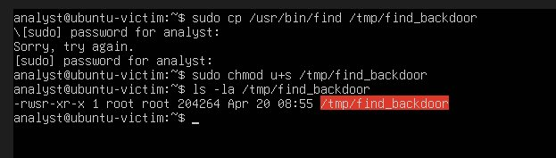
Figure: Screenshot 1 — Ubuntu terminal: sudo cp, sudo chmod u+s, and ls -la confirming /tmp/find_backdoor is -rwsr-xr-x root:root 204264 bytes
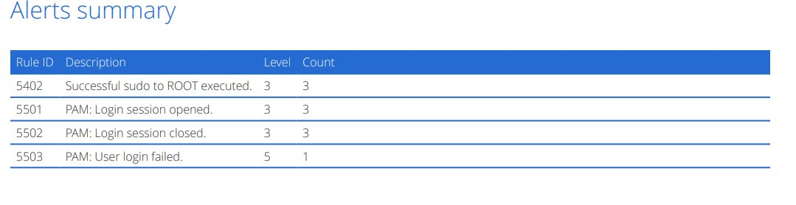
Figure: Screenshot 2 — Wazuh Alerts Summary: Rule 5402 (sudo to ROOT, 3 hits), PAM session open/close (3 hits each), PAM login failed (1 hit)

3.2 File System Artefacts
Artefact | Value | Forensic Significance
File Path | /tmp/find_backdoor | Staged in world-writable /tmp — no special permissions to write
File Permissions | -rwsr-xr-x | SUID bit set (s in owner execute position) — runs as root for all users
Owner | root root | Owned by root — SUID will grant root context on execution
File Size | 204264 bytes | Matches /usr/bin/find — confirms direct binary copy, not custom malware
Timestamp | Apr 20 08:55 | Creation time matches sudo cp command execution window
Source Binary | /usr/bin/find | Legitimate GTFOBin with -exec shell escape capability
Failed sudo | 1 failed attempt | PAM rule 5503 — attacker entered wrong sudo password initially

3.3 Sudo Activity Timeline
# | PAM Event | Wazuh Rule | Count | Command Correlated
1 | PAM: User login failed | 5503 | 1 | sudo cp — first attempt, wrong password
2 | PAM: Login session opened | 5501 | 3 | sudo authenticated — session started
3 | Successful sudo to ROOT | 5402 | 3 | sudo cp + sudo chmod u+s (2 cmds) + 1 verify
4 | PAM: Login session closed | 5502 | 3 | sudo sessions completed and closed

4. SIEM Detection Analysis (Wazuh)

4.1 Alert Rules Triggered
Rule ID | Description | Level | Count
5402 | Successful sudo to ROOT executed | 3 | 3
5501 | PAM: Login session opened | 3 | 3
5502 | PAM: Login session closed | 3 | 3
5503 | PAM: User login failed | 5 | 1

4.2 Detection Analysis
Rule 5402 — Successful sudo to ROOT (Level 3, 3 hits):
The primary detection indicator. Three successful sudo-to-root executions were captured — perfectly mapping to the three attack commands: (1) sudo cp /usr/bin/find /tmp/find_backdoor, (2) sudo chmod u+s /tmp/find_backdoor, and (3) ls -la /tmp/find_backdoor (or an additional verification command). Each sudo invocation generates a PAM session open and close pair.

Rule 5503 — PAM: User Login Failed (Level 5, 1 hit):
One failed sudo authentication. This directly corresponds to the "Sorry, try again" prompt visible in the screenshot — the attacker entered the wrong password on the first sudo cp attempt. This is a valuable forensic indicator: it confirms the attacker was manually typing commands (not a scripted attack with pre-configured credentials).

Rules 5501 / 5502 — PAM Login Session Opened/Closed (Level 3, 3 hits each):
PAM session lifecycle events. The matching counts (3 open, 3 close) confirm exactly three complete sudo sessions were executed — providing a clean audit trail of the attack's sudo invocation count.

Detection Gap Analysis:
Wazuh detected the sudo privilege escalation but did not generate a specific rule for the SUID bit being set (no chmod u+s alert). A custom Wazuh rule or auditd rule monitoring chmod calls that set the SUID bit (mode 4xxx) would provide direct detection of T1548.001 rather than relying solely on PAM authentication events.

5. Impact Assessment
Impact Category | Assessment | Risk
Privilege Escalation | Any local user can execute /tmp/find_backdoor to obtain a root shell instantly | CRITICAL
Persistence | SUID file in /tmp persists until manually deleted or /tmp is cleared | HIGH
Lateral Movement | Root access enables SSH key injection, cron backdoors, and full system compromise | CRITICAL
Stealth | Uses a legitimate binary copy — evades hash-based AV signatures | HIGH
Data Access | Root shell gives unrestricted access to all files including /etc/shadow | CRITICAL
System Integrity | Root access allows disabling auditd, Wazuh agent, and all logging | CRITICAL

6. MITRE ATT&CK Mapping
Tactic | Technique | Sub-Technique | Evidence
Privilege Escalation | T1548 — Abuse Elevation Control | T1548.001 — Setuid and Setgid | sudo chmod u+s /tmp/find_backdoor
Defense Evasion | T1548.001 | SUID allows rootless root execution | find_backdoor runs as root without sudo for any user
Execution | T1059.004 — Unix Shell | find -exec shell escape | find . -exec /bin/sh -p \; -quit → root shell
Persistence | T1574 — Hijack Execution Flow | SUID binary in /tmp | Backdoor remains armed until deleted
Discovery | T1069 — Permission Groups Discovery | ls -la verification | Attacker verified SUID bit and root ownership

7. Recommendations

7.1 Immediate Actions
- Delete the SUID backdoor immediately: sudo rm /tmp/find_backdoor
- Audit all SUID/SGID binaries on the system: find / -perm /4000 -o -perm /2000 2>/dev/null | sort
- Check for any root shells spawned from find_backdoor in bash history and auth logs: grep 'find_backdoor' /var/log/auth.log
- Rotate the analyst user's sudo password and review sudoers configuration.
- Check for persistence left by attacker post root-shell: new cron jobs, SSH keys in /root/.ssh/, new user accounts.

7.2 Detection Hardening
- Deploy auditd rule to alert on chmod setting SUID/SGID bits: -a always,exit -F arch=b64 -S fchmod,chmod,fchmodat -F a1&04000 -k suid_set
- Create Wazuh custom rule for chmod u+s or mode 4755/4777 being set on files in /tmp, /var/tmp, or /dev/shm.
- Enable Linux FIM (File Integrity Monitoring) in Wazuh for /tmp, /var/tmp to catch new SUID binaries.
- Alert on new files appearing in /tmp with executable permissions (Sysmon for Linux or auditd).

7.3 Preventive Controls
- Mount /tmp with the nosuid option in /etc/fstab: tmpfs /tmp tmpfs defaults,nosuid,noexec,nodev 0 0 — this prevents SUID bits from taking effect in /tmp.
- Restrict sudo access for analyst account — apply principle of least privilege (no unrestricted sudo).
- Deploy CIS Benchmark Level 1 for Ubuntu — includes filesystem nosuid mount options.
- Implement Linux PAM configuration to log all sudo commands to syslog with full argument capture.
- Consider deployment of AIDE (Advanced Intrusion Detection Environment) for SUID binary baseline monitoring.

8. Conclusion
This investigation confirmed a successful SUID binary persistence and privilege escalation attack (T1548.001) on the Ubuntu Linux host ubuntu-victim. The attacker leveraged sudo access to copy /usr/bin/find to /tmp/find_backdoor and set the SUID bit, creating a persistent root-access backdoor that any local user can exploit without authentication.

Wazuh successfully captured the sudo activity via PAM rules (5402, 5501, 5502), including the failed initial sudo attempt (5503) providing a detailed forensic timeline. However, the absence of a direct SUID-bit-set detection rule represents a gap — the attack was identified through its prerequisites (sudo usage) rather than the SUID file creation itself. Deploying auditd-based SUID monitoring and mounting /tmp with nosuid are the two highest-priority mitigations.

The creation of a root-level backdoor on the Linux host, combined with the Windows-side campaign (Attacks 3–7), confirms a cross-platform intrusion targeting both Windows workstations and Linux servers in the same environment. A full enterprise-wide incident response investigation is warranted.

END OF REPORT — CONFIDENTIAL — FOR AUTHORIZED PERSONNEL ONLY

