Link: https://youtu.be/fDODh7Ne2Ww

# Derivatives

Derivatives are the elements that derive their value from their underlying asset

Below are the examples:

1. A 10₹ note and 2000₹ are of same material, but the RBI governor sign on it is indicating that the 2000₹ note is of 2000 value differentiates 10₹ and 2000₹. HERE THE SIGN IS THE DERIVATIVE AND POWER OF RBI GOVERNER IS THE UNDERLYING ASSET
2. In a contract of land buying. The sellers sign on the contract paper for advance (token amount), acceptance will stop seller from selling the land for a certain period of time (as per contract) and gives buyer to buy the land at a same price for a certain period of time, meanwhile seller has the edge of taking the token amount as profit if the seller is not able to provide the money in stipulated amount of time. HERE THE SIGNATURE IS THE DERIVATIVE AND THE OWNERSHIP OF LAND, THE SELLER HAS IS THE UNDERLYING ASSET

## Categories of derivatives

Derivatives are categorized in to 4 types

1. Forwards
   1. Physical contracts that are generally used in everyday life, stock markets use their next version FUTURES
2. Futures
3. Options
4. Swaps

Expiry in futures is categorized in to 3 types:

1. Near
   1. If you are in OCT 2022 and if you buy ICICI future contract of the same month i.e., ICICIBANK OCT FUT, then that is called Near expiry
2. Next
   1. If you are in OCT 2022 and if you buy ICICI future contract of the next month i.e., ICICIBANK NOV FUT, then it is called next expiry
3. Far
   1. If you are in OCT 2022 and if you buy ICICI future contract of the month after the next month, i.e., ICICIBANK DEC FUT, then it is called far expiry

# What are Futures

Futures is also a contract, like other contracts has an expiry date, futures also has an expiry date.

You can buy/sell futures

## What is a lot size?

A lot size is the measure for a future scrip contract, a lot size can be better explained with banana analogy: we can buy banana’s in dozen, whereas one dozen of bananas =12. Similarly we can buy future scrip in lots

### Points to note:

All scrips does not have same lot size, in general scrips of higher share price will have less number of units as lot count, scrip price is inversely proportional to lot size

|  |  |  |  |
| --- | --- | --- | --- |
| scrip name | scrip price | lot size | price required to buy future of scrip = scrip price * lot size |
| tata motors | 409 | 1425 | 582825 |
| TCS | 3163 | 150 | 474450 |

## Is it mandatory to have the above-mentioned amount?

No, it is not required to have all amount before expiry, you need to have the amount mentioned by the broker, **but on the date of expiry you need to have the amount if you want to proceed with the contract, more details on this will be covered in the later parts of this documentation.**

## How do future prices increase or decrease?

If the underlying scrip price increase, then future price increase, and vice-versa with price decrease (with a few variables (like gamma, theta, Vega and delta) involved).

## Why are Futures used (for whom was it intended, and who are using it now)?

Futures are introduced for hedging

### What is hedging?

Hedging means **protect oneself against loss on (a bet or investment) by making balancing or compensating transactions.**

### How is hedging needed in stock market- an analogy

#### How investors are meant to be using it

Let’s say you are holding 3000 tata motors shares and the company is going to post its quarterly results in 3 days, all other automobiles companies posted bad results, therefore you are thinking that tata motors is also going to post results on similar lines with other automobile companies, which will lead to loss of your portfolio value, but you already know that tata motors is a good company with strong fundamentals, and the fall in share price is going to be temporary, so instead of selling your 3000 tatamo shares (which might lead to charges and other headaches), you can sell 2 lots of tatamo future scrip and buy them later at a fallen price, therefore the price fall in your original shares is covered up by the future lot you sold, a brief calculation is below

|  |  |  |  |  |  |
| --- | --- | --- | --- | --- | --- |
| scrip name | scrip price | shares held | price required | fall in price | loss incurred per share |
| tata motors | 409 | 3000 | 1227000 | 80 | 240000 |
|  |  |  |  |  |  |
| future scrip | scrip price at which you sold | lot size | lots held |  |  |
| tata motors nov | 409 | 1425 | 2 |  |  |
|  | scrip price at which you bought (409-80(loss incurred per share)) |  |  | profit occurred |  |
|  | 329 |  |  | 228000 |  |
|  |  |  |  |  |  |
| loss minimized because of hedge: | loss without hedging | = loss incurred per share -profit occured |  |  |  |
|  | 240000 | 12000 |  |  |  |

#### How are traders using it?

##### For selling

Actually you can not carry a sell position in the normal scrip for more than one trading day, but traders who are sure that a scrip is going to fall, will **sell** the future scrip and **buy again at a lower price** to take profits, but there is a **downfall to it** as well, if after selling the scrip, if the scrip starts going up instead of falling down, then trader has to pay extra amount (which will be his loss), vice a versa applies for buying as well

##### For buying

Traders who are sure that the scrip is going to go up and they think they need to buy more with the less amount, they have, they will **buy** the scrip and **sell** later again at a **higher price**

#### Why traders prefer buying futures and options (FNO) rather than buying/selling actual scrips

Buying/selling actual scrips require more money and also selling actual scrips can’t be more than one day(in delivery or intraday)

If you are buying 1500 shares of tata motors, you need 6,00,000

But to buy FNO contract you need around 40% of 6,00,000

### What happens if buyer/seller holds his future scrip till expiry

Theoretical explanation

From seller point of view:

On expiry he has to give the lot (number of shares) to the buyer and receive share price*lot amount

From buyer point of view

On expiry he has to give money to seller and has to get shares in return

Example explanation:

Contract name: OCT 2022 SBI FUT contract

Price: 310

Lot size: 3000

If a seller and buyer are involved in contract, then

buyer has to give 3000*310 = 930000 rupees to buyer even **if sbi share price is 400 or 200 or 0**

seller has to give 3000 shares (lot size) to seller and receive 930000 from seller **irrespective of share price**

#### What if seller does not maintain shares or buyer does not have enough money in their account:

The broker will check for relevant requirements 2 or 5 days before and will try to inform you over call or other communication channel and then square off the position in case you don’t have needed requirements

## Other advantages of Futures

Video link: https://youtu.be/3Dt_orPGZBo

Not only stocks, we have metals, Agri commodities, crude oil and water also have Futures

Let’s take the example of gold and try to explain it with an analogy

### An question here: How do gold shops make profit?

We are generally under the assumption that people involved in gold business try to buy bulk gold, when the price is cheaper and make ornaments and sell them. BUT WE ARE WRONG…

There is a saying **only two people know top and bottom of the market, GOD and THE LIAR. AND trying to time the price is similar to GAMBLING, because price depends upon various factors, let’s say the price of gold is X, if the next moment America declares war on Russia, the gold price might become 2X, if the india discovers a gold mine which is almost equal mining of gold that is discovered till date, then the gold price might become X/2**

I am fairly fantasizing the example, but only **a idiot does business on speculation**

**So, coming to the question again how does jewellery companies do business?**

They just make profits on the making charges, then how do they maintain same profit on fluctuating prices (if they bought gold at 100 rupees and making charge is 10 rupees so totally it is 110, if the next day gold price falls to 80 rupees, then they cant sell it at 110 because people wont buy gold if it is sold at a higher price, so they have to sell at 90 rupees (80 rupees gold price + 10 rupees making charge) but if they sell at 90 they are at effective loss of 20), the ANSWER is FUTURES OF GOLD,

If they buy 1kg gold at x rupees, then they will sell futures of 1kg gold at x rupees, so that if the price increases the future contract they sold will be at loss, but the value of the gold they are holding will increase. So now if they maintain healthy margin of making charges, they can be profitable all the time.

### Why should people deal with futures of metals or commodities or oils

Crude oil is needed for paint companies, tyre companies

Metals are needed for automobile companies, infra companies

Commodities are needed for countries

**Apply the same logic of above gold example to all these scenarios**

### When should you deal with futures

You should be dealing with futures in three scenarios

#### Scenario 1- if you have already bought the stock and you need to protect from future fluctuations

If you **buy** x amount of an item at y price, then **sell** same amount of futures of the same item at the Y price

#### Scenario 2- if you don’t have the item with you and you want to protect yourself from future fluctuations

if you have money, but if the commodity is not available then you can **buy** required amount of commodity **future** prices at current time

#### scenario 3- if you want to speculate and earn money

you can sell futures, if you think corresponding commodity price is going to fall, then **selling** commodity futures, and **buying** if Vice a versa happens

## Expiry

There are two types of expiries based on duration

### Weekly expiry

Available in Options (that too only for Indexes like Nifty, BankNifty)

When do weekly option contracts expire?

Weekly contracts expire on Thursday, if it is a holiday, then working day before that Thursday will be the expiry day.

### Monthly expiry

Available in both Futures and Options

When do Monthly option/futures expire?

Monthly contracts expire on last Thursday of the month, if it is a holiday, then the working day before that Thursday will be the expiry day

## spot price, future price

the price of the underlying asset is called spot price

the price of a future contract of the underlying asset is called future price

## settlement types

there is 2 types of settlement available

### Cash settlement

Before July 2018, cash settlement is an option, in cash settlement, lets assume

1: you bought tatamotors future contract on 4th nov 2022 at 330 and expiry is at 24th nov 2022 and you held it till expiry and at expiry the price is 340, 10₹ profit*lot size(5700) = 57000₹ will get credited to your demat account

2: you sold tatamotors future contract on 4th nov 2022 at 330 and expiry is at 24th nov 2022 and you held it till expiry and at expiry the price is 340, 10₹ loss*lot size(5700) = 57000₹ will get debited to your demat account

### Physical settlement

From July 2018, sebi implemented physical settlement in order to avoid speculation(of people wantedly buying contracts and then settling in cash (as it requires only less money)), in physical settlement, **if you are a buyer- you need to have required amount (future price* lot amount) to hold the contract till expiry, if you are a seller- you need to have required amount(number of lots*lot size) of shares in your demat**

lets assume

1: you bought tatamotors future contract on 4th nov 2022 at 330 and expiry is at 24th nov 2022 and you held it till expiry and at expiry the price is 340, you need 330 (buying price) *5700 = 18,81,000 in your account to carry it on till expiry, if the required amount is not there in your account a couple of days (time frame is decided by the broker or exchange(ex:NSE)) before the expiry then your contract will get squared off (sold or exited)

2: you sold tatamotors future contract on 4th nov 2022 at 330 and expiry is at 24th nov 2022 and you held it till expiry and at expiry the price is 340, you need to have 5770 shares at 330 rupees in your demat a couple of days (time frame is decided by the broker or exchange(ex:NSE)) before the expiry then your contract will get squared off (sold or exited)

### Types settlements for different instruments

Equity -> physical

Index -> cash

Commodities -> physical for few, cash for few

Currency -> cash

## margin and settlement concept

margin – how much amount is needed to buy/sell a contract or instrument

### how much money we need to buy/sell futures

delivery (NRML margin), intraday types

Buying and selling of future can be of 2 types

1: Delivery (holding for more than 1 day)

2: Intraday (holding for one day)

Money that we need to buy/sell a contract is **same for both intraday and delivery**. The amount that needs to be there to buy them will **slightly differ from broker to broker**

You can get the details of the amount needed by your broker by googling the “<broker name> margin calculator” ex link: <https://zerodha.com/margin-calculator/SPAN/>

### how profit/loss or settled in futures

profit/loss settles on day-to-day basis

let’s say today is 6th November 2022. And 7th you bought a future contract and you don’t have any balance left in your account

|  |  |  |
| --- | --- | --- |
| date | profit/loss | cumulative profit/loss |
| 07-11-2022 | 10000 | 10000 |
| 08-11-2022 | 15000 | 25000 |
| 09-11-2022 | -40000 | -15000 |

If by 9th November 2022, if you don’t maintain 15000 in your account so that the broker than settle your 15000 losses, then you will attract extra penalty and broker gets the right to terminate your contract altogether.

Doubt: does the contract gets squared off the next day we does not maintain balance, or does it wait till the contract expiry?

It is always suggested to maintain 50% of the contract value as an additional bonus to avoid the beginners mistake of attracting penalty

## Future Pricing or option pricing (V imp)

Future price is proportional to the remaining days of expiry

the price of the current month contract < price of next month contract

### formula to calculate ideal future pricing

#### Why this formula is of less relevance/importance

No matter how much you calculate, you are ultimately going to buy at the price which is available in the market

Also, there are very big people with most advanced systems and more professionals looking at these and trying to get them at the best price, the goal as of now for us will be to just focus on the initial earnings and then to focus on these types of things later

**Most of the times, The price that is there in the market- it is there for a reason and the price always tries to find its balance, so don’t give much importance(but give importance it deserves) to the price**

### Factors influencing contract price

1. Number of days left till expiry – **spot price>near expiry>next expiry>far expiry**
2. Dividend – if a company gives dividends, that’s deducted from stock price, then you also have to deduct it from future contract price
3. Market sentiment – if there are bullish sentiments, then buyers increase, therefore prices of stocks and future contracts increase, vice-a-versa for bearish contract

#### When does future price<spot price

1. When there is a dividend announced formula
2. When there is panic in market

# Options

Link: https://youtu.be/c0jOlM5yByw

## Why should we learn options carefully

**Options is important** because 85% of the profit comes from options, **options is dangerous** because 90% of the traders like us lose money in options

## What is call or put

If you think market/particular stock option is going to increase, then you will **buy** call option

If you think market/particular stock option is going to increase, then you will **buy** put option

**If call buy option contract value is indirectly proportional to put buy option contract value, and vice-a-versa applies for sell as well**

### Relation between spot price (it is stock price), future price, call price and option price

Spot price is directly proportional to future price and call price

Spot price is indirectly proportional to put option price

### When to buy what

If you think a stock is going to go up, then

1. Buy that stock or
2. Buy that stock’s future option
3. Buy that stock’s call option
4. Sell that stock’s put option

If you think a stock is going to go down then

1. Sell that stock or
2. Sell that stock’s future option
3. Sell that stock’s call option
4. Buy that stock’s put option

## Similarities between futures and options

* They have same lot size
* They almost have similar settlement with slight variation
* Both have OI

## What process happens between an option buyer and option seller during a **call** transaction

Before we understand, what happens between a buyer and seller, let us go through an analogy

### An analogy

Lets say there is a land, and there is an insider speculation that a ring road is coming near it, so you go to the land owner and say let us make an agreement for 5 months, I am giving you a **token amount** of 10,000 if I come within 5 months and ask you for this land you should sell me at a fixed price of 50 lakhs, if I don’t come within stipulated time, you can keep the token amount and sell it to someone else at the price of your wish

### Real time example

Let’s say there is tatamotors spot price at 330 and you buy call option tatamotors 330 CE (call option) at 15 rupees (**premium**), then you have to pay 15*5700 (lot size) = 85500 to seller so that **seller will offer the 5700 tatamotors shares at 330 rupees on expiry,** because **option buyer has the right to ask shares at the prefixed rate, but seller cannot force buyer to buy the stocks**

If anyone is buying the option tatamotors 330 CE (here strike price of the contract is 330), then he/she is under the assumption that the stock is going to go up, if anyone is selling the option tatamotors 330 CE, then he/she is under the assumption that the stock is going to go down or will be staying at 330 or 330+premium price range

### Different types of cases (possibilities) **on expiry day**

Lets say seller sold tatamotors 330 ce to buyer at 15 premium

|  |  |  |  |
| --- | --- | --- | --- |
| case | Buyer at | seller at | explanation |
| if expiry happens at 330 | loss | profit | if the expiry happens at the same price of the contract, then the buyer can get the stocks from open market at the same price and then the seller can have the token amount(15*5700), the buyer loses the token amount |
| if expiry happens at 330+premium(15) i.e, 345 | no loss | no loss |  |
| if the expiry happens above 330+premium(15) i.e., 350,360… | profit | loss | the profit for the buyer is (expiry price - (entry price + premium)) * lot size |
| if the expiry happens below 330 i.e., 280,260… | loss | profit | Token amount 85500, because the buyer does not have any mandatory rule to buy, he can buy if he wants, but no buyer wants to buy at loss |

The seller utmost can have the token amount as profit (because if the price happens to fall below the contract, the buyer will forgo the token amount), but the buyer can have utmost profit because, if the contract happens at 330 and the stock price goes to 1000 or even more before expiry, still the seller has to sell the lot at 330 per share, which is a loss to seller but unlimited profit to buyer

Risk profile

Buyer- risk limited, profit unlimited

Seller- risk unlimited, profit limited

### Important point to note

In the above discussed table **we discussed all scenarios at expiry date,** in all the above scenarios buyer has only one scenario where he gets profit

**But is it the only case where buyer gets profit?**

**No, there is another scenario where the option buyer can have profit**

let’s say the buyer has purchased tcs 3500 ce at 5 premium, the next day underlying stock moved up because of some positive news, then let’s say premium moved up to 10, then [(current premium - buying premium)*lot size] (10-5)*200 will be the profit

## put and call

link <https://youtu.be/Wd7uothcx5g>

#### what is put

if a option trader thinks that market/scrip is going to fall, then he will buy a put contract

##### a put option buyer is in profits when

when stock price goes down, the put option contract price goes up, he will be in profit

##### a put option seller is in losses when

when stock price goes up, the put option contract price goes down, he will be in loss

#### difference between put and call

similar to the process of having contract (a direct relationship) of call, **put** also **has** a **contract, but the contract formation in put (indirect contract) is a bit different**

for more details on call contract go here

##### an example

lets take tata motors share, its trading price is 330 ₹, we will take put contract tatamotors 330 pe, lot size 5700 expiry is 25 February

**if you think that 5700 tatamotors shares is going to fall, then you have 2 options**

1. Selling 5700 shares of tatamotors
2. Buying the tatamotors 330 pe option

Let’s say that you have gone with the second option of buying tatamotors 330 pe, so the **seller is giving you the guarantee** **that even if the tatamotors go to 1 rupee then as well seller will take your 5700 shares of tatamotors at 330**

###### What happens if tatamotors share is at contract price (330) or above contract price (340 or 350 or 360…) or below contract price (i.e., less than 330) on expiry

If the scrip is on or above contract price (330) on expiry then:

Then the option buyer **will not** **go to seller and ask him to buy his stocks at price (330 or 340 or 350…),**

If the scrip is below contract price (330) on expiry then:

**Seller has to buy at 330 from you for sure**

###### What happens in a typical put contract transaction at the end of the expiry

contract Seller will give you guarantee that he will give 5700*330₹ and take 330 tatamotors shares from contract buyer

##### comparison of share transfer between put buyer and put seller, call seller and call buyer

pe buyer **sell** stocks to pe seller

ce buyer **buy** stocks from ce seller

##### v v v v v imp (in regular income strategies)-main differences between put and call

###### in trading point of view (POV)

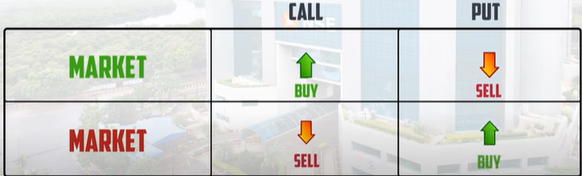

###### v v v v v imp –In buyer and seller POV

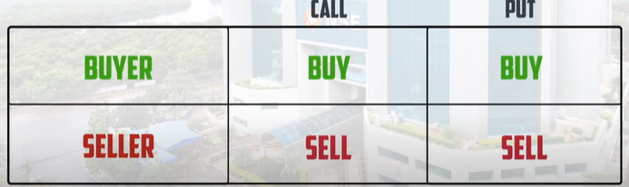

A buyer buys call option when he doesn’t have the stocks and thinks the stock will go up in future or if you know that the stock will go up and you want to buy the stock at current price

A seller who sells call option has already stocks with him and sells stocks to buyer who is ready to get stocks at a premium or when a seller who thinks the stock is going down, but he doesn’t have enough money to buy lot of shares

A buyer buys put option when he has stocks and thinks stock will go down and he wants to set a price and sell stocks at that price

A seller who sells put option will be ready to buy stocks from buyer

In a nutshell

In call option - a buyer (has the right to) buys the stocks (at a prefixed rate) and a seller sells the stocks

In put option (it is kind of reverse) - a buyer (has the right to) sells the stocks (at a prefixed rate) and a seller buys the stocks

An example scenario when does a call and put option buyers make profit and when does a call and put option seller make profit

Let’s take 330 ce as call option and 330 pe as put option, both are with 5 premium

A call option buyer makes profit when call option closes above 335 (330 strike price + 5 premium) on expiry

A put option buyer makes profit when put option closes below 325 (330 strike price – 5 premium) on expiry

A call option seller makes profit when call option closes below 335 (330 strike price + 5 premium) on expiry

A put option seller makes profit when put option closes above 325 (330 strike price – 5 premium) on expiry

From 10:20 I did not understand what he is saying- satya needs to explain

# How to decide Which option to buy- which call or which put?

Link <https://youtu.be/1qnCiEYdnNM>

We know that if a stock price is going to rise- we will buy call option, if the stock price is going to fall we will buy put option,

But which option to buy, i.e., if the stock is at 330,

1. if it is going up, should we buy 340 ce or 350 ce or 360 ce and so on…
2. if it is going down, should we buy 320 pe or 310 pe or 300 pe

to get these understanding, please continue reading below

## On what does the option premium depend upon

Value of Option premium depends upon **intrinsic value and time value and few other factors**

**Option premium = intrinsic value + time value + market volatility +interest rates (appreciation or depreciation by RBI) + dividends**

**Intrinsic value = stock price ~ strike price (i.e.,** if the stock price is 330 and strike price is 350, then intrinsic value is 20, I think the positivity and negativity of the price depends upon the option type i.e., call or put (more details needed 😊)**)**

**To understand the intrinsic value you need to understand ITM (In the Money), ATM (At The Money), OTM (Out of The Money) (discussed below)**

**time value = number of days left to expiry (directly proportional to option premium)**

**market volatility -> depends on various factors like geopolitical situations, economic crisis**

**you can ignore Interest rates and dividends**

more details here

#last_Stopped

## ITM, ATM, OTM

### Theoretical explanation of ITM, ATM, OTM for both call and put

Before we go for call and put, lets understand ITM, ATM, OTM

All the contract prices that the stock **has covered** for **is ITM**

The contract which is **nearer to the stock** price is **ATM**

The contract prices which the stock **has to cover** is called **OTM**

#### For call

The price goes up In call, so for the stock to reach 330, it should have covered 280 CE,290 CE,300 CE …325 CE **these are ITM**

the contract **near to the stock price is** 330CE, it is **ATM**

If the stock is at 330CE then it **has to cover** 340CE, 350CE …. These are **all OTM**

#### For put

Quite opposite to put

The price goes down In put, the stock price is 330, it should have covered340PE, **these are 340PE is ITM**

the contract **near to the stock price is** 330PE, it is **ATM**

the contracts that stock price is 330, the contracts 280 PE,290 PE,300 PE …325 PE, these are all **OTM**

### Intrinsic value

#### Intrinsic value of call option:

Let’s say there is a stock and its current price is 300

**A call option contract intrinsic value = stock price – strike price of call option**

Lets take 4 different call option contracts and check their intrinsic value, **intrinsic value cannot be negative, if you get negative intrinsic value** **for a contract, then make it 0**

1. 340 CE its intrinsic value is 300-340 => -40 this contract’s intrinsic value is 0 as it got negative intrinsic value
2. 300 CE its intrinsic value is 300-300 = 0
3. 280 CE its intrinsic value is 300 – 280 = 20
4. 260 CE its intrinsic value is 300 – 260 = 40

##### Explanation of ITM, ATM, OTM with an example in **call options**

Let’s take tatamotors with an example, its share price is 320, let’s say call options strike prices are with 5 difference i.e., 315CE, 320CE, 325CE, 330CE

ATM (near to the stock price): contract strike price nearest stock price

320CE is the ATM

Need clarity for below part:

Important point -> if the stock price is 318, the **nearest available** strike price are 320CE,315 CE but 320CE is more nearer

So ATM for this example is 320CE

ITM (Stock price already reached these contracts): strike price < stock price

So ITM contracts are 315 CE, 310CE …

OTM (Stock price yet to reach these contracts): strike price > stock price

So OTM contracts are 325CE, 330CE….

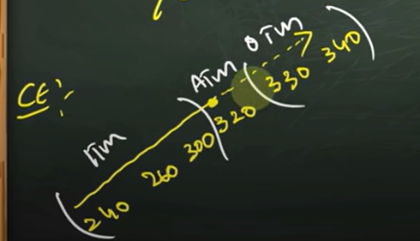

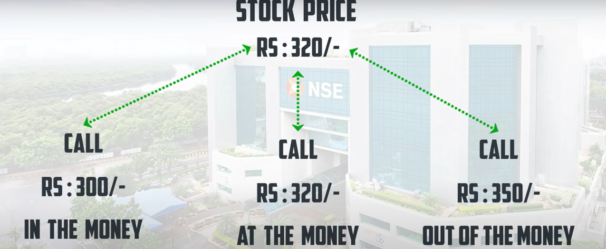

#### Intrinsic value of put option:

Let’s say there is a stock and its current price is 300

**A put option contract intrinsic value = strike price of put option - stock price**

Lets take 4 different put option contracts and check their intrinsic value **intrinsic value cannot be negative, if you get negative intrinsic value** **for a contract, then make it 0**

1. 260 PE its intrinsic value is 260-300 => -40 this contract’s intrinsic value is 0 as it got negative intrinsic value
2. 280 PE its intrinsic value is 280-300 = -20 this contract’s intrinsic value is 0 as it got negative intrinsic value
3. 300 PE its intrinsic value is 300-300 = 0
4. 340 PE its intrinsic value is 340-300 = 40, **but if you bought it at 50 premium and if the stock closed at 300, you will get back its intrinsic value, you wont get that extra 10 rupees as (it is the premium you paid for market conditions or any other factor which you thought**

##### Explanation of ITM, ATM, OTM with an example in **put options**

Let’s take tatamotors with an example, its share price is 320, let’s say put options strike prices are with 5 difference i.e., 315PE, 320PE, 325PE, 330PE

ATM (near to the stock price): contract strike price nearest stock price

320PE is the ATM

Need clarity for below part:

Important point -> if the stock price is 318, the **nearest available** strike price are 320PE,315 PE but 320PE is more nearer

So ATM for this example is 320PE

OTM (Stock price already reached these contracts): strike price > stock price

So OTM contracts are 315 PE, 310PE …

ITM (Stock price yet to reach these contracts): strike price < stock price

So ITM contracts are 325PE, 330PE….

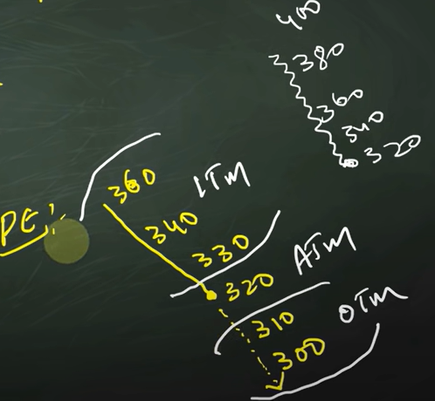

#### Importance of intrinsic value

**After expiry you are left with the amount which is Intrinsic value *lot size**

**Intrinsic value is only there for ITM contracts**

##### What does intrinsic value mean for ITM, ATM, OTM

ITM already **have positive intrinsic value**

ATM **has good chance to gain intrinsic** value (because they have very high chances of becoming positive according to intrinsic value formulas of call and put options discussed above)

OTM (in general bear negative values -10,-20..) has chance of intrinsic value as they need very much positive movement

FAR OTM (a very high negative value -90,-100…) has very less chance of intrinsic value as they need very much positive movement

## How should buyers/sellers decide which to buy

### For buyer

If you are confident go for ITM

If you have normal view go for ATM

If you have no view and you have gut feeling based on some numbers or you got some outsider news that market is going to have good momentum got for OTM (3 or 4 contracts away from ATM these are Hero Zero trades)

Going for deep OTM (10 or 15 contracts away from ATM) is **danger**

### For seller

Let’s take an example of call option, if you are a seller of call option, then that means you think market will fall, if nifty is at 18000CE, ITM will be 17950 CE ATM is 18000CE and OTM is 18050 CE

If you are super confident that market will fall then sell an ITM 17950

If you are confident that market will fall then sell an ATM 18000

If you have neutral view about market sell an OTM 18100 or something around

If you have no view then sell a deep OTM 18500 or something around

In nutshell:

Super confident – sell ITM

Confident – sell ATM

Neutral - sell OTM

No view – sell Deep OTM

# Volatility Index - Vix

Link: [https://youtu.be/hQcgMZ7nENU](https://www.google.com/url?q=https://youtu.be/hQcgMZ7nENU&sa=D&source=calendar&usd=2&usg=AOvVaw341BLIpOQ-EyDshW1_odnU)

Founded by CBOE – Chicago board Options Exchange

Launched in india by NSE in 2008

The combination of IMPLIED VOLATALITY of the nifty 50 options Implied Volatility

If VIX is increasing, that means Implied Volatility of Nifty 50 stocks is increasing

## Difference between volatility, Implied volatility and VIX

### Volatility

A stock fluctuating up and down is said to be volatility

## Increased volatility

If a stock is fluctuating at a higher range than it does on a normal level, then it is said to be of having increased volatility

## Implied volatility

The volatility of the options, it helps in deciding option premiums

## VIX

An index which is obtained based on calculations of Implied Volatility of nifty 50 options

### How to understand what does VIX value mean

If VIX is 60, It means in the next 12 months, nifty has the chance of going 60% up or down

### What happens in range boundedness and what happens in uncertainty

**When there is a range boundedness, sellers will be active, if there is no idea of what might happen, then buyers will be active.**

### When does implied volatility increase

It increases when option prices deviate from normal prices and **move towards higher prices**

This is applicable to both call and put options, to elaborate

* if panic increases -> number of sellers increase -> vix increases
* if greed increases -> number of buyers increase -> vix increases

but **in most of the cases panic and vix correlation is more than greed and vix correlation, therefore**

**nifty and vix have negative correlation**

### level of VIX

generally VIX falls between the level of 12 to 20 when there is no volatility

if VIX crosses level 40, then the event that is happening is a big one

### how should investor understand VIX

if market is high and vix is high, or if market is low and vix is high, then it means that the present move in stock market is because of some external conditions, and there are **very high (not 100% sure, but majorly yes) chances of this move coming back to its normal range and settle**

### how should trader understand VIX

for intraday in equity-if VIX is high, then we should be having big SL as, The volatility is high, there is a high chance of SL being hit

for swing traders (mostly in equity)- VIX does have a **minute impact** on SL, because Swing traders give most importance to SL, as SL will be in their mind

#need_clarity on below example

for option day trading – when IV increases Premium Increases, when you are buying options in high IV scenario, then it is always suggested to book profits (and maybe! wait for other opportunities in options), because if the market is down 1000 points and you bought a put (**you are playing along the market scenario, if market rose, you might have bought call**) at an increased premium and if market moves slightly in your favour i.e., 50 points down, if your premium is not increased and that shows weakness in the direction (downfall of 50 points when there is high IV is a weakness I presume) there are chances that IV cools off, which might lead to movement in opposite direction of your favour

should trade in high VIX scenarios only if you have high conviction

# What should we understand before we place stoploss and target for option contracts

Link: <https://www.youtube.com/watch?v=b7f0Ih1NbRE&list=PL_Bj8MwxMrhpO3liO_QRS3Kl5SDnMPINs&index=7&t=2s&ab_channel=DAYTRADER%E0%B0%A4%E0%B1%86%E0%B0%B2%E0%B1%81%E0%B0%97%E0%B1%812.0>

Revanth bro said that (by seeing chart- which chart exactly? Future chart or underlying scrip chart) it is easy to place target and stop loss for future contracts easily, I don’t know how please explain MR.satya #need_clarity

To analyse option contracts price movement and also to keep target and SL for the option contracts we deal with, we need to know option greeks

Option greeks are the 5 symbols which act as variables in the price movement of option contracts

They are

1. Gamma
2. Theta
3. Delta
4. vega
5. Rho

We don’t need to consider Rho as it is a variable that relates to interest rates, **we can almost ignore and think that Rho does not exist**

**The order of importance of greek options is as follows**

**Delta>Vega>theta>gamma**

Brokers and other resources displaying option greeks information

1. Upstox
2. Zerodha
3. Sensibull
4. Opstra

## Lets understand delta, theta, vega with an **brief** example

Below is the sample image of options in upstox

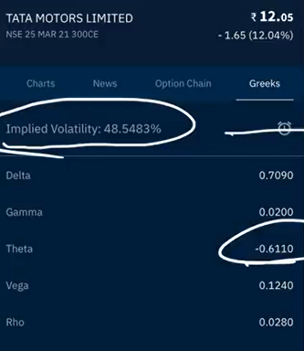

Ex: lets take **tatamotors option contract 300 ce trading with 12 premium**, at the time of this example that **tatamotors share price** is 305

### delta

let’s say Delta value for this example is 0.7090

For every one rupee increase in **tatamotors share price** (i.e., 305 to 306) **tata** **motors option contract 300 ce increases by 0.7090 (considering that, if we ignore all other factors and options)**

### Theta

Theta represents time value

Let’s say theta value for this example is -0.6

the tatamotors share price opened at 305, and had many fluctuations and again closed at 305, then the theta value gets added (if theta is negative, it gets subtracted) to the **tatamotors option contract 300 ce’s premium**

**i.e., 12-0.6 = 11.4**

### vega

the movement in **vega is directly proportional** to **Implied Volatility** (It is also seen in option chain data by NSE website)

**implied volatility- is it important? How is it related to vix?**

**Do we need to be seeing video on VIX by revanth brothers?** #need_clarity

Let’s say vega value for this example is 0.2

for every increase 1% of IV, **tatamotors option contract 300 ce’s premium** increases by 0.2

### rho

the movement in **rho is directly proportional** to **interest rates** (It is also seen in option chain data by NSE website)

Let’s say rho value for this example is 0.3

for every increase 1% of interest rate, **tatamotors option contract 300 ce’s premium** increases by 0.3

**rho can be neglected because, interest rates don’t go up/down that frequently**

## detailed explanation of option greeks

## delta

delta is **important** in having success of Option trading**,** so to implement an option strategy correctly, you need a good understanding of delta

example:

let’s say the stock price is 300, and call option contract of that stock 300CE is trading at 5 premium, its delta value is 0.5, the stock price moved by 10 rupees, the call option contract price will be with the formula

updated premium price = existing premium + (delta * price movement)

updated premium price = 5 + (0.5*10) = 10

### 4 types of cases involved from a buyer’s POV (point of view)

1. Moving in the direction of call buyer (a person buys call if he thinks the price is going to go up)
   1. updated premium price (will be higher than existing premium) = existing premium + (delta * price movement)
2. Moving in the opposite direction of call buyer (a person buys call if he thinks the price is going to go up)
   1. updated premium price (will be lower than existing premium) = existing premium - (delta * price movement)
3. Moving in the direction of put buyer (a person buys put if he thinks the price is going to go down)
   1. updated premium price (will be lower than existing premium) = existing premium + (delta * price movement)
4. Moving in the opposite direction of put buyer (a person buys put if he thinks the price is going to go down)
   1. updated premium price (will be higher than existing premium) = existing premium + (delta * price movement)

### types of cases involved from a seller’s POV

cases involved in sellers POV is opposite to the buyers POV (#need_clarity – need to discuss with chinnodu and write formulas for seller scenarios like above)

### delta values for call and put options for ATM,ITM,OTM

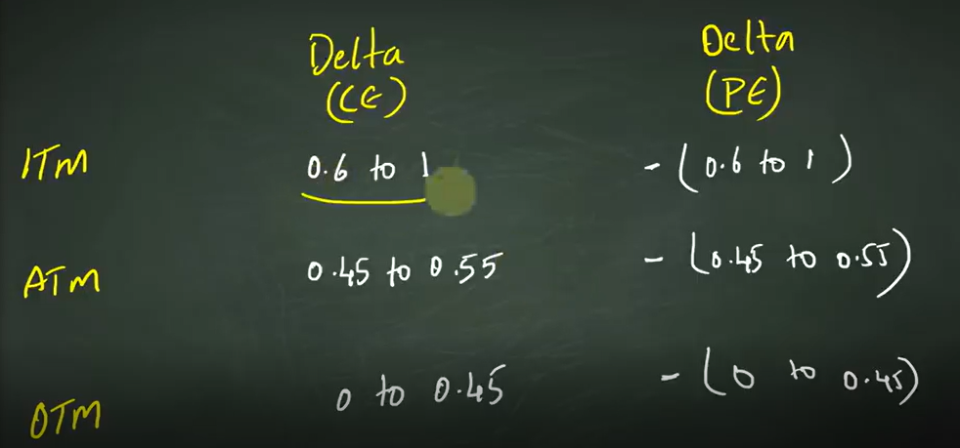

### In a nutshell

Delta value for ce lies between 0 to 1

Delta value for pe lies between -1 to 0

When your view proves to be right, delta value increases, -> premium + (delta * change)

Vice a versa decreases -> premium - (delta * change)

## Gamma

### Why gamma is required to decide delta

An example:

Let’s take tatamotors share. Its current price is 300 and tatamotors 300CE (**which is ATM**) is at 5₹ premium and it’s delta is 0.5 and then if the stock price moves by 10₹ then the **new strike price (premium) = 5 + 10(0.5) = 10,** now comes the interesting point, the contract we bought is 300CE and the share price is 310, now the contract 300CE is ITM, therefore in general ATM contracts premium < ITM contract premium. So therefore should the delta value of the contract should increase or not?

Yes it should increase

But **at what rate?**

At the rate of gamma. To explain it clearly, lets take tata motors at price 300, we bought 300 CE contract at 10 premium , delta as 0.5 and gamma as 0.02

If share price increases from 300 to 350 (we bought CE thinking it will increase, it is moving in the expected direction), then

New premium = 10 + (50*0.5) = 35

As share price is 350, and our contract 300CE becomes ITM, so its delta value should increase

**updated delta value = old delta value + (gamma * points)**

= 0.5 + (50*0.02)

= 0.5+0.1 = 0.6

### When is gamma value added and when it is subtracted?

If the share price moves in the support of our contract type(upside when we bought CE and downside when we bought PE) then gamma value is added to delta, if it moves in the opposite side of our contrast type then, it is subtracted

## Theta

If the share price ends in the same level at which it opened, then the premium reduces by theta

**Theta will always be negative**

It is the **biggest enemy of option buyers**

## Vega

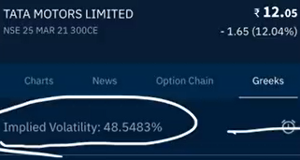

**Implied volatility, option price and vega are directly proportional.**

If volatility increases, then vega increases, then option price increases

If market is volatile downside, then put contracts have higher premiums because of higher vega

More detail on how vega acts as determining factor and calculation of premium price: here

If you are dealing with options, then you are paying a bit of money for IV, when you are buying a contract

## A formula to include Greek options in and calculate/estimate target

Theoretical explanation for the need of **black & scholes** formula

By seeing underlying scrip chart you will be able to guess how much it might go up and what should be stop loss (by doing technical analysis) you can also include delta in predicting, but there are other greek options such as theta and vega which are also to be included while determining the price, to calculate that, there is **black & scholes** formula

This formula is **not exact but approximate**

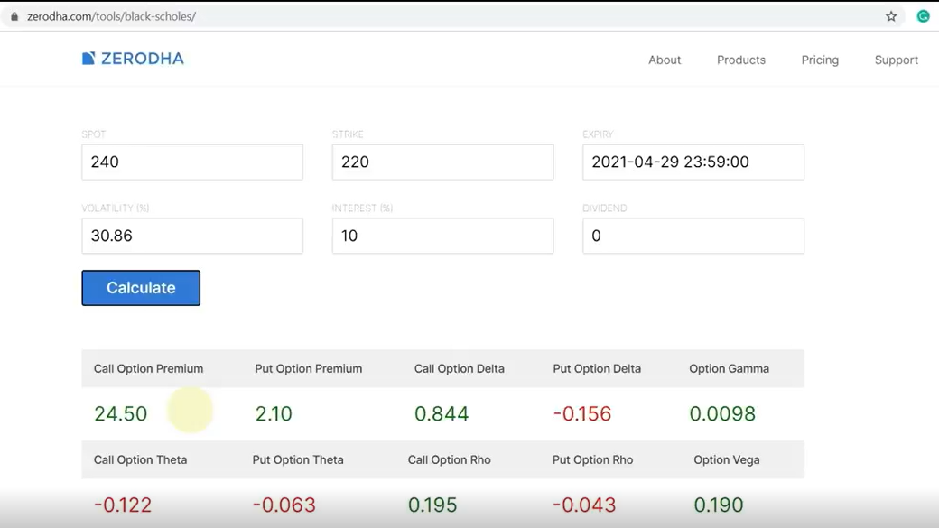

1. spot - the price to which you think the stock reaches
2. strike – the value of option, ex: 220 CE strike is 220
3. expiry – the expiry date of the contract
4. volatility – the IV available in option chain website or upstox
5. interest rate = 10%, because NSE uses 10% as interest rate for computing IV
6. call option premium, if the stock price moves to 240, then our premium becomes 24.5, you can also see other greek options available

### why **black & scholes** formula is not 100% accurate

in the input fields of the formula, you can see that except volatility all fields are fixed, only implied volatility changes due to few reasons and also people decision taking rationale based on market conditions will also differ from time to time

## how theta will keep you in loss even if stock price is moving in the direction, you expected **especially for OTM contracts**

lets say you bought a call option thinking that stock price will increase and the price of the stock is increasing, but increasing at a slower pace, the delta of the contract is 1 and if the **theta** of the contract is 2, for every increase in 1₹ of **delta**, you are actually at loss

so it is important that you need to have ***delta > theta***

## importance of “**EVENTS**” in profitable trading

events are like: rbi meeting, elections, company results

based on the event positivity and negativity premiums go up and down

you need to be careful when you are buying option contracts at or before events

it is better to buy contracts only when you have **higher conviction**, **because premiums will be higher because of the event anticipation and premiums will fall post (some times very fastly) the event**

let’s take an example:

if you have an expectation that **abc company** is going to post bumper results and you bought call option of that company and if the company posts normal results, as soon as the company posts then you can see big drop in premiums

# price, Open Interest, Volume

link: <https://www.youtube.com/watch?v=R_QOLIQzI-0&list=PL_Bj8MwxMrhpO3liO_QRS3Kl5SDnMPINs&index=7&ab_channel=DAYTRADER%E0%B0%A4%E0%B1%86%E0%B0%B2%E0%B1%81%E0%B0%97%E0%B1%81>

**volume**: number of quantities traded, volume is available for stocks, futures and options

when you are checking a stock volume at a given time period (it can be in days, hours or minutes), then it indicates how many stocks/contracts have traded i.e., changed hands (buyers to sellers **or** sellers to buyers)

**Open Interest:** the number of contracts open at a given time in that particular contract

When is a contract said to be open?

In buying POV

A contract is open when a person **A** sells some stock to another person **B**. that contract will be open unless person **A** buys (back) the same stock that he has sold to **B**

**Here person A and person B are said only for example, but an contract is open until the person who sells, will buy back that contract (from any person)**

**Important point to note:**

**There are 3 types of outcomes in OI**

1. **no contracts open at all**
2. **buy contracts open**
3. **sell contracts open**

If a lot of buy contracts are open, then it means people have already bought are holding what they have bought, if buy contracts are increasing, that means people are aggressive towards buying and are likely to buy at a higher price. **It is a bullish sign, vice a versa for sell contracts -> bearish sign**

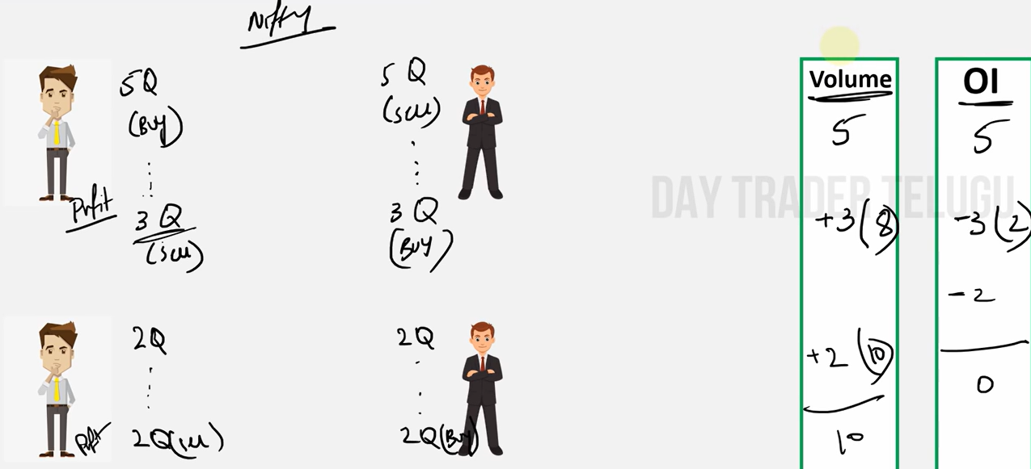

In the above example,

|  |  |  |
| --- | --- | --- |
| scenario | volume | open interest |
| person A buys 5 shares from B | 5 | 5 |
| person A sells 3 shares to B | 8 (5+3) | 2 (5-3) |
| person A sells 2 shares to B | 10 (8+2) | 0 (2-2) |

## relation between price, Open Interest, Volume

an increase in price with an increase in open interest and volume, is high likely to sustain

## long buildup, short buildup, short covering, long unwinding

long build up:

price is increasing, open interest is increasing, that means people are aggressively buying and count of open buy contracts is increasing -> bullish momentum

short build up:

price is decreasing, open interest is increasing, that means people are aggressively selling and count of open sell contracts is increasing -> bearish momentum

short covering:

price is increasing, open interest is **decreasing**. That means who are buying has increased and number of contracts is decreasing, that means people are buying to close their existing open sell contracts

long unwinding:

price is decreasing, open interest is **decreasing**. That means who are selling has increased and number of contracts is decreasing, that means people are selling to close their existing open buy contracts

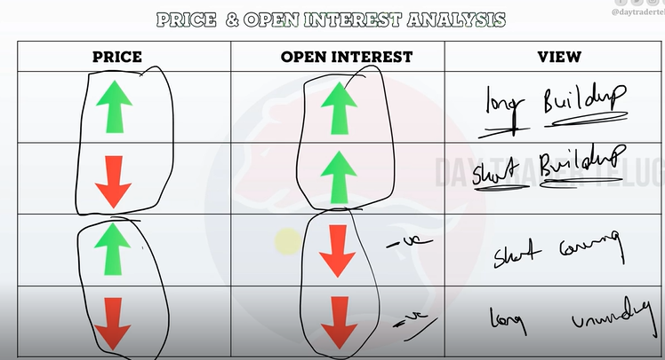

### **Importance of Open Interest in prediction**

If the open interest is positive in

1. buy side (long buildup), then the bullish view is strong
2. sell side (short buildup), then the bearish view is strong

## point to note

most activity and open interest can be seen in near expiry

greek options will only give direction, but not complete prediction, as there is a lot of volatility and external factors invloved

## how to select stocks for trading

# understanding market movement using Option Chain analysis

## why learn option chain analysis

1. to understand support and resistance, which helps in
   1. deciding should we enter or wait
   2. to understand if market is in rangebound or about to breakout
   3. to help us take better understanding before we decide stoploss and target
   4. to understand the trend of the market
2. Direction
   1. There might be scenarios where market might make a reverse , option chain analysis (along with OI analysis- discussed below) helps in understanding the scenario and that acts as a caution to take less trades

Should we be watching video on OI - <https://youtu.be/R_QOLIQzI-0> ??

We need to understand

* **What does a contract mean in stock market**
  + Contract means agreement formed between buyer and seller, when a seller sells an option to a buyer
* **What does writing a contract mean**
  + The process of a buyer buying a contract from a seller is called writing a contract
* **When is a contract said to be open**
  + When a contract is written, i.e., a buyer buying from a seller, then the contract is said to be open

## Understanding terms in Option chain

Page link: nseindia.com/option-chain



### What is Open Interest

The number of contracts that are open since the Option contract started (starting date)

### What is **change in OI**

The number of contracts that are formed in the recent trading day are said to be **change in OI**

### What is volume

Read it here .

### Implied Volatility

A detailed read here

### LTP

Last traded price – the last price at which this particular contract has formed between buyer and seller

### Change

The percentage of change in LTP at the end of the previous trading day to the LTP of the recently formed contract #need_to_check_in_real_scenario

### Bid qty

The number of contracts the buyers want to buy (already placed buy order)

### Bid price

The price at which the buyer want to buy the contract

### Sell qty

The number of contracts the Sellers want to buy (already placed Sell order)

### Sell price

The price at which the Seller want to Sell the contract

### Strike price

The numerical value (which represents a particular level of price of the underlying asset) ex: 18000 in Nifty 10 DEC 18000 CE

## How does Open Interest helps us in forming a view about current market scenario and how will it help us understand important levels

When you look at OI data, you can see that at a particular level (might be same or different level)for call and put data (for example- 18000 CE and 17500 PE) you can see there are high number of contracts that are open

### When high number of contracts are open, should we be taking seller or buyer POV

We should be taking seller POV, in both call and put

### Why should we be taking Sellers POV in both call and Put and how does level at which more contracts are built at calls acts as resistance and as support for puts

We should be taking sellers POV because,

1. option seller **has more risk (****see here** **for detail) if market moves in the opposite direction of his trade.** So let’s take the example of Nifty 18000 CE. A call seller of 1800 CE believes that nifty will move around or below 18000 levels, if it starts moving up, sellers will try to sell heavy weights of nifty and will try to cool the movement
2. seller invests more money
3. mostly HNI’s will be option sellers and retailers are option buyers
   1. HNI’s have more money, so that they will try to create pressure (by selling/buying heavy weights) if market does not move in their direction
4. a seller invests more money, expects limited profit, and has unlimited risk, even with all these factors, if seller sells a contract
   1. he has more conviction
   2. he does everything in his power (buying or selling heavyweights to let the current movement (which is opposite to his view) cool of

**therefore, we should be paying more interest to sellers in OI analysis**

more money invested+ limited profit + unlimited risk -> option seller

less money invested + unlimited profit + limited risk -> option buyer

#### How high number of call contracts will make it act as a resistance

We understood sellers will have priority in forming a view, if call contracts are high at a particular level, that means sellers are thinking that it will not go beyond that particular level and even if it tries to go, sellers will try to create pressure and revert that situation, which will make that level a **resistance**

**High contacts at a particular level in call side will make it a resistance**

#### How high number of put contracts will make it act as a support

We understood sellers will have priority in forming a view, if put contracts are high at a particular level, that means sellers are thinking that it has to go beyond that particular level and even if it tries to fall below that level, sellers will try to create pressure and revert that situation, which will make that level a **support**

**High contacts at a particular level in sell side will make it a support**

### How to see OI and **change in OI**

OI shows the long term view of Option sellers

Change in OI shows short term (intraday) view of option sellers

#### Always look for both high OI and high change in OI

If **change in OI** and OI are both high, that implies view of sellers is the same from past days and it is still continuing

If OI is high and **change in OI** is negative, check the recent OI and change in OI both high to the next level of current (OI high and change in OI negative)

|  |  |  |
| --- | --- | --- |
| OI | change in OI | strike price |
| 50000 | -1000 | 18000 |
| 45000 | 4000 | 18100 |

Here 18100 level is important compared to 18000

Strike Level at which call options have High OI + high change in OI is **Resistance**

Strike Level at which put options have High OI + high change in OI is **Support**

#### How to use OI and change in OI for stocks and indices to form view

* for stocks
  + stocks only have monthly contracts,
    - if you are starting of your month, look for high OI and change in OI for the current month
    - if you are at the ending of the month, look for high OI and change in OI for the next month
* for indices
  + indices have both weekly and monthly contracts
    - if you are at the starting or middle of the month, look for high OI and high change in OI of weekly Option chain data and make sure about it with Monthly high OI and monthly high change in OI
    - if you are at the ending of the month, look for high OI and high change in OI of #need_to_know (first) weekly Option chain data in the next month and make sure about it with Monthly high OI and monthly high change in OI of the next month

when market is rising, that means

* new support at a higher level (which previously acted as resistance) is preferred, and new resistance at a higher level is formed
* in bullish phase- if market moved from 17500 to 18000, that means call sellers (might be in loss and want to move to a further position) will unwind their 17500 CE and form new call sell contracts at new resistance (may be 18200 or 18500 something like that), put sellers (might be in profit and want to move to a further position because they currently are with less premium) will unwind their 17500 PE and form new put contracts around 17700 which they think might be the new support

when market is falling

* new support at a lower level (which previously acted as resistance) is preferred, and new resistance at a lower level is formed
* in bearish phase- if market moved from 18000 to 17500, that means call sellers (might be in profit and want to move to a further downward position because they currently are with less premium) will unwind their 17500 CE and form new call sell contracts at new resistance (may be 17000 CE or 17200 CE something like that), put sellers (might be in loss and want to move to a further downward position) will unwind their 17500 PE and form new put contracts around 17300 PE or 17400 PE which they think might be the new support

# Misc

* All shares are not in FNO, if a share is in derivative, then they have both FNO as they are interrelated`
* Even indexes, metals, currencies have FNO

# Hashtags

Topics that are needed clarity - #need_clarity

Things to be checked in realtime markert- #need_to_check_in_real_scenario