# Command prompt or powershell

## Ports

### To see which ports are running in your machine

netstat -ano

When you run "netstat -ano" in the command prompt or PowerShell, you will get a list of all network connections along with their state (e.g., established, listening, etc.), local and foreign addresses, and the corresponding process ID (PID) for each connection. You can then use the PID to look up the associated process in Task Manager or other system monitoring tools to determine which application is responsible for that network connection.

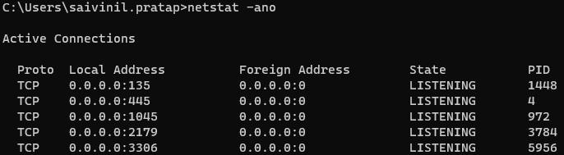

Local address: url at which ports are running

Syntax: ipadress:portnumber

Ex: 0.0.0.0:135

* + 1. – ip address

135 – port number

PID – Process identifier

you can use this PID to kill a particular port

### To see whether a particular port is running or not

netstat -ano | findstr <port number>

ex: netstat -ano | findstr 8000

or

netstat -ano | find “<port>”

ex: netstat -ano | find "8000"

### To kill a particular port using PID (you might need admin credentials)

taskkill /F /PID <PID>

ex: taskkill /F /PID 8000

## PATH

Note: commands that operate with PATH command in command prompt might behave differently when launched in admin mode

### echo %PATH%

this will list all your path variables.

## S