**V-Model**

The V-model is a software development and testing model that emphasizes the importance of testing throughout the entire software development lifecycle.

In this model, each stage of the software development process is associated with a corresponding testing stage. The development stages are represented on the left side of the V, while the testing stages are represented on the right side.

The V-model typically includes the following stages:

1. Requirements gathering and analysis
2. System design
3. Subsystem design
4. Implementation
5. Testing (unit, integration, system, and acceptance)
6. Deployment
7. Maintenance

**Requirements gathering and analysis:** In this stage, the requirements for the software are gathered and analyzed. This includes understanding what the software should do, what features it should have, what inputs and outputs it should support, and any constraints that should be taken into account.

**System design:** In this stage, the high-level design of the software is created. This includes defining the architecture, identifying the subsystems and components that will make up the system, and specifying the interfaces between them.

**Subsystem design:** In this stage, the detailed design of each subsystem is created. This includes defining the data structures, algorithms, and interfaces that will be used within each subsystem.

**Implementation:** In this stage, the software is actually developed. The code is written, tested, and integrated into the subsystems and the system as a whole.

**Testing:** In this stage, various types of testing are performed to ensure that the software meets its requirements and performs as intended.

**Deployment:** Once the project has been developed and tested, it is ready for deployment. In this stage, the software is installed and configured in the production environment.

**Maintenance:** The maintenance stage begins once the project is live in the production environment.

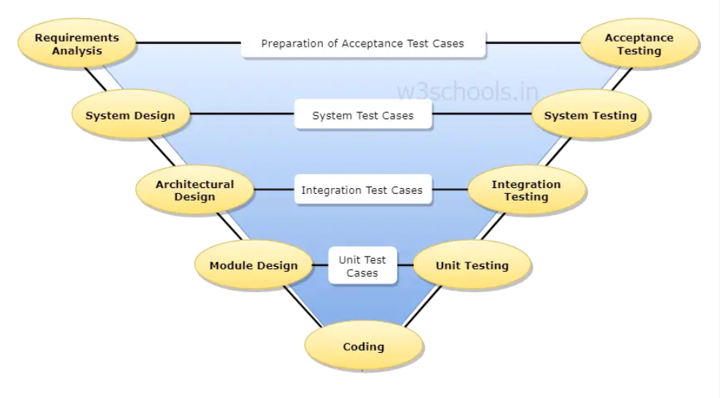

Each of these stages has a corresponding testing stage that is performed to ensure that the software meets its requirements and performs as intended. By testing at each stage, issues can be identified and corrected early in the process, which can save time and money and reduce the risk of defects in the final product.

The V-model is often used in safety-critical industries, such as aviation and medical device development, where the consequences of software failure can be severe.