**JAVA LAB -II SEM**

**Part A**

1. **Program to assign two integer values to X and Y. Using the ‘if’ statement the output of the program should display a message whether X is greater than Y.**

|  |
| --- |
| import java.util.Scanner; public class GreaterNumber{  public static void main(String args[]){  Scanner sc = new Scanner(System.in);  int x, y;   System.out.println("Enter two numbers: ");  x = sc.nextInt();  y = sc.nextInt();  if(x > y)  System.out.println(x + " is greater than " + y);  else  System.out.println(x + " is lesser than " + y);  }  } |

**Output** -

Enter two numbers: 3 2

3 is greater than 2

1. **Program to list the factorial of the numbers 1 to 10. To calculate the factorial value, use while loop. (Hint Fact of 4 = 4*3*2*1)**

|  |
| --- |
| public class Factorial{  public static void main(String args[]){  int i, n, fact;  for(i = 1; i <=10; i++)  {  fact = 1;  n = i;  while(n > 1)  {  fact *= n;  n--;  }  System.out.println("Factorial of " + i + " = " + fact);  }  }  } |

**Output** -

Factorial of 1 = 1

Factorial of 2 = 2

Factorial of 3 = 6

Factorial of 4 = 24

Factorial of 5 = 120

Factorial of 6 = 720

Factorial of 7 = 5040

Factorial of 8 = 40320

Factorial of 9 = 362880

Factorial of 10 = 3628800

1. **Program to add two integers and two float numbers. When no arguments are supplied, give a default value to calculate the sum. Use function overloading.**

|  |
| --- |
| public class Add{  void sum(int x, int y)  {  int s = x + y;  System.out.println("Sum = " + s);  }  void sum(float x, float y)  {  float s = x + y;  System.out.println("Sum = " + s);  }  void sum()  {  int x = 5;  int y = 10;  int s = x + y;  System.out.println("Sum = " + s);  }  public static void main(String args[])  {  Add a = new Add();  a.sum(1, 2);  a.sum(1.1f, 2.2f);  a.sum();  }  } |

**Output** -

Sum = 3

Sum = 3.3000002

Sum = 15

**4.Program to perform mathematical operations. Create a class called AddSub with methods to add and substract. Create another class called MulDiv that extends from AddSub class to use the member data of the Superclass. MulDiv should have methods to multiply and divide .A main function should access the methods and perform the mathematical operations.(File name: MulDiv.java)**

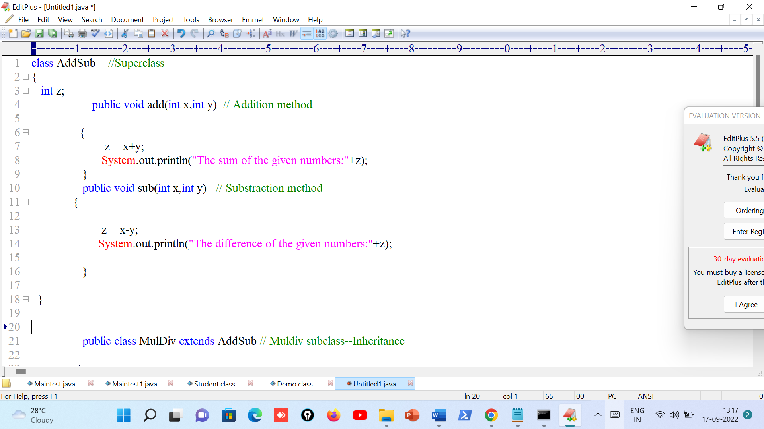

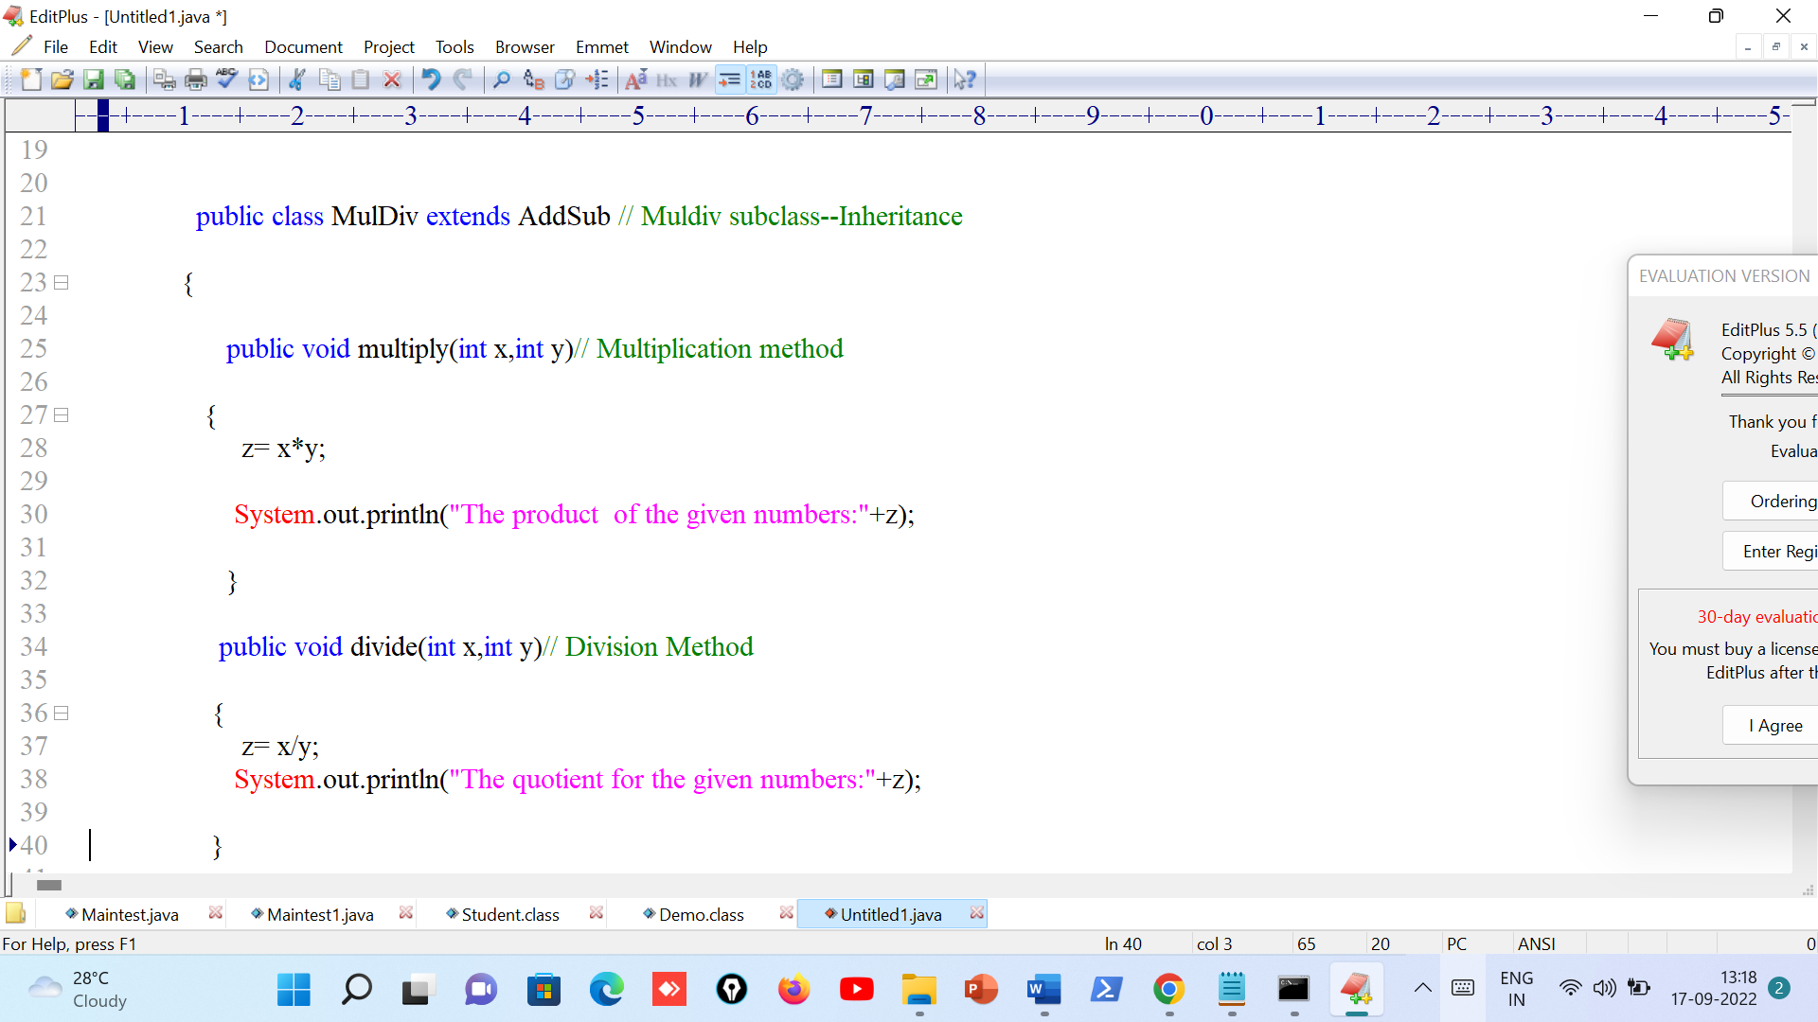

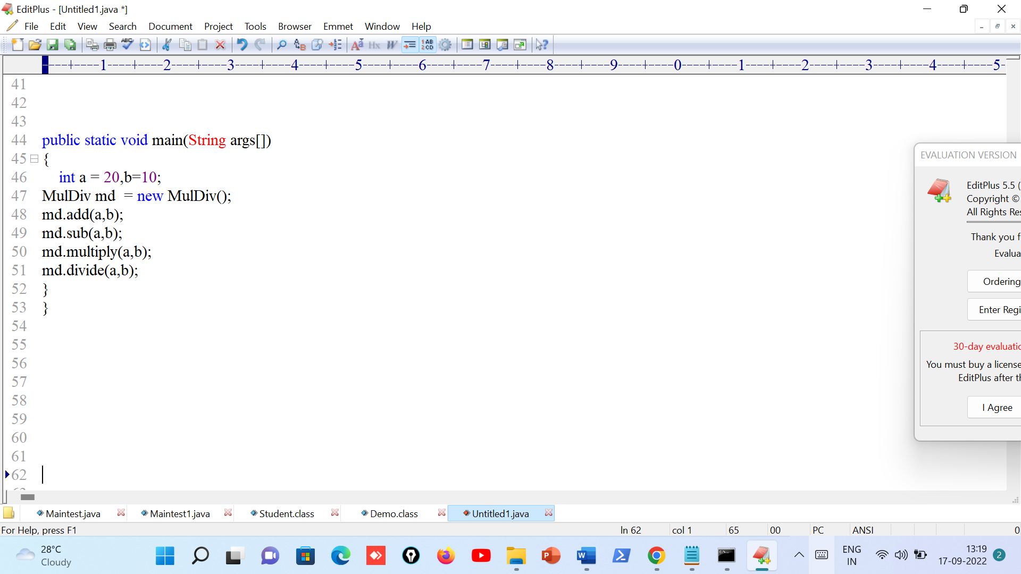

**Output:**

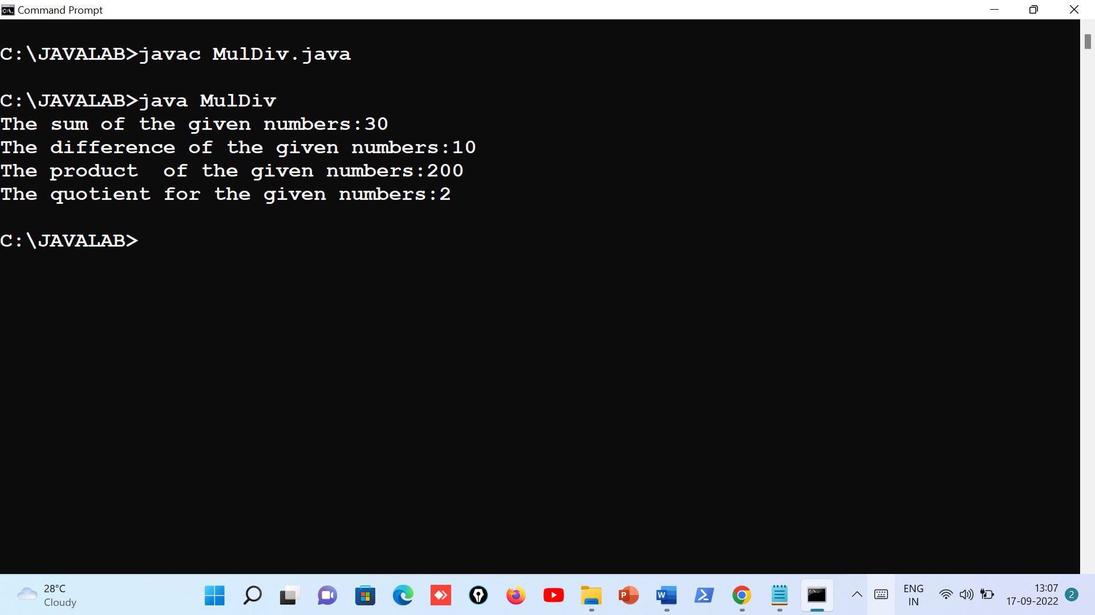

**5. Program with class variable that is available for all instances of a class. Use static variable declaration. Observe the changes that occur in the object’s member variable values.**

|  |
| --- |
| class Student{  int roll;  String name;  static String college;    Student(int r, String n, String c){  roll = r;  name = n;  college = c;  }  void display()  {  System.out.println(roll + " " + name + " " + college);  }  } class StaticExample{  public static void main(String args[]){  Student s1 = new Student(1, "s1", "sample1");  s1.display();  Student s2 = new Student(2, "s2", "sample2");  s2.display();  s1.display();  } } |

**Output**-

1 s1 sample1

2 s2 sample2

1 s1 sample2

**6. Program**

1. **To find the area and circumference of the circle by accepting the radius from the user.**

|  |
| --- |
| import java.util.Scanner; class A06aCircle{  public static void main(String args[]){  Scanner sc = new Scanner(System.in);  System.out.print("Enter the radius: ");  float r = sc.nextFloat();  float a = 3.14f * r * r;  float c = 2 * 3.14f * r;  System.out.println("Area = " + a);  System.out.println("Circumference = " + c);  } } |

**Output-**

Enter the radius: 3

Area = 28.26

Circumference = 18.84

1. **To accept a number and find whether the number is Prime or not.**

|  |
| --- |
| import java.util.Scanner; class A06bPrime{  public static void main(String[] args){  Scanner sc = new Scanner(System.in);  int i, c = 0;  System.out.print("Enter the number: ");  int n = sc.nextInt();  if(n <= 1)  System.out.println("It is not a prime number");  else  {  for ( i = 2; i < n; i++)  {  if (n % i == 0)  c++;  }  if (c == 0)  System.out.println("It is a prime number.");  else  System.out.println("It is not a prime number.");  }  } } |

**Output** -

Enter the number: 3

It is a prime number.

Enter the number : 2

It is not a prime number.

**7. Program to create a student class with following attributes; Enrollment No: Name, Mark of sub1, Mark of sub2, mark of sub3, Total Marks. Total of the three marks must be calculated only when the student passes in all three subjects. The pass mark for each subject is 50. If a candidate fails in any one of the subjects his total mark must be declared as zero. Using this condition, write a constructor for this class. Write separate functions for accepting and displaying student details. In the main method create an array of three student objects and display the details.**

|  |
| --- |
| import java.util.Scanner; public class A07Constructor{  public static void main(String args[]){  StudentInfo stu[] = new StudentInfo[3];  for(int i = 0; i < 3; i++)  stu[i] = new StudentInfo();  System.out.println("\t\tStudent Details");  System.out.println("Enrollment no.\t\tName\t\tTotal");  for(int i = 0; i < 3; i++)  stu[i].displayInfo();  } } class StudentInfo{  Scanner sc = new Scanner(System.in);  String eid;  String name;  int s1, s2, s3, total;  StudentInfo(){  readStudentInfo();  }  public void readStudentInfo(){  System.out.println("Enter student details");  System.out.println("Enrollment no: ");   eid = sc.next();  System.out.println("Name: ");  name = sc.next();  System.out.println("Enter marks of 3 subjects: ");  s1 = sc.nextInt();  s2 = sc.nextInt();  s3 = sc.nextInt();  if(s1 >= 50 && s2 >= 50 && s3 >= 50)  total = s1 + s2 + s3;  else  total = 0;  }   public void displayInfo(){  System.out.println(eid + "\t\t\t" + name + "\t\t\t" + total);  } } |

**Output -**

Enter student details

Enrollment no: 1

Name: Geetha

Enter marks of 3 subjects: 99 99 99

Enter student details

Enrollment no: 2

Name: Mohan

Enter marks of 3 subjects: 1 1 1

Enter student details

Enrollment no: 3

Name: Chaitra

Enter marks of 3 subjects: 12 5 1

Student Details

Enrollment no. Name Total

1 Geeta 297

2 Mohan 0

3 Chaitra 0