**Part A (8-11)**

**/\***

**Program-8: In a college first year class are having the following attributes**

**Name of the class (BCA, BCom, BSc),**

**Name of the staff (Class Teacher Name)**

**No of the students in the class,**

**Array of students in the class.**

**Display Student Information**

**\*/**

**import java.util.Scanner;**

**public class FirstYearClassRoom {**

**String className;**

**String classTeacherName;**

**int studentCount;**

**String studentName[] = new String[50]; // Student Name Array**

**Scanner sc = new Scanner(System.in);**

**// Below is constructor function that is called when you create object of this class**

**public FirstYearClassRoom(){**

**getInfo();**

**}**

**private void getInfo()**

**{**

**System.out.println("Please Enter the Class Name");**

**className = sc.nextLine();**

**System.out.println("Please Enter Class Teacher Name");**

**classTeacherName = sc.nextLine();**

**System.out.println("Please enter total number of students in the class");**

**studentCount = Integer.parseInt(sc.nextLine());**

**System.out.println("Please enter names of all " + studentCount + " students in the class");**

**for ( int i =0; i < studentCount ; i ++){**

**studentName[i] = sc.nextLine();**

**}**

**}**

**public void display()**

**{**

**System.out.println("Class Name: " + className);**

**System.out.println("Class Teacher Name: " + classTeacherName);**

**System.out.println(" Student Names ");**

**System.out.println(" ------------- ");**

**for ( int i =0; i < studentCount ; i ++){**

**System.out.println(studentName[i] );**

**}**

**}**

**public static void main (String args[]){**

**FirstYearClassRoom fy = new FirstYearClassRoom(); // this will trigger getinfo function**

**fy.display();**

**}**

**}**

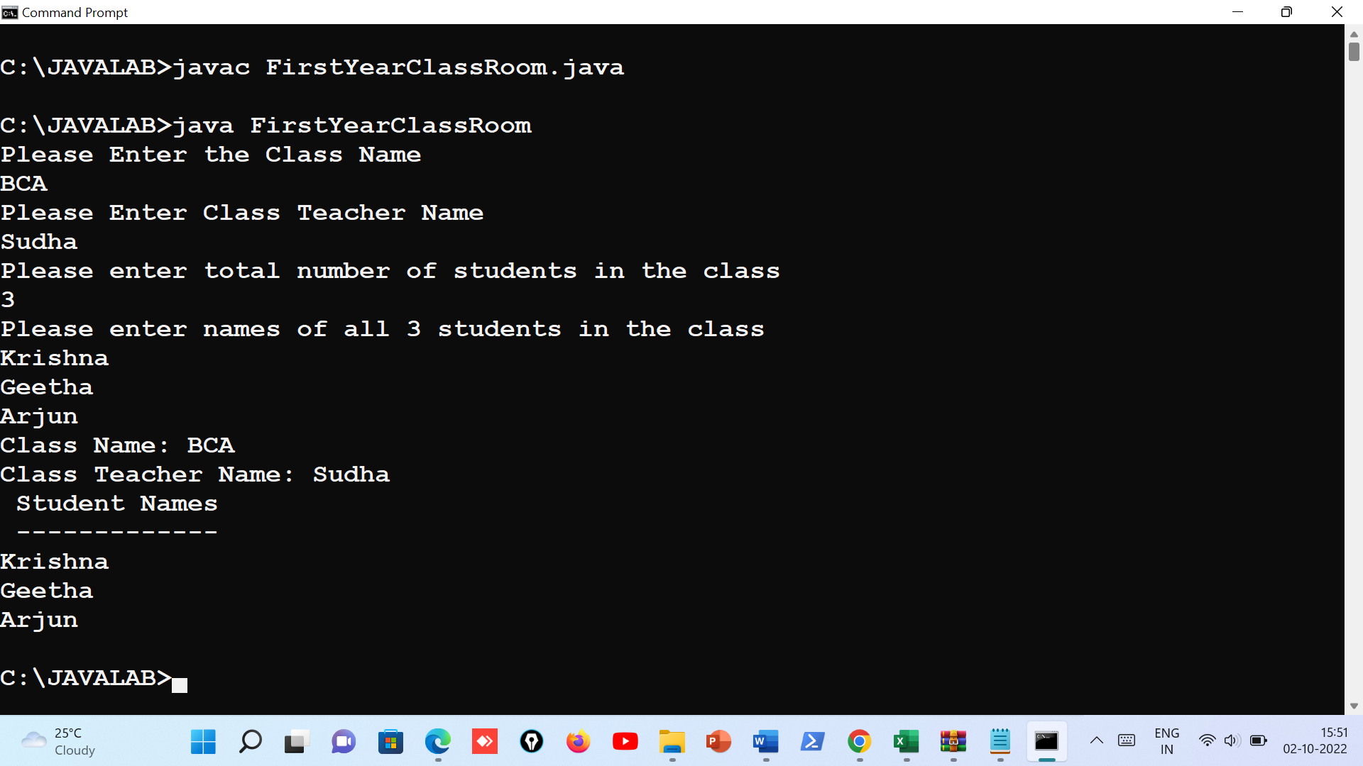

**/\***

**Program-9: Define a class called first year with above attributes and define a suitable**

**constructor.**

**Also write a method called best Student () which process a**

**first-year object and return the student with the highest total mark. In the**

**main method define a first-year object and find the best student of this class**

**\*/**

**import java.util.Scanner;**

**public class FirstYearClassBestMarks {**

**String className;**

**String classTeacherName;**

**int studentCount;**

**String studentName[] = new String[50]; // Student Name Array**

**int studentMarks[ ] = new int[50]; // Student Marks Array**

**Scanner sc = new Scanner(System.in);**

**// Below is constructor function that is called when you create object of this class**

**public FirstYearClassBestMarks(){**

**getInfo();**

**}**

**private void getInfo(){**

**System.out.println("Please Enter the Class Name");**

**className = sc.nextLine();**

**System.out.println("Please Enter Class Teacher Name");**

**classTeacherName = sc.nextLine();**

**System.out.println("Please enter total number of students in the class");**

**studentCount = Integer.parseInt(sc.nextLine());**

**System.out.println("Please enter names of all " + studentCount + " students in the class");**

**for ( int i =0; i < studentCount ; i ++){**

**studentName[i] = sc.nextLine();**

**}**

**System.out.println("Please start entering marks for students :");**

**for ( int i =0; i < studentCount ; i ++){**

**System.out.print("Enter marks for " + studentName[i] + " = ");**

**studentMarks[i] =sc.nextInt();**

**System.out.println(); // go to next line**

**}**

**}**

**public void display(){**

**System.out.println("Class and Student Info Display");**

**System.out.println("Class Name: " + className);**

**System.out.println("Class Teacher Name: " + classTeacherName);**

**System.out.println(" Student Names Marks");**

**System.out.println(" ------------- ------");**

**for ( int i =0; i < studentCount ; i ++){**

**System.out.println(studentName[i] + " " + studentMarks[i]);**

**}**

**}**

**public void bestStudent(){**

**int best = 0; // variable to keep track of best marks till now when looping**

**int k = -1 ; // variable to keep track of best student-index. Note that since index start from 0, initialize this to -1.**

**// loop through all student marks and pick best marks.**

**for(int i=0; i <= studentCount ; i++){**

**if( studentMarks[i] > best ){**

**best = studentMarks[i];**

**k = i; // keep track of index. As student at this index is best marks.**

**}**

**}**

**// once out of loop you will have student who got best marks. student index is k.**

**System.out.println("The best student is -" + studentName[k]);**

**System.out.println("He/She scored marks which was highest - " + studentMarks[k]);**

**}**

**public static void main (String args[]){**

**FirstYearClassBestMarks fyBestMarks = new FirstYearClassBestMarks(); // this will trigger getinfo function**

**fyBestMarks.display();**

**fyBestMarks.bestStudent();**

**}**

**}**

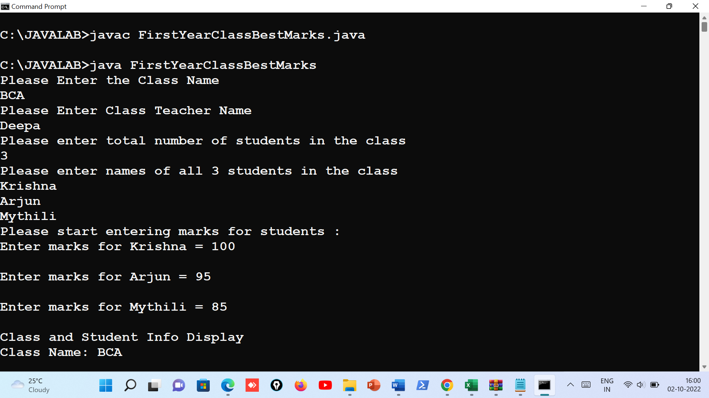

**Output:**

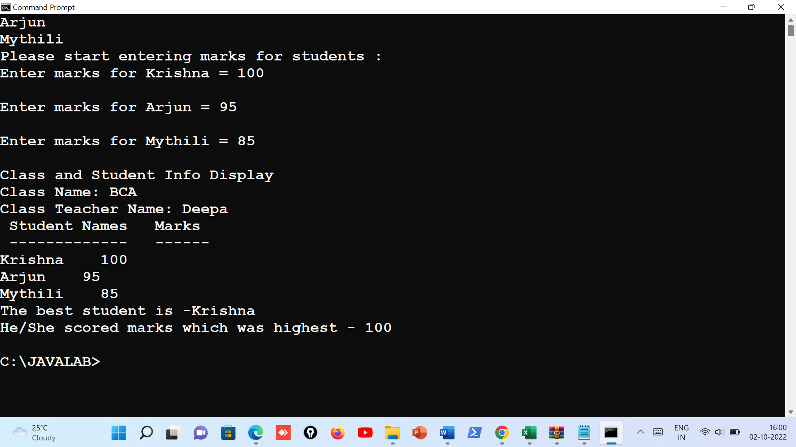

**/* Program 10: Program to define a class called employee with the name and date of**

**appointment. Create ten employee objects as an array and sort them as per**

**their date of appointment. ie, print them as per their seniority**

**\*/**

**import java.util.Date;**

**public class Employee {**

**String employeeName;**

**Date appointmentDate;**

**//Constructor**

**public Employee(String name, Date aptDate){**

**employeeName = name;**

**appointmentDate = aptDate;**

**}**

**public static void main (String args[]){**

**Employee emp[] = new Employee[10]; // array of 10 employee objects**

**emp[0] = new Employee("Ritika", new Date(2000,1,25));**

**emp[1] = new Employee("Rohit", new Date(1999,1,25));**

**emp[2] = new Employee("Himesh", new Date(2010,1,25));**

**emp[3] = new Employee("Gajendra", new Date(2022,1,15));**

**emp[4] = new Employee("Shilpa", new Date(2008,1,25));**

**emp[5] = new Employee("Deepa", new Date(2001,1,25));**

**emp[6] = new Employee("Nandini", new Date(2012,1,25));**

**emp[7] = new Employee("Ramesh", new Date(2010,1,28));**

**emp[8] = new Employee("Naseer", new Date(2011,1,25));**

**emp[9] = new Employee("Swetha", new Date(1990,1,25));**

**System.out.println("Display Employee List");**

**for(int i=0 ; i < emp.length; i++){**

**System.out.println( "Employee Name: " + emp[i].employeeName +**

**" Appointment date: " + emp[i].appointmentDate.getDate() + "/" + emp[i].appointmentDate.getMonth() + "/" + emp[i].appointmentDate.getYear() );**

**}**

**// Do sorting. Sort based on date.**

**for(int i=0 ; i < emp.length; i++)**

**{**

**for (int j = i + 1; j < emp.length; j++) {**

**if (emp[i].appointmentDate.after(emp[j].appointmentDate)) {**

**//swap**

**Employee temp = emp[i];**

**emp[i] = emp[j];**

**emp[j] = temp;**

**}**

**}**

**}**

**System.out.println("---------------------------------------");**

**System.out.println("Display Sorted Employee List as per Seniority ");**

**for(int i=0 ; i < emp.length; i++){**

**System.out.println( "Employee Name: " + emp[i].employeeName +**

**" Appointment date: " + emp[i].appointmentDate.getDate() + "/" + emp[i].appointmentDate.getMonth() + "/" + emp[i].appointmentDate.getYear() );**

**}**

**} // main end**

}

