**index.css**

@import url("https://fonts.googleapis.com/css?family=Concert+One");

@import url("https://fonts.googleapis.com/css?family=Ubuntu+Mono");

body {

background-color: #242424;

color: #fac9c9;

margin: 0%;

}

.nav {

background-color: #111111;

display: flex;

justify-content: space-between;

align-items: center;

}

.myname {

color: rgb(255, 122, 244);

font-family: "Concert One", monospace;

}

.nav-list {

list-style: none;

display: flex;

}

.nav-list > li {

padding: 10px;

}

.nav-list > li > button {

font-weight: bold;

border: none;

color: inherit;

background-color: inherit;

padding: 10px;

text-align: center;

text-decoration: none;

display: inline-block;

font-size: 16px;

cursor: pointer;

}

.current {

color: #ffffff;

}

.nav-logo {

padding-top: 15px;

width: 80px;

cursor: pointer;

}

.title {

padding-left: 10px;

font-family: monospace;

font-weight: 400;

padding-top: 40px;

letter-spacing: 1.025rem;

}

.list > li {

padding: 5px;

font-size: larger;

}

.list > li::marker {

font-size: 1.4rem;

color: rgb(255, 109, 109);

}

.footer {

position: fixed;

color: #fff;

left: 0;

bottom: 0;

width: 100%;

font-size: large;

text-align: center;

font-style: italic;

background-color: rgb(48, 48, 48);

padding-bottom: 10px;

font-family: "Ubuntu Mono", monospace;

}

a {

color: inherit;

text-decoration: none;

}

.github-link {

color: inherit;

font-style: italic;

}

.center {

text-align: center;

margin-left: auto;

margin-right: auto;

}

form {

padding-top: 50px;

}

label {

font-family: "Concert One", monospace;

}

input,

textarea {

margin-left: 30px;

margin-top: 20px;

padding: 10px;

font-family: monospace;

background-color: inherit;

color: inherit;

border-style: groove;

border-radius: 5px;

}

.form-button {

font-weight: bold;

color: inherit;

background-color: inherit;

margin: 40px 20px;

padding: 10px;

border-radius: 5px;

text-align: center;

text-decoration: none;

display: inline-block;

font-size: 16px;

cursor: pointer;

}

pre {

margin-top: 5px;

}

.underline {

text-decoration: underline;

}

**index.html**

<!DOCTYPE html>

<html>

<head>

<title> Sai Vishnu - The Great! </title>

<link rel="stylesheet" href="index.css">

</head>

<body>

<!-- Header -->

<header>

<nav class="nav">

<a href="./index.html"> <img src="./images/my-logo.png" class="nav-logo" alt="my image / logo" /> </a>

<a href="./index.html">

<h1 class="myname"> Sai Vishnu xD lol </h1>

</a>

<ul class="nav-list">

<li>

<button type="button"> <a href="./register.html"> Register </a> </button>

</li>

<li>

<button type="button"> <a href="./login.html"> Login </a> </button>

</li>

<li>

<button type="button"> <a href="./contact.html"> Contact </a></button>

</li>

</ul>

</nav>

</header>

<!-- title -->

<h1 class="title"> Fun facts about me </h1>

<!-- List -->

<main>

<ul class="list">

<li> was first released in 2003 </li>

<li> was created by my parents </li>

<li> a 19 year old student </li>

<li> is a Computer Science geek </li>

<li>

hobbies:

<ul class="hobbies">

<li> Coding </li>

<li> Reading </li>

<li> Watching movies</li>

<li> Staring at the wall </li>

</ul>

</li>

</ul>

</main>

<!-- Footer -->

<footer class="footer">

<small> ©2023 <a class="github-link" href="https://www.github.com/saivishnu725/">saivishnu725</a> Development.

All rights reserved.

</small>

</footer>

</body>

</html>

**register.html**

<!DOCTYPE html>

<html>

<head>

<title> Register </title>

<link rel="stylesheet" href="index.css">

</head>

<body>

<!-- Header -->

<header>

<nav class="nav">

<a href="./index.html"> <img src="./images/my-logo.png" class="nav-logo" alt="my image / logo" /> </a>

<a href="./index.html">

<h1 class="myname"> Sai Vishnu xD lol </h1>

</a>

<ul class="nav-list">

<li>

<button type="button"> <a class="current" href="./register.html"> Register </a> </button>

</li>

<li>

<button type="button"> <a href="./login.html"> Login </a> </button>

</li>

<li>

<button type="button"> <a href="./contact.html"> Contact </a></button>

</li>

</ul>

</nav>

</header>

<!-- Register -->

<main class="center">

<h2 class="title"> Register </h2>

<form class="register">

<table class="center">

<tr>

<td>

<label for="email"> E-mail </label>

</td>

<td>

<input type="text" id="email" placeholder="E-mail" />

</td>

</tr>

<tr>

<td>

<label for="phone"> Phone </label>

</td>

<td>

<input type="text" id="username" placeholder="Username" />

</td>

</tr>

<tr>

<td>

<label for="username"> Username </label>

</td>

<td>

<input type="text" id="username" placeholder="Username" />

</td>

</tr>

<tr>

<td>

<label for="password"> Password </label>

</td>

<td>

<input type="password" id="password" placeholder="Password" />

</td>

</tr>

<tr>

<td></td>

<td>

<pre> <a href="./login.html" class="underline">Already a user? Click here to login.</a> </pre>

</td>

</tr>

<tr>

<td>

<button type="submit" class="form-button"> Submit </button>

</td>

<td>

<button type="reset" class="form-button"> Reset </button>

</td>

</tr>

</table>

</form>

</main>

<!-- Footer -->

<footer class="footer">

<small> ©2023 <a class="github-link" href="https://www.github.com/saivishnu725/">saivishnu725</a> Development.

All rights reserved.

</small>

</footer>

</body>

</html>

**login.html**

<!DOCTYPE html>

<html>

<head>

<title> Login </title>

<link rel="stylesheet" href="index.css" />

</head>

<body>

<!-- Header -->

<header>

<nav class="nav">

<a href="./index.html">

<img src="./images/my-logo.png" class="nav-logo" alt="my image / logo" />

</a>

<a href="./index.html">

<h1 class="myname">Sai Vishnu xD lol</h1>

</a>

<ul class="nav-list">

<li>

<button type="button">

<a href="./register.html"> Register </a>

</button>

</li>

<li>

<button type="button">

<a class="current" href="./login.html"> Login </a>

</button>

</li>

<li>

<button type="button">

<a href="./contact.html"> Contact </a>

</button>

</li>

</ul>

</nav>

</header>

<!-- Login -->

<main class="center">

<h2 class="title">Login</h2>

<form class="login">

<div>

<label for="username"> Username </label>

<input type="text" id="username" placeholder="Username / E-mail" />

<pre> <a href="#" class="underline">Forgot username?</a> </pre>

</div>

<div>

<label for="password"> Password </label>

<input type="password" id="password" placeholder="Password" />

<pre> <a href="#" class="underline">Forgot password?</a> </pre>

</div>

<div>

<pre> <a href="./register.html" class="underline">New user? Click here to register.</a> </pre>

</div>

<div>

<button type="submit" class="form-button"> Submit </button>

<button type="reset" class="form-button"> Reset </button>

</div>

</form>

</main>

<!-- Footer -->

<footer class="footer">

<small> ©2023 <a class="github-link" href="https://www.github.com/saivishnu725/">saivishnu725</a> Development.

All rights reserved.

</small>

</footer>

</body>

</html>

**contact.html**

<!DOCTYPE html>

<html>

<head>

<title>Contact</title>

<link rel="stylesheet" href="index.css">

</head>

<body>

<!-- Header -->

<header>

<nav class="nav">

<a href="./index.html"> <img src="./images/my-logo.png" class="nav-logo" alt="my image / logo" /> </a>

<a href="./index.html">

<h1 class="myname"> Sai Vishnu xD lol </h1>

</a>

<ul class="nav-list">

<li>

<button type="button"> <a href="./register.html"> Register </a> </button>

</li>

<li>

<button type="button"> <a href="./login.html"> Login </a> </button>

</li>

<li>

<button type="button"> <a href="./contact.html" class="current"> Contact </a></button>

</li>

</ul>

</nav>

</header>

<!-- Main -->

<main class="center">

<h1 class="title"> Contact me </h1>

<form action="mailto:saivishnu725@gmail.com">

<div>

<label for="email"> Email address </label>

<input type="email" id="email" placeholder="Enter email">

</div>

<div>

<label for="phone"> Phone number</label>

<input type="tel" id="phone" placeholder="Enter phone-number">

</div>

<div>

<label for="address"> Address (op) </label>

<input type="email" id="address" placeholder="Enter your address">

</div>

<div>

<label for="message"> Message (op) </label>

<textarea id="message" placeholder="Message"></textarea>

</div>

<div>

<button type="submit" class="form-button"> Submit </button>

<button type="reset" class="form-button"> Reset </button>

</div>

</form>

</main>

<!-- Footer -->

<footer class="footer">

<small> ©2023 <a class="github-link" href="https://www.github.com/saivishnu725/">saivishnu725</a> Development.

All rights reserved.

</small>

</footer>

</body>

</html>

**index.html**

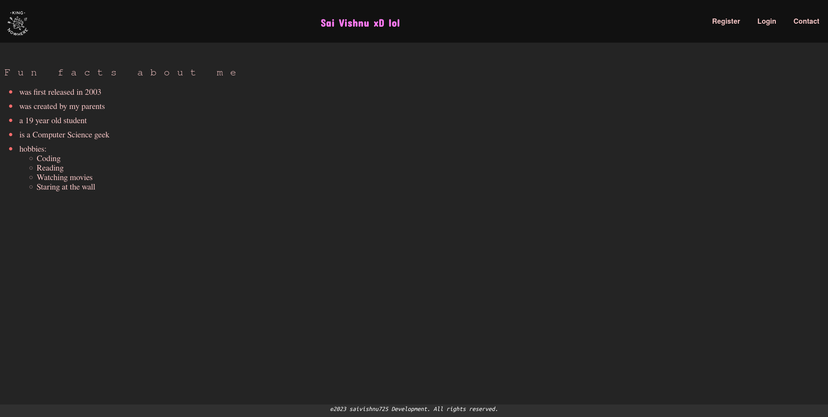

**register.html**

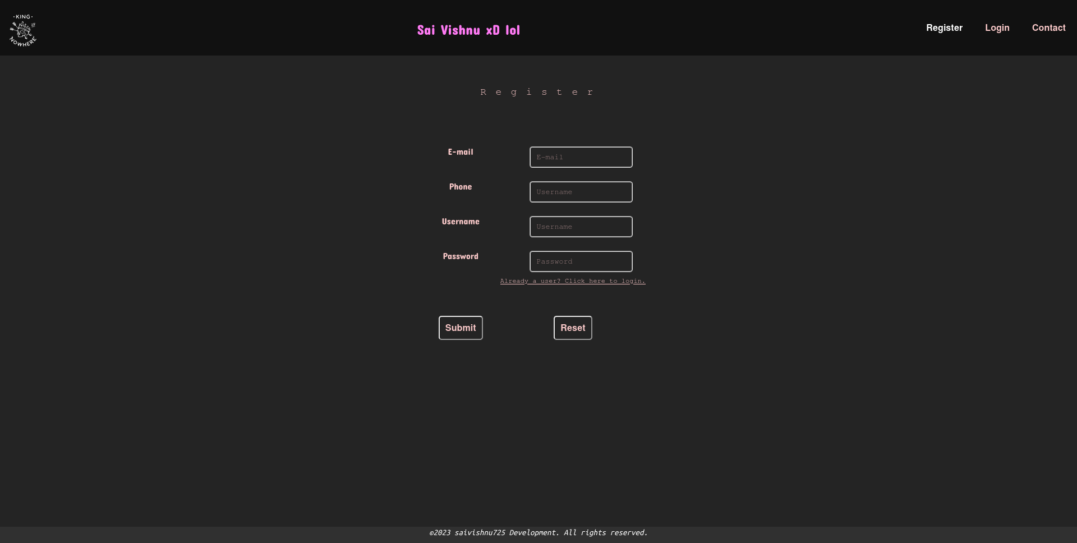

**login.html**

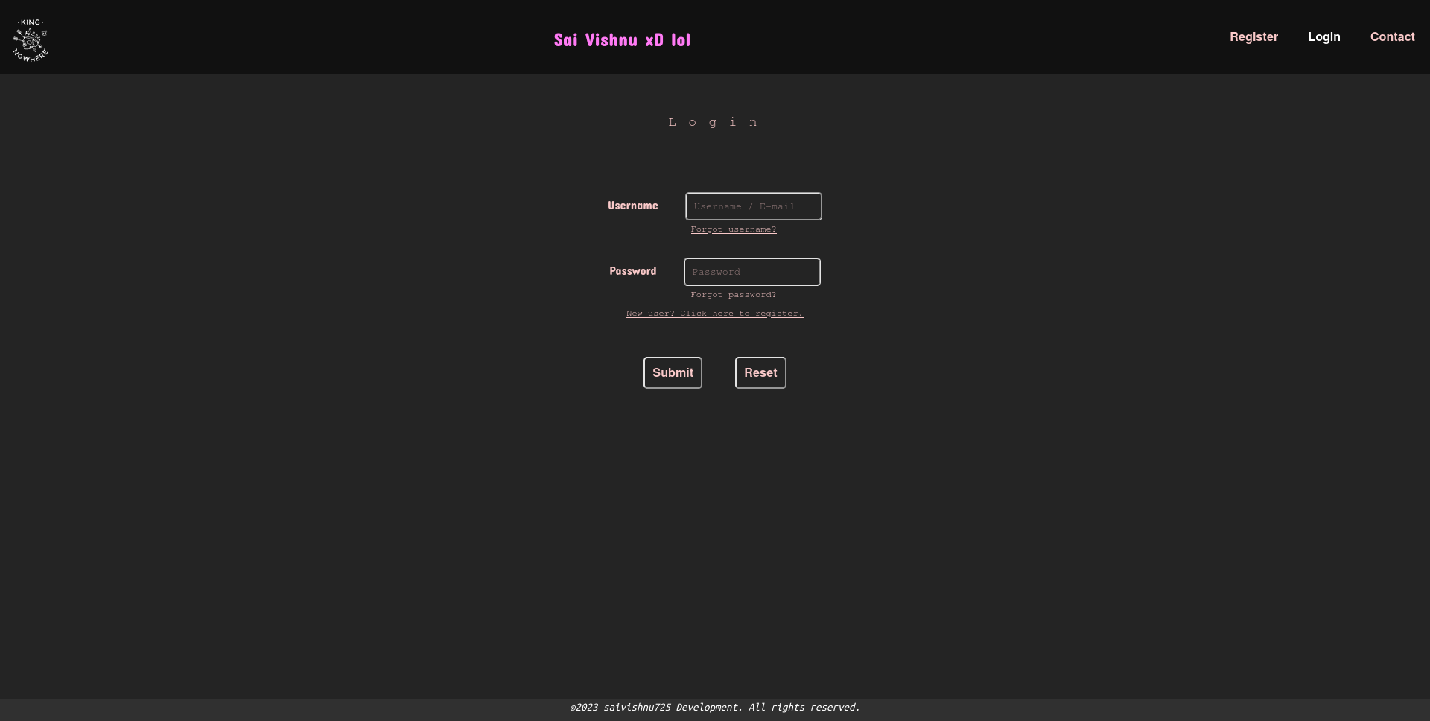

**contact.html**

