A Project Report

On

**Performance enhancement for limited power LoRaWAN systems using Golay codes as error correction scheme**

BY

**SAI VITTAL BATTULA (18XJ1A0238)**

**AALIYA AHMAD (18XJ1A0201)**

**SHEILA MALLAVARAPU (18XJ1A0241)**

**ROHAN KUNTA (18XJ1A0234)**

Under the supervision of

**DR. SAYANTAN HAZRA**

**&**

**DR. KRISHNA CHAITANYA BULUSU**

cid:image003.png@01D6594A.2604D070

**ÉCOLE CENTRALE SCHOOL OF ENGINEERING**

**HYDERABAD**

**(June 2021)**

**Abstract**

LoRaWAN is widely adopted these days for a variety of purposes. It guarantees present property in outside IoT applications, whereas keeping network structures and management simple. LoRa is a spread-spectrum development with a broad bandwidth of 125 kHz or more. LoRa is used for authentic bidirectionality, because of the symmetric association. Golay coding is a renowned error correction technique capable of correcting any combination of 3 bits or fewer random errors in a block of 24 bits. It permits high speed data transmission with low latency and allows secure communication. In this report, we describe Golay Code error correction scheme for Low Power Low Range Wide Area Network (LoRaWAN). GFSK modulation (and demodulation) scheme has been taken for an AWGN noise channel. Encoding and decoding this model using the binary Golay Codes gives a lower BER. The BER curves have been calculated for varying Signal-to-Noise Ratios (SNR). Additionally, OFDMA transmission technique was also implemented.

1. **Introduction**

**1.1. Introduction to LoRaWAN**

LoRaWAN is a long-range, low-power communication protocol based on the LoRa physical layer. Long Range (LoRa) is a radio modulation technology for wireless LAN networks that fall within the LPWAN (Low Power Wide Area Network) category.

The LoRa protocol stack has four layers Application layer, Media Access Control layer, Physical layer, and Radio Frequency layer. The Application Layer and the Media Access Control Layer together make up the LoRaWAN. The Physical Layer responsible for the radio and modulation part is known as Lora.

The LoRaWAN protocols are defined using the LoRa alliance. It is a non-profit organization with over 500 members dedicated to facilitating large-scale LPWAN IoT adoption by developing and promoting the LoRaWAN open standard. [1]

LoRaWAN works as a cellular network in which the gateways relay the messages between the numerous battery-powered end-devices (nodes) and a network server which then further routes the messages to the application servers. LoRaWAN is always deployed in star topology and the communication between nodes and gateways is Bidirectional.

Advantages of LoRa include low range, low power and low-cost connectivity; and security for both devices and network.

**1.2. Introduction to Golay codes**

This scheme reduces 99.9% of the errors, providing a relatively low bit error rate. The Golay code can allow the correction of up to $t=\left[\frac{d-1}{2}\right]=>t=\left[\frac{\left(7-1\right)}{2}\right]=3 errors$, $t$ is the error-correcting capability, and $d$ is the minimum Hamming distance of the code. The Golay encoding algorithm converts a 12-bit input sequence to a 24-bit sequence. The 24-bit coded sequence is sent across a channel to a receiver at the opposite end of the communication system. The Golay decoding method attempts to detect any bit mistakes in the received 24 bits. It can detect up to 4-bit errors in 24 bits and correct up to 3-bit errors in 24 bits. [2]

For instance, suppose we are sending a three-megabyte picture through a correspondence channel with a likelihood of mistake of 0.01. We would expect there to be 460,000 mistaken pieces (or error bits) in the encoded picture. At the point when we get this picture and begin to decode it, we should be able to correct 99.99% of all the received 23-bit segments. With the Golay code, we would expect to be able to correct the vast majority of the errors. After our error-correction, we would expect less than 50 error bits. [4]

1. **Problem Definition**

New technologies have emerged lately, such as LoRa (Long Range), Sigfox, and Weightless, enabling efficient long distances wireless communication. The LoRaWAN communication protocol can be used for the implementation of the IoT (Internet of Things) concept. [3]

Most of the time, the IoT concept entails a large number of nodes distributed over a wide geographical area, therefore forming a high density, large-scale architecture. It is important to determine the number of collisions so that we can assess the network performance. In order to get a high level of performance, the errors in the LoRaWAN systems must be reduced. One of these methods is discussed in this paper.

Transmission using LoRaWAN systems give a bit error rate of nearly 1%. While this may seem very small, in high amounts of data, there would be many errors. To prevent this, we encode the data before transmission and decode the data after receiving. This is called error correction. [7]

One of the most efficient methods of error correction is using Golay Codes. This scheme reduces 99.9% of the errors, providing a relatively low bit error rate. This paper observes the performance enhancement for limited power LoRaWAN systems using Golay codes as error correction scheme.

The simulations required for this paper are done using the simulation software, Simulink, which is a part of MATLAB. Then this has been converted into Verilog, a hardware description language that is used to model electronic systems.

**Figure 1.** LoRaWAN Working

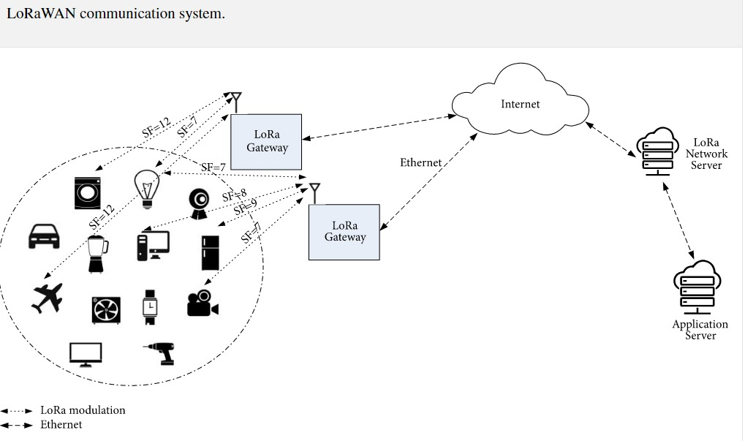

1. **Methodology**

The models made in Simulink for this particular project were designed taking into account the research done in a lot of research papers.

The Simulink models follow the following course of action:

Encode 🡪 Modulate 🡪 Channel 🡪 Demodulate 🡪 Decode

The modulation used is Gaussian Frequency Shift Keying.

Our idea for this project is to find the BER (Bit Error Rate) values with the use of Golay codes and without the use of Golay codes for the LoRaWAN model and compare which of the two models is better and come up with a possible explanation as to why that particular model is better.

Furthermore, we plotted the BER vs SNR curves using the tools that extract Simulink output data and MATLAB scripts.

Once the above-mentioned results are achieved, we converted the models to Verilog code for Altera Quartus II as synthesis tool and Arria 10 as the FPGA family.

1. **Implementation**

Before working on the implementation part of the project we understood the working of LoRaWAN systems and Golay codes.

The LoRaWAN specifications or the LoRaWAN MAC define three types of nodes or devices: classes A, B, and C. [1]

Let’s take class A for example and understand its working. Class A device sends messages to the Gateway module during certain periods of time, depending on the specifics of an application. Then, the LoRa node opens a reception slot to allow the Gateway to send acknowledgement, messages or other type of commands. The Gateway receives the messages from the LoRa node and sends them to the Network Server. This network server passes on the messages or acknowledgement further to the Application servers.

Class A devices have radio powered down for a majority of the time, they only wake up when they need to send messages. After the transmission is done, they briefly listen for an incoming message and then power down again. An example of such a device would be a temperature monitoring device which sends the temperature every 10-20 minutes. Class B devices are similar to class A devices with just one exception, they will power on the radio to listen for incoming messages at scheduled times. These devices are more reliable for receiving messages. Class C devices have their radio powered on almost all the time. They receive messages almost all the time except for when they are transmitting a message. An Example of a Class C device is an Actuator. [8]

The Golay encoding algorithm converts a 12-bit input sequence to a 24-bit sequence. The coded sequence of 24 bits is transmitted over a channel to a receiver at the other end of the communication system. The coded sequence of 24 bits appears in both the second and the third text fields.

Introduce bit errors in the 24 bits received. You do this by flipping bits in the third text field. The Golay coding can detect up to 4-bit errors in 24 bits, and can correct up to 3-bit errors in 24 bits. The Golay decoding algorithm tries to detect the bit errors occurred in the 24 bits received.

The Golay decoding method recognises the real bit defects and recovers the 24 bits that were meant to be communicated if the 24 bits received have 3-bit errors. The fourth text field displays the observed error pattern. In the fifth text field, the 12 information bits that were recovered are displayed. If the 24 bits received contain 4-bit mistakes, the decoding algorithm is capable of detecting the 4-bit faults but not of determining the error pattern. If the 24 bits received have greater than 4-bit errors, the error pattern detected by the decoding algorithm is not the actual error pattern occurred, and consequently the 12 bits recovered are not the same as the 12 information bits. [9]

**Table 1.** Parameters considered for our models.

|  |  |
| --- | --- |
| **DEFINITION** | **VALUE** |
| Data Frame | 64 symbols |
| Samples per Symbol | 8 |
| Roll of factor | 0.2 dB/decade |
| Up sampling | 8 |
| LNA power gain | 18 dB |
| LNA noise figure | 3 dB |
| LNA Impedance | 50 ohms |
| Phase Shift | 90 degrees Celsius |
| Down sampling | 8 |
| Receive delay | 72 |

Table 1 discuss the parameters that were widely used for building our models. Low power setting was used to simulate our models. [6]

The Golay code encoder was made out of three units: information way, control unit, and changing over unit. These units were planned cautiously to such an extent that the created design can work with '0' and 1 MSB messages. [10]

**Figure 2.** Simulink Model for LoRaWAN protocol without Golay Codes

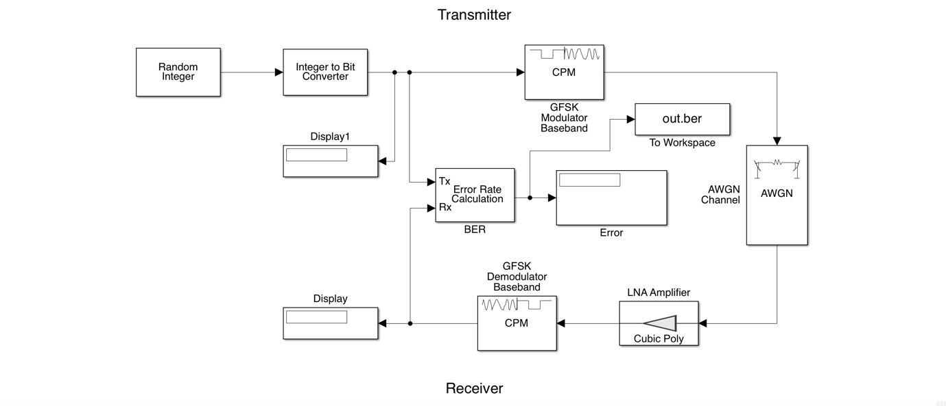

**Figure 3.** Simulink Model for LoRaWAN protocol with Golay Codes

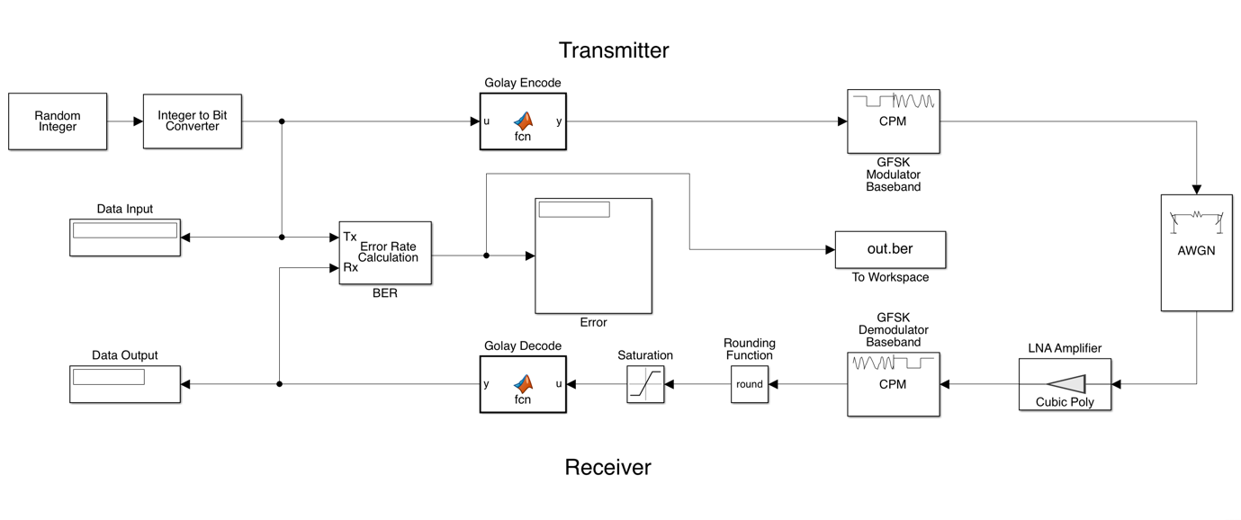

The above models were thoroughly analysed from various references and pruned properly to reduce errors. The MATLAB functions used to encode and decode using Golay scheme consists of a clever algorithm that takes only 12 bits at one time when huge amount of data is received, and is converted into 24 bits using the Golay Generator Matrix. This data is then appropriately modulated and demodulated (with addition of noise) and then decoded to get results that lie in the perspective of the theory. [5]

1. **Results**

BER vs SNR curves were plotted in comparison with the theoretical formula and simulation results using Monte Carlo simulation for 10000 iterations.

The theoretical formula used was ${BER}_{th}=\frac{1}{2} × erfc(\sqrt[2]{\frac{SNR}{2}})$

For Golay codes simulation, we have first simulated the model and used that data to fit and find a curve equation identical to the theoretical formula proposed above.

The equation found out to be similar to ${BER}_{th}=\frac{1}{2} × erfc(\sqrt[2]{\frac{SNR}{1.15}})$

**Figure 3.** a) BER vs SNR for LoRaWAN without Golay; b) with Golay. Both theoretical and simulated results are shown.

1. (b)

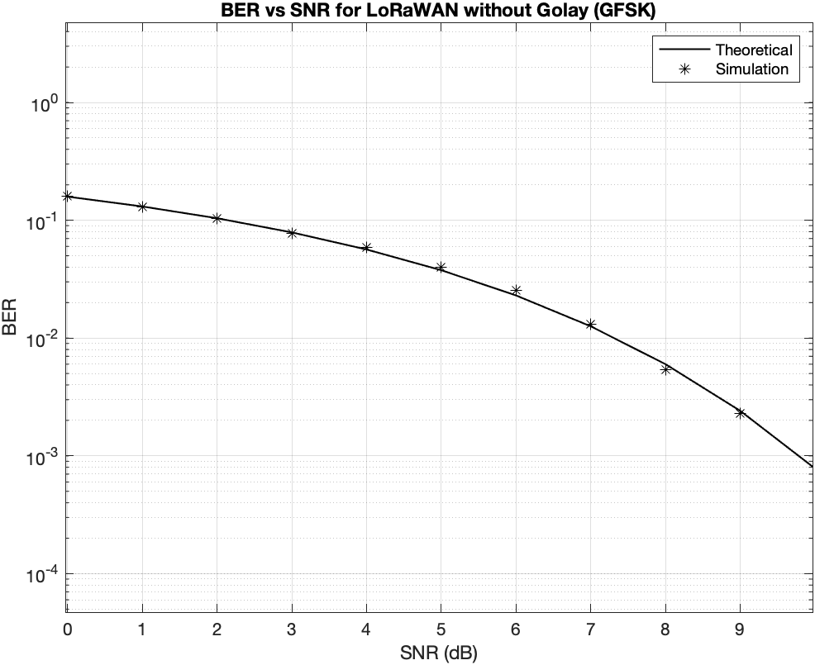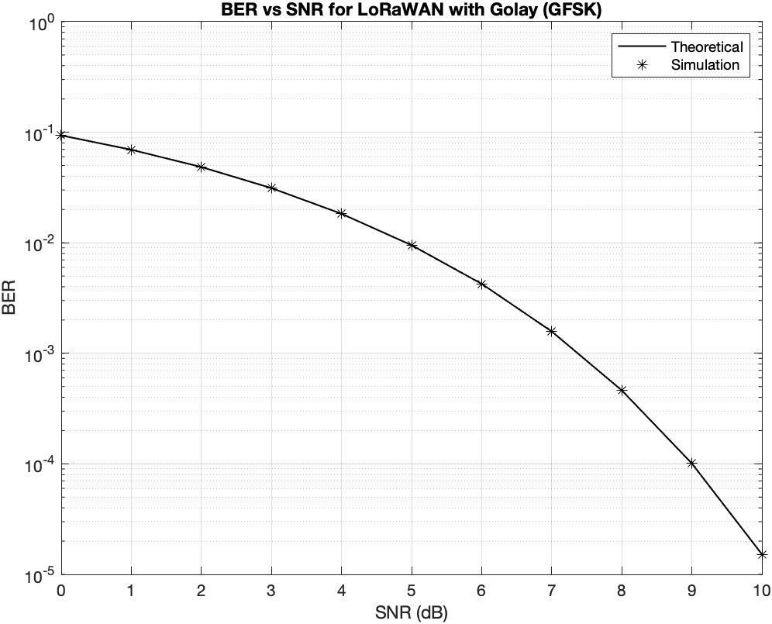

**Figure 4.** BER vs SNR for LoRaWAN with and without Golay Codes

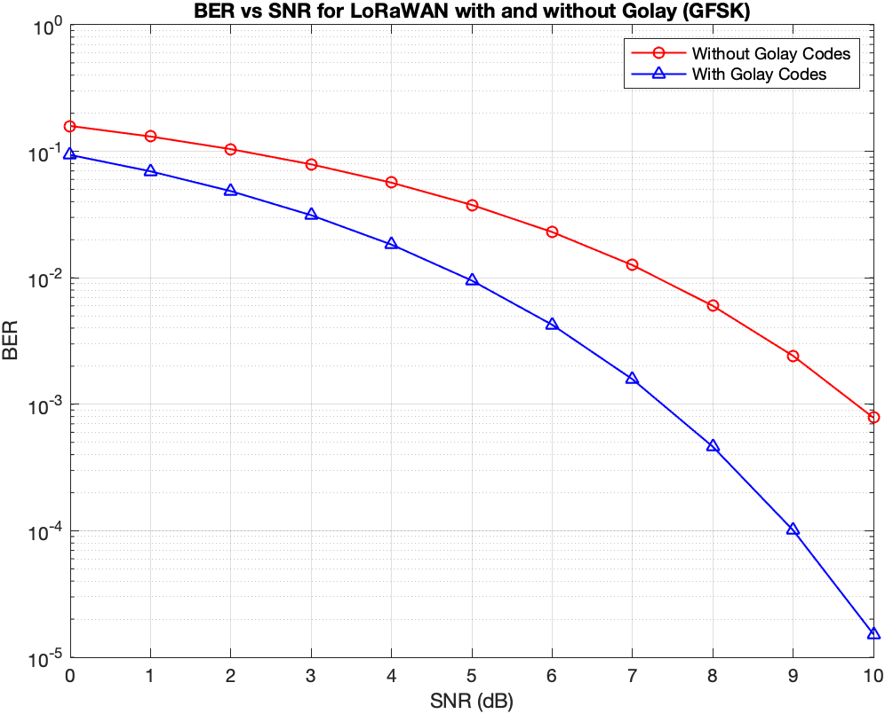

Along with the above, OFDMA transmission was also implemented with signal constellation (M) of 4, data points of 64 and block size of 8.

**Figure 5.** a) Transmitted data; b) Received data; c) Quadrature vs In-Phase for transmitted and received data; d) OFDMA transmitted signal

1. (b)

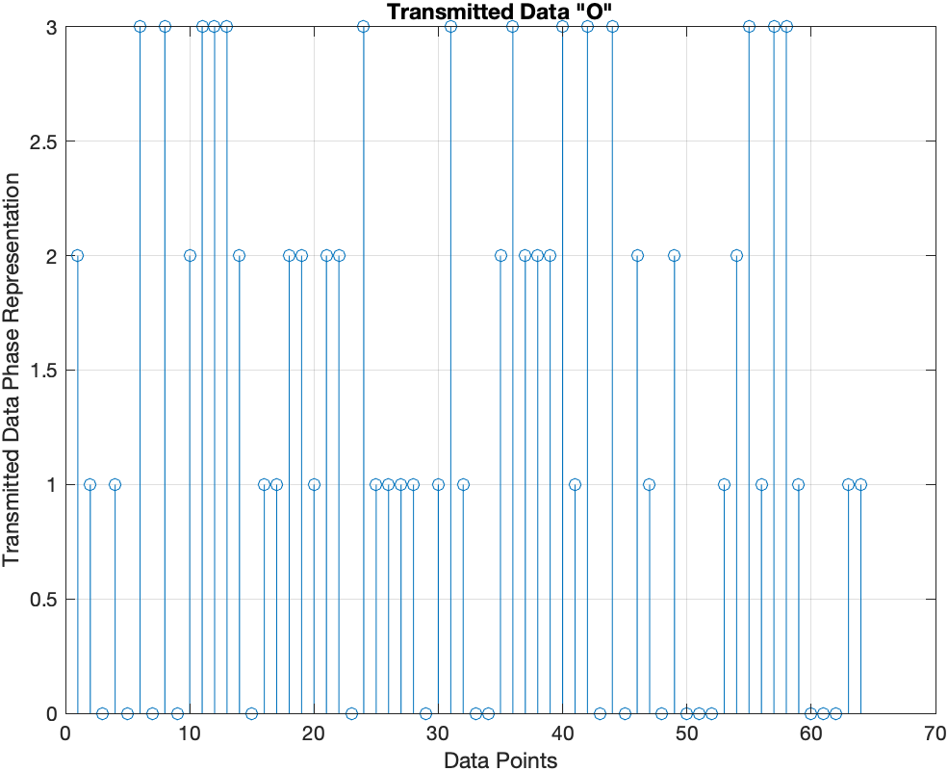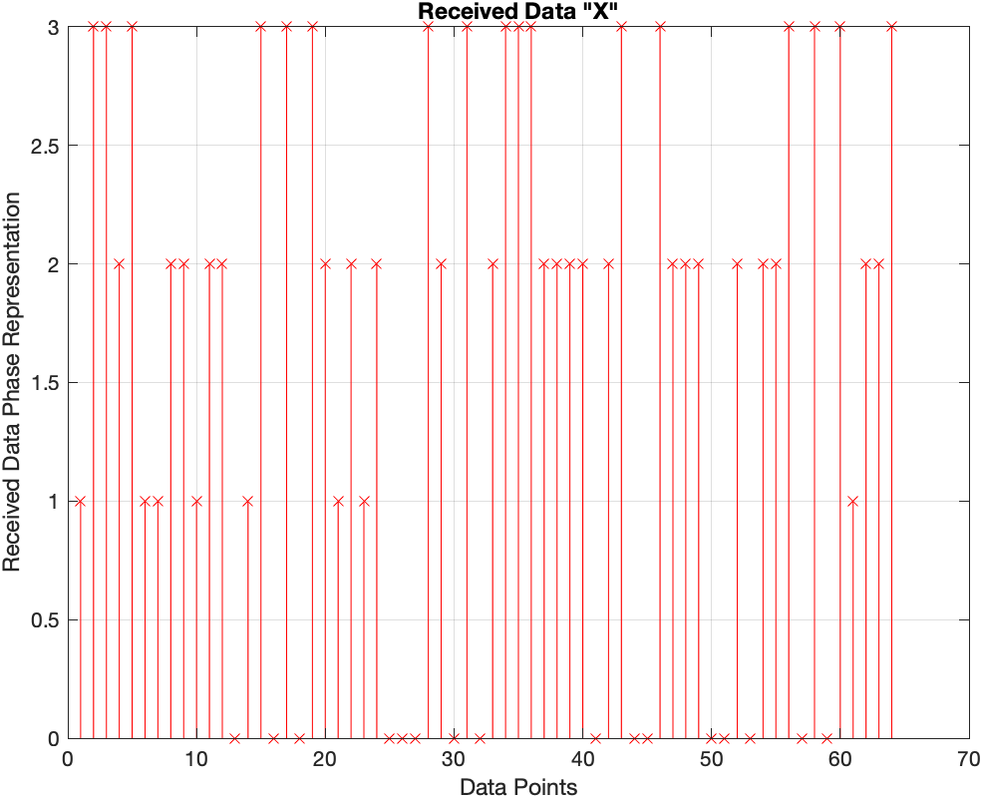

(c) (d)

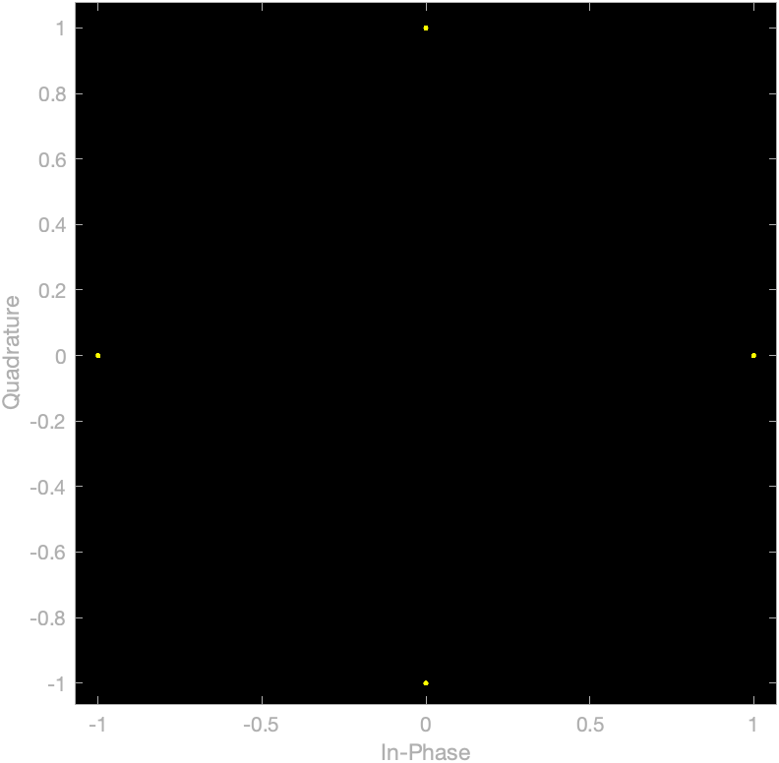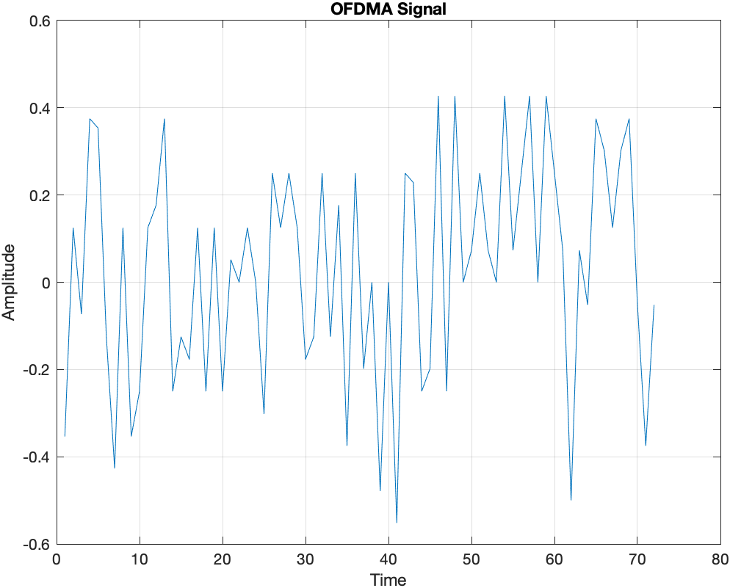

1. **Conclusion**

Simulated the LoRaWAN model through AWGN channel for a pre-specified low power setting and also designed the required encoders, decoders, modulators, demodulators and data sources. Significant improvement in BER vs SNR, even for low values of SNR was shown through our plots. Later, OFDMA transmission was implemented and the Simulink models were converted into VHDL for Altera Quartus II as synthesis tool and Arria 10 as the FPGA family. Both the models when converted into VHDL had a computational complexity of O(n2) and static program slicing was done in debugging.

# **References**

1. <https://www.link-labs.com/blog/what-is-lorawan> (accessed 3 June 2021).
2. <https://www.section.io/engineering-education/understanding-error-correcting-codes-part-2/> (accessed 3 June 2021).
3. Alexandru Lavric, Valentin Popa, "Performance Evaluation of LoRaWAN Communication Scalability in Large-Scale Wireless Sensor Networks", Wireless Communications and Mobile Computing, vol. 2018, Article ID 6730719, 9 pages,2018. https://doi.org/10.1155/2018/6730719.
4. <http://aqdi.com/articles/using-the-golay-error-detection-and-correction-code-3/> (accessed 3 June 2021).
5. Manoj G, Shafeeja P M , Sona O Kundukulam. Simulink Modeling of Extended Golay Coding Technique for Coaxial Cable Telemetry. IPASJ International Journal of Electronics & Communication (IIJEC). 5 (8). 2017.
6. Chaithrashree P Mundkur, Mrs Yasha Jyothi M Shirur and Mr Vishweshwara. Modelling of LoRa transceiver in MATLAB using Simulink. International Journal of Modern Trends in Engineering and Research (IJMTER) . 3(6). 2016.
7. Vitor Fialho & Fernado Azeved. Wireless Communication Based on Chirp Signals for LoRa IoT Devices. ISEL - High Institute of Engineering of Lisbon. 2018. 10.34629/ipl.isel.i-ETC.51.
8. Taha, Ashraf & Feteiha, Mohamed & Abdul, Wadood. (2019). Performance Evaluation for LoRa Transceiver. International Journal of Computer Science and Software Engineering. 8. 2409-4285.
9. <https://users.soe.ucsc.edu/~hongwang/ECC/golay.html> (accessed 3 June 2021).
10. M. Nazeri, A. Rezai and H. Azis, "An Efficient Architecture for Golay Code Encoder," 2018 2nd East Indonesia Conference on Computer and Information Technology (EIConCIT), 2018, pp. 114-117, doi: 10.1109/EIConCIT.2018.8878513.