**ABSTRACT**

We report a Golay Code error correction scheme for Low Power Low Range Wide Area Network (LoRa WAN). A GFSK modulation and demodulation for an AWGN noise channel has a Bit Error Rate (BER) of ___. Encoding and decoding this model using the binary Golay Codes gives a lower BER. The BER curves have been calculated for varying Signal-to-Noise Ratios (SNR). //This has been done for multiple access transmission techniques. Additionally, this has also been implemented for an orthogonal frequency-division multiple access (OFDMA).

**INTRODUCTION**

LoRaWAN is a long-range, low-power communication protocol based on the LoRa physical layer. Long Range (LoRa) is a radio modulation technology for wireless LAN networks that fall within the LPWAN (Low Power Wide Area Network) category. The LoRa protocol stack has four layers ie Application layer, Media Access Control (MAC) Layer, Physical layer, and Radio Frequency layer. The Application Layer and the Media Access Control Layer together make up the LoRaWAN. The Physical Layer responsible for the radio and modulation part is known as Lora. The LoRaWAN protocols are defined using the LoRa alliance. It is a non-profit organization with over 500 members dedicated to facilitating large-scale LPWAN IoT adoption by developing and promoting the LoRAWAN open standard. LoRaWAN works as a cellular network in which the gateways relay the messages between the numerous battery-powered end-devices(nodes) and a network server which then further routes the messages to the application servers. LoRAWAN is always deployed in star topology and the communication between nodes and gateways is Bidirectional. LoRaWAN devices can operate in 3 different ways which are classified as Class A, B, and C. The class A devices have radio powered down for a majority of the time, they only wake up when they need to send messages. After the transmission is done, they briefly listen for an incoming message and then power down again. An example of such a device would be a temperature monitoring device which sends the Temperature every 10-20 minutes. Class B devices are similar to class A devices with just one exception, they will power on the radio to listen for incoming messages at scheduled times. These devices are more reliable for receiving messages. Class C devices have their radio powered on almost all the time. They receive messages almost all the time except for when they are transmitting a message. An Example of a Class C device is an Actuator.

Transmission using LoRaWAN systems gives a bit error rate of nearly 0.01. While this may seem very small, in high amounts of data, there would be many errors. To prevent this, we encode the data before transmission and decode the data after receiving it. This is called error correction. One of the most efficient methods of error correction is using Golay Codes. This scheme reduces 99.9% of the errors, providing a relatively low bit error rate. The Golay code can allow the correction of up to t=⌊(d-1)/2⌋=⌊ (7-1)/2⌋=3 errors, t is the error-correcting capability, and d is the minimum Hamming distance of the code. The Golay encoding algorithm converts a 12-bit input sequence to a 24-bit sequence. The 24-bit coded sequence is sent across a channel to a receiver at the opposite end of the communication system. The Golay decoding method attempts to detect any bit mistakes in the received 24 bits. It can detect up to 4-bit errors in 24 bits and correct up to 3-bit errors in 24 bits.

This paper observes the performance enhancement for limited power LoRaWAN systems using Golay codes as an error correction scheme. The authors of this paper used Simulink in Matlab to design and simulate Models of LoRaWAN with GFSK modulation and Binary Golay codes as an error correction scheme. The authors compared the results of the BER vs SNR curve with and without the use of the error correction scheme. The Results in the paper confirm a significant amount of improvement in the BER vs SNR curve with the use of Binary Golay codes as the error correction scheme.

**EXPERIMENT**

In this paper, the authors first designed the modulator and the demodulator using the GFSK model for LoRaWAN on Simulink. Then an AWGN noise channel was simulated. The models were placed such that the **signal** is first modulated, the noise was added to the **signal** and again demodulated. The BER curves were calculated at this point for varying SNR values. After this, an encoder and a decoder were simulated using the binary Golay Codes Error Correction method. The encoder was placed before the modulator and the decoder, after the demodulator. The BER curves were calculated again for varying SNR values. These models were then converted to Verilog for better implementation. The following model was designed and simulated on Simulink to get results.

**Figure 1.** Simulink Model for LoRaWAN protocol without Golay Codes

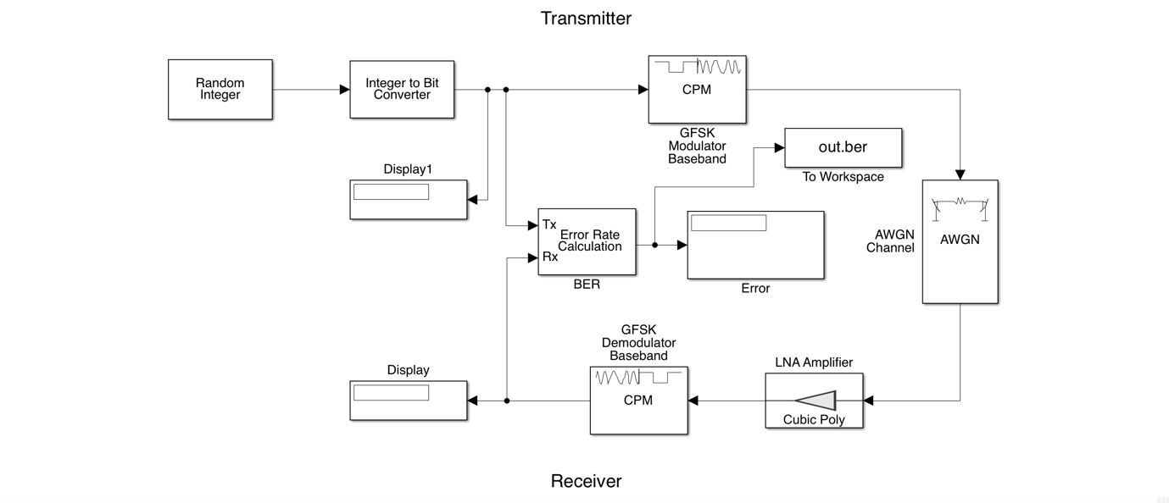

**Figure 2.** Simulink Model for LoRaWAN protocol with Golay Codes

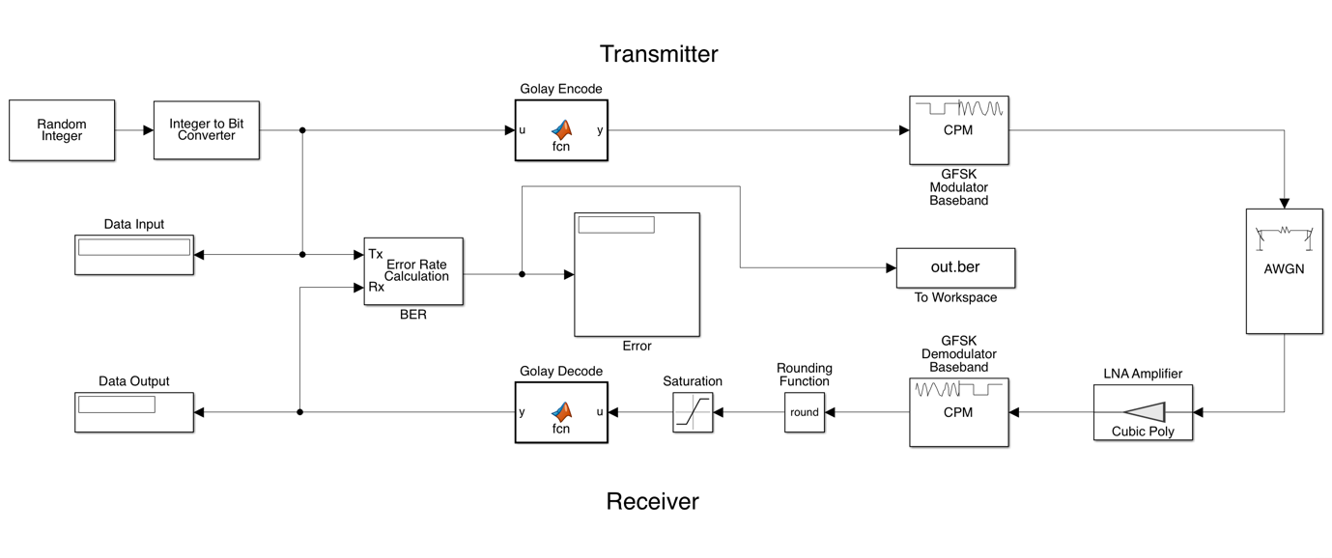

**RESULTS**

The Golay code encoder was made out of three units: information way, control unit, and changing over unit. These units were planned cautiously to such an extent that the created design can work with '0' and 1 MSB messages. *From implementation*

BER vs SNR curves were plotted in comparison with the theoretical formula and simulation results using Monte Carlo simulation for 10000 iterations.

The theoretical formula used was ${BER}_{th}=\frac{1}{2} × erfc(\sqrt[2]{\frac{SNR}{2}})$

For Golay codes simulation, the authors first simulated the model and used that data to fit and find a curve equation identical to the theoretical formula proposed above.

The equation found out to be similar to ${BER}_{th}=\frac{1}{2} × erfc(\sqrt[2]{\frac{SNR}{1.15}})$

From figure 3 and figure 4, it can be seen that BER improves with an increase in the SNR with the error correction scheme in comparison to without the scheme.

**Figure 3.** a) BER vs SNR for LoRaWAN without Golay; b) with Golay. Both theoretical and simulated results are shown.

1. (b)

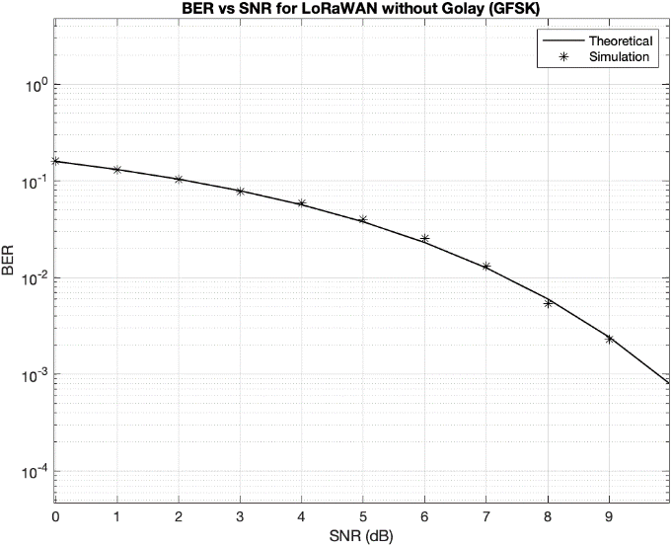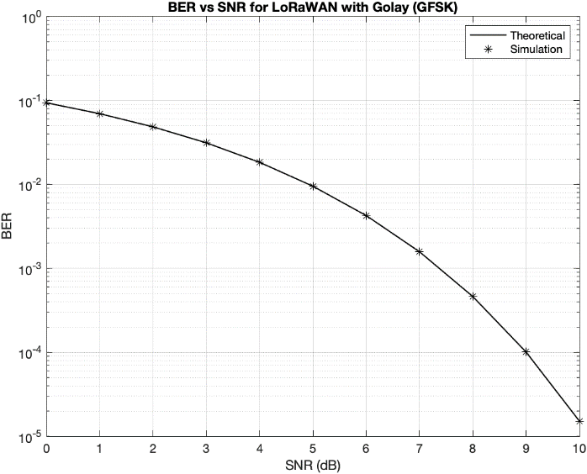

**Figure 4.** BER vs SNR for LoRaWAN with and without Golay Codes

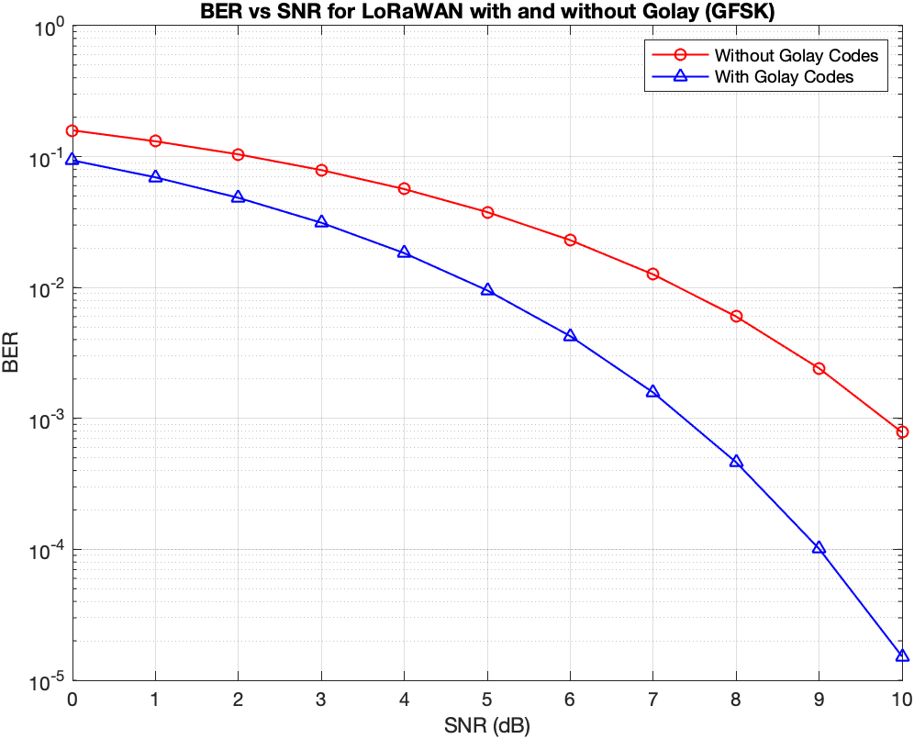

Furthermore, OFDMA transmission was also implemented with signal constellation (M) of 4 data points of 64 and block size of 8.

This is seen in figure 5. In Figure 5(a), the transmitted data is represented with a phase of zero to three. The received data is also in the same scale.

**Figure 5.** a) Transmitted data; b) Received data; c) Quadrature vs In-Phase for transmitted and received data; d) OFDMA transmitted signal

1. (b)

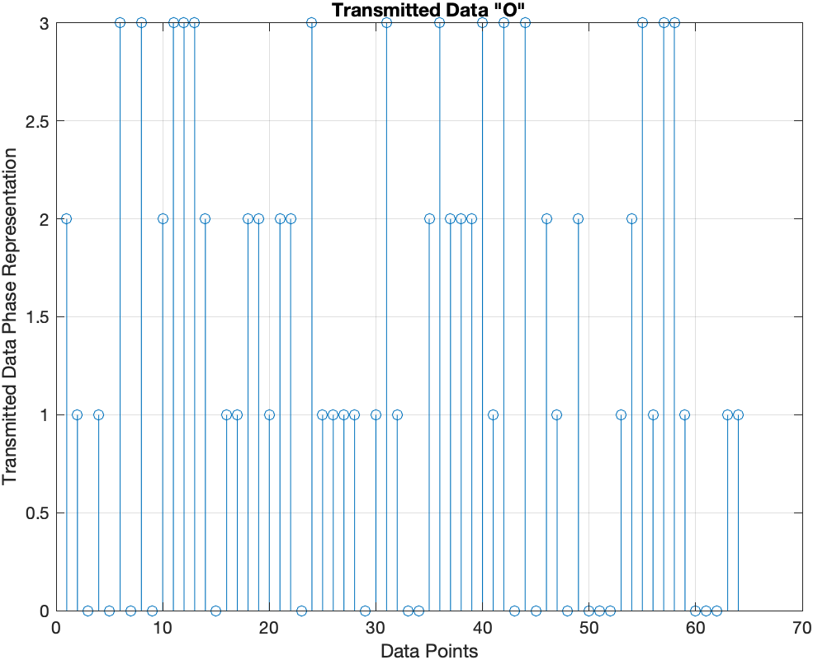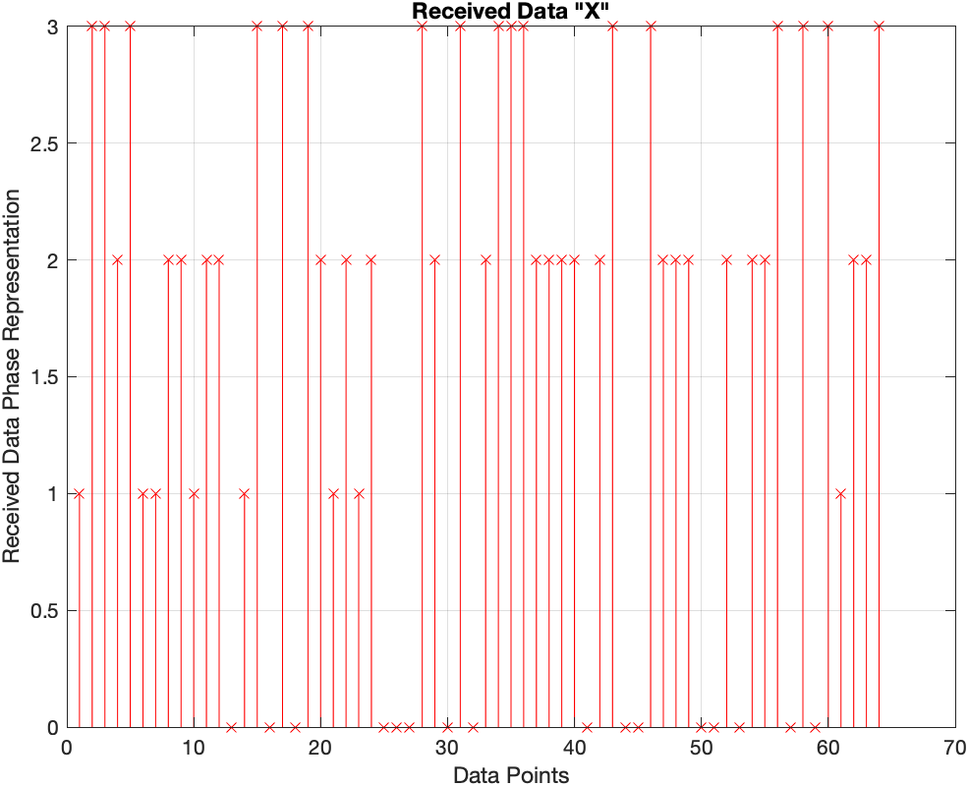

(c) (d)

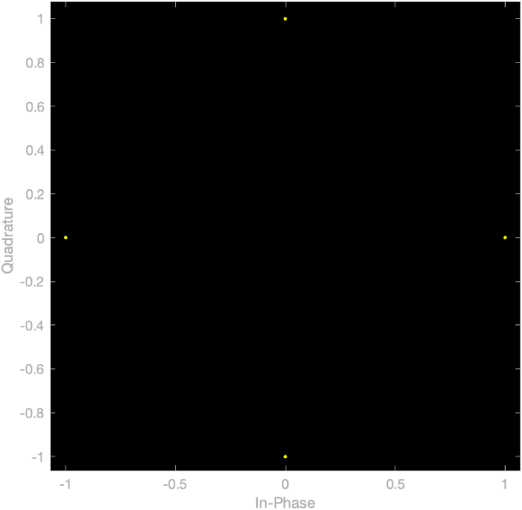 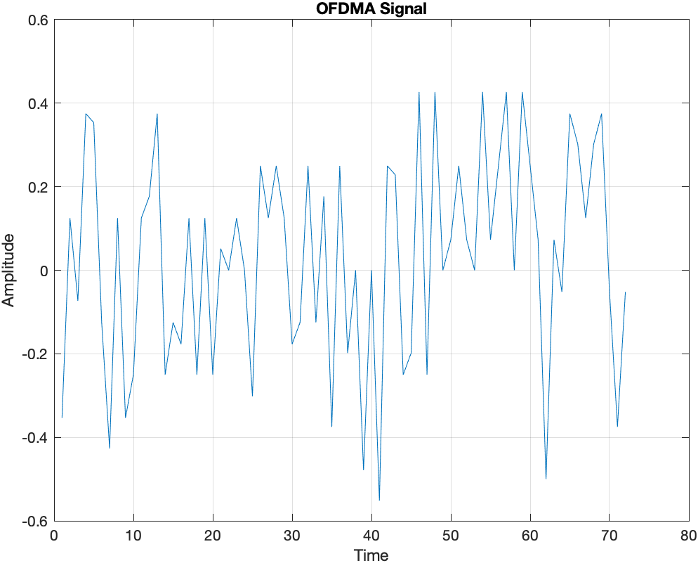

**CONCLUSION**

The Authors simulated the LoRaWAN model through AWGN channel for a pre-specified low power setting and also designed the required encoders, decoders, modulators, demodulators and data sources. Significant improvement in BER vs SNR using Golay codes as error correction scheme was shown through our plots. Later, OFDMA transmission was implemented and the Simulink models were converted into VHDL for Altera Quartus II as synthesis tool and Arria 10 as the FPGA family. Both the models when converted into VHDL had a computational complexity of O(n2) and static program slicing was done in debugging.