SOFTWARE ENGINEERING
LAB MANUAL

B.Tech – III year-I sem
DEPARTMENT OF
COMPUTER SCIENCE AND ENGINEERING


JNTUH COLLEGE OF ENGINEERING
SULTANPUR,PULKAL(M), SANGAREDDY DIST-502273

General Laboratory Instructions:

- Students are advised to come to the laboratory at least 5 minutes before (to the starting time), those who come after 5 minutes will not be allowed into the lab.

- Plan your task properly much before to the commencement, come prepared to the lab with the synopsis / program / experiment details.

Student should enter into the laboratory with:

- Laboratory observation notes with all the details (Aim , Problem Analysis and Project Planning, Software Requirement Analysis, Data Modeling, Software Designing, Prototype model, etc.,) filled in for the lab session.

- Laboratory Record updated up to the last session experiments and other utensils (if any) needed in the lab.

- Proper Dress code and Identity card.

- Sign in the laboratory login register, write the TIME-IN, and occupy the computer system allotted to you by the faculty.

- Execute your task in the laboratory, and record the results / output in the lab observation note book, and get certified by the concerned faculty.

- All the students should be polite and cooperative with the laboratory staff, must maintain the discipline and decency in the laboratory.

- Computer labs are established with sophisticated and high end branded systems, which should be utilized properly.

- Students must keep their mobile phones in SWITCHED OFF mode during the lab sessions. Misuse of the equipment, misbehaviors with the staff and systems etc., will attract severe punishment.

- Students must take the permission of the faculty in case of any urgency to go out; if anybody found loitering outside the lab / class without permission during working hours will be treated seriously and punished appropriately.

- Students should LOG OFF/ SHUT DOWN the computer system before he/she leaves the lab after completing the task (experiment) in all aspects. He/she must ensure the system / seat is kept properly.

Objectives and Outcomes:
Objectives:
- To understand the software engineering methodologies involved in the phases for project development.
- To gain knowledge about open source tools used for implementing software engineering methods.
- To exercise developing product-startups implementing software engineering methods.
Outcomes:
- Ability to understand the different phases of software project.
- Ability to understand the use of different open source tools for project design.
- Ability to develop product-startups implementing software engineering methods.

Recommended Software Requirements

- Open source Tools: StarUML / UMLGraph / Topcased
Useful Text Books/ References:
- Software engineering A practitioner’s Approach, Roger S Pressman, sixth edition
McGraw Hill International Edition.
- Software Engineering, Ian Sommerville, seventh edition, Pearson education.

INDEX

S.No. | List of Documents | Page No.
1 | Problem Analysis and Project Planning | 05-08
2 | Software Requirement Analysis | 09-11
3 | Data Modeling | 12-12
4 | Software Designing | 13-17
5 | Prototype model | 18-20
S.No. | List of Experiments | Page No.
1 | Course management system (CMS) | 21-31
2 | Easy Leave | 32-51
3 | E-Bidding | 52-68
4 | Electronic Cash counter | 69-86
 | Viva Questions | 86-86

- Problem Analysis
- Problem analysis is the process of understanding real-world problems and user's needs and proposing solutions to meet those needs.
- The goal of problem analysis is to gain a better understanding, before development begins, of the problem being solved.
- To identify the root cause, or the problem behind the problem, ask the people directly involved.
- Identifying the actors on the system is a key step in problem analysis.
Project Planning
Before starting a software project, it is essential to determine the tasks to be performed and properly manage allocation of tasks among individuals involved in the software development. Hence, planning is important as it results in effective software development.
Project planning is an organized and integrated management process, which focuses on activities required for successful completion of the project. It prevents obstacles that arise in the project such as changes in projects or organization's objectives, non-availability of resources, and so on.
Project planning also helps in better utilization of resources and optimal usage of the allotted time for a project. The other objectives of project planning are listed below.
- It defines the roles and responsibilities of the project management team members.
- It ensures that the project management team works according to the business objectives.
- It checks feasibility of the schedule and user requirements.
- It determines project constraints.

Project Planning Process
The project planning process involves a set of interrelated activities followed in an orderly manner to implement user requirements in software and includes the description of a series of project planning activities and individual(s) responsible for performing these activities. In addition, the project planning process comprises the following.

- Objectives and scope of the project
- Techniques used to perform project planning
- Effort (in time) of individuals involved in project
- Project schedule and milestones
- Resources required for the project
- Risks associated with the project.
Project planning process comprises several activities, which are essential for carrying out a project systematically. These activities refer to the series of tasks performed over a period of time for developing the software. These activities include estimation of time, effort, and resources required and risks associated with the project.

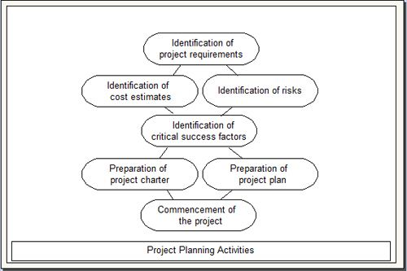

Project planning process consists of the following activities.
- Identification of project requirements: Before starting a project, it is essential to identify the project requirements as identification of project requirements helps in performing the activities in a systematic manner. These requirements comprise information such as project scope, data and functionality required in the software, and roles of the project management team members.
- Identification of cost estimates: Along with the estimation of effort and time, it is necessary to estimate the cost that is to be incurred on a project. The cost estimation includes the cost of hardware, network connections, and the cost required for the maintenance of hardware components. In addition, cost is estimated for the individuals involved in the project.
- Identification of risks: Risks are unexpected events that have an adverse effect on the project. Software project involves several risks (like technical risks and business risks) that affect the project schedule and increase the cost of the project. Identifying risks before a project begins helps in understanding their probable extent of impact on the project.
- Identification of critical success factors: For making a project successful, critical success factors are followed. These factors refer to the conditions that ensure greater chances of success of a project. Generally, these factors include support from management, appropriate budget, appropriate schedule, and skilled software engineers.
- Preparation of project charter: A project charter provides a brief description of the project scope, quality, time, cost, and resource constraints as described during project planning. It is prepared by the management for approval from the sponsor of the project.
- Preparation of project plan: A project plan provides information about the resources that are available for the project, individuals involved in the project, and the schedule according to which the project is to be carried out.
- Commencement of the project: Once the project planning is complete and resources are assigned to team members, the software project commences.
Project plan
A project plan helps a project manager to understand, monitor, and control the development of software project. This plan is used as a means of communication between the users and project management team. There are various advantages associated with a project plan, some of which are listed below.
- It ensures that software is developed according to the user requirements, objectives, and scope of the project.
- It identifies the role of each project management team member involved in the project.
- It monitors the progress of the project according to the project plan.
- It determines the available resources and the activities to be performed during software development.
- It provides an overview to management about the costs of the software project, which are estimated during project planning.
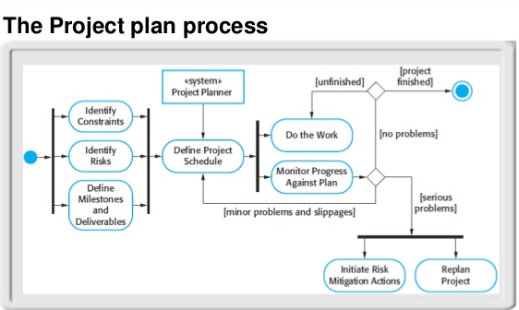

Identify project scope:

Defining project scope requires input from the project stakeholders, who together with project managers establish the key elements of budget, objectives, quality and timeline. To determine a project scope, project managers must collect requirements for what the stakeholders need from the project -- this includes the project's objective or the project's deliverables, when the project needs to be completed, and how much they can pay for it. The goal is to gather and record precise and accurate information during this process, so that the project scope effectively reflects all requirements and thus improves the chances for project leaders to deliver products that meet stakeholder expectations on time and on budget.

- Software Requirement Analysis:

The project management life cycle is usually broken down into four phases: initiation, planning, execution, and closure—these make up the path that takes your project from the beginning to the end. Some methodologies also include a fifth phase, controlling or monitoring
Here are 4 essential project management phases and processes that will ease your team’s work and speed up your efforts.
Project initiation phase – dedicated to finding out the exact requirements of your client and analyzing whether or not you have the essential resources to complete the project
Project planning phase – the perfect time for you to put down the exact detailed steps that need to be taken during the project development process
Project execution and monitoring phase – the most important stage during which you prepare deliverables and control the evolution of the project
Project closure phase – close all contracts and discuss what went wrong in the past to prepare for future projects
1. Project initiation phase
The initiation phase is when you need to find out the goals and requirements of your client, to determine the importance of a project for your company’s growth, and whether you have the necessary resources to successfully complete the project or not.
Here’s a checklist of two simple project management steps that you must have in order before moving on to the next phase:
A comprehensive list of the requirements of your client
A standard document that includes all of the project’s details
Steps to take:
1. You first need to have an initial meeting with your client. This step is crucial as you have to map out the exact requirements of your client. Make sure that you find out what is important for them and what they want to achieve in the end. In this way, you ensure the success of your project from the very beginning. No project manager wants to find out that they will have to change something after it’s done just because they haven’t understood the exact needs and goals of their clients.
Clear communication should be established between you and your clients even before the actual start of the project. Get all the details that you need and feel free to suggest improvements for their ideas. Analyze whether the decisions they made are right for the development of the project based on your past experience since you might have dealt with similar projects before. The issues and risks that arise are often similar. However, this time, you will certainly be able to handle them correctly and avoid unnecessary mistakes and errors in the project development process.
2. Project planning phase
After the first discussions with your client, you can start making the exact plans. These need to be well-written so that your team will have no difficulty in completing their duties. Any error and confusion regarding the main strategy can slow down the project’s development.
A project’s plan is essentially a manual that can guide the team towards reaching your general goals while preparing them for the risks and obstacles they might face. To differentiate this phase from the previous one, you have to think of the initiation step as one during which you only make presumptions based on initial information, while the project planning phase is when you actually put everything on paper and make definite decisions.
A typical project plan will outline all of the activities and tasks that the team will undertake depending on a series of resources and timelines.
Additionally, you can set some goals related to the benefits of the project on your company’s development and future projects.
3. Project execution and monitoring phase
This is the main and most important stage of your entire project management process. It is the real start of the project. You can look at this step as a result of the planning stage because it’s dependant on what you have chosen to do during that part of the project’s development.
During the project execution phase, you and your team will work on all of the aspects that you have planned and assessed during the previous steps. It is during this stage that you need to focus most of your attention and avoid making mistakes for a proper project development cycle. It’s also called the project implementation stage because you begin to implement the decisions that you have taken previously.
Your main goals for this phase will be to prepare deliverables, to motivate your team to complete their assigned activities in time for the final project delivery, and to control each aspect of the project’s progress.
Make sure to always create and submit products based on this simple flow:

4. Project closure phase
Also known as the completion phase, this stage’s focus is on the end result. Your main efforts should be directed toward the goals of delivering a final product on time and on budget, within the qualitative requirements established with the client.
A project is completed only after the product has been delivered to the client and the latter has accepted it as being the final version.
There are 3 main steps that you need to have in check before the project’s completion:
- A retrospective meeting
- The project’s general review
- Ending all contracts.

- Data Modeling:

Data modeling is often the first step in database design and object-oriented programming as the designers first create a conceptual model of how data items relate to each other. Data modeling involves a progression from conceptual model to logical model to physical schema.
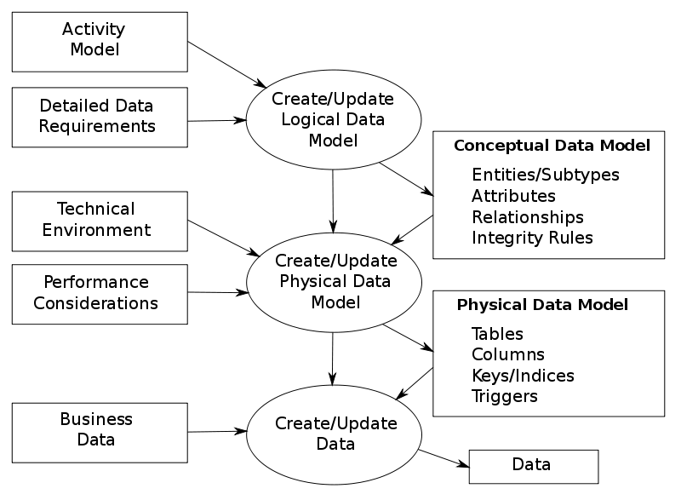
Data Dictionary:
A data dictionary is a collection of descriptions of the data objects or items in a data model for the benefit of programmers and others who need to refer to them. A first step in analyzing a system of objects with which users interact is to identify each object and its relationship to other objects. This process is called data modeling and results in a picture of object relationships. After each data object or item is given a descriptive name, its relationship is described (or it becomes part of some structure that implicitly describes relationship), the type of data (such as text or image or binary value) is described, possible predefined values are listed, and a brief textual description is provided. This collection can be organized for reference into a book called a data dictionary.

- Software Designing:

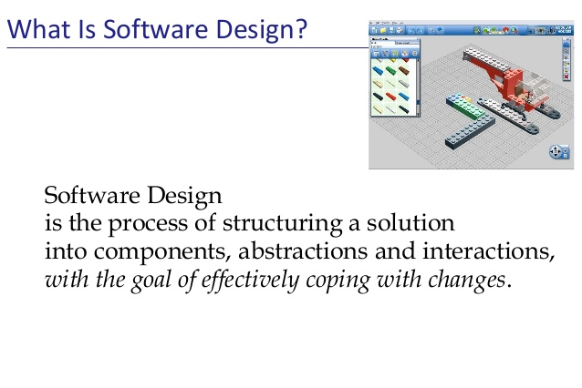
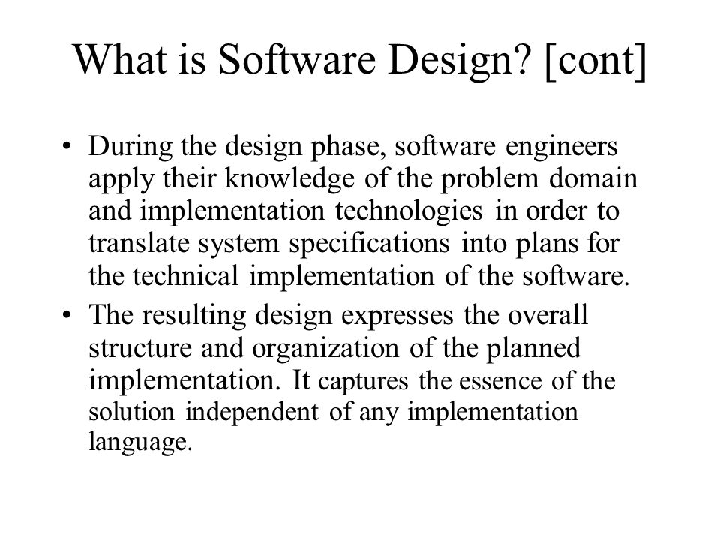

UML defines nine types of diagrams: class (package), object, use case, sequence, collaboration, state chart, activity, component, and deployment.

1. Class Diagrams
Class diagrams are the backbone of almost every object oriented method, including UML. They describe the static structure of a system.
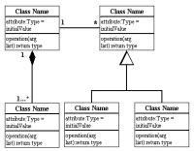

Package Diagrams
Package diagrams are a subset of class diagrams, but developers sometimes treat them as a separate technique. Package diagrams organize elements of a system into related groups to minimize dependencies between packages.

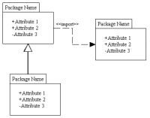

2. Object Diagrams
Object diagrams describe the static structure of a system at a particular time. They can be used to test class diagrams for accuracy.
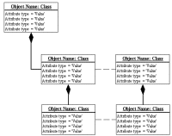

3. Use Case Diagrams
Use case diagrams model the functionality of system using actors and use cases.
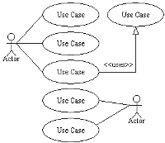

4. Sequence Diagrams
Sequence diagrams describe interactions among classes in terms of an exchange of messages over time.
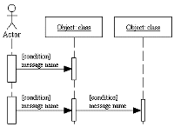

5. Collaboration Diagrams
Collaboration diagrams represent interactions between objects as a series of sequenced messages. Collaboration diagrams describe both the static structure and the dynamic behavior of a system.
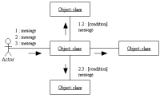

6. State chart Diagrams
State chart diagrams describe the dynamic behavior of a system in response to external stimuli. State chart diagrams are especially useful in modeling reactive objects whose states are triggered by specific events.
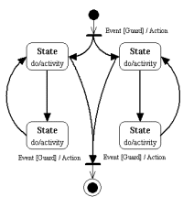

7. Activity Diagrams
Activity diagrams illustrate the dynamic nature of a system by modeling the flow of control from activity to activity. An activity represents an operation on some class in the system that results in a change in the state of the system. Typically, activity diagrams are used to model workflow or business processes and internal operation.
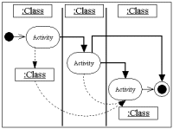

8. Component Diagrams
Component diagrams describe the organization of physical software components, including source code, run-time (binary) code, and executables.
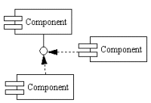

9. Deployment Diagrams
Deployment diagrams depict the physical resources in a system, including nodes, components, and connections.
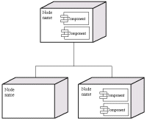

- Prototype model:
The Prototyping Model is a systems development method (SDM) in which a prototype (an early approximation of a final system or product) is built, tested, and then reworked as necessary until an acceptable prototype is finally achieved from which the complete system or product can now be developed
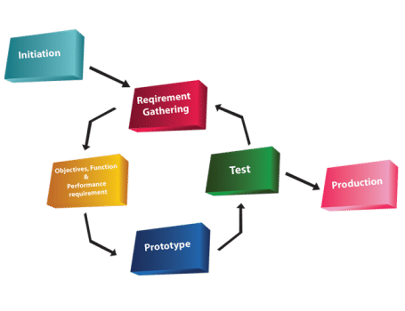
Diagram of Prototype model:
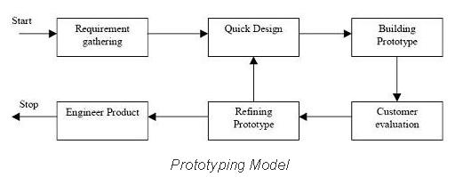

Advantages of Prototype model:
- Users are actively involved in the development
- Since in this methodology a working model of the system is provided, the users get a better understanding of the system being developed.
- Errors can be detected much earlier.
- Quicker user feedback is available leading to better solutions.
- Missing functionality can be identified easily.
Disadvantages of Prototype model:
- Leads to implementing and then repairing way of building systems.
- Practically, this methodology may increase the complexity of the system as scope of the system may expand beyond original plans.
- Incomplete application may cause application not to be used as the full system was designed incomplete or inadequate problem analysis.
When to use Prototype model:
- Prototype model should be used when the desired system needs to have a lot of interaction with the end users.
- Typically, online systems, web interfaces have a very high amount of interaction with end users, are best suited for Prototype model. It might take a while for a system to be built that allows ease of use and needs minimal training for the end user.
- Prototyping ensures that the end users constantly work with the system and provide a feedback which is incorporated in the prototype to result in a useable system. They are excellent for designing good human computer interface systems.

SRS Document:
A software requirements specification (SRS) is a document that captures complete description about how the system is expected to perform. It is usually signed off at the end of requirements engineering phase.
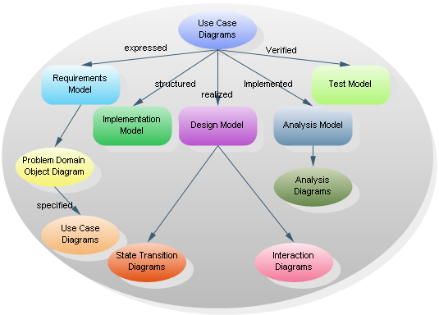

EXPERIMENT: 1 COURSE MANAGEMENT SYSTEM

Aim: To create a system to perform course management.

1.1 Problem Analysis and Project Planning
A course management system is a set of tools that enables the instructor to create online course content and post it on the Web without having to handle HTML or other programming languages.
Course management systems become an integral a part of the upper education system. They create teaching and course management easier by providing a framework and set of tools for instructors. The executive aspects of such systems could include class rosters and therefore the ability to record students' grades. With relevance the teaching aspects, however, it might include learning objects, class exercises, quizzes and tests. The CMS might also include tools for real-time chat, or asynchronous bulletin board kind communications. The CMS tool additionally focuses on all aspects of teaching, learning and teacher-student interaction.

    - Problems in the Existing System
For every education or course there should be consistent interaction between students for submitting assignments and home works, projects, and thesis and acquire feedback.

- Students need to visit faculties and take appointment from faculties or instructors to submit work.
- Cannot Upload and Download the latest updates.
- No use of Web Services and Remoting.
- Risk of mismanagement of data when the project is under development.
- No proper coordination between faculties and students.
- No use of Web Services and Remoting.
- Cannot Upload and Download the latest updates.

1.1.2 Proposed System

The system has been developed considering every single quality factor. Due to this reason the system is extremely secure from the crash down downside. Moreover, the system is very reliable and attributable to the safety features, provides for the course management system, unauthorized users cannot access the system.
- Without direct interaction with instructors students can take course and update homework given by instructor and get grades.
- Students from different departments can use this application by selecting available courses from the list and instructors.
- Students from any location can take course and instructors can give grades to students from any location.
- This application is web based application which will save time for students and instructors.

1.1.3 Project Infrastructure
The system will be operating within university environment. This environment has another systems that will interact with this system so we need interfaces between these systems.
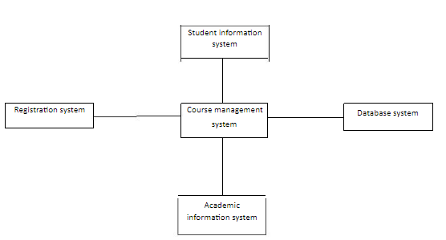

  - Software Requirement Analysis

    - System Modules

- Administrator
- Students
- Instructor

Administrator: Admin can produce accounts for college students and faculties and make course programmed list and add instructors and students to it course list.
Admin can produce course details exploitation course creation kind that consists in fact name, course id, and choose student. Using Student creator kind student details are entered to information. User name, adapt username, password, given name and name, ID. After accounts are produced supported every students and instructors are divided and accessorial to list exploitation create missing students kind.
Students: Student can register with application or the proposed system and login with user name and password. He will check and submit home work. Every student can have id.
Instructor: It can check student’s home works or the assignments and assign grades for work. This module accommodates preparation menu, choose student for grades.

    - Hardware & Software Requirements

Hardware Requirements

- Processor Needed: I3 or above.
- Hard Disk: 30GB
- RAM: 1 GB or more

Software Requirements
- Operating System: Windows XP or Windows 7 or Higher Windows OS.
- Programming Language: Core Java.
- IDE Used: Net beans 7 or Eclipse IDE.
- Database: Oracle 10g or Higher.
    - Functional Requirements

1. Creating Courses
Integration with registration system: The system shall periodically upload the latest registrar’s classes list to determine courses that offered in the current semester.
The system shall generate course for each class that registered and determine the current set of students that enrolled in that class. The system shall allow course instructor to update course content.
- Their account and check their grades at any time.
- The system shall provide statistical information such as averages, standard deviation, and median about student’s grades.
Track and Handle Re-grade Requests: The system shall be able to track and handle requests for re- grades, and all information about re-grades shall be available to the student, and the course instructor.
Posting of papers and other assignments:
- Accept submissions in multiple formats: The system shall accept submissions in multiple formats, including .zip, .txt, .doc, etc.
- Support for late submissions.
- The system shall provide information about late submissions, and also disallow submissions after a certain period of time.
An Integrated E-mail:
The system shall support Group Management features especially important for courses with group projects, this is especially important for large classes.

  - Data Modeling:

Administrator Accounts
Field | Type | Constraints
Id | Varchar2 | Primary Key
Username | Varchar2
Pwd | Varchar2

Instructor Accounts
Field | Type | Constraints
Id | Varchar2 | Primary Key
Username | Varchar2
Pwd | Varchar2

Student Accounts
Field | Type | Constraints
Id | Varchar2 | Primary Key
Username | Varchar2
Pwd | Varchar2

Courses
Field | Type | Constraints
Id | Varchar2 | Primary Key
Course name | Varchar2
Newcourse | Varchar2
Modifycourse | Varchar2
AddCourse | Varchar2
Removecourse | Varchar2

  - Software Designing:

Use case diagram

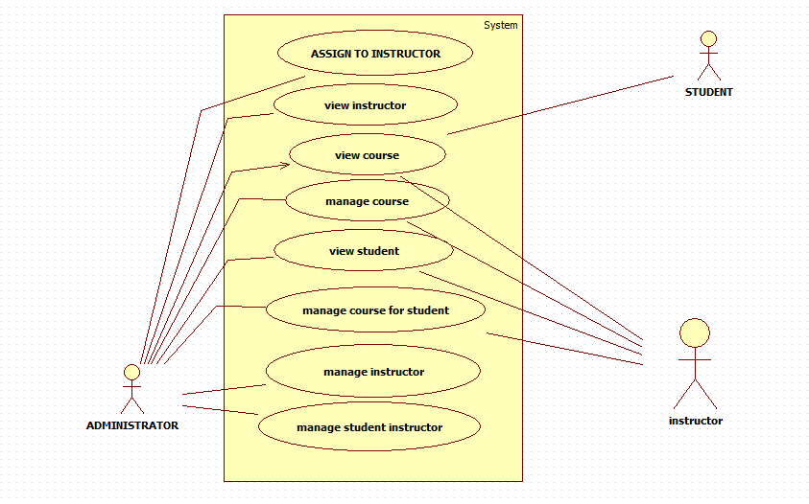

Class diagram
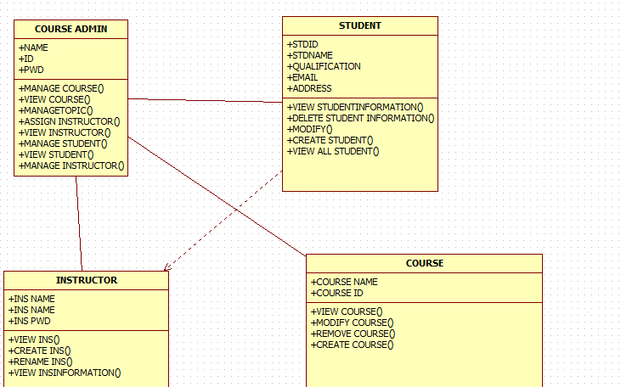

Sequence Diagram registration

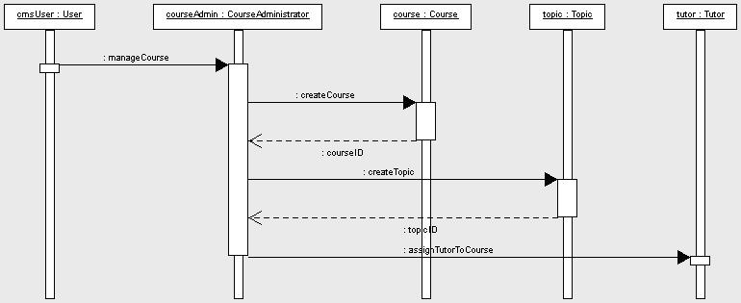

Activity Diagram
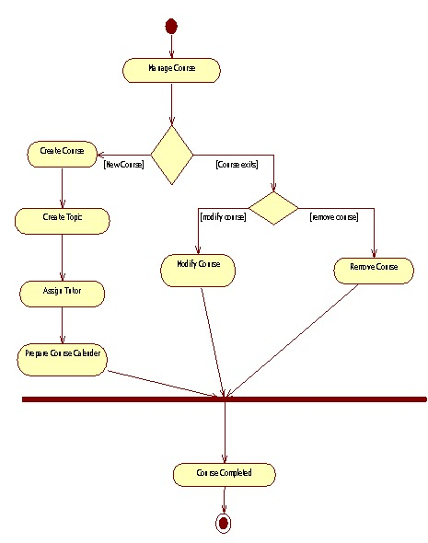

Collaboration Diagram
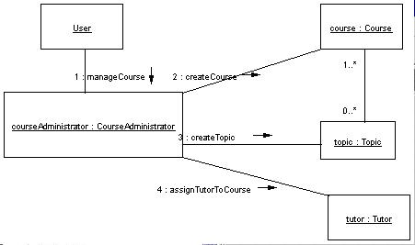

  - Prototype Model:

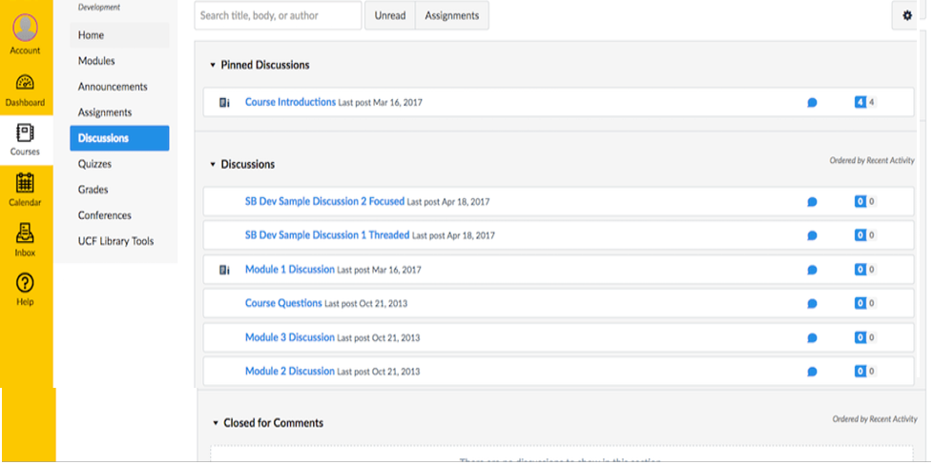
Sample prototype for Course Management project

Applications:
1. This project is useful for universities, Colleges and various Departments.

Experiment No.2 Easy Leave

Aim: This project is aimed at developing a web based Leave Management Tool, which is of
Importance to either an organization or a college.

2.1 Problem Analysis and Project Planning
The Easy Leave is an Intranet based application that can be accessed throughout the organization or a specified group/Dept. This system can be used to automate the workflow of leave applications and their approvals. The periodic crediting of leave is also automated. There are features like email notifications, cancellation of leave, automatic approval of leave, report generators etc in this Tool.
The project has been planned to be having the view of distributed architecture, with centralized storage of the database. The application for the storage of the data has been planned. Using the constructs of MS-SQL Server and all the user interfaces has been designed using the JAVA technologies. The database connectivity is planned using the “SQL Connection” methodology. The standards of security and data protective mechanism have been given a big choice for proper usage. The application takes care of different modules and their associated reports, which are produced as per the applicable strategies and standards that are put forwarded by the administrative staff.

2.1.1 Problems in the Existing System

- Cannot Upload and Download the latest updates.
- No use of Web Services and Remoting.
- Risk of mismanagement and of data when the project is under development.
- Less Security.
- No proper coordination between different Applications and Users.
- Fewer Users - Friendly.

2.1.2 Proposed System
The development of the new system contains the following activities, which try to automate the entire process keeping in view of the database integration approach.
- User friendliness is provided in the application with various controls.
- The system makes the overall project management much easier and flexible.
- Readily upload the latest updates, allows user to download the alerts by clicking the URL.
- There is no risk of data mismanagement at any level while the project development is under process.
To debug the existing system, remove procedures those cause data redundancy, make navigational sequence proper. To provide information about audits on different level and also to reflect the current work status depending on organization/auditor or date. To build strong password mechanism, it provides high level of security with different level of authentication.

2.1.3 Project Infrastructure

Easy-Leave
Administrator
Employee

Authentication

Report
Search
Provide services
Receive Report
Emp
_details
Emp_id
Search_id
Search Details

Register Employee

Search for Employee

Search for Status

Search for Products
Report_id
Report Details

2.2 Software Requirement Analysis

2.2.1 System Modules
- Administration
- Employee
- Search
- Report
- Authentication

Administrator:-
In this module the Administrator has the privileges to add all the Employees and register them in the organization and check the information of the Employee and check the status of the leave when they have taken and what type of leave they have taken and search is done based on the employee and report is generated based on employee.
Search:-
This module contain complete search like Leave search, Type of Leave, Employee based on the leave and starting and ending day of leave.
Employee:-
In this module employee has the privileges to use his username and password for login and he can see the request given by the customer and he can pass the process to the Business Manager and maintain the record of the customers.
Reports:-
This module contains all the information about the reports generated by the Employees based on the Performance and by the leave status.
Authentication:-
This module contains all the information about the authenticated user. User without his username and password can’t enter into the login if he is only the authenticated user then he can enter to his login.

2.2.2 Hardware & Software Requirements

Hardware Requirements

- PIV 2.8 GHz Processor and Above
- RAM 512MB and Above
- HDD 20 GB Hard Disk Space and Above

Software Requirements
- WINDOWS OS (XP / 2000 / 200 Server / 2003 Server)
- Visual Studio .Net 2005 Enterprise Edition
- Internet Information Server 5.0 (IIS)
- Visual Studio .Net Framework
- SQL Server 2000 Enterprise Edition

2.3 Data Modeling:

2.3.1 User Specification:
Two type of users
1. Administrator
2. Employee
Administrator: -
- To add all the Employees and register them.
- Check the information of the Employee.
- Check the status of the leave when they have taken and what type of leave they have taken and search is done based on the employee.
- Report is generation based on employee.
Employee:-
- To use his username and password for login.
- He can see the request given by the customer.
- He can pass the process to the Business Manager.
- Maintain the record of the customers.

2.3.2 Data Dictionary:

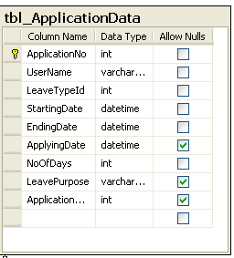

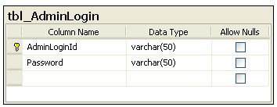

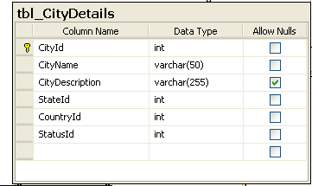

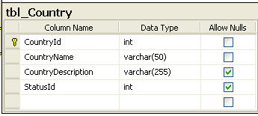

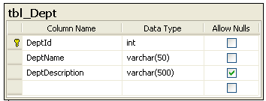

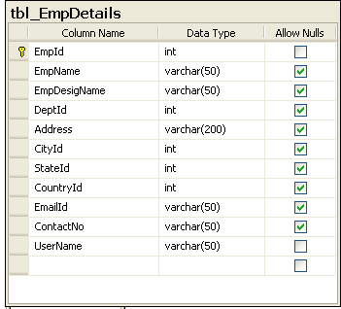

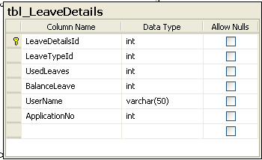

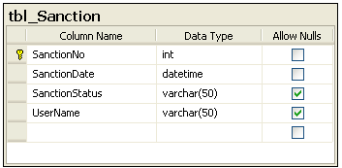

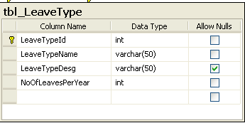

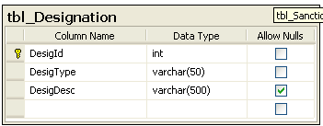

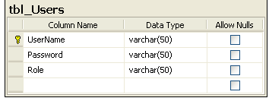

2.4 Software Designing:
Use Case diagram for Admin
Home Page
Login Page

Admin Home Page

Add/Delete Dept
Add/Delete Employee
Admin
Add / Delete Leave
Leave Checking

Leave Sanction
Monthly Leave Trans
Yearly Leave Trans
Repor
Search Employee

Search Leave
Search Dept

Use Case diagram for Employee
Update Info
Search Leave Type
Repor
Check Leave Type
Leave Sanction Status
Check Leave Status
Apply for Leave
Change Password
Change Own Info
Employee Home Page
Login Page
Home Page

Register Employee

Search for Employee

Employee

Activity diagram for Login:
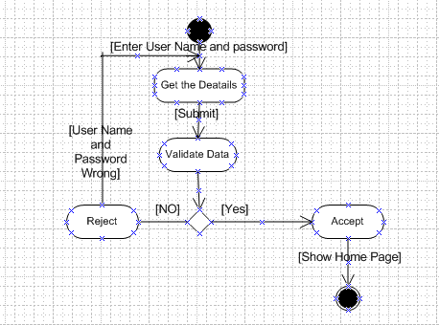

Activity diagram for User Registration

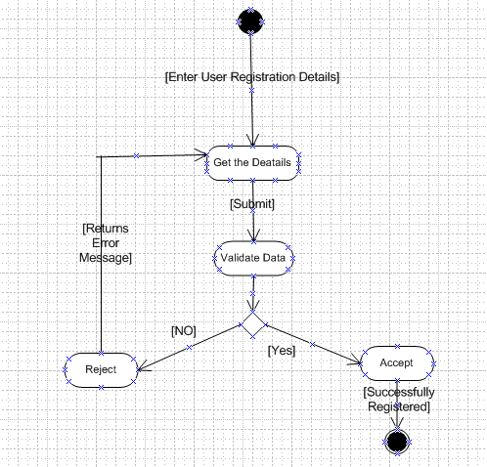

Class Diagrams
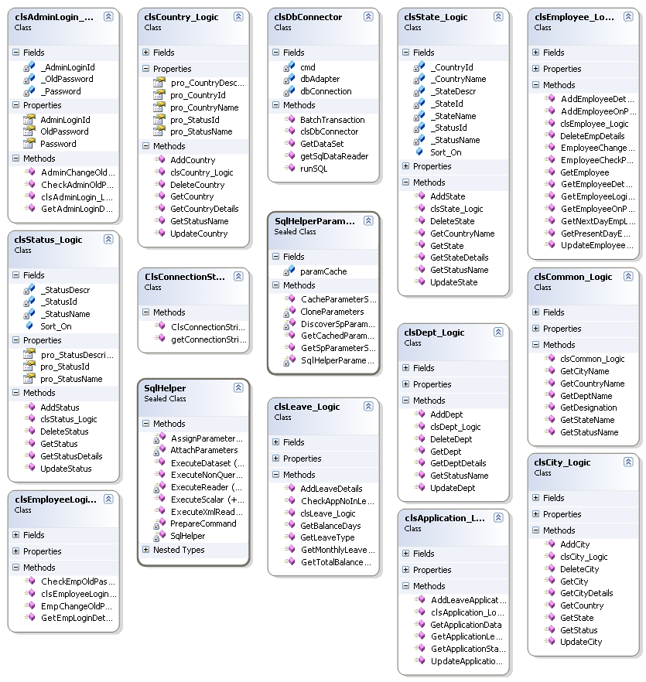

Collaboration diagrams for admin

Collaboration diagrams for employee

Sequence Diagrams
Sequence Diagrams Represent the objects participating the interaction horizontally and time vertically.
Sequence Diagrams 1

Time
Admin
Home Page
Database
Admin Home Page
Use URL
Press login button
If Yes Goes to its Home Page
If No Come Back to Home Page
Validate if NO

Sequence Diagrams 2

Employee Home Page
Database
Home Page

Employee

Use URL
Press login button

Time
Validate if NO
If No Come Back to Home Page

If Yes Goes to its Home Page

Sequence Diagrams for adding employee

2.5 Prototype Model:

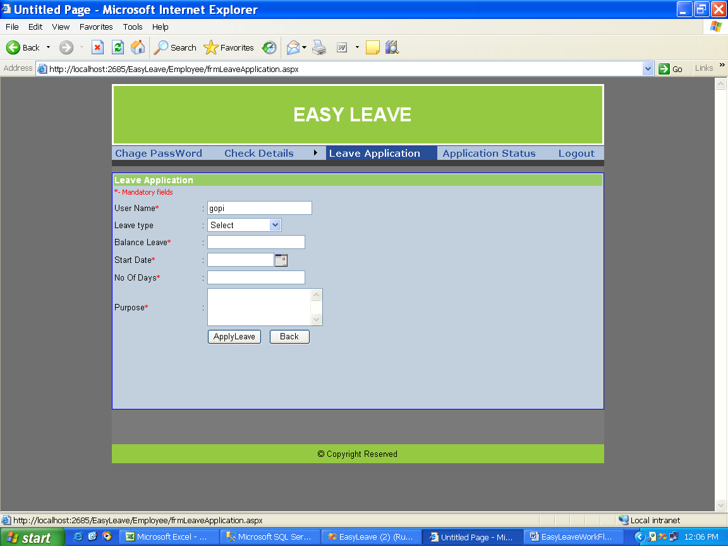
Sample prototype for Easy Leave Project

Applications:
1. This project is useful to either organization or college employees.

Experiment No.3 E-Bidding

Aim: To socialize the auction so that people from far & wide and even across the continent can participate in it.

3.1 Problem Analysis and Project Planning
The problem with public auction is that the participation of the general public is very limited. The "E-Bidding" site is developed with a vision to wipe out the inherent problems of "Conventional Auction House". The salient features of the project are as follows:
- Paperless Auction System
- It's accessible to everyone, at any time no matter where they are
- Reliable user validation & checking.
- Easy online settlement.

“E-Bidding” is designed in such a way that it is as user friendly as possible. So any aspiring bidder or seller can visit the site and engage in bidding with least effort.

3.1.1 Existing System

The existing "OPEN Auction House" is managed manually. Prior to each auction, the day of auction, the venue and the items on auction are announced through news media. Those who wish to take part in the auction have to arrive at the venue on that day on time. This conventional method most of the times prevent aspiring bidders from participating in the bidding process. Another headache of the old system is to track each bidding process and to make it culminate in financial settlement. So the system has to keep records of both buyers and sellers until the end of settlement. The process is very cumbersome and time consuming.

3.1.2 Proposed System

The slogan of this project is AAA, 'Anyone, Anytime, Anywhere'. That what it really is? .The “E-Bidding " is online auction house so the seller or bidder doesn't need to go anywhere, instead they can take part in the auction just sitting in the comfort of their living room, be it during the day or night.
The proposed computerized “E-Bidding " project has made auction process simple. The only 5 pre-condition is that the user must register and authenticate before he/she can take part in the bidding process. The system uses HTTP forms authentication which creates a session cookie for any signed in user. Throughout the span of the session the cookie remains valid until the user logs out.
An auction house needs to have products to auction, so in the proposed system this is done using product registration module. The module is open to user who is registered sellers and they need to authenticate before they register any product. The system controls the closing date by adding 14 days to the submitting date there by restricting the bidding process to go on indefinitely.

3.1.3 Project Objective:

E-Bidding is a service in which auction users can sell or bid for any products through the internet.

3.2 Software Requirement Analysis

3.2.1 System Modules
Login: Login Module includes various utilities like User Registration, Authentication, Change Password and Forgot Password.
Category Management: This module provides all facilities to admin for managing the Category.
Package Management: This module provides all facilities to admin for managing the Package.
Search: Search Module Provides Category wise Search of items.
Auction: In This Module Seller can Upload their Products for Auction, Bidders can bid for the Products finally Admin decides the Winner based on Highest Bidding Price.
Report: Report Generation Module can generate reports of past Auctions, Sellers and Bidders.

3.2.2 Hardware & Software Requirements

Hardware Requirements

Server side:-
Processor : 2.20 GHz
Ram : 2 GB
Hard Disk : 10 GB Free Spaces

Client side:-
Processor : 2.0 GHz
Ram : 1 GB
Hard Disk : 4 GB Free Spaces

Software Requirements

Server side:-
Operating system : Windows server 2003 or any compatible server OS
Framework : .Net framework 4.0
Web Server : IIS 6.0
Front End : ASP. NET with C# (.NET framework 4.0)
Back End : SQL server 2008

Client side:-
Operating system : Windows XP or any compatible OS
Browser : Internet Explorer 6.0 or any Compatible

3.3 Data Modeling:

3.3.1 User Specification:
Three type of users
1. Admin
2. Seller
3. Bidder

1. Admin
- Admin can manage user and product.
- Admin can manage category.
- Admin can send the update to the seller and bidder.
- Admin can manage biding.
- Admin can manage package.
- Admin can generate the whole system work report.

2. Seller
- Seller can upload auction product.
- Seller can set the starting prize of the item.
- Seller can view the bid information for their items.
- Seller can bid for product.

3. Bidder
- Bidder can also search the items.
- Bidder can buy package for auction.
- Bidder can view detail of product.
- Bidder can bid on particular product.
- Bidder can also modify the bidding prize.

3.3.2 Data Dictionary:

USERINFO

Field | Type | Constraints
User Id | Number | Primary key
LoginName | Varchar
Passwd | Varchar
FirstName | Varchar
LastName | Varchar
Role | SmallInt
RegDate | DateTime
Address | Varchar
Email | Varchar

The above table stores the user details of those who register at the site.

CATEGORY

Field | Type | Constraints
CatId | Number | Primary Key
CatName | Varchar
CatDesc | Varchar
The above table stores Product Category Name and Description.

Product

Field | Type | Constraints
ProdId | Number | Primary Key
ProductName | Varchar | Not Null
ProductDetails | Text
Img | Varchar
UserId | Number | Foreign Key
MinBidAmt | Money
MinIncValue | Money
ClosingDate | DateTime
LastBidValue | Money
CatId | Number | Foreign Key
DateCreated | DateTime
Status | Bit
HotProduct | Bit
The above table stores details of Products available for bidding.

BID TRANSACTION

Field | Type | Constraints
TransId | Number | Primary Key
UserId | Number | Foreign Key
ProdId | Number | Foreign Key
IncAmt | Money
BidAmt | Money
DateCreated | DateTime
The above table stores the details of Bidding Transaction.

CLOSED BIDS

Field | Type | Constraints
ClosedBidId | Number | Primary Key
ProdId | Number | Foreign Key
SellerId | Number | Foreign Key
SellerId | Number | Foreign Key
FinalAmt | Money
ClosedDate | Date/Time
SellerNotify | Bit
BidderNotify | Bit
TransNotify | Bit

The above table stores the Closed Bid details.

3.4 Software Designing:
Use-case Diagram for Admin
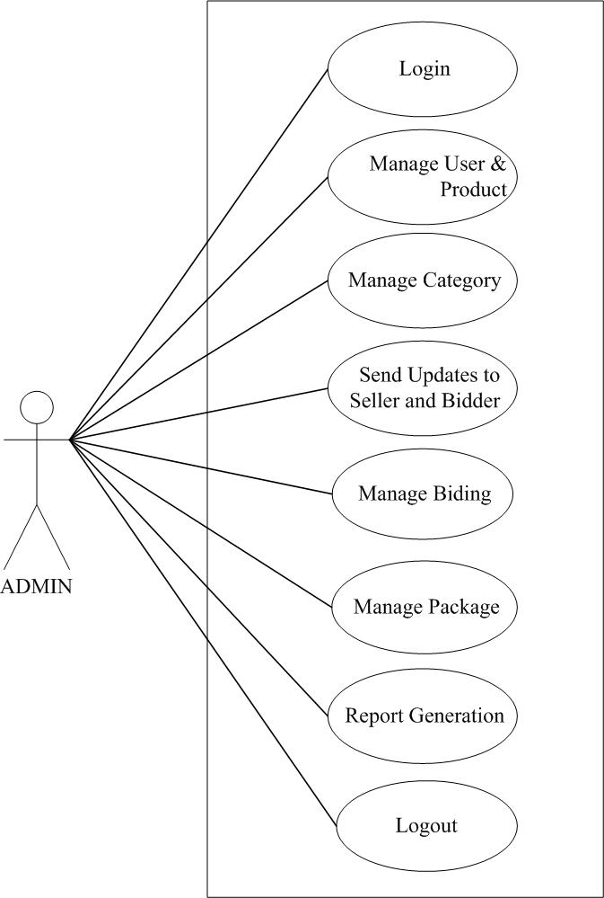

Use-case Diagram for Bidder

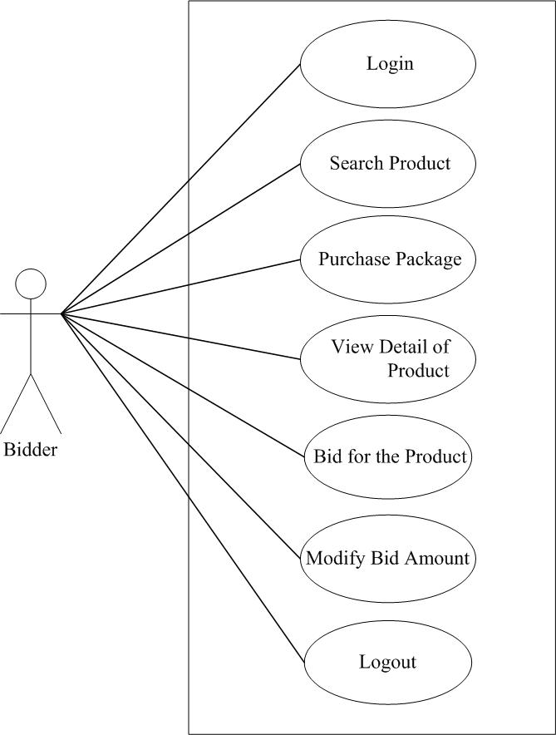

Use-case Diagram for Seller

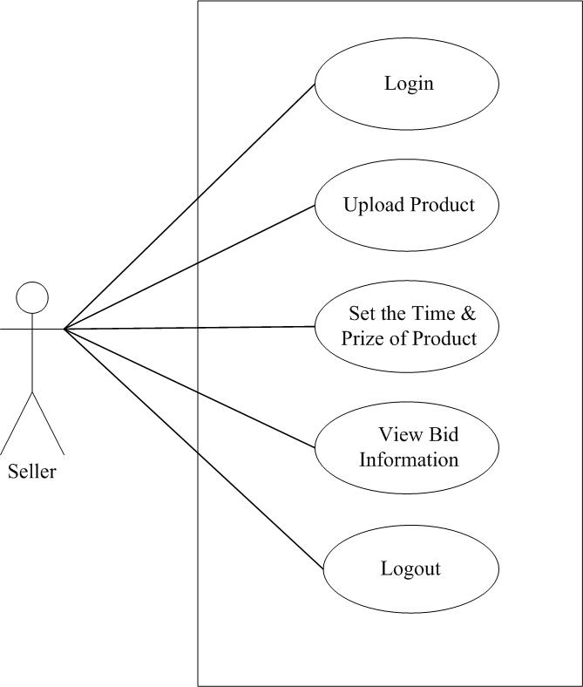

Activity Diagram for Admin

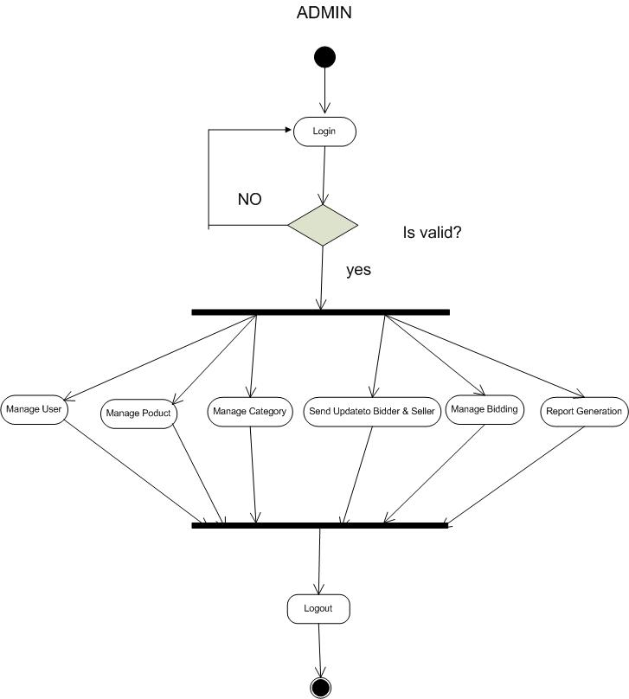

Activity Diagram for Bidder

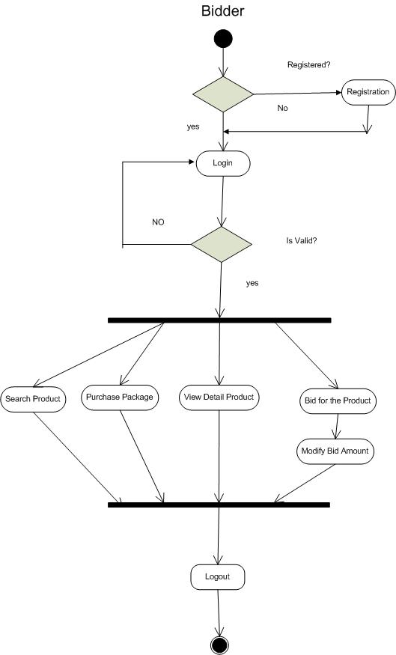

Activity Diagram for Bidder for Bidding a Product

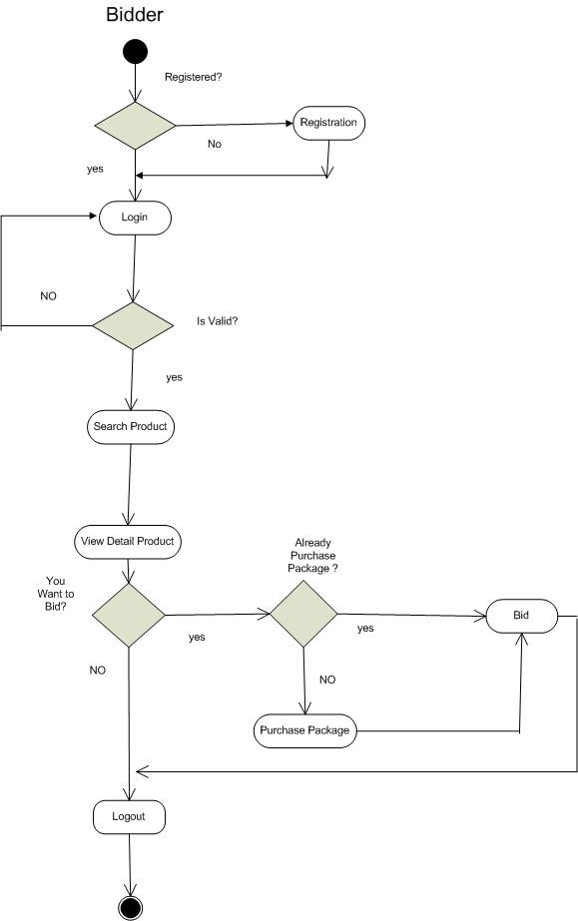

Activity Diagram for Seller

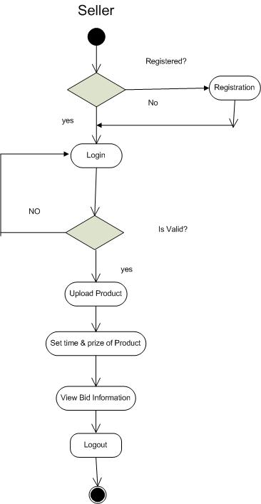

Class Diagram

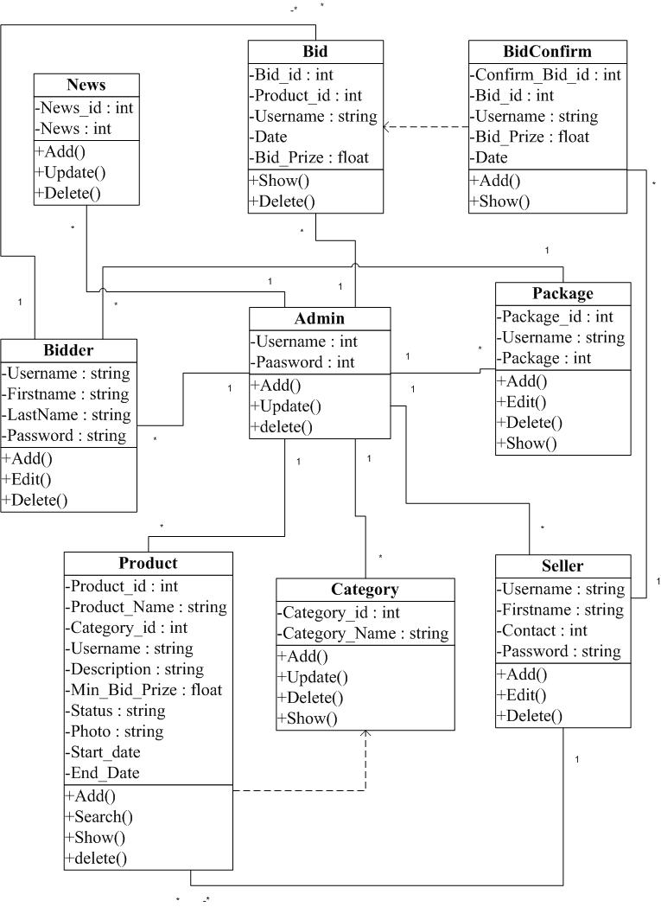

Sequence Diagram for Admin

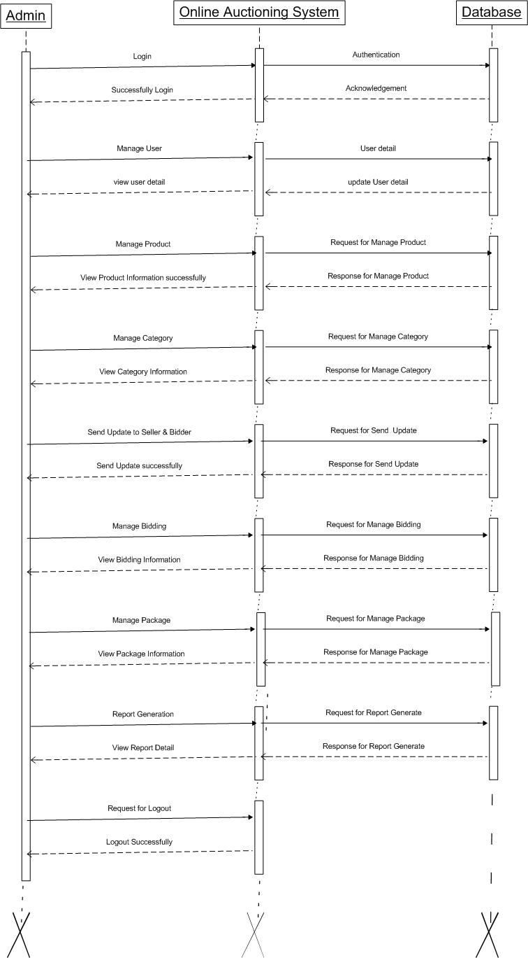

Sequence Diagram for Bidder

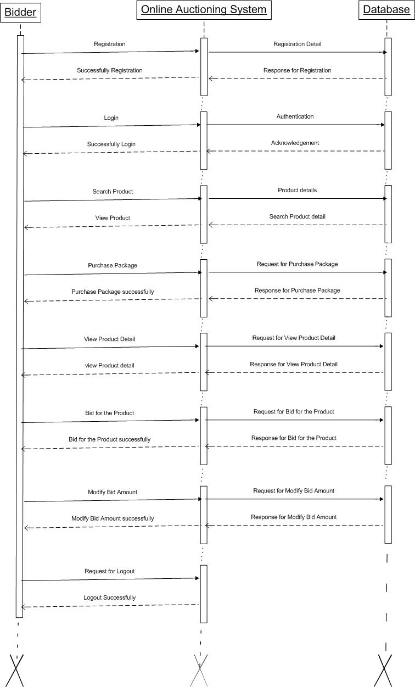

Sequence Diagram for Seller

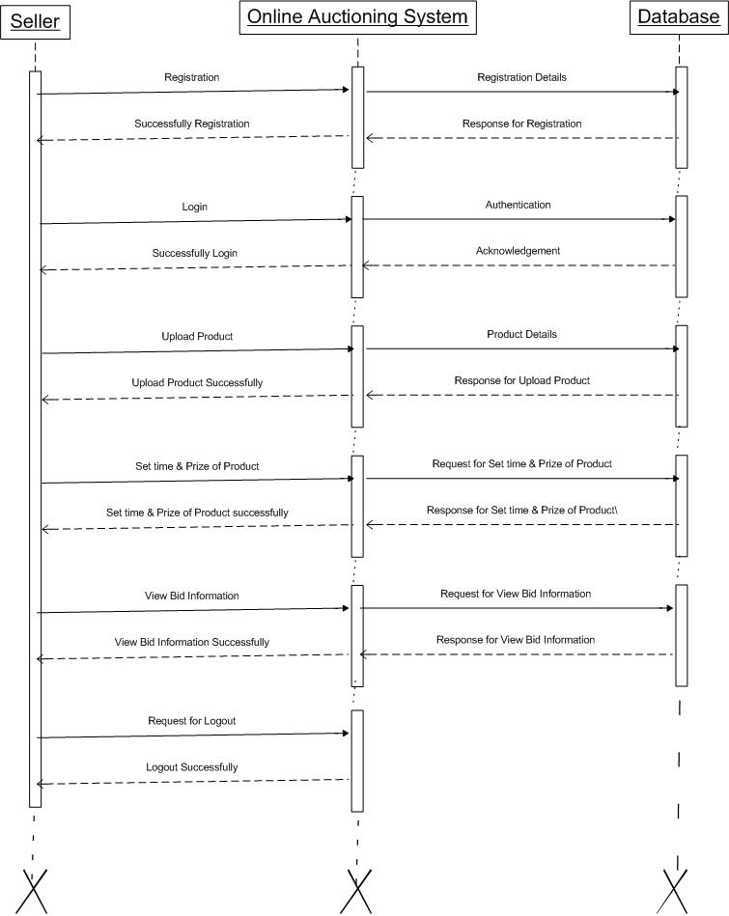

3.5 Prototype Model:

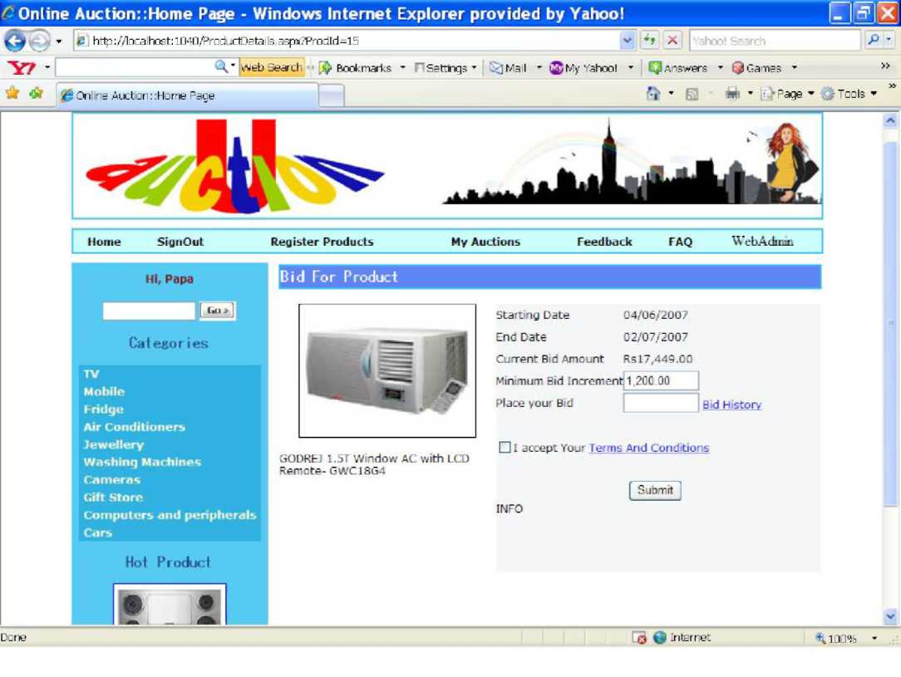
Sample prototype for E-Bidding project

Applications:
1. This project is useful people from far & wide and even across the continent can participate in auction.

Experiment No.4 Electronic Cash Counter

Aim: This system is aimed to give a better out look to the user interfaces and to implement all the banking transactions.

4.1 Problem Analysis and Project Planning
This project is mainly developed for the account division of a banking sector to provide better interface of the entire banking transactions. This system is aimed to give a better out look to the user interfaces and to implement all the banking transactions like:

- Supply of Account Information
- New Account Creations
- Deposits
- Withdraws
- Cheque book issues
- Stop payments
- Transfer of accounts
- Report Generations.

This service is open only to savings bank customers and not for current account holders. The customer is privileged to use most of the system only as a viewing phase, the only online transactions the customer can do are Cheque book requisition and fund transfer among his personal accounts. The project has been planned to be having the view of distributed architecture, with centralized storage of the database. The application for the storage of the data has been planned. Using the constructs of MS-SQLServer2000 and all the user interfaces has been designed using the ASP.Net technologies. The database connectivity is planned using the “SQL Connection” methodology. The standards of security and data protective mechanism have been given a big choice for proper usage. The application takes care of different modules and their associated reports, which are produced as per the applicable strategies and standards that are put forwarded by the administrative staff.
The entire project has been developed keeping in view of the distributed client server computing technology, in mind. The specification has been normalized up to 3NF to eliminate all the anomalies that may arise due to the database transaction that are executed by the general users and the organizational administration. The user interfaces are browser specific to give distributed accessibility for the overall system. The internal database has been selected as MS-SQL server 200.The basic constructs of table spaces, clusters and indexes have been exploited to provide higher consistency and reliability for the data storage. The MS-SQL server 200 was a choice as it provides the constructs of high-level reliability and security. The total front end was dominated using the ASP.Net technologies. At all proper levels high care was taken to check that the system manages the data consistency with proper business rules or validations. The database connectivity was planned using the latest “SQL Connection” technology provided by Microsoft Corporation. The authentication and authorization was crosschecked at all the relevant stages. The user level accessibility has been restricted into two zones namely.

    - Problems in the Existing System
- It is limited to a single system.
- It is less user-friendly.
- It is having lots of manual work (Manual system does not mean that you are working with pen and paper, it also include working on spread sheets and other simple software's).
- The present system is very less secure.
- It is unable to generate different kinds of report.
- It doesn’t have the mail and file upload feature.

    - Proposed System

The development of the new system contains the following activities, which try to automate the entire process keeping in view of the database integration approach.
- User friendliness is provided in the application with various controls.
- The system makes the overall project management much easier and flexible.
- It can be accessed over the Internet.
- Various classes have been used to provide file upload and mail features.
- There is no risk of data mismanagement at any level while the project development is under process.
- Report generation feature is provided using Crystal Reports to generate different kinds of reports like bar graphs, pie charts and table type charts etc.
It provides high level of security using different protocols like https etc.

4.1.3 Project Infrastructure

  - Software Requirement Analysis

    - System Modules
- Account Information
- New Account Creations
- Deposits
- Withdraws
- Cheque book issues
- Stop payments
- Transfer of accounts
- Report Generations

Account Information:
The account information service will provide customers a summary of their accounts. These accounts could be saving of current Deposit account. The customers can get details of each account, a snapshot of the balances, a record of payment and transfers made, whenever they require.
In addition to displaying the account balance information, the clients would get a warning when the account Balance falls below the minimum limit. This limit is decided by the bank.
The customers will also be provided account statements and transaction reports based on any user-defined criteria. Moreover, this system will make tracking of transactions easy, the User would be able to get details of the various transactions based on the Account number, the transaction date, the period of the transaction, and so on.
New Account Creations
Whenever a new customer comes, this system facilitates to create an account in his name. The customer must provide information regarding the type of account he wants to open, amount of deposit, his address and optionally his photo copy and digital signature.
Deposits:
All sort of banking deposits need to be implemented in the system. The user needs to enter the information like account number, the mode of deposit and the amount.
Withdrawals: All sort of banking withdrawals need to be implemented in the system. The user needs to enter the information like account number and the amount. The system must maintain the minimum amount for each account.
Cheque-Book Issues:
Cheque books should be issued to an account holder whenever he requests and it should be on the basis of the minimum balance. The Cheque book number generated by the system must be unique.
Stop Payments:
Withdraws on a particular Cheque must be stopped upon the request made by the customer.
Transfer of Amount from one Account to Other:
The system should transfer the amount transfers from one account to another. Here the user need to enter both the from account number and to account number. Both accounts should get updated during the transaction.
Report Generation:
Reports are very essential for the banking organization. It needs to generate different reports of banking information from the stored information. These reports can be printed and also can be stored as soft copies in the system for future use.

4.2.2 Hardware & Software Requirements

Hardware Requirements

- PIV 2.8 GHz Processor and Above
- RAM 1GB and Above
- HDD 20 GB Hard Disk Space and Above

Software Requirements

- WINDOWS OS (XP / 2000 / 200 Server / 2003 Server)
- Visual Studio .Net 2008 Enterprise Edition
- Internet Information Server 5.0 (IIS)
- Visual Studio .Net Framework (Minimal for Deployment)
- SQL Server 2005 Enterprise Edition

  - Data Modeling:

4.3.1 User Specification
In the flexibility of the uses the interface has been developed a graphics concept in mind, associated through a browser interface. The GUI’S at the top level have been categorized as
- Administrative user interface
- The operational or generic user interface

The administrative user interface concentrates on the consistent information that is practically, part of the organizational activities and which needs proper authentication for the data collection. The interfaces help the administrations with all the transactional states like Data insertion, Data deletion and Date updating along with the extensive data search capabilities.
The operational or generic user interface helps the users upon the system in transactions through the existing data and required services. The operational user interface also helps the ordinary users in managing their own information helps the ordinary users in managing their own information in a customized manner as per the assisted flexibilities.

    - Data Dictionary:

Admin
Field | Type | Constraints
AdminId | Number | Primary Key
AdminName | Varchar
Chequebookstatus | Bit | Foreign Key
Funddepositstatus | Bit | Foreign Key
Fundwithdrawstatus | Bit | Foreign Key
Customeraccount | Varchar

Customer
Field | Type | Constraints
CustId | Number | Primary Key
CustName | Varchar
Chequebookstatus | Bit | Foreign Key
Funddepositstatus | Bit | Foreign Key
Fundwithdrawstatus | Bit | Foreign Key
Customeraccount | Varchar

  - Software Designing:
Use Case diagram for Admin

Use Case diagram for Customer account Information

Use Case diagram for Change Password

Use Case diagram for Customer

Sequence diagram for admin

Sequence diagram for customer

Collaboration diagram for admin

Collaboration diagram for customer

Class diagram for project

4.5 Prototype Model:

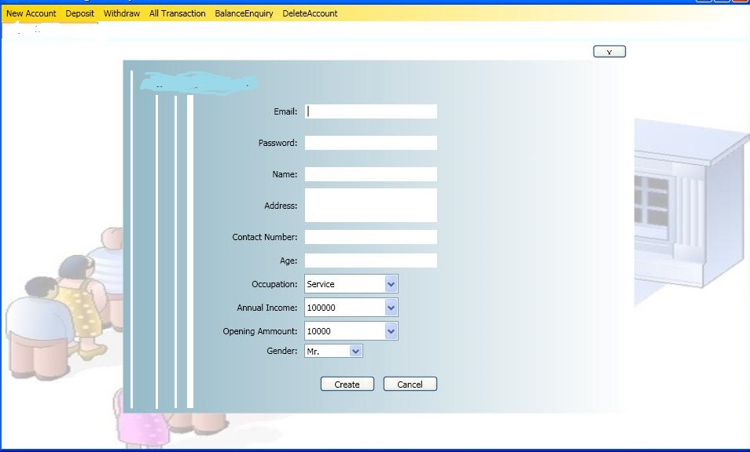
Sample prototype for Electronic Cash Counter Project
Applications:
1. This project is used in banking sector which gives better outlook interface to customers.

Sample Viva Questions:
- What is software engineering?
- What is software project management?
- What is CMMI?
- What are SDLC models available?
- What are various phases of SDLC?
- What is Software Development Process?
- What is project estimation?
- How can you measure project execution?
- What are software requirements?
- What is SRS?
- What are functional requirements?
- What are non-functional requirements?
- Can you differentiate computer software and computer program?
- What is data dictionary?
- Differentiate validation and verification?
- When does the deployment start?
- What is software re-engineering?
- What are CASE tools?
- Quality assurance vs. Quality Control?
- What is a bug?
- What is a defect?

