**Students Name: Group:**

**Date:**

**Relative Humidity: Temperature:**

**EXPERIMENT -III (a)**

**REBOUND HAMMER TEST TO DETERMINE THE COMPRESSIVE STRENGTH OF CONCRETE**

# **OBJECTIVE**

To determine the compressive strength of concrete using rebound hammer as per IS: 13311 (Part 2) – 1992, and change in compressive strength with progressive loading.

# **EQUIPMENTS AND MATERIALS**

## Rebound Hammer

The hammer consists of a spring controlled mass that slides on a plunger within a tubular housing. When the plunger is pressed against, the surface of concrete, it retracts against the force of the spring. When completely retracted the spring is automatically released. On the spring controlled mass rebound, it takes the rider with it along the guide scale. By pushing a button, the rider can be held in position to allow readings to be taken.

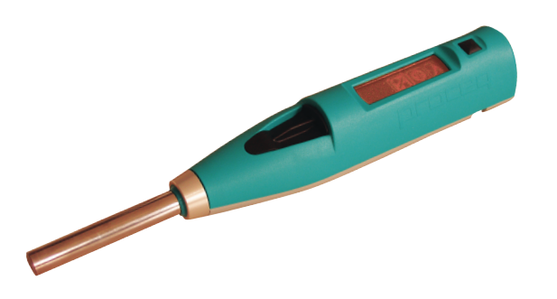

# **RELEVANT CODES**

IS 13311 : Part 2 : 1992 (Reaffirmed 2004) Methods of non-destructive testing of concrete: Part 2 Rebound hammer.

IS 516 : 1959 (Reaffirmed 2004) Method of test for strength of concrete

IS 8900 : 1978 (Reaffirmed 2001) Criteria for the rejection of outlying observations

# **CALIBRATION OF APPARATUS**

It is necessary that the rebound hammer is checked against the testing anvil before commencement of a test to ensure reliable results. The testing anvil should be of steel having Brinell hardness of about 5000N/mm2. The supplier/manufacturer of the rebound hammer should indicate the range of readings on the anvil suitable for different types of rebound hammers.

## **Procedure of Obtaining Correlation Between Compressive Strength of Concrete and Rebound Number**

To establish a correlation between the compressive strength of concrete and its rebound number, we measure both the properties on concrete cubes. The concrete cube specimens are held in a compression testing machine under a fixed load, measurements of rebound number taken and then the compressive strength determined as per IS 516 : 1959. The fixed load is of the order of 7N/mm2 when the impact energy is 2.2Nm. The load should be increased for calibrating rebound hammers of greater impact energy and decreased for calibrating rebound hammers of lesser impact energy.

150 mm cube specimens are preferred for calibrating rebound hammers of lower impact energy (2.2Nm), whereas for rebound hammers of higher impact energy, for example 30Nm, the test cubes should not be smaller than 300 mm.

The concrete cube specimens should be kept at room temperature for about 24 hours after taking it out from the curing pond, before testing it with the rebound hammer. To obtain a correlation between rebound numbers and strength of wet cured and wet tested cubes, it is necessary to establish a correlation between the strength of wet tested cubes and the strength of dry tested cubes on which rebound readings are taken. A direct correlation between rebound numbers on wet cubes and the strength of wet cubes is not recommended. Only the vertical faces of the cubes as cast should be tested. At least nine readings should be taken on each of the two vertical faces accessible in the compression testing machine when using the rebound hammers. The points of impact on the specimen must not be nearer an edge than 20mm and should be not less than 20mm from each other. The same points must not be impacted more than once.

# **PROCEDURE**

1. For testing, smooth, clean and dry surface is to be selected. If loosely adhering scale is present, this should be rubbed of with a grinding wheel or stone. Rough surfaces resulting from incomplete compaction, loss of grout, spalled or tooled surfaces do not give reliable results and should be avoided.
2. The point of impact should be at least 20 mm away from any edge or shape discontinuity.
3. For taking a measurement, the rebound hammer should be held at right angles to the surface of the concrete member. The test can thus be conducted horizontally on vertical surfaces or vertically upwards or downwards on horizontal surfaces. If the situation demands, the rebound hammer can be held at intermediate angles also, but in each case, the rebound number will be different for the same concrete.
4. Rebound hammer test is conducted around all the points of observation on all accessible faces of the structural element. Concrete surfaces are thoroughly cleaned before taking any measurement. Around each point of observation, six readings of rebound indices are taken and average of these readings after deleting outliers as per IS 8900:1978 becomes the rebound index for the point of observation.
5. Two concrete cubes are tested till failure and the ultimate load is noted.
6. The rebound hammer test is repeated for the remaining two cubes for different percentages of loading upto failure and the results are noted.

# **OBSERVATIONS**

## For undamaged cubes

|  |  |  |  |
| --- | --- | --- | --- |
| Point of Observation  (Cube Face) | Impact Number (R) | Outliers  (Yes/No) | Rebound Number  (average) |
| A | N1 | yes | (N2+N3+N4+N5+N6)/5 |
| N2 | no |
| N3 | no |
| N4 | no |
| N5 | no |
| N6 | No |
| B |  |  |  |
|  |  |
|  |  |
|  |  |
|  |  |
|  |  |
|  |  |  |  |
|  |  |
|  |  |
|  |  |
|  |  |
|  |  |
|  |  |  |  |
|  |  |
|  |  |
|  |  |
|  |  |
|  |  |
|  |  |  |  |
|  |  |
|  |  |
|  |  |
|  |  |

## For Damaged Cubes

|  |  |  |  |  |
| --- | --- | --- | --- | --- |
| Point of Test  (Cube Face) | Load level  (% of failure load) | Impact Number (R) | Outliers  (Yes/No) | Rebound Number  (Average) |
| A | 3% |  |  |  |
|  |  |  |
|  |  |  |
|  |  |  |
|  |  |  |
|  |  |  |
| A | 10% |  |  |  |
|  |  |  |
|  |  |  |
|  |  |  |
|  |  |  |
|  |  |  |
| A | 15% |  |  |  |
|  |  |  |
|  |  |  |
|  |  |  |
|  |  |  |
|  |  |  |

# **RESULTS AND CONCLUSIONS**

# **CONVERSION CURVES**

The SilverSchmidt N is provided with four conversion curves. An estimate of the compressive strength

is calculated on the basis of these conversion curves.

## Schmidt Hammer BN type

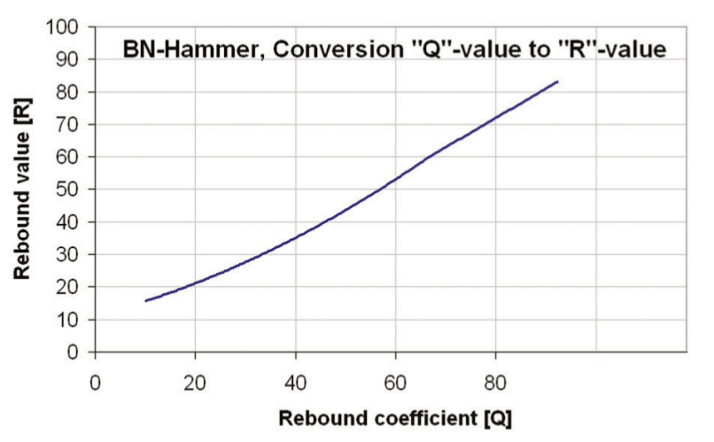

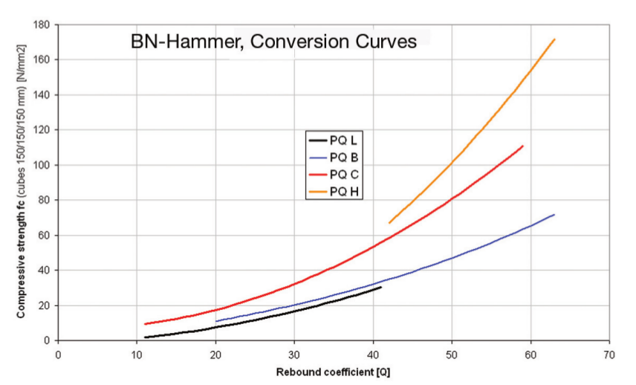

## Schmidt Hammer BL Type

