**Students Name: Group:**

**Date:**

**Relative Humidity: Temperature:**

**EXPERIMENT -III (c)**

**RESISTIVITY TEST TO DETERMINE THE ELECTRICAL RESISTIVITY OF CONCRETE**

# **OBJECTIVE**

Use the Resipod to determine the electrical resistivity of concrete and its variation with moisture content.

# **EQUIPMENTS AND MATERIALS**

Resipod resistivity meter

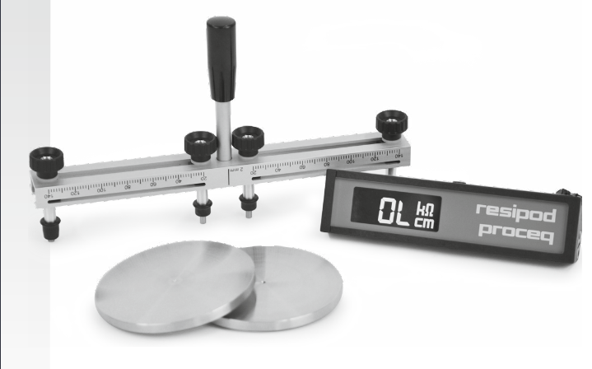

## **PRINCIPLE**

The Resipod is designed to measure the electrical resistivity of concrete. A current is applied to the two outer probes and the potential difference is measured between the two inner probes. The current is carried by ions in the pore liquid. The calculated resistivity depends on the spacing of the probes.

ρ = 2πaV/I (kΩcm)

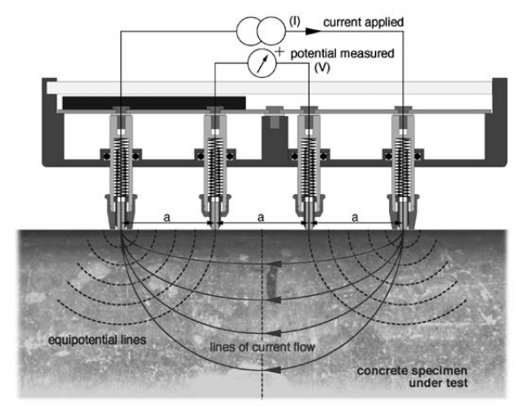

# **PROCEDURE**

1. Preparing the concrete surface :The concrete surface must not be coated with any electrically insulating coating, and it should be clean. The rebar grid beneath the surface should be marked out with the help of a rebar locator (e.g. Profoscope). If the concrete is completely dry it will not be possible to make a measurement as the current is carried by ions in the pore liquid. Therefore it may be necessary to wet the surface.
2. Making a Measurement: A good connection between the instrument and the concrete surface is the most important factor for obtaining a reliable measurement. Dip the contacts in water several times before making a measurement use a shallow container so you can press against its bottom this will fill the reservoirs. Press the Resipod firmly down until the outer two rubber caps rest on the surface to be tested.
3. Repeat the measurement process after drying the specimen to several moisture content.

# **OBSERVATIONS**

|  |  |  |  |  |
| --- | --- | --- | --- | --- |
| Sr. No. | Weight of dry specimen | Weight of wet specimen | Moisture content  (%) | Resistivity |
| 1. |  |  |  |  |
| 2. |  |  |  |  |
| 3. |  |  |  |  |
| 4. |  |  |  |  |
| 5. |  |  |  |  |

## Estimation of the likelihood of corrosion

Resistivity measurements can be used to estimate the likelihood of corrosion. When the electrical resistivity (ρ) of the concrete is low, the likelihood of corrosion increases. When the electrical resistivity is high (e.g. in case of dry and carbonated concrete), the likelihood of corrosion decreases. Empirical tests have arrived at the following typical values for the measured resistivity which can be used to determine the likelihood of corrosion. These figures are for Ordinary Portland Cement at 20°C.

When ≥ 100 kΩcm Negligible risk of corrosion

When = 50 to 100 kΩcm Low risk of corrosion

When = 10 to 50 kΩcm Moderate risk of corrosion

When ≤ 10 kΩcm High risk of corrosion

# **RESULTS AND CONCLUSIONS**