**Students Name: Group:**

**Date:**

**Relative Humidity: Temperature:**

**EXPERIMENT -III (b)**

**ULTRASONIC PULSE VELOCITY TEST TO DETERMINE THE UNIFORMITY OF CONCRETE**

# **OBJECTIVE**

Use the ultrasonic pulse velocity method to determine the homogeneity of concrete, the presence of cracks, voids and other imperfections, the values of dynamic elastic modulus of the concrete.

# **EQUIPMENTS AND MATERIALS**

The apparatus for ultrasonic pulse velocity measurement shall consist of the following:

## Electrical pulse generator,

## Transducer one pair,

Any suitable type of transducer operating within the frequency Lange of 20 kHz to 150 kHz ( see Table 1 ) may be used.

## Amplifier

## Electronic timing device.

It shall be capable of measuring the time interval elapsing between the onset of a pulse generated at the transmitting transducer and the onset of its arrival at the receiving transducer.

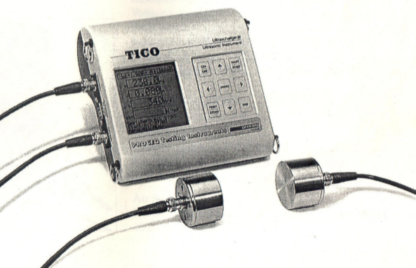

# **RELEVANT CODES**

IS 13311 : Part 1 : 1992 (Reaffirmed 2004) Non-destructive testing of concret: Part 1 Ultrasonic pluse velocity

## **PRINCIPLE**

The ultrasonic pulse is generated by an electroacoustical transducer. ,When the pulse is induced into the concrete from a transducer, it undergoes multiple reflections at the boundaries of the differ&t material phases within the concrete. A complex system of stress waves is developed which includes longitudinal ( compressional ), shear ( transverse ) and surface transducer ( rayleigh ) waves. The receiving detects the onset of the longitudinal waves, which is the fastest.

Because the velocity of the pulses is almost independent of the geometry of the material through which they pass and depends only on its elastic properties, pulse velocity method is a convenient technique for investigating structural concrete.

The underlying principle of assessing the quality of concrete is that comparatively higher velocities are obtained when the quality of concrete in terms of density, homogeneity and uniformity is good. In case of poorer quality, lower velocities are obtained. If there is a crack, void or flaw inside the concrete which comes in the way of transmission of the pulses, the pulse strength is attenuated and it passes around the discontinuity, thereby making the path length longer Consequently, lower velocities are obtained.The actual pulse velocity obtained depends primarily upon the materials and mix proportions of concrete. Density and modulus of elasticity of aggregate also significantly affect the puise velocity.

# **PROCEDURE**

1. Preparing for use: Before switching on the ‘V’ meter, the transducers should be connected to the sockets marked “TRAN” and ” REC”.The ‘V’ meter may be operated with either:
   1. the internal battery,
   2. an external battery or
   3. the A.C line.
2. Set reference: A reference bar is provided to check the instrument zero. The pulse time for the bar is engraved on it. Apply a smear of grease to the transducer faces before placing it on the opposite ends of the bar. Adjust the ‘SET REF’ control until the reference bar transit time is obtained on the instrument read-out.
3. Range selection: For maximum accuracy, it is recommended that the 0.1 microsecond range be selected for path length upto 400mm.
4. Pulse velocity: Having determined the most suitable test points on the material to be tested, make careful measurement of the path length ‘L’. Apply couplant to the surfaces of the transducers and press it hard onto the surface of the material. Do not move the transducers while a reading is being taken, as this can generate noise signals and errors in measurements. Continue holding the transducers onto the surface of the material until a consistent reading appears on the display, which is the time in microsecond for the ultrasonic pulse to travel the distance ‘L’. The mean value of the display readings should be taken when the units digit hunts between two values.
5. Two concrete cubes are tested till failure and the ultimate load is noted.
6. The UPV test is repeated for the remaining two cubes for different percentages of loading upto failure and the results are noted.

# **OBSERVATIONS**

The quality of concrete in terms of uniformity can be assessed from Table 2 of IS 13311(Part 1): 1992

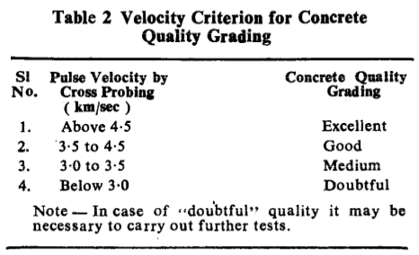The compressive strength of concrete can be estimated by establishing a correlation between the pulse velocity and the compressive strength of concrete specimens made with same mix. The estimated strength may vary from the actual strength by +/-20 percent.

The dynamic Young’s modulus of elasticity (E) of the concrete may be determined from the pulse velocity and the dynamic Poisson’s ratio (μ), using the following relationship:

E = ρ(1+ μ)(1-2 μ)V2/(1- μ)

E: Dynamic young’s modulus of elasticity in Mpa

ρ = density in kg/m3

V = pulse velocity in m/s

The value of the dynamic Poisson’s ratio varies from 0.20 to O-35, with 0.24 as average.

# **RESULTS AND CONCLUSIONS**