1.To Split Input into Tokens, Identify Delimiters, Handle Whitespace, Create Token Structures, Validate Token Streams, Debug Parsing Output.
code:
#include <stdio.h>
#include <string.h>
#include <stdlib.h>

#define MAX_TOKENS 50
#define MAX_LENGTH 100

struct Token {
char value[MAX_LENGTH];
};

int main() {
char input[MAX_LENGTH];
struct Token tokens[MAX_TOKENS];

int count = 0;

printf("Enter a command: ");
fgets(input, sizeof(input), stdin);

/* Remove newline */
input[strcspn(input, "\n")] = '\0';

/* Split input using delimiters */
char *token = strtok(input, " \t");

while (token != NULL && count < MAX_TOKENS) {

strcpy(tokens[count].value, token);
count++;

token = strtok(NULL, " \t");
}

/* Display tokens */
printf("\nTokens:\n");

for (int i = 0; i < count; i++) {
printf("Token %d: %s\n", i + 1, tokens[i].value);
}

/* Validate token stream */
if (count == 0) {
printf("\nInvalid input: No tokens found.\n");
} else {
printf("\nToken stream is valid.\n");
}

/* Debug output */
printf("\nDebug Parsing Output:\n");

for (int i = 0; i < count; i++) {
printf("[%d] -> %s\n", i, tokens[i].value);
}

return 0;
}
output:
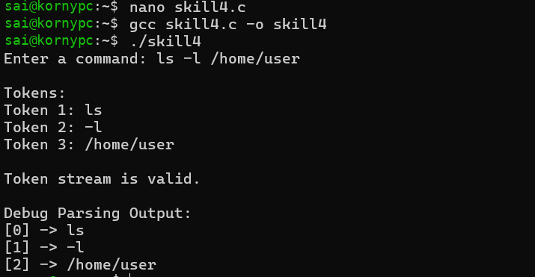
2.To Design Parser Logic, Generate Parse Trees, Validate Syntax, Detect Errors, Handle Empty Commands, Produce Execution Structures.
code: #include <stdio.h>
#include <string.h>

#define MAX_TOKENS 20
#define MAX_LENGTH 50

struct Node {
char value[MAX_LENGTH];
struct Node *child[MAX_TOKENS];
int childCount;
};

int main() {

char input[200];
char *tokens[MAX_TOKENS];

int count = 0;

printf("Enter command: ");
fgets(input, sizeof(input), stdin);

/* Remove newline */
input[strcspn(input, "\n")] = '\0';

/* Handle empty command */
if (strlen(input) == 0) {
printf("\nError: Empty command!\n");
return 0;
}

/* Tokenize input */
char *token = strtok(input, " \t");

while (token != NULL && count < MAX_TOKENS) {
tokens[count] = token;
count++;

token = strtok(NULL, " \t");
}

/* Check again for empty input */
if (count == 0) {
printf("\nError: No command found!\n");
return 0;
}

/* Create root node */
struct Node root;

strcpy(root.value, "COMMAND");
root.childCount = count;

/* Create child nodes */
struct Node nodes[MAX_TOKENS];

for (int i = 0; i < count; i++) {

strcpy(nodes[i].value, tokens[i]);
nodes[i].childCount = 0;

root.child[i] = &nodes[i];
}

/* Syntax validation */
if (count >= 1) {
printf("\nSyntax: VALID\n");
} else {
printf("\nSyntax: INVALID\n");
return 0;
}

/* Display parse tree */
printf("\nParse Tree:\n");

printf("%s\n", root.value);

for (int i = 0; i < root.childCount; i++) {
printf(" |\n");
printf(" ---> %s\n", root.child[i]->value);
}

/* Execution structure */
printf("\nExecution Structure:\n");

printf("Command: %s\n", tokens[0]);

if (count > 1) {
printf("Arguments:\n");

for (int i = 1; i < count; i++) {
printf(" Argument %d: %s\n", i, tokens[i]);
}
} else {
printf("Arguments: None\n");
}

return 0;
}
output:
