- To Apply Single Quotes, Preserve Literal Content, Ignore Variable Expansion, Store Quoted Strings, Validate Parsing Results, Test Edge Cases.
Code: #!/bin/bash

name="Sridhar"

echo "----- Single Quotes -----"

single='Hello $name'
echo "$single"

echo "----- Double Quotes -----"

double="Hello $name"
echo "$double"

echo "----- Spaces -----"

message="Welcome to Linux Shell Scripting"
echo "$message"

echo "----- Edge Cases -----"

empty=''
echo "Empty string: [$empty]"

special='Special characters: $ @ # !'
echo "$special"

nested="This is a 'nested' quote"
echo "$nested"
output:
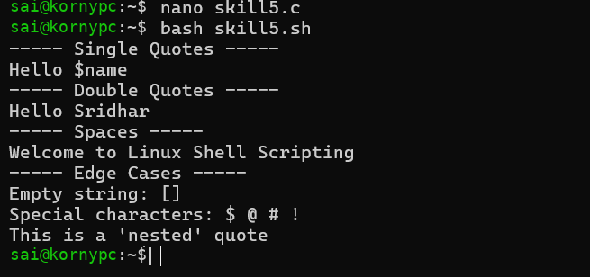
Q:To Apply Double Quotes, Preserve Spaces, Allow Variable Expansion, Parse Nested Tokens, Validate Outputs, Test Quoted Commands
Code:
#!/bin/bash

echo "----- Double Quotes Demonstration -----"

# 1. Preserve Spaces
name="Sridhar Reddy"
echo "Name: $name"

# 2. Allow Variable Expansion
age=19
echo "My age is $age"

# 3. Store Quoted Strings
message="Welcome to Linux Shell Programming"
echo "Message: $message"

# 4. Parse Nested Tokens
command="echo Hello Linux"
echo "Stored command: $command"

# 5. Validate Outputs
echo "Variable value: $name"
echo "Length of message: ${#message}"

# 6. Test Quoted Commands
filename="my file.txt"
echo "File name: $filename"

echo "----- Execution Completed -----"
Output:
