- Create a client-server application using Named Pipes (FIFOs). The client sends messages and the server processes and responds to them. Analyze FIFO behavior when multiple clients communicate simultaneously.

Create a POSIX signal handling program that captures SIGINT, SIGTERM, and SIGUSR1. Demonstrate asynchronous event handling and explain the role of signal handlers.

Code:
Server:
#include <stdio.h>
#include <stdlib.h>
#include <string.h>
#include <unistd.h>
#include <fcntl.h>
#include <sys/types.h>
#include <sys/stat.h>

#define REQUEST_FIFO "/tmp/request_fifo"
#define RESPONSE_FIFO "/tmp/response_fifo"
#define BUFFER_SIZE 256

int main() {

char buffer[BUFFER_SIZE];
char response[BUFFER_SIZE];

// Create request FIFO
mkfifo(REQUEST_FIFO, 0666);

// Create response FIFO
mkfifo(RESPONSE_FIFO, 0666);

printf("=================================\n");
printf(" FIFO SERVER STARTED \n");
printf("=================================\n");
printf("Waiting for client messages...\n");

while (1) {

// Open request FIFO
int request_fd = open(REQUEST_FIFO, O_RDONLY);

if (request_fd == -1) {
perror("Error opening request FIFO");
return 1;
}

// Read message
ssize_t bytes_read =
read(request_fd, buffer, BUFFER_SIZE - 1);

close(request_fd);

if (bytes_read <= 0) {
continue;
}

buffer[bytes_read] = '\0';

printf("\nClient message: %s\n", buffer);

// Exit command
if (strcmp(buffer, "exit") == 0) {

printf("Server shutting down...\n");
break;
}

// Process message
snprintf(
response,
BUFFER_SIZE,
"Server processed: %s",
buffer
);

// Open response FIFO
int response_fd = open(RESPONSE_FIFO, O_WRONLY);

if (response_fd == -1) {
perror("Error opening response FIFO");
return 1;
}

// Send response
write(
response_fd,
response,
strlen(response) + 1
);

close(response_fd);

printf("Response sent: %s\n", response);
}

// Remove FIFOs
unlink(REQUEST_FIFO);
unlink(RESPONSE_FIFO);

return 0;
}

Code
Client:
#include <stdio.h>
#include <stdlib.h>
#include <string.h>
#include <unistd.h>
#include <fcntl.h>

#define REQUEST_FIFO "/tmp/request_fifo"
#define RESPONSE_FIFO "/tmp/response_fifo"
#define BUFFER_SIZE 256

int main() {

char message[BUFFER_SIZE];
char response[BUFFER_SIZE];

printf("=================================\n");
printf(" FIFO CLIENT STARTED \n");
printf("=================================\n");

while (1) {

printf("\nEnter message: ");
fflush(stdout);

fgets(message, BUFFER_SIZE, stdin);

// Remove newline
message[strcspn(message, "\n")] = '\0';

// Open request FIFO
int request_fd = open(REQUEST_FIFO, O_WRONLY);

if (request_fd == -1) {
perror("Error opening request FIFO");
return 1;
}

// Send message
write(
request_fd,
message,
strlen(message)
);

close(request_fd);

// Exit
if (strcmp(message, "exit") == 0) {
break;
}

// Open response FIFO
int response_fd = open(RESPONSE_FIFO, O_RDONLY);

if (response_fd == -1) {
perror("Error opening response FIFO");
return 1;
}

// Read server response
ssize_t bytes_read =
read(response_fd, response, BUFFER_SIZE - 1);

close(response_fd);

if (bytes_read > 0) {

response[bytes_read] = '\0';

printf("Server response: %s\n", response);
}
}

return 0;
}

Outputs:
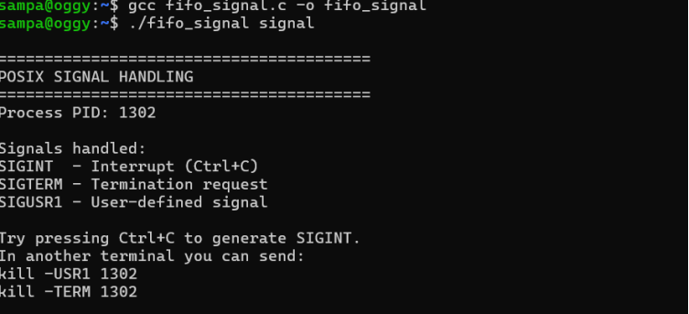

Create a POSIX signal handling program that captures SIGINT, SIGTERM, and SIGUSR1. Demonstrate asynchronous event handling and explain the role of signal handlers
code: #include <stdio.h>
#include <stdlib.h>
#include <unistd.h>
#include <signal.h>

void signal_handler(int sig)
{
if (sig == SIGINT)
{
printf("\nSIGINT received! Ctrl+C was pressed.\n");
}
else if (sig == SIGTERM)
{
printf("\nSIGTERM received! Terminating process...\n");
exit(0);
}
else if (sig == SIGUSR1)
{
printf("\nSIGUSR1 received! User-defined signal handled.\n");
}
}

int main()
{
// Register signal handlers
signal(SIGINT, signal_handler);
signal(SIGTERM, signal_handler);
signal(SIGUSR1, signal_handler);

printf("Process started.\n");
printf("Process ID (PID): %d\n", getpid());
printf("Waiting for signals...\n");

while (1)
{
printf("Process is running...\n");
sleep(3);
}

return 0;
}
output:

