8.Develop a program using malloc(), calloc(), realloc(), and free(). Monitor memory allocation behavior and identify memory leaks using Valgrind.

Develop a program that demonstrates Copy-on-Write behavior after a fork(). Analyze memory usage before and after modifying data in the child process.

Code:
#include <stdio.h>
#include <stdlib.h>

int main() {
int i;

// -------------------------------
// 1. malloc()
// -------------------------------
int *arr = (int *)malloc(5 * sizeof(int));

if (arr == NULL) {
printf("malloc failed!\n");
return 1;
}

for (i = 0; i < 5; i++) {
arr[i] = i + 1;
}

printf("After malloc(): ");
for (i = 0; i < 5; i++) {
printf("%d ", arr[i]);
}
printf("\n");

// -------------------------------
// 2. calloc()
// -------------------------------
int *zero_arr = (int *)calloc(5, sizeof(int));

if (zero_arr == NULL) {
printf("calloc failed!\n");
free(arr);
return 1;
}

printf("After calloc(): ");
for (i = 0; i < 5; i++) {
printf("%d ", zero_arr[i]);
}
printf("\n");

// -------------------------------
// 3. realloc()
// -------------------------------
arr = (int *)realloc(arr, 10 * sizeof(int));

if (arr == NULL) {
printf("realloc failed!\n");
free(zero_arr);
return 1;
}

for (i = 5; i < 10; i++) {
arr[i] = i + 1;
}

printf("After realloc(): ");
for (i = 0; i < 10; i++) {
printf("%d ", arr[i]);
}
printf("\n");

// -------------------------------
// 4. free()
// -------------------------------
free(arr);
free(zero_arr);

printf("Memory freed successfully.\n");

return 0;
}

Output:
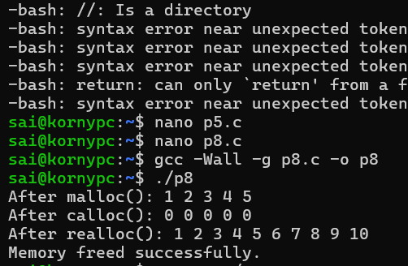

Copy-on-Write using fork()
Code:
#include <stdio.h>
#include <stdlib.h>
#include <unistd.h>
#include <sys/wait.h>

#define SIZE 10000000

int main() {

// Allocate a large array
int *data = malloc(SIZE * sizeof(int));

if (data == NULL) {
perror("malloc");
return 1;
}

// Initialize the array
for (long i = 0; i < SIZE; i++) {
data[i] = i;
}

printf("Array initialized.\n");
printf("Parent PID: %d\n", getpid());

printf("Forking process...\n");

pid_t pid = fork();

if (pid < 0) {
perror("fork failed");
free(data);
return 1;
}

// -------------------------------
// CHILD PROCESS
// -------------------------------
if (pid == 0) {

printf("\nChild process started.\n");
printf("Child PID: %d\n", getpid());

printf("Child is now modifying the array...\n");

// Modify many elements
for (long i = 0; i < SIZE; i++) {
data[i] = data[i] + 100;
}

printf("Child finished modifying the array.\n");
printf("Child data[0] = %d\n", data[0]);

free(data);

printf("Child exiting.\n");

exit(0);
}

// -------------------------------
// PARENT PROCESS
// -------------------------------
else {

printf("\nParent process continues.\n");
printf("Parent PID: %d\n", getpid());
printf("Child PID: %d\n", pid);

// Wait for child
wait(NULL);

printf("\nChild process finished.\n");

// Parent's copy is unchanged
printf("Parent data[0] = %d\n", data[0]);

free(data);

printf("Parent memory freed.\n");
}

return 0;
}

Output: