- To Detect Variable References, Expand Values, Handle Undefined Variables, Update Tokens, Support Nested Variables, Test Expansion Logic.

Code: #include <stdio.h>
#include <stdlib.h>

int main() {
char *value = getenv("HOME");

if (value != NULL)
printf("HOME = %s\n", value);
else
printf("Variable not found\n");

return 0;
}
output:
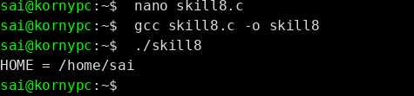
To Identify Built-ins, Create Dispatch Table, Execute In-Process Commands, Handle Invalid Commands, Maintain State, Test Dispatch Logic.
code:
#include <stdio.h>
#include <stdlib.h>

int main() {
char *value = getenv("MYVAR");

if (value != NULL)
printf("MYVAR = %s\n", value);
else
printf("MYVAR is undefined\n");

return 0;
}
output:
