Gestionarea unei baze de date pentru turnee de esports

Sefcic Adrian Ionut, 342

# Prezentarea si utilitatea bazei de date

Aceasta este o baza de date care contine diferite informatii relevante unui mediu profesionist de esports precum datele jucatorilor si ce meciuri au jucat, echipele acestora si sponsorii echipelor etc.. Utilitatea principala a acestei baze de date este accesul usor la aceste informatii pentru a fi puse in online. (spre ex. <https://liquipedia.net/valorant/Portal:Teams> )

# Diagrama entitate-relatie

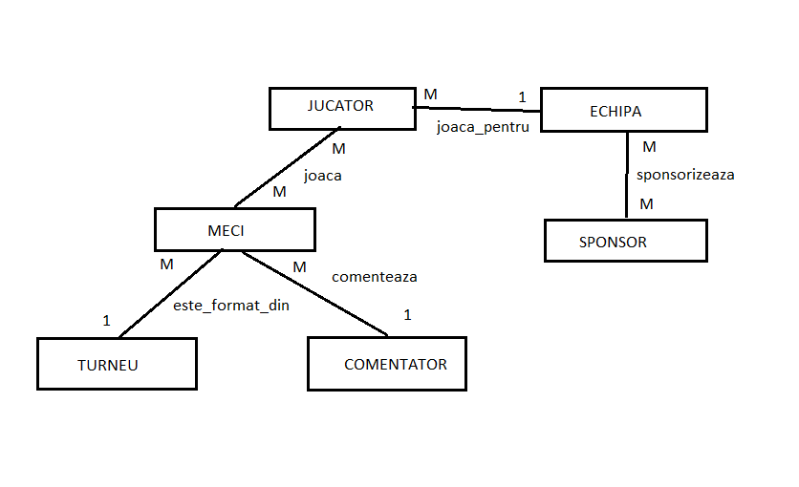

Diagrama Conceptuala

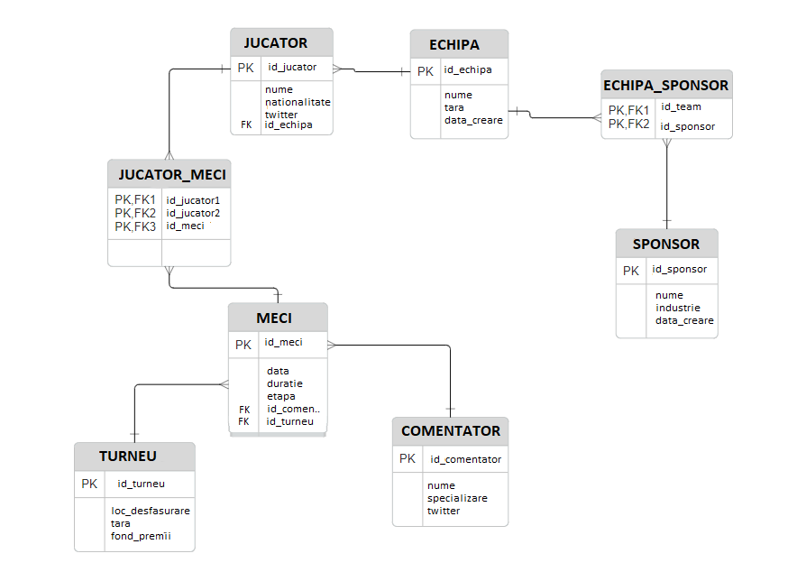

# Implementarea diagramei

CREATE TABLE ECHIPA (

id_echipa NUMBER PRIMARY KEY,

nume VARCHAR2(50),

tara VARCHAR2(50),

data_creare DATE

);

CREATE TABLE JUCATOR (

id_jucator NUMBER PRIMARY KEY,

nume VARCHAR2(50),

nationalitate VARCHAR2(50),

twitter VARCHAR2(30),

id_echipa NUMBER,

FOREIGN KEY (id_echipa) REFERENCES ECHIPA(id_echipa)

);

CREATE TABLE SPONSOR (

id_sponsor NUMBER PRIMARY KEY,

nume VARCHAR2(50),

industrie VARCHAR2(50),

data_creare DATE

);

CREATE TABLE ECHIPA_SPONSOR (

id_echipa NUMBER,

id_sponsor NUMBER,

PRIMARY KEY (id_echipa, id_sponsor),

FOREIGN KEY (id_echipa) REFERENCES ECHIPA(id_echipa),

FOREIGN KEY (id_sponsor) REFERENCES SPONSOR(id_sponsor)

);

CREATE TABLE TURNEU (

id_turneu NUMBER PRIMARY KEY,

loc_desfasurare VARCHAR2(100),

tara VARCHAR2(50),

fond_premii NUMBER

);

CREATE TABLE COMENTATOR (

id_comentator NUMBER PRIMARY KEY,

nume VARCHAR2(100),

specializare VARCHAR2(50),

twitter VARCHAR2(255)

);

CREATE TABLE MECI (

id_meci NUMBER PRIMARY KEY,

data DATE,

duratie NUMBER,

etapa VARCHAR2(50),

id_comentator NUMBER,

id_turneu NUMBER,

FOREIGN KEY (id_comentator) REFERENCES COMENTATOR(id_comentator)

);

CREATE TABLE JUCATOR_MECI (

id_jucator1 NUMBER,

id_jucator2 NUMBER,

id_meci NUMBER,

PRIMARY KEY (id_jucator1, id_jucator2, id_meci),

FOREIGN KEY (id_jucator1) REFERENCES JUCATOR(id_jucator),

FOREIGN KEY (id_jucator2) REFERENCES JUCATOR(id_jucator),

FOREIGN KEY (id_meci) REFERENCES MECI(id_meci)

);

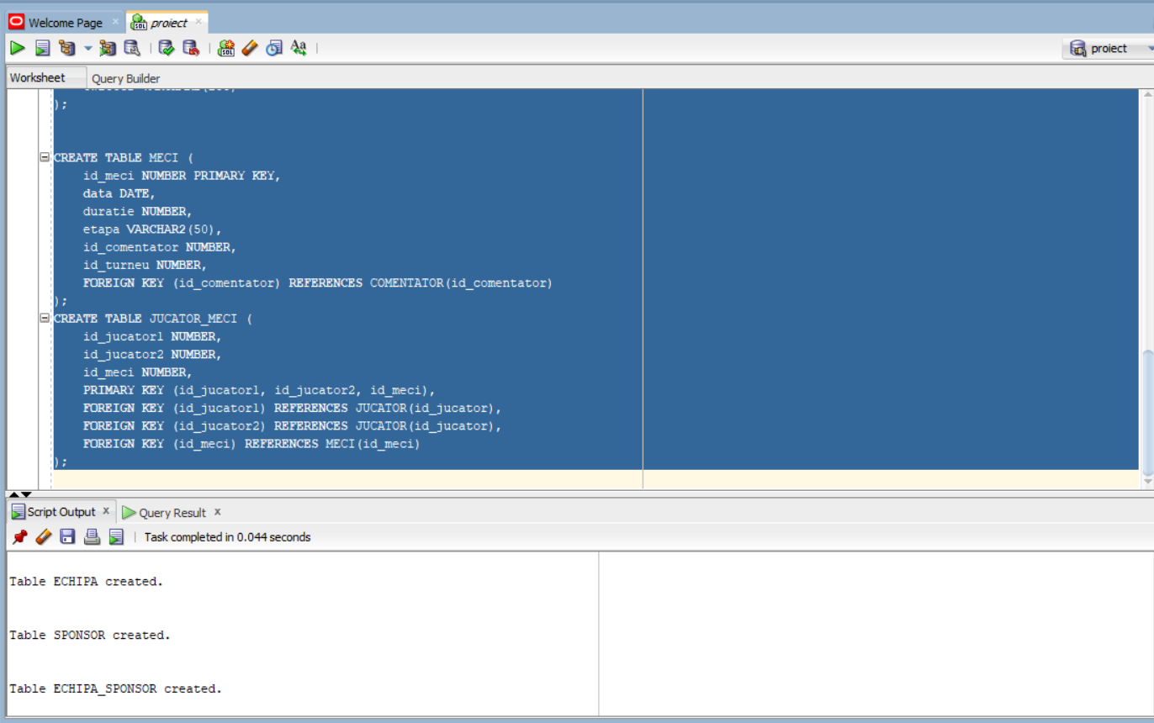

# Adaugarea informatiilor in tabele

INSERT INTO COMENTATOR VALUES (1, 'Sophie Müller', 'Color', 'sophiemuller');

INSERT INTO COMENTATOR VALUES (2, 'Luca Rossi', 'Play By Play', 'therealrossi');

INSERT INTO COMENTATOR VALUES (3, 'Elena Popescu', 'Play By Play', 'popescuelena');

INSERT INTO COMENTATOR VALUES (4, 'Andreas Schmidt', 'Play By Play', 'aschmidt');

INSERT INTO COMENTATOR VALUES (5, 'Isabella Conte', 'Color', 'isabella_conte');

INSERT INTO COMENTATOR VALUES(6, 'Testeanu Verif', 'Play By Play', '@verift');

INSERT INTO TURNEU VALUES (100, 'Berlin Esports Arena', 'Germany', 100000);

INSERT INTO TURNEU VALUES (101, 'Paris Gaming Stadium', 'France', 120000);

INSERT INTO TURNEU VALUES (102, 'London Esports Center', 'United Kingdom', 90000);

INSERT INTO TURNEU VALUES (103, 'Stockholm Esports Hall', 'Sweden', 110000);

INSERT INTO TURNEU VALUES (104, 'Madrid Gaming Arena', 'Spain', 95000);

INSERT INTO SPONSOR VALUES (200, 'TechGear', 'Technology', TO_DATE('2023-03-01', 'YYYY-MM-DD'));

INSERT INTO SPONSOR VALUES (201, 'FinanceCorp', 'Finance', TO_DATE('2023-04-01', 'YYYY-MM-DD'));

INSERT INTO SPONSOR VALUES (202, 'GamingTech', 'Gaming', TO_DATE('2023-05-01', 'YYYY-MM-DD'));

INSERT INTO SPONSOR VALUES (203, 'FashionArena', 'Fashion', TO_DATE('2023-06-01', 'YYYY-MM-DD'));

INSERT INTO SPONSOR VALUES (204, 'FoodFiesta', 'Food', TO_DATE('2023-07-01', 'YYYY-MM-DD'));

INSERT INTO ECHIPA VALUES (300, 'G2 Esports', 'Germany', TO_DATE('2023-01-01', 'YYYY-MM-DD'));

INSERT INTO ECHIPA VALUES (301, 'Fnatic', 'France', TO_DATE('2023-02-01', 'YYYY-MM-DD'));

INSERT INTO ECHIPA VALUES (302, 'Ninjas in Pyjamas', 'Sweden', TO_DATE('2023-03-01', 'YYYY-MM-DD'));

INSERT INTO ECHIPA VALUES (303, 'Team Vitality', 'Italy', TO_DATE('2023-04-01', 'YYYY-MM-DD'));

INSERT INTO ECHIPA VALUES (304, 'OG Esports', 'Spain', TO_DATE('2023-05-01', 'YYYY-MM-DD'));

INSERT INTO ECHIPA_SPONSOR VALUES (300, 200);

INSERT INTO ECHIPA_SPONSOR VALUES (301, 201);

INSERT INTO ECHIPA_SPONSOR VALUES (302, 202);

INSERT INTO ECHIPA_SPONSOR VALUES (303, 203);

INSERT INTO ECHIPA_SPONSOR VALUES (304, 204);

INSERT INTO ECHIPA_SPONSOR VALUES (300, 201);

INSERT INTO ECHIPA_SPONSOR VALUES (301, 202);

INSERT INTO ECHIPA_SPONSOR VALUES (302, 203);

INSERT INTO ECHIPA_SPONSOR VALUES (303, 204);

INSERT INTO ECHIPA_SPONSOR VALUES (304, 200);

INSERT INTO JUCATOR VALUES (400, 'Maximilian Schmidt', 'Germany', 'max_smith_gamer', 300);

INSERT INTO JUCATOR VALUES (401, 'Rafael Silva', 'Portugal', 'rafael_silva_esports', 300);

INSERT INTO JUCATOR VALUES (402, 'Lukas Novak', 'Czech Republic', 'lukas_novak_88', 301);

INSERT INTO JUCATOR VALUES (403, 'Igor Petrov', 'Russia', 'iggy_petrov', 301);

INSERT INTO JUCATOR VALUES (404, 'Matej Horvat', 'Slovenia', 'matty_horizon', 302);

INSERT INTO JUCATOR VALUES (405, 'Gustav Berg', 'Sweden', 'gustav_b_thunder', 302);

INSERT INTO JUCATOR VALUES (406, 'Luca Rossi', 'Italy', 'luca_the_sniper', 303);

INSERT INTO JUCATOR VALUES (407, 'Carlos López', 'Spain', 'carlos_lightning', 303);

INSERT INTO JUCATOR VALUES (408, 'Sebastian Weber', 'Germany', 'seb_gaming_master', 304);

INSERT INTO JUCATOR VALUES (409, 'Antonio Costa', 'Portugal', 'toni_costa_legend', 304);

INSERT INTO JUCATOR VALUES (410, 'Adriano Sai', 'Romania', 'saimeistr', 304);

INSERT INTO MECI VALUES (500, TO_DATE('2023-08-01', 'YYYY-MM-DD'), 30, 'Semifinals', 1, 100);

INSERT INTO MECI VALUES (501, TO_DATE('2023-08-03', 'YYYY-MM-DD'), 35, 'Semifinals', 2, 100);

INSERT INTO MECI VALUES (502, TO_DATE('2023-08-06', 'YYYY-MM-DD'), 40, 'Grand Finals', 3, 100);

INSERT INTO MECI VALUES (503, TO_DATE('2023-08-10', 'YYYY-MM-DD'), 25, 'Semifinals', 4, 101);

INSERT INTO MECI VALUES (504, TO_DATE('2023-08-15', 'YYYY-MM-DD'), 30, 'Semifinals', 5, 101);

INSERT INTO MECI VALUES (505, TO_DATE('2023-08-18', 'YYYY-MM-DD'), 35, 'Grand Finals', 1, 101);

INSERT INTO MECI VALUES (506, TO_DATE('2023-08-22', 'YYYY-MM-DD'), 20, 'Semifinals', 2, 102);

INSERT INTO MECI VALUES (507, TO_DATE('2023-08-26', 'YYYY-MM-DD'), 25, 'Semifinals', 3, 102);

INSERT INTO MECI VALUES (508, TO_DATE('2023-08-30', 'YYYY-MM-DD'), 30, 'Grand Finals', 4, 102);

INSERT INTO MECI VALUES (509, TO_DATE('2023-09-4', 'YYYY-MM-DD'), 33, 'Semifinals', 5, 103);

INSERT INTO MECI VALUES (510, TO_DATE('2023-09-5', 'YYYY-MM-DD'), 27, 'Semifinals', 1, 103);

INSERT INTO MECI VALUES (511, TO_DATE('2023-09-7', 'YYYY-MM-DD'), 43, 'Grand Finals', 2, 103);

INSERT INTO MECI VALUES (512, TO_DATE('2023-09-7', 'YYYY-MM-DD'), 21, 'Showmatch', 1, 103);

INSERT INTO JUCATOR_MECI VALUES (400, 401, 500);

INSERT INTO JUCATOR_MECI VALUES (402, 403, 501);

INSERT INTO JUCATOR_MECI VALUES (400, 402, 502);

INSERT INTO JUCATOR_MECI VALUES (404, 405, 503);

INSERT INTO JUCATOR_MECI VALUES (406, 407, 504);

INSERT INTO JUCATOR_MECI VALUES (404, 406, 505);

INSERT INTO JUCATOR_MECI VALUES (407, 408, 506);

INSERT INTO JUCATOR_MECI VALUES (409, 401, 507);

INSERT INTO JUCATOR_MECI VALUES (409, 408, 508);

INSERT INTO JUCATOR_MECI VALUES (402, 404, 509);

INSERT INTO JUCATOR_MECI VALUES (401, 407, 510);

INSERT INTO JUCATOR_MECI VALUES (401, 402, 511);

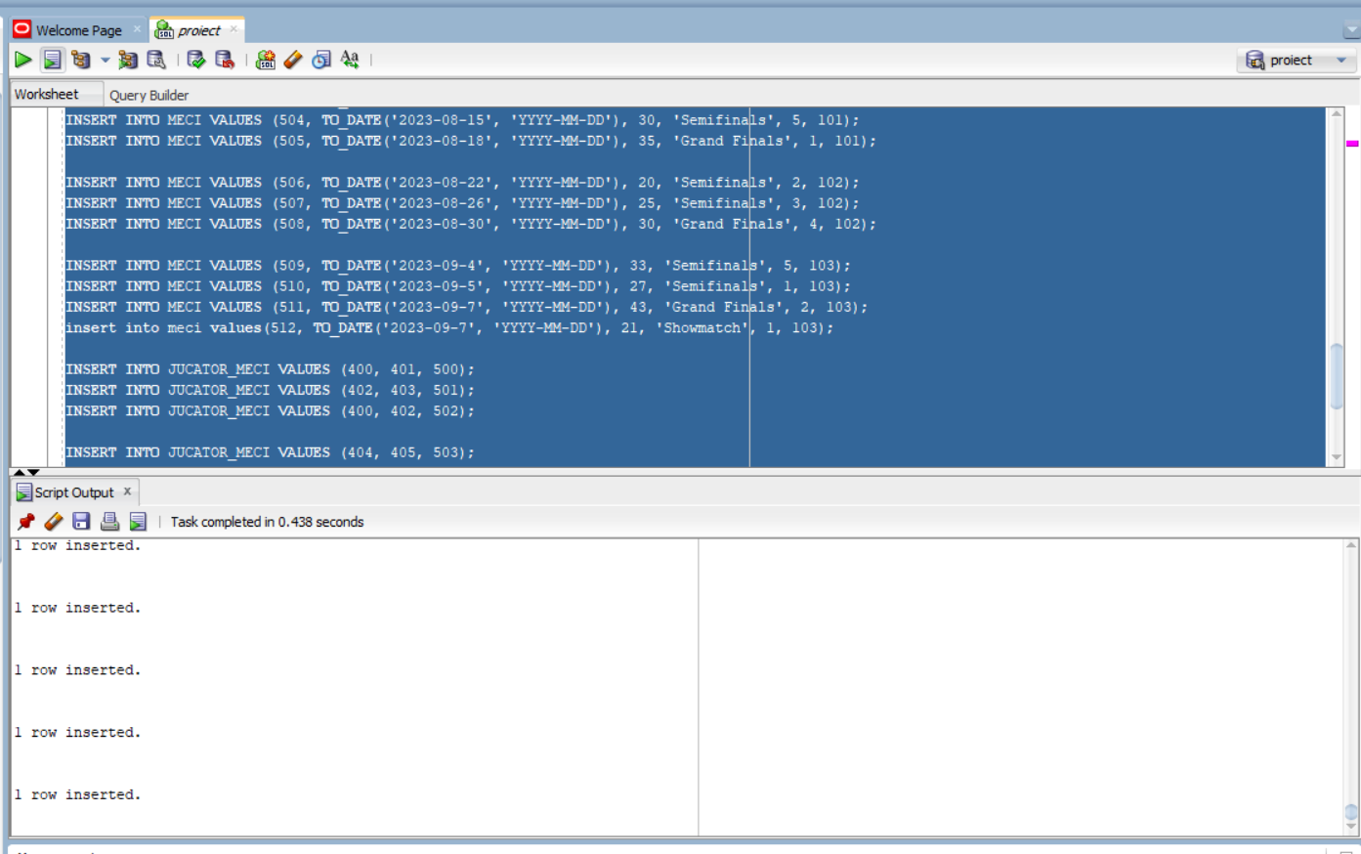

# CERINTA 6

Date ca parametri nume a doi sponsori sa se afiseze:

-pentru primul, numele si id-ul echipelor pe care le sponsorizeaza

-pentru al doilea, doar numele echipelor

-numarul de echipe sponsorizate pentru fiecare

CREATE OR REPLACE PROCEDURE cerinta6 (nume Sponsor.nume%TYPE, nume_doi Sponsor.nume%TYPE)

AS

TYPE tabel_indexat IS TABLE OF Echipa%ROWTYPE INDEX BY PLS_INTEGER;

t tabel_indexat;

TYPE tabel_imbricat IS TABLE OF VARCHAR2(50);

y tabel_imbricat;

TYPE vector IS VARRAY(20) OF NUMBER;

u vector:= vector();

BEGIN

SELECT E.*

BULK COLLECT INTO t

FROM ECHIPA E

JOIN ECHIPA_SPONSOR ES ON E.ID_ECHIPA = ES.ID_ECHIPA

JOIN SPONSOR S ON ES.ID_SPONSOR = S.ID_SPONSOR

WHERE S.NUME = cerinta6.nume;

u.extend;

u(1) := t.COUNT;

FOR i IN 1..t.COUNT LOOP

DBMS_OUTPUT.PUT_LINE(t(i).nume || ', ' || t(i).id_echipa);

END LOOP;

DBMS_OUTPUT.PUT_LINE('');

SELECT E.nume

BULK COLLECT INTO y

FROM ECHIPA E

JOIN ECHIPA_SPONSOR ES ON E.ID_ECHIPA = ES.ID_ECHIPA

JOIN SPONSOR S ON ES.ID_SPONSOR = S.ID_SPONSOR

WHERE S.NUME = cerinta6.nume_doi;

u.extend;

u(2) := y.COUNT;

FOR i IN 1..y.COUNT LOOP

DBMS_OUTPUT.PUT_LINE(y(i));

END LOOP;

DBMS_OUTPUT.PUT_LINE('');

DBMS_OUTPUT.PUT_LINE(u(1) || ', ' || u(2));

END cerinta6;

/

BEGIN

cerinta6('FinanceCorp', 'GamingTech');

END;

/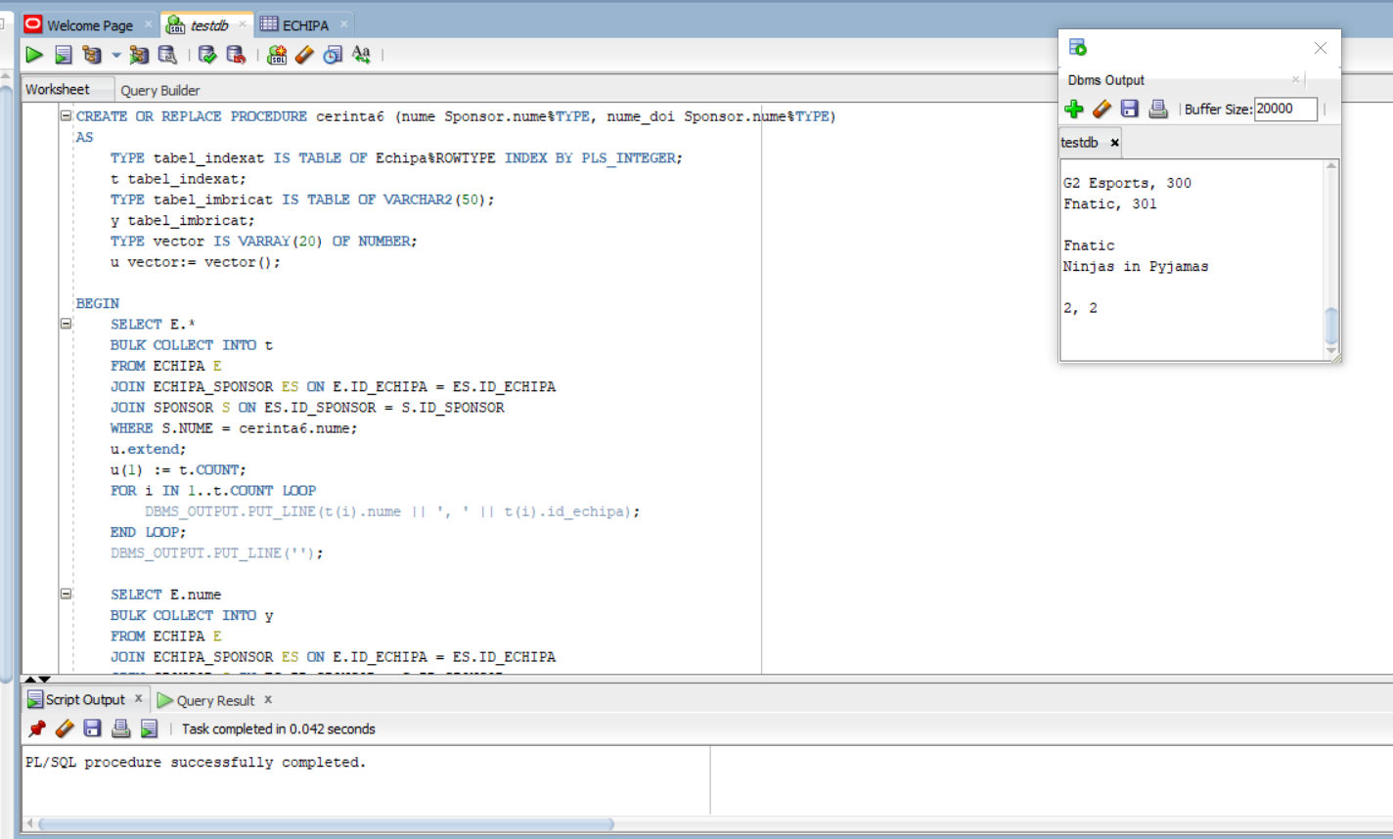

# CERINTA 7

Sa se afiseze id-ul si numele fiecarui jucator si numarul de jucatori care fac parte din aceasi echipa ca el (coechipieri).

CREATE OR REPLACE PROCEDURE cerinta7 AS

CURSOR c1 IS

SELECT j.id_jucator, j.nume, j.id_echipa

FROM JUCATOR j;

CURSOR c2 (v_id_echipa ECHIPA.id_echipa%TYPE) IS

SELECT COUNT(*)

FROM ECHIPA e

JOIN JUCATOR j ON e.id_echipa = j.id_echipa

WHERE e.id_echipa = v_id_echipa;

v_id_jucator JUCATOR.id_jucator%TYPE;

v_nume_jucator JUCATOR.nume%TYPE;

v_id_echipa ECHIPA.id_echipa%TYPE;

v_total_jucatori NUMBER;

BEGIN

OPEN c1;

LOOP

FETCH c1 INTO v_id_jucator, v_nume_jucator, v_id_echipa;

EXIT WHEN c1%NOTFOUND;

DBMS_OUTPUT.PUT_LINE(v_id_jucator || ', ' || v_nume_jucator);

OPEN c2(v_id_echipa);

FETCH c2 INTO v_total_jucatori;

DBMS_OUTPUT.PUT_LINE('are ' || (v_total_jucatori - 1) || ' coechipier(i).');

CLOSE c2;

END LOOP;

CLOSE c1;

END;

/

BEGIN

cerinta7();

END;

/

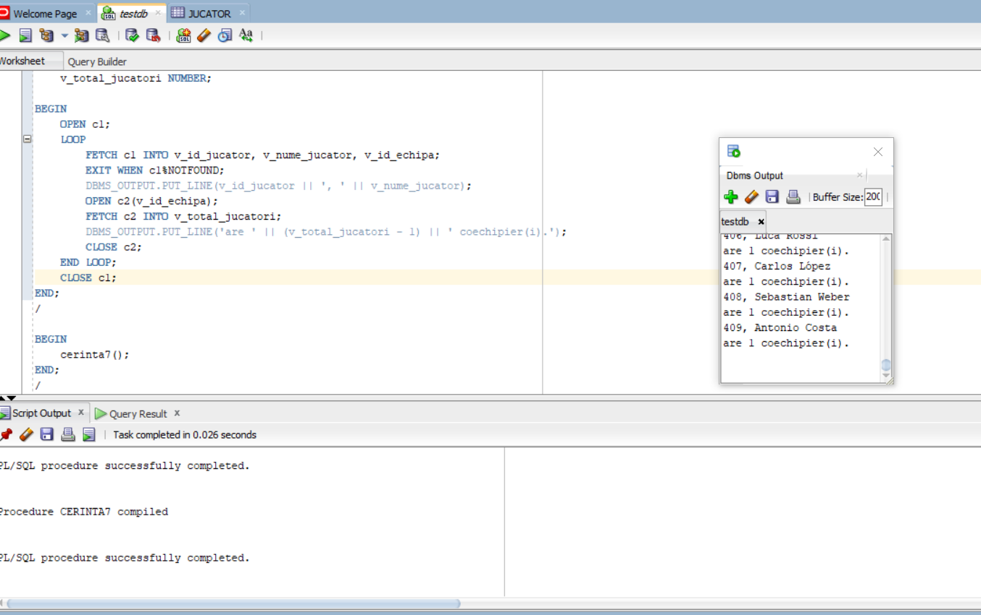

# CERINTA 8

Sa se afiseze numarul de turnee la care un commentator a fost prezent la meciuri.

CREATE OR REPLACE FUNCTION cerinta8(id NUMBER) RETURN NUMBER IS

nr_turnee NUMBER;

aux NUMBER;

nume_com COMENTATOR.nume%TYPE;

v_comentator COMENTATOR%ROWTYPE;

WRONG_ID EXCEPTION;

NO_TOURNAMENTS EXCEPTION;

BEGIN

SELECT COUNT(*) into aux

FROM comentator

WHERE id_comentator = id;

IF aux = 0 THEN

RAISE WRONG_ID;

END IF;

SELECT COUNT(DISTINCT t.id_turneu) into nr_turnee

FROM MECI m

JOIN COMENTATOR c on m.id_comentator = c.id_comentator

JOIN TURNEU t on m.id_turneu = t.id_turneu

WHERE m.id_comentator = id;

IF nr_turnee = 0 THEN

RAISE NO_TOURNAMENTS;

END IF;

RETURN nr_turnee;

EXCEPTION

WHEN WRONG_ID THEN

DBMS_OUTPUT.PUT_LINE('Niciun comentator nu are acest id');

RETURN -1;

WHEN NO_TOURNAMENTS THEN

DBMS_OUTPUT.PUT_LINE('Comentatorul nu a fost la niciun turneu');

RETURN -1;

END;

/

DECLARE

nr NUMBER;

BEGIN

nr := cerinta8(1);

DBMS_OUTPUT.PUT_LINE(nr);

nr := cerinta8(6);

DBMS_OUTPUT.PUT_LINE(nr);

nr := cerinta8(7);

DBMS_OUTPUT.PUT_LINE(nr);

END;

/

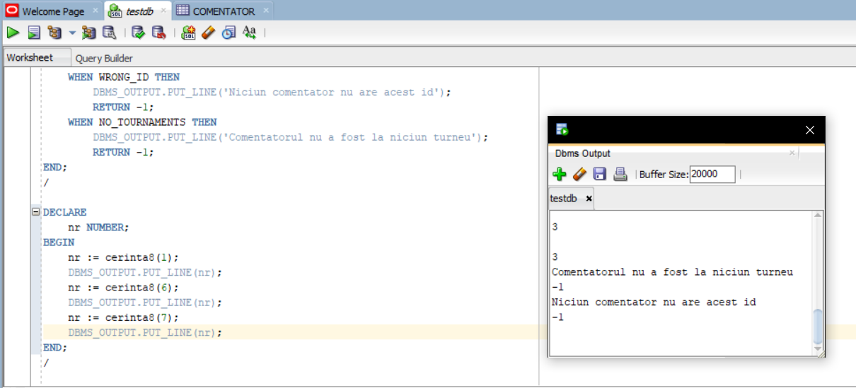

# CERINTA 9

Dandu-se ca parametru id-ul unui meci sa se afiseze sponsorii prezenti in meciul respectiv.

CREATE OR REPLACE PROCEDURE cerinta9(id NUMBER)

AS

TYPE vector_id_echipe IS VARRAY(2) OF NUMBER;

u vector_id_echipe:= vector_id_echipe();

v_sponsor VARCHAR2(50);

NO_DATA_FOUND EXCEPTION;

TOO_MANY_ROWS EXCEPTION;

aux NUMBER;

WRONG_ID EXCEPTION;

BEGIN

SELECT COUNT(*) into aux

FROM meci

WHERE id_meci = id;

IF aux = 0 THEN

RAISE WRONG_ID;

END IF;

FOR rec IN (

SELECT DISTINCT j.id_echipa

FROM meci m

JOIN jucator_meci jm ON m.id_meci = jm.id_meci

JOIN jucator j ON jm.id_jucator1 = j.id_jucator OR jm.id_jucator2 = j.id_jucator

WHERE m.id_meci = id

) LOOP

u.EXTEND;

u(u.LAST) := rec.id_echipa;

END LOOP;

IF u(u.LAST) IS null THEN

RAISE NO_DATA_FOUND;

RETURN;

END IF;

IF u.COUNT > 2 THEN

RAISE TOO_MANY_ROWS;

RETURN;

END IF;

DBMS_OUTPUT.PUT_LINE(u.LAST);

DBMS_OUTPUT.PUT_LINE('Pentru meciul ' || id);

FOR val in 1..u.COUNT LOOP

IF u.COUNT = 1 THEN

DBMS_OUTPUT.PUT_LINE('Ambii jucatori fac parte din aceeasi organizatie (' || u(1) || ')');

DBMS_OUTPUT.PUT_LINE('Sponsorii prezenti sunt:');

ELSE

DBMS_OUTPUT.PUT_LINE('Echipa jucatorului ' || val || ' (' || u(1) || ') are sponsorii:');

END IF;

FOR rez IN (SELECT s.nume

FROM sponsor s

JOIN echipa_sponsor es ON es.id_sponsor = s.id_sponsor

JOIN echipa e ON e.id_Echipa = es.id_echipa AND e.id_echipa = u(val))

LOOP

v_sponsor := rez.nume;

DBMS_OUTPUT.PUT_LINE(v_sponsor);

END LOOP;

END LOOP;

EXCEPTION

WHEN NO_DATA_FOUND THEN

DBMS_OUTPUT.PUT_LINE('no data found');

WHEN TOO_MANY_ROWS THEN

DBMS_OUTPUT.PUT_LINE('too many rows');

WHEN WRONG_ID THEN

DBMS_OUTPUT.PUT_LINE('wrong id');

END;

/

BEGIN

cerinta9(511);DBMS_OUTPUT.PUT_LINE(' ');

cerinta9(513);DBMS_OUTPUT.PUT_LINE(' ');

cerinta9(550);DBMS_OUTPUT.PUT_LINE(' ');

END;

/

A fost nevoie de niste inserturi extra pentru a declansa

INSERT INTO JUCATOR VALUES (411, 'Test 1', 'test1', 'test1', null);

INSERT INTO JUCATOR VALUES (412, 'Test2', 'test2', 'test2', null);

INSERT INTO MECI VALUES (513, TO_DATE('2023-09-7', 'YYYY-MM-DD'), 21, 'test', 1, 103);

INSERT INTO JUCATOR_MECI VALUES (411, 412, 513);

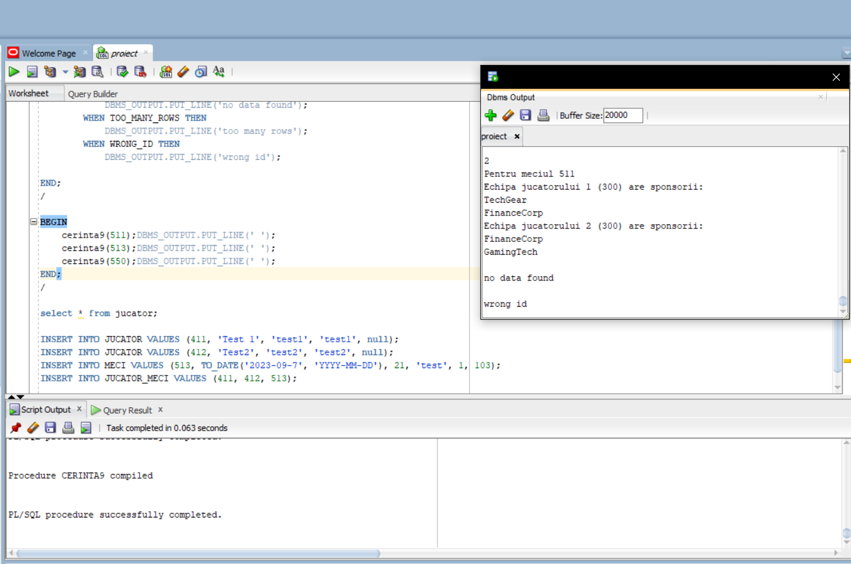

# CERINTA 10

CREATE OR REPLACE TRIGGER cerinta10

BEFORE INSERT OR UPDATE OR DELETE ON MECI

DECLARE

ora CONSTANT NUMBER := 18;

BEGIN

IF TO_NUMBER(TO_CHAR(SYSDATE, 'HH24')) >= ora THEN

RAISE_APPLICATION_ERROR(-20001, 'Operatiuni interzise dupa ora ' || ora || ':00');

END IF;

END;

/

INSERT INTO MECI VALUES (513, TO_DATE('2023-11-7', 'YYYY-MM-DD'), 25, 'TEST', 1, 103);

Pentru testare am folosit ora ca fiind 9

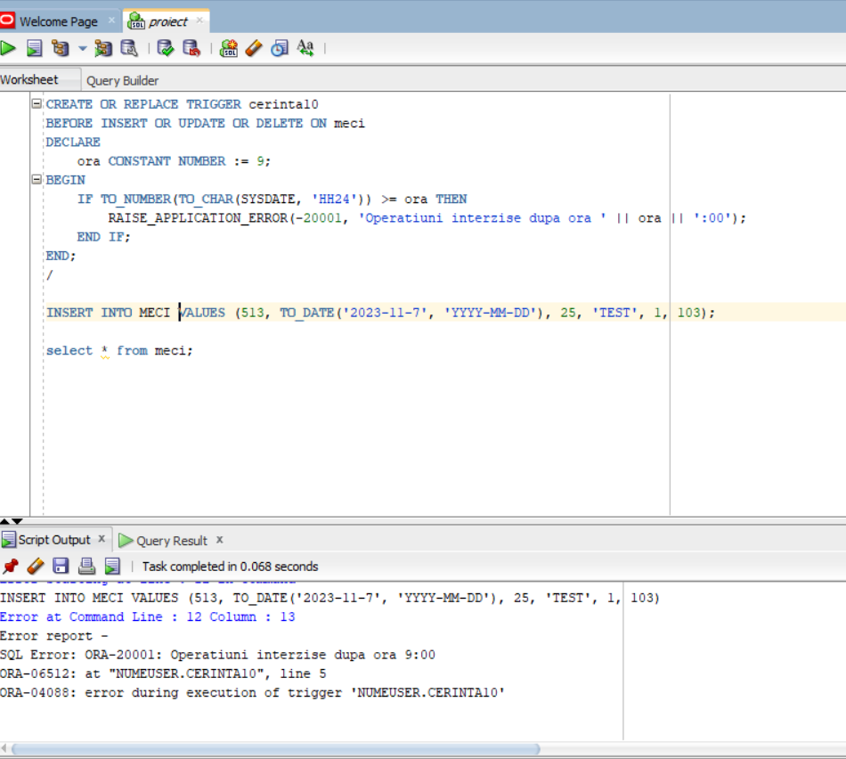

# CERINTA 11

CREATE OR REPLACE TRIGGER cerinta11

BEFORE UPDATE OF id_jucator ON JUCATOR

FOR EACH ROW

WHEN (new.id_jucator <> old.id_jucator)

BEGIN

RAISE_APPLICATION_ERROR(-20001, 'ID-ul jucatorului trebuie sa ramana la fel');

END;

/

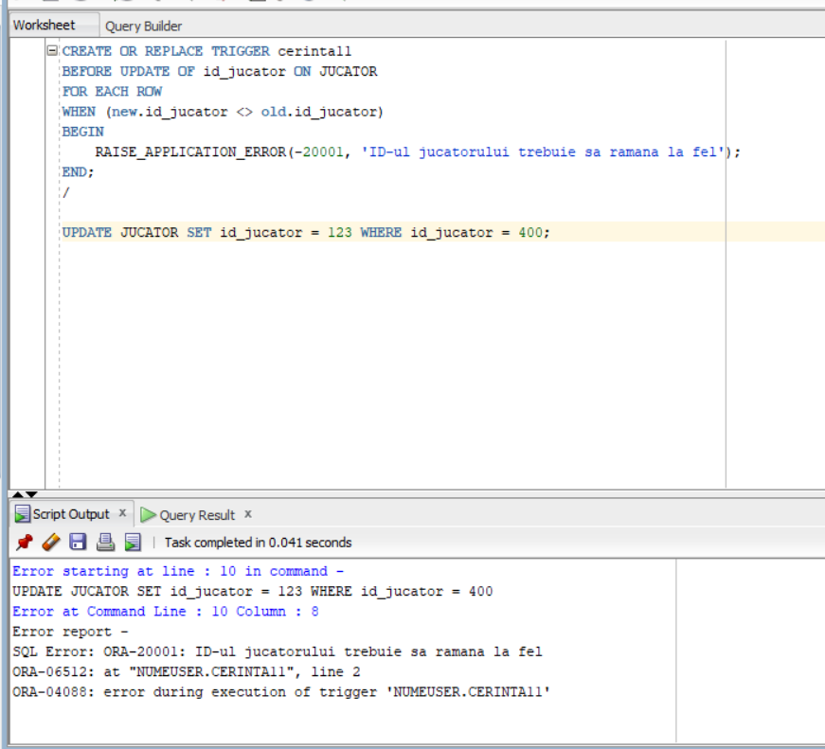

# CERINTA 12

CREATE TABLE audit_cerinta12(

utilizator VARCHAR2(30),

nume_bd VARCHAR2(50),

eveniment VARCHAR2(20),

nume_obiect VARCHAR2(30),

data DATE);

CREATE OR REPLACE TRIGGER cerinta12

AFTER CREATE OR DROP OR ALTER ON SCHEMA

BEGIN

INSERT INTO audit_cerinta12

VALUES (SYS.LOGIN_USER, SYS.DATABASE_NAME, SYS.SYSEVENT,

SYS.DICTIONARY_OBJ_NAME, SYSDATE);

END;

/

CREATE TABLE audit_test(col_test VARCHAR(10), col_test_2 NUMBER(5));

ALTER TABLE audit_test DROP COLUMN col_test;

DROP TABLE audit_test;

SELECT * FROM audit_cerinta12;

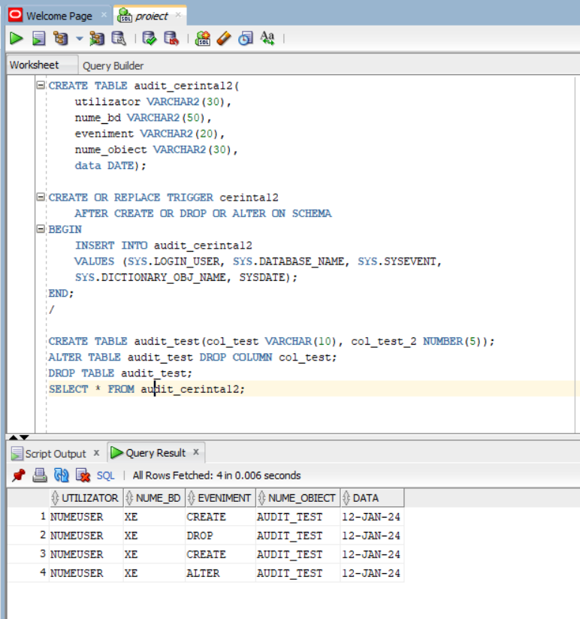

# CERINTA 13

CREATE OR REPLACE PACKAGE cerinta13

AS

PROCEDURE cerinta6(nume Sponsor.nume%TYPE, nume_doi Sponsor.nume%TYPE);

PROCEDURE cerinta7;

FUNCTION cerinta8(id NUMBER) RETURN NUMBER;

PROCEDURE cerinta9(id NUMBER);

END cerinta13;

/

CREATE OR REPLACE PACKAGE BODY cerinta13

AS

PROCEDURE cerinta6 (nume Sponsor.nume%TYPE, nume_doi Sponsor.nume%TYPE) AS

TYPE tabel_indexat IS TABLE OF Echipa%ROWTYPE INDEX BY PLS_INTEGER;

t tabel_indexat;

TYPE tabel_imbricat IS TABLE OF VARCHAR2(50);

y tabel_imbricat;

TYPE vector IS VARRAY(20) OF NUMBER;

u vector:= vector();

BEGIN

SELECT E.*

BULK COLLECT INTO t

FROM ECHIPA E

JOIN ECHIPA_SPONSOR ES ON E.ID_ECHIPA = ES.ID_ECHIPA

JOIN SPONSOR S ON ES.ID_SPONSOR = S.ID_SPONSOR

WHERE S.NUME = cerinta6.nume;

u.extend;

u(1) := t.COUNT;

FOR i IN 1..t.COUNT LOOP

DBMS_OUTPUT.PUT_LINE(t(i).nume || ', ' || t(i).id_echipa);

END LOOP;

DBMS_OUTPUT.PUT_LINE('');

SELECT E.nume

BULK COLLECT INTO y

FROM ECHIPA E

JOIN ECHIPA_SPONSOR ES ON E.ID_ECHIPA = ES.ID_ECHIPA

JOIN SPONSOR S ON ES.ID_SPONSOR = S.ID_SPONSOR

WHERE S.NUME = cerinta6.nume_doi;

u.extend;

u(2) := y.COUNT;

FOR i IN 1..y.COUNT LOOP

DBMS_OUTPUT.PUT_LINE(y(i));

END LOOP;

DBMS_OUTPUT.PUT_LINE('');

DBMS_OUTPUT.PUT_LINE(u(1) || ', ' || u(2));

END;

PROCEDURE cerinta7 AS

CURSOR c1 IS

SELECT j.id_jucator, j.nume, j.id_echipa

FROM JUCATOR j;

CURSOR c2 (v_id_echipa ECHIPA.id_echipa%TYPE) IS

SELECT COUNT(*)

FROM ECHIPA e

JOIN JUCATOR j ON e.id_echipa = j.id_echipa

WHERE e.id_echipa = v_id_echipa;

v_id_jucator JUCATOR.id_jucator%TYPE;

v_nume_jucator JUCATOR.nume%TYPE;

v_id_echipa ECHIPA.id_echipa%TYPE;

v_total_jucatori NUMBER;

BEGIN

OPEN c1;

LOOP

FETCH c1 INTO v_id_jucator, v_nume_jucator, v_id_echipa;

EXIT WHEN c1%NOTFOUND;

DBMS_OUTPUT.PUT_LINE(v_id_jucator || ', ' || v_nume_jucator);

OPEN c2(v_id_echipa);

FETCH c2 INTO v_total_jucatori;

DBMS_OUTPUT.PUT_LINE('are ' || (v_total_jucatori - 1) || ' coechipier(i).');

CLOSE c2;

END LOOP;

CLOSE c1;

END;

FUNCTION cerinta8(id NUMBER) RETURN NUMBER IS

nr_turnee NUMBER;

aux NUMBER;

nume_com COMENTATOR.nume%TYPE;

v_comentator COMENTATOR%ROWTYPE;

WRONG_ID EXCEPTION;

NO_TOURNAMENTS EXCEPTION;

BEGIN

SELECT COUNT(*) into aux

FROM comentator

WHERE id_comentator = id;

IF aux = 0 THEN

RAISE WRONG_ID;

END IF;

SELECT COUNT(DISTINCT t.id_turneu) into nr_turnee

FROM MECI m

JOIN COMENTATOR c on m.id_comentator = c.id_comentator

JOIN TURNEU t on m.id_turneu = t.id_turneu

WHERE m.id_comentator = id;

IF nr_turnee = 0 THEN

RAISE NO_TOURNAMENTS;

END IF;

RETURN nr_turnee;

EXCEPTION

WHEN WRONG_ID THEN

DBMS_OUTPUT.PUT_LINE('Niciun comentator nu are acest id');

RETURN -1;

WHEN NO_TOURNAMENTS THEN

DBMS_OUTPUT.PUT_LINE('Comentatorul nu a fost la niciun turneu');

RETURN -1;

END;

PROCEDURE cerinta9(id NUMBER)

AS

TYPE vector_id_echipe IS VARRAY(2) OF NUMBER;

u vector_id_echipe:= vector_id_echipe();

v_sponsor VARCHAR2(50);

NO_DATA_FOUND EXCEPTION;

TOO_MANY_ROWS EXCEPTION;

aux NUMBER;

WRONG_ID EXCEPTION;

BEGIN

SELECT COUNT(*) into aux

FROM meci

WHERE id_meci = id;

IF aux = 0 THEN

RAISE WRONG_ID;

END IF;

FOR rec IN (

SELECT DISTINCT j.id_echipa

FROM meci m

JOIN jucator_meci jm ON m.id_meci = jm.id_meci

JOIN jucator j ON jm.id_jucator1 = j.id_jucator OR jm.id_jucator2 = j.id_jucator

WHERE m.id_meci = id

) LOOP

u.EXTEND;

u(u.LAST) := rec.id_echipa;

END LOOP;

IF u(u.LAST) IS null THEN

RAISE NO_DATA_FOUND;

RETURN;

END IF;

IF u.COUNT > 2 THEN

RAISE TOO_MANY_ROWS;

RETURN;

END IF;

DBMS_OUTPUT.PUT_LINE(u.LAST);

DBMS_OUTPUT.PUT_LINE('Pentru meciul ' || id);

FOR val in 1..u.COUNT LOOP

IF u.COUNT = 1 THEN

DBMS_OUTPUT.PUT_LINE('Ambii jucatori fac parte din aceeasi organizatie (' || u(1) || ')');

DBMS_OUTPUT.PUT_LINE('Sponsorii prezenti sunt:');

ELSE

DBMS_OUTPUT.PUT_LINE('Echipa jucatorului ' || val || ' (' || u(1) || ') are sponsorii:');

END IF;

FOR rez IN (SELECT s.nume

FROM sponsor s

JOIN echipa_sponsor es ON es.id_sponsor = s.id_sponsor

JOIN echipa e ON e.id_Echipa = es.id_echipa AND e.id_echipa = u(val))

LOOP

v_sponsor := rez.nume;

DBMS_OUTPUT.PUT_LINE(v_sponsor);

END LOOP;

END LOOP;

EXCEPTION

WHEN NO_DATA_FOUND THEN

DBMS_OUTPUT.PUT_LINE('no data found');

WHEN TOO_MANY_ROWS THEN

DBMS_OUTPUT.PUT_LINE('too many rows');

WHEN WRONG_ID THEN

DBMS_OUTPUT.PUT_LINE('wrong id');

END;

END cerinta13;

/

