2.

MEMBER member_id not null, unique

TITLE title_id not null, unique

TITLE_COPY copy_id not null; title_id not null

RENTAL book_date not null, unique; member_id not null; title_id not null

RESERVATION res_date not null, unique; member_id not null, title_id not nul

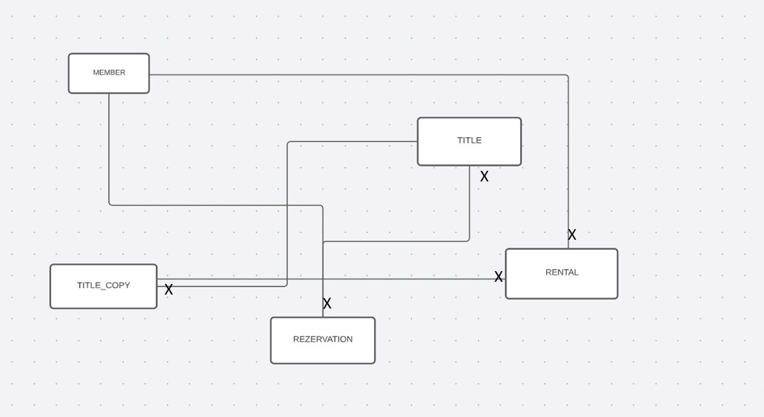

3.