E1:

DECLARE

TYPE emp_id_array IS VARRAY(20) OF NUMBER(6);

emp_ids emp_id_array;

salary_var NUMBER(8, 2) := 0;

BEGIN

SELECT employee_id BULK COLLECT INTO emp_ids

FROM (SELECT employee_id

FROM employees

WHERE commission_pct IS NULL

ORDER BY salary)

WHERE ROWNUM < 6;

FOR i IN 1..5 LOOP

SELECT salary INTO salary_var

FROM employees

WHERE employee_id = emp_ids(i);

DBMS_OUTPUT.PUT_LINE(salary_var || ' ');

END LOOP;

FOR i IN 1..5 LOOP

SELECT salary INTO salary_var

FROM employees

WHERE employee_id = emp_ids(i);

salary_var := salary_var + (5 / 100) * salary_var;

DBMS_OUTPUT.PUT_LINE(salary_var || ' ');

END LOOP;

END;

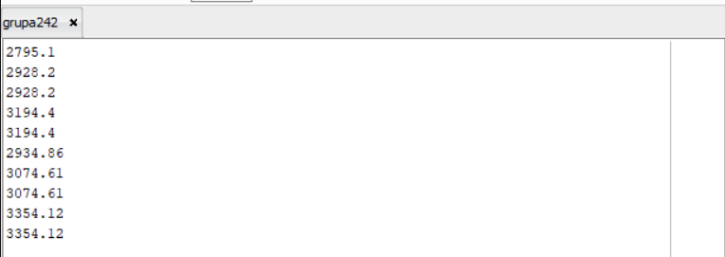

E2:

CREATE OR REPLACE TYPE tip_orase_SAI AS VARRAY(20) OF VARCHAR2(50);

CREATE TABLE excursie_SAI (

cod_excursie NUMBER(4),

denumire VARCHAR2(20),

orase tip_orase_SAI,

status VARCHAR2(20)

);

INSERT INTO excursie_SAI VALUES (1, 'Excursie 1', tip_orase_SAI('Oras1', 'Oras2', 'Oras3'), 'Disponibila');

INSERT INTO excursie_SAI VALUES (2, 'Excursie 2', tip_orase_SAI('Oras2', 'Oras4', 'Oras5'), 'Disponibila');

INSERT INTO excursie_SAI VALUES (3, 'Excursie 3', tip_orase_SAI('Oras1', 'Oras3', 'Oras5'), 'Disponibila');

INSERT INTO excursie_SAI VALUES (4, 'Excursie 4', tip_orase_SAI('Oras3', 'Oras4'), 'Disponibila');

INSERT INTO excursie_SAI VALUES (5, 'Excursie 5', tip_orase_SAI('Oras5', 'Oras1', 'Oras2'), 'Disponibila');