E1:

DECLARE

name employees.first_name%type;

salary employees.salary%type;

title jobs.job_title%type;

title_two jobs.job_title%type;

CURSOR c IS

SELECT job_title,first_name,salary

FROM employees e

RIGHT JOIN jobs j ON e.job_id=j.job_id;

BEGIN

OPEN c;

LOOP

FETCH c INTO title,name,salary;

EXIT WHEN c%NOTFOUND;

DBMS_OUTPUT.PUT_LINE(title);

DBMS_OUTPUT.PUT_LINE(name || ' ' || salary);

LOOP

FETCH c INTO title_two,name,salary;

EXIT WHEN title_two!=title;

DBMS_OUTPUT.PUT_LINE(name || ' ' || salary);

END LOOP;

END LOOP;

CLOSE c;

END;

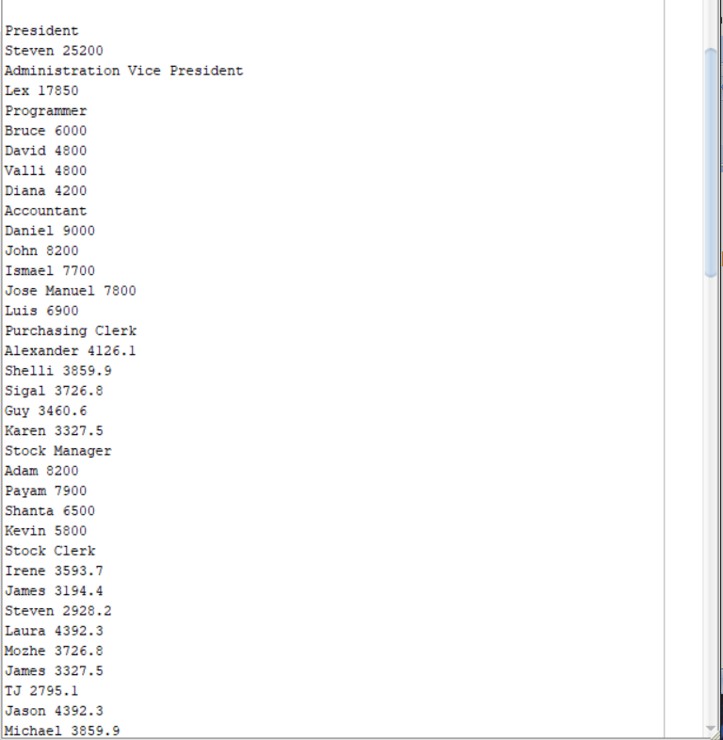

E2:

DECLARE

name employees.first_name%type;

salary employees.salary%type;

title jobs.job_title%type;

title_two jobs.job_title%type;

empNo NUMBER(3):= 0;

totalIncome NUMBER(10):= 0;

avgIncome NUMBER(10):= 0;

income NUMBER(10):= 0;

comission employees.commission_pct%TYPE;

CURSOR c IS

SELECT job_title,first_name,salary,commission_pct

FROM employees e

RIGHT JOIN jobs j ON e.job_id=j.job_id;

BEGIN

OPEN c;

LOOP

empNo:= 0;

totalIncome:= 0;

FETCH c INTO title,name,salary,comission;

empNo:=empNo+1;

IF comission IS NOT NULL

THEN

income:= salary + comission * salary;

ELSE

income:= salary;

END IF;

totalIncome:= totalIncome + income;

EXIT WHEN c%NOTFOUND;

DBMS_OUTPUT.PUT_LINE(title);

DBMS_OUTPUT.PUT_LINE(name || ' ' || salary);

LOOP

FETCH c INTO title_two,name,salary,comission;

EXIT WHEN title_two!=title;

empNo:=empNo+1;

IF comission IS NOT NULL

THEN

income:= salary + comission * salary;

ELSE

income:= salary;

END IF;

DBMS_OUTPUT.PUT_LINE(name || ' ' || salary);

totalIncome:= totalIncome + income;

END LOOP;

avgIncome:= totalIncome / empNo;

DBMS_OUTPUT.PUT_LINE(empNo || ' ' || totalIncome || ' ' || avgIncome);

END LOOP;

CLOSE c;

END;

