**4a Reasoning for your choice of automation software and reporting.**

I have used Java and Selenium Framework for the automation test because Java Selenium is a popular choice for web automation because its versatile and java is widely adopted programming language. I am personally more comfortable using this framework. However, I wanted to work on test cafe framework and wanted to learn something new but due to some issue's I was not able to proceed further with the same. For reporting I have used extent report in selenium because they provide detailed and customizable test results, making it easier to analyse test outcomes and share them.

**4b Any installation instructions for your software and framework**

|  |  |
| --- | --- |
| **Frameworks & Tools** | **Version** |
| Selenium Java | 4.15.0 |
| Web driver Manager | 5.5.3 |
| Maven | 2.11.0 |
| POM | 4.0.0 |
| TestNG | 7.7.1 |
| Extent Reports | 3.1.5 |
| Apache POI | 5.2.3 |

**4c Instructions and commands to run your code.**

•         Import the project file into the eclipse workspace.

•         Save the pom.xml file.

•         Update the Maven project (Maven->Update Project).

•         To Run the program in respective browser such as Chrome, Firefox, Edge changes the browser name in the Packt properties file (Properties->Packt.properties).

•         To run the test class, go to src/test/java:

•         TestScript ->PacktTest.java.

(This package contains the TestNG script to run the code.

•         Run the class with TestNG.

•         To Run both the smoke and regression test suites continuously right click on MastertestngSuite.xml file and click RunAs->TestngSuite.

**4d Any other information you would like us to know, the more documentation the better.**

**Structure Details:**

•         **src/main/java**:

•         library package ->Browser, Reusable Methods, ScreenShot, ReadProperties, UseProperties files.

(This package contains reusable and browser calling methods to be used in automation)

•         Pages package -> HomePage.java

(This package contains pages to be automated)

•         Reports package -> ExtentReportsPage.

(This package contains extent report files to create an extent report)

•         **src/test/java:**

•         TestScript package ->PacktTest.java

(This package contains the TestNG script to run the code.

•         **Reports:**

•         It contains the Extent Report for the automated project file.

•         **Screenshot:**

•         It contains the screenshot taken during the execution of the program.

•                     **Browser Options:**

•                     1.Chrome

•                     2.Firefox

•                     3.Microsoft Edge

* **Project Structure:**

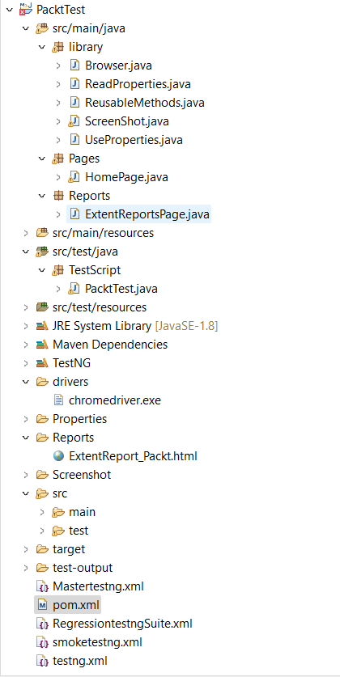

•                     **Suggested Site:** <https://subscription.packtpub.com/>