Below are clear, end-to-end steps to deploy a Flask app on an EC2 instance (beginner-friendly, production-ready approach).

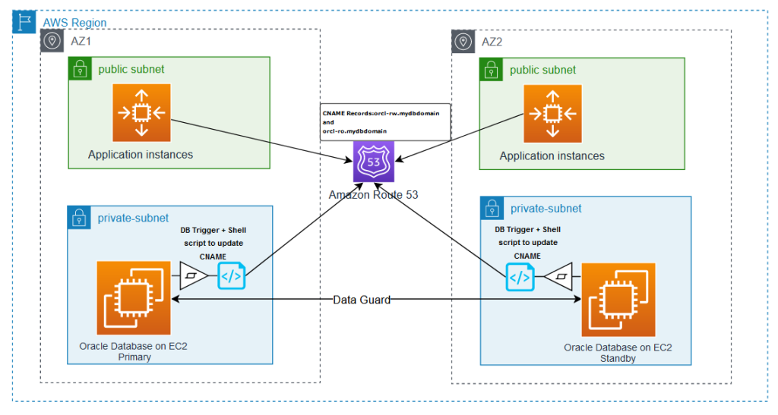
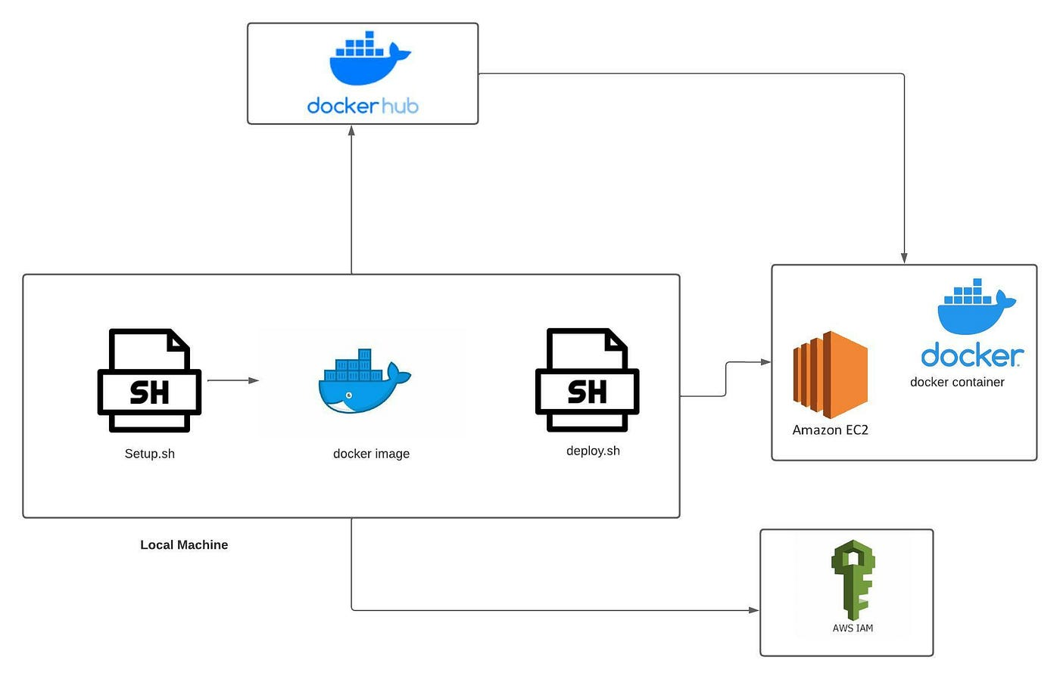
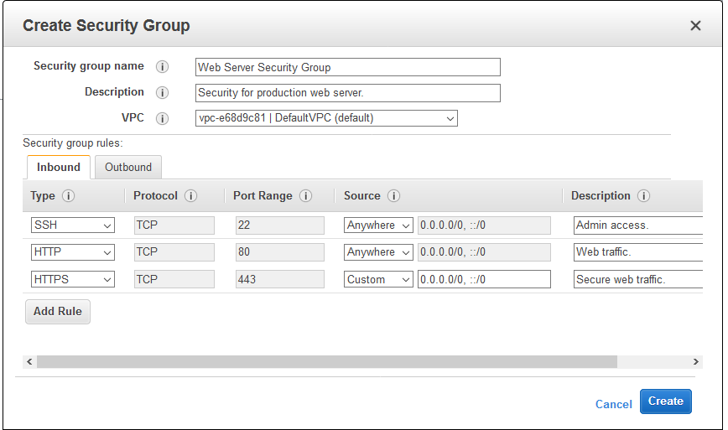
4

1️⃣ Launch an EC2 Instance
- Log in to Amazon Web Services Console
- Go to EC2 → Launch Instance
- Choose Ubuntu 22.04 LTS
- Instance type: t2.micro (Free Tier)
- Create/download a key pair (.pem)
- Security Group:
  - SSH → Port 22
  - HTTP → Port 80
  - Custom → Port 5000 (optional, for testing)
- Launch the instance

2️⃣ Connect to EC2 via SSH (From Local Machine)
chmod 400 mykey.pem
ssh -i mykey.pem ubuntu@<EC2_PUBLIC_IP>

3️⃣ Update System & Install Dependencies
sudo apt update && sudo apt upgrade -y
sudo apt install python3 python3-pip python3-venv nginx git -y

4️⃣ Clone Your Flask Application
git clone https://github.com/your-username/your-flask-app.git
cd your-flask-app

5️⃣ Create Virtual Environment & Install Python Packages
python3 -m venv venv
source venv/bin/activate
pip install -r requirements.txt

6️⃣ Test Flask App (Optional but Important)
python app.py
Open browser:
http://<EC2_PUBLIC_IP>:5000
If it works → proceed.

7️⃣ Run Flask with Gunicorn (Production Server)
pip install gunicorn
gunicorn --bind 0.0.0.0:8000 app:app
app:app → filename:flask_app_variable

8️⃣ Configure Gunicorn as a Service
sudo nano /etc/systemd/system/flaskapp.service
Paste:
[Unit]
Description=Gunicorn Flask App
After=network.target

[Service]
User=ubuntu
WorkingDirectory=/home/ubuntu/your-flask-app
ExecStart=/home/ubuntu/your-flask-app/venv/bin/gunicorn --workers 3 --bind unix:flaskapp.sock app:app

[Install]
WantedBy=multi-user.target
Enable service:
sudo systemctl start flaskapp
sudo systemctl enable flaskapp

9️⃣ Configure Nginx (Reverse Proxy)
sudo nano /etc/nginx/sites-available/flaskapp
Paste:
server {
listen 80;
server_name <EC2_PUBLIC_IP>;

location / {
include proxy_params;
proxy_pass http://unix:/home/ubuntu/your-flask-app/flaskapp.sock;
}
}
Enable config:
sudo ln -s /etc/nginx/sites-available/flaskapp /etc/nginx/sites-enabled
sudo nginx -t
sudo systemctl restart nginx

Imp:
Sudo chmod 775 /home/ubuntu

🔟 Final Access
Open browser:
http://<EC2_PUBLIC_IP>
🎉 Your Flask app is live!

