Project Architecture
Developer
│
▼
GitHub Repository
│
▼
Jenkins Pipeline
│
├── Build Node.js App
├── Run Tests
├── Build Docker Image
├── Push Image to DockerHub/ECR
└── Helm Upgrade
│
▼
AWS EKS Cluster
│
┌─────────┴─────────┐
│ │
Blue Deployment Green Deployment
│ │
└─────────┬─────────┘
│
Kubernetes Service
│
AWS Load Balancer

Folder Structure
blue-green-eks/
│
├── terraform/
│ ├── provider.tf
│ ├── versions.tf
│ ├── variables.tf
│ ├── vpc.tf
│ ├── iam.tf
│ ├── eks.tf
│ ├── outputs.tf
│ └── terraform.tfvars
│
├── app/
│ ├── server.js
│ ├── package.json
│ ├── Dockerfile
│ └── Jenkinsfile
│
├── helm/
│ └── blue-green-app/
│ ├── Chart.yaml
│ ├── values.yaml
│ └── templates/
│ ├── blue-deployment.yaml
│ ├── green-deployment.yaml
│ ├── service.yaml
│ ├── ingress.yaml
│ └── _helpers.tpl
│
├── README.md
└── screenshots/

Phase 1 — Build Node.js Application

Step 1
Create simple Express application.
mkdir app
cd app
npm init -y
npm install express
server.js
const express = require("express");

const app = express();

const version = process.env.APP_VERSION || "blue";

app.get("/", (req,res)=>{
res.send(`Application Version : ${version}`);
});

app.listen(3000,()=>{
console.log("Server Running");
});

Step 2
Create Dockerfile
FROM node:20-alpine

WORKDIR /app

COPY package*.json ./

RUN npm install

COPY . .

EXPOSE 3000

CMD ["node","server.js"]

Step 3
Test
docker build -t bluegreen:v1 .

docker run -p 3000:3000 bluegreen:v1

Phase 2 — Terraform Infrastructure
Terraform creates
- VPC
- Internet Gateway
- NAT Gateway
- Public Subnets
- Private Subnets
- Route Tables
- IAM Roles
- EKS Cluster
- Managed Node Group

Commands
cd terraform

terraform init

terraform validate

terraform fmt

terraform plan

terraform apply -auto-approve

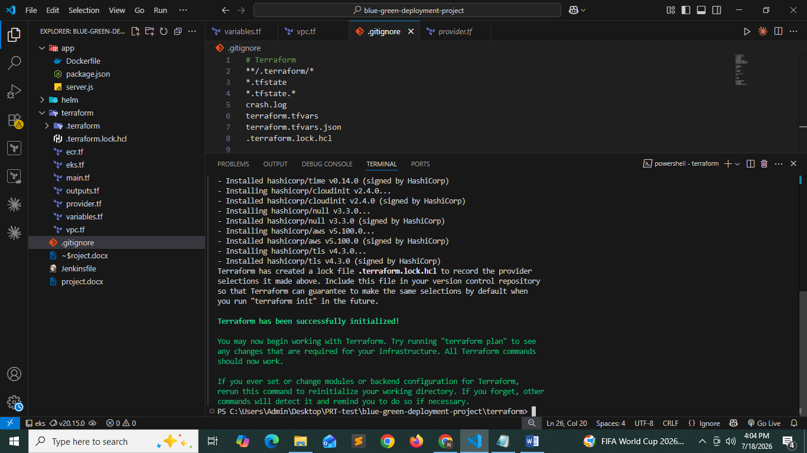

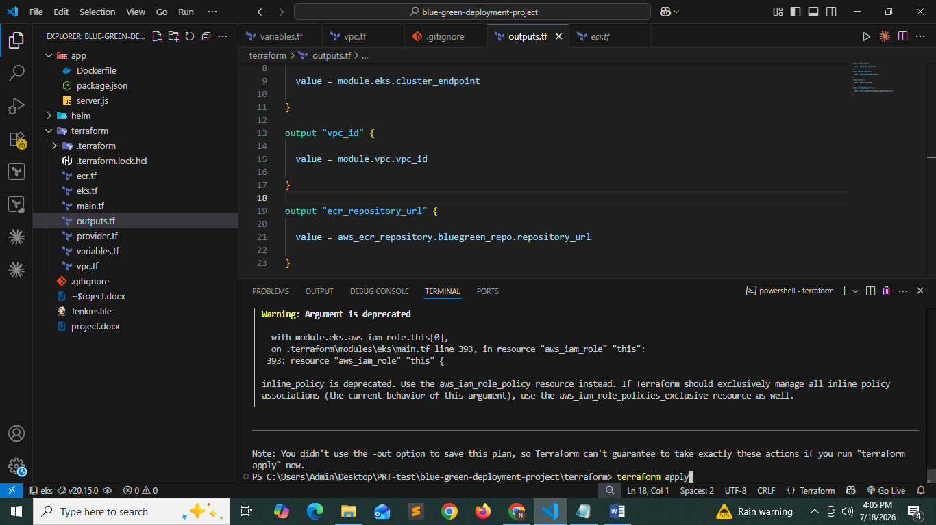

Update kubeconfig
aws eks update-kubeconfig \
--region ap-south-1 \
--name bluegreen-cluster
Check
kubectl get nodes

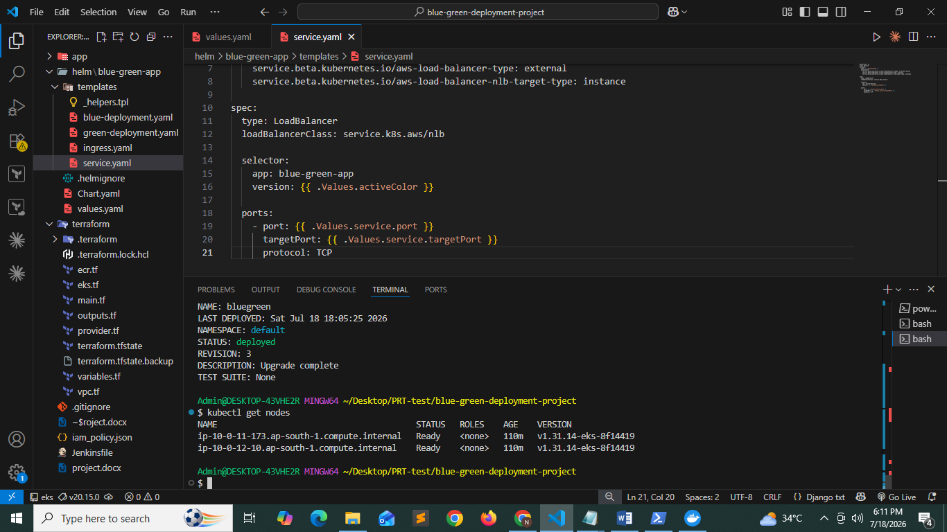

Phase 3 — Install Required Components

Install Helm
helm version

Install Metrics Server
kubectl apply -f https://github.com/kubernetes-sigs/metrics-server/releases/latest/download/components.yaml

Install AWS Load Balancer Controller
Associate IAM
eksctl utils associate-iam-oidc-provider \
--cluster bluegreen-cluster \
--approve
Create IAM Policy
curl -o iam_policy.json https://raw.githubusercontent.com/kubernetes-sigs/aws-load-balancer-controller/main/docs/install/iam_policy.json
Create policy
aws iam create-policy \
--policy-name AWSLoadBalancerControllerIAMPolicy \
--policy-document file://iam_policy.json
Create Service Account
eksctl create iamserviceaccount \
--cluster bluegreen-cluster \
--namespace kube-system \
--name aws-load-balancer-controller \
--attach-policy-arn arn:aws:iam::<ACCOUNT_ID>:policy/AWSLoadBalancerControllerIAMPolicy \
--approve
Install controller
helm repo add eks https://aws.github.io/eks-charts

helm repo update

helm install aws-load-balancer-controller eks/aws-load-balancer-controller \
-n kube-system \
--set clusterName=bluegreen-cluster

Phase 4 — Helm Blue Green
Helm chart contains
blue deployment
green deployment
service
ingress
helm install bluegreen ./helm/blue-green-app
kubectl get pods
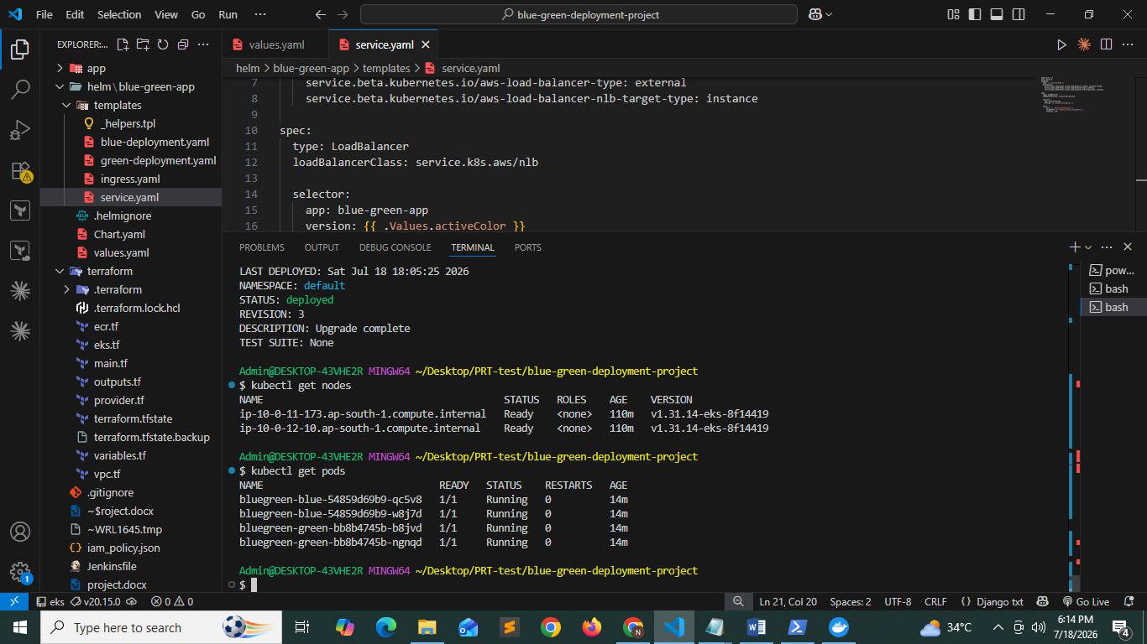

Kubectl get svc
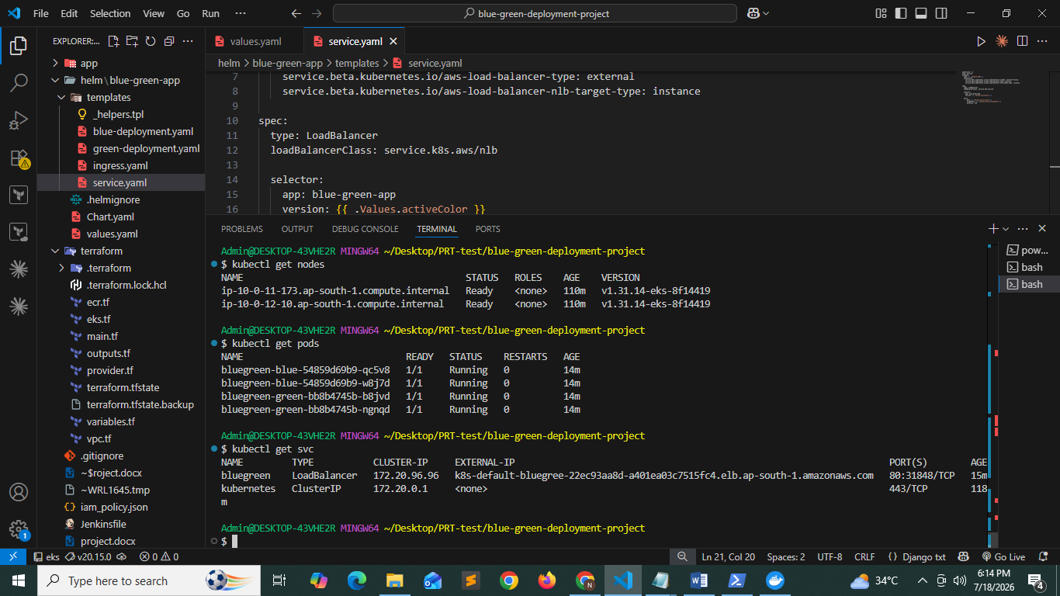

Kubectl describe svc bluegreen
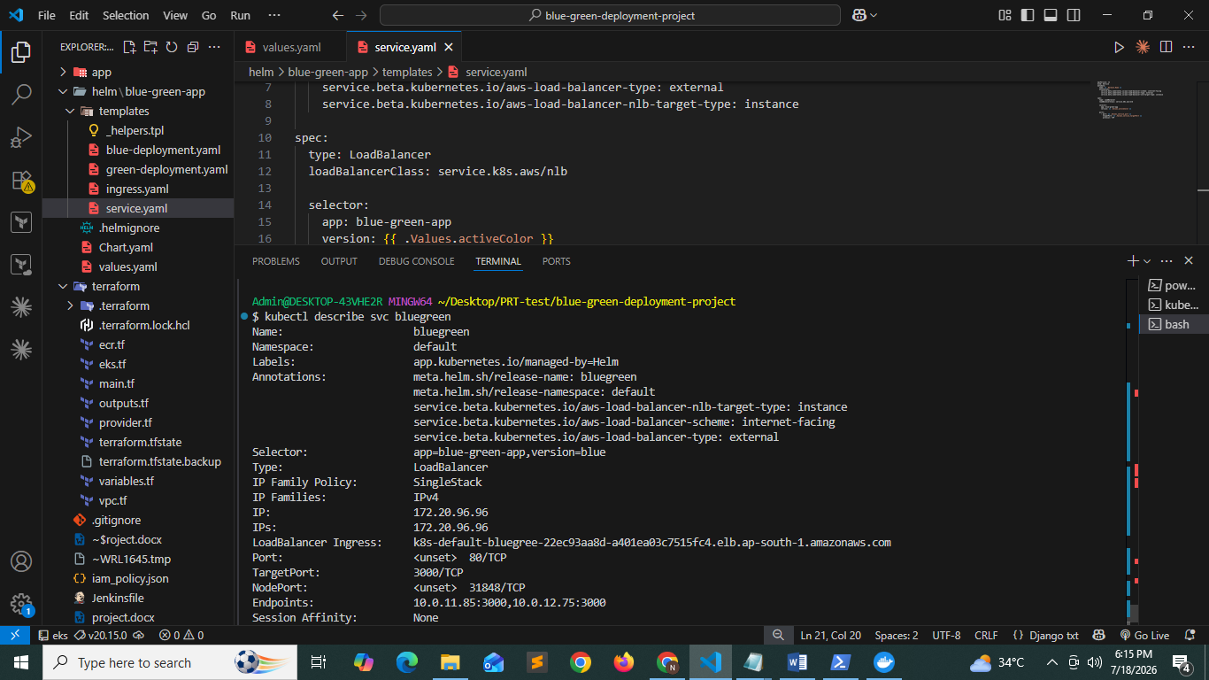

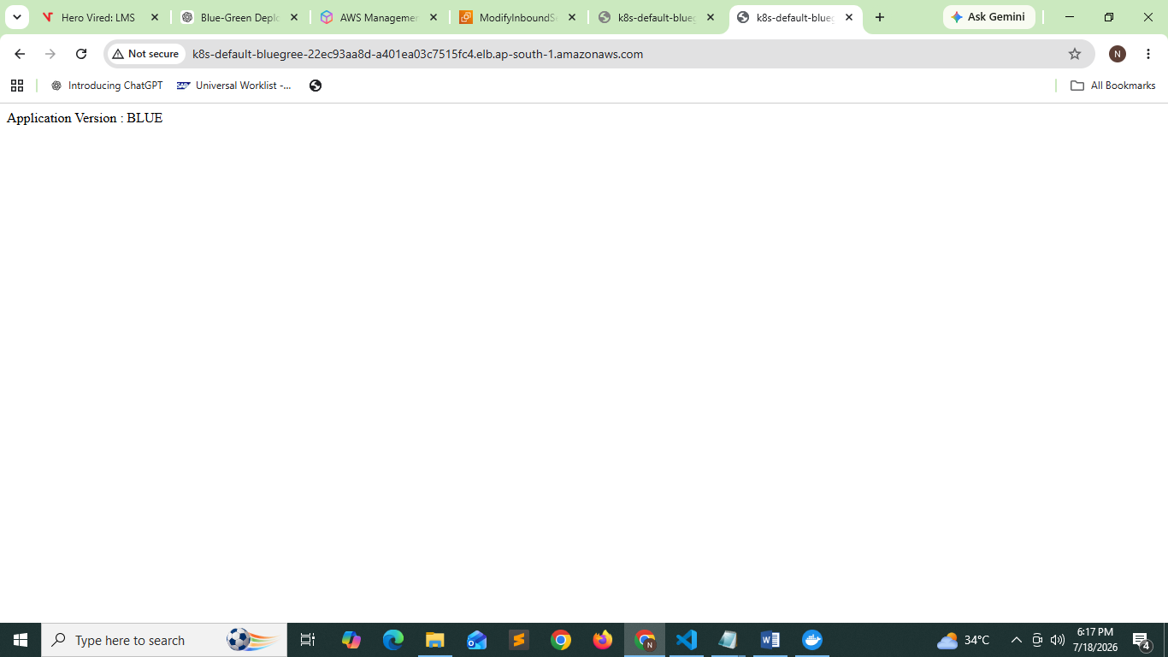

Switch Traffic to Green
Update the Helm value:
helm upgrade bluegreen ./helm/blue-green-app \
--set activeColor=green
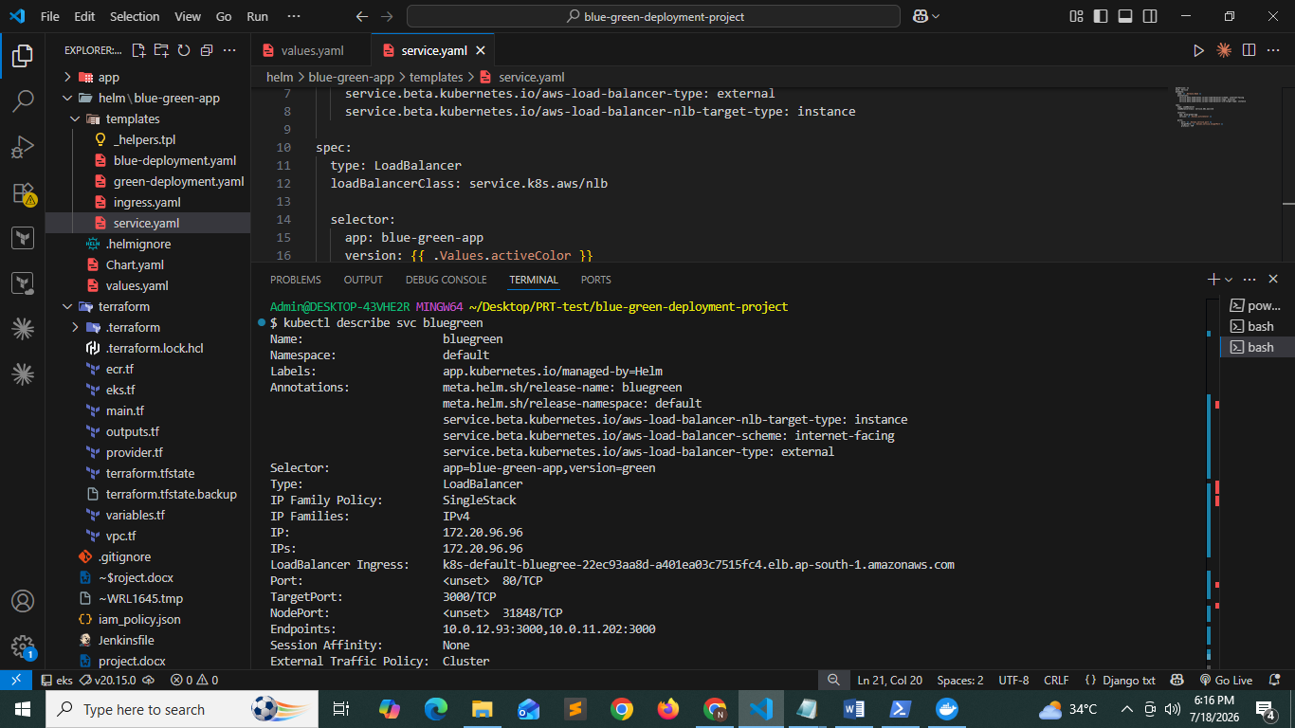

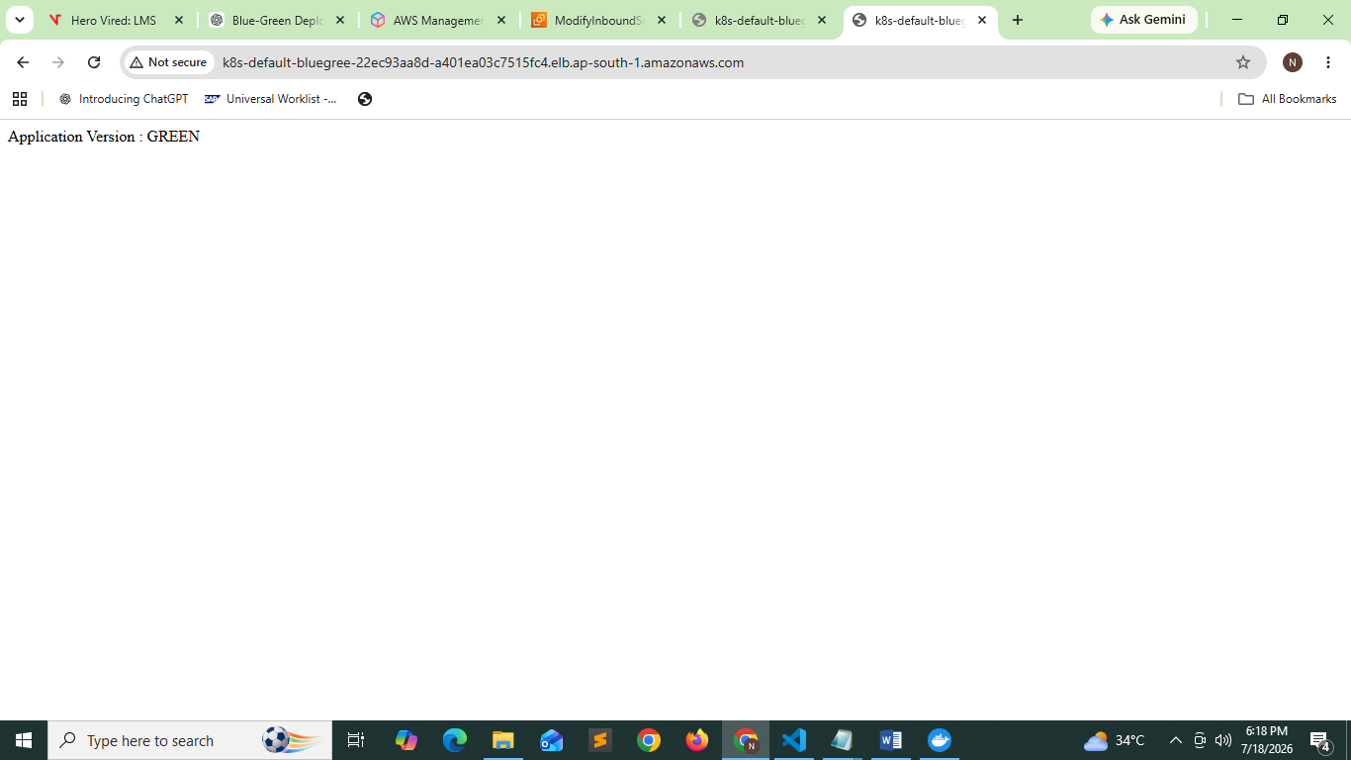

Roll Back to Blue

helm upgrade bluegreen ./helm/blue-green-app --set activeColor=blue

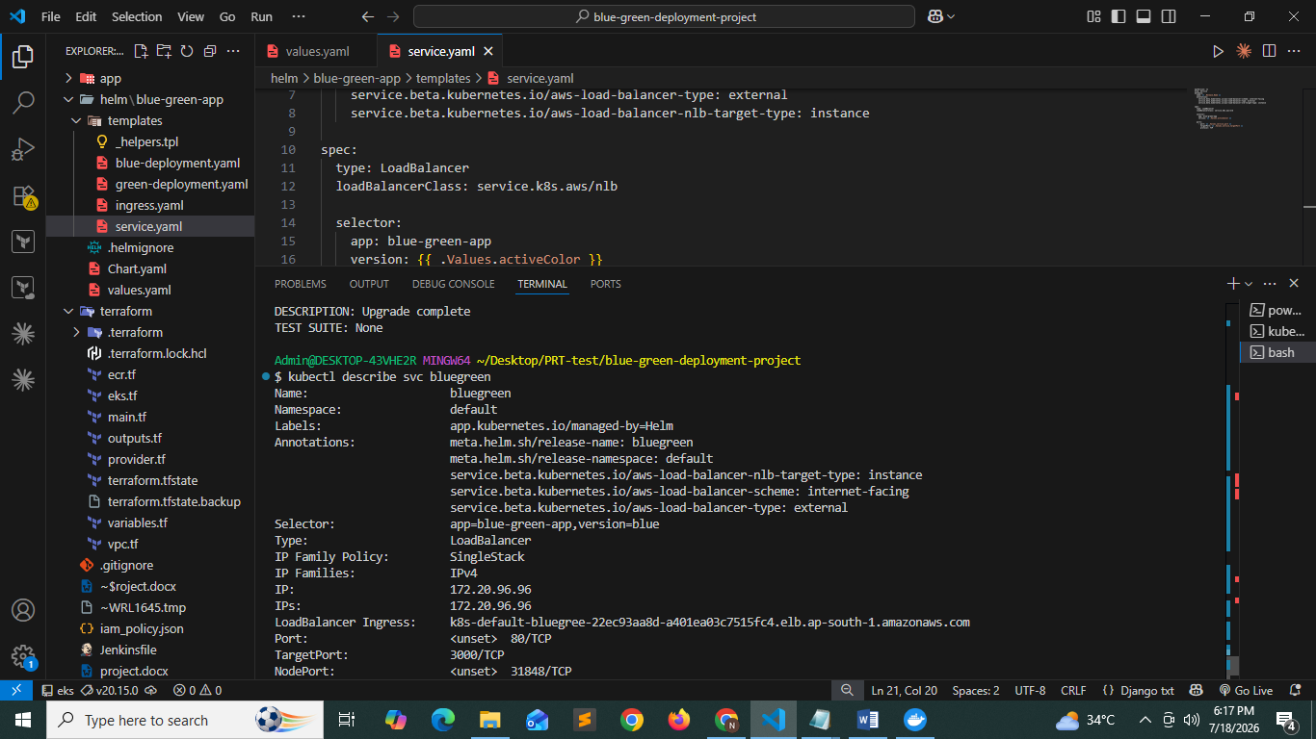

Phase 5 — Jenkins Installation

Launching an ec2 instance

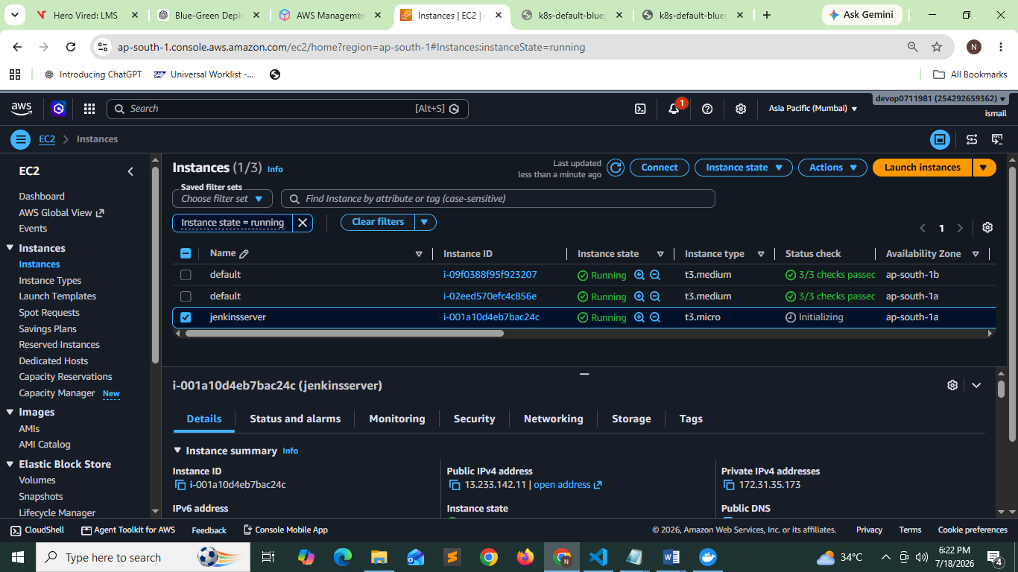
Jenkins configuration:

1. Update System
sudo apt update && sudo apt upgrade -y

2. Install Git

sudo apt install git -y

Verify:

git --version

3. Install Python3

sudo apt install python3 python3-pip python3-venv -y

Verify:

python3 --version

pip3 --version

4. Install Docker

sudo apt install docker.io -y

sudo systemctl enable docker

sudo systemctl start docker

sudo usermod -aG docker $USER

Apply the group change:

newgrp docker

Verify:

docker --version

5. Install AWS CLI v2

curl "https://awscli.amazonaws.com/awscli-exe-linux-x86_64.zip" -o "awscliv2.zip"

sudo apt install unzip -y

unzip awscliv2.zip

sudo ./aws/install

Verify:

aws --version

6. Install kubectl

curl -LO "https://dl.k8s.io/release/$(curl -L -s https://dl.k8s.io/release/stable.txt)/bin/linux/amd64/kubectl"

chmod +x kubectl

sudo mv kubectl /usr/local/bin/

Verify:

kubectl version --client

7. Install Trivy

sudo apt install wget gnupg lsb-release apt-transport-https -y

wget -qO - https://aquasecurity.github.io/trivy-repo/deb/public.key | \

gpg --dearmor | \

sudo tee /usr/share/keyrings/trivy.gpg > /dev/null

echo "deb [signed-by=/usr/share/keyrings/trivy.gpg] https://aquasecurity.github.io/trivy-repo/deb $(lsb_release -sc) main" | \

sudo tee /etc/apt/sources.list.d/trivy.list

sudo apt update

sudo apt install trivy -y

Verify:

trivy --version

8. Install Terraform (Optional)

wget -O- https://apt.releases.hashicorp.com/gpg | \

gpg --dearmor | \

sudo tee /usr/share/keyrings/hashicorp-archive-keyring.gpg

echo "deb [signed-by=/usr/share/keyrings/hashicorp-archive-keyring.gpg] \

https://apt.releases.hashicorp.com $(lsb_release -cs) main" | \

sudo tee /etc/apt/sources.list.d/hashicorp.list

sudo apt update

sudo apt install terraform -y

Verify:

terraform version

9. Configure AWS CLI

aws configure

Enter:

AWS Access Key ID

AWS Secret Access Key

Region: ap-south-1

Output: json

Verify:

aws sts get-caller-identity

10. Connect to EKS

aws eks update-kubeconfig --region ap-south-1 --name bluegreen-eks-cluster

Verify:

kubectl get nodes

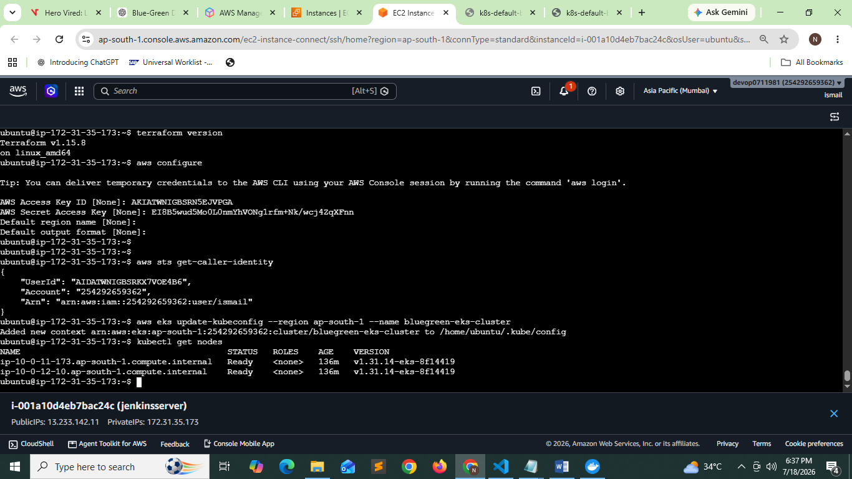

11 Jenkins installation

sudo apt update

sudo apt install fontconfig openjdk-21-jre

java -version

sudo wget -O /etc/apt/keyrings/jenkins-keyring.asc \

https://pkg.jenkins.io/debian-stable/jenkins.io-2026.key

echo "deb [signed-by=/etc/apt/keyrings/jenkins-keyring.asc]" \

https://pkg.jenkins.io/debian-stable binary/ | sudo tee \

/etc/apt/sources.list.d/jenkins.list > /dev/null

sudo apt update

sudo apt install jenkins

sudo usermod -aG docker jenkins

sudo systemctl restart jenkins

sudo systemctl restart docker

Phase 6 — Jenkins Pipeline
Pipeline
Checkout

↓

Install dependencies

↓

Run Tests

↓

Docker Build

↓

Docker Push

↓

Update values.yaml

↓

helm upgrade

↓

Verify rollout

↓

Switch Service

↓

Cleanup

pipeline {

agent any

environment {

AWS_REGION = "ap-south-1"

CLUSTER_NAME = "bluegreen-eks-cluster"

ECR_REPO = "254292659362.dkr.ecr.ap-south-1.amazonaws.com/node-app"

HELM_RELEASE = "bluegreen"

HELM_CHART = "./helm/blue-green-app"

IMAGE_TAG = "blue"
}

stages {

stage('Checkout') {

steps {

git branch: 'main',
credentialsId: 'github-creds',
url: 'https://github.com/YOUR_USERNAME/blue-green-deployment-project.git'
}
}

stage('Build Docker Image') {

steps {

sh '''
docker build -t $ECR_REPO:$IMAGE_TAG ./app
'''
}
}

stage('Login to Amazon ECR') {

steps {

withCredentials([
[$class: 'AmazonWebServicesCredentialsBinding',
credentialsId: 'aws-creds']
]) {

sh '''
aws ecr get-login-password \
--region $AWS_REGION | \
docker login \
--username AWS \
--password-stdin $ECR_REPO
'''
}
}
}

stage('Push Docker Image') {

steps {

sh '''
docker push $ECR_REPO:$IMAGE_TAG
'''
}
}

stage('Configure kubectl') {

steps {

withCredentials([
[$class: 'AmazonWebServicesCredentialsBinding',
credentialsId: 'aws-creds']
]) {

sh '''
aws eks update-kubeconfig \
--region $AWS_REGION \
--name $CLUSTER_NAME
'''
}
}
}

stage('Deploy Green') {

steps {

sh '''
helm upgrade --install $HELM_RELEASE $HELM_CHART \
--set image.greenTag=$IMAGE_TAG \
--set activeColor=green
'''
}
}

stage('Wait for Rollout') {

steps {

sh '''
kubectl rollout status deployment/bluegreen-green
'''
}
}

stage('Health Check') {

steps {

sh '''
URL=$(kubectl get svc bluegreen \
-o jsonpath='{.status.loadBalancer.ingress[0].hostname}')

sleep 30

curl -f http://$URL
'''
}
}

stage('Switch Traffic') {

steps {

sh '''
helm upgrade $HELM_RELEASE $HELM_CHART \
--set activeColor=green \
--reuse-values
'''
}
}

}

post {

success {

echo "Blue-Green Deployment Successful"
}

failure {

echo "Deployment Failed"

sh '''
helm rollback bluegreen
'''
}
}

}

Phase 7 — First Deployment
Deploy Blue
helm install bluegreen ./helm/blue-green-app
Check
kubectl get pods

kubectl get svc

kubectl get ingress

Phase 8 — Deploy Green
Build new image
v2
Deploy
helm upgrade bluegreen \
./helm/blue-green-app \
--set image.tag=v2 \
--set activeColor=green
Now
Traffic
Blue → Green

Phase 9 — Verify
Check
kubectl get deployments

kubectl get pods

kubectl describe svc bluegreen

kubectl get ingress
Open
http://<LoadBalancerDNS>
Should show
Application Version : Green

Phase 10 — Rollback
If Green fails
helm rollback bluegreen 1
or
helm upgrade bluegreen \
./helm/blue-green-app \
--set activeColor=blue
Traffic immediately returns to Blue.

