Deployment on EC2 using GitHub Actions

Deploying a simple static HTML application to an AWS EC2 Ubuntu instance with Nginx as the web server using github actions.

Project Solution:

Launch an EC2 Instance
Name : ubuntuInstance
Ami : ubuntu24.0 LTS
Type: t2 micro
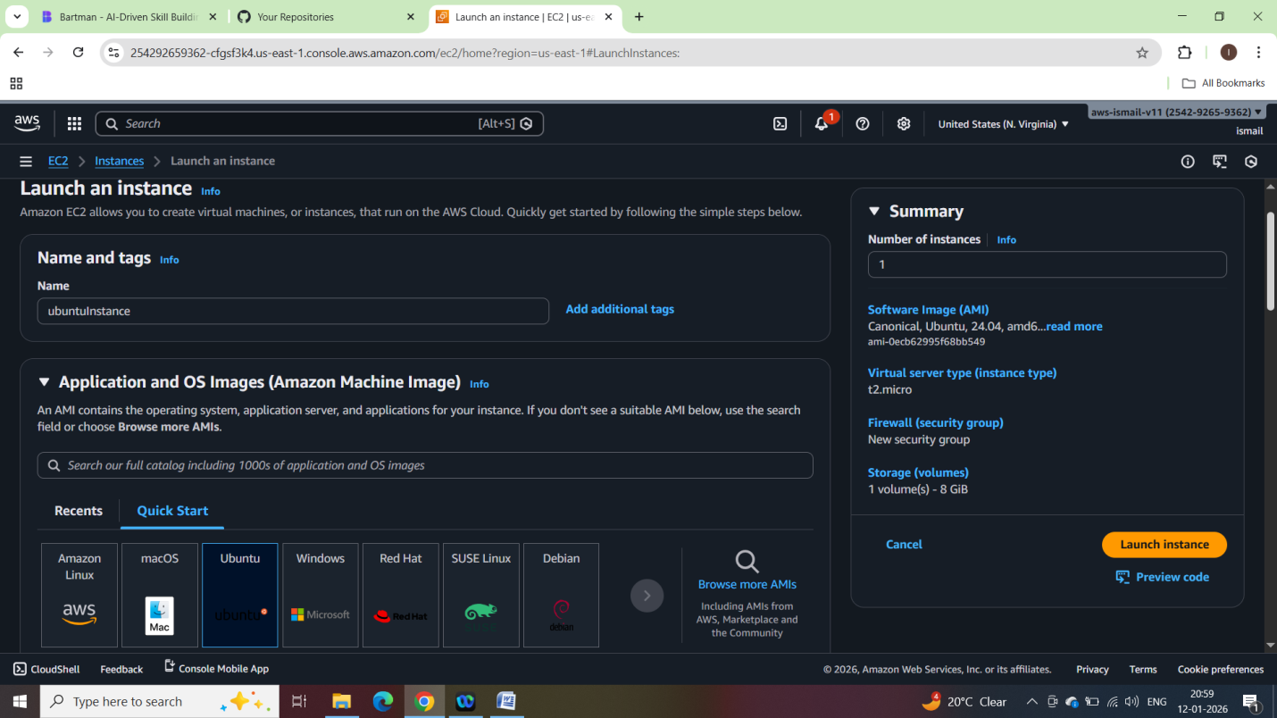
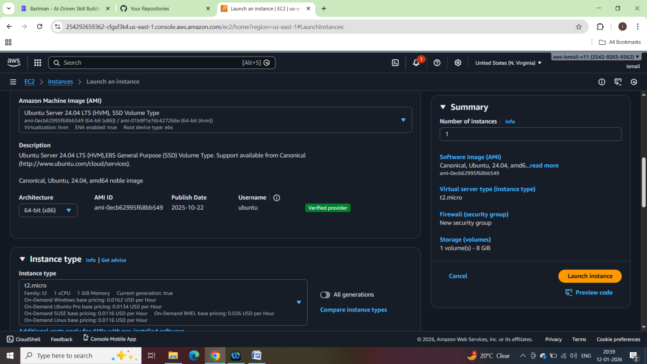
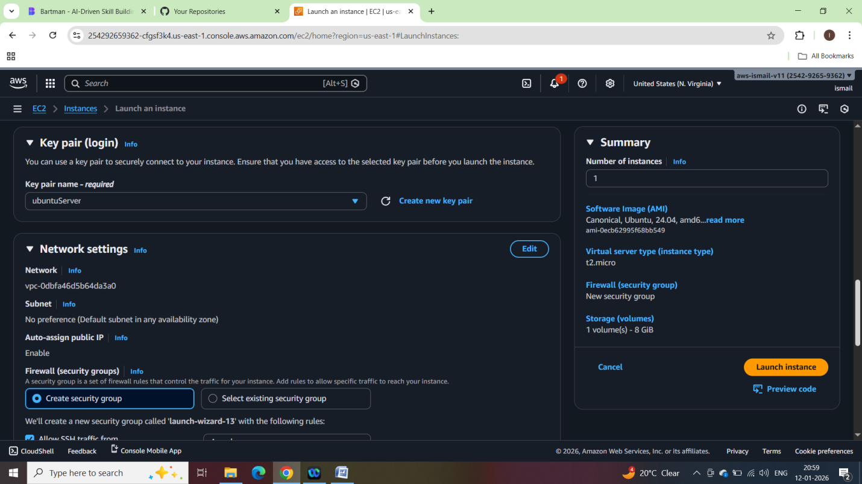
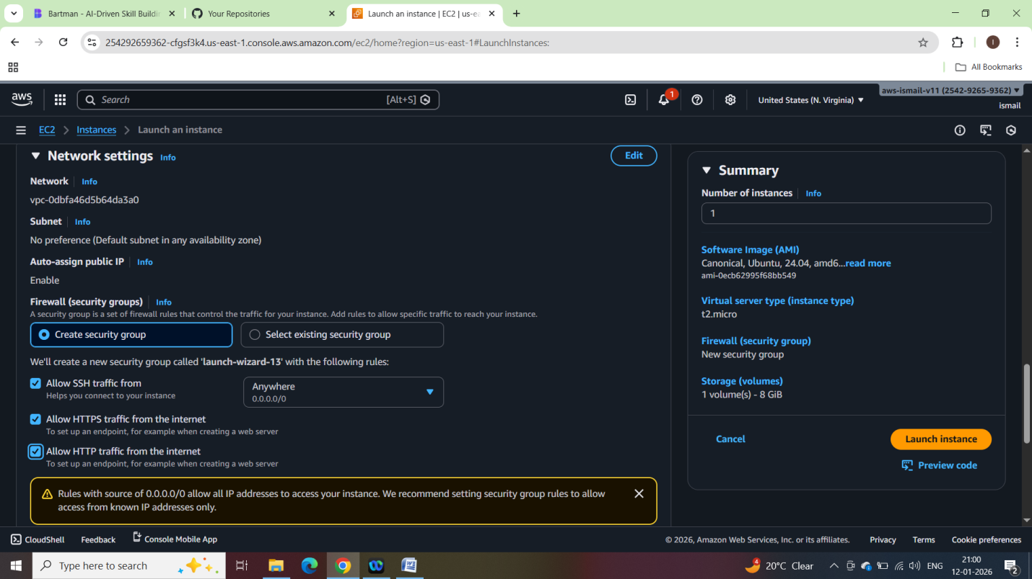
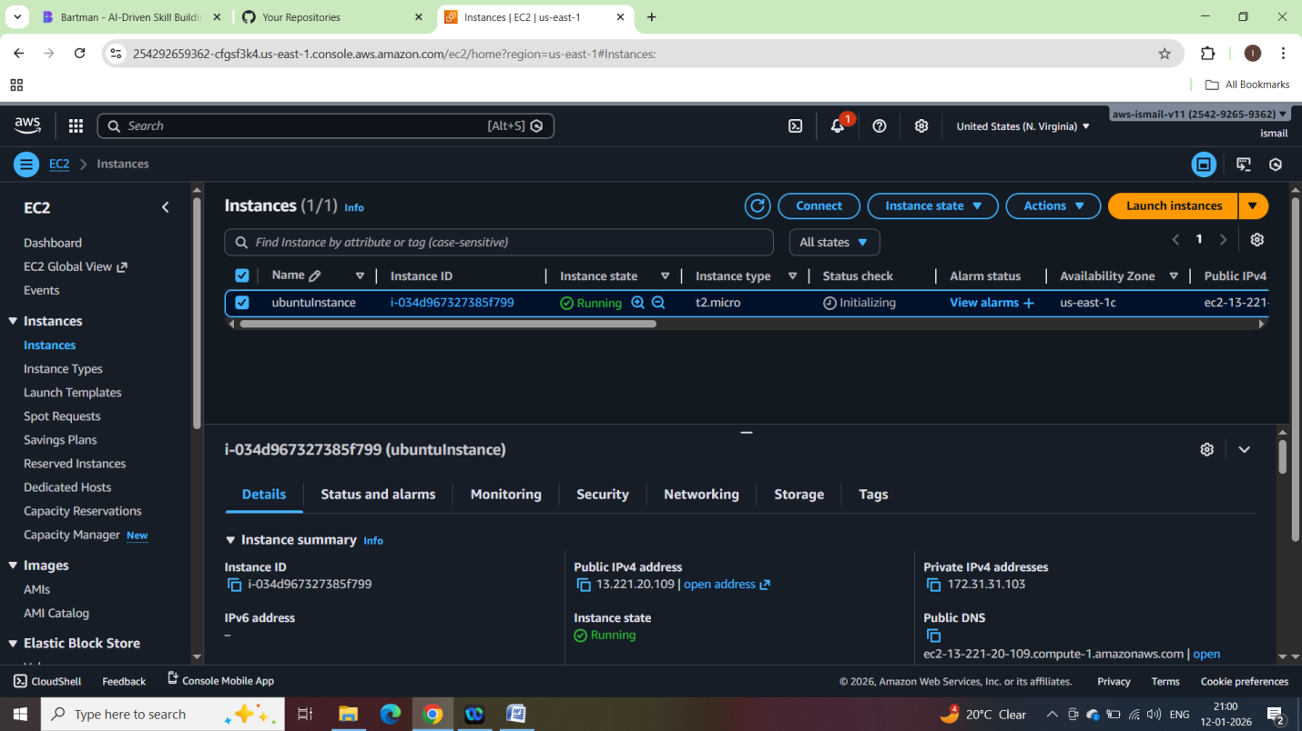

Login into ec2 instance:
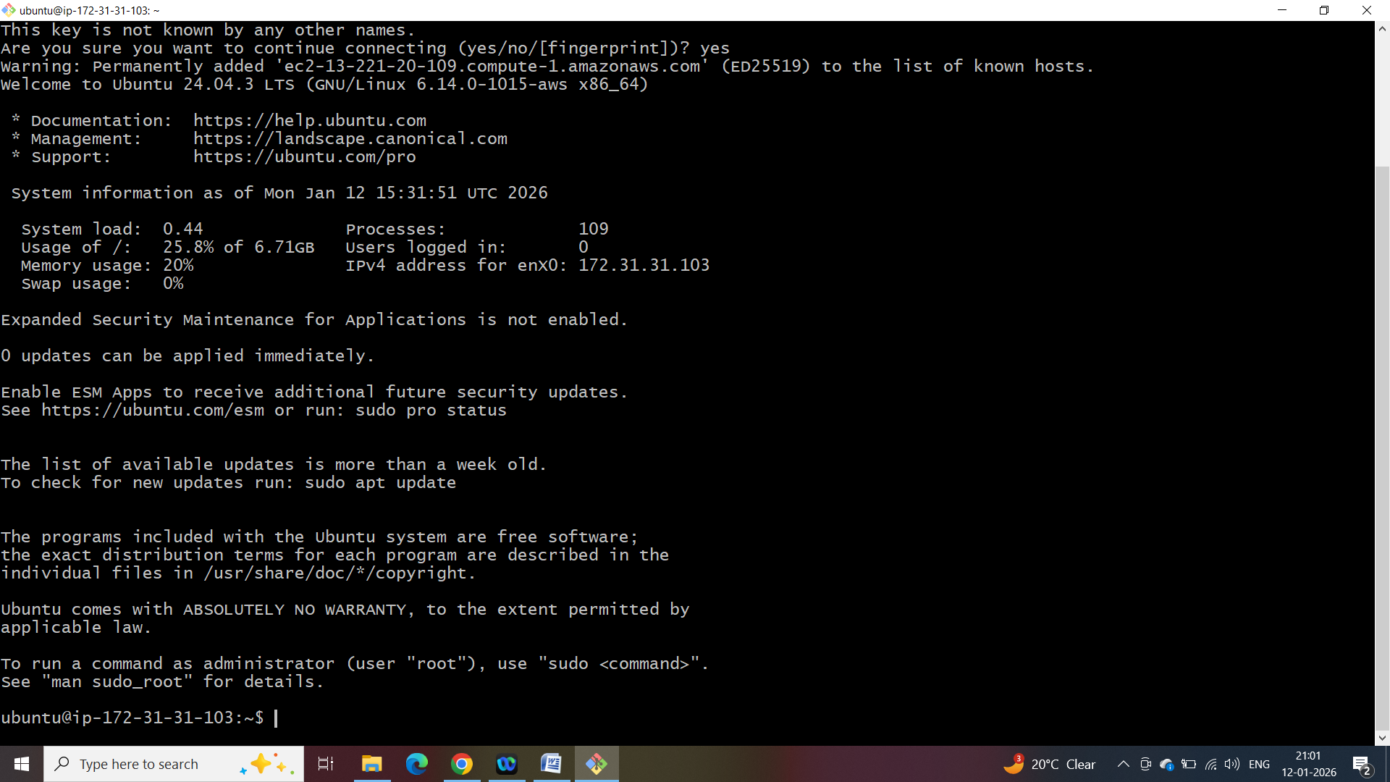

Creating a devops user
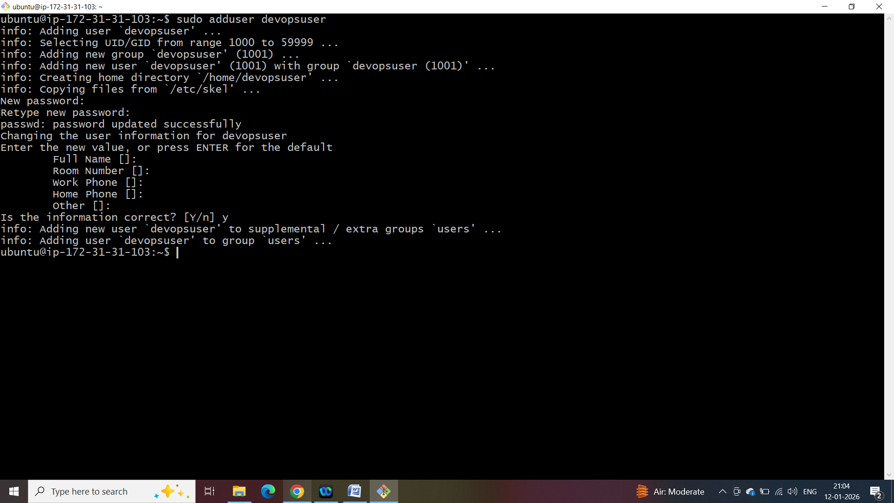
# Switch to the new user
sudo su - devopsuser
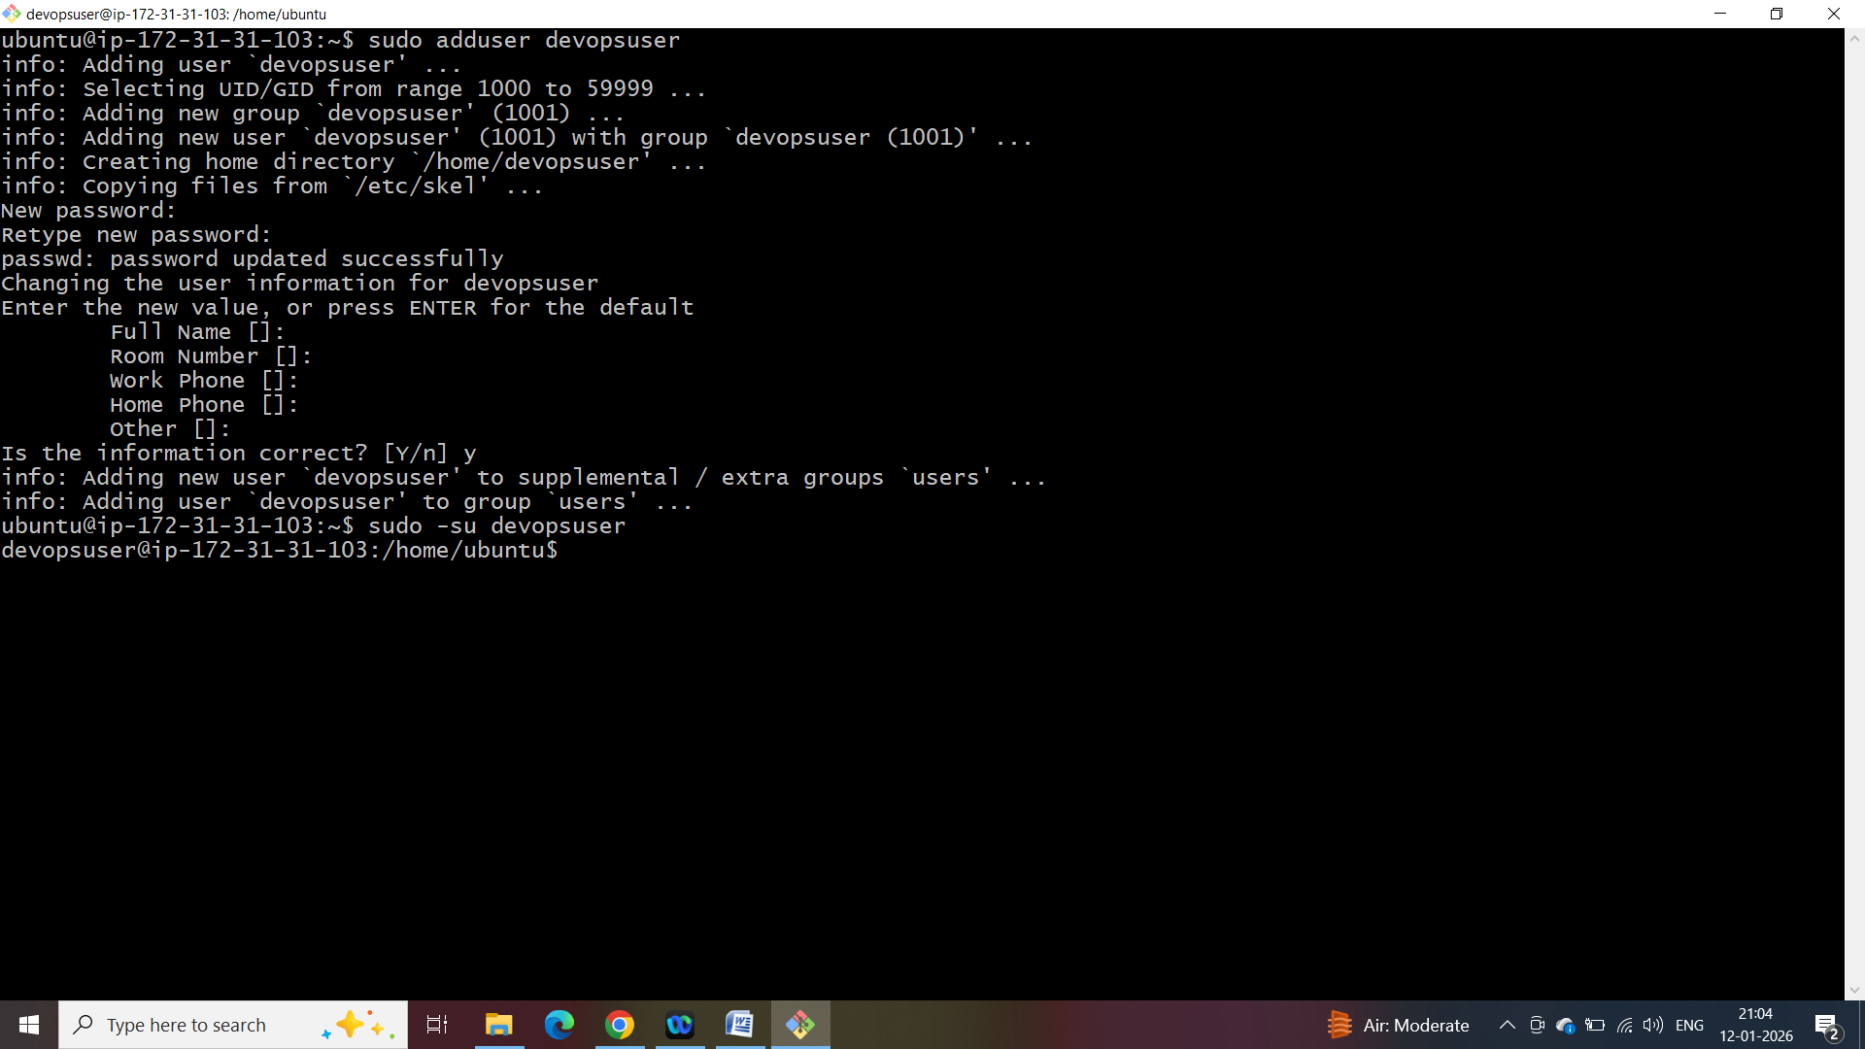
Generate a new SSH key pair in local computer
ssh-keygen -t rsa -b 4096 -C "devopsuser"
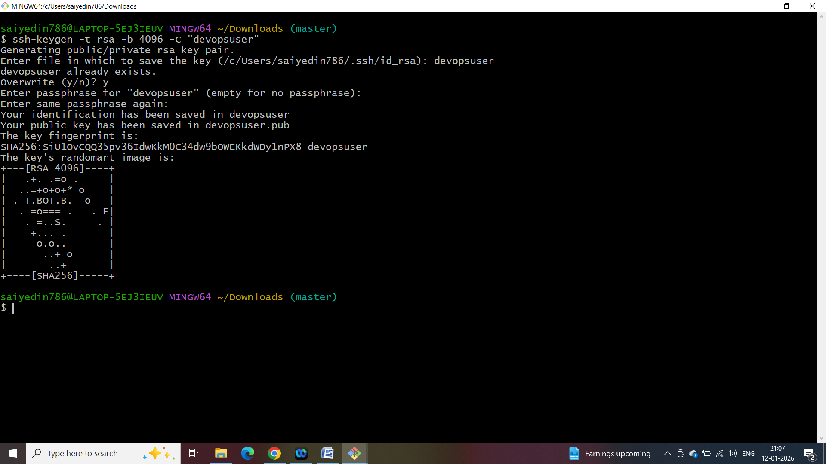
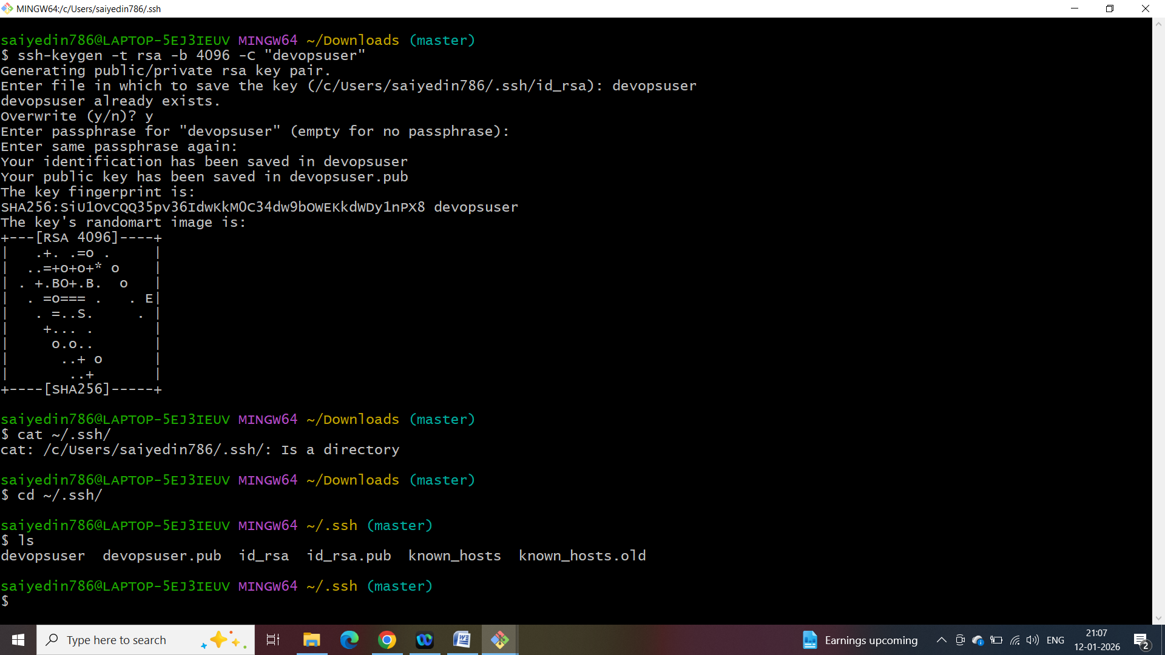

# Copy the public key to EC2
Open ~/devopsuser.pub in notepad copy and than paste in ec2Instance at location
~/home/devopsuser/.ssh/authorized_keys

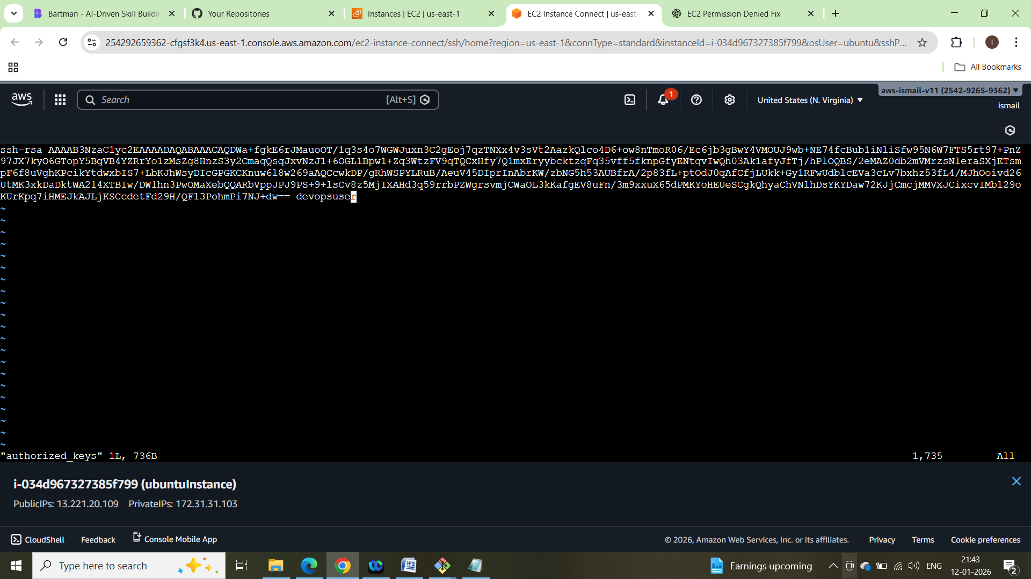

# Login as DevOps user
ssh -i ~/.ssh/devopsuser devopsuser@13.221.20.109
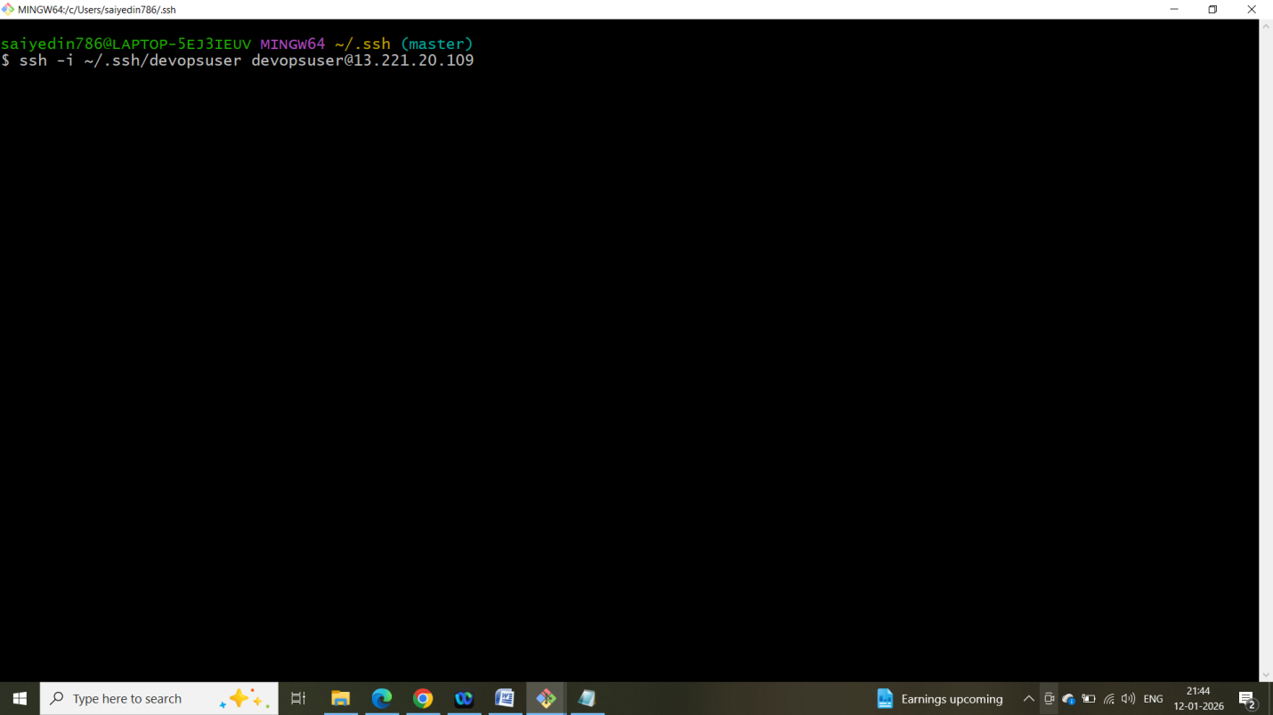
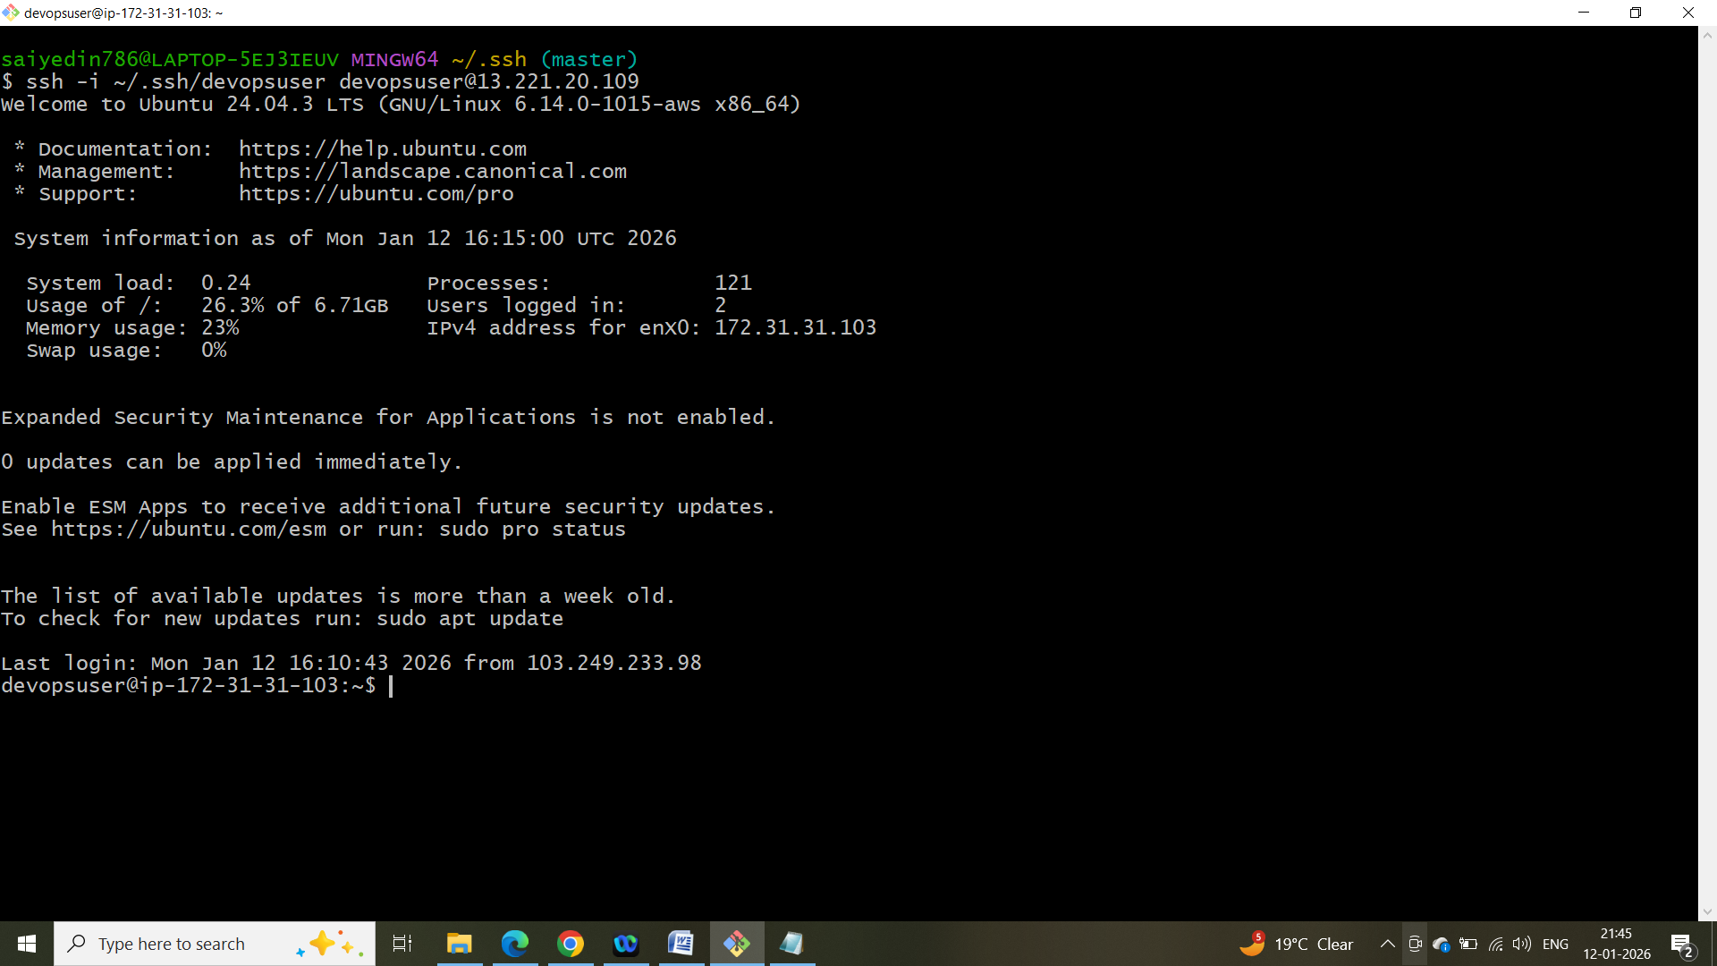

Create a GitHub Repository
Name : html-ec2-deploy
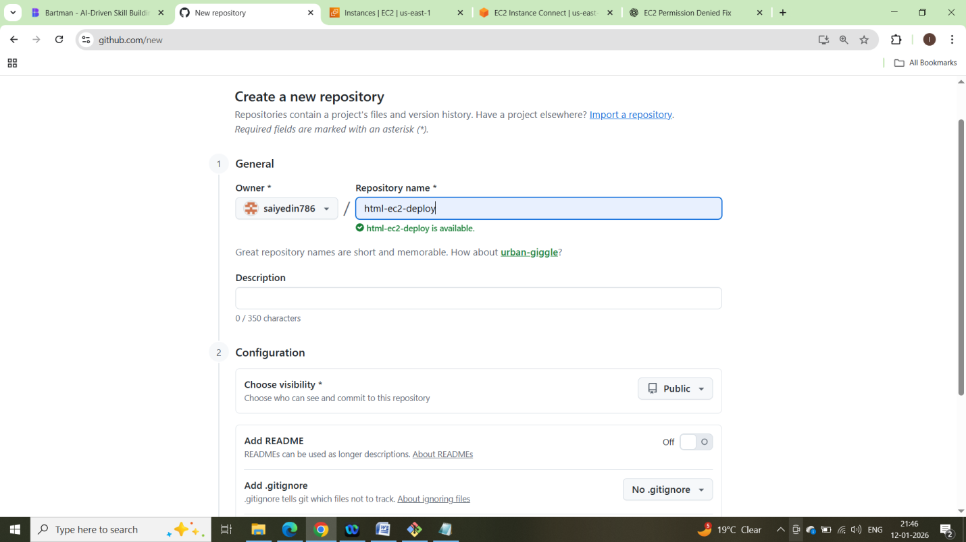
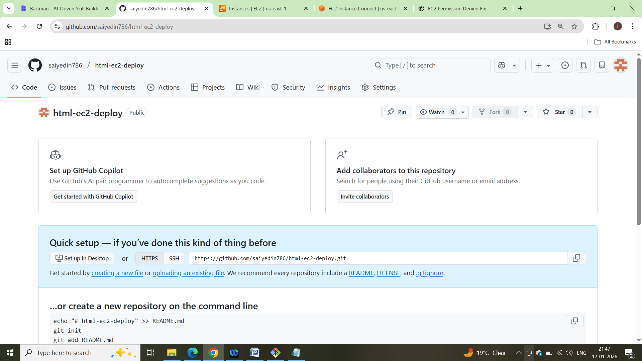

Set git repo locally:
echo "# html-ec2-deploy" >> README.md
git init
git add README.md
git commit -m "first commit"
git branch -M main
git remote add origin https://github.com/saiyedin786/html-ec2-deploy.git
git push -u origin main

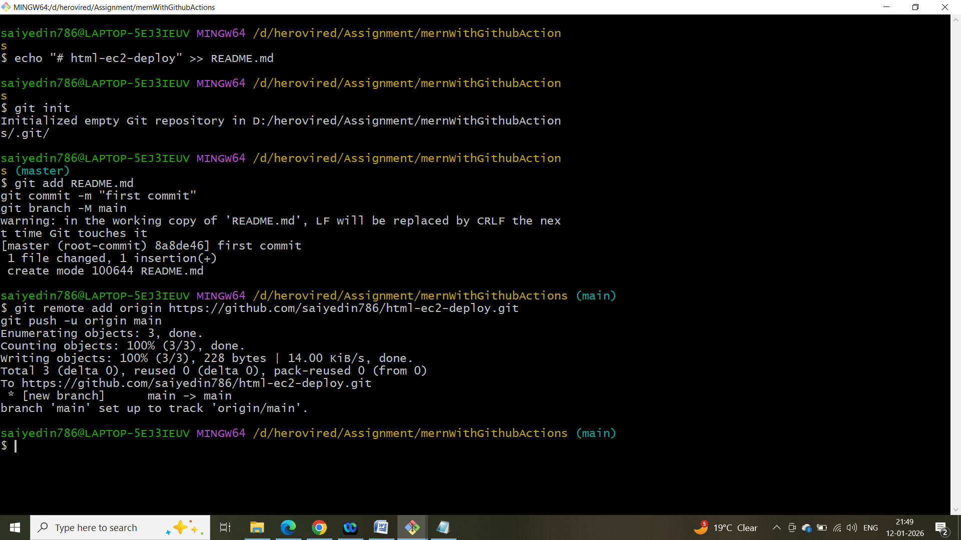

Make an index.html file locally:
<!DOCTYPE html>
<html>
<head>
<title>DevOps Demo</title>
</head>
<body>
<h1>Hello from GitHub Actions & EC2!</h1>
</body>
</html>

