Problem statement:
Deploying a simple static HTML application to an AWS EC2 Ubuntu instance with Nginx as the web server using github actions

Project Solution:

Step 1.1 – Launch an EC2 Instance
To launch an EC2 instance on AWS, follow these steps: Go to the AWS Console, navigate to EC2, and select 'Launch Instance'. For this project, choose the 'Ubuntu t3.micro' instance type, which is eligible for the Free Tier. This allows you to use AWS resources without incurring charges initially. After selecting the instance type, proceed to download the key pair (test.pem) that will allow you to access your instance securely.
Before launching the instance, ensure you configure the security group settings. Specifically, allow inbound traffic on port 22 for SSH access and port 80 for HTTP access. This configuration is essential for enabling secure connections and web traffic to your application once deployed.

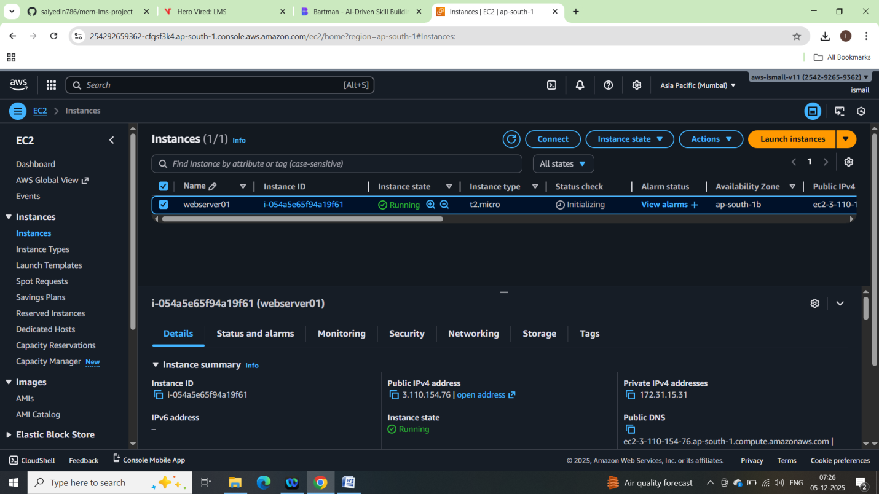
# Example command to connect to your EC2 instance
ssh -i test.pem ubuntu@<EC2-PUBLIC-IP>
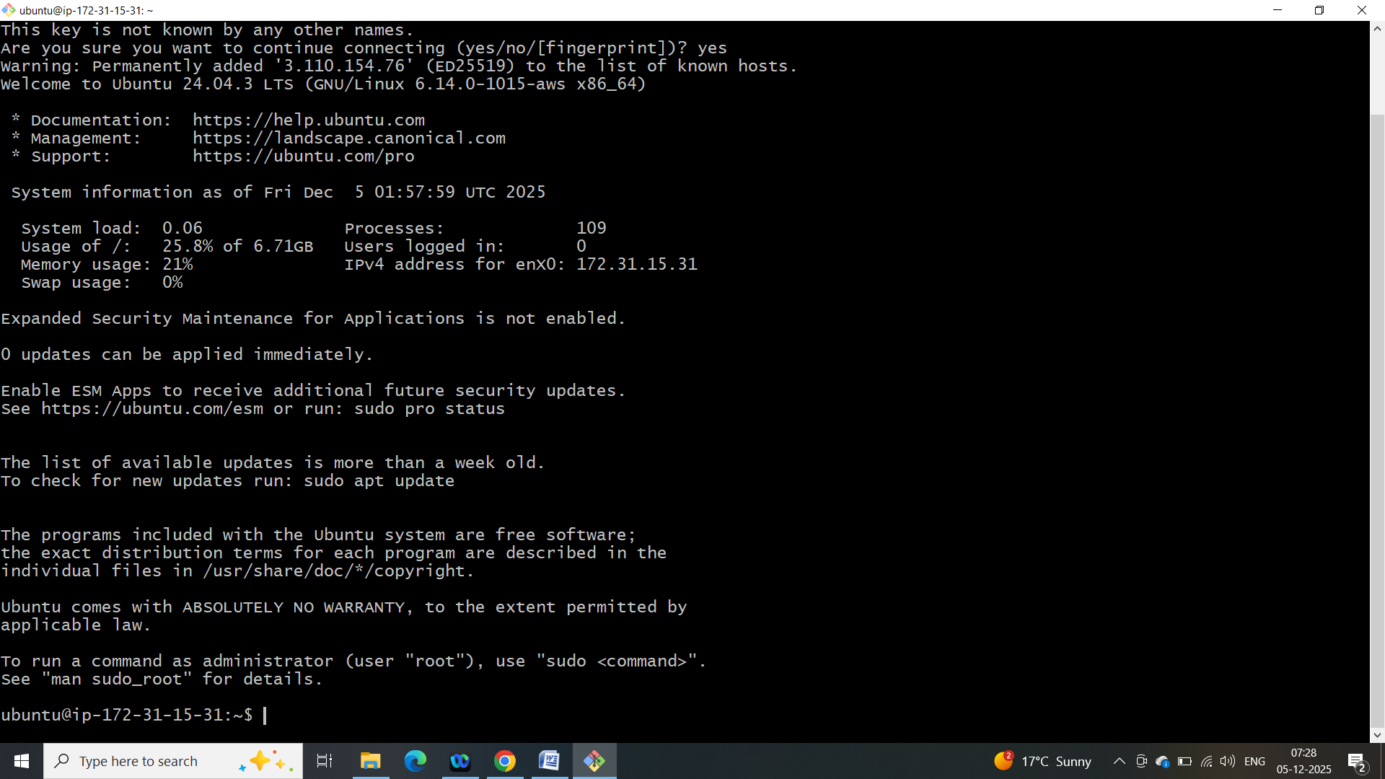

Step 1.2 – Create a DevOps User for Deployment
Once your EC2 instance is running, you can SSH into it using the command provided above. After logging in, create a new user specifically for deployment tasks. This separation of user roles is a best practice in DevOps, as it enhances security and management.
# Create a new user
sudo adduser devopsuser
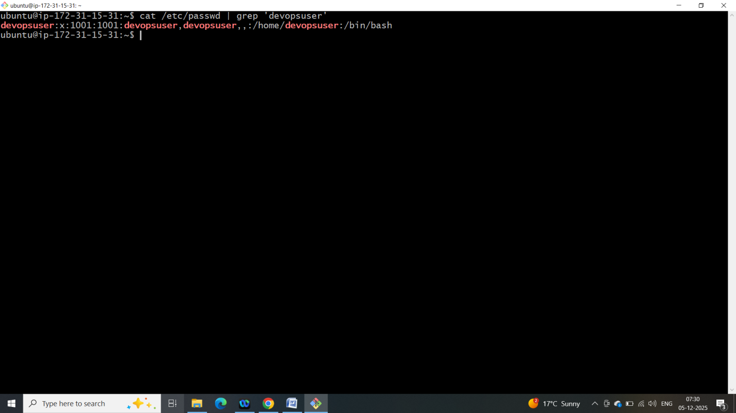

# Switch to the new user
sudo su – devopsuser
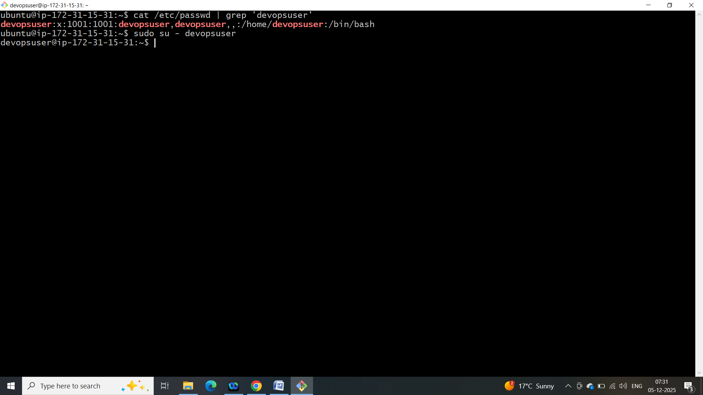

Step 1.3 – Configure SSH Key for devopsuser
To allow the new DevOps user to connect securely, generate an SSH key pair on your local machine. This key pair will facilitate secure communication between your local environment and the EC2 instance.
# Generate a new SSH key pair
ssh-keygen -t rsa -b 4096 -C "devopsuser"
Explain
After generating the SSH key, copy the public key to your EC2 instance. This step is crucial for enabling secure access for the DevOps user. Paste the public key into the authorized_keys file, which grants SSH access to the specified user.
# Copy the public key to EC2
cat ~/.ssh/devopsuser.pub | ssh -i test.pem ubuntu@<EC2-PUBLIC-IP> "nano ~/.ssh/authorized_keys"
Explain
Now you can log in as the DevOps user using the following command. This marks the completion of your initial setup, ready for using GitHub Actions to automate deployments.
# Login as DevOps user
ssh -i ~/.ssh/devopsuser devopsuser@<EC2-PUBLIC-IP>
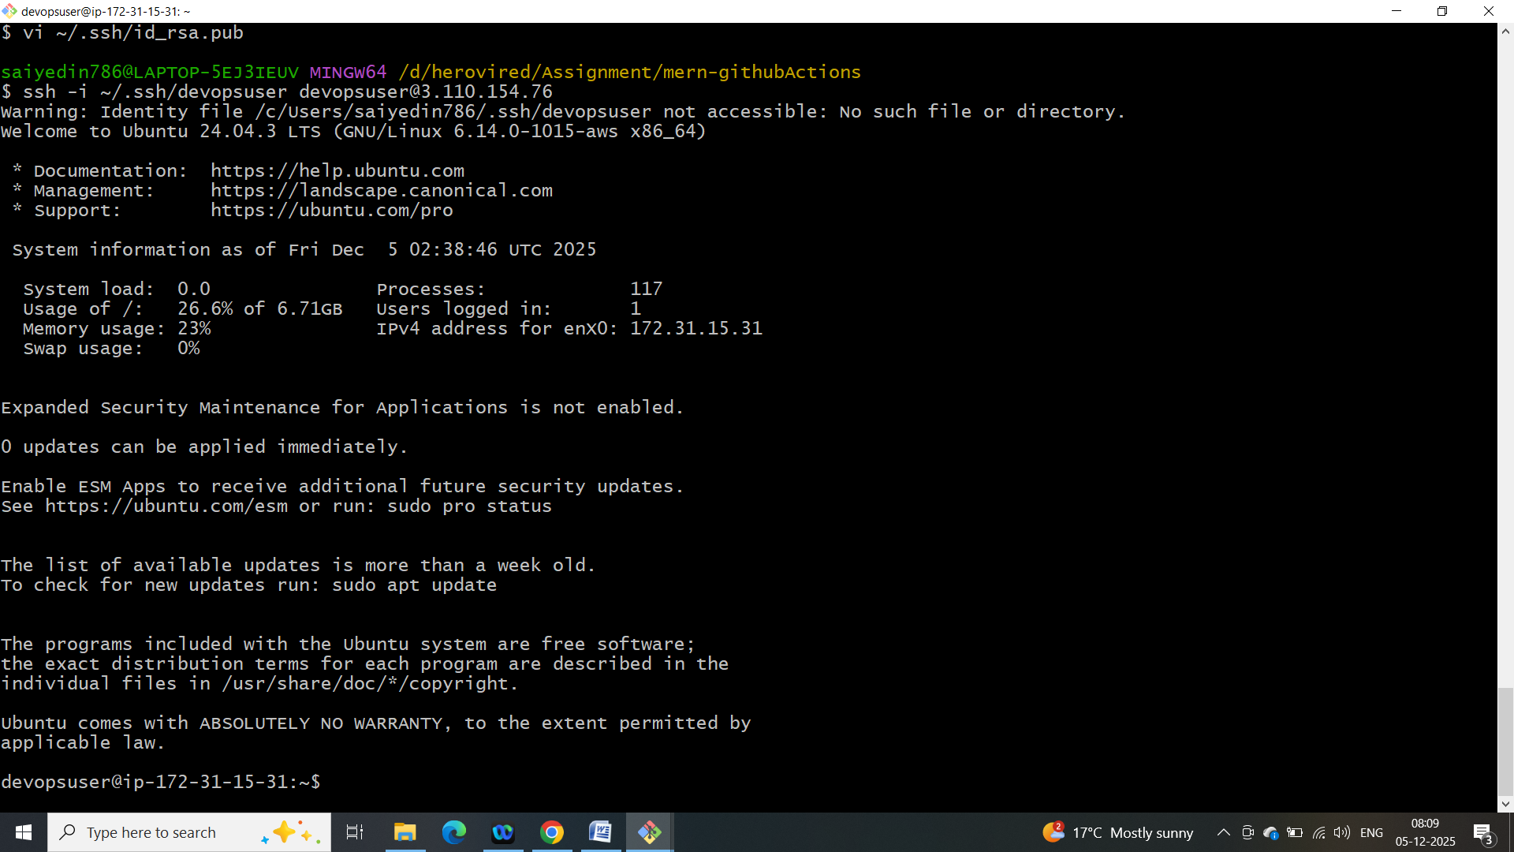

Instructions:

Create a Repo in GitHub
In this lesson, you will create a GitHub repository called "html-ec2-deploy" and add a basic HTML page that serves as a placeholder for your upcoming CI/CD pipeline project. This foundational step is crucial for understanding how to implement continuous integration and continuous deployment (CI/CD) using GitHub Actions. You'll also learn how to push your code to GitHub, which is a vital skill for any developer looking to collaborate and showcase their work.
GitHub is a platform that provides version control using Git. It allows developers to collaborate on projects, track changes, and maintain code history. Mastering GitHub is essential for modern software development, particularly when working with CI/CD pipelines and cloud deployments.

Step 1: Create a GitHub Repository
Follow these steps to create your repository:
Sign in to your GitHub account.
Click on the '+' icon in the top right corner and select 'New repository'.
Name your repository 'html-ec2-deploy'.
Add a description (optional): 'A simple HTML page for CI/CD demo'.
Choose 'Public' or 'Private' based on your preference.
Initialize the repository with a README file (optional).
Click 'Create repository'.
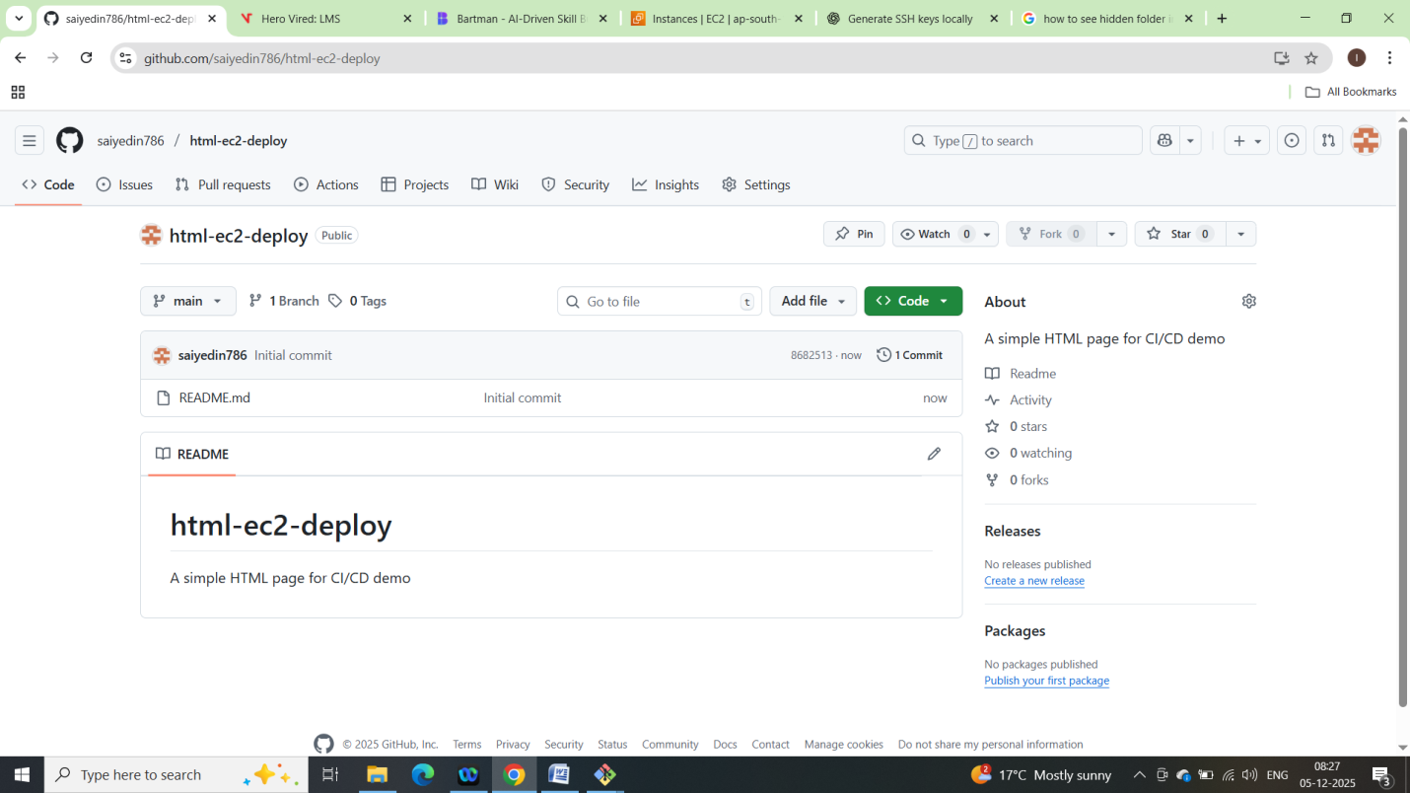

Step 2: Add a Simple HTML Page
<!DOCTYPE html>
<html>
<head>
<title>DevOps Demo</title>
</head>
<body>
<h1>Hello from GitHub Actions & EC2!</h1>
</body>
</html>
Explain
Create a new file in your repository named <index.html> and copy the HTML code provided above. This page serves as a simple greeting message and will be the first component of your CI/CD project.
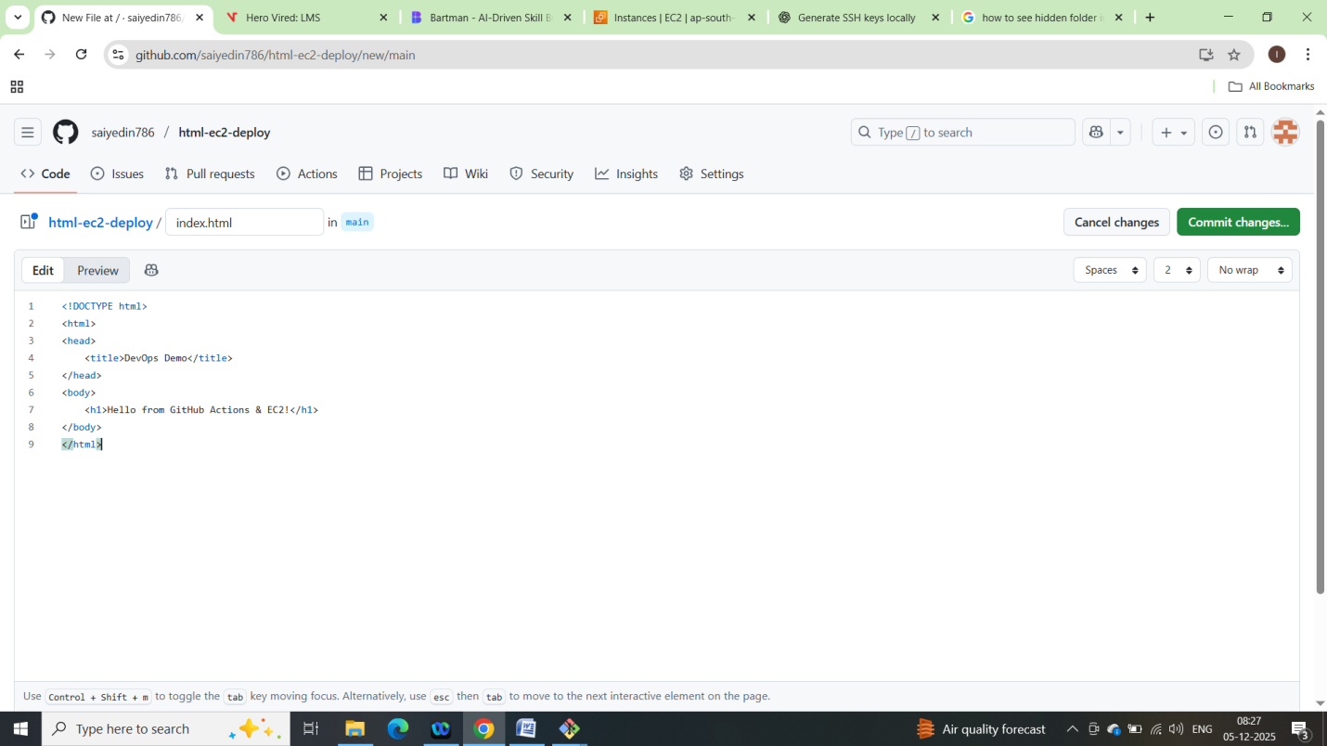
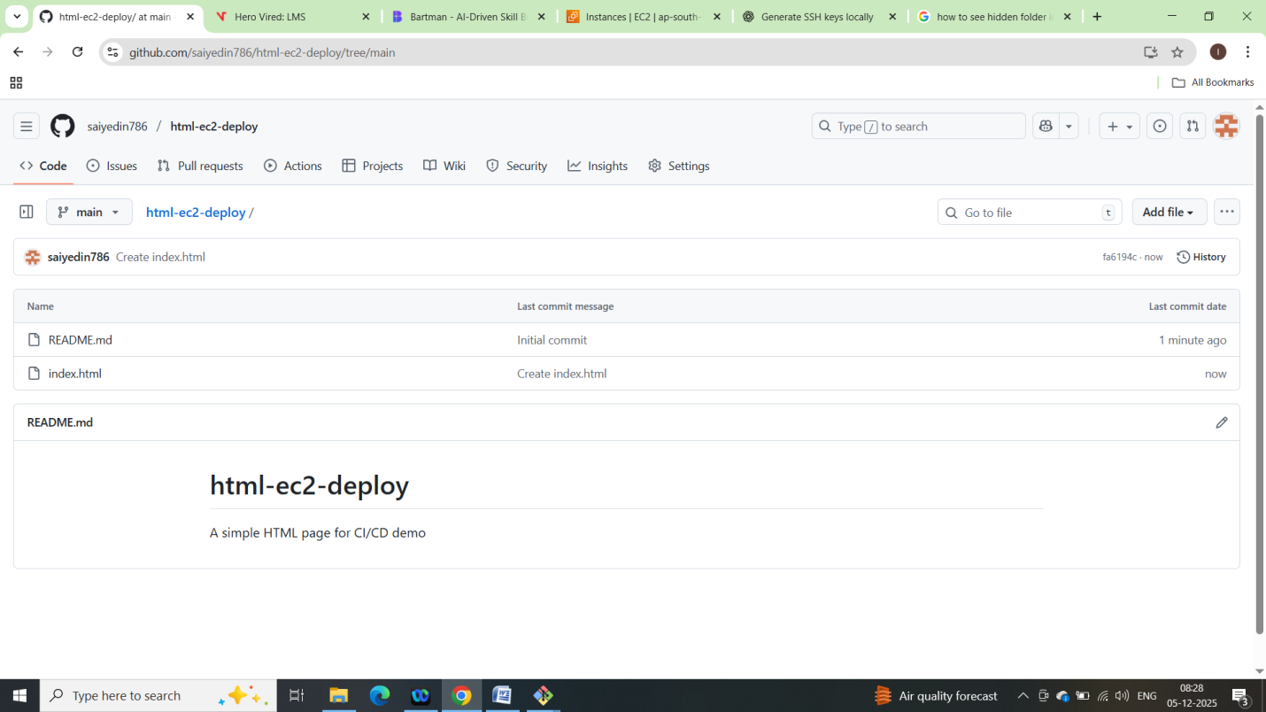

Step 3: Push to GitHub
After adding your HTML file, follow these steps to push your changes to GitHub:
Open your terminal or command prompt.
Navigate to your local repository folder.
Run 'git add index.html' to stage your changes.
Commit your changes with 'git commit -m "Add simple HTML page"'.
Push your changes to GitHub with 'git push origin main'.
Congratulations! You have successfully created a GitHub repository, added a simple HTML page, and pushed your changes. This is the first step towards building a robust CI/CD pipeline using GitHub Actions and deploying your applications to AWS EC2.

Next Steps
In the next lesson, you will learn how to configure GitHub Actions to automate the deployment of your HTML application to an AWS EC2 instance. Make sure to review the concepts of CI/CD before moving forward!

