GitHub Actions CI/CD Pipeline Flask App
Objective:
Implement a CI/CD workflow using GitHub Actions for a Python application.
Requirements:
1. Setup:
- Use a provided Python application repository on GitHub (provide a link to a sample Python application repository).
- Ensure the repository has a main branch and a staging branch.
2. GitHub Actions Workflow:
- Create a .github/workflows directory in your repository.
- Inside the directory, create a YAML file to define the workflow.
3. Workflow Steps:
- Define a workflow that performs the following jobs:
- Install Dependencies: Install all necessary dependencies for the Python application using pip.
- Run Tests: Execute the test suite using a framework like pytest.
- Build: If tests pass, prepare the application for deployment.
- Deploy to Staging: Deploy the application to a staging environment when changes are pushed to the staging branch.
- Deploy to Production: Deploy the application to production when a release is tagged.
4. Environment Secrets:
- Use GitHub Secrets to store sensitive information required for deployments (e.g., deployment keys, API tokens).
5. Documentation:
- Update the README.md file with instructions on how the GitHub Actions workflow works and how to configure the necessary secrets.
6. Submission:
- Provide the URL to the GitHub repository with the workflow file and updated README.md.
- Include screenshots of the GitHub Actions workflow runs showing successful execution of all steps.

Project solution:
1. Setup:
- Use a provided Python application repository on GitHub (provide a link to a sample Python application repository).
- Ensure the repository has a main branch and a staging branch.
Creating a new github repository named python-github-actions-repo
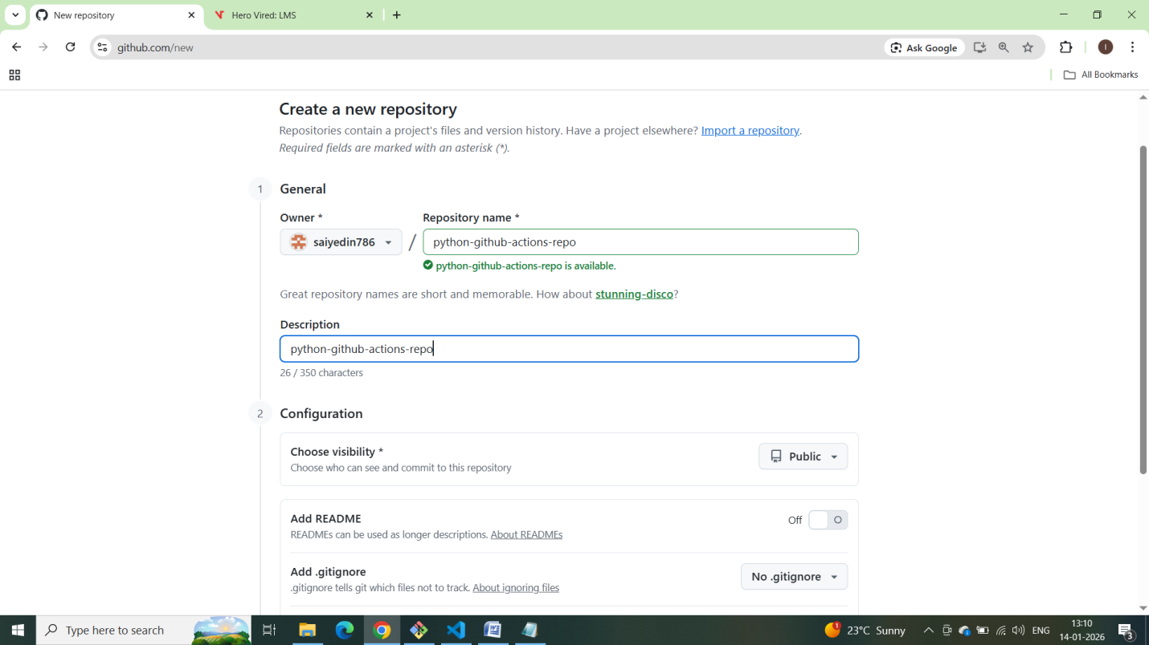
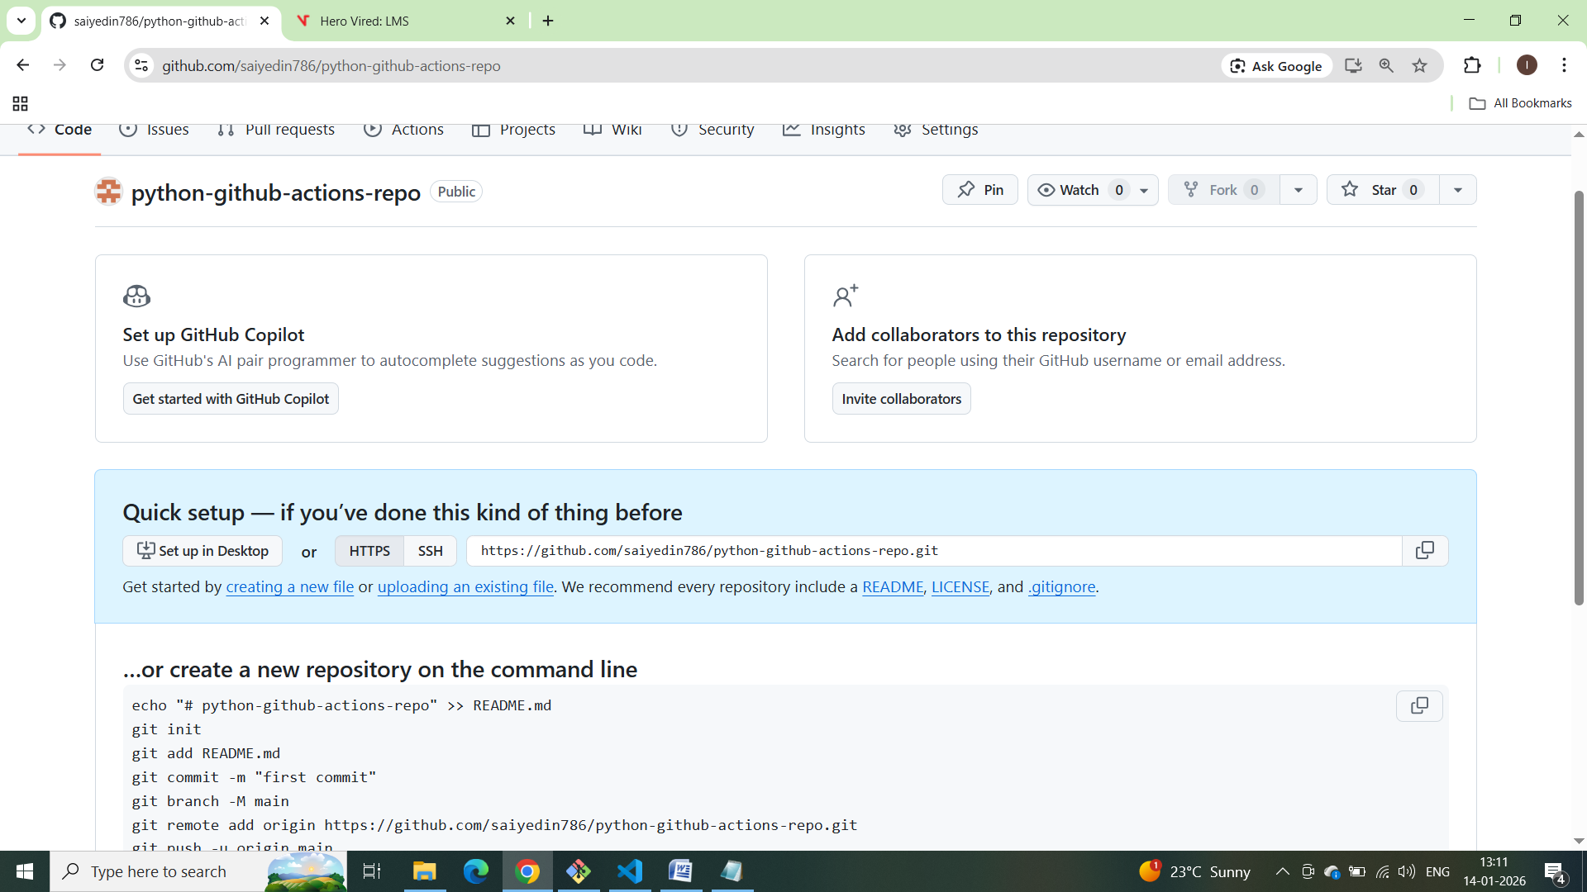

Creating local repo in local computer:
echo "# python-github-actions-repo" >> README.md
git init
git add README.md
git commit -m "first commit"
git branch -M main
git remote add origin https://github.com/saiyedin786/python-github-actions-repo.git
git push -u origin main

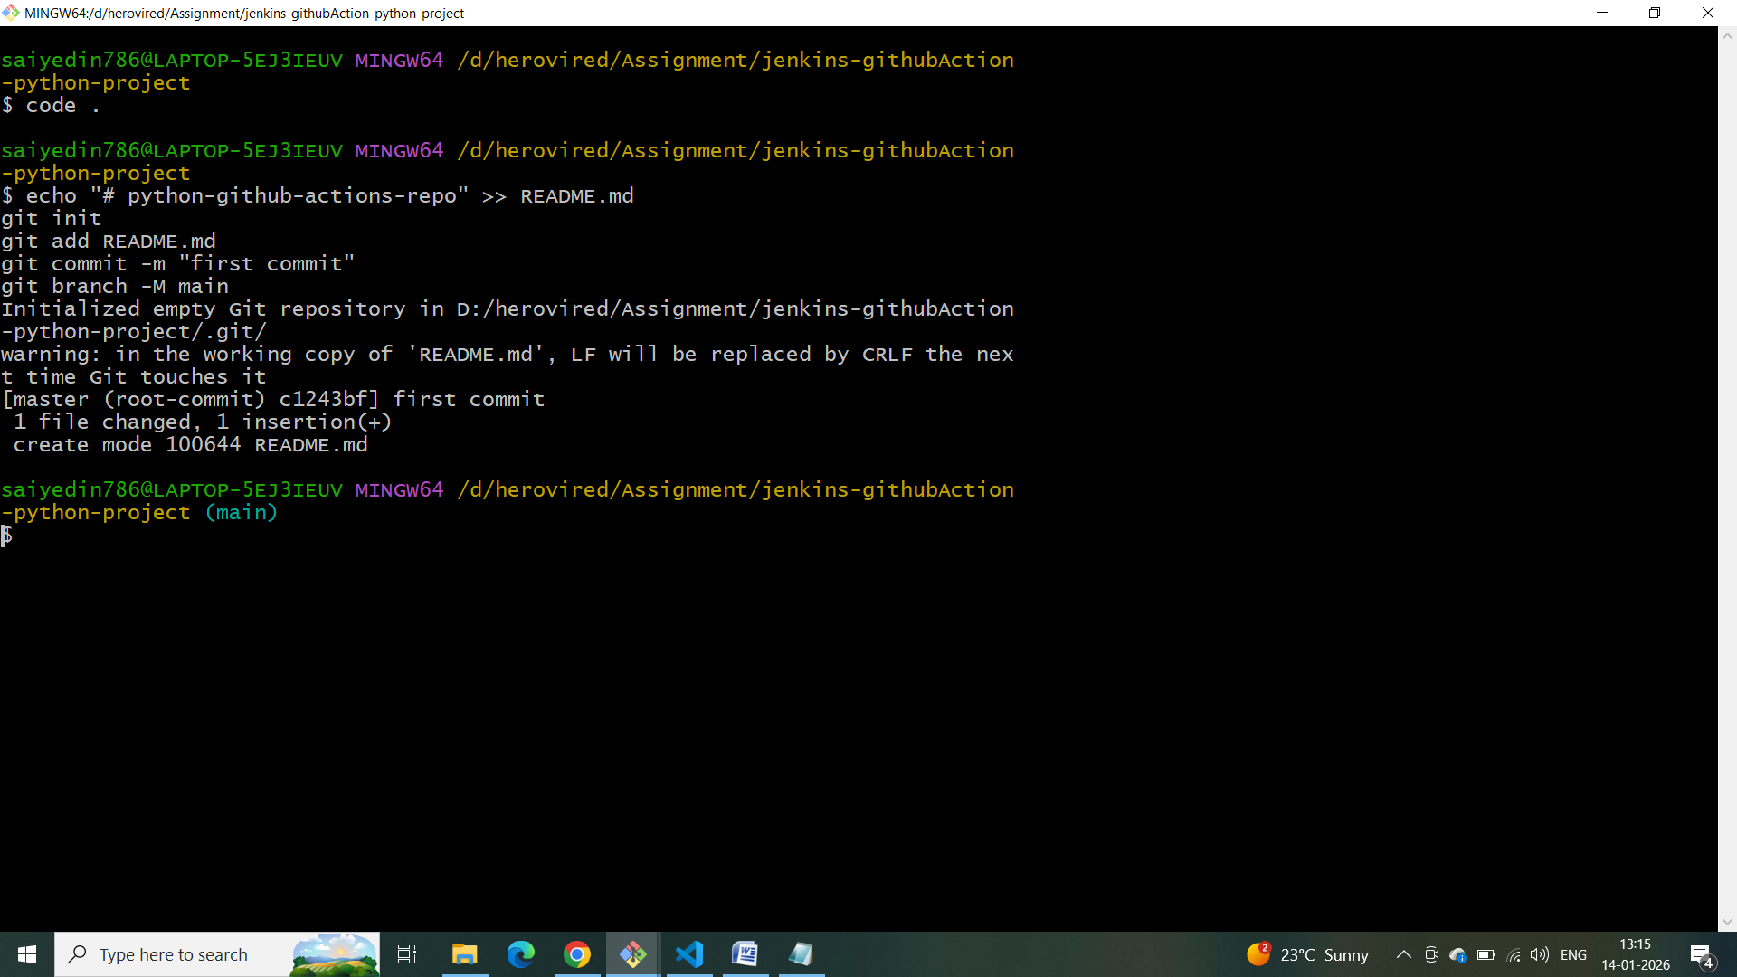
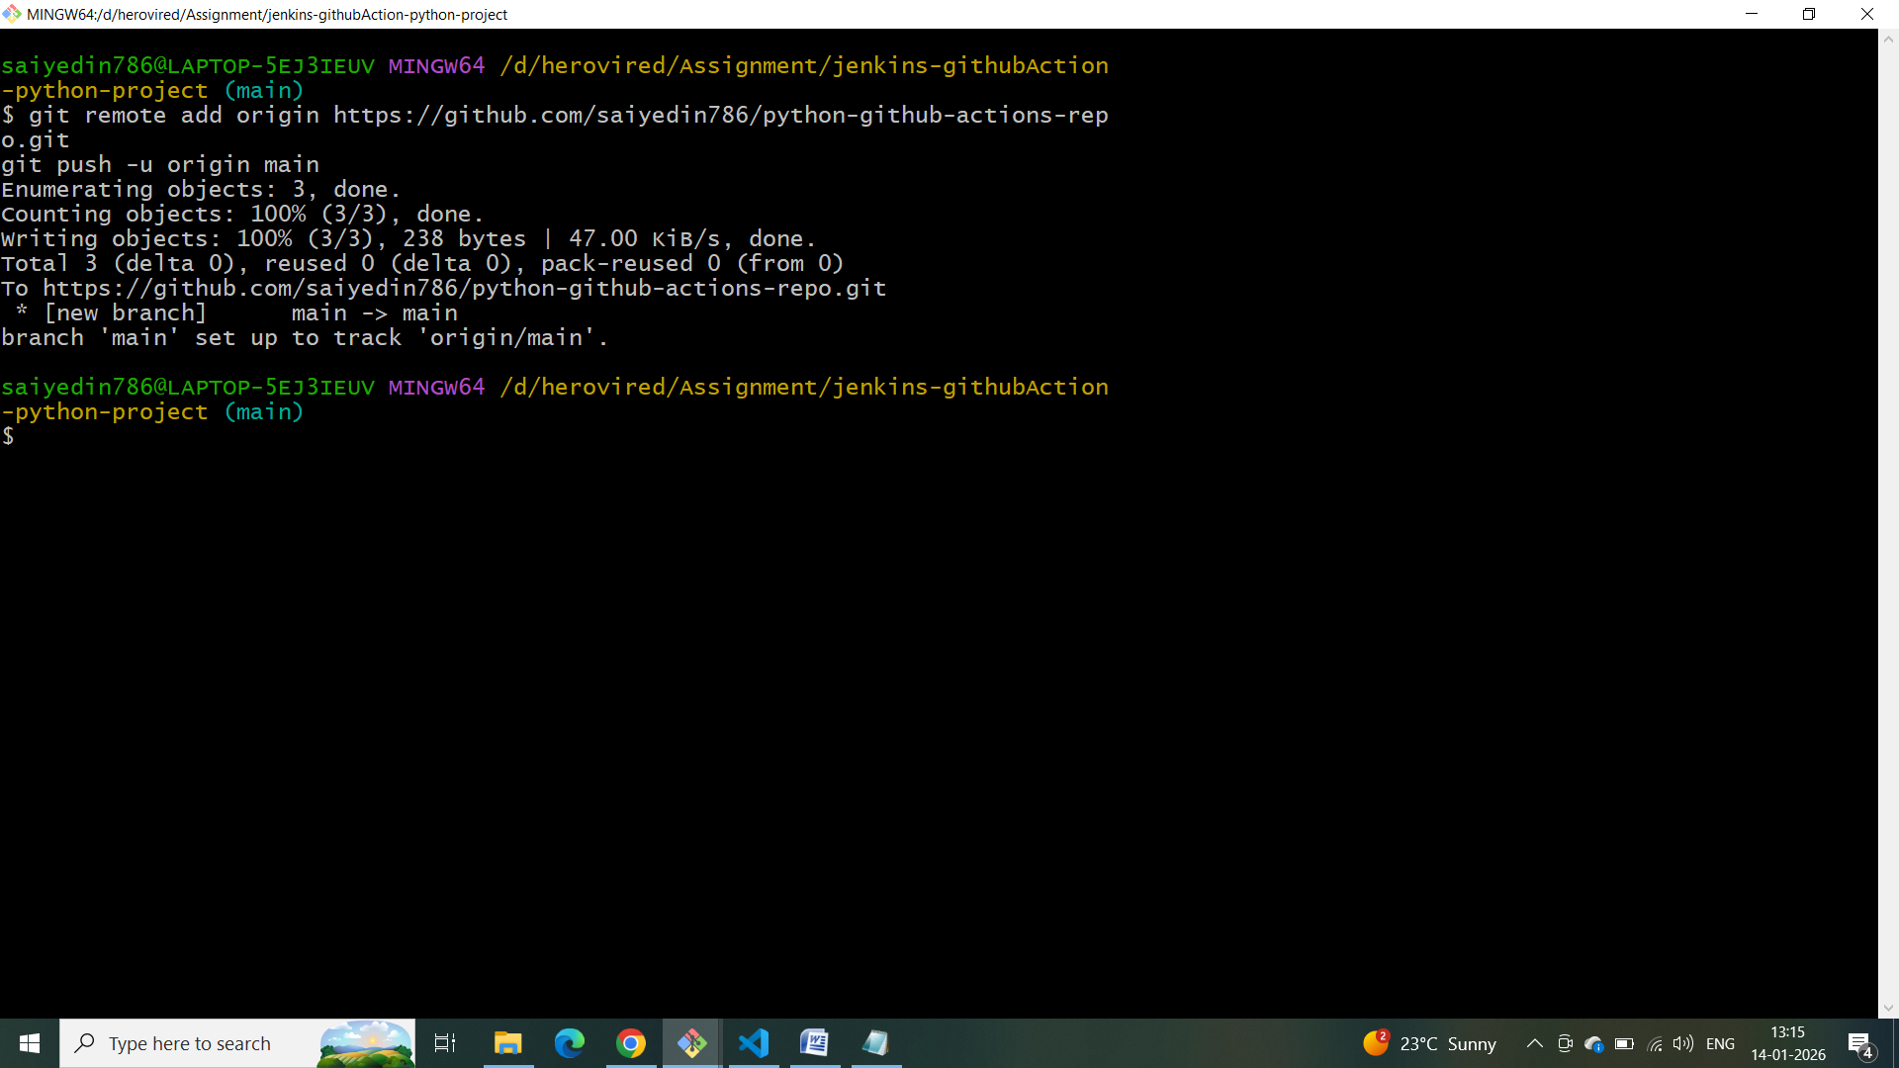

Creating a branch called staging:
Git branch staging
